Appendix A: Supplementary information

This file includes:
- Supplementary Materials and Methods
- Figures
  - S1: Predictor ranking proportions across 10-fold cross-validation
  - S2: Spatial projection of the modeled uncertainty
  - S3: Area of applicability and dissimilarity index
  - S4: Environmental effects on t₅₀ and model parameters
  - S5: Correlation matrix of response variables and the full initial predictor set
- Table S1: Simulated parameter values of the sigmoidal regrowth curve for each of the 32 sites
- Supplementary References
Supplementary Materials and Methods

Bayesian modeling of AGC recovery
All data and statistical analyses were carried out using RStudio¹ and the Stan programming language², through the rstan package (version 2.32.7)³. For a given data model and prior distributions, Stan simulates draws from the posterior distribution through the No-U-Turn-Sampler (NUTS), a specific Markov-Chain Monte Carlo (MCMC) algorithm. The use of MCMC enables efficient exploration of the posterior probability space by generating samples that are more likely to fall in regions of high posterior density, thereby improving convergence and reducing computational cost². For all modeled and calculated parameters, 90% credible intervals (CI) were calculated as the lower and upper 5% quantiles of the corresponding draws from the posterior probability distribution.
Recovery model
The recovery of AGC to the OGF reference state was modeled using the following sigmoidal function, inspired by the Chapman-Richards growth model^{4,5}(equation 1).
$µ_{X,t}=α_{X}+(ω_{X}-α_{X})∙{(1-\exp\left(-λ_{X} ∙ t\right))}^{δ_{X}}$ (1)
with µ_{X,t} [Mg C ha⁻¹] the AGC recovery at time t for a specific site X, α_{X} [Mg C ha⁻¹] the site-specific modeled starting value of succession (i.e. the value for µ_{X,t}(t = 0), which accounts for the standing biomass due to remnant trees), ω_{X} [Mg C ha⁻¹] the site-specific modeled asymptotic value (i.e. the OGF situation), λ_{X} [year⁻¹] the site-specific intrinsic recovery rate, and δ_{X} the instantaneous growth rate in the inflection point of the sigmoidal curve [dimensionless].
In each iteration, the likelihood of observed data points from both SF and OGF plots - given the parameter values proposed by the Stan algorithm - was evaluated against lognormal distributions as follows:
$${AGC}_{t} \sim logN(µ_{X,t}, σ_{X,SF}^{2})$$
$${AGC}_{OGF} \sim logN(µ_{X,OGF}, σ_{ X,OGF}^{2})$$
with AGC_{t} the vector of observed AGC values from secondary forest for a given forest age (here indicated as time t), µ_{X,t} the modeled AGC for a site X at time t, σ²_{X,SF} the modeled dispersion of the lognormal law on the observations from secondary forest plots, AGC_{OGF} the vector of observed AGC value from OGF across sites, µ_{X,OGF} the modeled AGC for OGF across sites, and σ²_{X,OGF} the modeled dispersion of the lognormal law on the observations from secondary forest plots. Since µ_{X,t} also contains a modeled outcome for ω_{X}, OGF reference values could also be estimated in the absence of field-observed OGF data.
Introduced error on age estimates
Because age estimates of secondary forest plots derived from interviews with local informants are subject to substantial uncertainty due to inaccurate recall or misinterpretation, observed plot ages were treated as uncertain observations of an underlying true stand age. The true age was modeled as a latent variable drawn from a normal distribution with mean equal to the observed age. The standard deviation of this distribution was parameterized such that 90% of the probability mass is located within ±20% of the observed age.
Hyperlaws and priors
The model contains two hierarchical levels: site-level parameter estimates (the base level) are evaluated on higher-level lognormal hyperdistributions.
The site-specific α_{X}, λ_{X}, and δ_{X} from equation (1) were additionally modeled in a non-centered parametrization (general form):
$${param}_{X}={med}_{param, hyper}∙exp⁡({param}_{X, tilde} ∙ σ_{ param, hyper}^{2})$$
with param_{X} the modeled site-specific or class-level parameter value, med_{param,hyper} the median of the lognormal hyperlaw on the parameter, param_{X,tilde} a standard-normally distributed parameter corresponding to param_{X}, and σ²_{param,hyper} the dispersion of the lognormal hyperlaw on the modeled parameter. All param_{X,tilde} were thus evaluated on standard-normal priors.
All dispersion parameters (σ) were evaluated on half-normal distributions with µ = 0 and σ = 3. General hyperlaw medians (med_{param,general}) were evaluated on weakly informative exponential priors in the following way:
$$µ_{ω, hyper} \sim exponential(λ=0.001)$$
$$µ_{α, hyper} \sim exponential(λ=0.05)$$
$$µ_{λ, hyper} \sim exponential(λ=1)$$
$$µ_{δ, hyper} \sim exponential(λ=0.1)$$
We used exponential priors along with lower bounds of 10⁻⁶ (i.e., a very small positive number) specified in Stan’s parameter declarations to ensure strictly positive estimates for the parameters of interest. Lower bounds were set slightly above zero rather than at zero to improve computational efficiency, as Stan evaluates likelihoods on the log scale and struggles with values near zero. Upper bounds for hyperdistributions medians were set to 500 for med_{α,general}, 1 for med_{λ,general}, and 10 for med_{δ,general}, based on expert knowledge and preliminary model runs. These constraints help prevent extremely high parameter values, which are therefore rejected when proposed by the Stan algorithm. Importantly, the bounds are still unrealistically wide to allow the posterior distributions to express their full shape without artificial truncation.
Reinforcing the OGF representation
Because observed OGF values play a key role in shaping the estimated recovery trajectories and asymptotic biomass—yet are typically based on relatively few reference plots compared to the number of secondary forest plots—we specified informative priors for the parameter ωₓ, representing the asymptotic value of the succession trajectory. These priors were derived from the upper 10th percentile of the European Space Agency’s Climate Change Initiative (CCI) biomass map, after masking out regrowing forest areas, thereby capturing a broader, spatially continuous estimate of potential old-growth biomass conditions.
Importantly, OGF measurements entered a likelihood term for the parameter ωₓ, which was separate from secondary forest plots. This approach allows the asymptotic value to be informed both by empirical OGF plot data and by a regionally representative prior, thereby reducing sensitivity to the limited number and potential sampling bias of OGF plots without excluding them from model calibration.
Biomass was converted to AGC using a conversion factor of 0.456, assuming a wood carbon content of 45.6% for tropical angiosperms⁶. The mean of the normal prior on log(ωₓ) was defined as the mean of the log-transformed AGC values, and the standard deviation was chosen such that, in the corresponding lognormal distribution of ωₓ, 90% of the probability mass lay within ±100% of the mean, allowing substantial flexibility while remaining informative.
Posterior calculations
The following posterior calculations were executed for each iteration in the Stan algorithm, yielding probability distributions for all calculated variables.
The time to recovery of X% of the OGF reference AGC stock was derived by dividing both sides of equation (1) by ω_{X}, resulting in a recovery fraction at time t: fract = µ_{X,t} / ω_{X}. This expression was then rearranged to solve for t, yielding t_{fract} – the time to achieve a given recovery fraction:
$$t_{fract}= -\frac{1}{λ_{X}}∙log\left(1-{\left(\frac{fract- \frac{α_{X}}{ω_{X}}}{1- \frac{α_{X}}{ω_{X}}}\right)}^{\frac{1}{δ_{X}}}\right)$$
We simulated t_{fract} for recovery fractions ranging from α_{X} / ω_{X} up to 0.99, as the function is undefined for values below α_{X} / ω_{X} or equal to or exceeding 1. This produced a continuous curve describing the time to recovery across the full range of valid fractions. Recovery times are thus based on the modeled asymptotic value of AGC recovery, rather than directly on field-based OGF reference measurements. In the following, only the time to 90% recovery (t₉₀) is discussed.
Forest AGC recovery trajectories were simulated for t going from 1 to 100 years using equation (1), which allows for a truthful visualization of the full sigmoidal curve. This range is typically sufficient to capture the complete shape of the recovery trajectory, including the inflection point and asymptotic phase.
Early aboveground carbon accrual during the first 20 years of succession (CA₂₀) was calculated as the difference between modeled total AGC at 20 years (AGC₂₀) and the site-specific starting value (α_{X}). Model fitting was initially performed on the full dataset, including remnant trees. However, exploratory analyses for sites in Liberia, the Republic of Guinea, and Sierra Leone yielded unrealistically high estimates of CA₂₀ (exceeding 100 Mg C ha⁻¹ by up to 50-60%), which were driven by near-zero estimates of the initial AGC value α_{X}. This artefact arose because large remnant trees were largely absent from the youngest plots (approximately 5 years since disturbance) but became increasingly prevalent in older plots. As a result, their delayed appearance inflated apparent early-stage AGC accumulation rates. Because remnant tree abundance would not be expected to systematically increase with stand age under comparable land-use histories—and given the lack of detailed, plot-level land-use information—we interpret this pattern as a bias in the estimated starting conditions of succession rather than a true ecological signal.
To address this issue, remnant trees were identified and excluded based on a maximum diameter growth threshold of 5 cm yr⁻¹. At the same time, fast-growing pioneer species (notably Musanga and Macaranga spp.) were retained, as these taxa can legitimately achieve such growth rates during early regeneration. This filtering procedure was applied consistently across all sites and plots to ensure comparability and avoid introducing additional biases in model parameter estimation. For the affected sites, CA₂₀ estimates and corresponding environmental effect-size analyses were therefore derived from the remnant-removed dataset. In contrast, all other trajectory metrics and visualizations were based on the full dataset. Consequently, CA₂₀ incorporates remnant tree contributions at all sites except those explicitly identified above, providing a more robust and ecologically meaningful estimate of early successional AGC accumulation where necessary, while preserving the full signal elsewhere.
Posterior distribution analysis
Model convergence was evaluated by making sure the R-hat statistics for the modeled parameters were always smaller than 1.01, as noted in Stan’s user manual². Additionally, Stan outputs warning messages in case of divergent transitions or low effective sample sizes, and the Markov chains were visually checked using the ShinyStan package (version 2.6.0)⁷. Posterior predictive distribution checks were used to visually compare newly simulated observations with the actual data points.
The full Stan code used to model the AGC recovery trajectories can be found below.

data { Stan code
int<lower=0, upper=1> prior_only;
int<lower=0> n_obs_rec;
int<lower=0> n_obs_old;
int<lower=0> n_reg;
vector[n_obs_rec] A_rec;
vector[n_obs_old] A_old;
vector[n_obs_rec] t_obs;
int<lower=1, upper=n_reg> reg_rec[n_obs_rec];
int<lower=1, upper=n_reg> reg_old[n_obs_old];
vector[n_reg] prior_logmu_ogf;
real<lower=0> logdisp_OGF;
real<lower=0> disp_age_help;
}
parameters {
vector<lower=1e-6>[n_reg] sigma_rec_reg;
vector<lower=1e-6>[n_reg] sigma_old_reg;
vector<lower=1e-6>[n_reg] omega_reg;
vector[n_reg] alpha_reg_tilde;
vector[n_reg] lambda_reg_tilde;
vector[n_reg] delta_reg_tilde;
real<lower=1e-6, upper=500> mu_alpha;
real<lower=1e-6, upper=1> mu_lambda;
real<lower=1e-6, upper=10> mu_delta;
real<lower=1e-6> sigma_alpha;
real<lower=1e-6> sigma_lambda;
real<lower=1e-6> sigma_delta;
vector<lower=1e-6>[n_obs_rec] t_true;
}
transformed parameters {
vector[n_reg] alpha_reg = mu_alpha * exp(alpha_reg_tilde * sigma_alpha);
vector[n_reg] lambda_reg = mu_lambda * exp(lambda_reg_tilde * sigma_lambda);
vector[n_reg] delta_reg = mu_delta * exp(delta_reg_tilde * sigma_delta);
}

model { Stan code
// Age uncertainty: t_true ~ Normal(t_obs, disp_age_help * t_obs)
for (i in 1:n_obs_rec)
target += normal_lpdf(t_true[i] | t_obs[i], disp_age_help * t_obs[i]);
// Informative lognormal prior on omega_reg (region-specific asymptote)
for (r in 1:n_reg)
target += normal_lpdf(log(omega_reg[r]) | prior_logmu_ogf[r], logdisp_OGF);
// Old-growth likelihood
for (i in 1:n_obs_old) {
int reg = reg_old[i];
if (!prior_only)
A_old[i] ~ lognormal(log(omega_reg[reg]), sigma_old_reg[reg]);
}
// Secondary forest likelihood
for (i in 1:n_obs_rec) {
int reg = reg_rec[i];
real mu = alpha_reg[reg] + (omega_reg[reg] - alpha_reg[reg]) *
pow(1 - exp(-lambda_reg[reg] * t_true[i]), delta_reg[reg]);
if (!prior_only)
A_rec[i] ~ lognormal(log(mu), sigma_rec_reg[reg]);
}
// Priors
sigma_rec_reg ~ normal(0, 3);
sigma_old_reg ~ normal(0, 3);
alpha_reg_tilde ~ std_normal();
lambda_reg_tilde ~ std_normal();
delta_reg_tilde ~ std_normal();
mu_alpha ~ exponential(0.05);
mu_lambda ~ exponential(1);
mu_delta ~ exponential(0.1);
sigma_alpha ~ normal(0, 3);
sigma_lambda ~ normal(0, 3);
sigma_delta ~ normal(0, 3);
}
Environmental effects on CA₂₀, t₉₀, and AGC₂₀
Initial predictor set
The environmental effects on the trajectory properties (t₉₀, CA₂₀, and AGC₂₀), estimated using the first Stan model, were assessed using a second model. As a first step, an initial set of 8 potential predictors was selected, based on prior beliefs that climatic, edaphic, and landscape conditions may govern recovery rates^{8–13}. The included climatic variables were: mean annual temperature (MAT), temperature seasonality (TS; i.e., the standard deviation of mean monthly temperatures), mean annual precipitation (MAP), and the absolute value of the maximum cumulative water deficit (MCWD; calculated as the minimum value of the cumulative monthly water balance [precipitation minus potential evapotranspiration] reached during a year). All indices were extracted or computed from the historical WorldClim bioclimatic variables database (averaged over 1970 – 2000) at 30’’ resolution¹⁴. The landscape context was characterized using the 30-m resolution global tree cover map for the year 2000¹⁵, corrected for oil palm plantations¹⁶. We derived the following three metrics: mean forest cover (MFC), contagion (CONT), and minimal distance to a 30% forest-cover threshold (D30). Mean forest cover and contagion were calculated within a 500 m radius as a representative scale to capture local landscape structure relevant to seed dispersal and edge effects, while remaining comparable across sites¹³. Contagion quantifies the spatial aggregation of forest cover within a given buffer, with higher values indicating a more clumped and spatially continuous forest pattern and lower values reflecting a more fragmented landscape. It was computed¹⁷ from the tree cover raster by first classifying pixel values into 10 discrete classes of 10% tree cover increments (0–10%, 10–20%, …, 90–100%), then counting how often neighboring pixels (using 8-neighbor connectivity) share the same class, and finally summarizing this spatial adjacency pattern using a Shannon entropy–based index normalized to its theoretical maximum, expressing contagion as a percentage. Lastly, the distance metric quantified the shortest distance from each plot to the nearest pixel with at least 30% tree cover. This threshold was selected because it is also applicable in particularly sparse forest landscapes such as miombo woodlands. Finally, while high-resolution data from local soil analyses are sparse, the potential influence of edaphic conditions on secondary forest recovery should not be neglected^{18–21}. Therefore, we included soil pH-H₂O of the upper 0–20 cm soil layer as a ‘master soil variable,’²² extracted from 30 m spatial resolution maps²³.
Predictor selection
To reduce the risk of overfitting and construct parsimonious models with reduced predictor redundancy and multicollinearity, we reduced the predictor set using projection predictive variable selection^{24–26}, as implemented in the cv_varsel function of the projpred package (version 2.10.0)²⁷. This approach searches for the minimal subset of predictors, starting from a full reference model, that achieves predictive performance close to that of the full model. Rather than searching for a single “true” model, projection predictive selection projects the predictive information contained in the full reference model onto progressively smaller submodels, adding predictors sequentially and identifying at each step the submodel that best preserves the predictive utility of the reference model. Because submodel selection is anchored to the regularized predictions of the full model rather than repeatedly refitting models directly to the observed outcomes, the approach is generally less prone to overfitting than classical stepwise selection procedures.
This method is specifically intended for predictor reduction in predictive modeling settings and is not designed as a general-purpose feature selection procedure. We believe, however, that this method is adequate for the present analysis as our dataset (n = 32) leaves little room for redundant or correlated predictors without compromising model stability.
To facilitate integration of t₉₀, CA₂₀, and AGC₂₀ – derived from the preceding Stan model – into the projection predictive framework, an intermediate Bayesian linear regression model was fitted using the brms package (version 2.23.0)²⁸. The response variable was specified as the per-site mean of the log-transformed posterior samples, with its associated uncertainty partially propagated into the model via the corresponding per-site standard deviation. To encourage sparsity and regularize the environmental effect size estimates, regularized horseshoe priors were placed on the regression coefficients, with the sparsity parameter (par_ratio) set to reflect a prior expectation of four relevant predictors out of eight candidates. Normal and exponential priors were specified for the intercept and standard deviation, respectively. The model implementation is shown below:
formula <- bf(y | mi(y_sd) ~ . ) R code
prior_rhs <- c(
prior(horseshoe(df = 3, df_global = 3, df_slab = 4, scale_slab = 3, par_ratio = 4/(8-4)), class = "b"),
prior(normal(0, 1), class = "Intercept"),
prior(exponential(1), class = "sigma"))
fit <- brm(
formula = formula,
data = data,
family = gaussian(),
prior = prior_rhs,
chains = 4, iter = 10000, warmup = 5000, cores = 1,
save_pars = save_pars(all = TRUE),
control = list(adapt_delta = 0.999, max_treedepth = 18))
Predictors were retained if they were present in 100% of 10 cross-validation folds (Supplementary Information Fig. S1) – a confirmation that the chosen subset is robust and not an artifact of any particular data partition.
Final regression model with full uncertainty propagation
After the first predictor selection step using brms, the linear regression models were run again, but now with full uncertainty propagation from the response variables (t₉₀, CA₂₀, and AGC₂₀) and only the response-specific retained predictors. 500 random draws from the metric’s posterior distribution were used as uncertain observations of a ‘true’ latent variable with a lognormal distribution:
$$μ_{draw} \sim logN(μ_{true}, σ_{draws}^{2})$$
with µ_{draw} the vector containing 100 randomly drawn values from the posteriors of CA₂₀, t₉₀, or AGC₂₀, µ_{true} the estimated true value of these metrics, and σ²_{draws} the dispersion of the lognormal distribution. The resulting estimated true value was assumed to follow a lognormal distribution, with its median characterized by a multiple linear regression capturing the influence of environmental conditions:
$$μ_{true} \sim logN(β_{0}+β∙X, σ_{true}^{2})$$
with µ_{true} [Mg C ha⁻¹ or years] the estimated true value of CA₂₀, t₉₀, or AGC₂₀, β₀ the intercept of the multiple linear regression, β the vector of effect sizes, X the matrix of site-specific environmental covariate values, and σ²_{true} the dispersion of the lognormal distribution. The dispersion parameters for both lognormal distributions, i.e., for the latent variable μ_{true} and the regression model, were evaluated on normal distributions with µ = 0 and σ = 5, as was the case for the effect sizes β. For the intercept β₀, the dispersion was set to σ = 10.
The full Stan code used to model the environmental effects can be found below.

Spatial predictions
Using the posterior parameter estimates from the final Stan model, uncertainty was fully propagated into the spatial predictions. For each recovery metric, 1000 draws were randomly sampled from the joint posterior distribution of the intercept and regression coefficients. Each draw was then combined with the corresponding pre-scaled environmental covariate rasters – one raster layer per retained predictor – by computing the linear predictor pixel-wise, yielding a single spatially explicit prediction map per draw. This resulted in a stack of 1000 prediction maps per metric, each representing one plausible realization of the spatial pattern given posterior uncertainty in the regression parameters. Covariate rasters were standardized prior to prediction using the same centering and scaling parameters applied to the site-level environmental data during model fitting, ensuring that the spatial predictions are fully consistent with the regression model. Finally, pixel-wise summary statistics – mean, median, and 5th and 95th percentiles – were derived across the 1000-layer prediction stack, providing spatially explicit estimates of both central tendency and predictive uncertainty for each metric across the study region.
To delineate the spatial extent to which model predictions can be considered reliable, we assessed the Area of Applicability (AOA) for each response metric (t₉₀, CA₂₀, AGC₂₀) using the CAST package in R (version 1.0.4)²⁹. For each metric, predictor rasters were subset to the metric-specific variables identified during model selection and masked to the study region using a biome-based 30% canopy cover threshold mask^{15,16,30}. The Dissimilarity Index (DI) and AOA were computed using the aoa function, with all predictors contributing equally to the dissimilarity calculation. The DI threshold was derived from distances among all training observations rather than cross-validation folds. The resulting binary AOA layer (1 = within, 0 = outside applicability) and continuous DI raster were exported for each metric.
data { Stan code
int<lower=1> N;
int<lower=1> S;
int<lower=1> P;
matrix[N, P] X;
matrix<lower=0>[N, S] metric_draws;
int<lower=0> n_fixed;
int<lower=1, upper=P> fixed_idx[n_fixed];
}
parameters {
real intercept;
vector[P] beta_raw;
real<lower=0> sigma_proc;
real<lower=0> sigma_meas;
vector[N] log_metric_true;
}
transformed parameters {
vector[P] beta = beta_raw;
for (k in 1:n_fixed)
beta[fixed_idx[k]] = 0;
}
model {
intercept ~ normal(0, 10);
beta_raw ~ normal(0, 5);
sigma_proc ~ normal(0, 5);
sigma_meas ~ normal(0, 5);

log_metric_true ~ normal(intercept + X * beta, sigma_proc);
for (i in 1:N)
metric_draws[i] ~ lognormal(log_metric_true[i], sigma_meas);
}
Supplementary figures

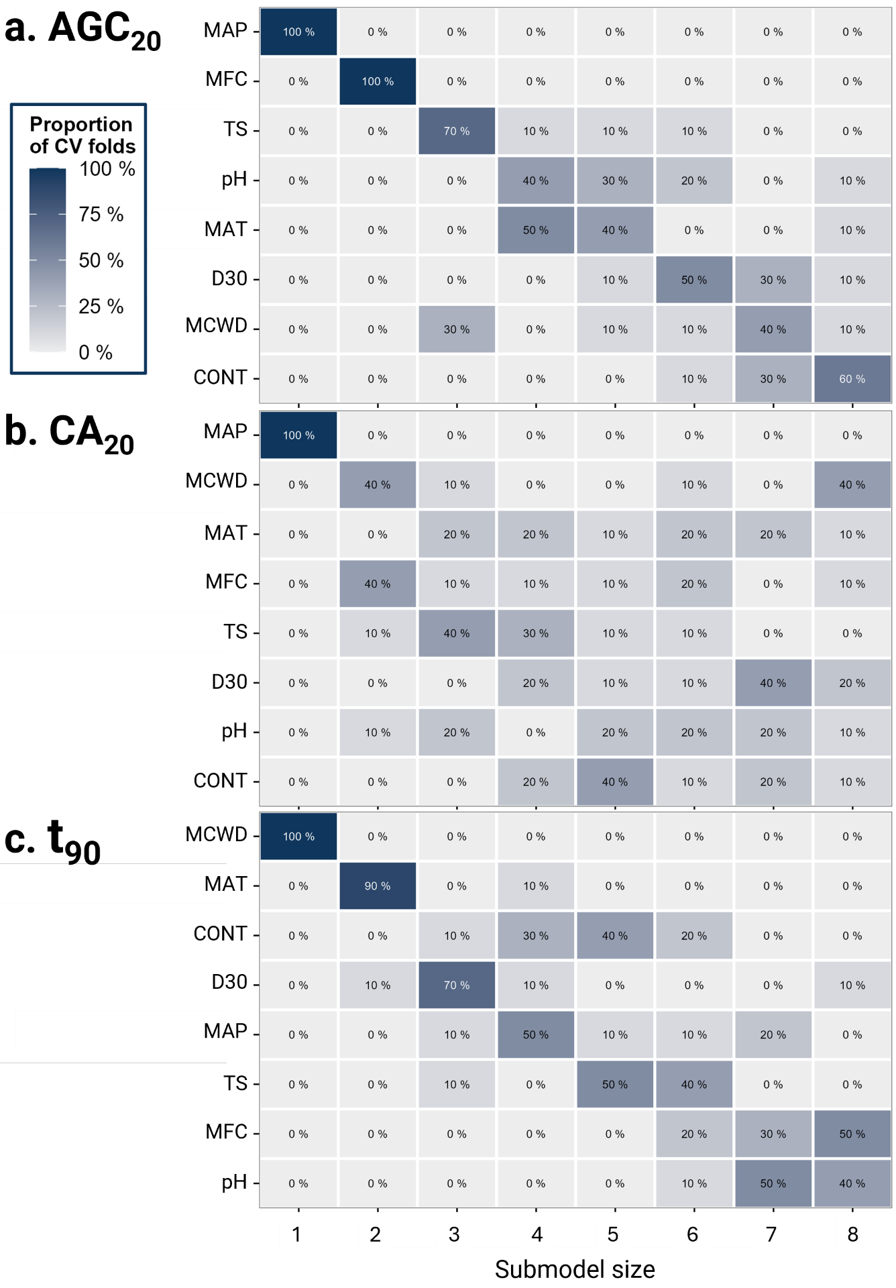

Supplementary Information Figure S1 | Predictor ranking proportions across 10-fold cross-validation (CV) with fold-specific searches for a, the total aboveground carbon stocks at 20 years of succession (AGC₂₀), b, the aboveground carbon accrual during the first 20 years of succession (CA₂₀), and c, the time to 90% recovery (t₉₀). Each tile shows the proportion of CV folds in which a given predictor was ranked at a certain position during the fold-wise forward search. Proportions are displayed as rounded whole percentages. Abbreviations: MCWD = maximum cumulative water deficit; MAT = mean annual temperature, ‘CONT’ = contagion; ‘D30’ = distance to nearest pixel with at least 30% tree cover, MAP = mean annual precipitation; ‘TS’ = temperature seasonality; ‘MFC’ = mean forest cover; ‘pH’ = soil pH-H₂O in the upper 20 cm layer. The correlation matrix of response and predictor variables is shown in Supplementary Information Figure S5.
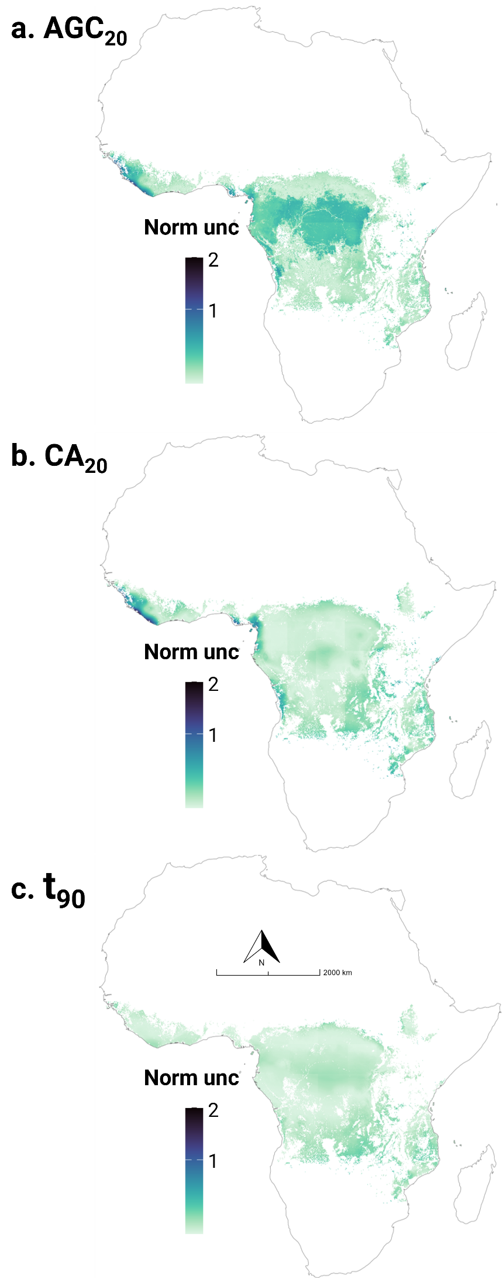
Supplementary Information Figure S2 | Spatial projection of the modeled uncertainty for the and total aboveground carbon stocks at 20 years of succession (AGC₂₀; a), the aboveground carbon accrual during the first 20 years of succession (CA₂₀; b), and the time to 90% recovery (t₉₀; c). Uncertainty (Norm unc) is quantified as the credible interval width normalized by the median – specifically, the difference between the upper and lower 90% credible interval limits divided by the corresponding median value – based on 1,000 draws from the posterior distribution of the linear regression models. Scales are log-transformed to resolve spatial variation among the predominant low-value pixels. Pixels with a normalized uncertainty greater than 5 are shown in dark red. Regions where values were extrapolated beyond the range of the calibration data are indicated in Supplementary Information Fig. S4.

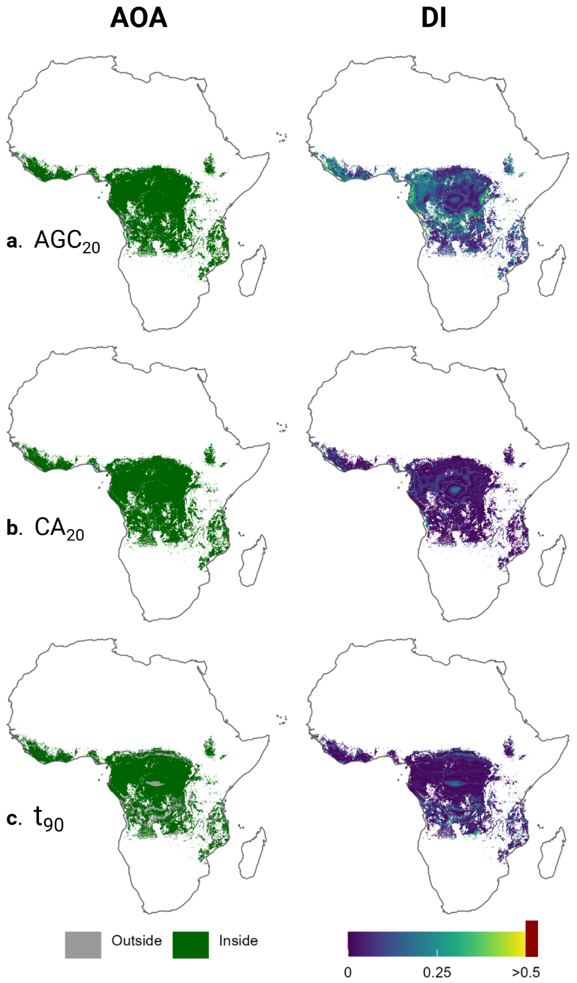
Supplementary Information Figure S3 | Area of Applicability (AOA) and Dissimilarity Index (DI) for AGC₂₀ (a), CA₂₀ (b), and t₉₀ (c) across African tropical forests. Left panels show the binary AOA, where dark green indicates locations within the applicability of the model (i.e., environmentally similar to the training data) and grey indicates locations outside it. Right panels show the continuous DI, reflecting the degree of dissimilarity between each pixel and the training data; values exceeding the threshold of 0.5 are shown in dark red. Predictions in areas outside the AOA should be interpreted with caution.

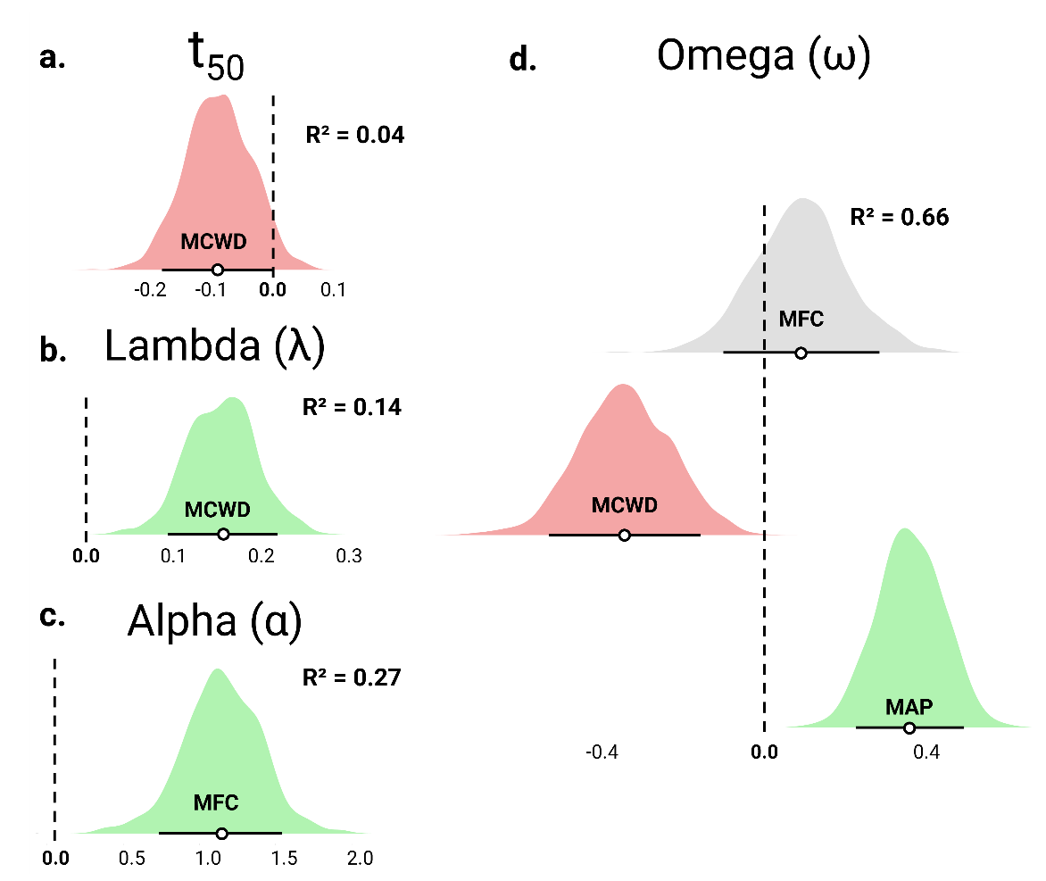
Supplementary Information Figure S4 | Environmental effects on the time to 50% recovery (t₅₀; a), as well as the parameter estimates of the sigmoidal recovery curve – b, lambda; c, alpha; and d, omega. For the 4th model parameter (delta), no relationships with the environmental predictor set were retained following predictor selection. Points indicate posterior median effect sizes, and error bars denote 90% credible intervals. Abbreviations: ‘MCWD’ = maximum cumulative water deficit; ‘MFC’ = mean percentage forest cover; ‘MAP’ = mean annual precipitation. ‘R²’ represents the Bayesian R-squared³¹. Effect size posterior distributions with 90% credible intervals that do not overlap zero are shown in green (positive) or red (negative).

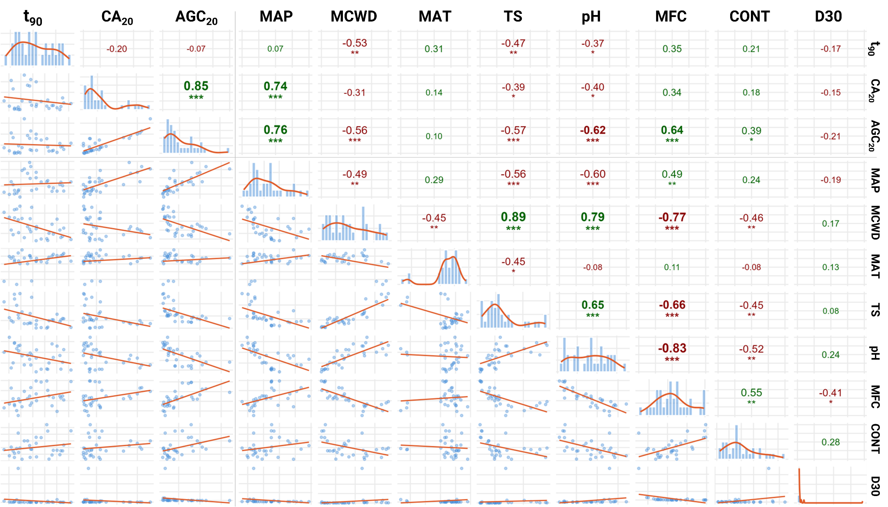
Supplementary Information Figure S5 | Correlation matrix of response variables and the full initial predictor set. Abbreviations: response variables: ‘t₉₀’ = the time to 90% recovery; ‘CA₂₀‘ = aboveground carbon accrual during the first 20 years of succession; ‘AGC₂₀’ = total aboveground carbon stocks at 20 years of succession. Response variables: Abbreviations: MAP = mean annual precipitation; MCWD = maximum cumulative water deficit; MAT = mean annual temperature, ‘TS’ = temperature seasonality; ‘pH’ = soil pH-H₂O in the upper 20 cm soil layer; ‘MFC’ = mean forest cover; CONT = contagion; ‘D30’ = distance to nearest pixel with at least 30% tree cover. Significance levels are indicated as follows: *** p < 0.001, ** p < 0.01, * p < 0.05, based on the cor.test function of the stats package (version 4.5.0)³².
Supplementary tables
Supplementary Information Table S1 | Simulated parameter values of the sigmoidal regrowth curve for each of the 32 sites. Abbreviations: 'MLE' = maximum likelihood estimate in the joint posterior space; '5% Qt' and '95% Qt' = lower and upper bounds of the 90% credible interval, respectively. See the Supplementary Materials and Methods section for model details. Note that the MLE and median of the regional posterior distributions frequently diverge, as the joint posterior maximum does not necessarily coincide with the mode of any individual parameter's marginal distribution. The MLE is the appropriate choice when reconstructing or reporting the best-fit recovery trajectory, whereas the parameter- and region-specific medians are preferable when interpreting parameter values in isolation.
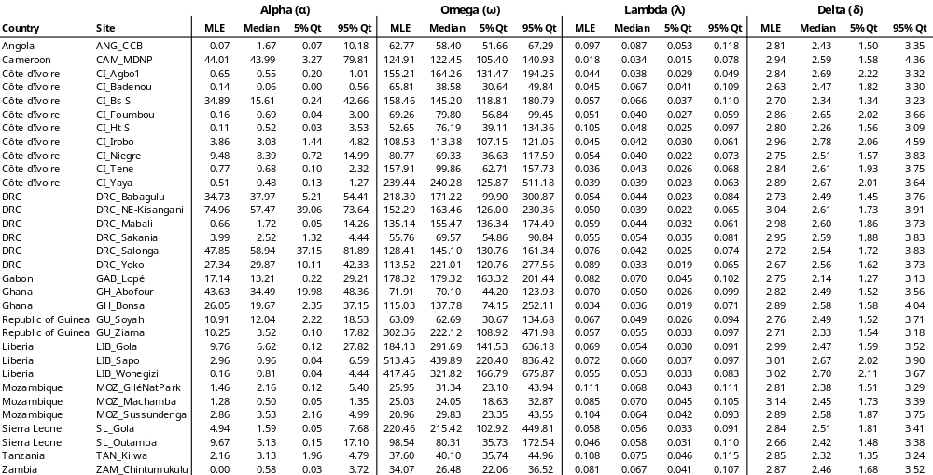
Supplementary References
1. RStudio Team. RStudio: Integrated Development for R. (2020).
2. Stan Development Team. Stan User’s Guide. (2024).
3. Guo, J. et al. rstan: R Interface to Stan. (2025).
4. Richards, F. J. A Flexible Growth Function for Empirical Use. Journal of Experimental Botany 10, 290–301 (1959).
5. Maurent, E. et al. A common framework to model recovery in disturbed tropical forests. Ecological Modelling 483, 110418 (2023).
6. Martin, A. R., Doraisami, M. & Thomas, S. C. Global patterns in wood carbon concentration across the world’s trees and forests. Nature Geosci 11, 915–920 (2018).
7. Gabry, J. et al. shinystan: Interactive Visual and Numerical Diagnostics and Posterior Analysis for Bayesian Models. (2022).
8. Poorter, L. et al. Biomass resilience of Neotropical secondary forests. Nature 530, 211–214 (2016).
9. Amani, B. H. K. et al. Lessons from a regional analysis of forest recovery trajectories in West Africa. Environ. Res. Lett. 17, 115005 (2022).
10. Titenwi, P. N. et al. Carbon recovery in secondary forests: Insights from three West African countries. Forest Ecology and Management 575, 122386 (2025).
11. Requena Suarez, D. et al. Variation in aboveground biomass in forests and woodlands in Tanzania along gradients in environmental conditions and human use. Environ. Res. Lett. 16, 044014 (2021).
12. Hordijk, I. et al. Land use history and landscape forest cover determine tropical forest recovery. Journal of Applied Ecology 61, 2365–2381 (2024).
13. Fricke, E. C., Cook-Patton, S. C., Harvey, C. F. & Terrer, C. Seed dispersal disruption limits tropical forest regrowth. Proceedings of the National Academy of Sciences 122, e2500951122 (2025).
14. Fick, S. E. & Hijmans, R. J. WorldClim 2: new 1-km spatial resolution climate surfaces for global land areas. International Journal of Climatology 37, 4302–4315 (2017).
15. Hansen, M. C. et al. High-Resolution Global Maps of 21st-Century Forest Cover Change. Science 342, 850 LP – 853 (2013).
16. Descals, A., Gaveau, D. L. A., Wich, S., Szantoi, Z. & Meijaard, E. Global mapping of oil palm planting year from 1990 to 2021. Earth System Science Data 16, 5111–5129 (2024).
17. Hesselbarth, M. H. K., Sciaini, M., With, K. A., Wiegand, K. & Nowosad, J. landscapemetrics: an open-source R tool to calculate landscape metrics. Ecography 42, 1648–1657 (2019).
18. Powers, J. S. & Marín-Spiotta, E. Ecosystem Processes and Biogeochemical Cycles in Secondary Tropical Forest Succession. Annual Review of Ecology, Evolution, and Systematics 48, 497–519 (2017).
19. Bauters, M. et al. Increasing calcium scarcity along Afrotropical forest succession. Nature Ecology & Evolution 6, 1122–1131 (2022).
20. Matsuo, T. et al. Drivers of biomass stocks and productivity of tropical secondary forests. Ecology 106, e4488 (2025).
21. Jakovac, C. C. et al. The role of land-use history in driving successional pathways and its implications for the restoration of tropical forests. Biological Reviews 96, 1114–1134 (2021).
22. Neina, D. The Role of Soil pH in Plant Nutrition and Soil Remediation. Applied and Environmental Soil Science 2019, 5794869 (2019).
23. Hengl, T. et al. African soil properties and nutrients mapped at 30 m spatial resolution using two-scale ensemble machine learning. Sci Rep 11, 6130 (2021).
24. Piironen, J., Paasiniemi, M. & Vehtari, A. Projective inference in high-dimensional problems: Prediction and feature selection. Electronic Journal of Statistics 14, 2155–2197 (2020).
25. Piironen, J. & Vehtari, A. Comparison of Bayesian predictive methods for model selection. Stat Comput 27, 711–735 (2017).
26. McLatchie, Y., Rögnvaldsson, S., Weber, F. & Vehtari, A. Advances in Projection Predictive Inference. Statistical Science 40, 128–147 (2025).
27. Piironen, J. et al. projpred: Projection Predictive Feature Selection. (2025).
28. Bürkner, P.-C. et al. brms: Bayesian Regression Models using ‘Stan’. (2025).
29. Meyer, H. et al. CAST: ‘caret’ Applications for Spatial-Temporal Models. (2026).
30. Dinerstein, E. et al. An Ecoregion-Based Approach to Protecting Half the Terrestrial Realm. BioScience 67, 534–545 (2017).
31. Gelman, A., Goodrich ,Ben, Gabry ,Jonah & and Vehtari, A. R-squared for Bayesian Regression Models. The American Statistician 73, 307–309 (2019).
32. R Core Team. The R Stats Package. (2025).

