Supplementary Figures
Article Title: Construction of a Cancer Driver Gene Prognostic Index in Clear Cell Renal Cell Carcinoma Based on Machine Learning and Multi-omics Analysis for Improved Clinical Outcomes and Drug Sensitivity
Running Title: an Cancer Driver Gene Prognostic index for KIRC patients
Author Data: Feifan Tang¹ Biao Zhang²
1 Department of Urology, the Nanxishan Hospital of Guangxi Zhuang Autonomous Region, Guilin 541002, China.

2 Scientific Research Department, the Second Affiliated Hospital of Guilin Medical University, Guilin, 541199, China.

† Corresponding author:
Songbai Liao
Department of Urology, the Nanxishan Hospital of Guangxi Zhuang Autonomous Region, Guilin 541002, China.
E-mail: 1182194916@qq.com
Xianliang Hou
Research Administration Office, the Second Affiliated Hospital of Guilin Medical University, Guilin, 541199, China.
E-mail: houxl115@126.com

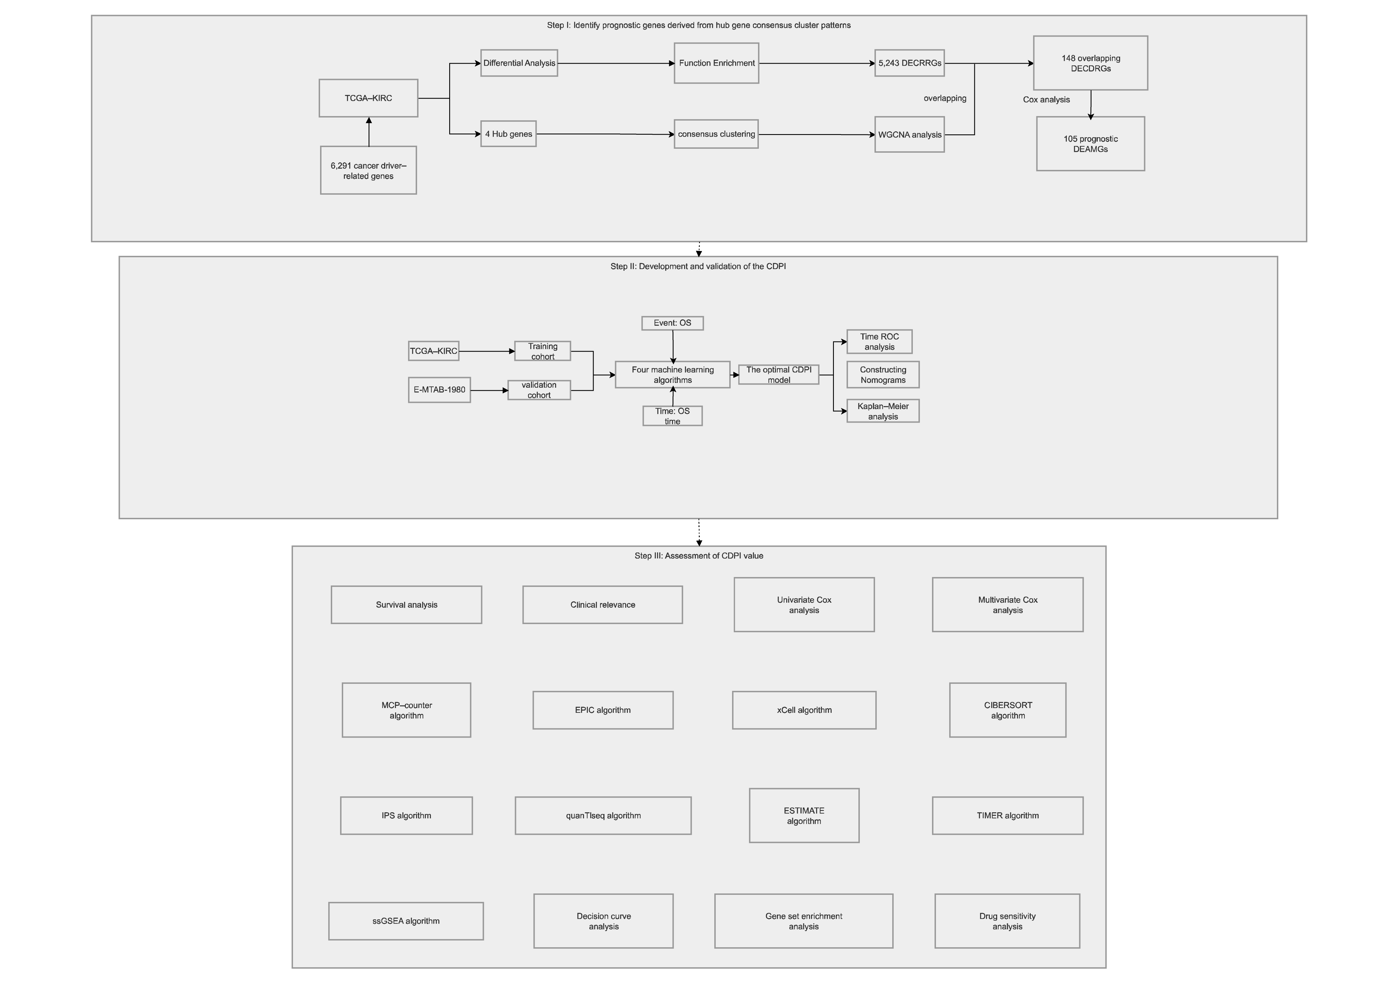
Figure S1. The overall design of this study.

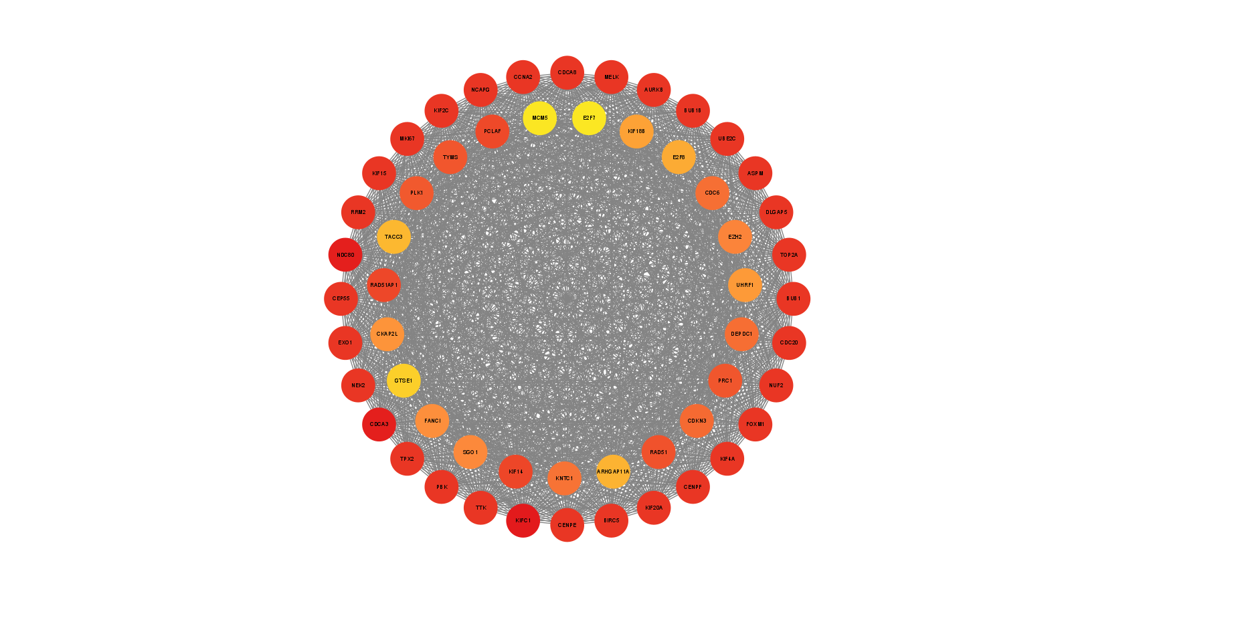

Figure S2. MCODE plug-in gets a main network module.

Figure S3. Univariate Cox regression forest plot identifying 105 prognostic DECDRGs in the TCGA-KIRC cohort.

A
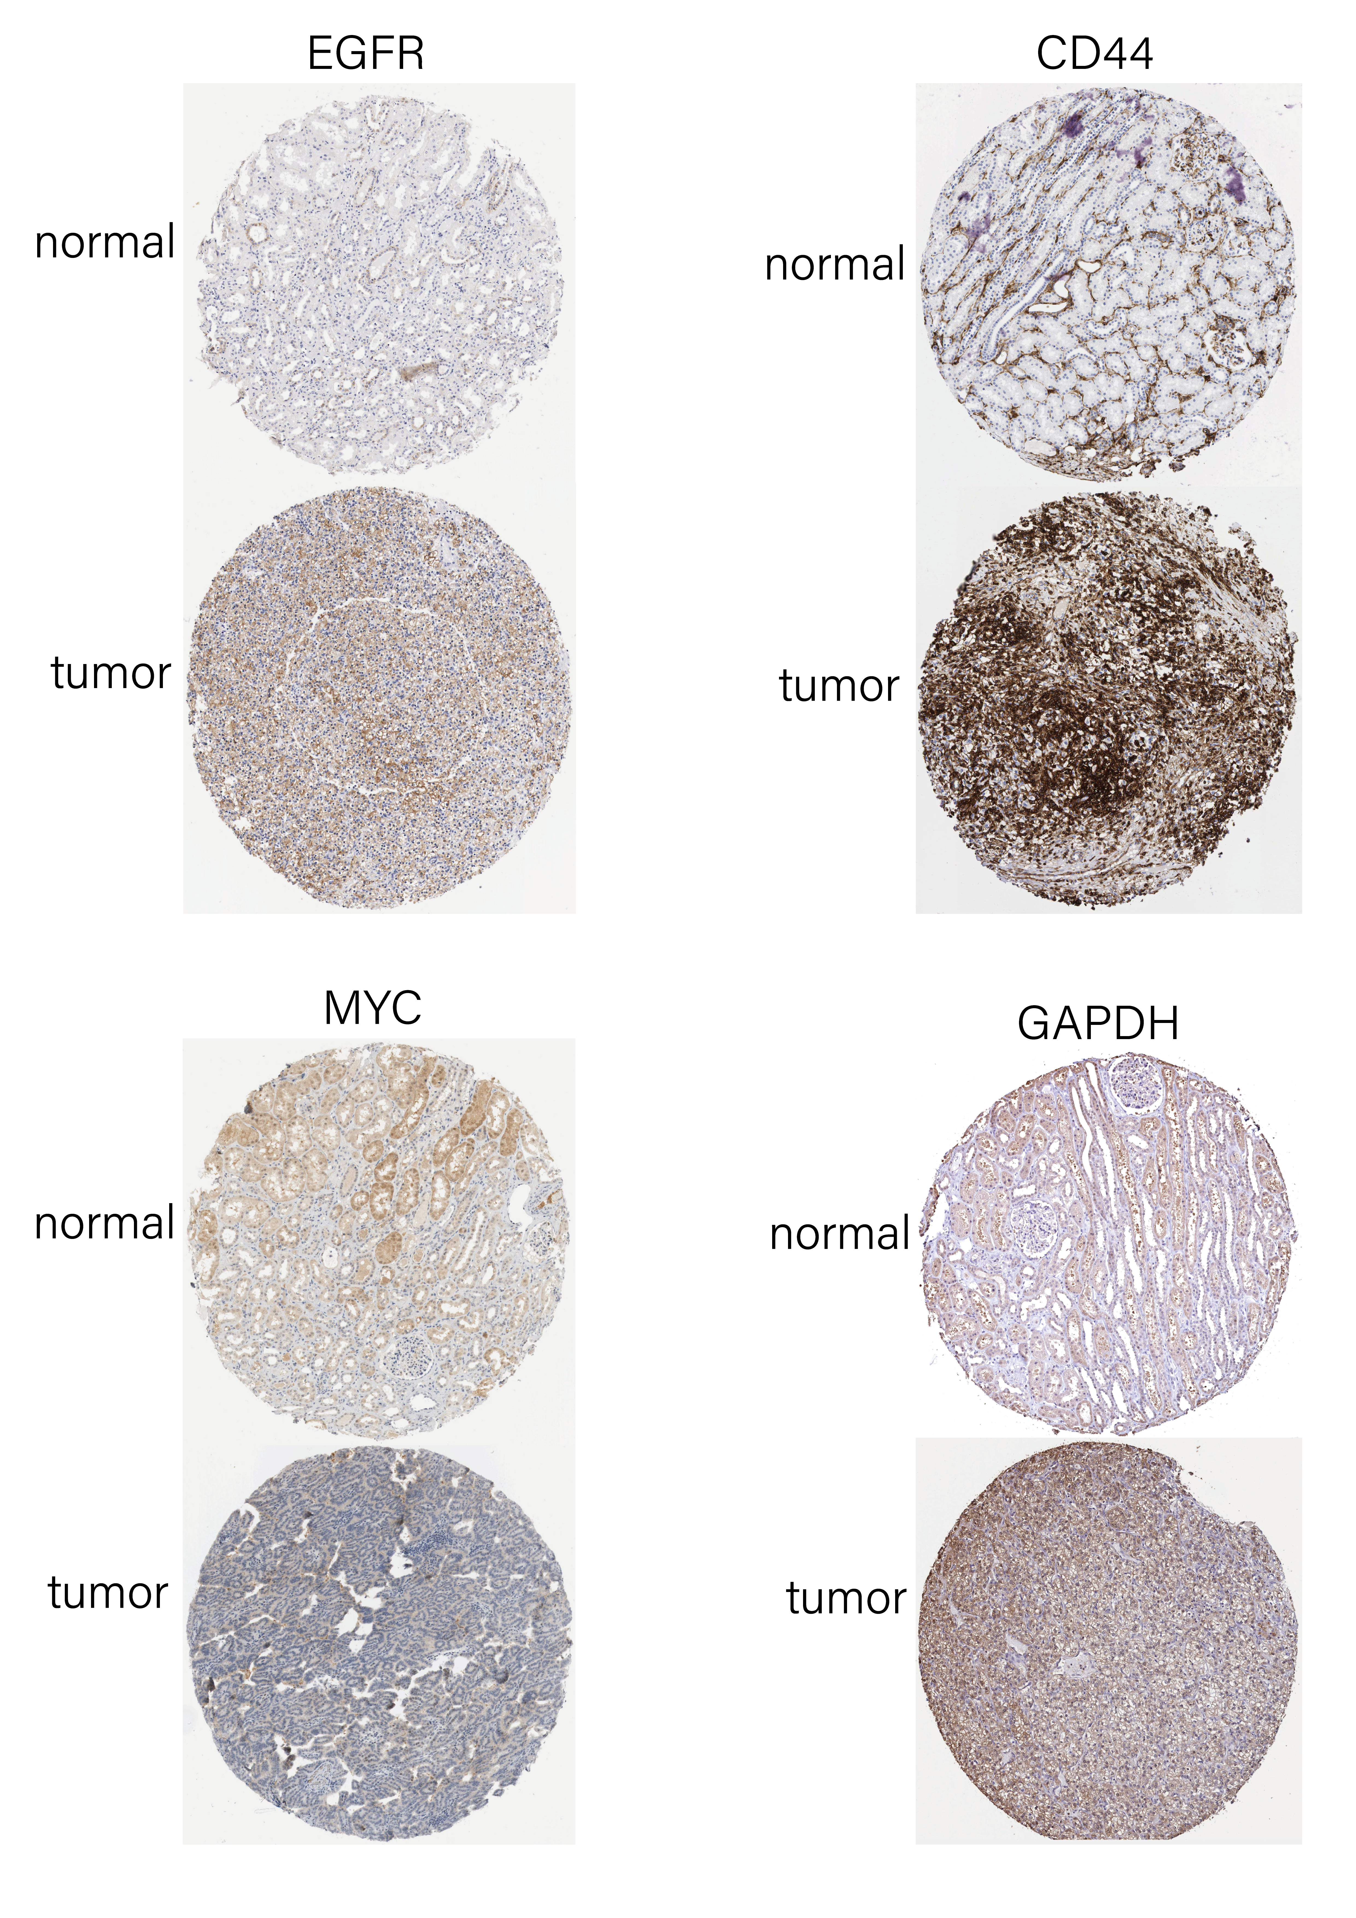
B
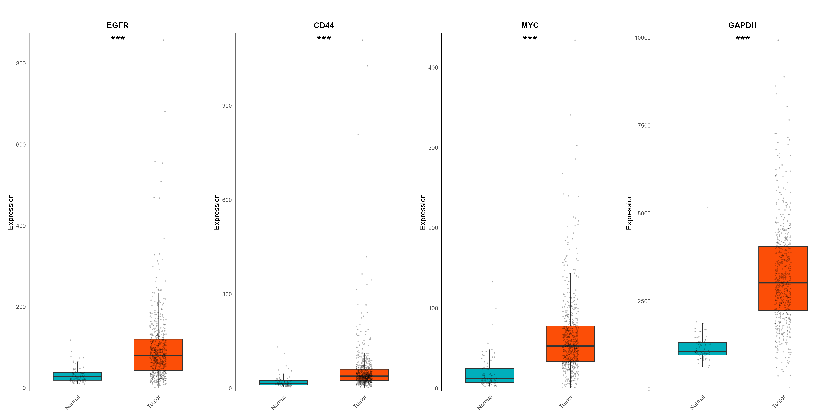
Figure S4. Immunohistochemistry analysis of the five hub genes and three characteristic DECDRGs. (A) Immunohistochemical results of the DECDRGs in tumor and normal tissues. (B) Differential expression of the DECDRGs between tumor tissue and normal tissue in the TCGA-LUAD cohort, * p < 0.05, **p < 0.01, ***p < 0.001.

Figure S5. Six other algorithms, including the MCP-counter algorithm, EPIC algorithm, xCell algorithm, CIBERSORT algorithm, quanTIseq algorithm, and TIMER algorithm, further verified the stability and robustness of the ssGSEA results for two clusters.

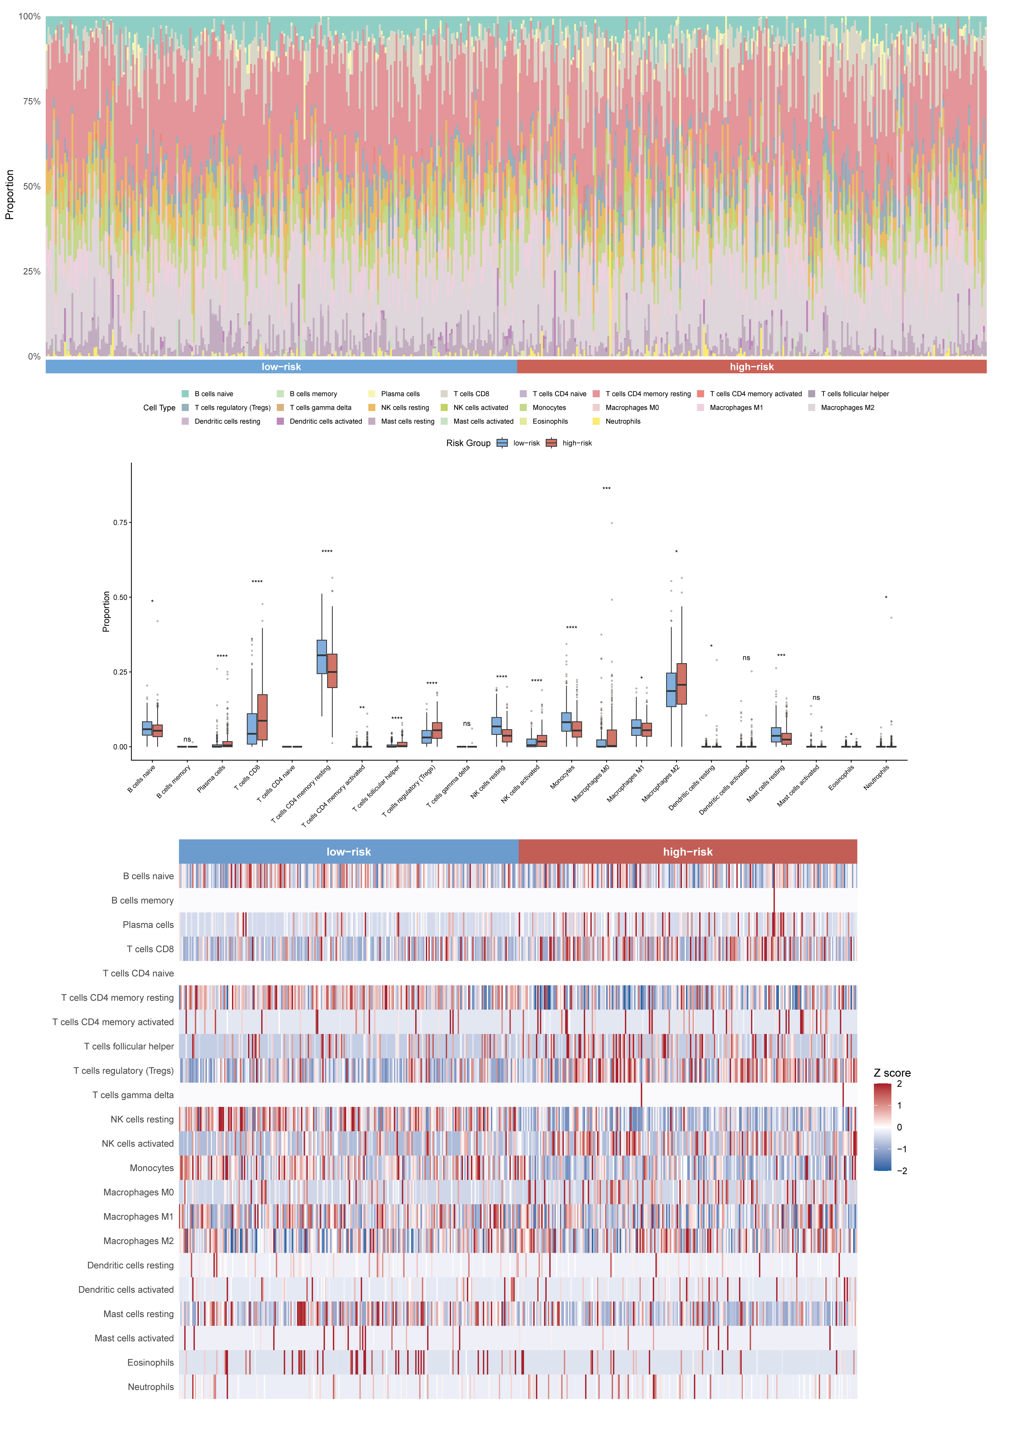
Figure S6. CIBERSORT score of immune cell infiltration between the two CDPI groups.

Figure S7. Six other algorithms, including the MCP-counter algorithm, EPIC algorithm, xCell algorithm, CIBERSORT algorithm, quanTIseq algorithm, and TIMER algorithm, further verified the stability and robustness of the ssGSEA results for two CDPI groups.

