Supporting Information
Defects in Iron-Based Metal Organic Frameworks facilitate Targeted Drug Delivery System for Neuroblastoma Therapy
Izuchika Nduka,¹ Lofti Boujema,¹ Diego Gianolio,² Ivan da Silva,³ Manfred Erwin Schuster,² Sara Namvar,¹ Rosa Arrigo^{1,2,*}
¹ School of Science, Engineering and Environment, University of Salford, Manchester, M5 4WT, United Kingdom
² Diamond Light Source, Harwell Science and Innovation Campus, Didcot, OX11 0DE, United Kingdom
³ ISIS Neutron and Muon Source, STFC Rutherford Appleton Laboratory, Didcot, OX11 0QX, UK

Computational methods

Fig. S 1 Atom-type definitions used in the GCMC simulations for MIL-100(Fe)
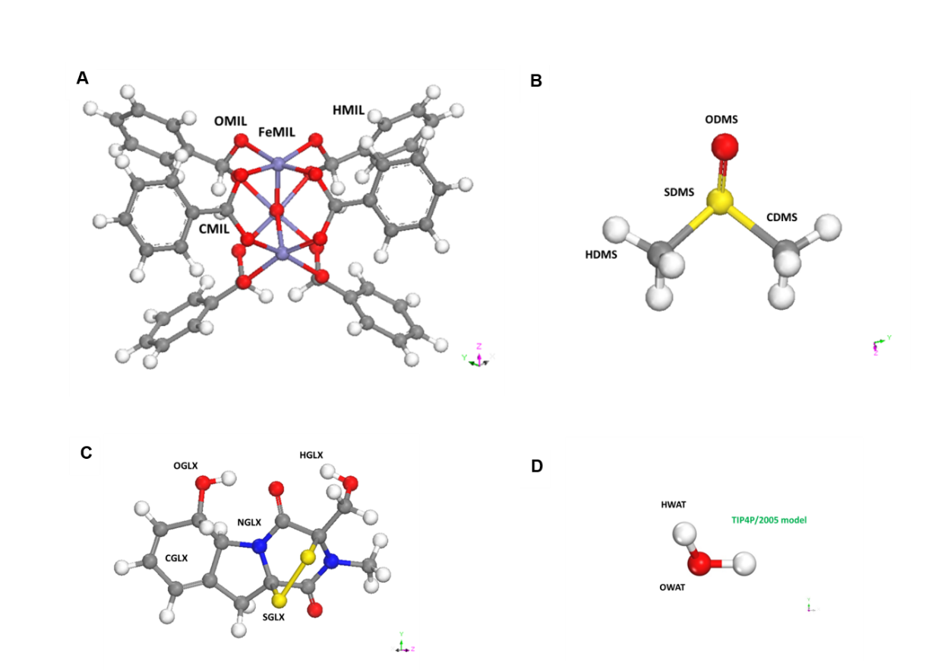
(A), DMSO (B), gliotoxin (C), and water (D), as employed in the force-field parameterization of adsorption simulations.

Table S 1 : Bond stretching parameters for the flexible MIL-100(Fe) framework. Bonded interactions within the MIL-100 framework were modeled using harmonic bond potentials derived from a DREIDING-type force field adapted for Fe-carboxylate coordination environments, these parameters reported by Mayo et al.. These parameters preserve the structural integrity of the Fe₃O cluster nodes and the carboxylate linkers while allowing local structural relaxation around guest molecules,
Bond Type | Force Constant k (kJ·mol⁻¹·Å⁻²) | Equilibrium Distance r₀ (Å)
Fe-O | 500 | 1.96
Fe-O | 300 | 2.10
O-C | 700 | 1.26
O-C | 500 | 1.33
C-C (aromatic) | 650 | 1.40
C-C (single) | 450 | 1.48
C-H | 340 | 1.09

Table S 2: Angle bending parameters for flexible MIL-100. Angle bending interactions were modeled using harmonic potentials. These angular constraints preserve Fe octahedral coordination geometry and the planarity of aromatic linkers within the MIL-100 framework.

Angle Type | Force Constant kθ (kJ·mol⁻¹·rad⁻²) | Equilibrium Angle θ₀ (°)
O-Fe-O | 200 | 120
O-Fe-O | 180 | 90
Fe-O-C | 200 | 130
O-C-O | 250 | 125
O-C-C | 150 | 120
C-C-C (aromatic) | 200 | 120
C-C-H | 100 | 120

Table S 3: Dihedral parameters for MIL-100 framework. Torsional interactions describing linker rotations were modeled using harmonic dihedral potentials. These dihedral parameters maintain aromatic planarity and carboxylate conjugation while allowing limited rotational flexibility.
Dihedral Type | kφ (kJ·mol⁻¹) | Phase δ (°) | Multiplicity n
O-C-C-C | 40 | 180 | 2
C-C-C-C | 50 | 180 | 2
Fe-O-C-C | 20 | 180 | 2
O-C-C-O | 30 | 180 | 2
C-C-C-H | 5 | 180 | 3

Table S 4: Lennard-Jones self-parameters. Lennard-Jones parameters describing van der Waals interactions for each atom type used in the simulations. Partial charges for MIL-100, DMSO and gliotoxin were derived from CHELPG electrostatic potential fitting at the DFT level.
Atom Type | ε (kJ·mol⁻¹) | σ (Å)
FeMIL | 0.054392 | 2.5943
OMIL | 0.251040 | 3.1182
CMIL | 0.439320 | 3.4309
HMIL | 0.184096 | 2.5711
OWAT | 0.636400 | 3.1507
HWAT | 0.000000 | 0.0000
SDMS | 1.439296 | 3.5903
ODMS | 0.400409 | 3.0332
CDMS | 0.397480 | 3.4730
HDMS | 0.063597 | 2.8464
CGLX | 0.397480 | 3.4730
OGLX | 0.400409 | 3.0332
SGLX | 1.439296 | 3.5903
NGLX | 0.200000 | 3.2500
HGLX | 0.063597 | 2.8464

Table S 5: Atomic charges of water molecule using the TIP4P/2005 model reported by Jorgensen and al.
Atom | Partial Charge (e)
O | 0.000000
H | 0.241000
H | 0.241000
LP | -0.241000
LP | -0.241000

Table S 6: CHELPG Atomic Charges of Gliotoxin Calculated Using a DFT Approach (ωB97X-D/cc-pVTZ).
Atom | CHELPG Charge (e)
C | 0.357205
C | -0.546184
C | 0.507341
C | -0.316172
C | -0.354581
C | 0.252984
N | -0.541274
C | 0.312848
C | -0.087014
S | 0.091197
S | -0.225609
O | -0.529916
O | -0.505312
H | 0.218655
H | 0.183323
H | 0.196295
H | 0.412438
H | 0.400089
H | 0.030494
H | 0.143193

Table S 7: CHELPG atomic charges of dimethyl sulfoxide (DMSO) calculated using a DFT approach (ωB97X-D/cc-pVTZ).
Atom | CHELPG Charge (e)
S | 0.313482
O | -0.444023
C | -0.496922
C | -0.501459
H | 0.199279
H | 0.167801
H | 0.195327
H | 0.169426
H | 0.199478
H | 0.197611

Table S 8: CHELPG atomic charges of the MIL-100(Fe) cluster calculated using a DFT approach (ωB97X-D/cc-pVTZ).
Atom Type | CHELPG Charge (e)
O | -0.664152
O | -0.652549
O | -0.655452
O | -0.665210
O | -0.660357
O | -0.679056
O | -0.681276
O | -0.654287
O | -0.704535
O | -0.673570
O | -0.674093
O | -0.703232
C | 0.715895
C | 0.687735
C | 0.692327
C | 0.705583
C | 0.679952
C | 0.685033
Fe | 1.280192
O | -0.893862
Fe | 1.591542
Fe | 1.655988
H | 0.030755
H | 0.043518
H | 0.043621
H | 0.036883
H | 0.057508
H | 0.055097

Table S 9: Binary intermolecular Lennard-Jones interactions: MIL-100-Water, these parameters reported by Lenard Jones. These parameters describe water coordination and hydrogen bonding interactions near Fe open metal sites.
Atom i | Atom j | ε (kJ·mol⁻¹) | σ (Å)
FeMIL | OWAT | 0.186 | 2.873
OMIL | OWAT | 0.400 | 3.134
CMIL | OWAT | 0.529 | 3.291
HMIL | OWAT | 0.342 | 2.861

Table S 10: Binary intermolecular Lennard-Jones interactions: MIL-100 – DMSO. These interactions describe DMSO adsorption and coordination competition at Fe open metal sites.
Atom i | Atom j | ε (kJ·mol⁻¹) | σ (Å)
FeMIL | SDMS | 0.280 | 3.092
FeMIL | ODMS | 0.148 | 2.814
OMIL | SDMS | 0.601 | 3.354
CMIL | SDMS | 0.795 | 3.511

Table S 11: Binary intermolecular Lennard-Jones interactions: MIL-100 – Gliotoxin. These interactions describe host–guest stabilization of gliotoxin within the MIL-100 cages.
Atom i | Atom j | ε (kJ·mol⁻¹) | σ (Å)
FeMIL | CGLX | 0.147 | 3.034
FeMIL | SGLX | 0.280 | 3.092
OMIL | CGLX | 0.332 | 3.275
CMIL | CGLX | 0.439 | 3.431
HMIL | CGLX | 0.284 | 3.001

Table S 12: Mixing Rules for Cross Interactions.Cross Lennard-Jones parameters were generated using Lorentz-Berthelot mixing rules, reported by Lorentz, H. A and Berthelot. These mixing rules were applied automatically in DL_MONTE to generate all binary and ternary intermolecular interactions between MIL-100, water, DMSO, and gliotoxin.
$$σ_{ij}=\frac{σ_{i}+σ_{j}}{2}$$
$$ε_{ij}=\sqrt{ε_{i}ε_{j}}$$
Table S 13: Systems simulated in GCMC. These systems were simulated to evaluate solvent competition, adsorption hierarchy, and cage occupancy within MIL-100.
System | Composition
Pure GLTX adsorption | Gliotoxin
Binary solvent system | 5% GLTX + 95% Water
Binary solvent system | 5% GLTX + 95% DMSO
Ternary system | 1% GLTX + 90% Water + 9% DMSO

Table S 14: Ternary intermolecular Lennard–Jones interactions: Water – DMSO – Gliotoxin. This table complements the binary interaction tables and explicitly clarifies the interactions governing the competitive ternary adsorption system used in the GCMC simulations.
Atom i | Atom j | ε (kJ·mol⁻¹) | σ (Å)
OWAT | SDMS | 0.957 | 3.371
OWAT | ODMS | 0.505 | 3.092
OWAT | CDMS | 0.503 | 3.312
OWAT | HDMS | 0.200 | 2.999
OWAT | CGLX | 0.503 | 3.312
OWAT | OGLX | 0.505 | 3.092
OWAT | SGLX | 0.957 | 3.371
OWAT | NGLX | 0.357 | 3.201
OWAT | HGLX | 0.200 | 2.999
HWAT | SDMS | 0.000 | 1.795
HWAT | ODMS | 0.000 | 1.516
HWAT | CDMS | 0.000 | 1.736
HWAT | HDMS | 0.000 | 1.423
HWAT | CGLX | 0.000 | 1.736
HWAT | OGLX | 0.000 | 1.516
HWAT | SGLX | 0.000 | 1.795
HWAT | NGLX | 0.000 | 1.625
HWAT | HGLX | 0.000 | 1.423

Characterisation

Fig. S 2
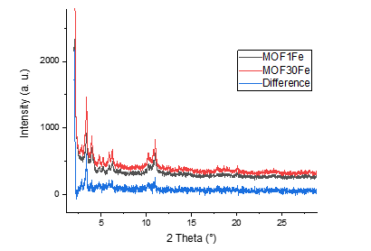
Overlay of XRD patterns for MOF1Fe and MOF30Fe together with their difference profile

Table S 15: Particle size distribution of the synthesized Fe-MOFs

Sample | Structure | Crystallite Size (nm)
MOF1Fe | MIL-100(Fe) | 45
MOF5Fe | MIL-100(Fe) | 27
MOF30Fe | MIL-100(Fe) | 84

Fig. S 3 Secondary electron mode SEM images for MOF5Fe
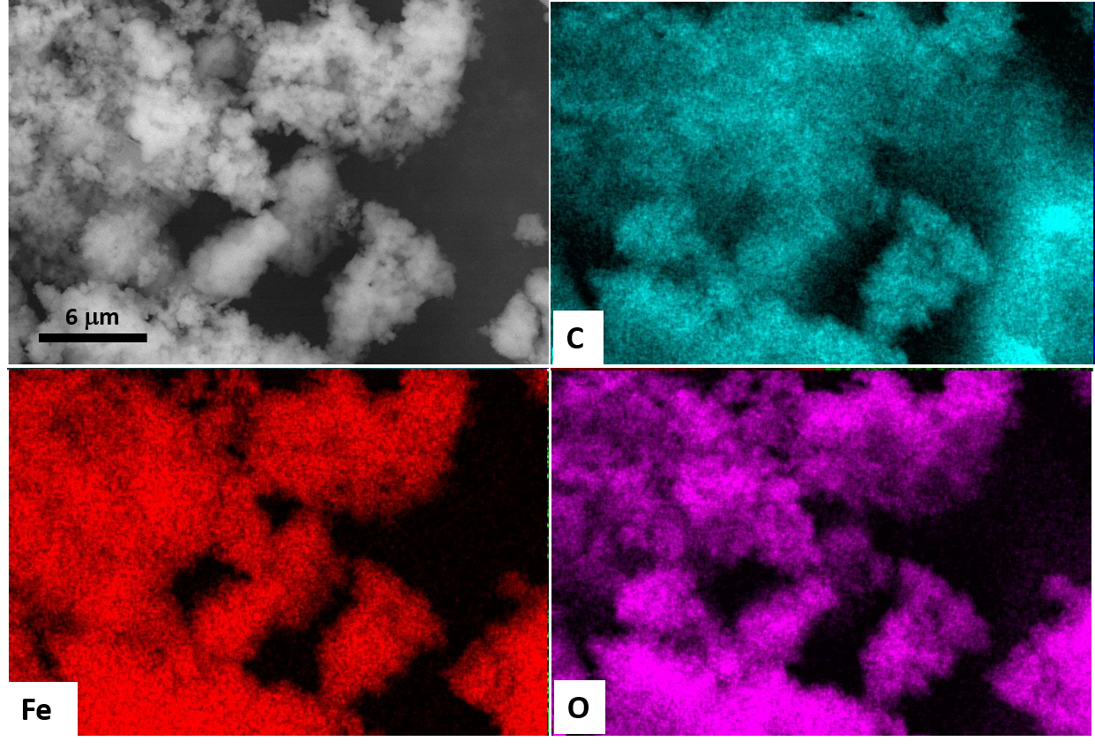
Measurements at 20 kV and 10000x and corresponding C, Fe and O EDX elemental mapping.

Fig. S 4 Secondary electron mode SEM images for MOF30Fe
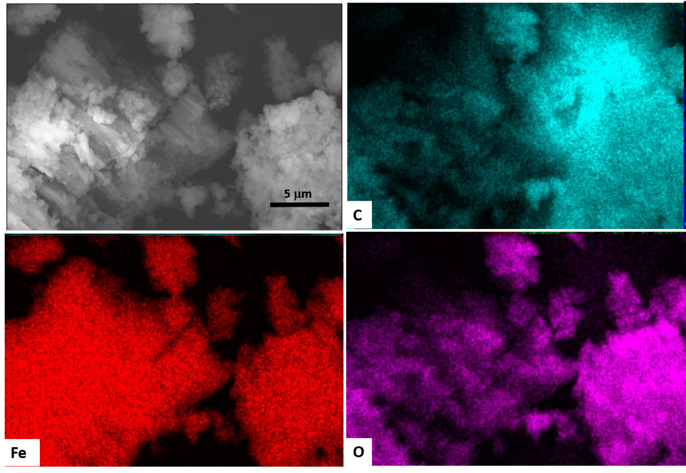
Measurements at 20 kV and 10000x and corresponding C, Fe and O EDX elemental mapping.

Fig. S 5 Thermogravimetric and textural characterization of MOF1Fe before and after GLTX loading.
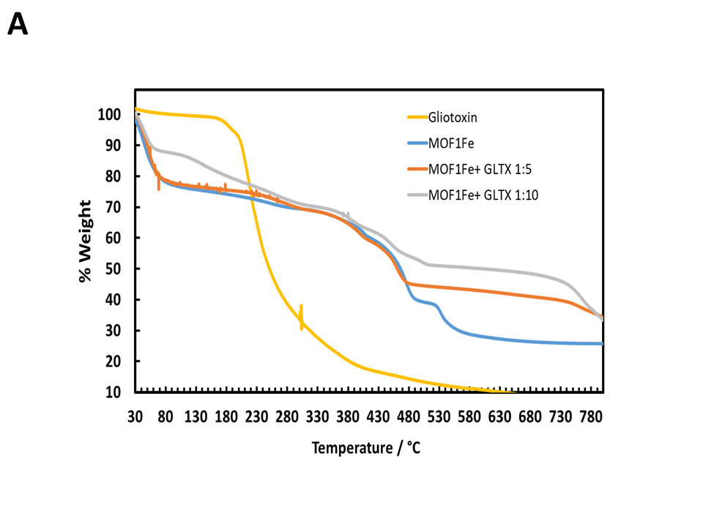
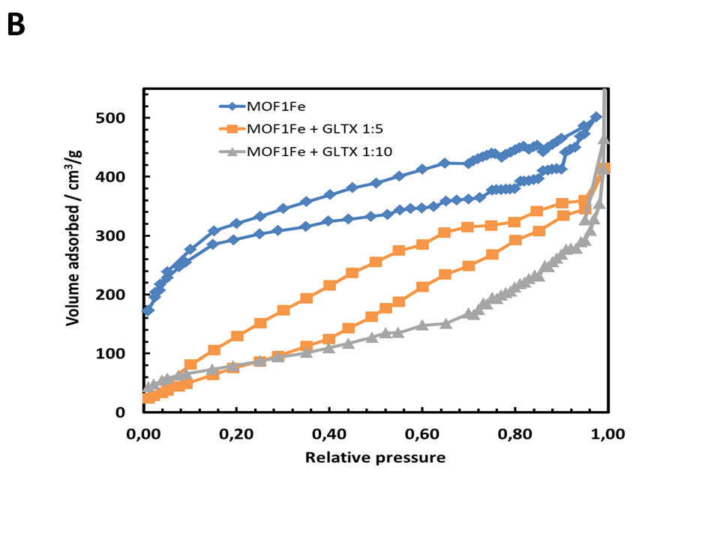
(A) TGA curves of pure GLTX, pristine MOF1Fe, and GLTX-loaded MOF1Fe composites prepared at GLTX ratios of 1:5 and 1:10. (B) N₂ adsorption–desorption isotherms of MOF1Fe before and after GLTX loading, showing the evolution of the adsorbed volume and porosity after drug incorporation.

Fig. S 6 FT-IR spectra of MOF1Fe, MOF5Fe, and MOF30Fe before and after gliotoxin loading
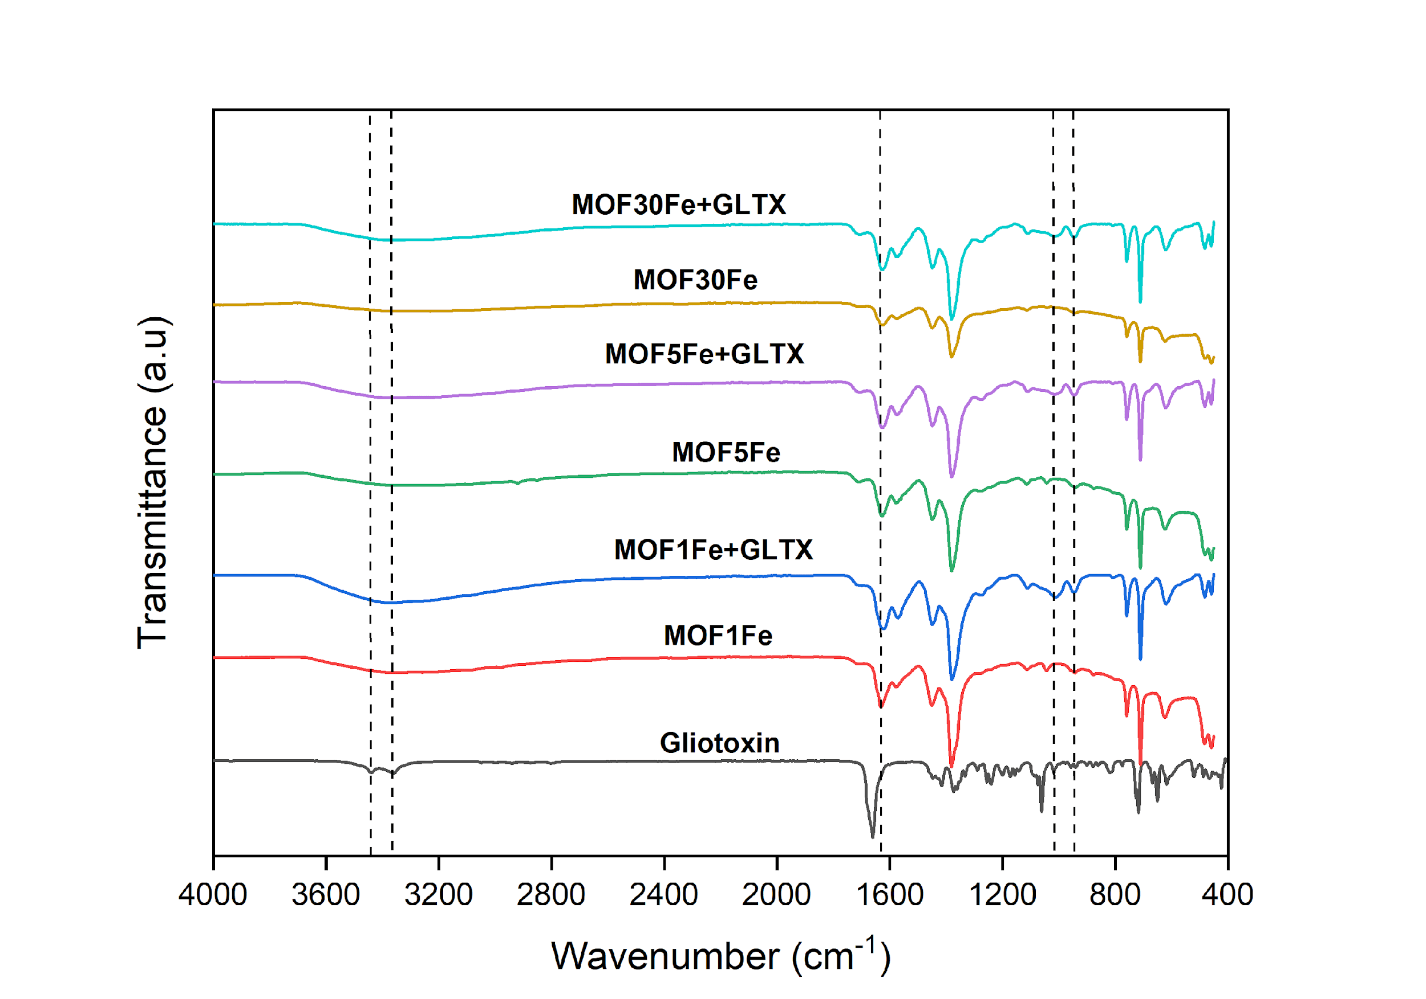
Dashed lines aim to indicate the vibrations of the functional groups where main differences are observed between the samples.

Fig. S 7 Fluorescent Yield Fe K-edge XANES
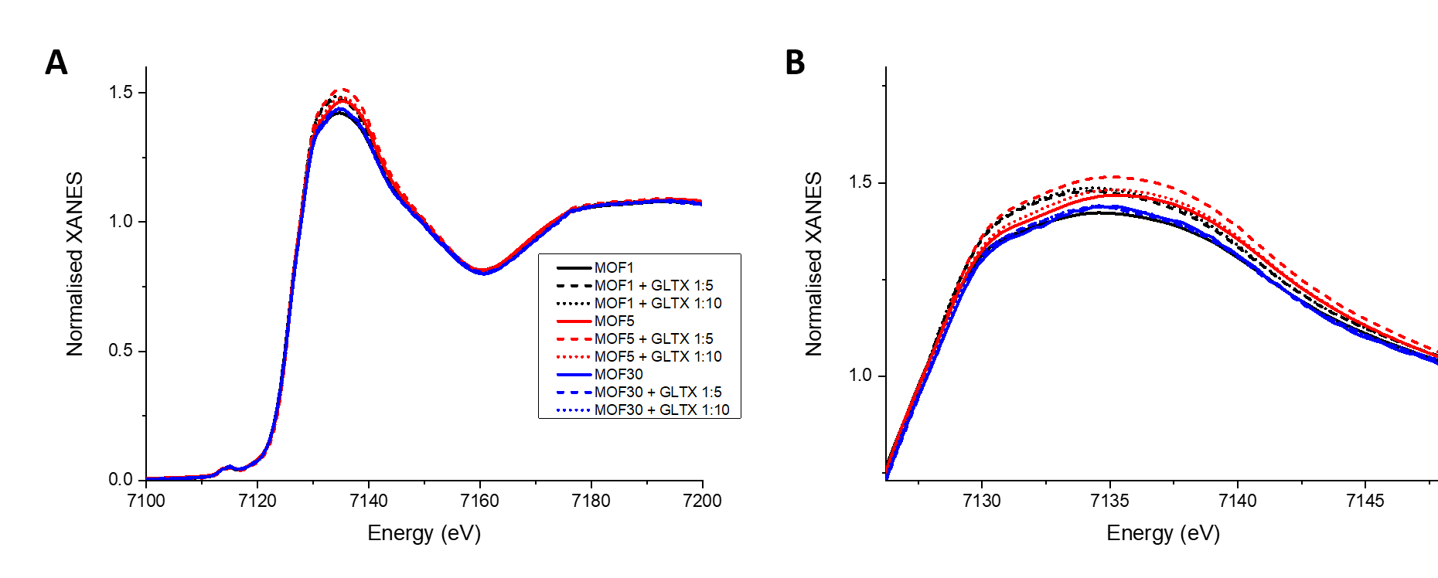
(A) and Pre-edge region (B) spectra of pristine MOF1Fe, MOF5Fe, and MOF30Fe and after GLTX immobilisation at concentrations as indicated.
Fig. S 8 Effect of exposure to different FeMOF-gliotoxin concentrations on the viability of SHSY-5Y cell line compared to free gliotoxin after 24 h.
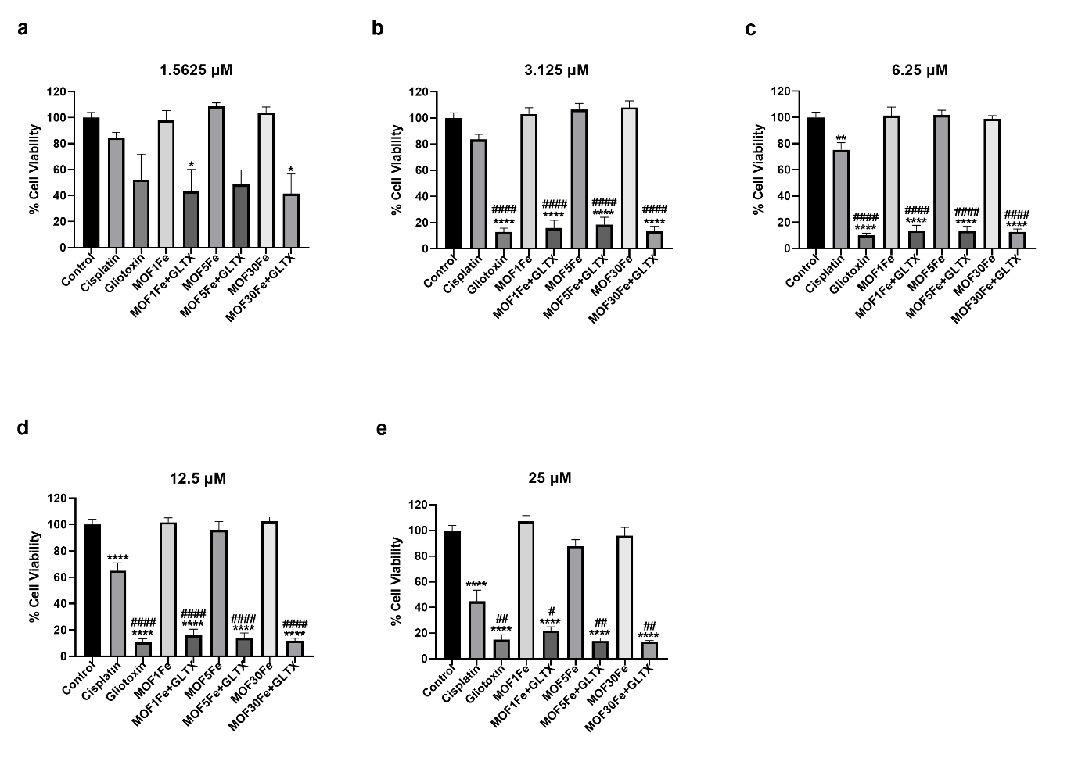
Neuroblastoma cells were exposed to control media, and media containing 1.5625 μM (a), 3.125 μM (b), 6.25 μM (c), 12.5 μM (d), and 25 μM (e ) of cisplatin, gliotoxin, MOF1Fe, MOF1Fe+GLTX, MOF5Fe, MOF5Fe+GLTX, MOF30Fe, and MOF30Fe+GLTX respectively, for 24 h, and cell viability assessed using MTT assay. Data is presented as mean ± SEM, n = 3 per group. *, #, $ indicate statistical significance obtained using a one-way ANOVA (*p < 0.05, **p < 0.01, ***p < 0.001, ****p < 0.0001 indicates statistical significance between control and treatment groups; #p < 0.05, ##p < 0.01, ###p < 0.001, ####p < 0.0001 indicates statistical significance between cisplatin and the other treatment groups; $p < 0.05, $$p < 0.01, $$$p < 0.001, $$$$p < 0.0001 indicates statistical significance between gliotoxin and the other treatment groups).

After 24 h exposure to each treatment at 1.5625 µM (Fig. S8a), a statistically significant decline in the viability of neuroblastoma cells was observed in the MOF1Fe+GLTX and MOF30Fe+GLTX groups relative to controls, suggesting enhanced toxicity of gliotoxin by the MOF. At 3.125 µM concentration (Fig. S8e), a statistically significant difference in cytotoxic effect on cell viability of the neuroblastoma cells was seen between all the treatment groups (except cisplatin) and the control. Also, at this concentration, gliotoxin and the MOF-encased gliotoxins were more cytotoxic than cisplatin, which suggests that these MOF drug conjugates are potent even at low concentrations. At 6.25 µM (Fig. S8c), 12.5 µM (Fig. s8d), and 25 µM (Fig. s8e), all the treatment groups had a statistically significant effect on the cell viability compared to the control group and cisplatin treatment group. At these concentrations, gliotoxin and MOF-encased gliotoxins were more cytotoxic than cisplatin, again suggesting potency of these compounds as anti-cancer agents in neuroblastoma therapy.

Fig. S 9 Effect of exposure to different FeMOF-gliotoxin concentrations on the viability of SHSY-5Y cell line compared to free gliotoxin after 48 h
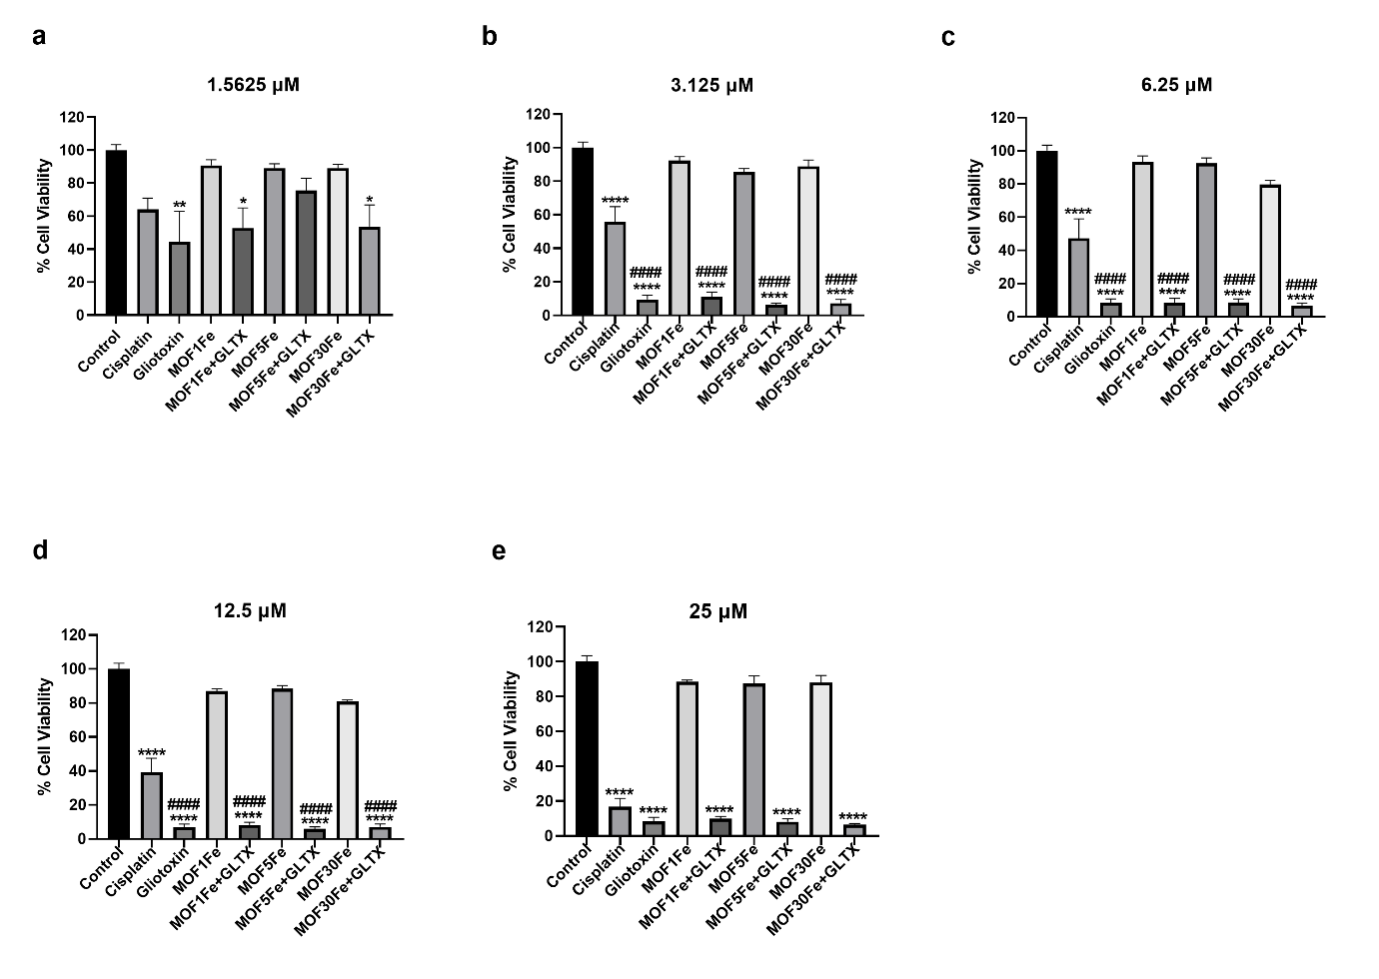
.
Neuroblastoma cells were exposed to control media, and media containing 1.5625 μM (a), 3.125 μM (b), 6.25 μM (c), 12.5 μM (d), and 25 μM (e) of cisplatin, gliotoxin, MOF1Fe, MOF1Fe+GLTX, MOF5Fe, MOF5Fe+GLTX, MOF30Fe, and MOF30Fe+GLTX respectively, for 48 h, and cell viability assessed using MTT assay. Data is presented as mean ± SEM, n = 3 per group. *, #, $ indicate statistical significance obtained using a one-way ANOVA (*p < 0.05, **p < 0.01, ***p < 0.001, ****p < 0.0001 indicates statistical significance between control and treatment groups; #p < 0.05, ##p < 0.01, ###p < 0.001, ####p < 0.0001 indicates statistical significance between cisplatin and the other treatment groups; $p < 0.05, $$p < 0.01, $$$p < 0.001, $$$$p < 0.0001 indicates statistical significance between gliotoxin and the other treatment groups).

After 48 h of treatment with the 1.5625 μM (Fig. S9a) concentration, gliotoxin, MOF1Fe+GLTX, and MOF30Fe+GLTX were the only samples to have a significant cytotoxic effect on the neuroblastoma cells compared to the control. At the 3.125 μM (Fig. S9b), 6.25 μM (Fig. S9c), 12.5 μM (Fig. S9d), and 25 μM (Fig. S9e) concentrations, all the treatment groups had a significant cytotoxic effect on the neuroblastoma cells. On comparison with cisplatin, gliotoxin, and the MOF-encased gliotoxins were more cytotoxic at the 3.125 μM, 6.25 μM, and 12.5 μM concentrations. Overall, only the 1.5625 μM concentration at the 24 h time point showed that the MOF-encased gliotoxins were more cytotoxic than the free gliotoxin; for the other concentrations at both time points, no significant difference was observed. However, it can be said that the efficacy of the MOF-drug complexes has been established against this tumour type.

Fig. S 10 Effect of exposure to different FeMOF-gliotoxin concentrations on the viability of CCD1070-Sk cell line compared to free gliotoxin after 24 h.
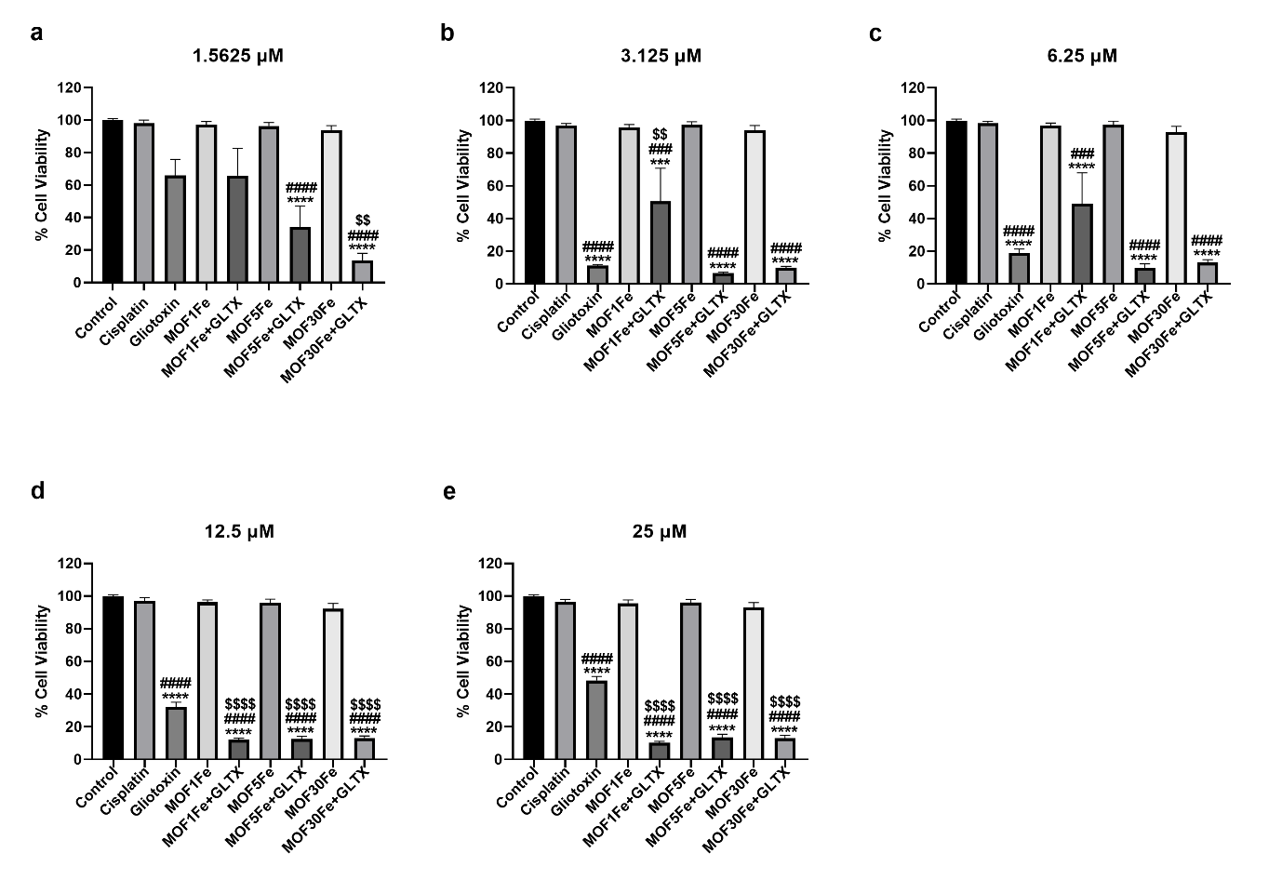
Skin fibroblasts were exposed to control media, and media containing 1.5625 μM (a), 3.125 μM (b), 6.25 μM (c), 12.5 μM (d), and 25 μM (e) of cisplatin, gliotoxin, MOF1Fe, MOF1Fe+GLTX, MOF5Fe, MOF5Fe+GLTX, MOF30Fe, and MOF30Fe+GLTX respectively, for 24 h, and cell viability assessed using MTT assay. Data is presented as mean ± SEM, n = 3 per group. *, #, $ indicate statistical significance obtained using a one-way ANOVA (*p < 0.05, **p < 0.01, ***p < 0.001, ****p < 0.0001 indicates statistical significance between control and treatment groups; #p < 0.05, ##p < 0.01, ###p < 0.001, ####p < 0.0001 indicates statistical significance between cisplatin and the other treatment groups; $p < 0.05, $$p < 0.01, $$$p < 0.001, $$$$p < 0.0001 indicates statistical significance between gliotoxin and the other treatment groups).

After 24 h of treatment with the 1.5625 μM (Fig. S10a) concentration, only MOF5Fe+GLTX and MOF30Fe+GLTX had a significant cytotoxic effect on the non-tumour cells compared to the control. These two FeMOF-gliotoxin complexes were also more toxic than cisplatin, and only the MOF30Fe+GLTX was more toxic than the free gliotoxin. At the 3.125 μM (Fig. S10b), 6.25 μM (Fig. S10c), 12.5 μM (Fig. S10d), and 25 μM (Fig. S10e) concentrations, all the treatment groups except cisplatin had significant toxic effects on the non-tumour cells compared to the control, and compared to cisplatin, gliotoxin and the MOF-encased gliotoxins were also more toxic to the cells. At the 3.125 μM concentration, only MOF1Fe+GLTX was less toxic than gliotoxin. Whereas, at the 12.5 μM and 25 μM concentrations, the MOF-encased gliotoxins were more toxic to the tumour cells compared to the free gliotoxin.

Fig. S 11 Effect of exposure to different FeMOF-gliotoxin concentrations on the viability of CCD1070-Sk cell line compared to free gliotoxin after 48 h
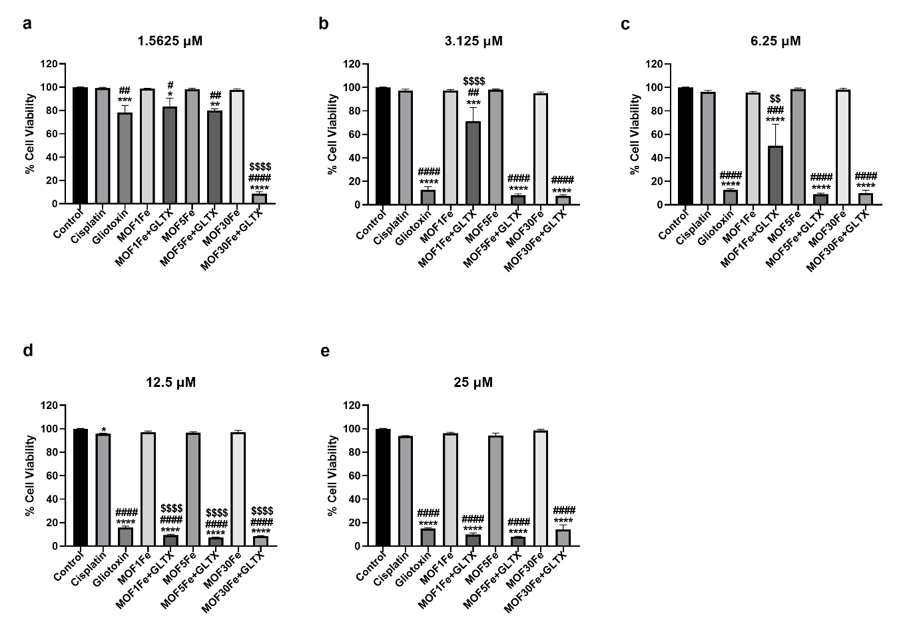
Skin fibroblasts were exposed to control media, and media containing 1.5625 μM (a), 3.125 μM (b), 6.25 μM (c), 12.5 μM (d), and 25 μM (e) of cisplatin, gliotoxin, MOF1Fe, MOF1Fe+GLTX, MOF5Fe, MOF5Fe+GLTX, MOF30Fe, and MOF30Fe+GLTX respectively, for 48 h, and cell viability assessed using MTT assay. Data is presented as mean ± SEM, n = 3 per group. *, #, $ indicate statistical significance obtained using a one-way ANOVA (*p < 0.05, **p < 0.01, ***p < 0.001, ****p < 0.0001 indicates statistical significance between control and treatment groups; #p < 0.05, ##p < 0.01, ###p < 0.001, ####p < 0.0001 indicates statistical significance between cisplatin and the other treatment groups; $p < 0.05, $$p < 0.01, $$$p < 0.001, $$$$p < 0.0001 indicates statistical significance between gliotoxin and the other treatment groups).

After 48 h of treatment, all the treatment groups except cisplatin had a statistically significant toxic effect on the cell viability of the non-tumour cells at 1.5625 μM (Fig. S11a), 3.125 μM (Fig. S11b), 6.25 μM (Fig. S11c), and 25 μM (Fig. S11e) concentrations. Compared to cisplatin, gliotoxin and the MOF-encased gliotoxins were more toxic against the non-tumour cells across all the examined concentrations. Compared to the free gliotoxin, MOF30Fe+GLTX was more toxic at 1.5625 μM; MOF1Fe+GLTX was less toxic at 3.125 μM and at 6.25 μM; and all three MOFFe-gliotoxin complexes were more toxic at 12.5 μM (Fig. S11d) concentration.
Overall, the results suggests that at both time points, encasing gliotoxin in MOF1Fe at 6.25 μM may be ideal in neuroblastoma treatment as seen by the reduced toxicity of the MOF-gliotoxin complex on the non-tumour cells.

References
Mayo SL, Olafson BD, Goddard WA (1990) DREIDING: A generic force field for molecular simulations. J Phys Chem 94:8897–8909.
Mahoney MW, Jorgensen WL (2000) A five-site model for liquid water. J Chem Phys 112:8910–8922.
Lennard-Jones JE (1924) On the determination of molecular fields. Proc R Soc A 106:463–477.
Berthelot D (1898) Sur le mélange des gaz. C R Acad Sci 126:1703–1855.
Lorentz HA (1881) Ueber die Anwendung des Satzes vom Virial. Ann Phys 248:127–136.

