Simultaneously Enhancing Aggregation-Induced Emission and Boosting Two-Photon Absorption Performance of Perylene Diimides through Regioisomerization

Liang Xu*, Xueting Long, Ziqi Deng, Sirui Yang, Jieyu Wu, Lingfeng Yin, Xiao-Fang Jiang, Fushen Lu, Ming-De Li, Qichun Zhang*

Table of contents
1. Synthetic details 2
1.1 Synthesis of B-PDI-ANT 2
1.2 Synthesis of O-PDI-ANT 3
2. Results 4
2.1 ¹H and ¹³C NMR 4
2.2 Femtosecond transient absorption spectra and kinetics fitting of B-PDI-ANT and O-PDI-ANT in THF 6
2.3 Nanosecond transient absorption spectra and kinetics fitting of O-PDI-ANT in THF 11
2.4 Femtosecond transient absorption spectra and kinetics fitting of B-PDI-ANT and O-PDI-ANT in THF-H₂O with different f_{w} 13
2.5 The optimized XYZ coordinates 19
2.6 The optimized molecular structures of B-PDI-ANT and O-PDI-ANT in the ground state (S₀) and the first excited state (S₁) 29
2.7 The optimized molecular orbital (MO) diagrams of B-PDI-ANT and O-PDI-ANT 30
2.8 The summary of the previously reported 2PA data for small organic molecules containing one or two PDI unit in recent ten years from 2011-2021 31
3. References 33

1. Synthetic details

1.1 Synthesis of B-PDI-ANT
Supplementary Scheme 1. The synthetic route to B-PDI-ANT.

Compounds 1 and 2 were synthesized according to the literature.¹ A mixture of 1 (0.4 g, 0.48 mmol),2 (0.176 g, 0.58mmol), Pd(PPh₃)₄ (0.055 g, 0.047mmol), K₂CO₃(0.132g,0.96mmol),DMF (10 mL) was stirred at 80 °C under N₂ atmosphere for 24h. After coolingto room temperature, the solvent was removed under reduced pressure.Then the collected solid was redissolved in dichloromethane (100 mL) and washed with brine (100 mL) twice. The organic layer was dried over NaSO₄ and concentrated by the rotary evaporator in vacuum. The crude product was further purified by column chromatography(DCM/petroleum ether=16:1 to 6:1) to give the desired product as the dark purple solid (372 mg, 0.4mmol, 83% yield).¹H NMR (400 MHz, CDCl₃) δ 8.79-8.61(m,5H), 8.51-8.46(d,2H), 8.36(s,1H), 8.06-7.99(m,4H), 7.96-7.93(d,1H), 7.55-7.51(m, 2H), 7.27-7.25 (d, 1H), 5.26-5.10(m,2H), 2.32-2.14(m,4H), 1.88-1.79(m,4H), 1.32-1.19(m,32H), 0.84-0.78(m,12H).¹³C NMR (100 MHz, CDCl₃) δ 141.84, 140.01, 135.22, 135.00, 134.83, 132.88, 132.71, 131.21, 130.78, 130.66, 129.54, 129.03, 128.73, 128.58, 128.42, 127.89, 127.47, 127.04, 126.52, 126.39, 123.96, 123.13, 55.25, 55.12, 53.87, 32.86, 32.79, 32.23, 32.19, 31.89, 29.69, 27.38, 23.05, 14.50.

1.2 Synthesis of O-PDI-ANT
Supplementary Scheme 2. The synthetic route to O-PDI-ANT.

Compounds 2 and 3 were synthesized according to the literature.^{1c, 2}A mixture of 3 (0.2 g, 0.24 mmol), 2 (0.15 g, 0.48 mmol), Pd(PPh₃)₄ (0.03 g, 0.025 mmol), K₂CO₃(0.066g,0.48mmol),DMF (30 mL) was stirred at 80 °C under N₂ atmosphere for 24h. After cooling, remove DMF with rotary evaporator.Then the collected solid was redissolved in dichloromethane (100 mL) and washed with brine (100 mL) twice. The organic layer was dried over NaSO₄ and concentrated by the rotary evaporator in vacuum. The residue was then purified by silica gel column chromatography (petroleum ether/DCM=6:1 to 1:1). A dark red solid of O-PDI-AN (0.07g, 0.08mmol) was obtained in 33% yield.¹H NMR (400 MHz, CDCl₃) δ 8.74-8.54(m,7H), 8.38-8.33(d,2H), 8.06(s,1H), 7.97-7.91(d,3H), 7.43(s,3H), 5.20-5.02(m,2H), 2.29-2.21(m,4H), 1.90-1.79(m,4H), 1.34-1.24(m,32H),0.88-0.81(m,12H).¹³C NMR (100 MHz, CDCl₃) δ 134.55, 134.26, 131.98, 131.92, 131.52, 130.85, 130.77, 130.52, 128.58, 128.11, 128.01, 127.53, 126.92, 126.62, 126.39, 126.20, 125.53, 123.27, 123.02, 122.78, 54.75, 53.40, 32.39, 32.22, 31.76, 31.43, 30.19, 29.22, 26.94, 22.61, 14.07.

2. Results

2.1 ¹H and ¹³C NMR
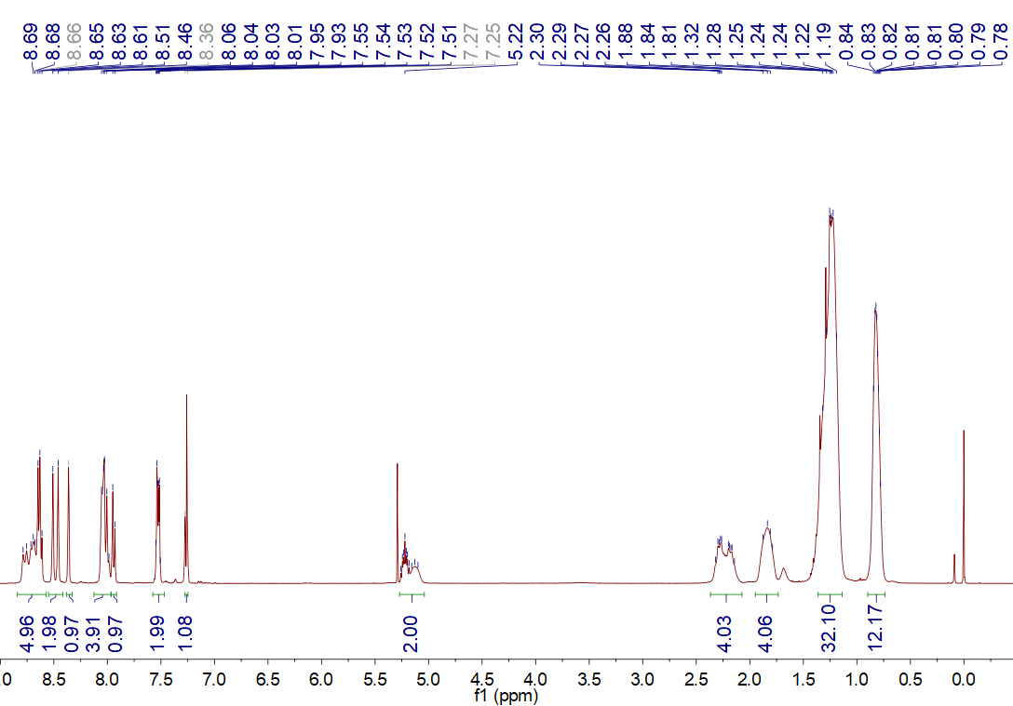
SupplementaryFigure 1.¹H NMR of B-PDI-ANT in chloroform-d.

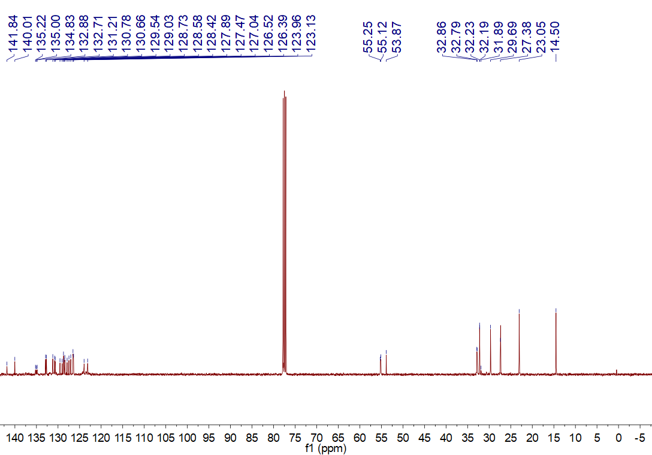
SupplementaryFigure 2.¹³C NMR of B-PDI-ANT in chloroform-d.

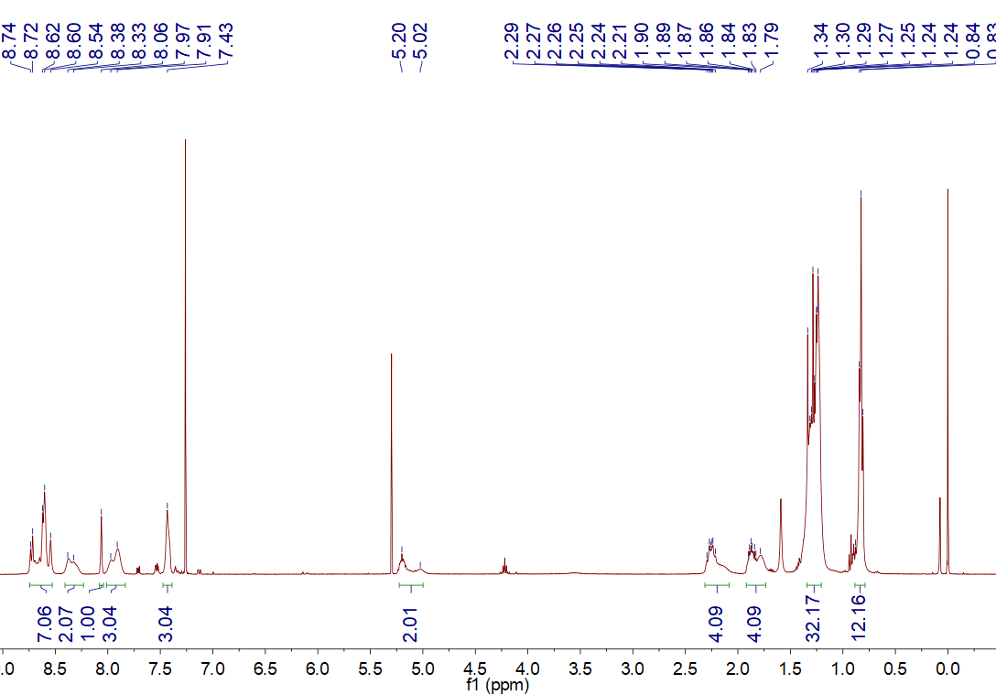
SupplementaryFigure 3.¹H NMR of O-PDI-ANT in chloroform-d.

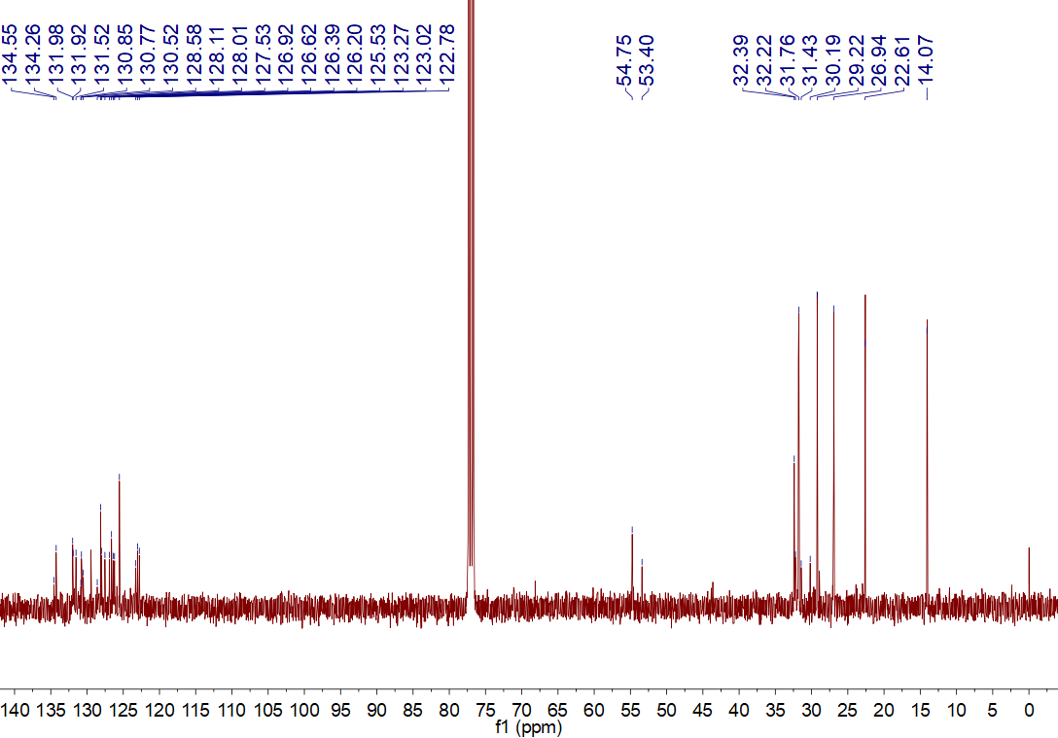
SupplementaryFigure 4.¹³C NMR of O-PDI-ANT in chloroform-d.

2.2 Femtosecond transient absorption spectra and kinetics fitting of B-PDI-ANT and O-PDI-ANT in THF
SupplementaryFigure 5.Femtosecond transient absorptionspectra(process 1) of B-PDI-ANT in THF.

SupplementaryFigure 6.Femtosecond transient absorptionspectra(process 2) of B-PDI-ANT in THF.

SupplementaryFigure 7.Global fitting dynamics of B-PDI-ANT in THF.

SupplementaryFigure 8.Kinetics fitting of B-PDI-ANTat 430 nm in THF.

SupplementaryFigure 9.Femtosecond transient absorptionspectra(process 1) of O-PDI-ANT in THF.

SupplementaryFigure 10.Femtosecond transient absorptionspectra(process 2) of O-PDI-ANT in THF.

SupplementaryFigure 11.Global fitting of O-PDI-ANT in THF.

SupplementaryFigure 12.Wavelength fitting ofO-PDI-ANTat 430 nm in THF.

Supplementary Table 1.Summary of the global fitting andwavelength fitting for B-PDI-ANT and O-PDI-ANT in THF
Sample | Fitting method | τ₁ (ps) | τ₂ (ps) | τ₃ (ps)
B-PDI-ANT | Global fitting | 0.43 | 1.92 | 250
B-PDI-ANT | Wavelength fitting at 430 nm | 0.49 | 1.71 | 220
O-PDI-ANT | Global fitting | 0.36 | 3.00 | 39
O-PDI-ANT | Wavelength fitting at 430 nm | 0.21 | 2.34 | 33

Global fitting of B-PDI-ANT at all wavelengths gives three time constants: 0.43 ps (τ₁), 1.92 ps (τ₂) and 250 ps (τ₃). Wavelength fitting of B-PDI-ANTat 430 nm gives three very similar time constants: 0.49 ps (τ₁), 1.71 ps (τ₂) and 220 ps (τ₃).Global fitting of O-PDI-ANT at all wavelengths gives three time constants: 0.36 ps (τ₁), 3.00 ps (τ₂) and 39 ps (τ₃). Wavelength fitting of O-PDI-ANTat 430 nm also gives three very similar time constants: 0.21 ps (τ₁), 2.34 ps (τ₂) and 33 ps (τ₃).

2.3 Nanosecond transient absorption spectra and kinetics fitting of O-PDI-ANT in THF
SupplementaryFigure 13.Nanosecond transient absorptionspectraof O-PDI-ANT in THFpurged withN₂.

SupplementaryFigure 14.Nanosecond transient absorptionspectraof O-PDI-ANT in THFpurged withO₂.

SupplementaryFigure 15.Kinetics fitting of O-PDI-ANTat 504 nm in THFpurged withN₂ or O₂.

Supplementary figure 13shows that the signals (470 and 504 nm) generated by ISC are gradually decreased to the baseline from 7.51 ns to 2.94μs. The kinetic fitting at 504 nm shows that O-PDI-ANT has a long lifetime of τ₁ = 2.7μs. When the solution is purged with oxygen (Supplementary figure 14), the long-lifetime transient state is significantly quenched by the oxygen and the lifetime dropsdown to 0.0465μs. This demonstrates that the long-lifetime transient statewith main peaks at 470 and 504 nm of O-PDI-ANT has a triplet-state nature.

2.4 Femtosecond transient absorption spectra and kinetics fitting of B-PDI-ANT and O-PDI-ANT in THF-H₂O with different f_{w}
SupplementaryFigure 16.Femtosecond transient absorptionspectra(process 1) of B-PDI-ANT in THF/H₂O (f_{w} = 60%).

SupplementaryFigure 17.Femtosecond transient absorptionspectra(process 2) of B-PDI-ANT in THF/H₂O (f_{w} = 60%).

SupplementaryFigure 18.Femtosecond transient absorptionspectra(process 3) of B-PDI-ANT in THF/H₂O (f_{w} = 60%).

SupplementaryFigure 19.Kinetics fitting of B-PDI-ANTat 430 nm in THF/H₂O (f_{w} = 60%).

SupplementaryFigure 20.Femtosecond transient absorptionspectra(process 1) of B-PDI-ANT in THF/H₂O (f_{w} = 90%).
SupplementaryFigure 21.Femtosecond transient absorptionspectra(process 2) of B-PDI-ANT in THF/H₂O (f_{w} = 90%).

SupplementaryFigure 22.Femtosecond transient absorptionspectra(process 3) of B-PDI-ANT in THF/H₂O (f_{w} = 90%).

SupplementaryFigure 23.Kinetics fitting of B-PDI-ANTat 430 nm in THF/H₂O (f_{w} = 90%).

SupplementaryFigure 24.Femtosecond transient absorptionspectra(process 1) of O-PDI-ANT in THF/H₂O (f_{w} = 60%).

SupplementaryFigure 25.Femtosecond transient absorptionspectra(process 2) of O-PDI-ANT in THF/H₂O (f_{w} = 60%).

SupplementaryFigure 26.Femtosecond transient absorptionspectra(process 3) of O-PDI-ANT in THF/H₂O (f_{w} = 60%).

SupplementaryFigure 27.Kinetics fitting ofO-PDI-ANTat 430 nm in THF/H₂O (f_{w} = 60%).

Supplementary Table 2.Summary of the wavelength fitting for B-PDI-ANT and O-PDI-ANT at 430 nm in THF/H₂0 with different f_{w}.
 | f_{w} (%) | τ₁ (ps) (amplitude) | τ₂ (ps) (amplitude) | τ₃ (ps) (amplitude)
B-PDI-ANT | 0 | 0.49 (33.5%) | 1.71 (27.6%) | 220 (38.5%)
 | 60 | 0.107 (44.6%) | 2.99 (9.08%) | 152 (31.3%)
 | 90 | 0.219 (71%) | 3.73 (8.39%) | 91 (14.9%)
O-PDI-ANT | 0 | 0.205 (39.3%) | 2.34 (28.6%) | 32.5 (30.4%)
 | 60 | 0.0908 (80%) | 2.75 (10.8%) | 201 (7.95%)
SupplementaryFigure 28.The obtained amplitude of rotation (τ₃) for B-PDI-ANT andO-PDI-ANT in THF/H₂0 with different f_{w}.

2.5 The optimized XYZ coordinates
S₀of B-PDI-ANT
C -5.00442 0.44034 -0.02777
N -5.64676 -0.80101 0.08161
C -4.96579 -1.99497 0.32045
C 5.09953 -1.8745 0.31904
N 5.74392 -0.73117 -0.15329
C 5.05924 0.38678 -0.65322
O -5.55734 -3.04318 0.5077
O -5.64177 1.47142 -0.14661
O 5.72097 -2.86418 0.66347
O 5.66106 1.3261 -1.1422
C 7.23271 -0.65483 -0.21579
C -7.13581 -0.76624 -0.00952
C -7.74278 -1.87416 -0.87545
C -7.79083 -0.59986 1.36915
C 7.9461 -1.1456 1.04754
C 7.78197 -1.23549 -1.52677
C -3.48178 -1.95054 0.33054
C -3.5228 0.45279 -0.00399
C -2.78894 -0.73756 0.15262
C -2.77767 -3.11425 0.5282
C -1.38082 -3.08728 0.56792
C -0.66529 -1.91232 0.40035
C -1.37296 -0.69851 0.14867
C -0.69565 0.54467 -0.07422
C -1.45041 1.72534 -0.09792
C -2.85992 1.64794 -0.08727
C 3.61698 -1.84645 0.39441
C 3.58149 0.39045 -0.55626
C 2.88888 -0.71478 -0.02296
C 1.4742 -0.69778 0.06569
C 0.80113 -1.88052 0.48075
C 1.55081 -2.96859 0.89852
C 2.94891 -2.95114 0.86821
C 2.87402 1.47341 -1.01746
C 1.4801 1.5198 -0.88599
C 0.76443 0.48798 -0.2973
C -7.14761 -1.96451 -2.27932
C -7.68568 -1.75609 2.36311
C -8.45214 -1.46787 3.65369
C -7.88728 -2.96142 -3.16965
C -8.35485 -2.59562 4.6788
C -9.12228 -2.31294 5.96889
C -7.29325 -3.07853 -4.57165
C -8.03249 -4.07394 -5.46375
C -9.01775 -3.44526 6.98667
C -7.43062 -4.18502 -6.86171
C 7.65621 -2.74096 -1.75859
C 7.45499 -0.4885 2.33599
C 8.31878 -3.17249 -3.06659
C 8.30035 -0.86919 3.55011
C 7.81275 -0.23548 4.85117
C 8.19745 -4.67012 -3.33964
C 8.86125 -5.10657 -4.64424
C 8.65875 -0.61336 6.06552
C 8.16342 0.02381 7.36069
C 8.73366 -6.60432 -4.9077
H 7.40933 0.41949 -0.27527
H -7.31591 0.17253 -0.53417
H -8.80946 -1.62698 -0.95992
H -7.67633 -2.84476 -0.38455
H -8.85228 -0.38693 1.18388
H -7.37959 0.31001 1.82319
H 9.00432 -0.8901 0.90272
H 7.88779 -2.22959 1.14227
H 8.84393 -0.95807 -1.56738
H 7.30194 -0.69779 -2.35354
H -3.32412 -4.04077 0.66116
H -0.85741 -4.02158 0.72777
H -3.44365 2.56015 -0.12994
H 1.05901 -3.86466 1.25619
H 3.5254 -3.80973 1.19275
H 3.41391 2.29855 -1.46759
H 0.96386 2.39235 -1.25672
H -6.09336 -2.2606 -2.21654
H -7.16235 -0.97255 -2.75213
H -6.63551 -1.95337 2.60331
H -8.06558 -2.67954 1.91194
H -9.50941 -1.28331 3.41723
H -8.07657 -0.53718 4.10156
H -8.94319 -2.66753 -3.2464
H -7.88048 -3.94866 -2.68836
H -7.29834 -2.77886 4.91842
H -8.72854 -3.5269 4.23139
H -10.178 -2.13137 5.72892
H -8.74847 -1.38226 6.41525
H -6.23801 -3.37531 -4.49564
H -7.29606 -2.09034 -5.05235
H -9.08648 -3.77683 -5.5403
H -8.02954 -5.06077 -4.98303
H -9.57569 -3.21764 7.90032
H -7.9749 -3.62638 7.26936
H -9.41497 -4.38083 6.57786
H -7.97841 -4.90357 -7.47926
H -6.38617 -4.51265 -6.81656
H -7.45056 -3.21881 -7.37777
H 6.60099 -3.03376 -1.77492
H 8.10426 -3.2917 -0.92396
H 6.41373 -0.77664 2.52508
H 7.45702 0.60416 2.2184
H 9.38135 -2.89251 -3.04767
H 7.87483 -2.61419 -3.90268
H 9.34442 -0.57627 3.3731
H 8.30516 -1.96222 3.65764
H 6.76975 -0.53093 5.03084
H 7.80344 0.85802 4.74277
H 7.13537 -4.95061 -3.362
H 8.63943 -5.22905 -2.50337
H 9.92258 -4.8271 -4.62078
H 8.41904 -4.54781 -5.47934
H 9.70055 -0.31773 5.88595
H 8.66763 -1.70569 6.17341
H 8.78646 -0.26277 8.21359
H 7.13477 -0.28131 7.58214
H 8.17502 1.11716 7.29207
H 9.21704 -6.89011 -5.84713
H 7.68218 -6.90583 -4.96871
H 9.1968 -7.18694 -4.10381
C -0.89032 3.1051 -0.05108
C -1.26403 4.0506 -0.96346
C -0.02038 3.48119 1.02687
C -0.7908 5.39686 -0.88673
H -1.92799 3.78496 -1.78188
C 0.44232 4.75236 1.13948
H 0.25501 2.73093 1.76073
C -1.15498 6.36314 -1.82255
C 0.085 5.75886 0.18793
H 1.09197 5.02802 1.96533
C -0.68662 7.67501 -1.73787
H -1.82036 6.08936 -2.63758
C 0.55276 7.06743 0.27441
C -1.05202 8.67521 -2.69014
C 0.18988 8.03661 -0.66252
H 1.21641 7.34139 1.09078
C -0.57968 9.94728 -2.58308
H -1.71693 8.39727 -3.50305
C 0.66308 9.38204 -0.5869
C 0.29177 10.30637 -1.51469
H -0.86468 10.69859 -3.31282
H 1.32736 9.65168 0.22932
H 0.65809 11.32585 -1.44646

S₁ of B-PDI-ANT
C -0.28477900 5.00662400 -0.29231100
N -1.41262000 5.82216300 -0.18780700
C -2.71525600 5.36480000 0.01064900
C -4.18591800 -4.54067700 0.12296900
N -3.12703600 -5.33983000 -0.30612500
C -1.86952700 -4.86661800 -0.68649600
O -3.63616800 6.16036100 0.10232600
O 0.83019600 5.47861900 -0.45287000
O -5.25852000 -5.04598300 0.41387300
O -0.99708100 -5.62624200 -1.07855100
C -3.38590200 -6.77427300 -0.38170300
C -1.24271500 7.26915800 -0.27390000
C -2.90933500 3.90802000 0.09881100
C -0.51698000 3.55492800 -0.19959600
C -1.82073800 3.03725300 -0.01050600
C -4.19751200 3.39983300 0.28912500
C -4.40343800 2.04156300 0.36443000
C -3.33354700 1.12409100 0.24646300
C -2.01659600 1.62686200 0.05164600
C -0.89908900 0.75506100 -0.09556500
C 0.42903000 1.32237800 -0.07373800
C 0.57231300 2.70527400 -0.20000200
C -3.94197200 -3.09106200 0.19855600
C -1.65430900 -3.41331300 -0.58129600
C -2.68549700 -2.55890400 -0.13894700
C -2.45890200 -1.15479000 -0.04591900
C -3.53628100 -0.30184700 0.30517200
C -4.78006800 -0.88109700 0.64769200
C -4.97343200 -2.24558100 0.60479500
C -0.42887800 -2.87910600 -0.97167200
C -0.18697000 -1.52534700 -0.85932500
C -1.15810000 -0.63929300 -0.32231700
H -2.44003700 -7.27023500 -0.58870500
H -0.18819400 7.46711300 -0.45068700
H -5.01935700 4.10229800 0.36640000
H -5.41407200 1.67443100 0.48820000
H 1.55754300 3.15677400 -0.20633200
H -5.60092700 -0.24838300 0.96063100
H -5.92589900 -2.68951800 0.87074000
H 0.31993500 -3.55146300 -1.37424800
H 0.75256100 -1.12923500 -1.21838200
C 1.63708100 0.55040500 0.23408700
C 2.83249300 0.82223300 -0.40637500
C 1.63234400 -0.43837500 1.27958000
C 4.03139800 0.14606500 -0.07433600
H 2.85852900 1.55501300 -1.20728000
C 2.76892700 -1.08546600 1.63855100
H 0.70421700 -0.63593700 1.80321900
C 5.23373500 0.41039900 -0.74085800
C 4.01192800 -0.83181500 0.97670300
H 2.75194100 -1.81143300 2.44608900
C 6.41381100 -0.24759700 -0.40177300
H 5.24599100 1.14993600 -1.53724000
C 5.18793400 -1.48783200 1.31377900
C 7.64818100 0.01669600 -1.07028600
C 6.39278500 -1.22104000 0.65197500
H 5.17584100 -2.22668300 2.11078900
C 8.78697700 -0.64082000 -0.71626700
H 7.65808800 0.75492900 -1.86679600
C 7.60544300 -1.88626600 0.99090900
C 8.76474700 -1.60578900 0.32926700
H 9.72017400 -0.43268500 -1.22931400
H 7.58835000 -2.62275200 1.78887000
H 9.68213600 -2.11963900 0.59814500
H -3.81026700 -7.11648400 0.56363500
H -4.10383700 -6.98735300 -1.17883500
H -1.56999700 7.73827100 0.65726200
H -1.85285300 7.66423900 -1.08869700

S₀ of O-PDI-ANT
C 5.82012 -0.26082 0.12321
N 6.44564 -1.45797 0.47132
C 5.74462 -2.59949 0.88624
C -4.32713 -2.40617 0.63178
N -4.96278 -1.24328 0.21759
C -4.28067 -0.04449 -0.05303
O 6.33247 -3.60012 1.25635
O 6.45795 0.73995 -0.14946
O -4.9492 -3.40034 0.96348
O -4.90973 0.97908 -0.24137
C -6.45152 -1.1655 0.13571
C 7.93307 -1.57821 0.47258
C 8.61421 -1.00421 -0.77337
C 8.54557 -1.12357 1.80512
C -7.10955 -2.36871 -0.54664
C -7.0819 -0.76936 1.47842
C 4.26436 -2.55193 0.85141
C 4.33548 -0.24636 0.08798
C 3.58669 -1.38397 0.44952
C 3.5461 -3.66576 1.21461
C 2.1476 -3.6457 1.18058
C 1.44157 -2.5199 0.789
C 2.16946 -1.35235 0.41501
C 1.51428 -0.15319 0.0094
C 2.28729 0.94362 -0.33401
C 3.68543 0.90215 -0.29535
C -2.84548 -2.39329 0.65587
C -2.79399 -0.07167 -0.10567
C -2.10664 -1.24613 0.29299
C -0.68841 -1.29162 0.33743
C -0.03054 -2.48889 0.74651
C -0.80032 -3.58613 1.09137
C -2.19522 -3.53931 1.04759
C -2.06848 1.05439 -0.47722
C -0.66099 0.99339 -0.42225
C 0.04207 -0.12593 -0.02853
C 8.05969 -1.54514 -2.08993
C 8.48011 0.36082 2.16338
C 9.2083 0.66229 3.47297
C 8.8735 -1.09518 -3.30187
C 9.14979 2.13546 3.87125
C 9.88169 2.44264 5.17633
C 8.32349 -1.61631 -4.62787
C 9.13902 -1.17228 -5.84066
C 9.81639 3.91698 5.56524
C 8.58212 -1.69879 -7.16039
C -6.99962 -1.76416 2.63582
C -6.53287 -2.7006 -1.92154
C -7.73907 -1.25678 3.87362
C -7.31924 -3.79507 -2.6409
C -6.74216 -4.15812 -4.0074
C -7.66462 -2.21713 5.0586
C -8.4064 -1.71488 6.29581
C -7.52641 -5.25403 -4.72649
C -6.94001 -5.61297 -6.08893
C -8.3256 -2.68108 7.47427
H -6.60714 -0.31074 -0.5229
H 8.0797 -2.65799 0.43704
H 9.66974 -1.29542 -0.68917
H 8.58162 0.08504 -0.77954
H 9.59821 -1.43637 1.78331
H 8.07682 -1.71249 2.60314
H -8.1662 -2.09369 -0.66469
H -7.07708 -3.25363 0.08816
H -8.13864 -0.55244 1.272
H -6.63589 0.18457 1.78385
H 4.08315 -4.55507 1.52394
H 1.62296 -4.54628 1.47286
H 1.81789 1.86863 -0.64369
H 4.27593 1.7702 -0.56503
H -0.33236 -4.51046 1.40481
H -2.7918 -4.40219 1.31996
H 7.02137 -1.21547 -2.21824
H 8.03304 -2.64326 -2.05658
H 7.43698 0.68366 2.24738
H 8.91367 0.96434 1.35809
H 10.25903 0.35193 3.38636
H 8.77897 0.0511 4.27927
H 9.9141 -1.42801 -3.18521
H 8.90622 0.00242 -3.32759
H 8.09976 2.44584 3.96294
H 9.57577 2.74737 3.06419
H 10.93103 2.1337 5.08345
H 9.45591 1.83093 5.98243
H 7.28434 -1.27989 -4.7479
H 8.2849 -2.71426 -4.60001
H 10.17717 -1.50821 -5.72027
H 9.1766 -0.07555 -5.86892
H 10.34796 4.10995 6.50235
H 8.77919 4.2445 5.69678
H 10.26512 4.54916 4.79107
H 9.18462 -1.3672 -8.01167
H 7.55602 -1.35091 -7.32285
H 8.56374 -2.79416 -7.17166
H -5.95292 -1.95698 2.8947
H -7.41441 -2.73263 2.33462
H -5.49045 -3.02497 -1.8173
H -6.51481 -1.79507 -2.54425
H -8.7929 -1.075 3.62021
H -7.32813 -0.28169 4.17044
H -8.36331 -3.47488 -2.76129
H -7.34746 -4.69264 -2.0086
H -5.69848 -4.48001 -3.88714
H -6.71111 -3.26044 -4.64052
H -6.61152 -2.39653 5.3155
H -8.07316 -3.19302 4.76223
H -9.45853 -1.53635 6.03857
H -7.99747 -0.73997 6.59141
H -8.56855 -4.93154 -4.84863
H -7.55824 -6.14979 -4.09287
H -7.52035 -6.39924 -6.58167
H -5.90885 -5.97048 -5.99286
H -6.92631 -4.74269 -6.75426
H -8.86487 -2.29817 8.34626
H -7.28563 -2.85144 7.77376
H -8.7576 -3.65428 7.21665
H -0.13355 1.88675 -0.72949
C -2.6431 2.33807 -0.96986
C -3.38518 2.38072 -2.19504
C -2.3705 3.50164 -0.31309
C -3.82326 3.55979 -2.70187
H -3.58837 1.45154 -2.71636
C -2.83678 4.76246 -0.79858
H -1.8039 3.48525 0.61424
C -3.57668 4.79577 -2.02446
H -4.37847 3.58322 -3.63525
C -2.58711 5.95414 -0.12161
C -4.0282 6.01861 -2.51332
C -3.04147 7.18092 -0.60845
H -2.02728 5.9288 0.81017
C -3.78076 7.21415 -1.83587
H -4.58999 6.04347 -3.44386
C -2.79455 8.40991 0.07634
C -4.24114 8.47499 -2.32387
C -3.25018 9.59199 -0.42188
H -2.23429 8.38005 1.00674
C -3.98528 9.62491 -1.6417
H -4.80197 8.49566 -3.25416
H -3.05597 10.51919 0.1083
H -4.3414 10.57672 -2.02307

S₁ of O-PDI-ANT
C 5.24635900 -3.63290500 0.13694600
N 6.56665100 -3.19141200 0.08412700
C 6.95824700 -1.85515700 -0.00183400
C -0.26867400 5.09398200 -0.23695500
N -1.58801300 4.66363100 -0.18738500
C -1.99505500 3.32883300 -0.13871600
O 8.13668500 -1.53699200 -0.04213200
O 4.99708000 -4.82517900 0.21422400
O 0.01491800 6.27947900 -0.31673000
O -3.18383800 3.06623200 -0.21682200
C -2.64508700 5.66750200 -0.27424400
C 7.59749800 -4.22460800 0.12815400
C 5.87827300 -0.85192700 -0.04078600
C 4.19339900 -2.60373900 0.09618000
C 4.52674100 -1.23957500 0.01114600
C 6.21494400 0.50008000 -0.12775800
C 5.23036900 1.46188100 -0.16417000
C 3.85363800 1.11909800 -0.11157000
C 3.49775500 -0.25348700 -0.02045600
C 2.13957600 -0.66571900 0.04210900
C 1.85170400 -2.05404200 0.11556400
C 2.85484400 -2.99691300 0.14242500
C 0.76023000 4.04211700 -0.19911100
C -0.94477700 2.29779500 0.00493600
C 0.41531300 2.68070500 -0.08785200
C 1.45653200 1.70436800 -0.06595700
C 2.81534100 2.11397500 -0.14537300
C 3.10463000 3.49830000 -0.25246800
C 2.09873300 4.43406900 -0.27965900
C -1.28292400 0.93364200 0.16099700
C -0.26160400 -0.00310100 0.15879100
C 1.10569900 0.33373300 0.03483800
H -3.45497900 5.38749600 0.39823200
H 8.56218500 -3.73335800 0.03528500
H 7.26508400 0.76542400 -0.16483100
H 5.52690500 2.50029300 -0.23034700
H 0.82429300 -2.39206000 0.14571000
H 2.63336500 -4.05635500 0.20062600
H 4.13017100 3.83647200 -0.31819400
H 2.31206200 5.49326300 -0.36280700
H -0.54808800 -1.03659300 0.30021100
C -2.66083100 0.42082800 0.39412600
C -3.39317200 0.83561100 1.55452400
C -3.19110700 -0.53156000 -0.42570800
C -4.60131000 0.29317000 1.84541500
H -2.96008400 1.58702400 2.20589000
C -4.47411700 -1.10833000 -0.17076400
H -2.64739200 -0.85452400 -1.30956400
C -5.19473700 -0.69299800 0.99574600
H -5.14403100 0.60586000 2.73280600
C -5.03871200 -2.06255100 -1.01440500
C -6.43910600 -1.25608300 1.26374900
C -6.28902200 -2.62496800 -0.75019500
H -4.49469600 -2.37554500 -1.90233600
C -7.00677100 -2.21263300 0.41984600
H -6.98439400 -0.94106300 2.15007600
C -6.88161000 -3.60073500 -1.60852400
C -8.28389500 -2.79576500 0.68149400
C -8.10260600 -4.13261700 -1.32508000
H -6.33571200 -3.90915300 -2.49573400
C -8.81474600 -3.72402000 -0.16108100
H -8.82394900 -2.48024600 1.56997700
H -8.54254600 -4.87277600 -1.98606800
H -9.78695500 -4.15933100 0.04873600
H 7.53583500 -4.77123400 1.07089200
H 7.44390700 -4.93191600 -0.68813200
H -2.21710100 6.62920500 -0.00045300
H -3.04286400 5.71772400 -1.29142200

2.6 The optimized molecular structures of B-PDI-ANT and O-PDI-ANT in the ground state (S₀) and the first excited state (S₁)
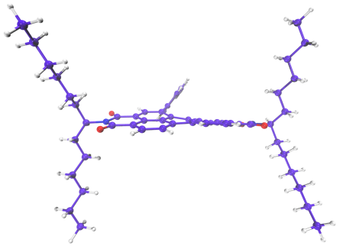
SupplementaryFigure 29.Theoptimized S₀ of B-PDI-ANT.

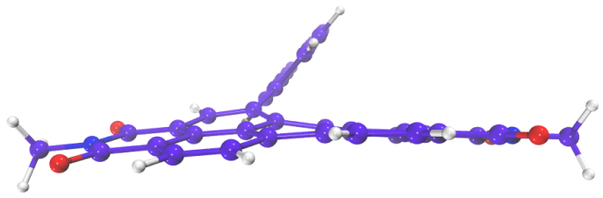
SupplementaryFigure 30.Theoptimized S₁ of B-PDI-ANT.
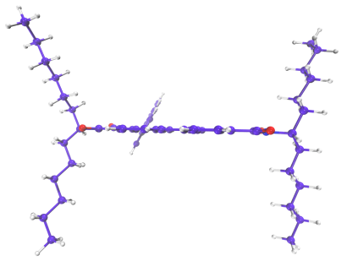
SupplementaryFigure 31.Theoptimized S₀ of O-PDI-ANT.

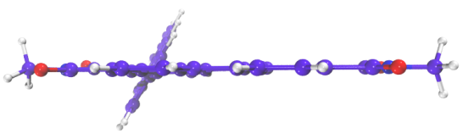
SupplementaryFigure 32.Theoptimized S₁ of O-PDI-ANT.

2.7 The optimized molecular orbital (MO) diagrams of B-PDI-ANT and O-PDI-ANT
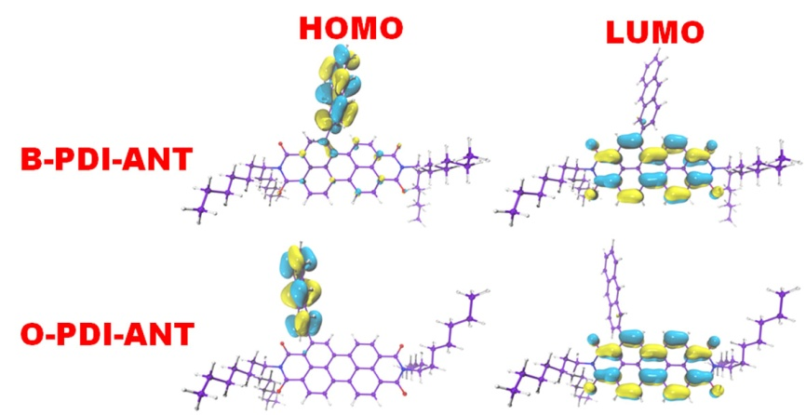
SupplementaryFigure 33.Theoptimized HOMO and LUMO of B-PDI-ANT andO-PDI-ANT.

2.8 The summary of the previously reported 2PA data for small organic molecules containing one or two PDI unit in recent ten years from 2011-2021
Supplementary Table 3.Summary of the previously reported 2PA data for small organic molecules containing one or two PDI unit in recent ten years from 2011-2021.
Dyes | Method | Solvent | λ_{2PA}/  nm | δ/  GM | Refer-ence
 | fs-TPEF | toluene | 625 | 1075 | 47
 | fs-TPEF | dichloro-  methane | 720 | 324 | 48
 | fs-TPEF | toluene | 669 | 470 | 49
 | fs-TPEF | toluene | 1220 | 1110 | 50
 | fs-TPEF | acetoni-  trile | 850 | 180 | 51
 | fs Z-scan | dichloro-  methane | 800 | 1073 | 52
 | fs Z-scan | dichloro-  methane | 900 | 140 | 53
 | fs-TPEF | chloro-  form | 800 | 125 | 54
 | fs Z-scan | dichloro-  methane | 639 | 3340 | 55
 | fs-TPEF | chloro-  form | 800 | 18.4 | 56
 | fs-TPEF | THF | 1100 | 1104 | 57
 | fs Z-scan | THF | 650 | 2400 | 58

3. References
1. (a) Holman, M. W.; Liu, R.; Adams, D. M., Single-Molecule Spectroscopy of Interfacial Electron Transfer. Journal of the American Chemical Society 2003, 125 (41), 12649-12654;(b) Davis, N. J. L. K.; MacQueen, R. W.; Roberts, D. A.; Danos, A.; Dehn, S.; Perrier, S.; Schmidt, T. W., Energy transfer in pendant perylene diimide copolymers. Journal of Materials Chemistry C 2016, 4 (35), 8270-8275;(c) Xu, L.; Li, Y.; Jiang, R.; Qin, Z.; Li, Y., 2,6-Anthracenyl(anthraquinonyl)-substituted difluoroboron dipyrromethenes: Synthesis, spectroscopy, electrochemistry and quantum chemical calculations. Dyes and Pigments 2014, 107, 90-96.
2. (a) Teraoka, T.; Hiroto, S.; Shinokubo, H., Iridium-Catalyzed Direct Tetraborylation of Perylene Bisimides. Organic Letters 2011, 13 (10), 2532-2535;(b) Han, H.; Ma, L.-K.; Zhang, L.; Guo, Y.; Li, Y.; Yu, H.; Ma, W.; Yan, H.; Zhao, D., Tweaking the Molecular Geometry of a Tetraperylenediimide Acceptor. ACS Applied Materials & Interfaces 2019, 11 (7), 6970-6977.

