Supplementary materials

Table S1: Excerpts of interview guide and Observational Checklist
Interview questions | Observational Checklist
Beginning of care and decision in caregiving | Environment
Did you have any doubts or uncertainties about your decision to become a caregiver?  Probe  - The right decision to become a caregiver  - How you manage everything | Does the residence have enough space to accommodate all residents comfortably?
(B) Facing Challenges/Barrier | Caregiver
What is the most difficult part of caregiving as caregiver?  Probe  - Behaviour  - Daily Task  - Adl/iadl | Is the caregiver able to maintain a healthy and balanced lifestyle?
Coping Strategies/ | Interaction between caregiver and older person under care
Please tell us about the most significant changes you have experienced in caring for your family member  Probe  - Relationship with spouse/family  - Working | Does the caregiver use language that the older person understands and vice versa?
Caregiver capacity | Does the relationship between the caregiver and the older person appear warm, polite, and respectful?
What do you think that you need to increase your capacity to care for your loved one?
Probe
- Learning
- Help from outsde
- Reassurance
- Financial / government incentive
Describe the types of support you have received and would expect to help take care of yourself.
Probes
- Respite Care
- Financial aids
- Mobility/Transport
- Help Services

Table S2: Summary of home visit observations
Participant | Physical Environment | Caregiver- Caregiver relationship | Caregiver Well-being
Ridwan | - Medium-sized apartment shared by a nuclear family (Ridwan, wife, three kids, mother, aunt).  - Hospital beds are in the living area, and there is limited space.  - There is a toilet in the primary bedroom, and one shared toilet.  - The home appeared slightly messy. | looked stressed and used a firm tone with his aunt despite visitors being present. | Limited space and privacy; shared facilities; visible stress and emotional strain.  Ridwan received a visit from a nearby community to show support and donate carer equipment.  Good community support from the Ridwan housing community.  Ridwan also received diapers, milk products, and hospital bed rentals from an NGO and the neighborhood.
Noraini | - Terrace house; no hospital bed or ripple mattress.  - The patient (father) is bedridden.  - The bed is placed between the hall and the dining area.  - A wheelchair was positioned nearby.  - The house is lively, and six grandchildren are present. | appeared reserved and followed the siblings' directions without providing suggestions. | Lack of appropriate medical equipment (e.g., hospital bed, ripple mattress).  Noraini 's perceived lack of confidence  Noraini has four siblings, all actively helping with caregiving tasks.

Table S3:Summary of Major Theme
Global Theme | Major theme | Subthemes | Quote
- Challenges of Caregiving | - Physical and Psychological Strain | - physical exhaustion | Being a caregiver to two people who need attention is not easy. ………I often take medical leave …I am tired and often have headaches. Even with medical leave, I still have to take care of them. I do not get to rest"
- Challenges of Caregiving | - Physical and Psychological Strain | - emotional exhaustion | It's emotionally challenging. I don't understand why she refuses to eat or drink milk. It causes stress, and sometimes we raise our voices, which makes her feel like we're angry
- Challenges of Caregiving | - Physical and Psychological Strain | - emotional exhaustion | Oh, the frustration is real. For her and for me. She’ll ask the same question 30 times in ten minutes. My teacher's brain, wired for progress and answers, used to scream inside
- Challenges of Caregiving | - Physical and Psychological Strain | - role exhaustion | It is like I am running out of energy (from housework and caregiving), but I still need to keep going
- Challenges of Caregiving | - Physical and Psychological Strain | - role exhaustion | Managing multiple health issues simultaneously can be exhausting and leave little time for self-care
- Challenges of Caregiving | - Physical and Psychological Strain | - work-caregiving conflict | I often arrive late at work because I need to take care of them first. There are still salary deductions
- Challenges of Caregiving | - Physical and Psychological Strain | - work-caregiving conflict | I gave up the desire to work (advancing career) because I felt sorry for my mother taking care of my father alone
- Challenges of Caregiving | - Social Isolation |  | I do not have much time to see my friends or engage in social activities … Sometimes I feel that I cannot interact with my friends as much as I would like to because of my caregiving duties
- Challenges of Caregiving |  |  | My relationship with my husband has become strained because I sleep with my mother every night to prevent her from wandering off… There have been arguments with my husband when we both get stressed. He also complains that we cannot go anywhere because we need to care for my mother
- Challenges of Caregiving | - Resource Constraints | - Financial strain | Financial problems are also an issue… I had to use my own money to support my mother and aunt. ...with the rising cost of living, my wife and I have to use our monthly salaries to cover the living expenses
- Challenges of Caregiving | - Resource Constraints | - Financial strain | My daughter had to reduce her working hours to take care of her dad
- Challenges of Caregiving | - Resource Constraints | - Support system disparity | I have applied for assistance (from welfare), but it keeps getting rejected.... Even though I explained that I was facing financial problems, they said I was not eligible. I feel that people like me are somewhat left out in terms of support
- Enablers Of Caregiving Capacity | Intrinsic capacity | - Filial piety | As the eldest son and having responsibilities as a son, I have to take on that responsibility… They are my mother and my aunt. I am the chosen one to serve them as long as they are still alive
- Enablers Of Caregiving Capacity | Intrinsic capacity | - Filial piety | This is the time to serve our parents… As long as I can, I want to take care of my parents because parents cannot be replaced… Even though I have my marital problems, I still want to take care of my father
- Enablers Of Caregiving Capacity | Intrinsic capacity | - Filial piety | I know it is my responsibility as a wife
- Enablers Of Caregiving Capacity | Intrinsic capacity | - Filial piety | He has sacrificed a lot for us. So now it is my turn to repay his kindness. Not everyone gets the chance to take care of their parents.
- Enablers Of Caregiving Capacity | Intrinsic capacity | - Filial piety | As an only child living with him, there was no other choice. I took on this responsibility out of love and a sense of duty as a child. He sacrificed for me, and now it is my turn to sacrifice for him
- Enablers Of Caregiving Capacity | Intrinsic capacity | - Personal fulfilment and growth | "I never thought I could do all this. But day by day, I learned... and now I feel like I've become better, not just for her, but for myself too
- Enablers Of Caregiving Capacity | Intrinsic capacity | - Personal fulfilment and growth | I feel grateful to be chosen to take care of my father. He has sacrificed a lot for us. He cared for me when I was little, so it is my turn to repay his kindness
- Enablers Of Caregiving Capacity | Intrinsic capacity | - Personal fulfilment and growth | But as a Muslim, I consider this a test, and I must always think positively
- Enablers Of Caregiving Capacity | Intrinsic capacity | - Personal fulfilment and growth | Every time I bathe or feed her, I tell myself—this is my pahala (reward). I believe Allah is watching, and that gives me peace
- Enablers Of Caregiving Capacity | Extrinsic capacity | - Family support | My husband is very supportive…sometimes he is the one taking care of my mother
- Enablers Of Caregiving Capacity | Extrinsic capacity | - Family support | My siblings help as well, especially when they have days off………… she (sister) often takes my father for checkups
- Enablers Of Caregiving Capacity | Extrinsic capacity | - Community support and resourses | Having neighbors who are understanding and offer help occasionally is very comforting.
- Enablers Of Caregiving Capacity | Extrinsic capacity | - Community support and resourses | My friends come to visit me a… they help a lot by giving motivation and advice. They also provide some help when they visit
- Enablers Of Caregiving Capacity | Extrinsic capacity | - Psychoeducational support | I did not receive any formal training. I learned everything on the job through trial and error, Google searches, and doctor's advice
- Enablers Of Caregiving Capacity | Extrinsic capacity | - Psychoeducational support | I learned everything by myself.
- Enablers Of Caregiving Capacity | Extrinsic capacity | - Governmental and healthcare support | When I meet the doctor, I ask for guidance to ensure I do not make mistakes
- Enablers Of Caregiving Capacity | Extrinsic capacity | - Governmental and healthcare support | My most scarce resource is time... for myself. I need regular respite care I can count on. Not just for emergencies, but for a scheduled, guilt-free break where I can switch off from being "the caregiver" and remember who I am. A few hours to sleep, see a friend, or just sit in silence would allow me to return to him as a better, more patient daughter

S3: Images from Field Visit
Figure | Description
S3a  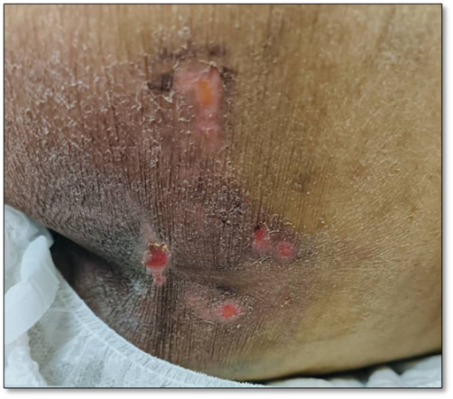 | The pressure injury (Figure 1a) serves as tangible evidence of how caregiver exhaustion can inadvertently lead to unintentional neglect despite the caregiver's best efforts to provide quality care.
S3b  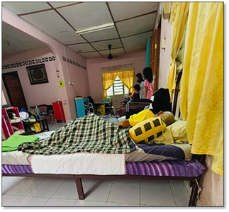 | The home visit to Noraini's household (Figure 1b) highlighted a dynamic environment where caregiving responsibilities are shared among family members
S3c  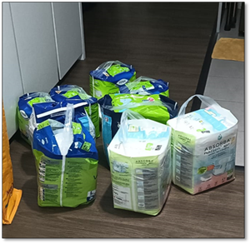 | Figure 1c illustrates how informal networks can provide essential resources and reduce some practical burdens on caregivers

