Preliminary Study on Virtual MRI Generation Driven by 3D Intraoperative Ultrasound Deformation Field for Glioma Surgery
This supplementary material provides detailed data and additional methodological figures that support the findings reported in the main manuscript. The content is organized as follows:
Supplementary Figures (Figs. S1–S5): Additional methodological illustrations and image examples
Supplementary Tables (Tables S1–S2): Detailed TRE data for each deformation state

Supplementary Figures
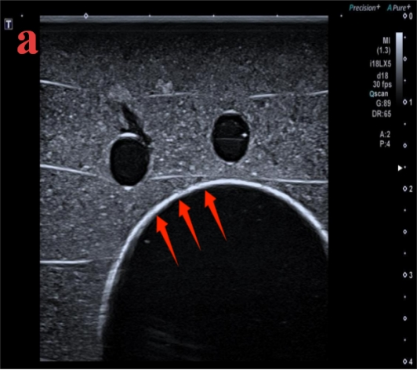 | 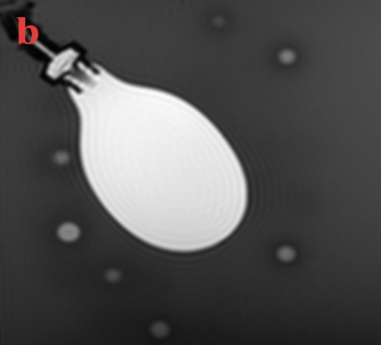
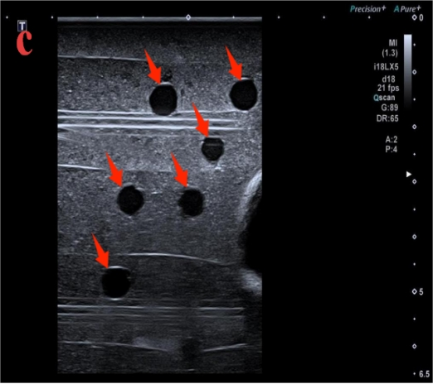 | 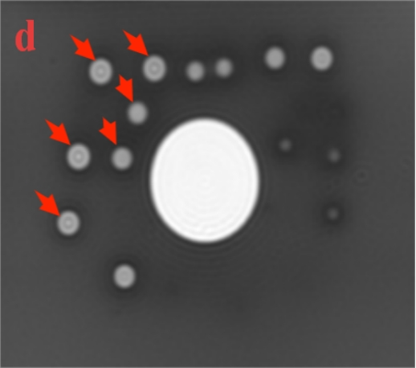
Fig.S1 Multimodal images of the in vitro phantom. (a) B-mode ultrasound showing arc-shaped hyperechoic of balloon capsule (arrow); (b) MRI T2WI showing uniform hyperintense intra-balloon liquid; (c) Ultrasound showing anechoic surrounding markers (arrow); (d) Corresponding high-signal markers on T2WI MRI.

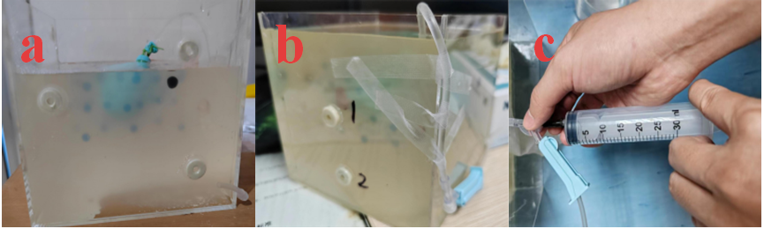Fig. S2 In vitro deformation simulation device. (a) Transparent acrylic outer container; (b) Internal fixing assembly; (c) Syringe-driven volume adjustment module.

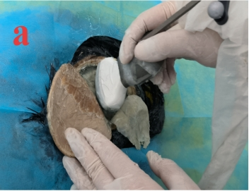 | 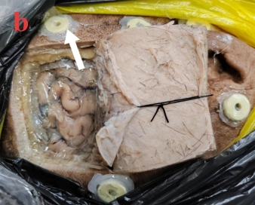 | 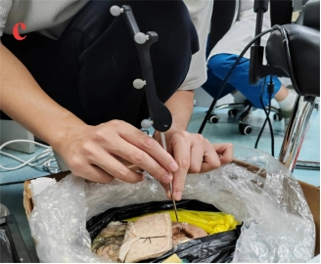
Fig.S3 Surgical preparation and spatial registration of cadaver specimens. (a) Temporoparietal bone window and ultrasound-guided balloon implantation; (b) CT/MRI-compatible skull fiducials (arrow); (c) Optical navigation probe landmark sampling workflow.

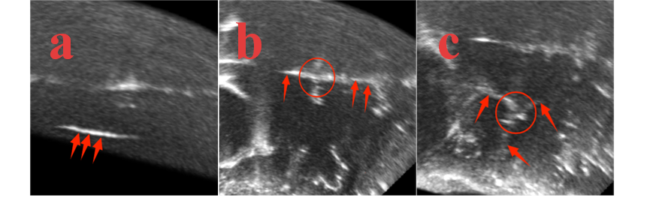Fig. S4 Anatomical landmarks on cadaveric ultrasound images. (a) Clear hyperintense lateral ventricular boundary (arrow); (b) Junction of falx cerebri and cerebral sulcus (red circle); (c) Confluence of multiple cerebral sulci (circular hyperechoic).

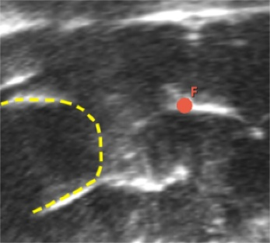 | 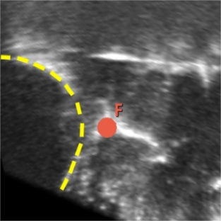 | 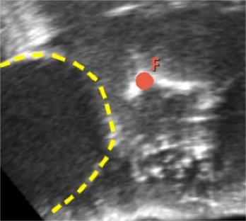
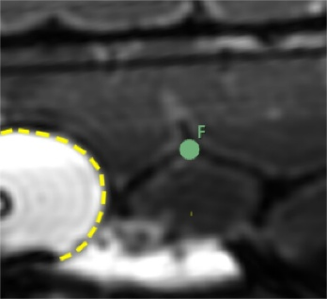 | 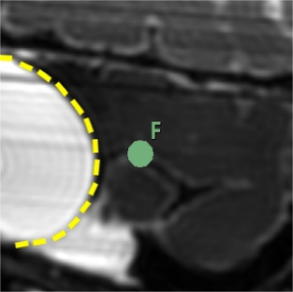 | 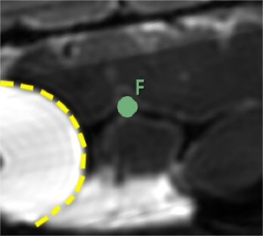
S0 (5 mL) | S4(25 mL) | S5(10 mL)
Fig.S5 Paired landmark correspondence between ultrasound and MRI across deformation states. Upper row: ultrasound images; lower row: matching anatomical markers on MRI. Dots represent trackable identical anatomical structures under each deformation state.

Supplementary Tables
Table S1 Detailed target registration errors for each deformation state (in vitro phantom)
State | Volume (mL) | Initial Rigid TRE (mm) | Cross-modal TRE (mm) | Gold-standard TRE (mm)
S1 | 60 | 2.56 ± 0.75 | 3.16 ± 1.17 | 1.97 ± 1.07
S2 | 70 | 2.27 ± 1.07 | 3.01 ± 1.00 | 2.59 ± 0.91
S3 | 80 | 3.27 ± 1.05 | 3.17 ± 1.49 | 4.10 ± 1.69
S4 | 60 | 2.05 ± 0.81 | 2.50 ± 1.23 | 2.93 ± 1.67
S5 | 40 | 2.70 ± 1.03 | 3.19 ± 1.23 | 3.23 ± 1.00
S6 | 20 | 2.38 ± 0.51 | 2.92 ± 1.20 | 2.80 ± 1.50
Overall | — | 2.56 ± 0.88 | 2.99 ± 1.22 | 2.94 ± 1.31
Note: Values are presented as mean ± SD. n = 25 landmarks per state. Initial rigid: MRI vs US; Cross-modal: vMRI vs US; Gold-standard: vMRI vs MRI.

Table S2 Detailed target registration errors for each deformation state (ex vivo cadaver specimens)
State | Volume (mL) | Initial Rigid TRE (mm) | Cross-modal TRE (mm) | Gold-standard TRE (mm)
S1 | 10 | 2.50 ± 0.86 | 2.36 ± 0.74 | 1.76 ± 0.61
S2 | 15 | 3.73 ± 1.69 | 3.08 ± 1.43 | 1.86 ± 0.62
S3 | 20 | 2.64 ± 1.20 | 2.36 ± 0.70 | 1.87 ± 0.69
S4 | 25 | 4.20 ± 1.56 | 3.46 ± 1.92 | 3.32 ± 1.27
S5 | 10 | 1.72 ± 0.51 | 2.21 ± 0.62 | 1.57 ± 0.58
S6 | 0 | 3.40 ± 1.21 | 2.39 ± 0.80 | 3.30 ± 0.71
Overall | — | 2.84 ± 1.08 | 2.64 ± 1.04 | 2.28 ± 0.75
Note: Values are presented as mean ± SD. n = 10 landmarks per state. Initial rigid: MRI vs US; Cross-modal: vMRI vs US; Gold-standard: vMRI vs MRI.

