Supplementary Material

to

National Borders Impede Collaboration on Climate Adaptation, Yet Conducive Factors Exist: A New Framework and Network-Analytical Evidence

[author information redacted for peer review]

Figure S1. Survey starting page
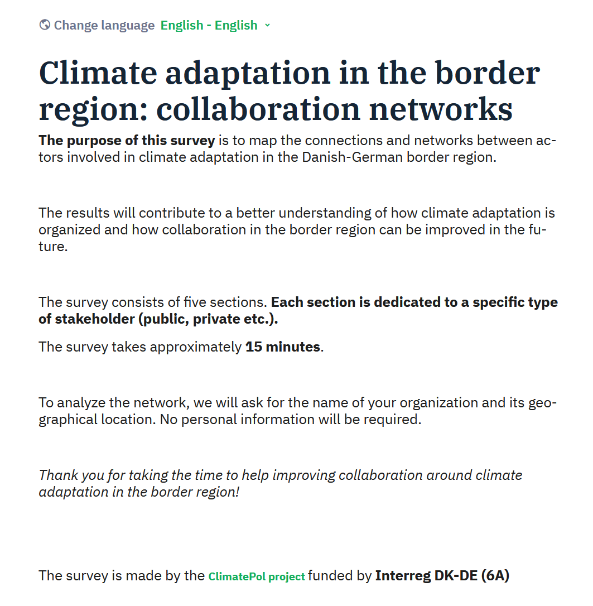

Figure S2. Example list in the survey: research institutions and think tanks
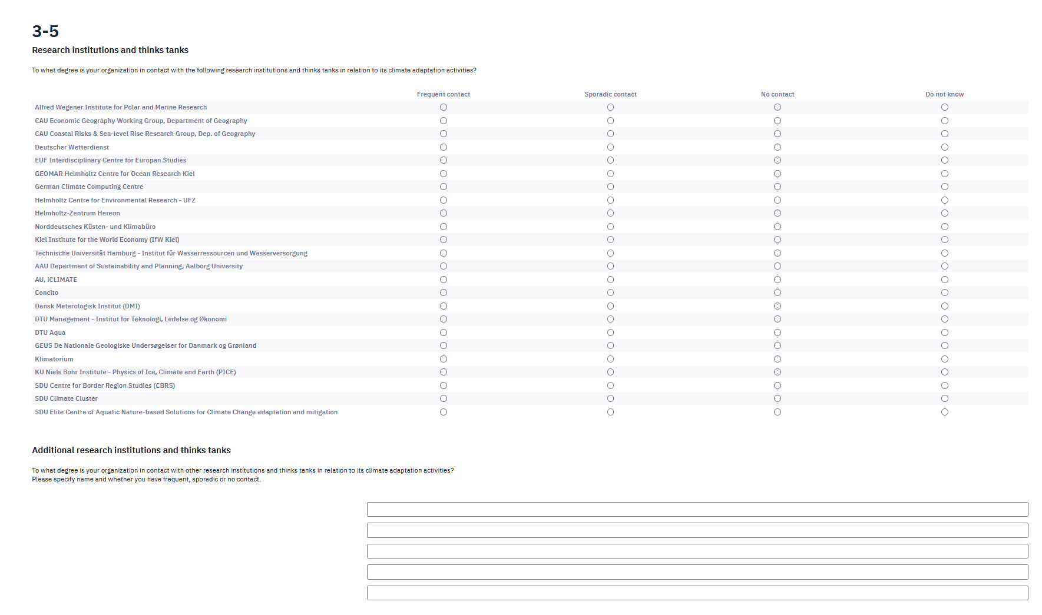

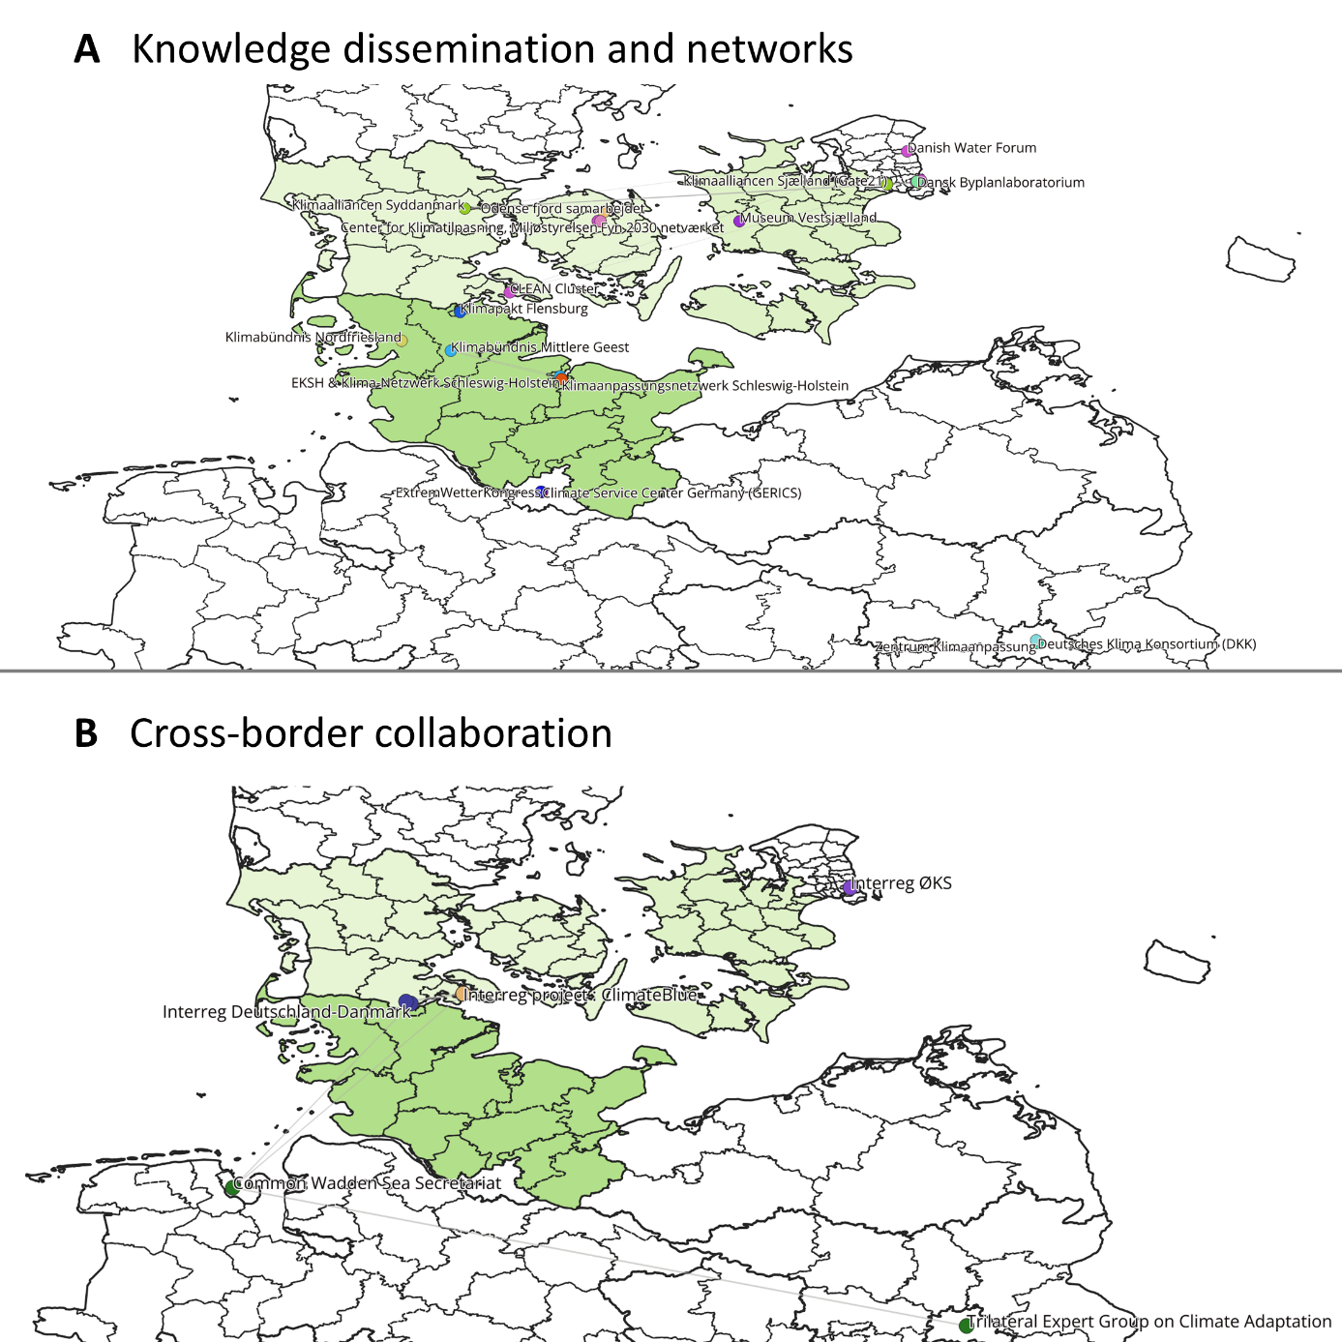
Figure S3. Two additional subnetworks

Table S1. Community detection network statistics
Modularity Report | Resolution γ | Modularity  Q | Modularity with Resolution | Number of Communities  (main clusters in brackets)
Complete Network | 1.1 | .368 | .457 | 3(2)
Public Sector | 1.1 | .485 | .568 | 7(3)
Private Sector | 1.1 | .494 | .594 | 26
Research Institutions/Think Thanks | 1.1 | .214 | .276 | 12(2)
Knowledge dissemination and networks | 1.1 | .301 | .369 | 17
Cross-border collaboration | 1.1 | .347 | .433 | 11

Table S2. Density network statistics

Network | Tie density: directed | Weighted degree
Complete Network | .049 | 14.43
Denmark | .081 | 14.77
Germany | .091 | 10.19
Cross-border collaboration | .033 | .77
Knowledge dissemination and networks | .034 | 1.31
Research institution or think tank | .062 | 2.92
Private sector or interest organization | .027 | 2.26
Public sector | .089 | 10.44

