Supplementary Information

Chemically and Microstructurally Modulated High-Temperature Release of CsI in Nd-doped UO₂ Nanoceramics
Daniil Shirokiy^{1*}, Karin Popa^{2*}, Marco Cologna², Felix Brandt¹, Jean-Yves Colle², Damien Prieur^{3,4}, Olaf Walter², Walter Bonani², Anna Isabel Martinez Ferri², Ondřej Beneš², Martina Klinkenberg¹,
Răzvan Buda², Dirk Bosbach¹ and Gabriel L. Murphy^{1*}
¹Institute of Fusion Energy and Nuclear Waste Management (IFN-2), Forschungszentrum Jülich GmbH, 52428 Jülich, Germany
²European Commission, Joint Research Centre (JRC), 76344 Karlsruhe, Germany
³Rossendorf Beamline (BM20), European Synchrotron Radiation Facility, Avenue des Martyrs 71, 38043 Grenoble, France
⁴Institute of Resource Ecology, Helmholtz-Zentrum Dresden-Rossendorf, Bautzner Landstraße 400, 01328 Dresden, Germany
* Corresponding authors: Daniil Shirokiy (d.shirokiy@fz-juelich.de), Karin Popa (karin.popa@ec.europa.eu), Gabriel L. Murphy (g.murphy@fz-juelich.de)

Supplementary Information Note 1 – The KEMS spectra of all gaseous fractions
Supplementary Figure 1 displays KEMS signal for each of the gaseous fractions measured.
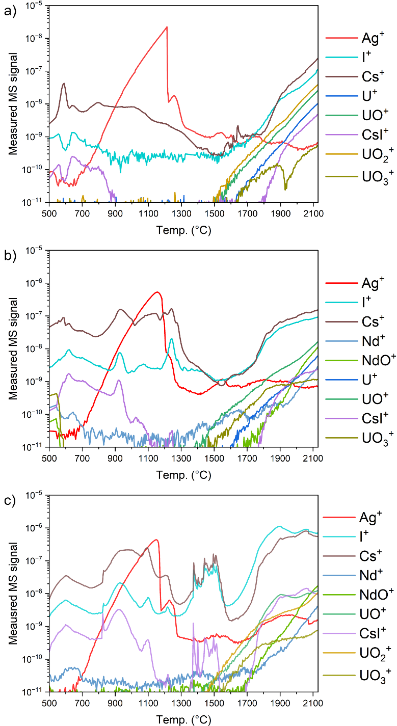
Supplementary Figure 1 – KEMS signal from all the measured gaseous fractions for a) Nd 0%, b) Nd 15% and c) Nd 30% samples.

Supplementary Information Note 2 – Nd-doped UO₂ nanoparticles
Supplementary shows the nanoparticles of Nd-doped UO₂ produced from thermal decomposition.
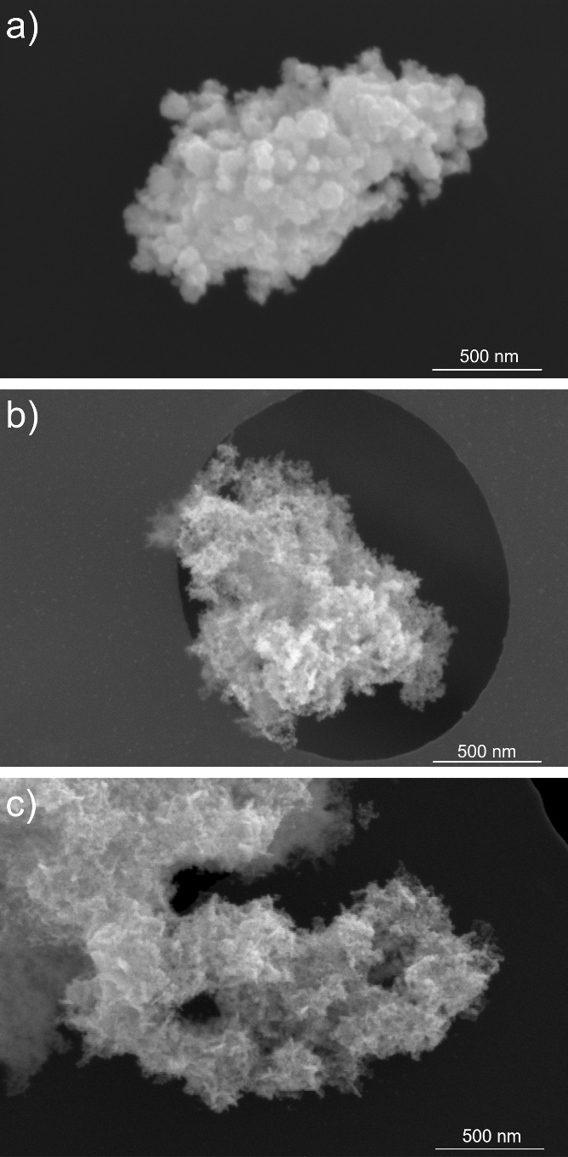
Supplementary Figure 2 – Nanoparticles obtained by hydrothermal decomposition of a) Nd-free uranyl nitrate, b) a mixture of uranyl nitrate (85 mol %) and Nd nitrate (15 mol %), and c) a mixture of uranyl nitrate (70 mol %) and Nd nitrate (30 mol %).

Supplementary Information Note 3 – Lattice parameter linear fit
A linear fit was performed using the Origin software tool with the y = a + b × x function. Values of a and b, together with their uncertainties, as well as the R² values are presented in the Supplementary Table 1.
Supplementary Table 1 – The linear fit values for the lattice parameter as a function of temperature and Nd doping
Sample | a | b | R²
As a function of temperature
Nd 0% | 5.4548(13) | 6.28(19) × 10⁻⁵ | 0.99430
Nd 15% | 5.44090(110) | 7.03(17) × 10⁻⁵ | 0.99652
Nd 30% | 5.43718(141) | 6.71(22) × 10⁻⁵ | 0.99384
As a function of Nd-doping
– | 5.4567(39) | -5.6(2.0) × 10⁻⁴ | 0.77531

Supplementary Information Note 4 – Overlaid electron dispersive X-ray spectroscopy images
Supplementary Figure 3 presents the overview of the pellet cross section surface and overlaid EDX maps on Cs and I.
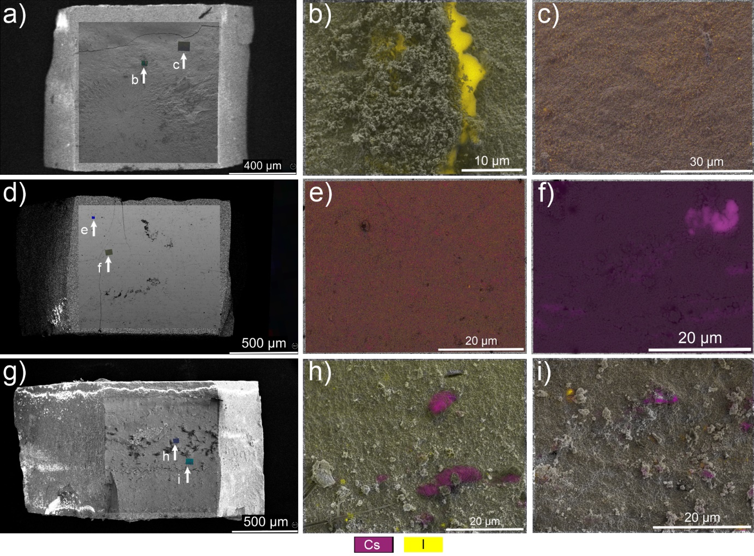
Supplementary Figure 3 – The overview of the pellet cross section surface together with the overlaid EDX I and Cs maps in two distinct locations (indicated by the white arrow marks) for samples a,b,c) Nd 0%, d,e,f) for sample Nd 15%, g,h,i) for sample Nd 30%, that highlight the differences between Cs and I distribution, indicating the occurrence of CsI speciation when Nd is introduced.

