SUPPLEMENTARY MATERIAL 1

1.1 – Table with the trials carried out and their respective municipalities and crop seasons.
Trial | Municipalities | Crop Seasons
Trial | Municipalities | 2011/12 | 2012/13 | 2013/14 | 2015/16
VCU 1 | Palotina | X | X
VCU 1 | Rolandia | X | X
VCU 1 | Toledo | X | X
VCU 1 | Campo Mourão |  | X
VCU 1 | Dourados |  | X
VCU 1 | Londrina |  | X
VCU 1 | St Terezinha De Itaipu |  | X
VCU 1 | Ubiratã |  | X
VCU 2 | Maracaju | X | X
VCU 2 | Palotina | X | X
VCU 2 | Campo Mourão |  | X
VCU 2 | Dourados |  | X
VCU 2 | Londrina |  | X
VCU 2 | Rolandia |  | X
VCU 2 | St Terezinha De Itaipu |  | X
VCU 2 | Ubiratã |  | X
VCU 3 | Cascavel |  |  | X
VCU 3 | Dourados |  |  | X
VCU 3 | Floresta |  |  | X
VCU 3 | Maracaju |  |  | X
VCU 3 | Naviraí |  |  | X
VCU 3 | Palotina |  |  | X
VCU 3 | St Terezinha De Itaipu |  |  | X
VCU 3 | Toledo |  |  | X
VCU 4 | Cascavel |  |  | X
VCU 4 | Dourados |  |  | X
VCU 4 | Maracaju |  |  | X
VCU 4 | Naviraí |  |  | X
VCU 4 | Palotina |  |  | X
VCU 4 | St Terezinha De Itaipu |  |  | X
VCU 4 | Toledo |  |  | X
VCU 11 | Abelardo | X
VCU 11 | Cafelândia | X | X
VCU 11 | Marechal Cândido Rondon | X
VCU 11 | Palotina | X
VCU 11 | Toledo | X | X | X
VCU 11 | Cascavel |  | X | X
VCU 11 | Palotina |  | X
VCU 11 | Rolandia |  | X
VCU 11 | St Terezinha De Itaipu |  | X
VCU 15 | Dourados |  | X
VCU 15 | Maracaju |  | X
VCU 15 | Naviraí |  | X
VCU 21 | Abelardo | X
VCU 21 | Bela Vista | X
VCU 21 | Cafelândia | X | X | X
VCU 21 | Campo Mourão | X
VCU 21 | Dourados | X |  | X
VCU 21 | Floresta | X |  | X
VCU 21 | Florinea | X
VCU 21 | Ipora | X
VCU 21 | Mambore | X |  | X
VCU 21 | Maracaju | X |  | X
VCU 21 | Marechal Cândido Rondon | X |  | X
VCU 21 | Naviraí | X |  | X
VCU 21 | Palotina | X
VCU 21 | Ponta Porã | X |  | X
VCU 21 | Rolandia | X | X | X
VCU 21 | Toledo | X | X | X
VCU 21 | Cascavel |  | X | X
VCU 21 | Mambore |  | X
VCU 21 | Ubiratã |  | X
VCU 21 | Assis |  |  | X
VCU 21 | Palotina |  | X | X
VCU 21 | Ponta Porã
VCU 21 | St Terezinha De Itaipu |  |  | X
VCU 21 | Ubiratã |  |  | X
VCU 22 | Abelardo | X
VCU 22 | Bela Vista | X
VCU 22 | Cafelândia | X | X | X
VCU 22 | Campo Mourão | X
VCU 22 | Florinea | X
VCU 22 | Dourados | X
VCU 22 | Floresta | X
VCU 22 | Ipora | X
VCU 22 | Mambore | X | X
VCU 22 | Maracaju | X
VCU 22 | Marechal Cândido Rondon | X |  | X
VCU 22 | Naviraí | X |  | X
VCU 22 | Palotina | X | X | X
VCU 22 | Ponta Porã | X |  | X
VCU 22 | Rolandia | X | X | X
VCU 22 | Toledo | X | X | X
VCU 22 | Cascavel |  | X | X
VCU 22 | Ubiratã |  | X | X
VCU 22 | Assis |  |  | X
VCU 22 | Bela Vista |  |  | X
VCU 22 | Dourados |  |  | X
VCU 22 | Floresta |  |  | X
VCU 22 | Mambore |  |  | X
VCU 22 | Maracaju |  |  | X
VCU 22 | Ponta Porã |  |  | X
VCU 22 | Sidrolândia |  |  | X
VCU 22 | St Terezinha De Itaipu |  | X | X
VCU 23 | Abelardo | X
VCU 23 | Bela Vista | X
VCU 23 | Cafelândia | X
VCU 23 | Campo Mourão | X
VCU 23 | Ipora | X
VCU 23 | Mambore | X
VCU 23 | Maracaju | X
VCU 23 | Marechal Cândido Rondon | X |  | X
VCU 23 | Naviraí | X
VCU 23 | Palotina | X
VCU 23 | Ponta Porã | X |  | X
VCU 23 | Rolandia | X |  | X
VCU 23 | Toledo | X | X
VCU 23 | Cafelândia |  | X | X
VCU 23 | Cascavel |  | X
VCU 23 | Dourados | X | X | X
VCU 23 | Francisco Alves |  | X
VCU 23 | Londrina |  | X
VCU 23 | Mambore |  | X
VCU 23 | Naviraí |  | X | X
VCU 23 | Palotina |  | X | X
VCU 23 | St Terezinha De Itaipu |  | X | X
VCU 23 | Ubiratã |  | X | X
VCU 23 | Assis |  |  | X
VCU 23 | Bela Vista |  | X | X
VCU 23 | Dourados
VCU 23 | Florinea | X
VCU 23 | Floresta | X |  | X
VCU 23 | Mambore |  |  | X
VCU 23 | Maracaju |  |  | X
VCU 23 | Ponta Porã |  | X
VCU 23 | Rolandia |  | X
VCU 23 | Sidrolândia |  |  | X
VCU 23 | Toledo |  |  | X
VCU 24 | Abelardo | X
VCU 24 | Cafelândia | X | X
VCU 24 | Bela Vista | X | X | X
VCU 24 | Campo Mourão | X |  | X
VCU 24 | Dourados | X | X
VCU 24 | Florinea | X
VCU 24 | Ipora | X
VCU 24 | Mambore | X |  | X
VCU 24 | Maracaju | X | X | X
VCU 24 | Marechal Cândido Rondon | X |  | X
VCU 24 | Naviraí | X | X | X
VCU 24 | Palotina | X | X | X
VCU 24 | Ponta Porã | X | X | X
VCU 24 | Rolandia | X |  | X
VCU 24 | Toledo | X | X | X
VCU 24 | Cascavel |  | X
VCU 24 | Francisco Alves |  | X
VCU 24 | Londrina |  | X | X
VCU 24 | Mambore |  | X | X
VCU 24 | St Terezinha De Itaipu |  | X | X
VCU 24 | Ubiratã
VCU 24 | Assis |  |  | X
VCU 24 | Floresta | X |  | X
VCU 24 | Mambore
VCU 24 | Sidrolândia |  |  | X
VCU 24 | Ubiratã |  | X | X
VCU 25 | Abelardo | X
VCU 25 | Dourados | X
VCU 25 | Florinea | X
VCU 25 | Ipora | X
VCU 25 | Maracaju | X
VCU 25 | Marechal Cândido Rondon | X
VCU 25 | Naviraí | X | X
VCU 25 | Palotina | X | X
VCU 25 | Ponta Porã | X | X
VCU 25 | Rolandia | X | X
VCU 25 | Toledo | X | X
VCU 25 | Bela Vista |  | X
VCU 25 | Cafelândia |  | X
VCU 25 | Floresta |  | X
VCU 25 | Francisco Alves |  | X
VCU 25 | Londrina |  | X
VCU 25 | Mambore |  | X
VCU 25 | St Terezinha De Itaipu |  | X
VCU 26 | Abelardo | X
VCU 26 | Dourados | X
VCU 26 | Florinea | X
VCU 26 | Ipora | X
VCU 26 | Maracaju | X
VCU 26 | Marechal Cândido Rondon | X
VCU 26 | Naviraí | X
VCU 26 | Palotina | X | X
VCU 26 | Ponta Porã | X | X
VCU 26 | Rolandia | X | X
VCU 26 | Toledo | X | X
VCU 26 | Bela Vista |  | X
VCU 26 | Cafelândia |  | X
VCU 26 | Dourados |  | X
VCU 26 | Francisco Alves |  | X
VCU 26 | Londrina |  | X
VCU 26 | Mambore |  | X
VCU 26 | Maracaju |  | X
VCU 26 | Naviraí |  | X
VCU 26 | St Terezinha De Itaipu |  | X
VCU 27 | Dourados |  | X
VCU 27 | Floresta |  | X
VCU 27 | Francisco Alves |  | X
VCU 27 | Londrina |  | X
VCU 27 | Maracaju |  | X
VCU 27 | Naviraí |  | X
VCU 27 | Palotina |  | X
VCU 27 | Ponta Porã |  | X
VCU 27 | Rolandia |  | X
VCU 27 | St Terezinha De Itaipu |  | X
VCU 27 | Ubiratã |  | X
VCU 28 | Bela Vista |  | X
VCU 28 | Dourados |  | X
VCU 28 | Floresta |  | X
VCU 28 | Francisco Alves |  | X
VCU 28 | Londrina |  | X
VCU 28 | Maracaju |  | X
VCU 28 | Naviraí |  | X
VCU 28 | Palotina |  | X
VCU 28 | Ponta Porã |  | X
VCU 28 | Rolandia |  | X
VCU 28 | St Terezinha De Itaipu |  | X
VCU 28 | Ubiratã |  | X
VCU 73 | Assis |  |  |  | X
VCU 73 | Bela Vista |  |  |  | X
VCU 73 | Campo Mourão |  |  |  | X
VCU 73 | Francisco Alves |  |  |  | X
VCU 73 | Londrina |  |  |  | X
VCU 73 | Maracaju |  |  |  | X
VCU 73 | Naviraí |  |  |  | X
VCU 73 | Palotina |  |  |  | X
VCU 73 | Ponta Porã |  |  |  | X
VCU 73 | St Terezinha De Itaipu |  |  |  | X
VCU 74 | Assis |  |  |  | X
VCU 74 | Bela Vista |  |  |  | X
VCU 74 | Campo Mourão |  |  |  | X
VCU 74 | Francisco Alves |  |  |  | X
VCU 74 | Londrina |  |  |  | X
VCU 74 | Maracaju |  |  |  | X
VCU 74 | Naviraí |  |  |  | X
VCU 74 | Palotina |  |  |  | X
VCU 74 | Ponta Porã |  |  |  | X
VCU 74 | St Terezinha De Itaipu |  |  |  | X
VCU 121 | Abelardo | X
VCU 121 | Bela Vista | X
VCU 121 | Cafelândia | X
VCU 121 | Campo Mourão | X
VCU 121 | Florinea | X
VCU 121 | Dourados | X
VCU 121 | Floresta | X
VCU 121 | Ipora | X
VCU 121 | Mambore | X
VCU 121 | Maracaju | X
VCU 121 | Marechal Cândido Rondon | X
VCU 121 | Naviraí | X
VCU 121 | Palotina | X
VCU 121 | Rolandia | X
VCU 121 | Toledo | X
VCU 122 | Abelardo | X
VCU 122 | Bela Vista | X
VCU 122 | Cafelândia | X
VCU 122 | Campo Mourão | X
VCU 122 | Dourados | X
VCU 122 | Floresta | X
VCU 122 | Florinea | X
VCU 122 | Ipora | X
VCU 122 | Mambore | X
VCU 122 | Maracaju | X
VCU 122 | Marechal Cândido Rondon | X
VCU 122 | Naviraí | X
VCU 122 | Rolandia | X
VCU 122 | Toledo | X
VCU 123 | Abelardo | X
VCU 123 | Bela Vista | X
VCU 123 | Cafelândia | X
VCU 123 | Campo Mourão | X
VCU 123 | Dourados | X
VCU 123 | Floresta | X
VCU 123 | Florinea | X
VCU 123 | Ipora | X
VCU 123 | Mambore | X
VCU 123 | Maracaju | X
VCU 123 | Marechal Cândido Rondon | X
VCU 123 | Naviraí | X
VCU 123 | Rolandia | X
VCU 123 | Toledo | X
VCU 124 | Abelardo | X
VCU 124 | Cafelândia | X
VCU 124 | Campo Mourão | X
VCU 124 | Dourados | X
VCU 124 | Floresta | X
VCU 124 | Florinea | X
VCU 124 | Ipora | X
VCU 124 | Mambore | X
VCU 124 | Maracaju | X
VCU 124 | Marechal Cândido Rondon | X
VCU 124 | Naviraí | X
VCU 124 | Palotina | X
VCU 124 | Rolandia | X
VCU 124 | Toledo | X
VCU 125 | Abelardo | X
VCU 125 | Bela Vista | X
VCU 125 | Cafelândia | X
VCU 125 | Campo Mourão | X
VCU 125 | Dourados | X
VCU 125 | Floresta | X
VCU 125 | Florinea | X
VCU 125 | Ipora | X
VCU 125 | Mambore | X
VCU 125 | Maracaju | X
VCU 125 | Marechal Cândido Rondon | X
VCU 125 | Naviraí | X
VCU 125 | Palotina | X
VCU 125 | Rolandia | X
VCU 125 | Toledo | X
VCU 126 | Abelardo | X
VCU 126 | Cafelândia | X
VCU 126 | Campo Mourão | X
VCU 126 | Dourados | X
VCU 126 | Floresta | X
VCU 126 | Florinea | X
VCU 126 | Ipora | X
VCU 126 | Naviraí | X
VCU 126 | Palotina | X
VCU 126 | Rolandia | X
VCU 126 | Toledo | X
VCU 521 | Dourados |  |  |  | X
VCU 521 | Floresta |  |  |  | X
VCU 521 | Naviraí |  |  |  | X
VCU 521 | Palotina |  |  |  | X
VCU 521 | Rolandia |  |  |  | X
VCU 521 | Bela Vista |  |  |  | X
VCU 521 | Cafelândia |  |  |  | X
VCU 521 | Marechal Cândido Rondon |  |  |  | X
VCU 521 | Ponta Porã |  |  |  | X
VCU 521 | St Terezinha De Itaipu |  |  |  | X
VCU 521 | Toledo |  |  |  | X
VCU 522 | Dourados |  |  |  | X
VCU 522 | Floresta |  |  |  | X
VCU 522 | Naviraí |  |  |  | X
VCU 522 | Palotina |  |  |  | X
VCU 522 | Rolandia |  |  |  | X
VCU 522 | Bela Vista |  |  |  | X
VCU 522 | Cafelândia |  |  |  | X
VCU 522 | Marechal Cândido Rondon |  |  |  | X
VCU 522 | Ponta Porã |  |  |  | X
VCU 522 | St Terezinha De Itaipu |  |  |  | X
VCU 522 | Toledo |  |  |  | X
VCU 721 | Assis
VCU 721 | Bela Vista Do Paraíso
VCU 721 | Cafelândia
VCU 721 | Dourados
VCU 721 | Floresta
VCU 721 | Ipora
VCU 721 | Londrina |  |  |  | X
VCU 721 | Marechal Cândido Rondon |  |  |  | X
VCU 721 | Palotina
VCU 721 | Assis
VCU 721 | Ponta Porã
VCU 721 | Rolandia
VCU 721 | Santa Terezinha De Itaipu
VCU 721 | Ubiratã |  |  |  | X
VCU 721 | Assis |  |  |  | X
VCU 721 | Bela Vista |  |  |  | X
VCU 721 | Caarapo |  |  |  | X
VCU 721 | Cafelândia |  |  |  | X
VCU 721 | Campo Mourão |  |  |  | X
VCU 721 | Cascavel |  |  |  | X
VCU 721 | Dourados |  |  |  | X
VCU 721 | Floresta |  |  |  | X
VCU 721 | Francisco Alves |  |  |  | X
VCU 721 | Maracaju |  |  |  | X
VCU 721 | Marechal Cândido Rondon
VCU 721 | Naviraí |  |  |  | X
VCU 721 | Palotina |  |  |  | X
VCU 721 | Ponta Porã |  |  |  | X
VCU 721 | Rio Brilhante |  |  |  | X
VCU 721 | Rolandia |  |  |  | X
VCU 721 | Londrina |  |  |  | X
VCU 721 | St Terezinha De Itaipu |  |  |  | X
VCU 721 | Toledo |  |  |  | X
VCU 722 | Assis |  |  |  | X
VCU 722 | Bela Vista Do Paraíso
VCU 722 | Cafelândia |  |  |  | X
VCU 722 | Dourados |  |  |  | X
VCU 722 | Floresta |  |  |  | X
VCU 722 | Ipora
VCU 722 | Londrina |  |  |  | X
VCU 722 | Marechal Cândido Rondon |  |  |  | X
VCU 722 | Palotina |  |  |  | X
VCU 722 | Ponta Porã |  |  |  | X
VCU 722 | Rolandia
VCU 722 | Santa Terezinha De Itaipu
VCU 722 | Sidrolândia
VCU 722 | Toledo |  |  |  | X
VCU 722 | Ubiratã |  |  |  | X
VCU 722 | Bela Vista |  |  |  | X
VCU 722 | Caarapo |  |  |  | X
VCU 722 | Campo Mourão |  |  |  | X
VCU 722 | Cascavel |  |  |  | X
VCU 722 | Francisco Alves |  |  |  | X
VCU 722 | Naviraí |  |  |  | X
VCU 722 | Rio Brilhante |  |  |  | X
VCU 722 | Rolandia |  |  |  | X
VCU 722 | St Terezinha De Itaipu |  |  |  | X

SUPPLEMEMTARY MATERIAL 2

2.1 - GGE Biplot with the first two principal components (PC1 and PC2), corresponding to the representation of genotypes (numbers preceded by letter G) and environments (numbers preceded by letter A), for the identification of mega-environments in the planting sites of VCU 1 of the 2011/2012 crop season.

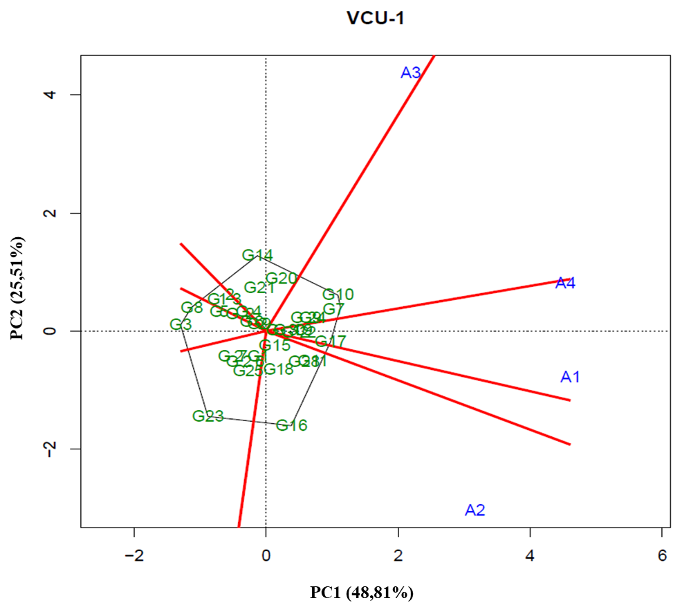

2.2 - GGE Biplot with the first two principal components (PC1 and PC2), corresponding to the representation of genotypes (numbers preceded by letter G) and environments (numbers preceded by letter A), for the identification of mega-environments in the planting sites of VCU 11 of the 2011/2012 crop season.
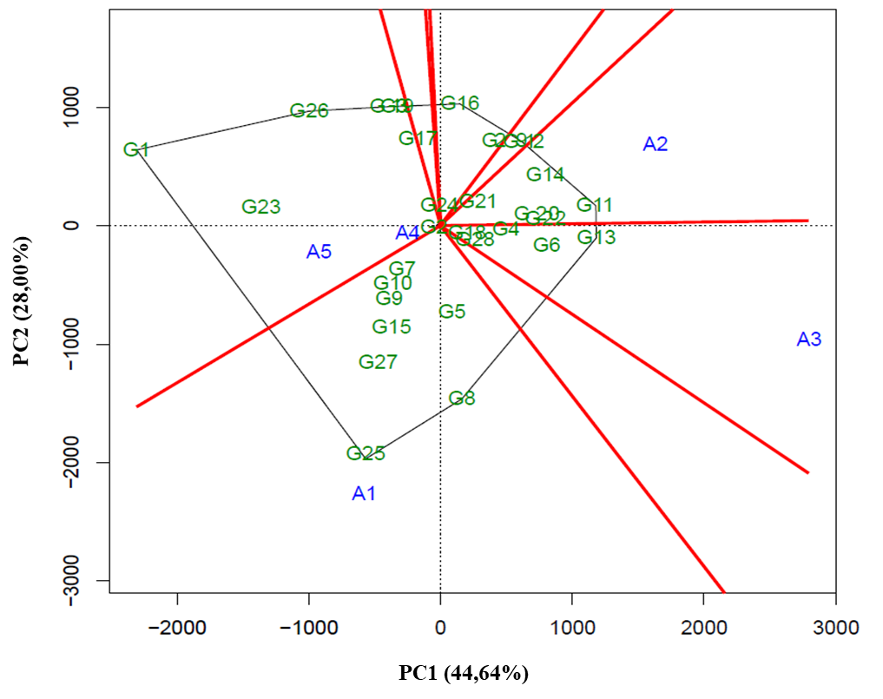
2.3 - GGE Biplot with the first two principal components (PC1 and PC2), corresponding to the representation of genotypes (numbers preceded by letter G) and environments (numbers preceded by letter A), for the identification of mega-environments in the planting sites of VCU 21 of the 2011/2012 crop season.
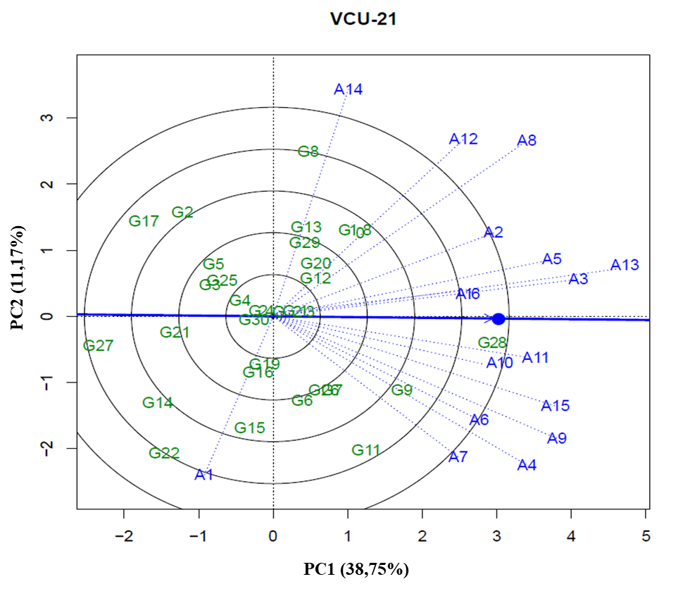
2.4- GGE Biplot with the first two principal components (PC1 and PC2), corresponding to the representation of genotypes (numbers preceded by letter G) and environments (numbers preceded by letter A), for the identification of mega-environments in the planting sites of VCU 21 – GR(1) of the 2011/2012 crop season.
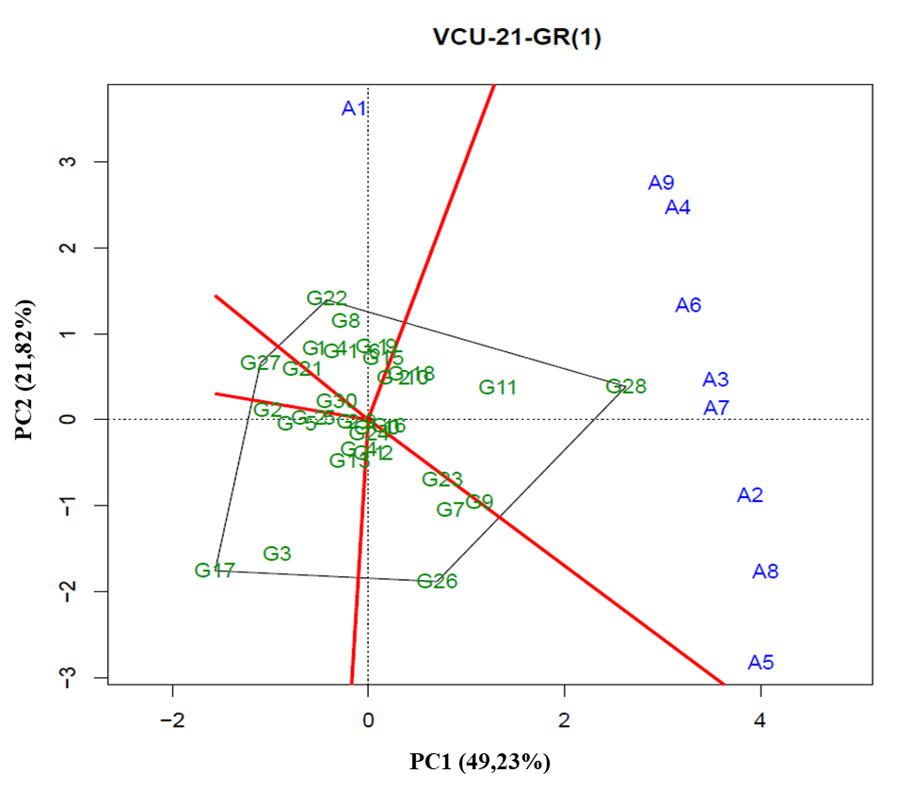
2.4 - GGE Biplot with the first two principal components (PC1 and PC2), corresponding to the representation of genotypes (numbers preceded by letter G) and environments (numbers preceded by letter A), for the identification of mega-environments in the planting sites of VCU 21 – GR(2) of the 2011/2012 crop season.
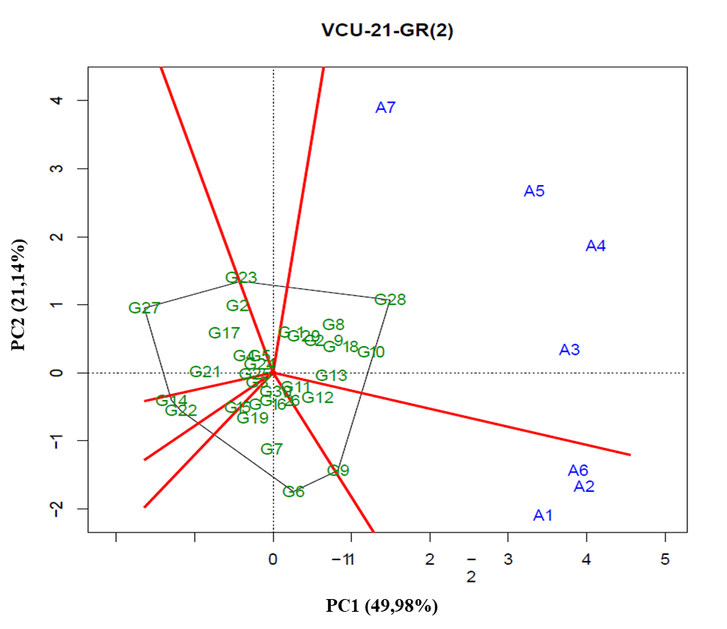
2.5 - GGE Biplot with the first two principal components (PC1 and PC2), corresponding to the representation of genotypes (numbers preceded by letter G) and environments (numbers preceded by letter A), for the identification of mega-environments in the planting sites of VCU 22 of the 2011/2012 crop season.
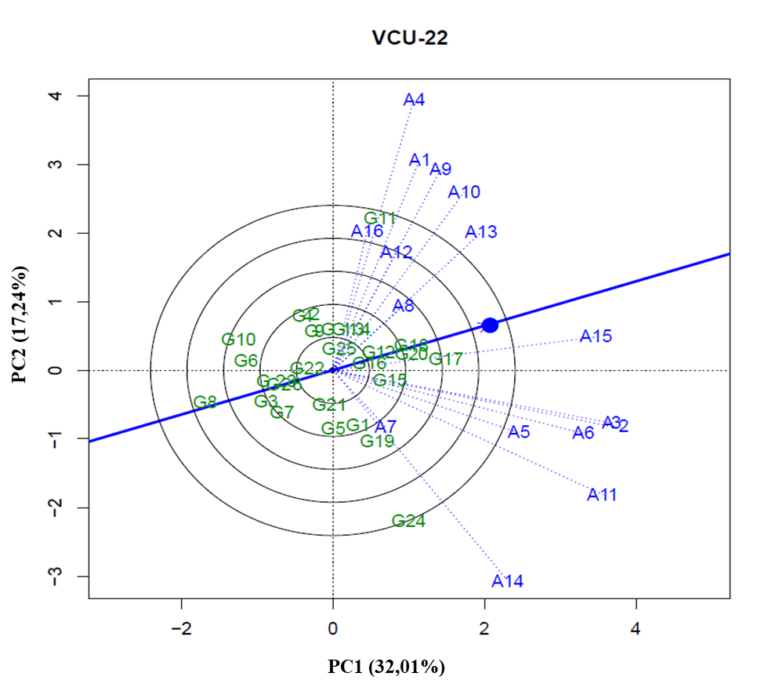
2.6 - GGE Biplot with the first two principal components (PC1 and PC2), corresponding to the representation of genotypes (numbers preceded by letter G) and environments (numbers preceded by letter A), for the identification of mega-environments in the planting sites of VCU 22 – GR(1) of the 2011/2012 crop season.
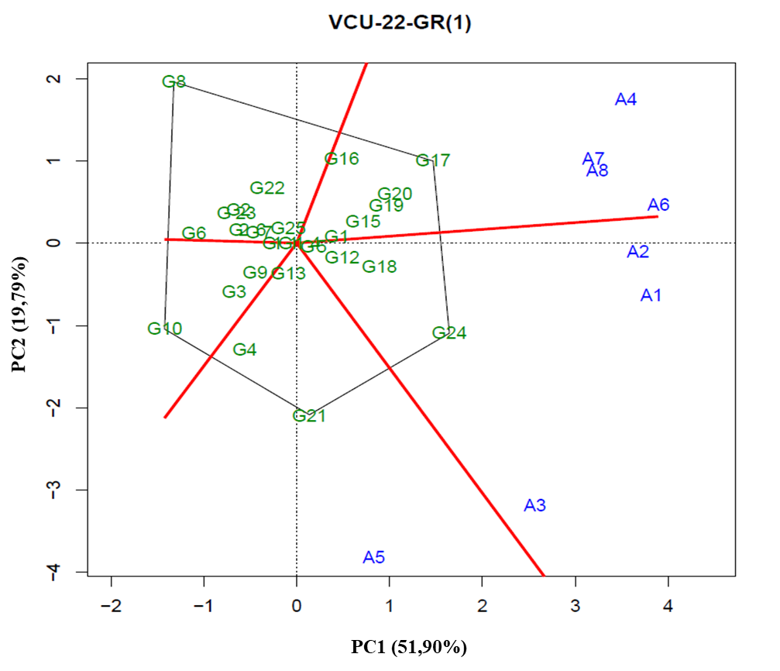
2.7 - GGE Biplot with the first two principal components (PC1 and PC2), corresponding to the representation of genotypes (numbers preceded by letter G) and environments (numbers preceded by letter A), for the identification of mega-environments in the planting sites of VCU 22 – GR(2) of the 2011/2012 crop season.
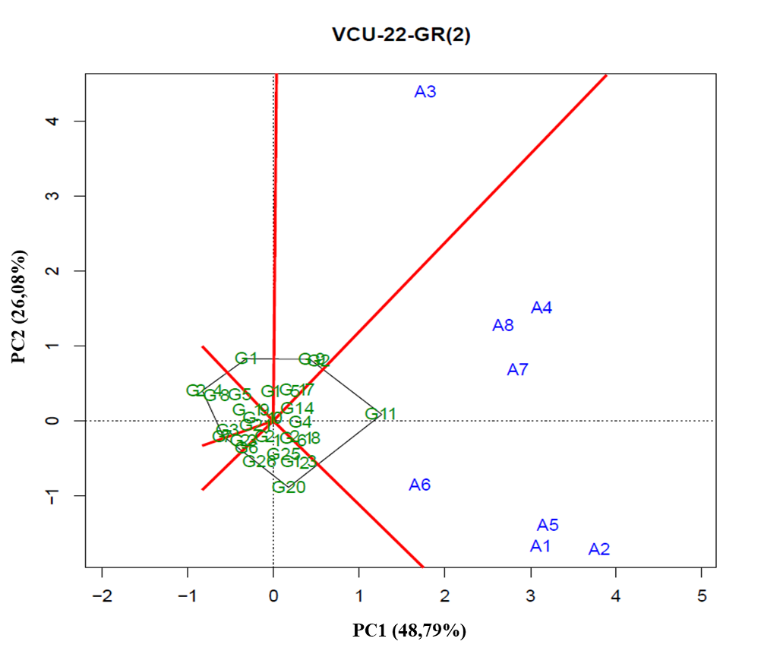
2.8 - GGE Biplot with the first two principal components (PC1 and PC2), corresponding to the representation of genotypes (numbers preceded by letter G) and environments (numbers preceded by letter A), for the identification of mega-environments in the planting sites of VCU 23 of the 2011/2012 crop season.
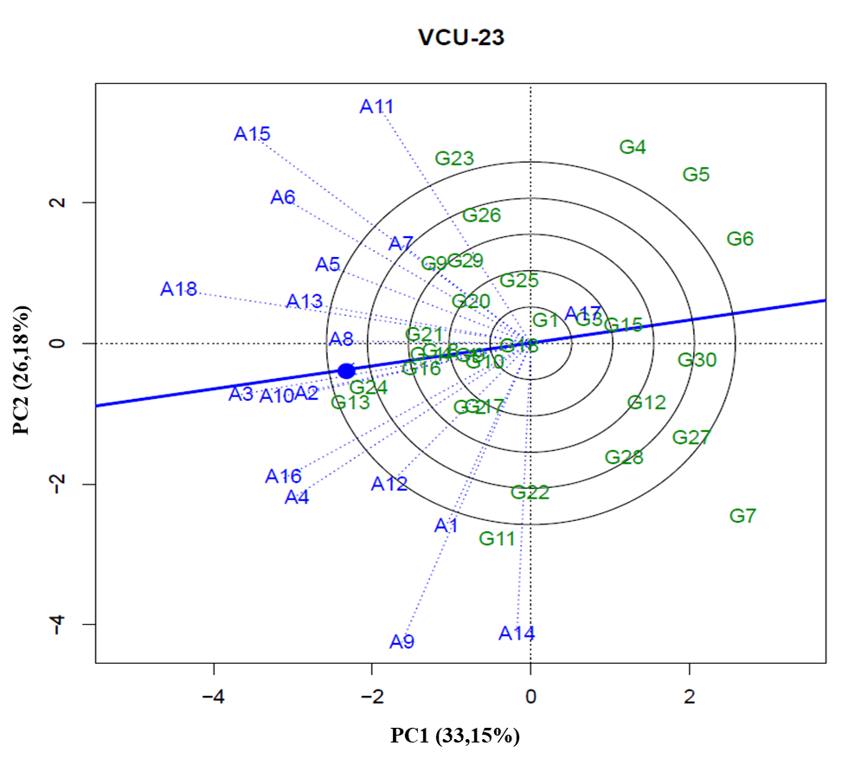
2.9 - GGE Biplot with the first two principal components (PC1 and PC2), corresponding to the representation of genotypes (numbers preceded by letter G) and environments (numbers preceded by letter A), for the identification of mega-environments in the planting sites of VCU 23 – GR(1) of the 2011/2012 crop season.
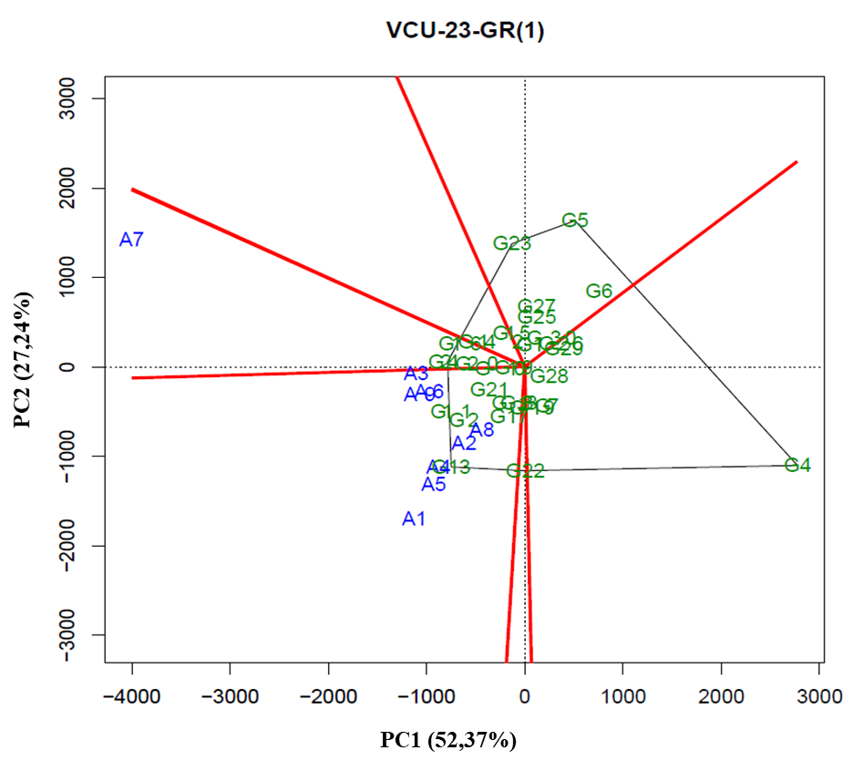
2.10 - GGE Biplot with the first two principal components (PC1 and PC2), corresponding to the representation of genotypes (numbers preceded by letter G) and environments (numbers preceded by letter A), for the identification of mega-environments in the planting sites of VCU 23 – GR(2) of the 2011/2012 crop season.
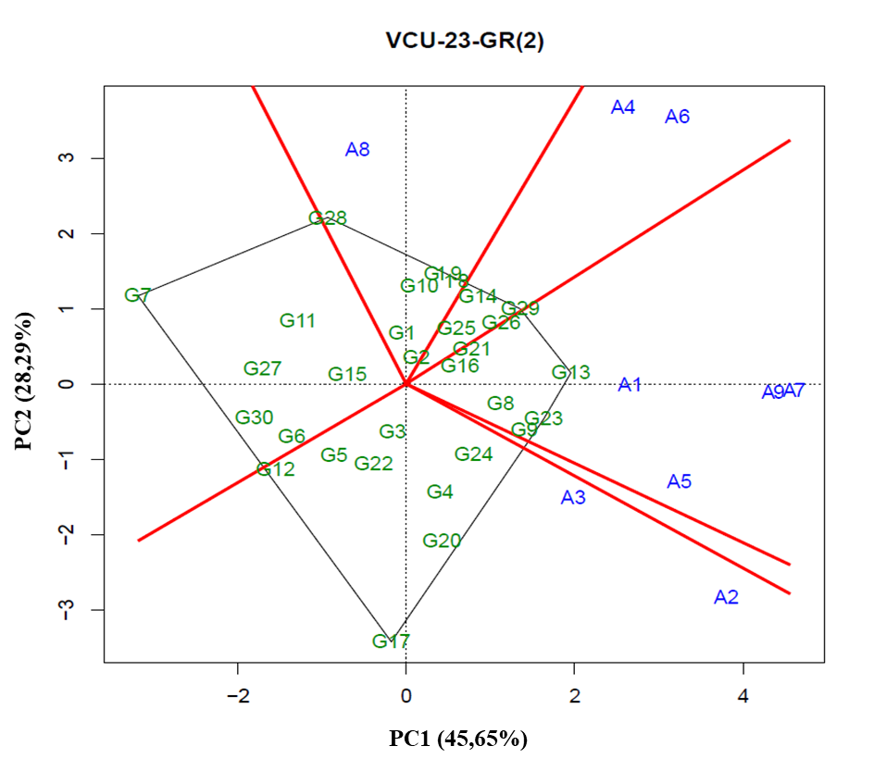
2.11 - GGE Biplot with the first two principal components (PC1 and PC2), corresponding to the representation of genotypes (numbers preceded by letter G) and environments (numbers preceded by letter A), for the identification of mega-environments in the planting sites of VCU 24 of the 2011/2012 crop season.
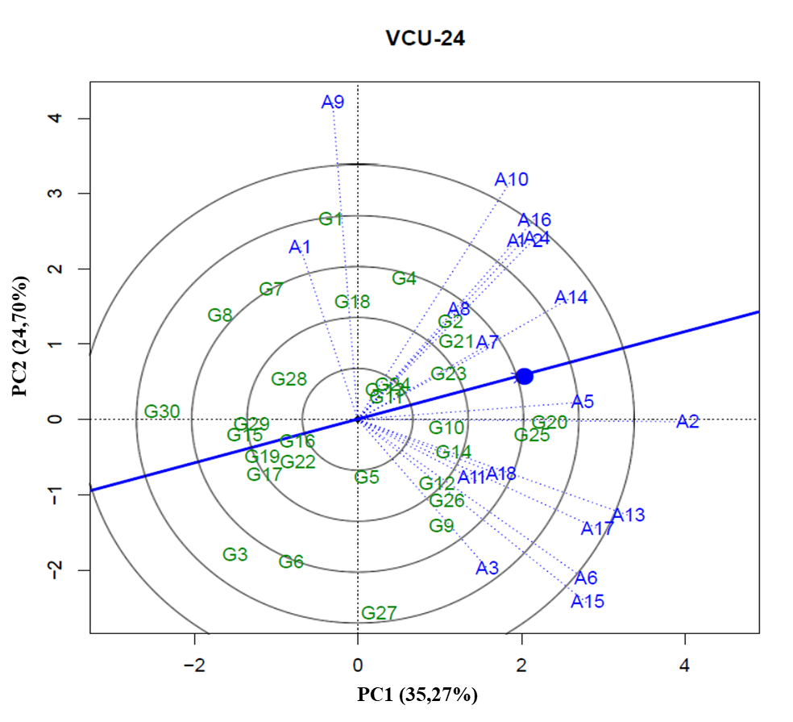
2.12 - GGE Biplot with the first two principal components (PC1 and PC2), corresponding to the representation of genotypes (numbers preceded by letter G) and environments (numbers preceded by letter A), for the identification of mega-environments in the planting sites of VCU 24 – GR(1) of the 2011/2012 crop season.
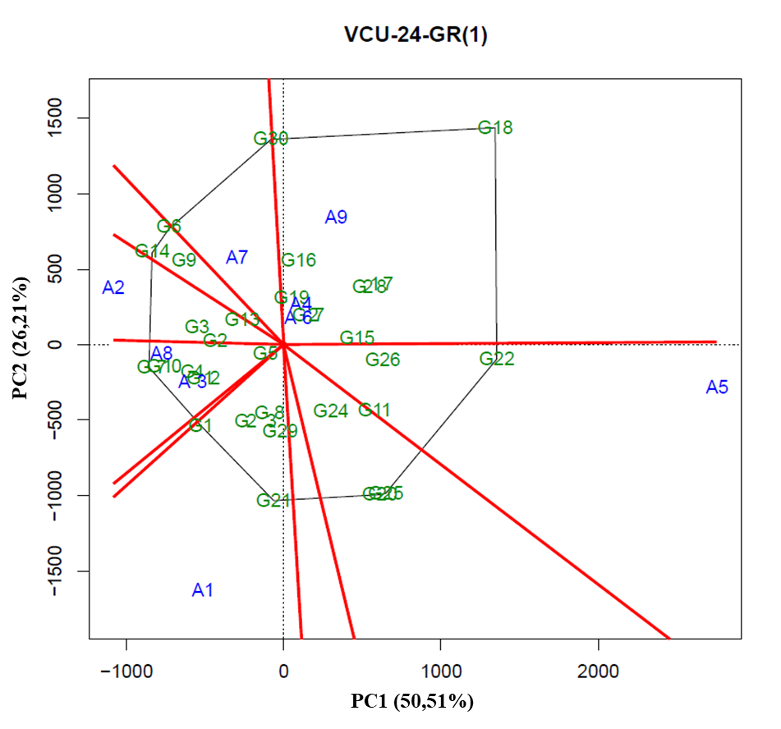
2.13 - GGE Biplot with the first two principal components (PC1 and PC2), corresponding to the representation of genotypes (numbers preceded by letter G) and environments (numbers preceded by letter A), for the identification of mega-environments in the planting sites of VCU 24 – GR(2) of the 2011/2012 crop season.
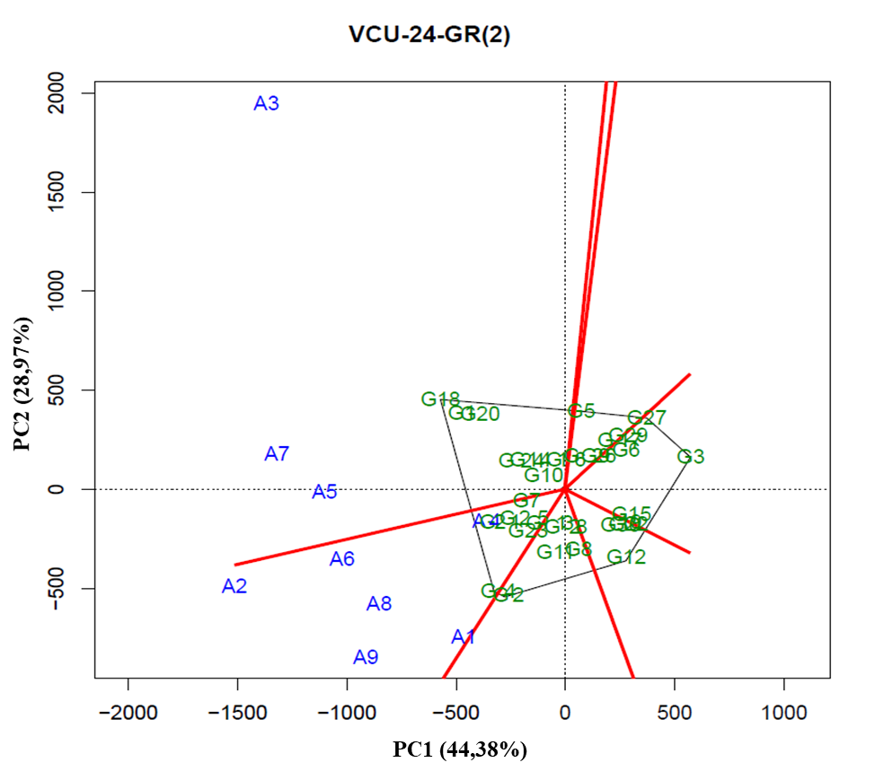
2.14- GGE Biplot with the first two principal components (PC1 and PC2), corresponding to the representation of genotypes (numbers preceded by letter G) and environments (numbers preceded by letter A), for the identification of mega-environments in the planting sites of VCU 25 of the 2011/2012 crop season.
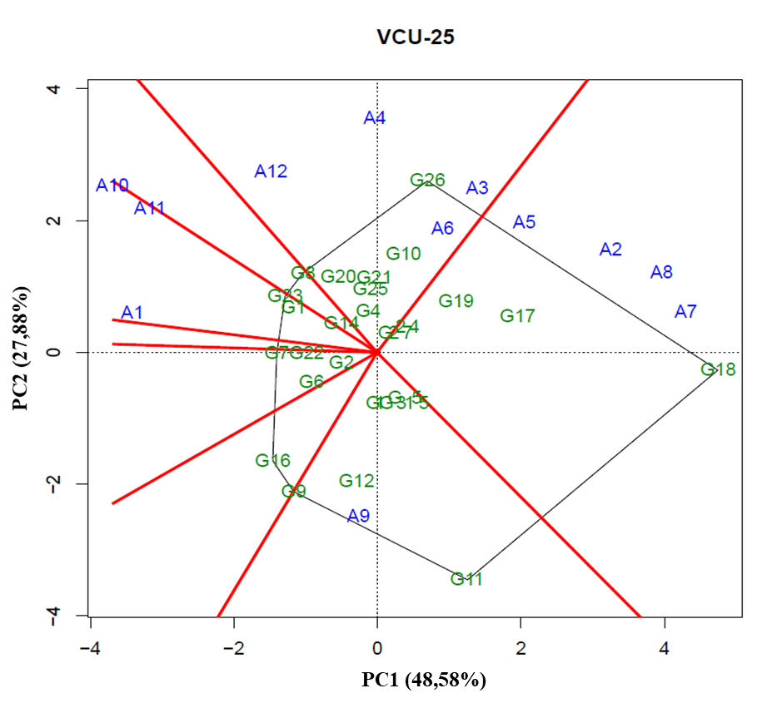
2.15 - GGE Biplot with the first two principal components (PC1 and PC2), corresponding to the representation of genotypes (numbers preceded by letter G) and environments (numbers preceded by letter A), for the identification of mega-environments in the planting sites of VCU 121 of the 2011/2012 crop season.
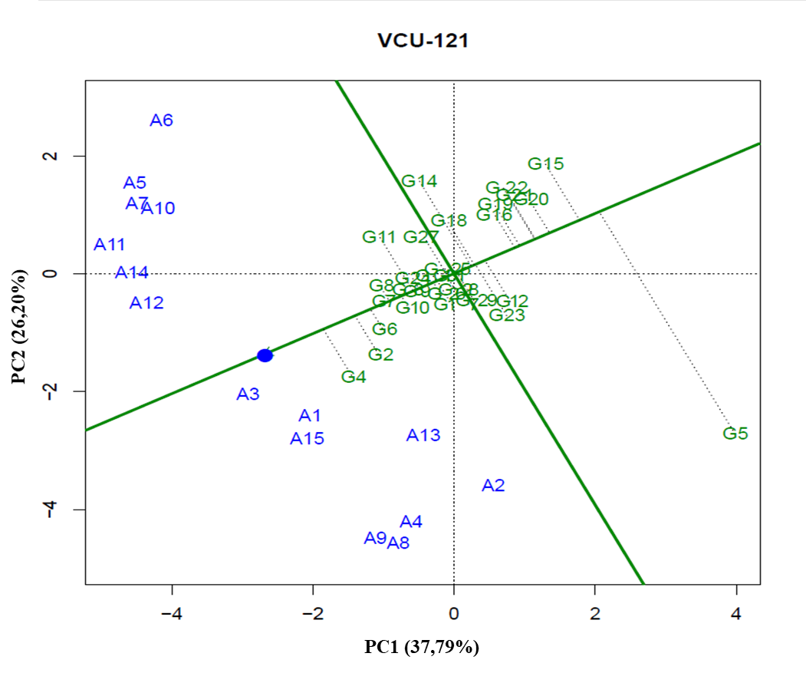
2.16 - GGE Biplot with the first two principal components (PC1 and PC2), corresponding to the representation of genotypes (numbers preceded by letter G) and environments (numbers preceded by letter A), for the identification of mega-environments in the planting sites of VCU 121 – GR(1) of the 2011/2012 crop season.
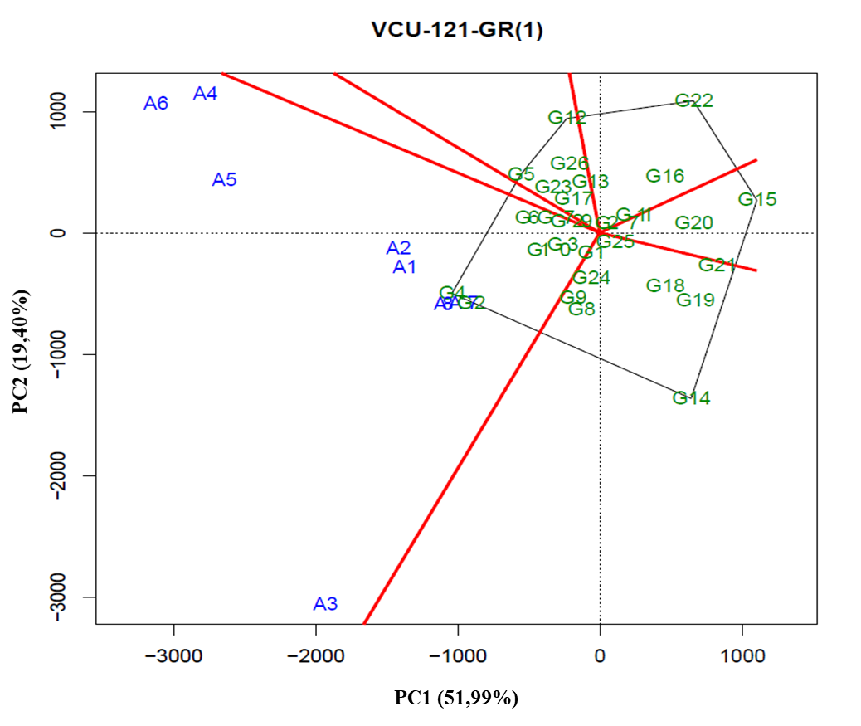
2.17 - GGE Biplot with the first two principal components (PC1 and PC2), corresponding to the representation of genotypes (numbers preceded by letter G) and environments (numbers preceded by letter A), for the identification of mega-environments in the planting sites of VCU 121 – GR(2) of the 2011/2012 crop season.
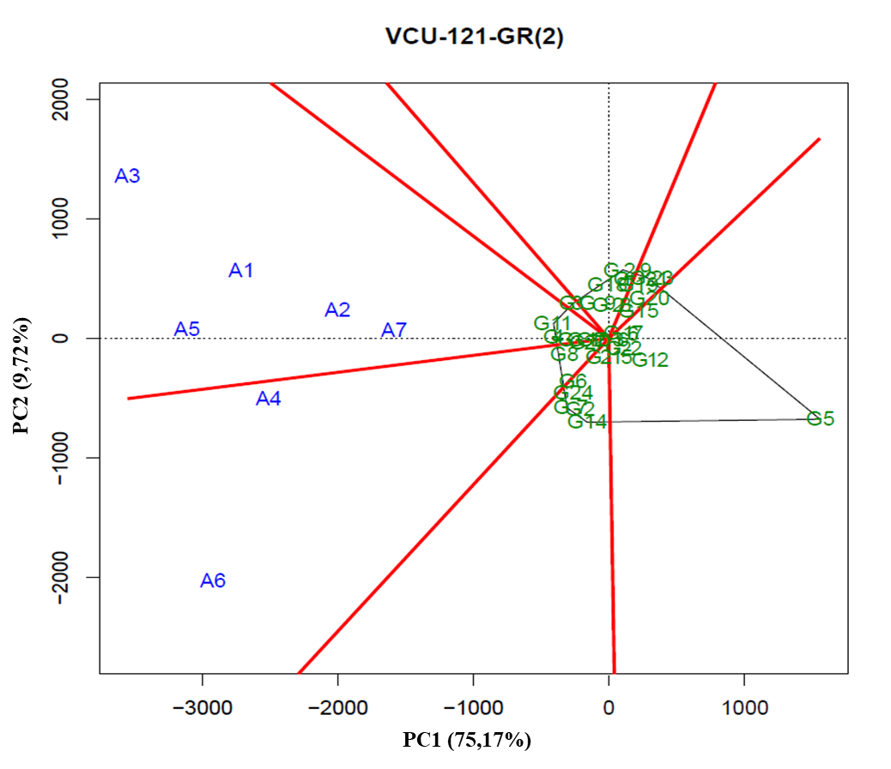
2.18 - GGE Biplot with the first two principal components (PC1 and PC2), corresponding to the representation of genotypes (numbers preceded by letter G) and environments (numbers preceded by letter A), for the identification of mega-environments in the planting sites of VCU 122 of the 2011/2012 crop season.
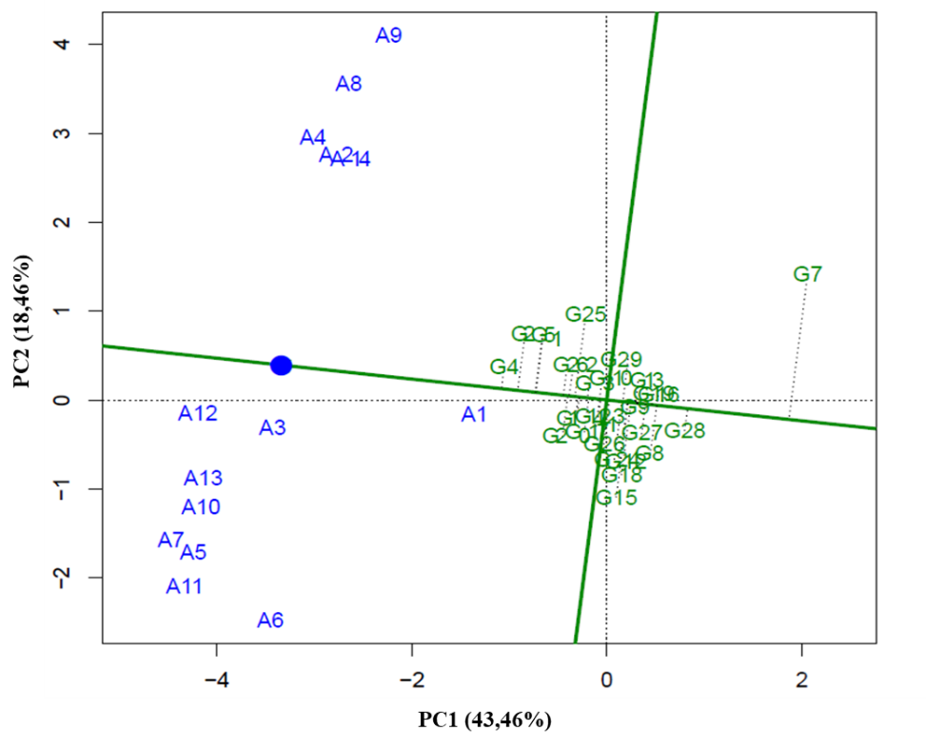
2.19 - GGE Biplot with the first two principal components (PC1 and PC2), corresponding to the representation of genotypes (numbers preceded by letter G) and environments (numbers preceded by letter A), for the identification of mega-environments in the planting sites of VCU 122 – GR(1) of the 2011/2012 crop season.
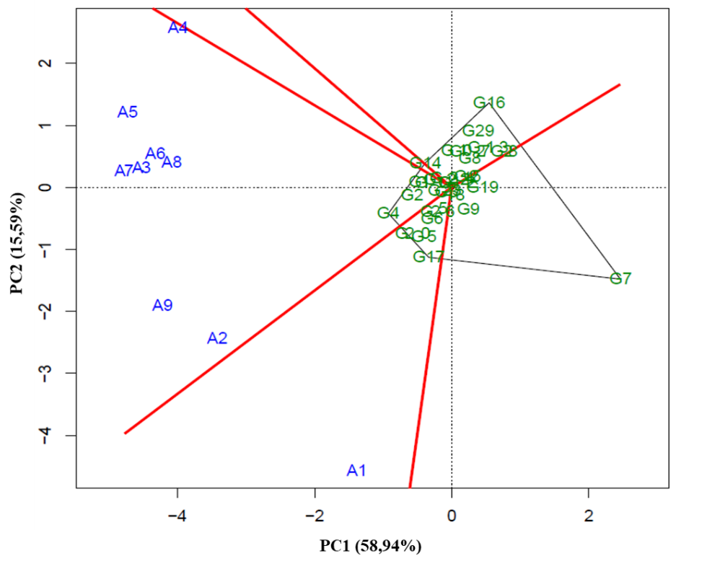
2.20 - GGE Biplot with the first two principal components (PC1 and PC2), corresponding to the representation of genotypes (numbers preceded by letter G) and environments (numbers preceded by letter A), for the identification of mega-environments in the planting sites of VCU 122 – GR(2) of the 2011/2012 crop season.
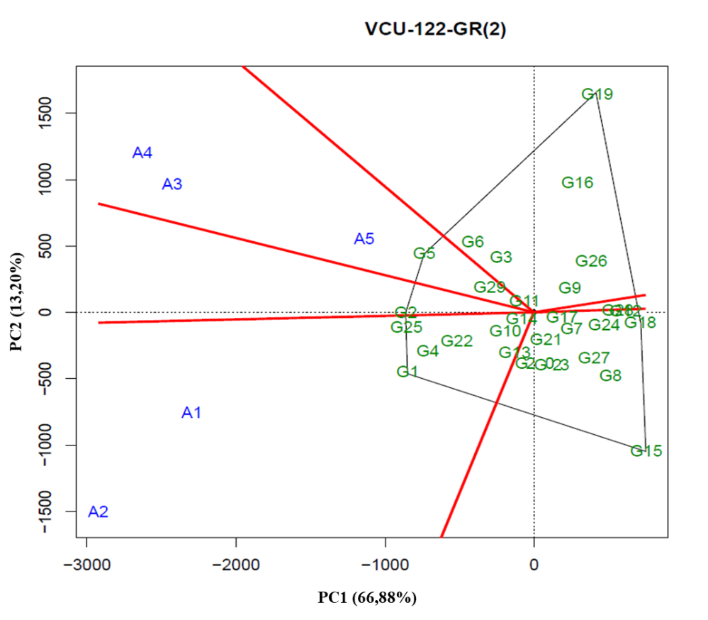
2.21 - GGE Biplot with the first two principal components (PC1 and PC2), corresponding to the representation of genotypes (numbers preceded by letter G) and environments (numbers preceded by letter A), for the identification of mega-environments in the planting sites of VCU 123 of the 2011/2012 crop season.
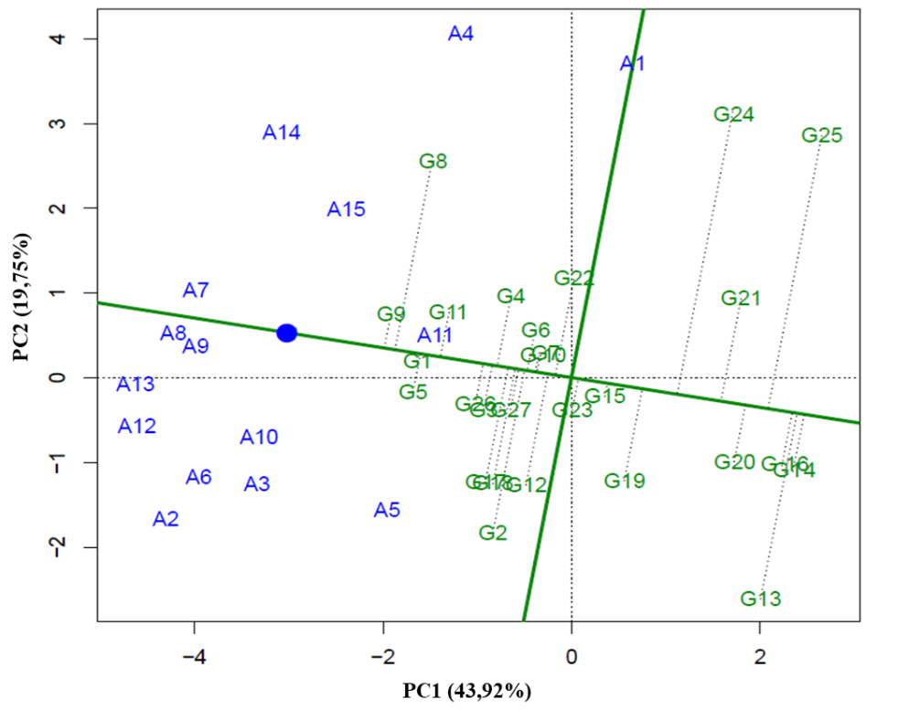
2.22 - GGE Biplot with the first two principal components (PC1 and PC2), corresponding to the representation of genotypes (numbers preceded by letter G) and environments (numbers preceded by letter A), for the identification of mega-environments in the planting sites of VCU 123 – GR(1) of the 2011/2012 crop season.
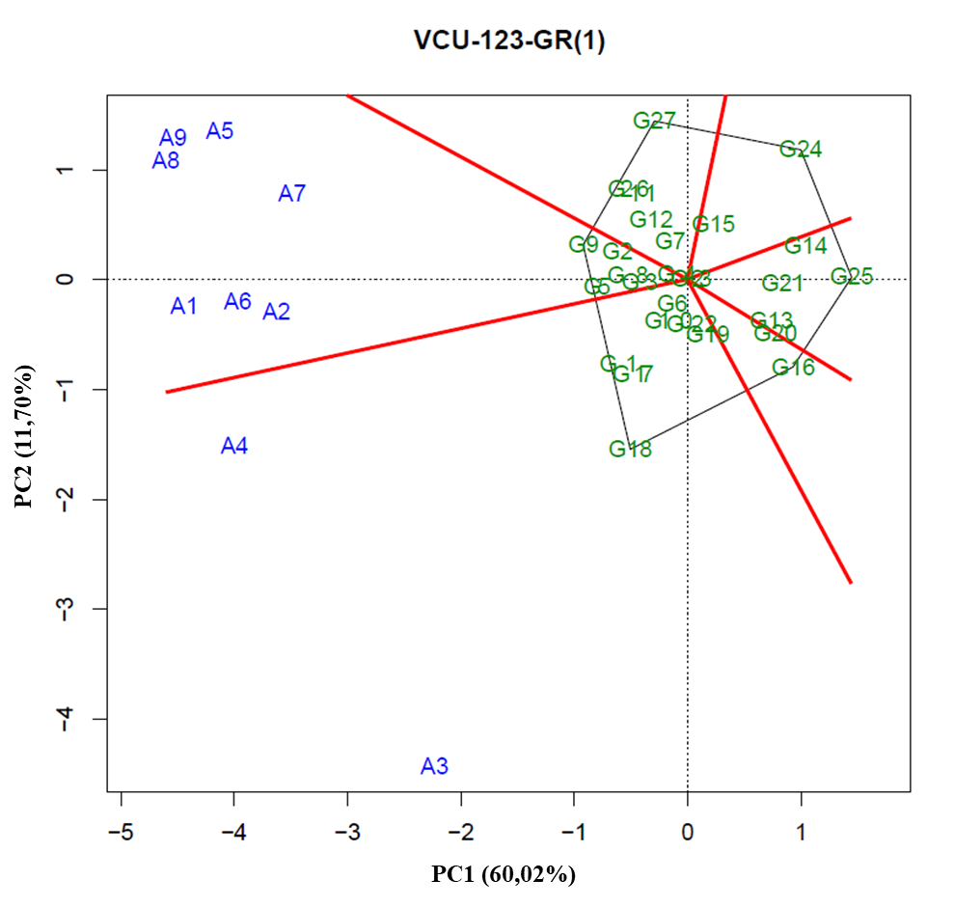
2.23 - GGE Biplot with the first two principal components (PC1 and PC2), corresponding to the representation of genotypes (numbers preceded by letter G) and environments (numbers preceded by letter A), for the identification of mega-environments in the planting sites of VCU 123 – GR(2) of the 2011/2012 crop season.
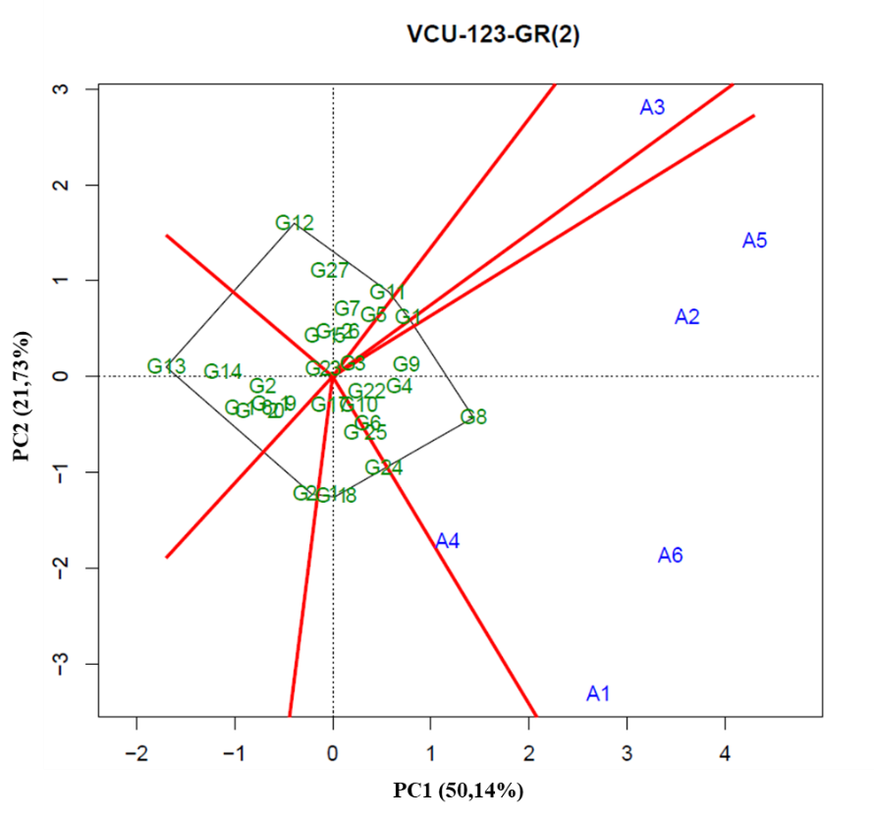
2.24 - GGE Biplot with the first two principal components (PC1 and PC2), corresponding to the representation of genotypes (numbers preceded by letter G) and environments (numbers preceded by letter A), for the identification of mega-environments in the planting sites of VCU 124 of the 2011/2012 crop season.
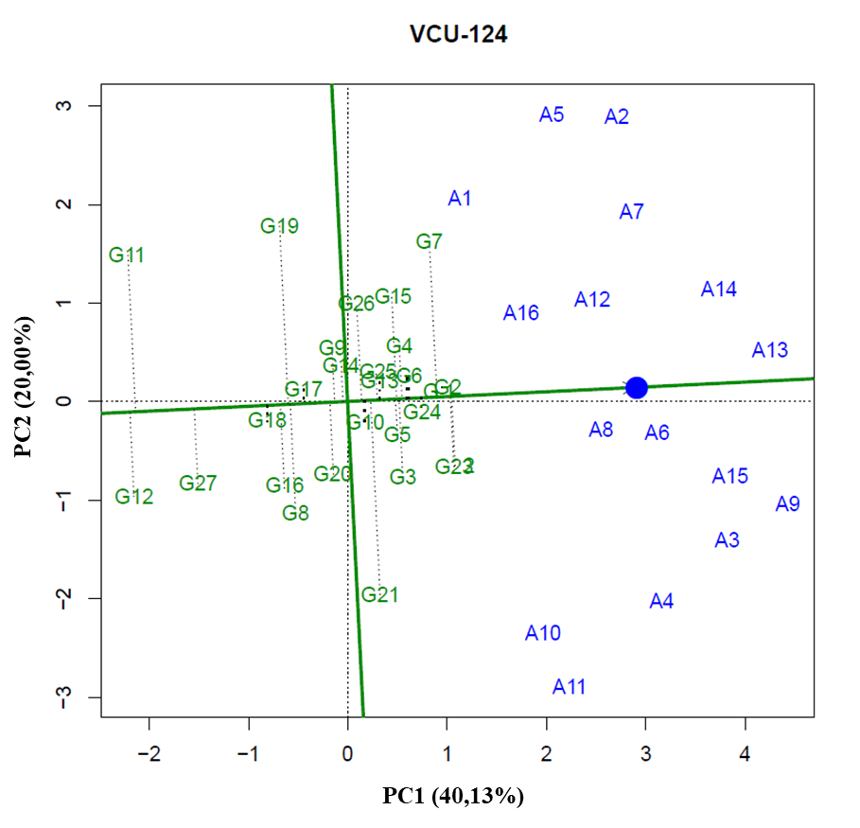
2.25 - GGE Biplot with the first two principal components (PC1 and PC2), corresponding to the representation of genotypes (numbers preceded by letter G) and environments (numbers preceded by letter A), for the identification of mega-environments in the planting sites of VCU 124 – GR(1) of the 2011/2012 crop season.
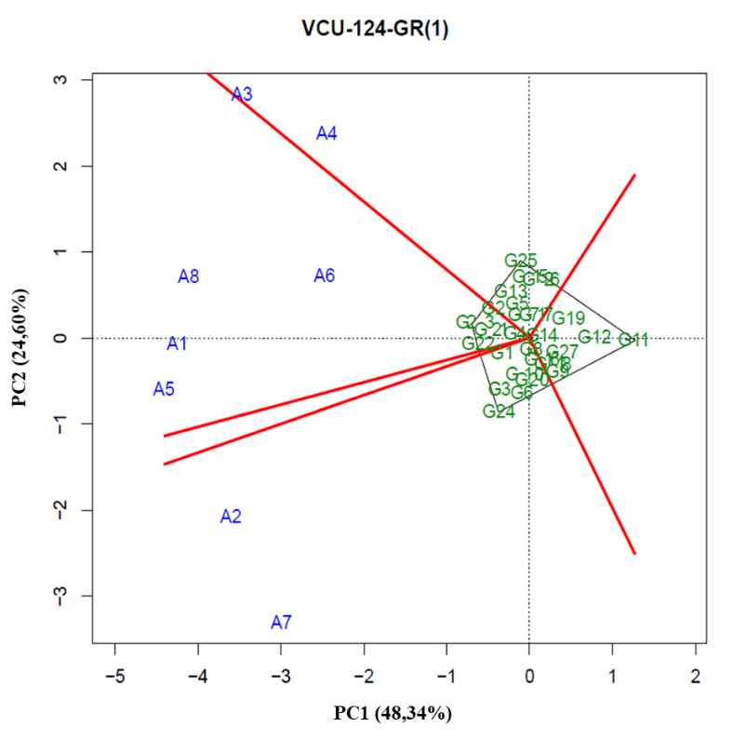
2.26 - GGE Biplot with the first two principal components (PC1 and PC2), corresponding to the representation of genotypes (numbers preceded by letter G) and environments (numbers preceded by letter A), for the identification of mega-environments in the planting sites of VCU 124 – GR(2) of the 2011/2012 crop season.
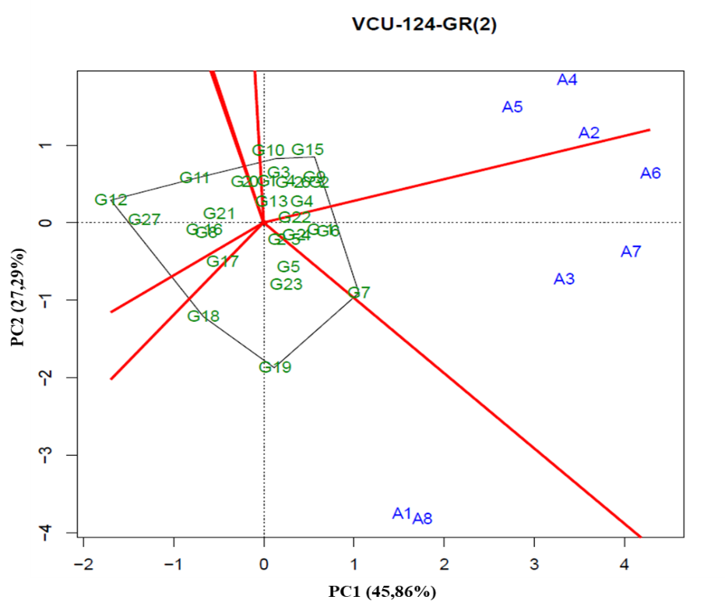
2.27 - GGE Biplot with the first two principal components (PC1 and PC2), corresponding to the representation of genotypes (numbers preceded by letter G) and environments (numbers preceded by letter A), for the identification of mega-environments in the planting sites of VCU 125 of the 2011/2012 crop season.
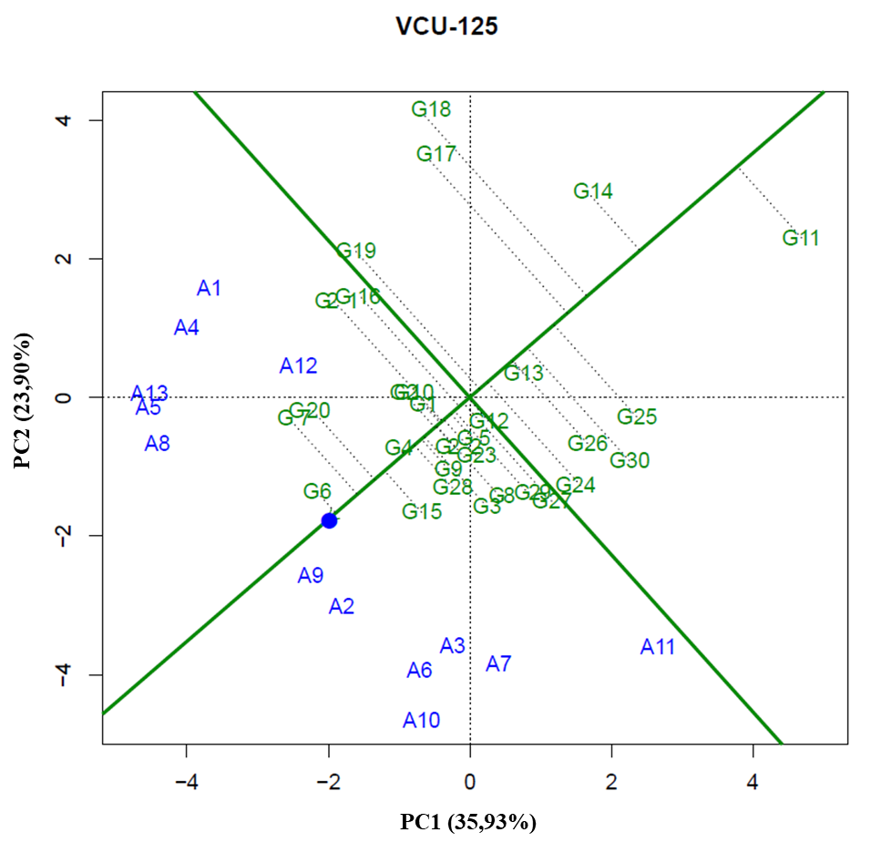
2.28 - GGE Biplot with the first two principal components (PC1 and PC2), corresponding to the representation of genotypes (numbers preceded by letter G) and environments (numbers preceded by letter A), for the identification of mega-environments in the planting sites of VCU 125 – GR(1) of the 2011/2012 crop season.
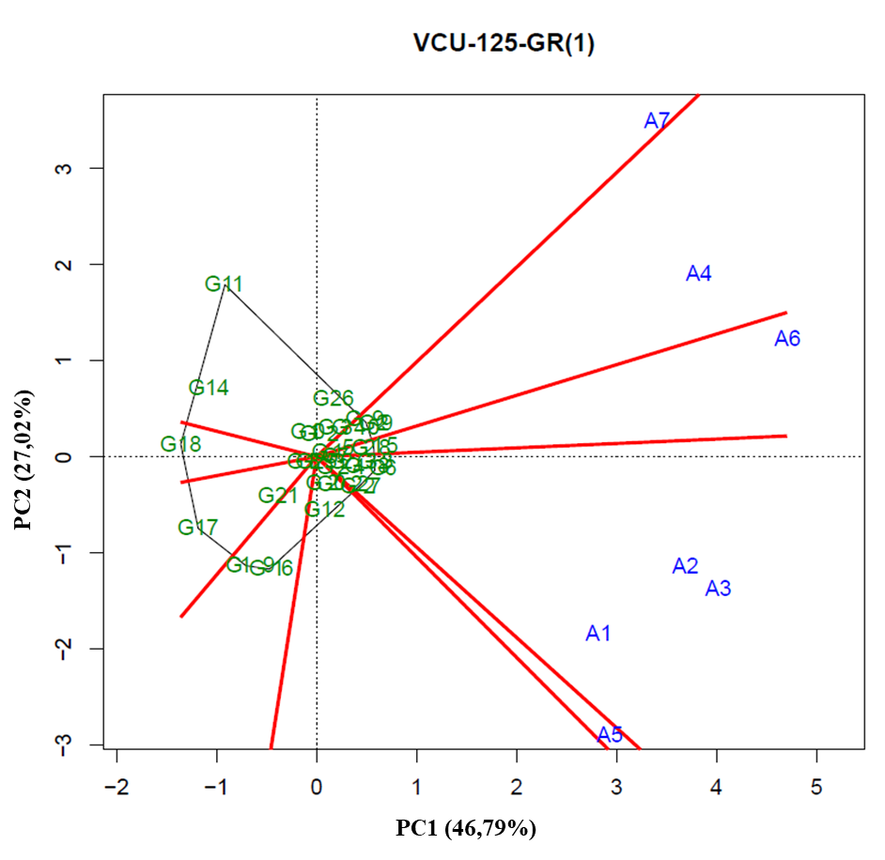
2.29 - GGE Biplot with the first two principal components (PC1 and PC2), corresponding to the representation of genotypes (numbers preceded by letter G) and environments (numbers preceded by letter A), for the identification of mega-environments in the planting sites of VCU 125 – GR(2) of the 2011/2012 crop season.
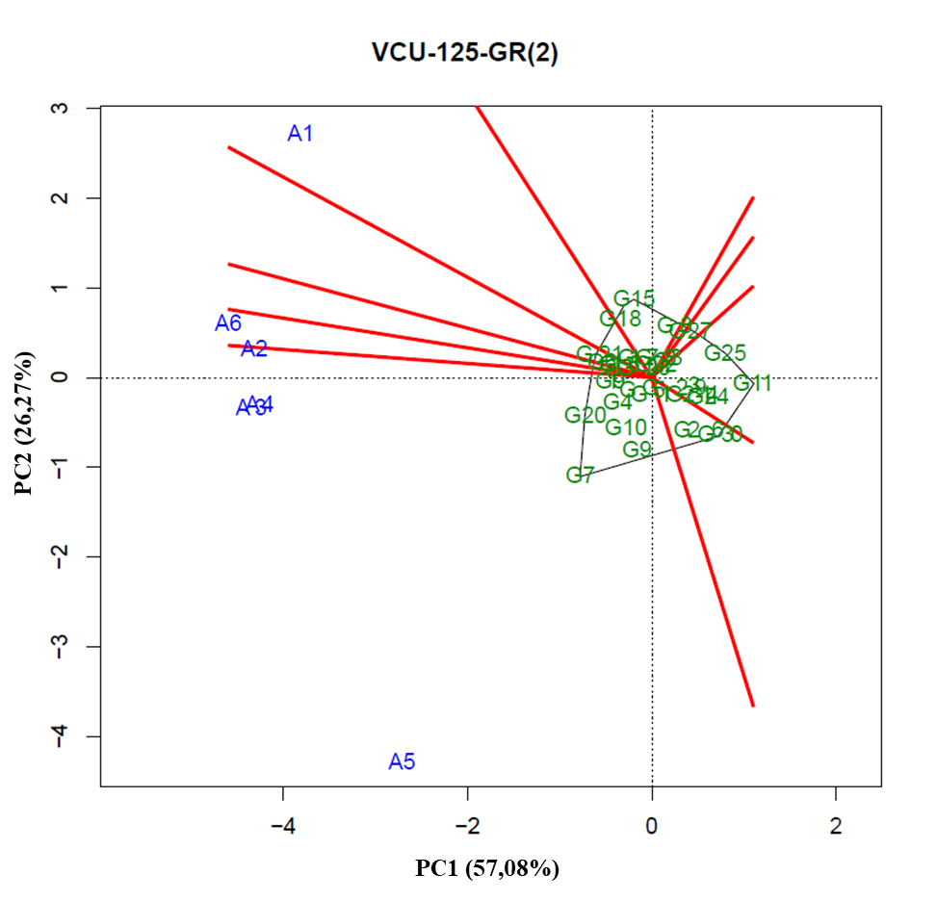
2.30 - GGE Biplot with the first two principal components (PC1 and PC2), corresponding to the representation of genotypes (numbers preceded by letter G) and environments (numbers preceded by letter A), for the identification of mega-environments in the planting sites of VCU 126 da of the 2011/2012 crop season.
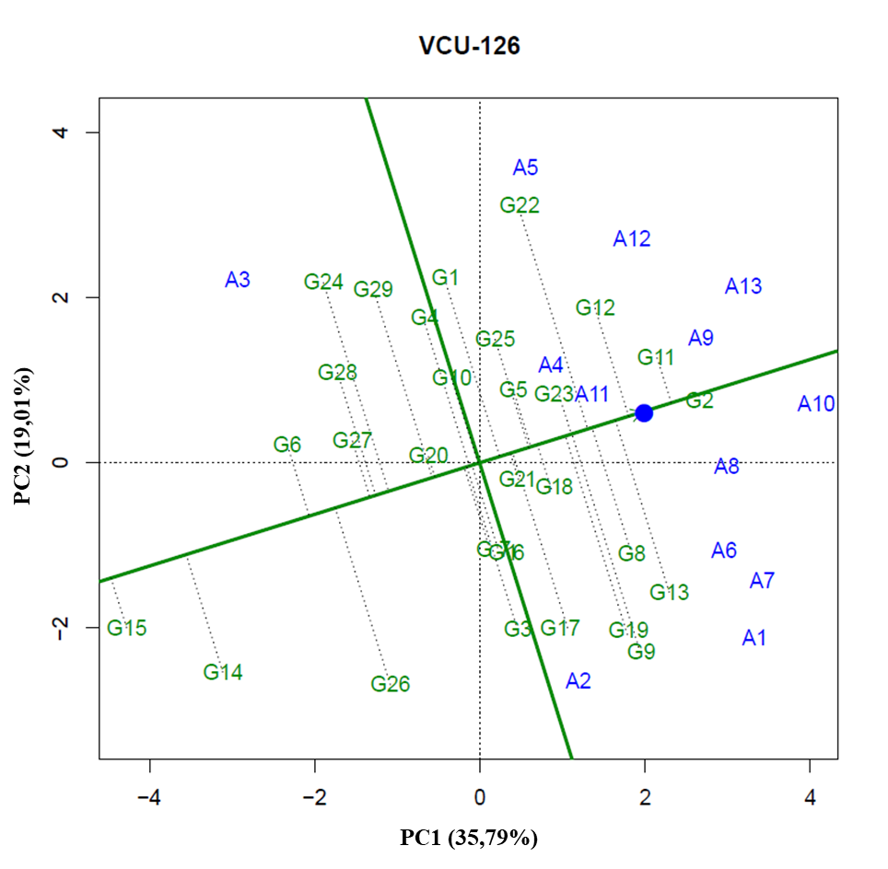
3.31 - GGE Biplot with the first two principal components (PC1 and PC2), corresponding to the representation of genotypes (numbers preceded by letter G) and environments (numbers preceded by letter A), for the identification of mega-environments in the planting sites of VCU 126 – GR(1) of the 2011/2012 crop season.
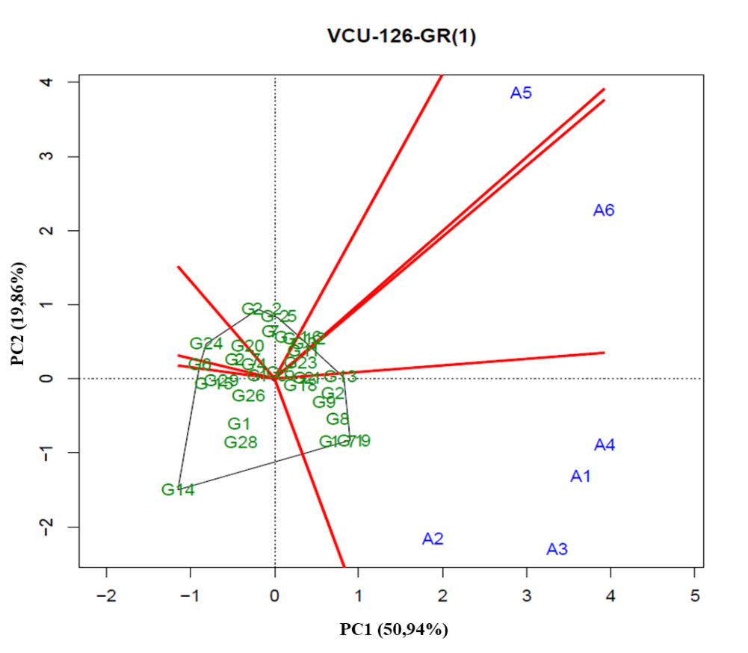
2.32 - GGE Biplot with the first two principal components (PC1 and PC2), corresponding to the representation of genotypes (numbers preceded by letter G) and environments (numbers preceded by letter A), for the identification of mega-environments in the planting sites of VCU 126 – GR(2) of the 2011/2012 crop season.
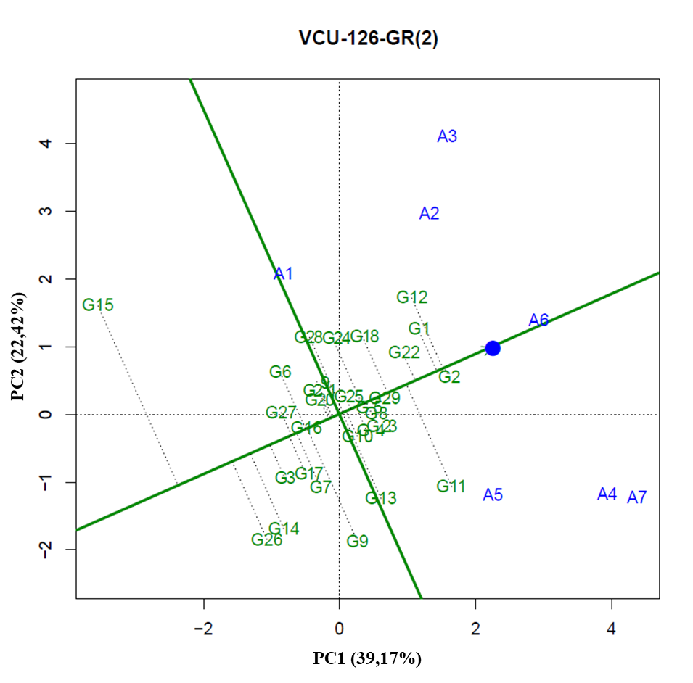
2.33 - GGE Biplot with the first two principal components (PC1 and PC2), corresponding to the representation of genotypes (numbers preceded by letter G) and environments (numbers preceded by letter A), for the identification of mega-environments in the planting sites of VCU 126 – GR(2 - 1) of the 2011/2012 crop season.
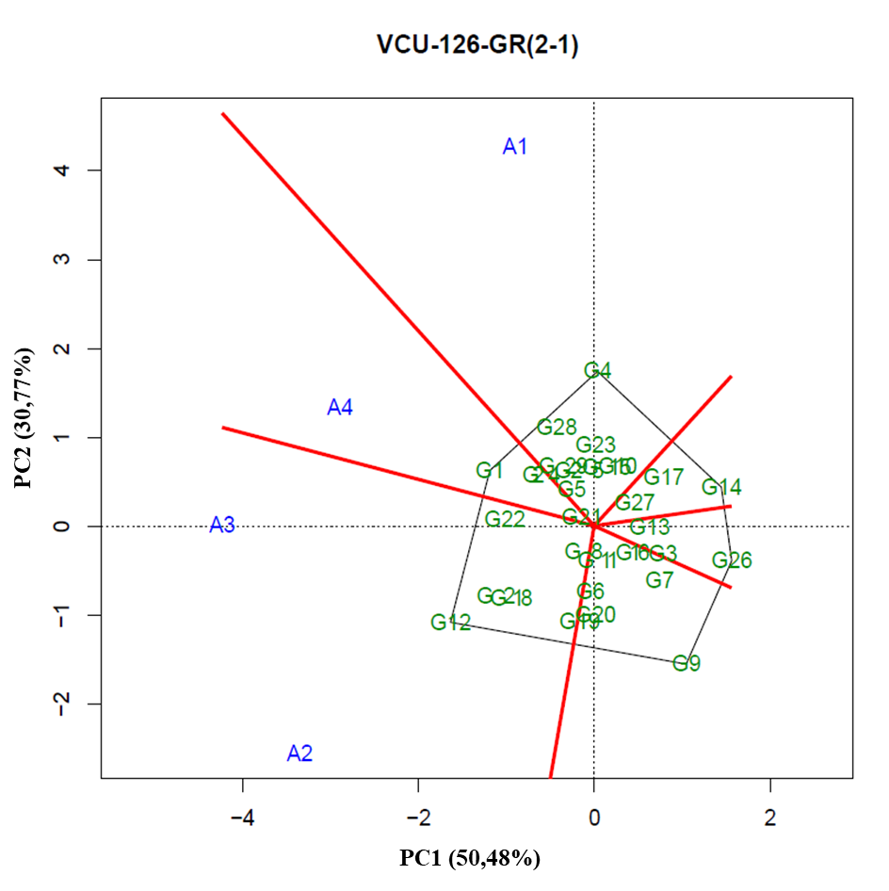
2.34 - GGE Biplot with the first two principal components (PC1 and PC2), corresponding to the representation of genotypes (numbers preceded by letter G) and environments (numbers preceded by letter A), for the identification of mega-environments in the planting sites of VCU 126 – GR(2 - 2) of the 2011/2012 crop season.
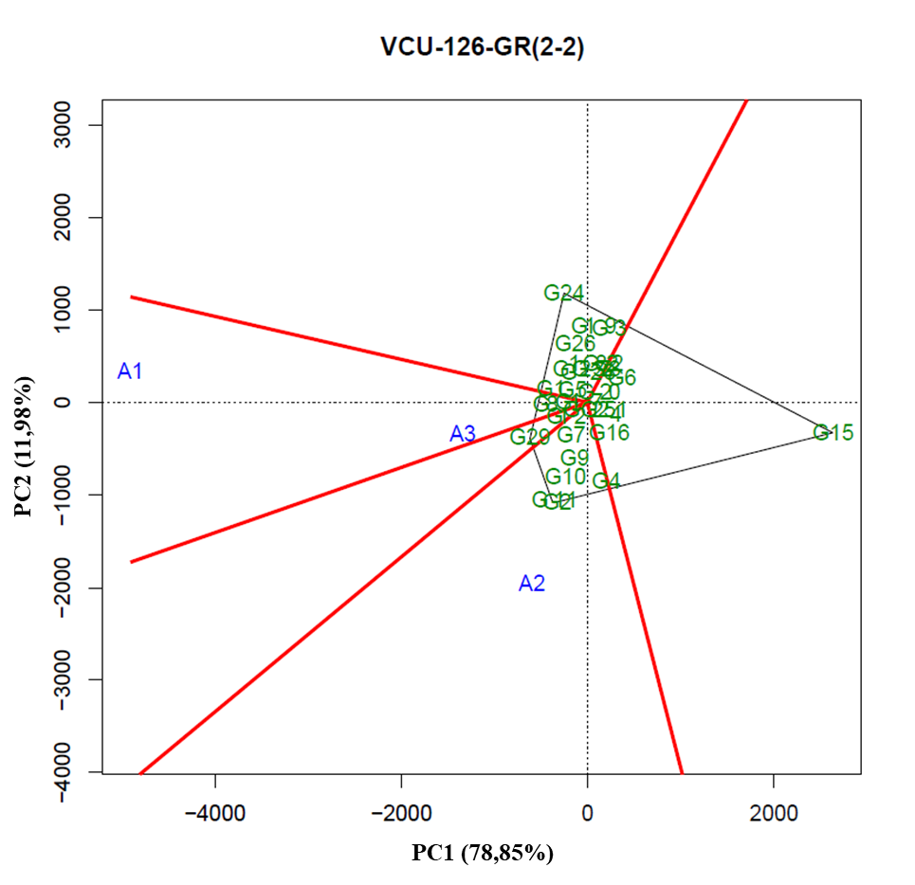
2.35 - GGE Biplot with the first two principal components (PC1 and PC2), corresponding to the representation of genotypes (numbers preceded by letter G) and environments (numbers preceded by letter A), for the identification of mega-environments in the planting sites of VCU 2 of the 2012/2013 crop season.
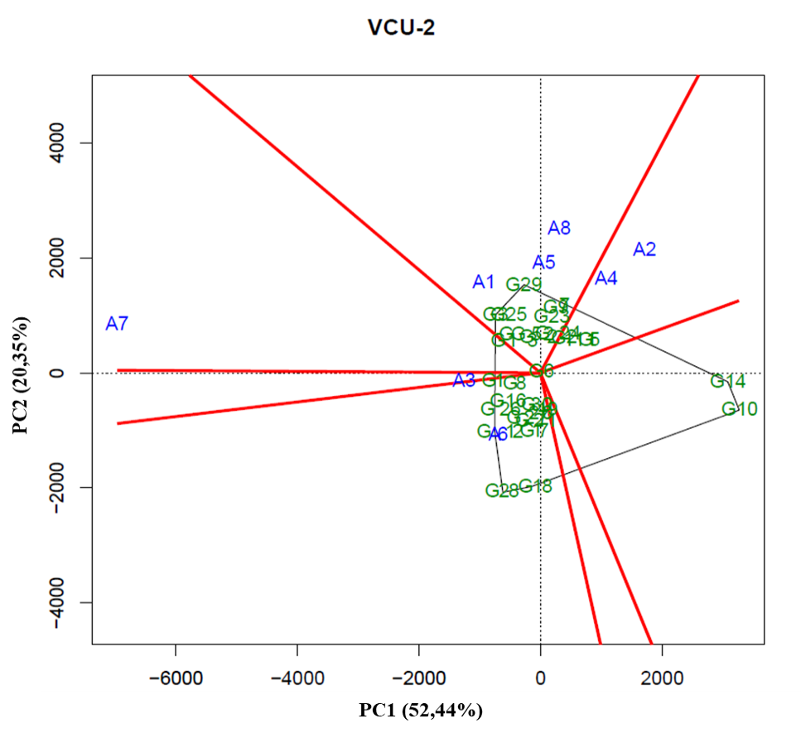
2.36 - GGE Biplot with the first two principal components (PC1 and PC2), corresponding to the representation of genotypes (numbers preceded by letter G) and environments (numbers preceded by letter A), for the identification of mega-environments in the planting sites of VCU 11 of the 2012/2013 crop season.
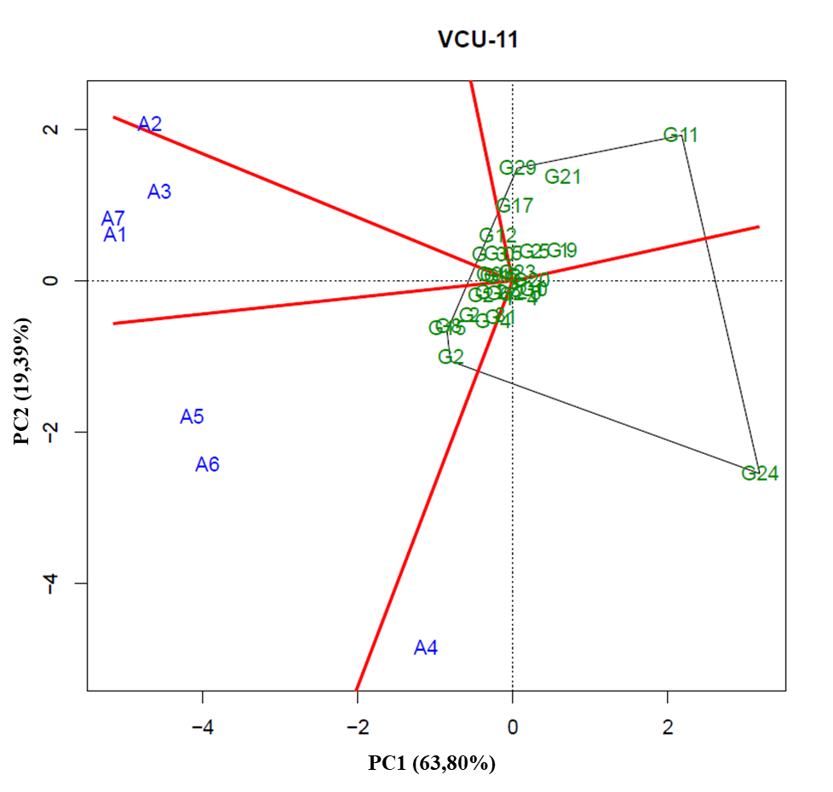
2.37 - GGE Biplot with the first two principal components (PC1 and PC2), corresponding to the representation of genotypes (numbers preceded by letter G) and environments (numbers preceded by letter A), for the identification of mega-environments in the planting sites of VCU 15 of the 2012/2013 crop season.
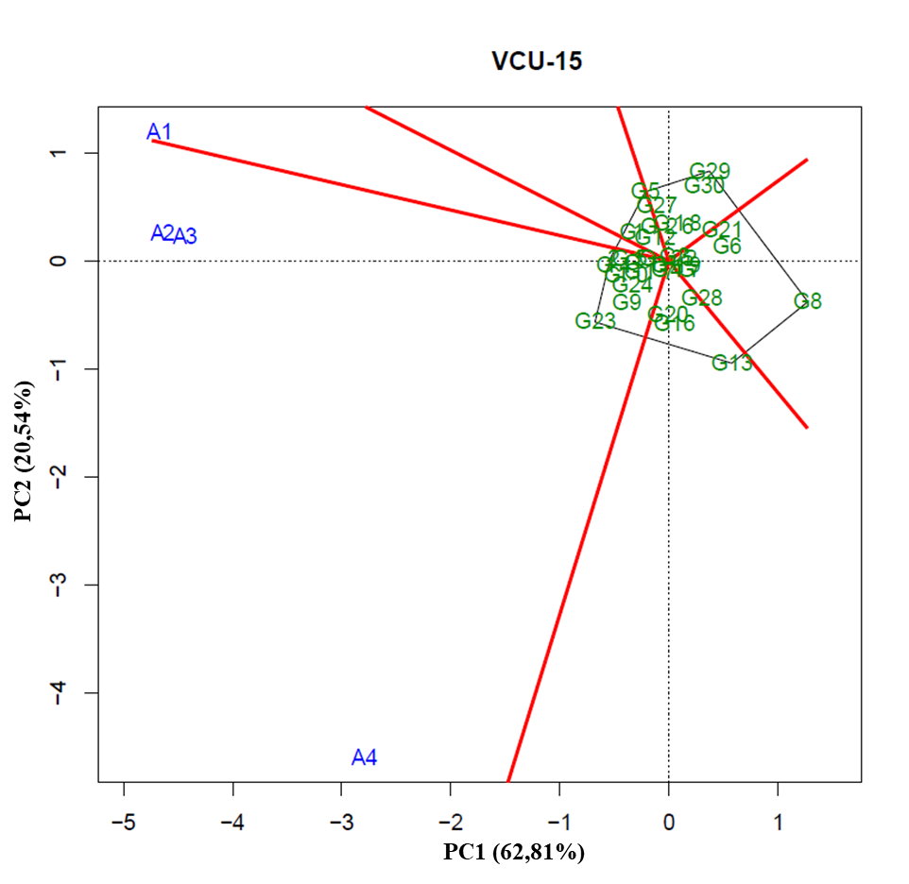
2.38 - GGE Biplot with the first two principal components (PC1 and PC2), corresponding to the representation of genotypes (numbers preceded by letter G) and environments (numbers preceded by letter A), for the identification of mega-environments in the planting sites of VCU 21 of the 2012/2013 crop season.
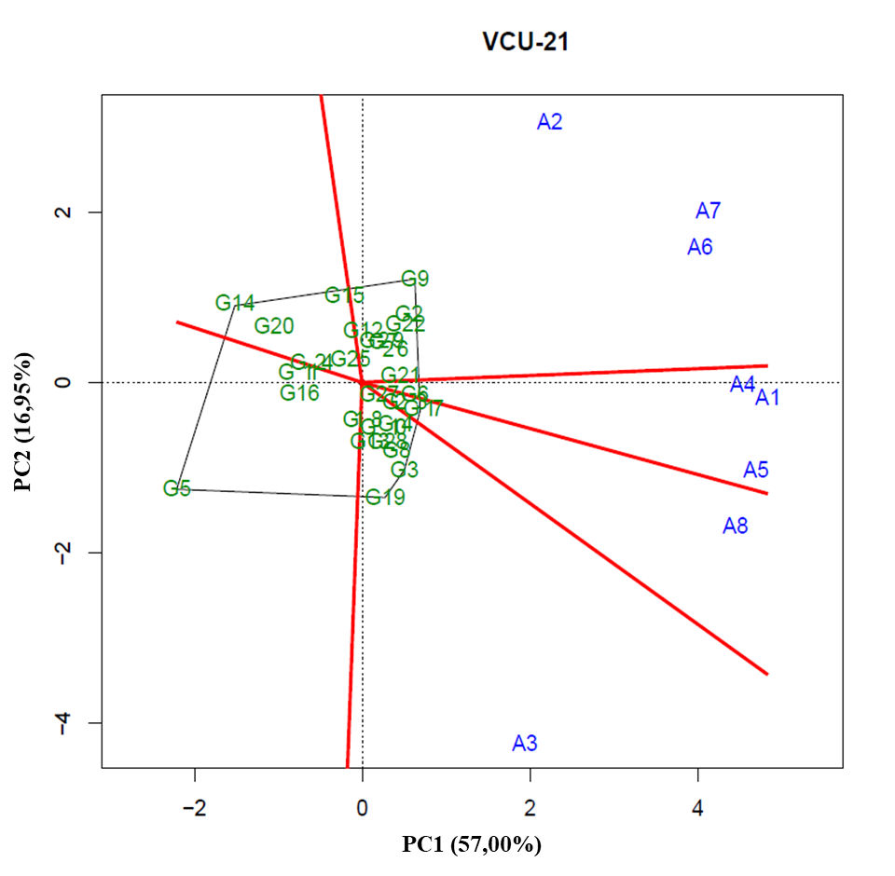
2.39 - GGE Biplot with the first two principal components (PC1 and PC2), corresponding to the representation of genotypes (numbers preceded by letter G) and environments (numbers preceded by letter A), for the identification of mega-environments in the planting sites of VCU 22 of the 2012/2013 crop season.
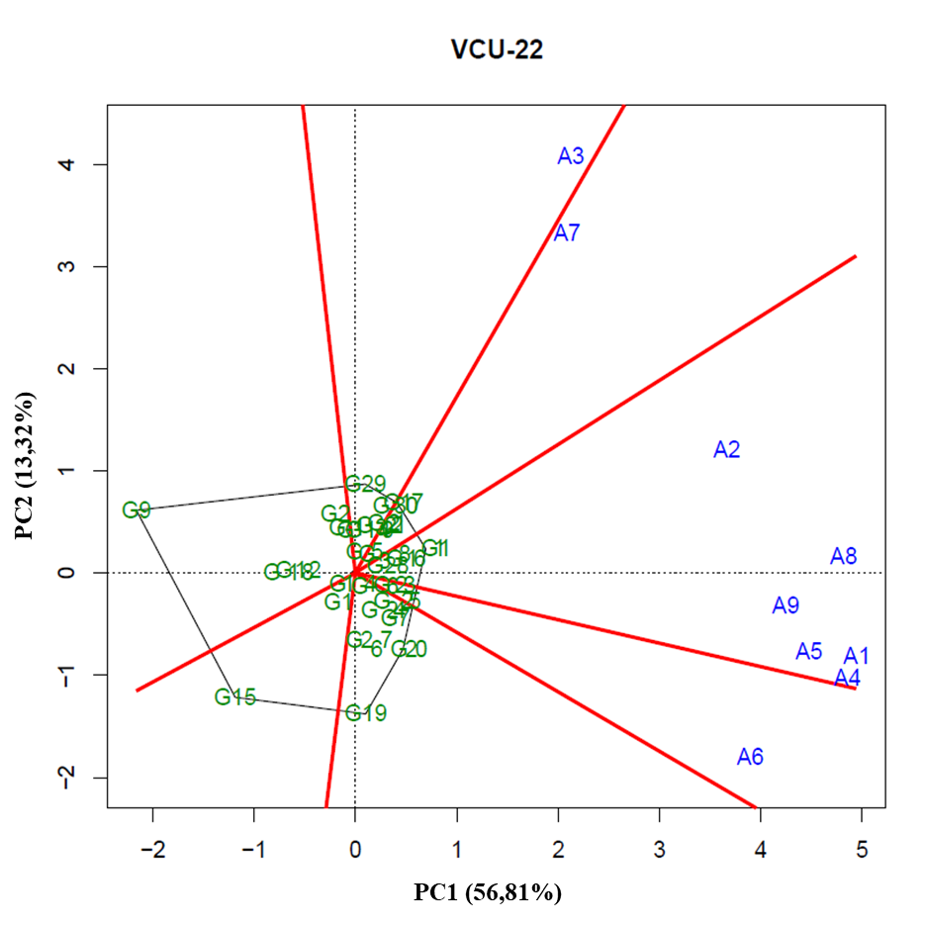
2.40 - GGE Biplot with the first two principal components (PC1 and PC2), corresponding to the representation of genotypes (numbers preceded by letter G) and environments (numbers preceded by letter A), for the identification of mega-environments in the planting sites of VCU 23 of the 2012/2013 crop season.
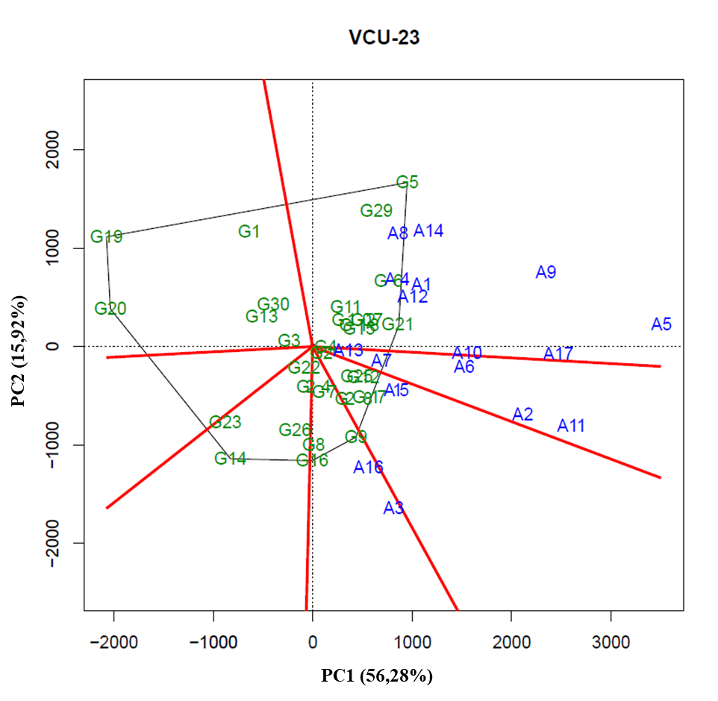
2.41 - GGE Biplot with the first two principal components (PC1 and PC2), corresponding to the representation of genotypes (numbers preceded by letter G) and environments (numbers preceded by letter A), for the identification of mega-environment in the planting sites of VCU 24 of the 2012/2013 crop season.
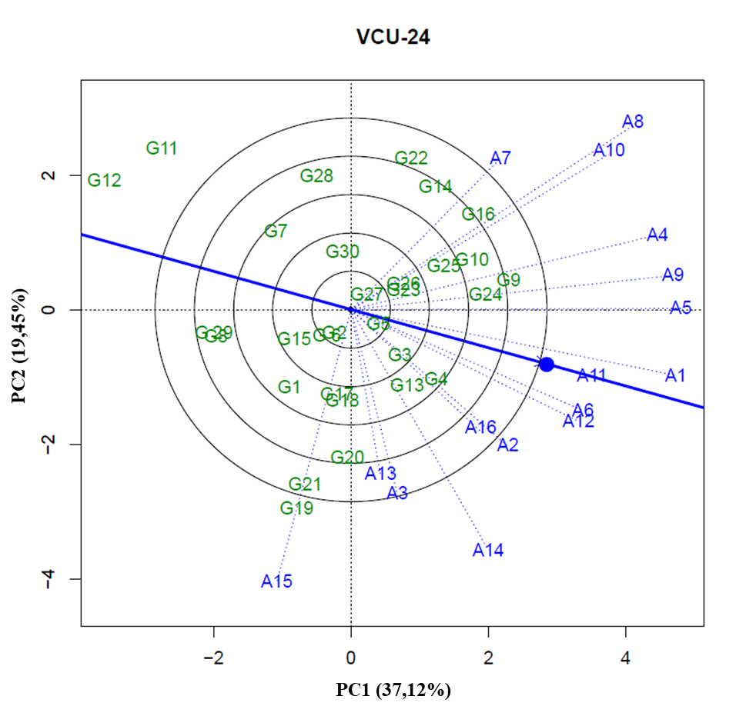
2.42 - GGE Biplot with the first two principal components (PC1 and PC2), corresponding to the representation of genotypes (numbers preceded by letter G) and environments (numbers preceded by letter A), for the identification of mega-environment in the planting sites of VCU 24 – GR(1) of the 2012/2013 crop season.
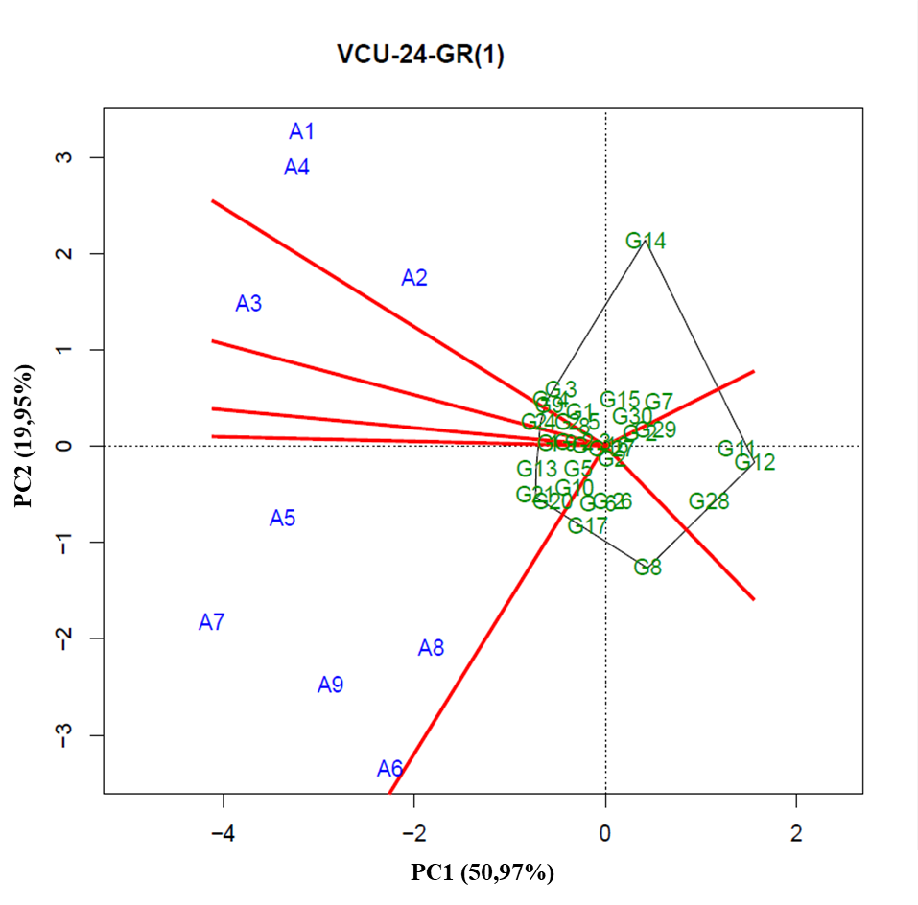
2.43 - GGE Biplot with the first two principal components (PC1 and PC2), corresponding to the representation of genotypes (numbers preceded by letter G) and environments (numbers preceded by letter A), for the identification of mega-environment in the planting sites of VCU 24 – GR(2) of the 2012/2013 crop season.
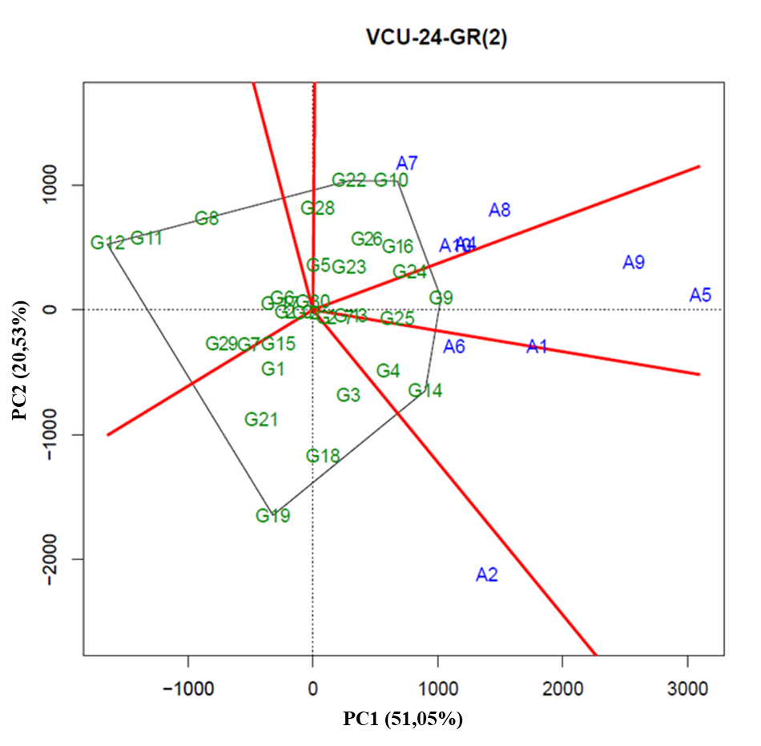
2.44 - GGE Biplot with the first two principal components (PC1 and PC2), corresponding to the representation of genotypes (numbers preceded by letter G) and environments (numbers preceded by letter A), for the identification of mega-environment in the planting sites of VCU 25 of the 2012/2013 crop season.
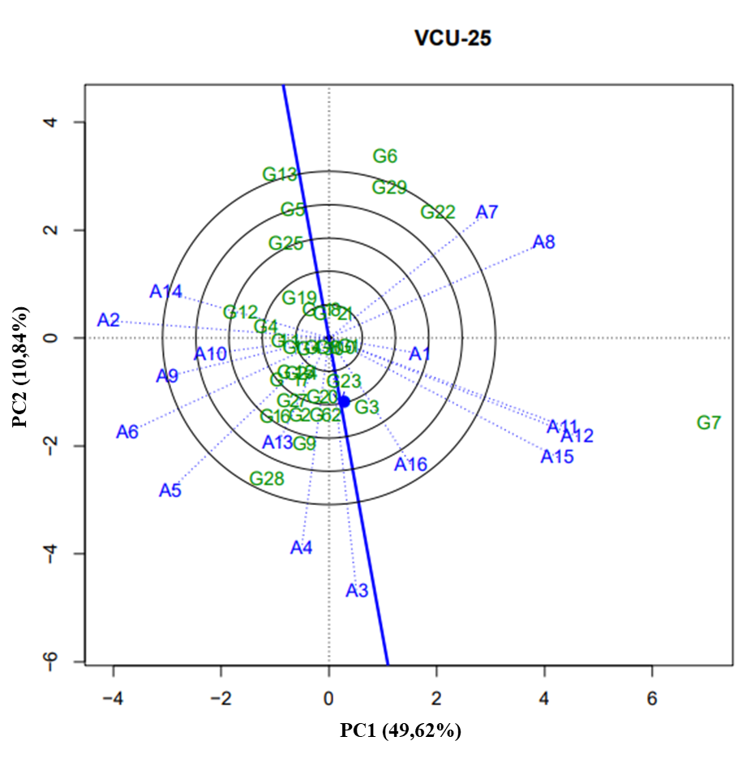
2.45 - GGE Biplot with the first two principal components (PC1 and PC2), corresponding to the representation of genotypes (numbers preceded by letter G) and environments (numbers preceded by letter A), for the identification of mega-environment in the planting sites of VCU 25 – GR (1) of the 2012/2013 crop season.
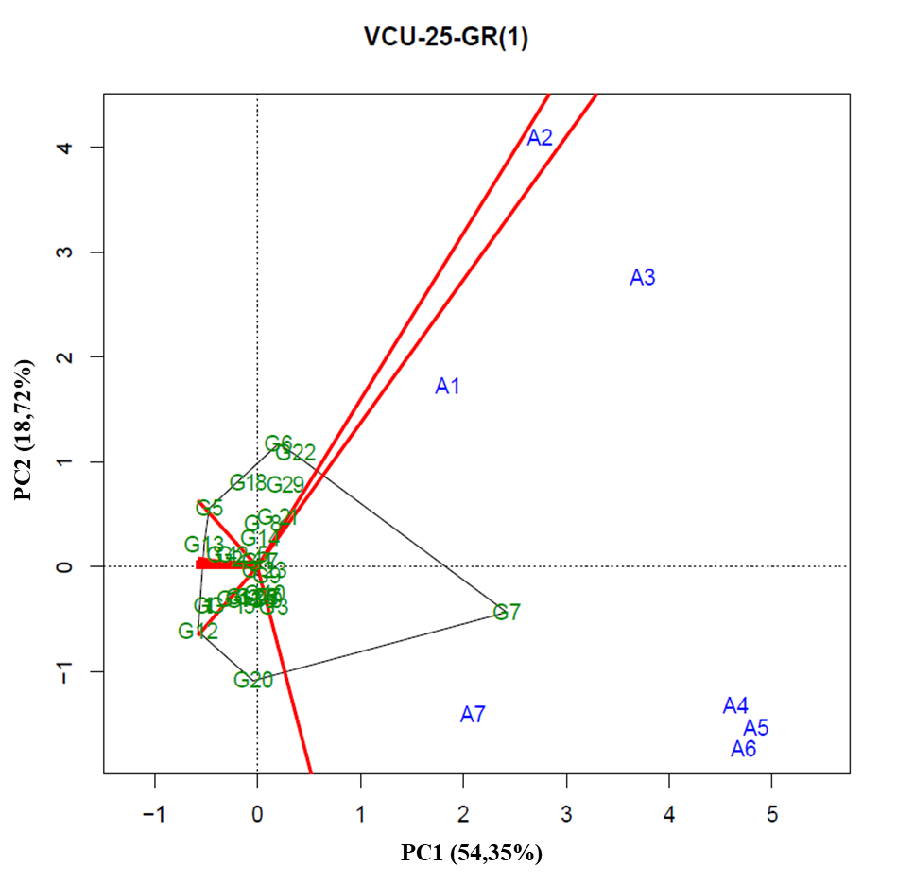
2.46 - GGE Biplot with the first two principal components (PC1 and PC2), corresponding to the representation of genotypes (numbers preceded by letter G) and environments (numbers preceded by letter A), for the identification of mega-environment in the planting sites of VCU 25 – GR(2) of the 2012/2013 crop season.
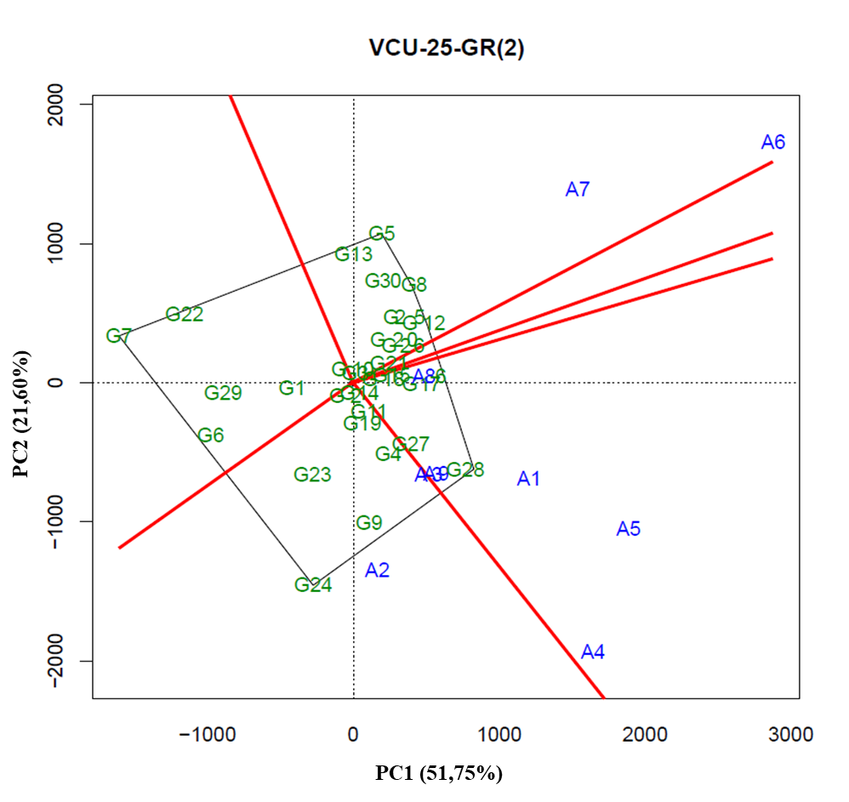
2.47 - GGE Biplot with the first two principal components (PC1 and PC2), corresponding to the representation of genotypes (numbers preceded by letter G) and environments (numbers preceded by letter A), for the identification of mega-environment in the planting sites of VCU 26 of the 2012/2013 crop season.
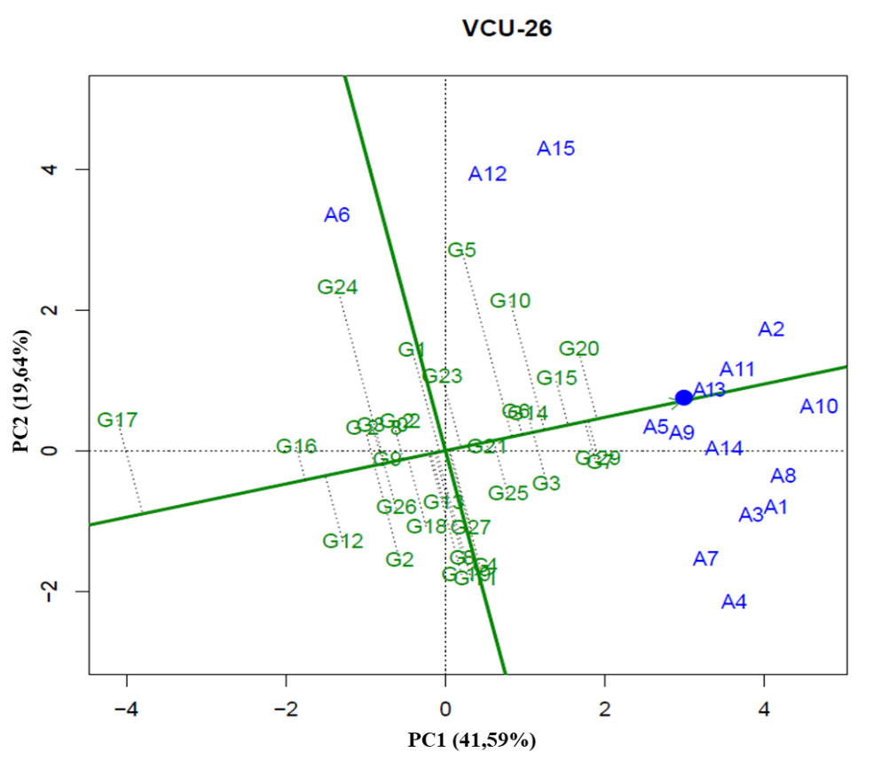
2.48 - GGE Biplot with the first two principal components (PC1 and PC2), corresponding to the representation of genotypes (numbers preceded by letter G) and environments (numbers preceded by letter A), for the identification of mega-environment in the planting sites of VCU 26 – GR(1) of the 2012/2013 crop season.
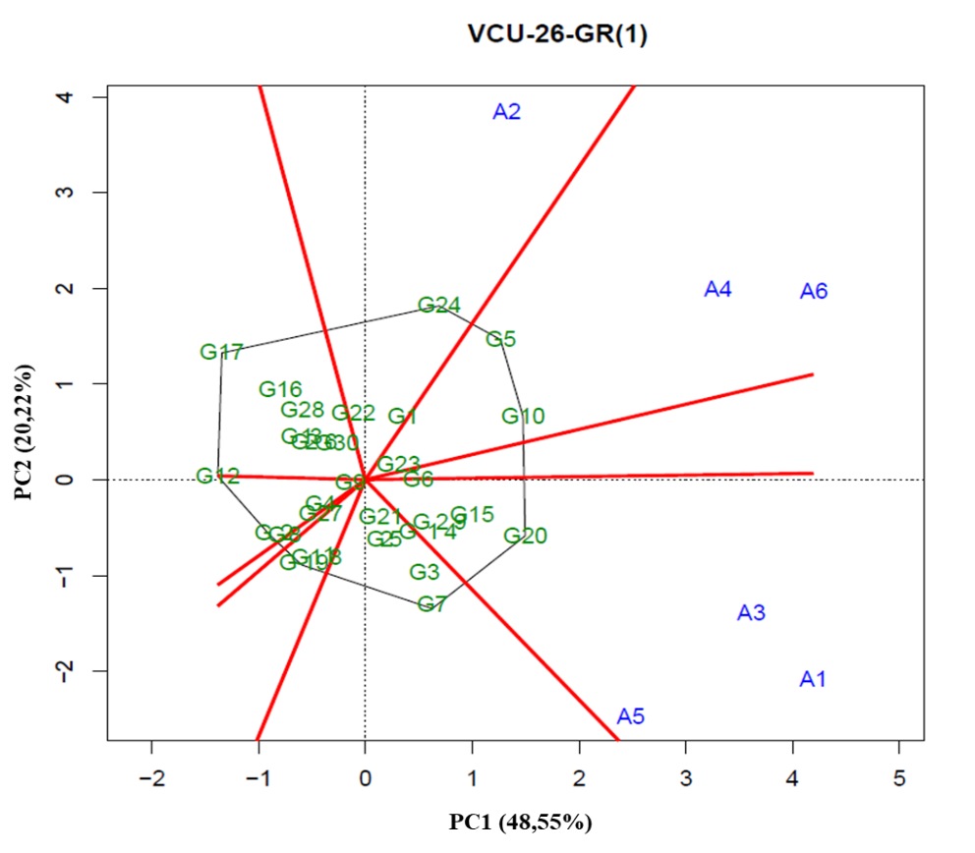
2.49 - GGE Biplot with the first two principal components (PC1 and PC2), corresponding to the representation of genotypes (numbers preceded by letter G) and environments (numbers preceded by letter A), for the identification of mega-environment in the planting sites of VCU 26 – GR(2) of the 2012/2013 crop season.
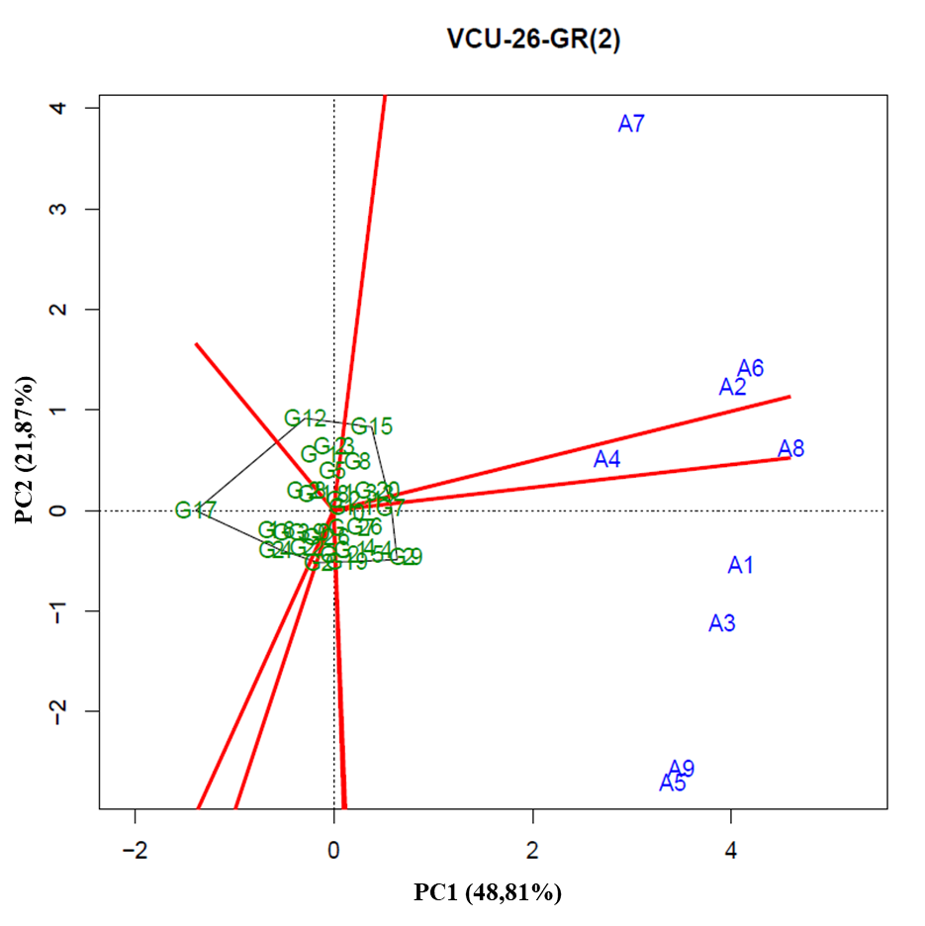
2.50 - GGE Biplot with the first two principal components (PC1 and PC2), corresponding to the representation of genotypes (numbers preceded by letter G) and environments (numbers preceded by letter A), for the identification of mega-environment in the planting sites of VCU 27 of the 2012/2013 crop season.
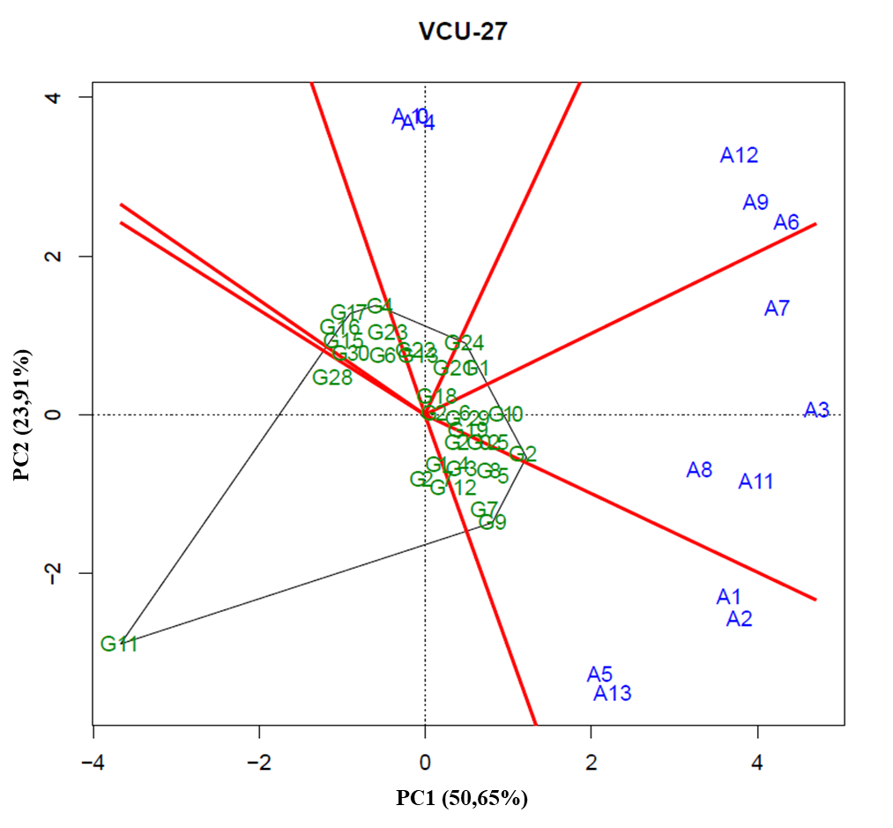
2.51 - GGE Biplot with the first two principal components (PC1 and PC2), corresponding to the representation of genotypes (numbers preceded by letter G) and environments (numbers preceded by letter A), for the identification of mega-environment in the planting sites of VCU 28 of the 2012/2013 crop season.
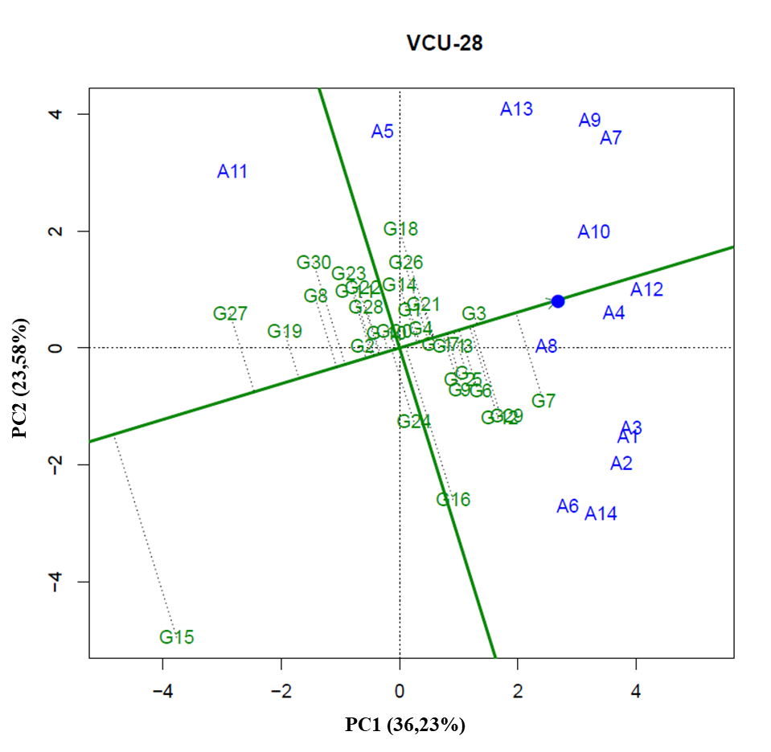
2.52 - GGE Biplot with the first two principal components (PC1 and PC2), corresponding to the representation of genotypes (numbers preceded by letter G) and environments (numbers preceded by letter A), for the identification of mega-environment in the planting sites of VCU 28 – GR(1) of the 2012/2013 crop season.
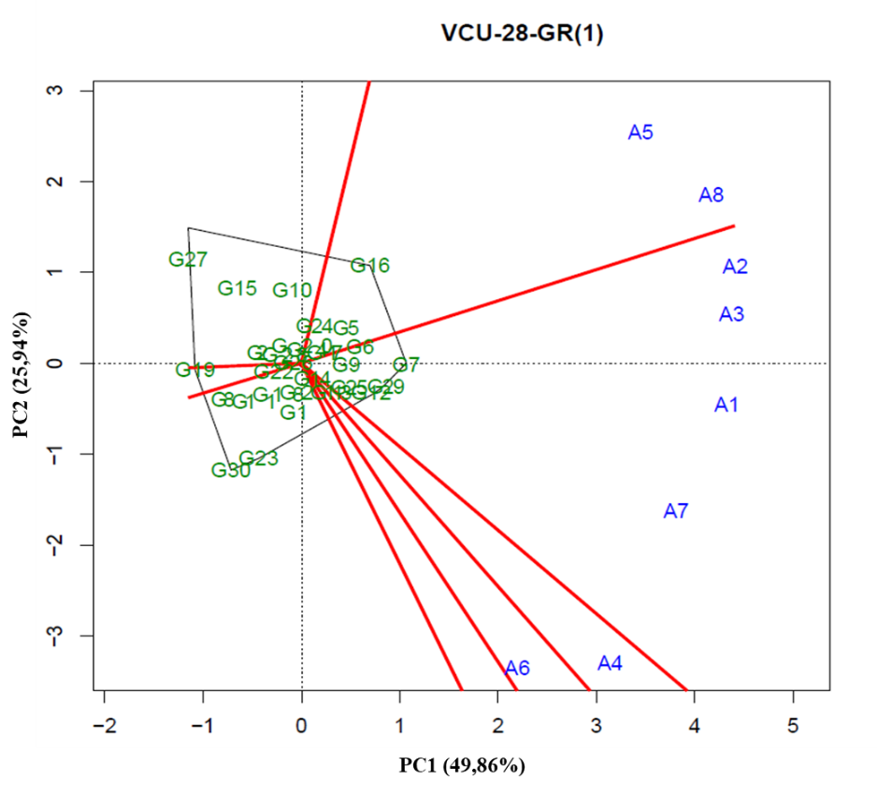
2.53- GGE Biplot with the first two principal components (PC1 and PC2), corresponding to the representation of genotypes (numbers preceded by letter G) and environments (numbers preceded by letter A), for the identification of mega-environment in the planting sites of VCU 28 – GR(2) of the 2012/2013 crop season.
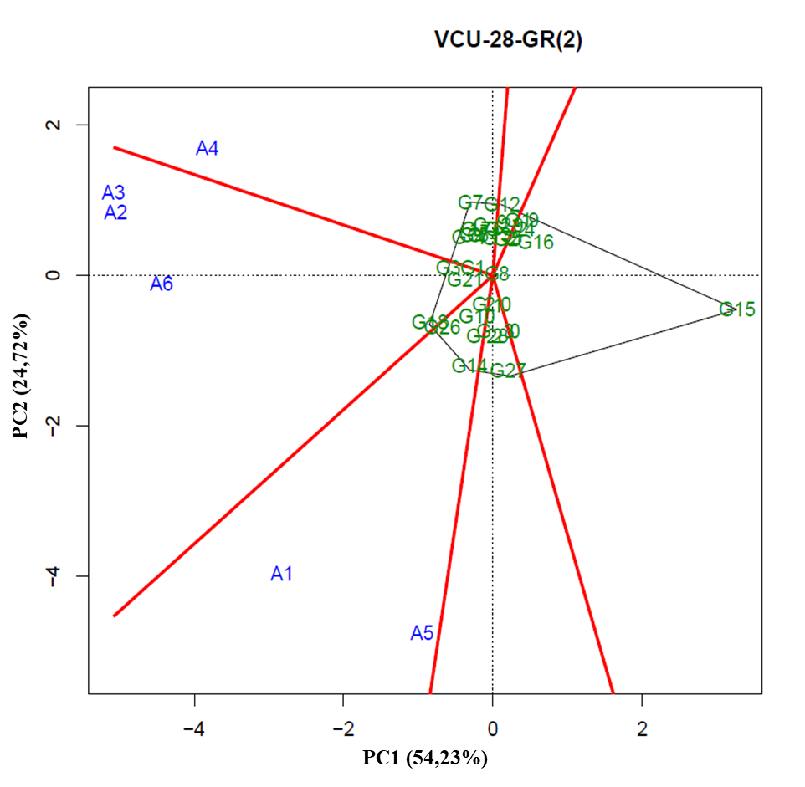
2.54 - GGE Biplot with the first two principal components (PC1 and PC2), corresponding to the representation of genotypes (numbers preceded by letter G) and environments (numbers preceded by letter A), for the identification of mega-environment in the planting sites of VCU 3 of the 2013/2014 crop season.
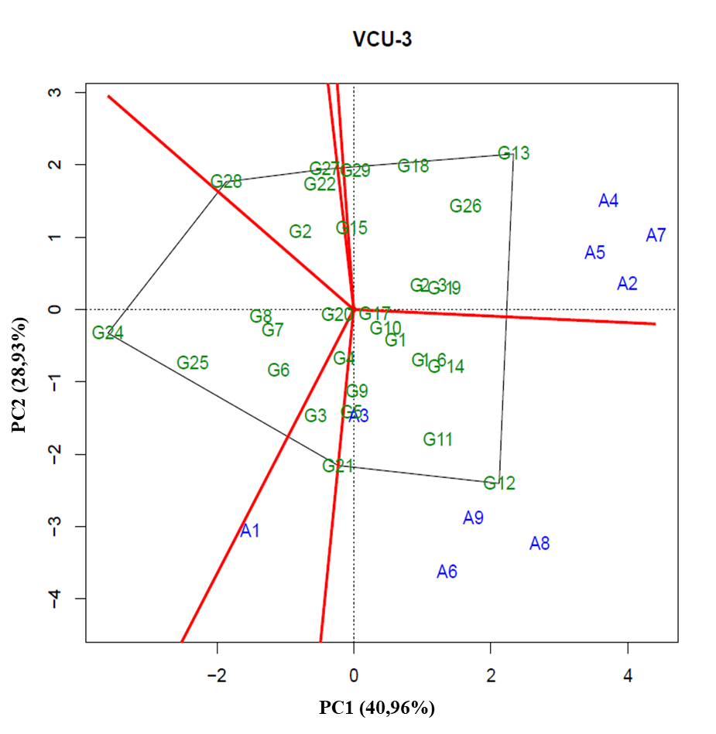
2.55 - GGE Biplot with the first two principal components (PC1 and PC2), corresponding to the representation of genotypes (numbers preceded by letter G) and environments (numbers preceded by letter A), for the identification of mega-environment in the planting sites of VCU 4 of the 2013/2014 crop season.
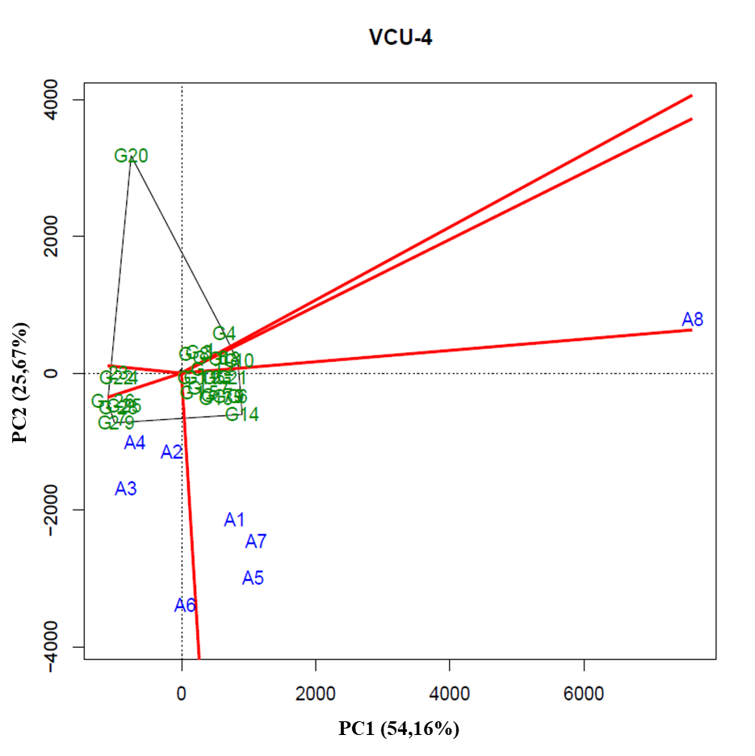
2.56 - GGE Biplot with the first two principal components (PC1 and PC2), corresponding to the representation of genotypes (numbers preceded by letter G) and environments (numbers preceded by letter A), for the identification of mega-environment in the planting sites of VCU 11 of the 2013/2014 crop season.
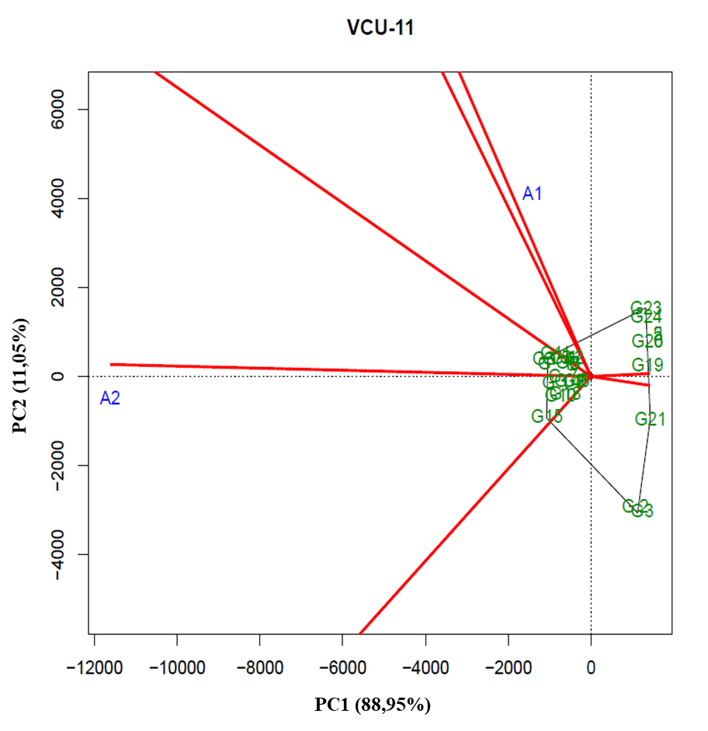
2.57 - GGE Biplot with the first two principal components (PC1 and PC2), corresponding to the representation of genotypes (numbers preceded by letter G) and environments (numbers preceded by letter A), for the identification of mega-environment in the planting sites of VCU 21 of the 2013/2014 crop season.
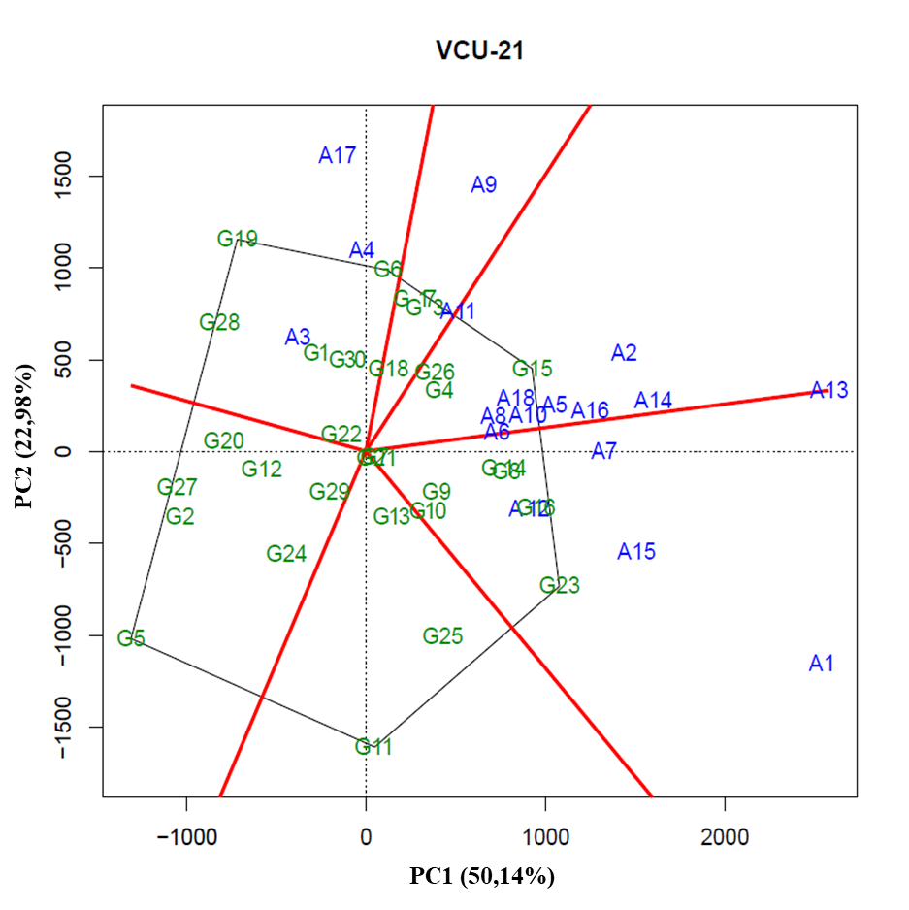
2.58 - GGE Biplot with the first two principal components (PC1 and PC2), corresponding to the representation of genotypes (numbers preceded by letter G) and environments (numbers preceded by letter A), for the identification of mega-environment in the planting sites of VCU 22 of the 2013/2014 crop season.
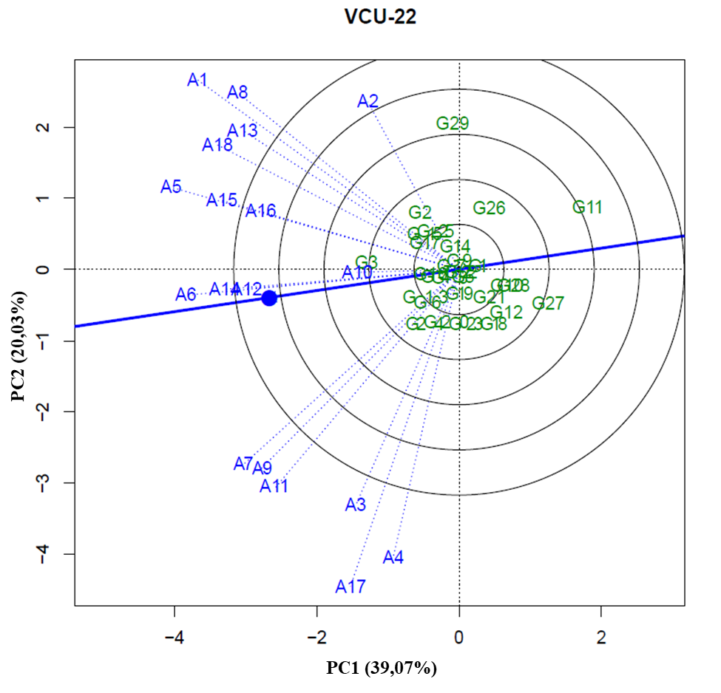
2.59 - GGE Biplot with the first two principal components (PC1 and PC2), corresponding to the representation of genotypes (numbers preceded by letter G) and environments (numbers preceded by letter A), for the identification of mega-environment in the planting sites of VCU 22 – GP(1) of the 2013/2014 crop season.
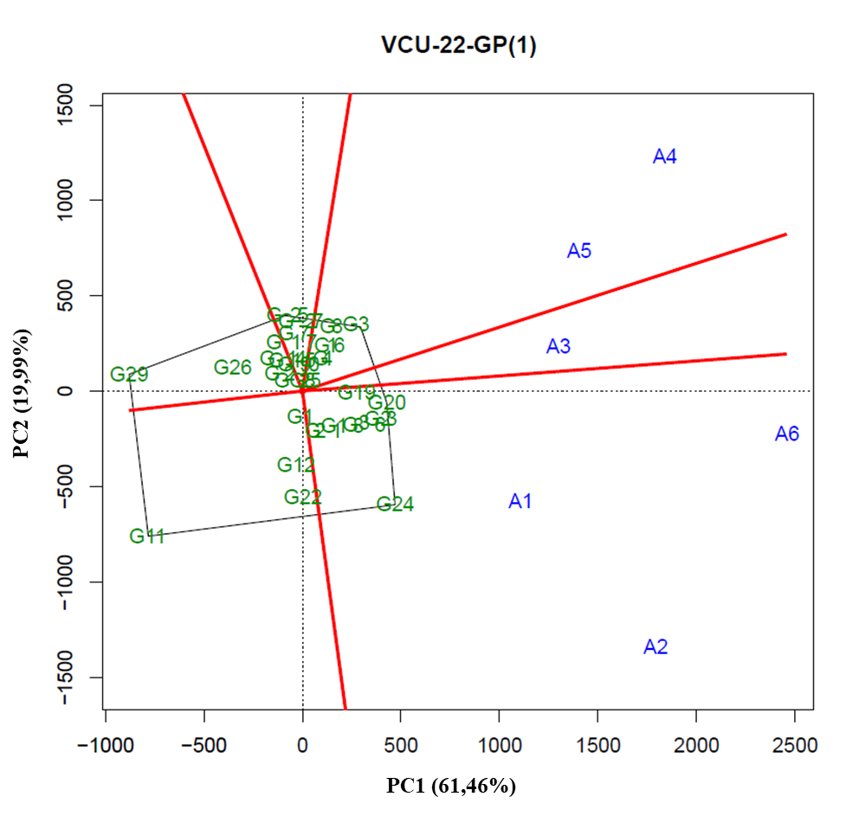
2.60 - GGE Biplot with the first two principal components (PC1 and PC2), corresponding to the representation of genotypes (numbers preceded by letter G) and environments (numbers preceded by letter A), for the identification of mega-environment in the planting sites of VCU 22 – GP(2) of the 2013/2014 crop season.
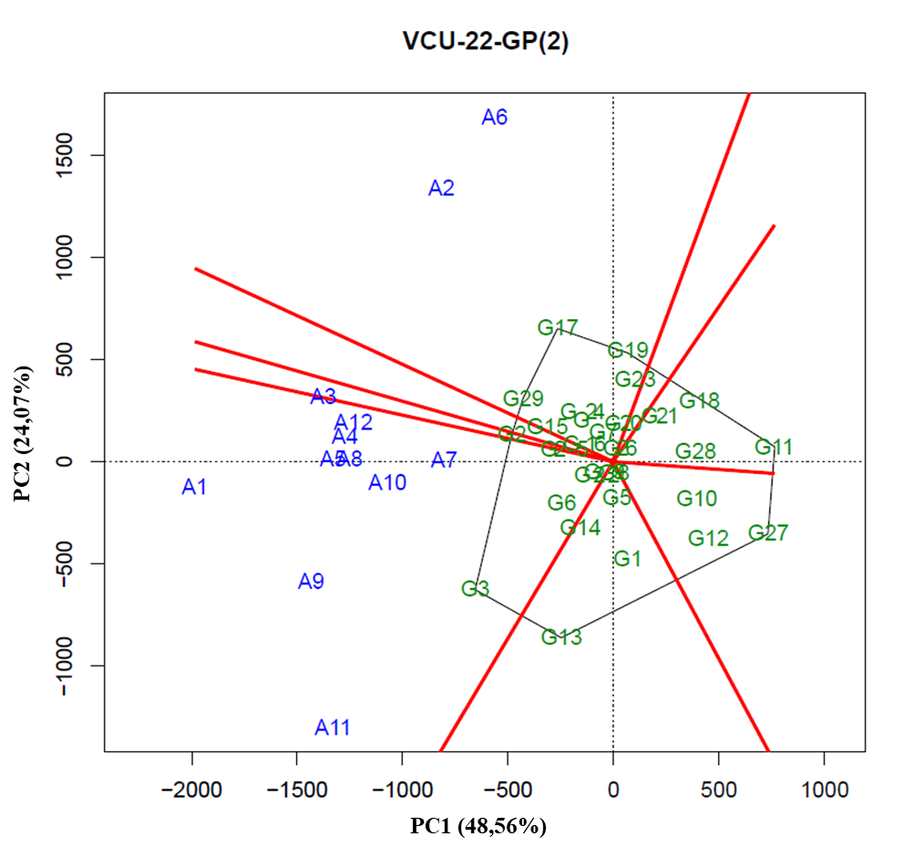
2.61 - GGE Biplot with the first two principal components (PC1 and PC2), corresponding to the representation of genotypes (numbers preceded by letter G) and environments (numbers preceded by letter A), for the identification of mega-environment in the planting sites of VCU 73 of the 2015/2016 crop season.
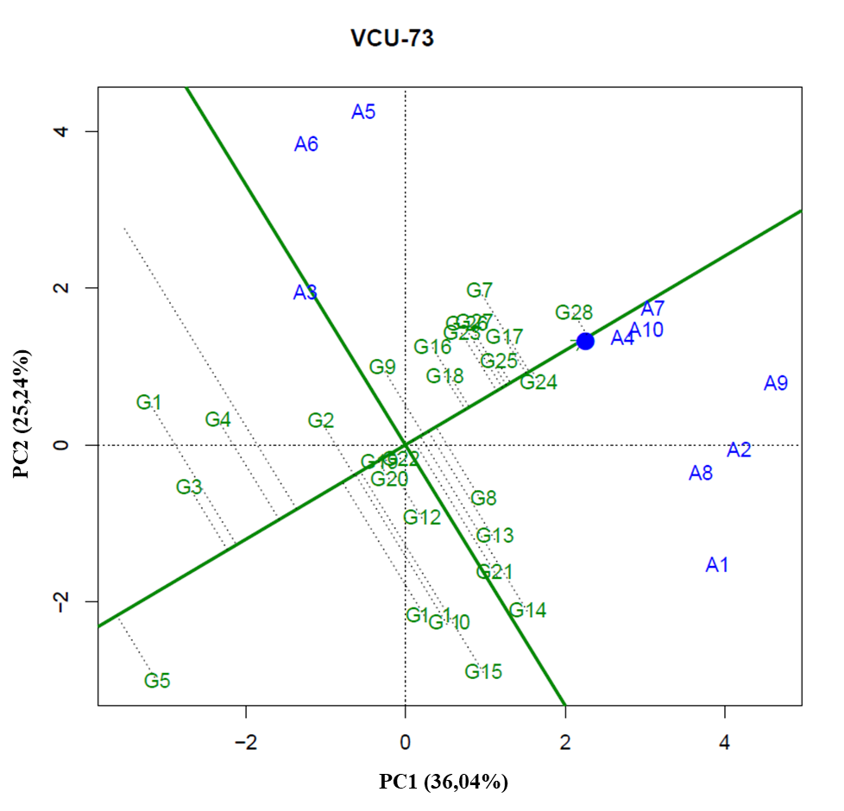
2.62 - GGE Biplot with the first two principal components (PC1 and PC2), corresponding to the representation of genotypes (numbers preceded by letter G) and environments (numbers preceded by letter A), for the identification of mega-environment in the planting sites of VCU 73 – GP(1) of the 2015/2016 crop season.
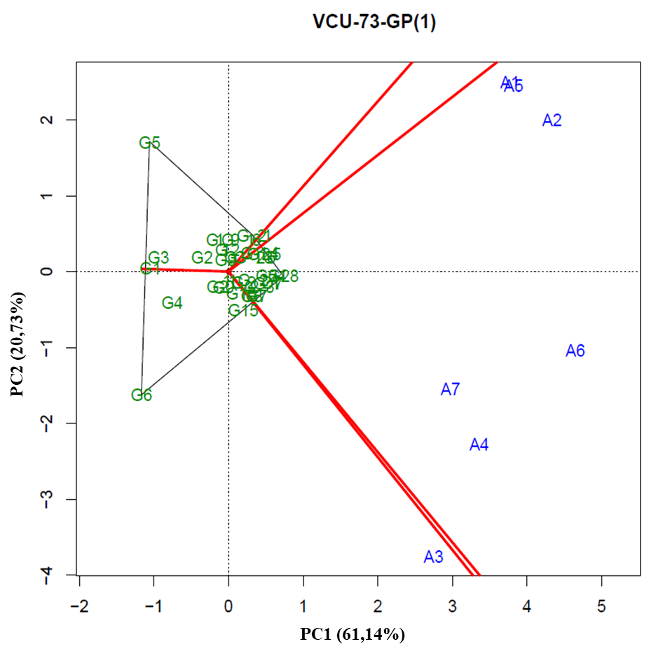
2.63 - GGE Biplot with the first two principal components (PC1 and PC2), corresponding to the representation of genotypes (numbers preceded by letter G) and environments (numbers preceded by letter A), for the identification of mega-environment in the planting sites of VCU 73 – GP(2) of the 2015/2016 crop season.
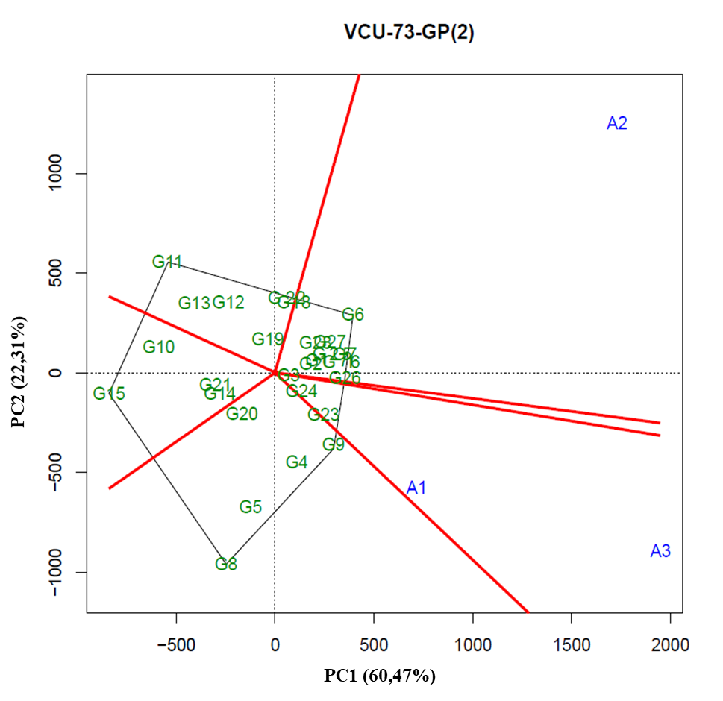
2.64 - GGE Biplot with the first two principal components (PC1 and PC2), corresponding to the representation of genotypes (numbers preceded by letter G) and environments (numbers preceded by letter A), for the identification of mega-environment in the planting sites of VCU 74 of the 2015/2016 crop season.
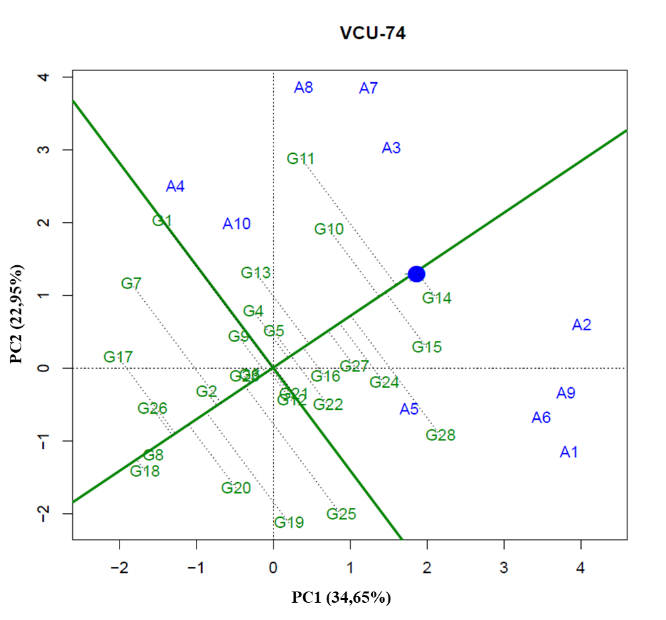
2.65 - GGE Biplot with the first two principal components (PC1 and PC2), corresponding to the representation of genotypes (numbers preceded by letter G) and environments (numbers preceded by letter A), for the identification of mega-environment in the planting sites of VCU 74 – GP(1) of the 2015/2016 crop season.
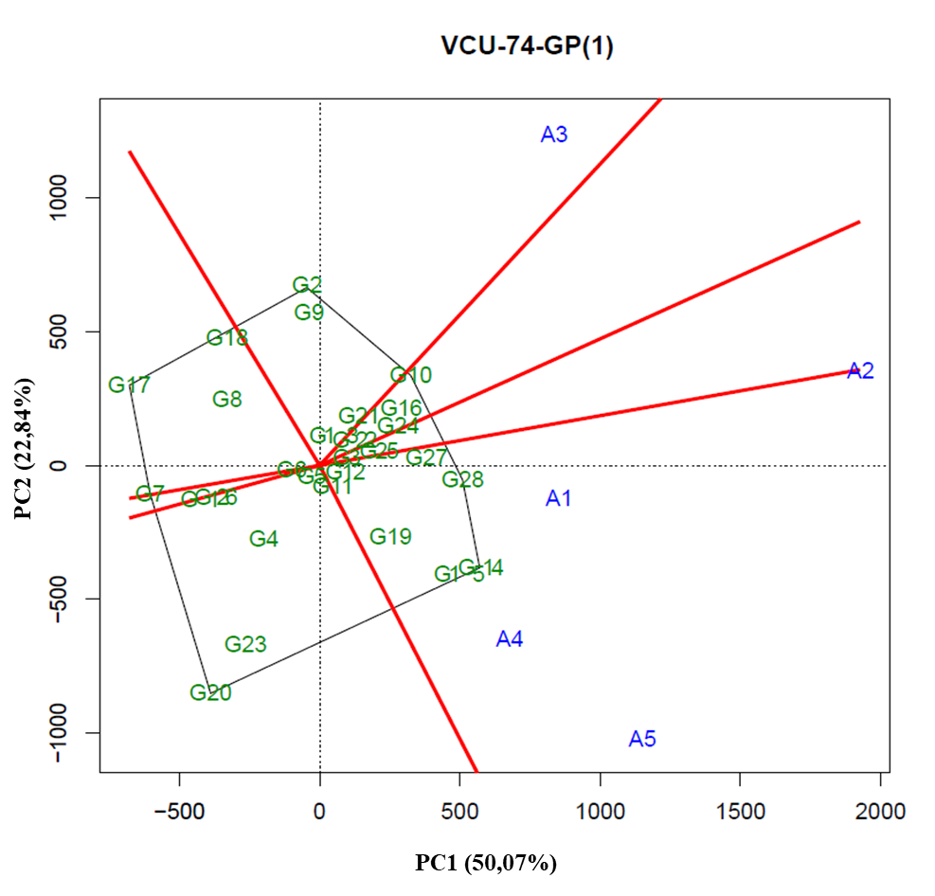
2.66 - GGE Biplot with the first two principal components (PC1 and PC2), corresponding to the representation of genotypes (numbers preceded by letter G) and environments (numbers preceded by letter A), for the identification of mega-environment in the planting sites of VCU 74 – GP(2) of the 2015/2016 crop season.
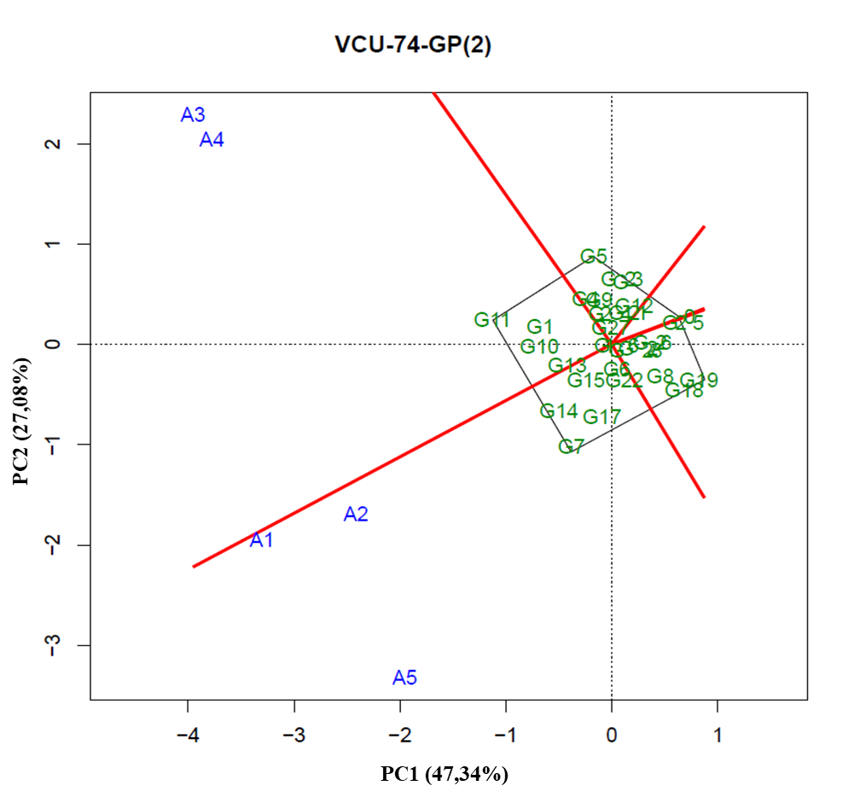
2.67 - GGE Biplot with the first two principal components (PC1 and PC2), corresponding to the representation of genotypes (numbers preceded by letter G) and environments (numbers preceded by letter A), for the identification of mega-environment in the planting sites of VCU 521 of the 2015/2016 crop season.
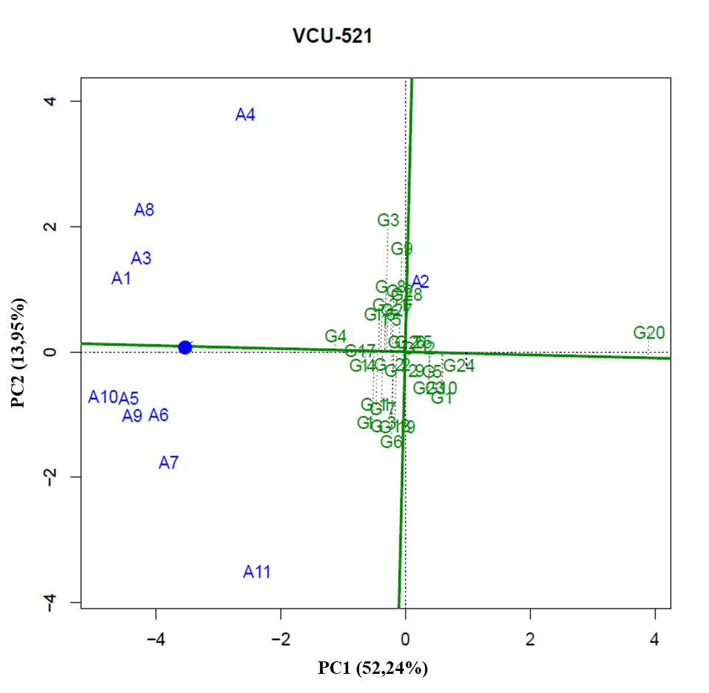
2.68 - GGE Biplot with the first two principal components (PC1 and PC2), corresponding to the representation of genotypes (numbers preceded by letter G) and environments (numbers preceded by letter A), for the identification of mega-environment in the planting sites of VCU 521 – GP(1) of the 2015/2016 crop season.
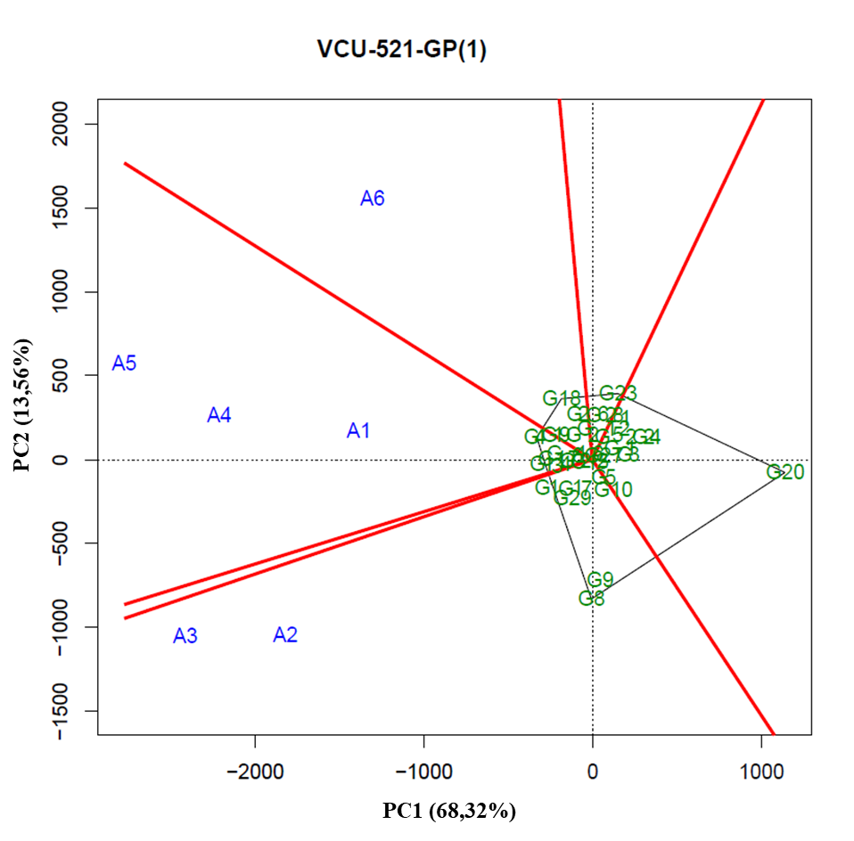
2.69 - GGE Biplot with the first two principal components (PC1 and PC2), corresponding to the representation of genotypes (numbers preceded by letter G) and environments (numbers preceded by letter A), for the identification of mega-environment in the planting sites of VCU 521 – GP(2) of the 2015/2016 crop season.
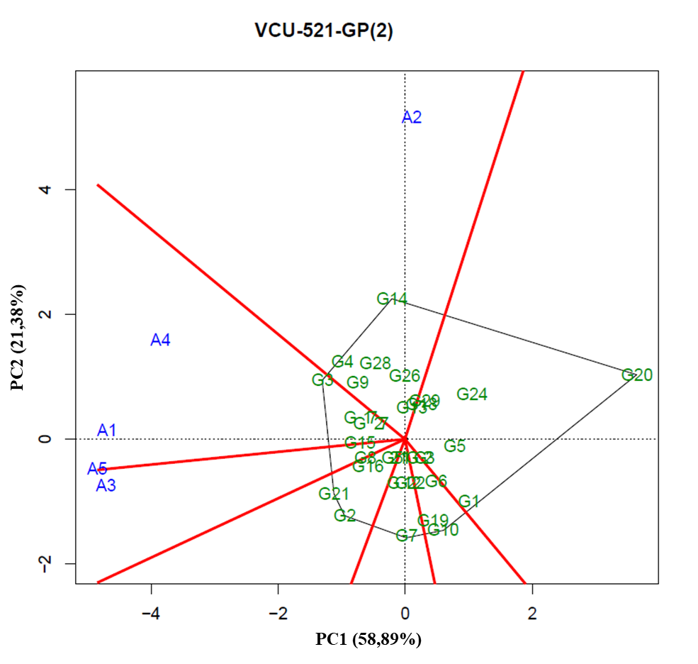
2.70 - GGE Biplot with the first two principal components (PC1 and PC2), corresponding to the representation of genotypes (numbers preceded by letter G) and environments (numbers preceded by letter A), for the identification of mega-environment in the planting sites of VCU 522 of the 2015/2016 crop season.
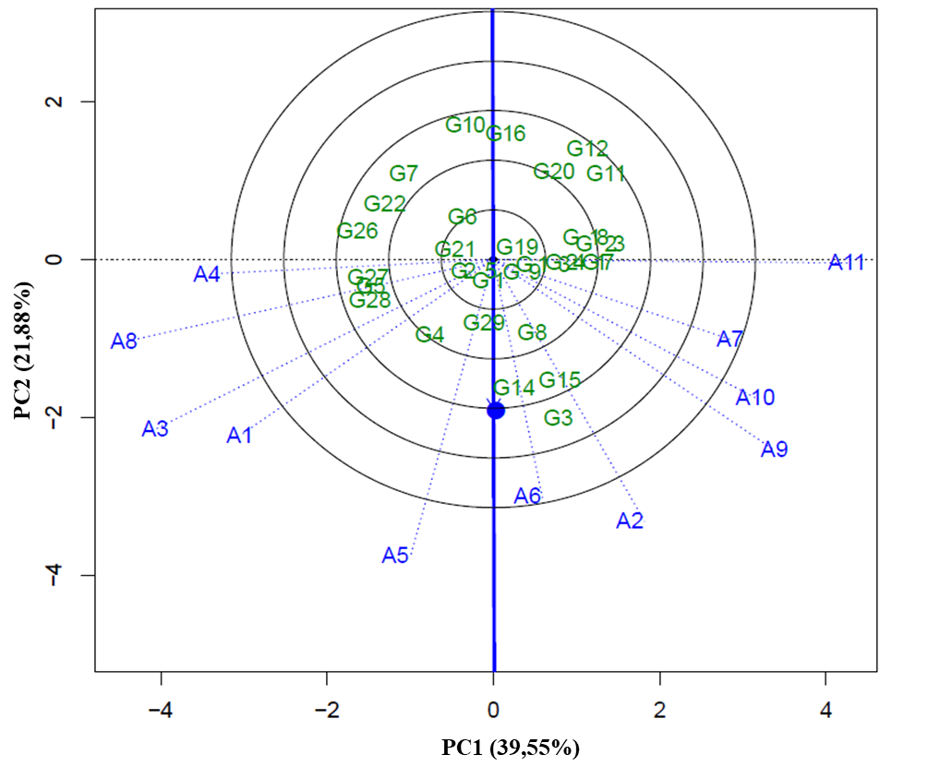
2.71 - GGE Biplot with the first two principal components (PC1 and PC2), corresponding to the representation of genotypes (numbers preceded by letter G) and environments (numbers preceded by letter A), for the identification of mega-environment in the planting sites of VCU 522 – GP(1) of the 2015/2016 crop season.
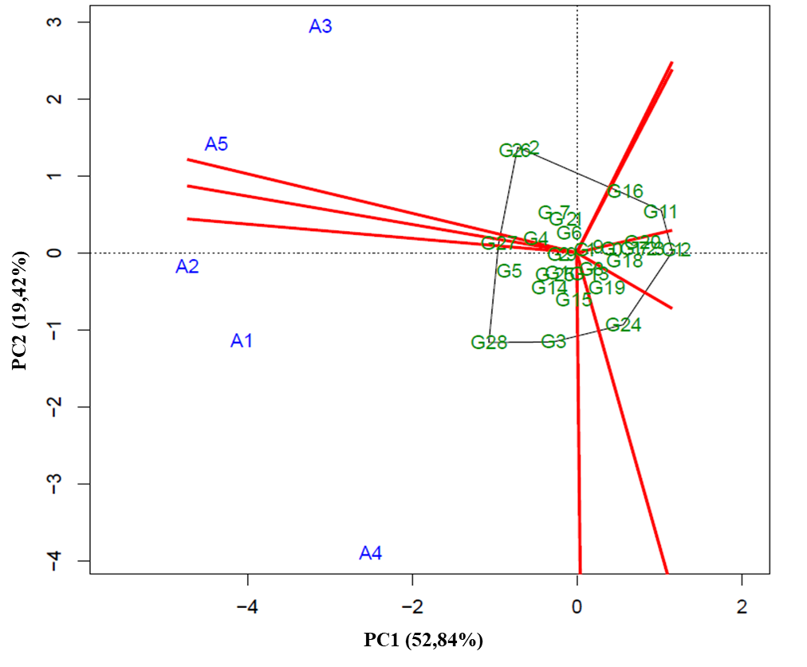
2.72 - GGE Biplot with the first two principal components (PC1 and PC2), corresponding to the representation of genotypes (numbers preceded by letter G) and environments (numbers preceded by letter A), for the identification of mega-environment in the planting sites of VCU 522 – GP(2) of the 2015/2016 crop season.
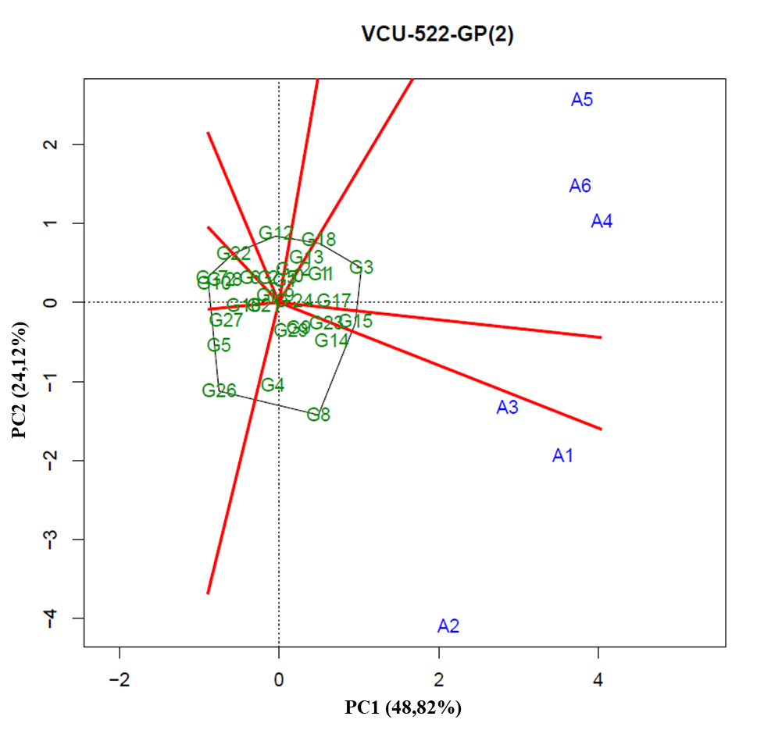
2.73 - GGE Biplot with the first two principal components (PC1 and PC2), corresponding to the representation of genotypes (numbers preceded by letter G) and environments (numbers preceded by letter A), for the identification of mega-environment in the planting sites of VCU 721 of the 2015/2016 crop season.
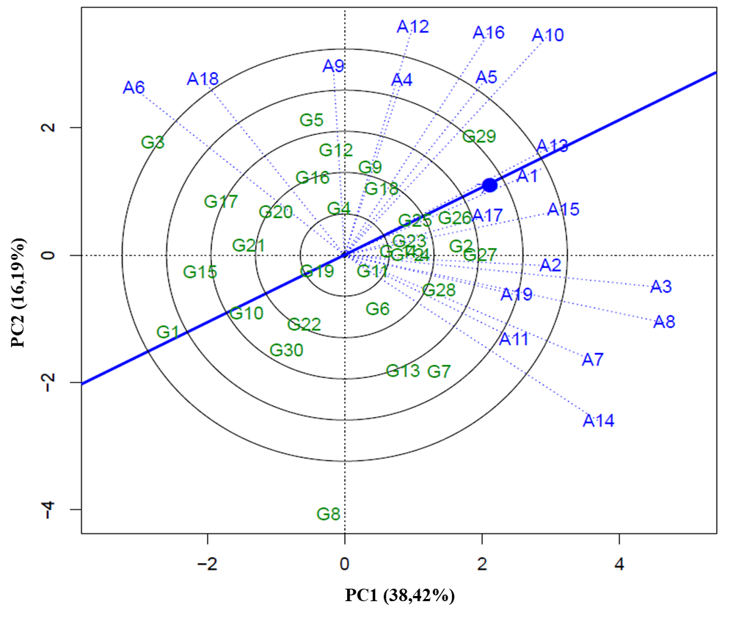
2.74 - GGE Biplot with the first two principal components (PC1 and PC2), corresponding to the representation of genotypes (numbers preceded by letter G) and environments (numbers preceded by letter A), for the identification of mega-environment in the planting sites of VCU 721 – GP(1) of the 2015/2016 crop season.
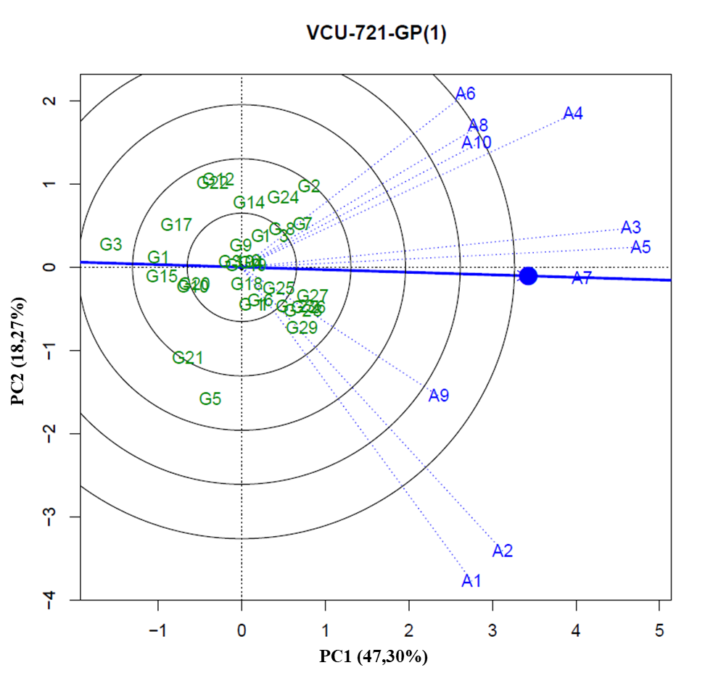
2.75 - GGE Biplot with the first two principal components (PC1 and PC2), corresponding to the representation of genotypes (numbers preceded by letter G) and environments (numbers preceded by letter A), for the identification of mega-environment in the planting sites of VCU 721 – GP(1 - 1) of the 2015/2016 crop season.
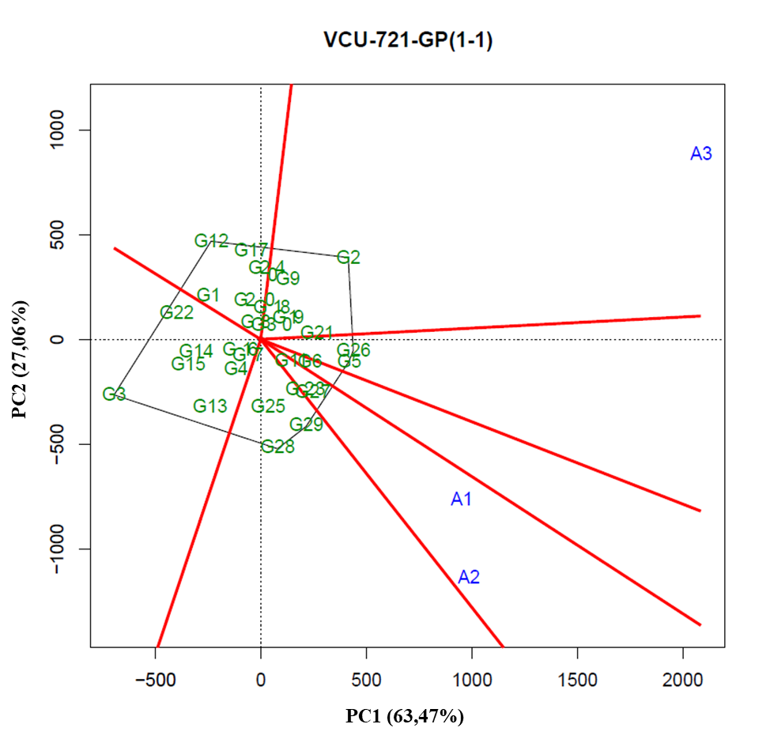
2.76 - GGE Biplot with the first two principal components (PC1 and PC2), corresponding to the representation of genotypes (numbers preceded by letter G) and environments (numbers preceded by letter A), for the identification of mega-environment in the planting sites of VCU 721 – GP(1 - 2) of the 2015/2016 crop season.
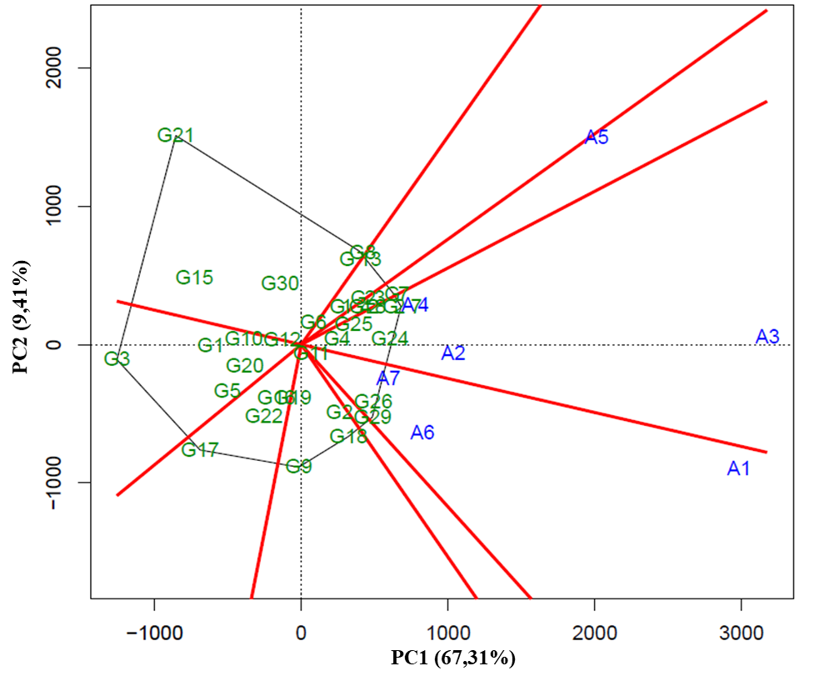
2.77 - GGE Biplot with the first two principal components (PC1 and PC2), corresponding to the representation of genotypes (numbers preceded by letter G) and environments (numbers preceded by letter A), for the identification of mega-environment in the planting sites of VCU 721 – GP(2) of the 2015/2016 crop season.
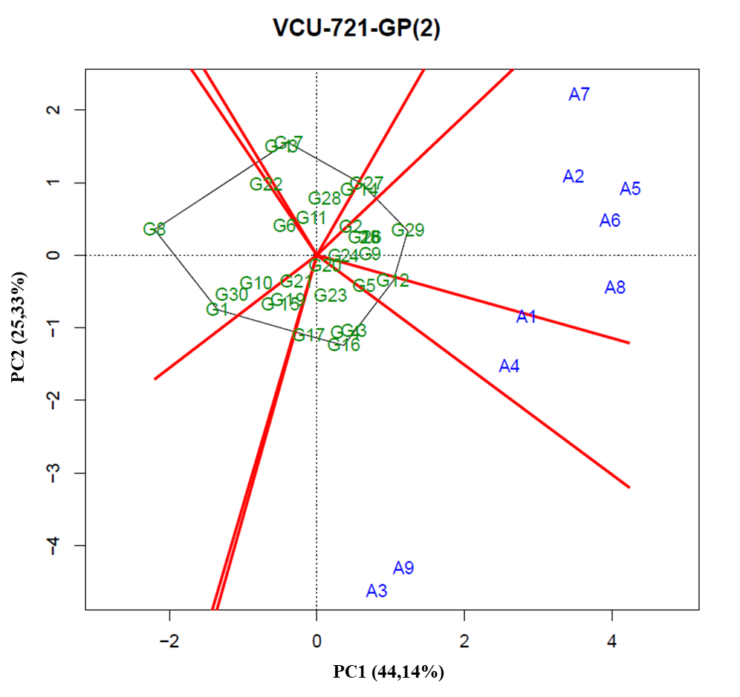
2.78 - GGE Biplot with the first two principal components (PC1 and PC2), corresponding to the representation of genotypes (numbers preceded by letter G) and environments (numbers preceded by letter A), for the identification of mega-environment in the planting sites of VCU 722 of the 2015/2016 crop season.
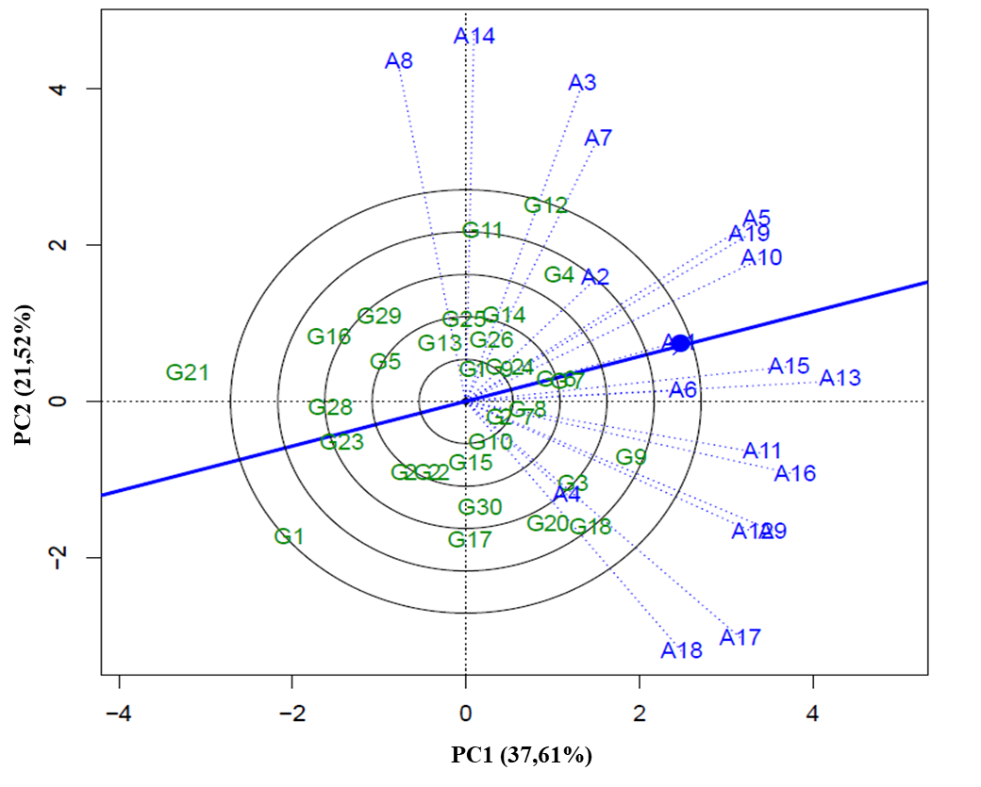
2.79 - GGE Biplot with the first two principal components (PC1 and PC2), corresponding to the representation of genotypes (numbers preceded by letter G) and environments (numbers preceded by letter A), for the identification of mega-environment in the planting sites of VCU 722 – GP(1) of the 2015/2016 crop season.
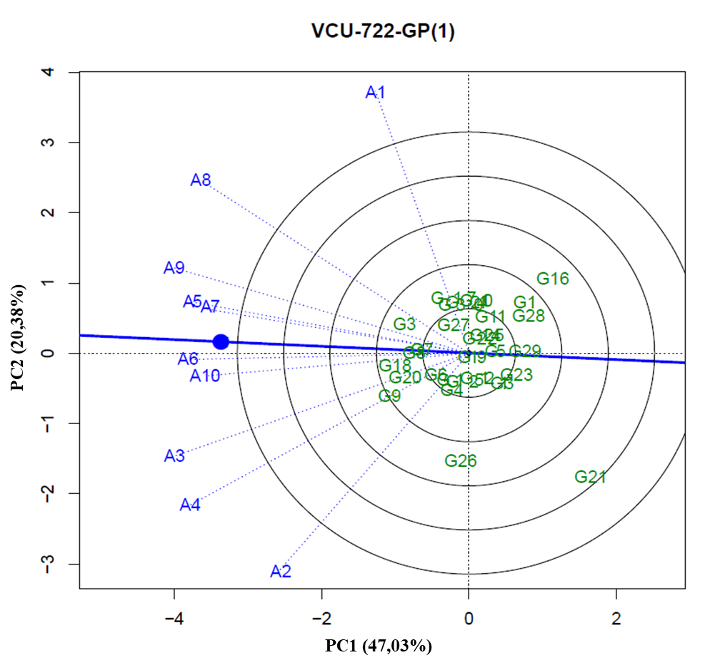
2.80 - GGE Biplot with the first two principal components (PC1 and PC2), corresponding to the representation of genotypes (numbers preceded by letter G) and environments (numbers preceded by letter A), for the identification of mega-environment in the planting sites of VCU 722 – GP(1 - 1) of the 2015/2016 crop season.
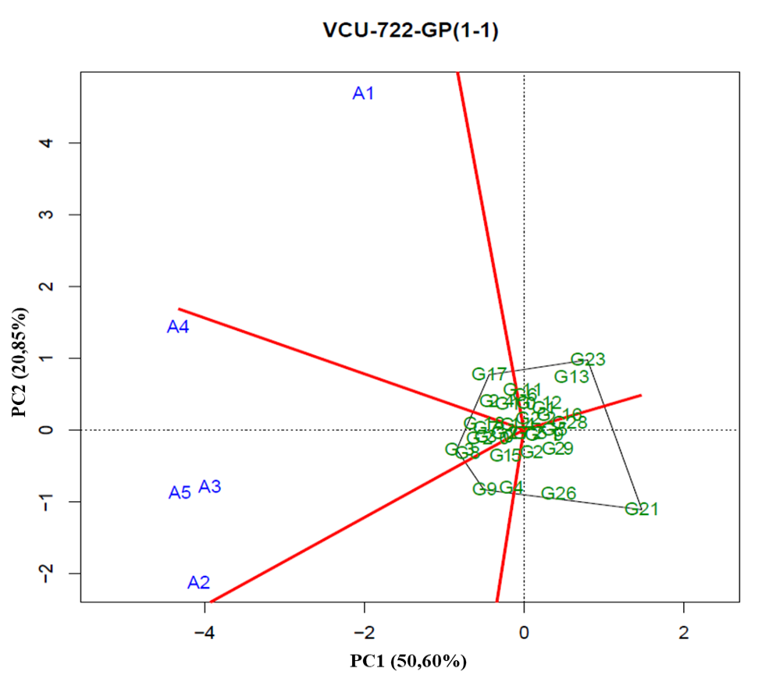
2.81 - GGE Biplot with the first two principal components (PC1 and PC2), corresponding to the representation of genotypes (numbers preceded by letter G) and environments (numbers preceded by letter A), for the identification of mega-environment in the planting sites of VCU 722 – GP(1 – 2) of the 2015/2016 crop season.
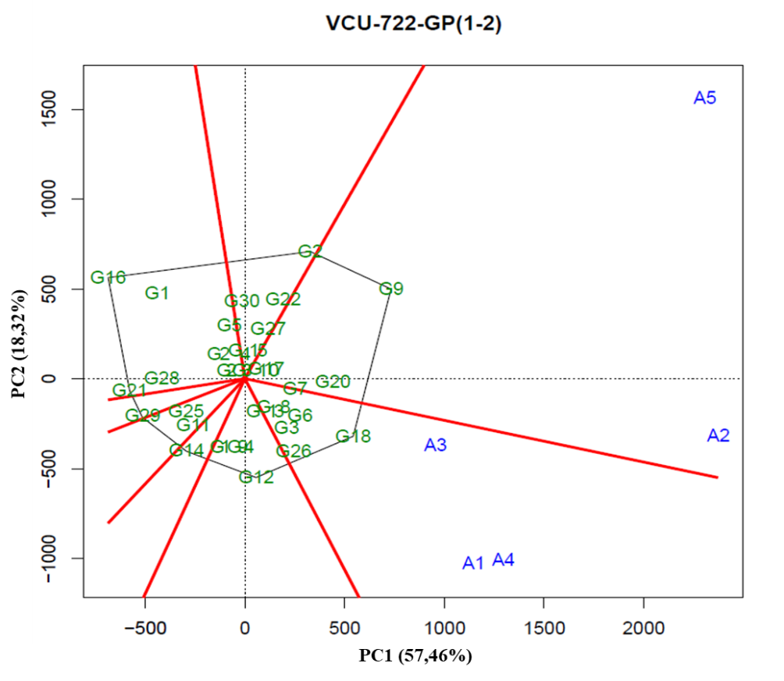
2.82 - GGE Biplot with the first two principal components (PC1 and PC2), corresponding to the representation of genotypes (numbers preceded by letter G) and environments (numbers preceded by letter A), for the identification of mega-environment in the planting sites of VCU 722 – GP(2) of the 2015/2016 crop season.
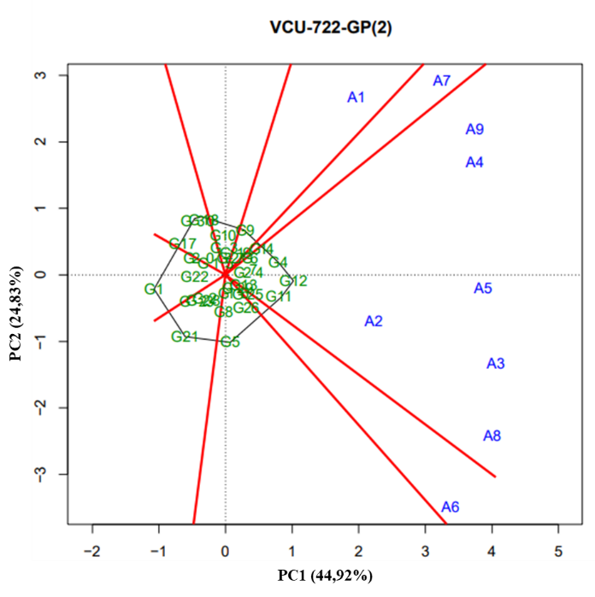

SUPPLEMENTARY MATERIAL 3

3.1 –Summary of the variance analysis for the data of line yield and cultivars evaluated in VCUs in the 2011/2012 crop season.
Sources of Variation | Degree of Freedom |  |  |  |  | Mean Square
Sources of Variation | VCU 1 | VCU 11 | VCU 21 | VCU 22 |  | VCU 1 | VCU 11 | VCU 21 | VCU 22
Blocks/Environments | 8 | 10 | 32 | 32 |  | 304391,11** | 133247,61** | 181237,01** | 203620,80**
Genotypes (G) | 29 | 28 | 29 | 25 |  | 1473010,36** | 2332615,90** | 2643335,58** | 1361120,72**
Environment (A) | 3 | 4 | 15 | 15 |  | 93397279,83** | 5075198,89** | 102231082,85** | 78166226,04**
GxE | 87 | 112 | 435 | 375 |  | 553915,04** | 2358179,55** | 393728,05** | 374116,26**
Residue | 232 | 280 | 928 | 800 |  | 262042,05** | 217706,06** | 192909,57** | 191155,62**
Mean | - | - | - | - |  | 3403,08 | 3576,09 | 3911,71 | 4045,87
CV (%) | - | - | - | - |  | 15,04 | 13,05 | 11,23 | 10,81

Sources of Variation | Degree of Freedom |  |  |  |  | Mean Square
Sources of Variation | VCU 23 | VCU 24 | VCU 25 | VCU 26 |  | VCU 23 | VCU 24 | VCU 25 | VCU 26
Blocks/Environments | 36 | 36 | 24 | 26 |  | 128545,75** | 245809,53** | 276230,86** | 162333,05**
Genotypes (G) | 29 | 29 | 26 | 22 |  | 1585077,74** | 1085093,19** | 1.224.243,28** | 961741,71**
Environment (A) | 17 | 17 | 11 | 12 |  | 114352267,36** | 103257925,81** | 140601619,96** | 43250145,74**
GxE | 493 | 493 | 286 | 264 |  | 406001,04** | 354106,63** | 917370,11** | 431808,94**
Residue | 1044 | 1044 | 624 | 572 |  | 168529,88** | 181033,45** | 180499,30** | 202958,10**
Mean | - | - | - | - |  | 3998,23 | 3920,58 | 4065,04 | 3720,96
CV (%) | - | - | - | - |  | 10,27 | 10,85 | 10,45 | 12,11

Sources of Variation |  | Degree of Freedom |  |  |  |  |  |  |  | Mean Square
 |  | VCU 121 |  | VCU 122 |  | VCU 123 |  |  |  | VCU 121 |  | VCU 122 |  | VCU 123
Blocks/Environments |  | 30 |  | 28 |  | 30 |  |  |  | 201418,39** |  | 305788,83** |  | 317016,29**
Genotypes (G) |  | 28 |  | 28 |  | 26 |  |  |  | 4746354,61** |  | 5891747,00** |  | 4716669,12**
Environment (A) |  | 14 |  | 13 |  | 14 |  |  |  | 72984896,32** |  | 56076629,60** |  | 46779333,18**
GxE |  | 392 |  | 364 |  | 364 |  |  |  | 684168,61** |  | 654670,55** |  | 528604,09**
Residue |  | 840 |  | 784 |  | 780 |  |  |  | 193226,89** |  | 206133,88** |  | 251233,12**
Mean |  | - |  | - |  | - |  |  |  | 3947,93 |  | 4164,88 |  | 4167,33**
CV (%) |  | - |  | - |  | - |  |  |  | 11,13 |  | 10,90 |  | 12,03**
Sources of Variation | Degree of Freedom |  |  |  |  |  |  |  |  | Mean Square
Sources of Variation | VCU 124 |  | VCU 125 |  | VCU 126 |  |  |  | VCU 124 |  | VCU 125 |  | VCU 126
Blocks/Environments | 32 |  | 26 |  | 26 |  |  |  | 219920,40** |  | 356571,13** |  | 299072,84**
Genotypes (G) | 26 |  | 29 |  | 28 |  |  |  | 3495062,24** |  | 2629047,02** |  | 1551681,61**
Environment (A) | 15 |  | 12 |  | 12 |  |  |  | 46476265,41** |  | 30081370,10** |  | 29377771,48**
GxE | 390 |  | 348 |  | 336 |  |  |  | 485333,03** |  | 687247,88** |  | 649072,28**
Residue | 832 |  | 754 |  | 728 |  |  |  | 249764,29** |  | 203800,23** |  | 210241,39**
Mean | - |  | - |  | - |  |  |  | 4131,26 |  | 3968,63 |  | 4146,34
CV (%) | - |  | - |  | - |  |  |  | 12,10 |  | 11,38 |  | 11,06
** = significant at 0,01 of probability by the F test.

3.2 – Summary of the variance analysis for the data of line yield and cultivars evaluated in VCUs in the 2011/2012 crop season.
Sources of Variation |  | Degree of Freedom |  |  |  |  |  |  |  |  |  |  | Mean Square
 |  | VCU 2 |  | VCU 11 |  | VCU 15 |  |  | VCU 21 |  |  |  | VCU 2 |  | VCU 11 |  |  | VCU 15 |  |  | VCU 21
Blocks/Environments |  | 16 |  | 14 |  | 8 |  |  | 16 |  |  |  | 449331,45** |  | 258.307,40** |  |  | 82978,98** |  |  | 346610,79**
Genotypes (G) |  | 29 |  | 29 |  | 29 |  |  | 28 |  |  |  | 1983092,89** |  | 9561569,13** |  |  | 1198258,23** |  |  | 5240731,85**
Environment (A) |  | 7 |  | 6 |  | 3 |  |  | 7 |  |  |  | 269935657,92** |  | 62590994,54** |  |  | 142130313,88** |  |  | 107993478,20**
GxE |  | 203 |  | 174 |  | 87 |  |  | 196 |  |  |  | 129430,97** |  | 1048171,39** |  |  | 242905,93** |  |  | 586332,97**
Residue |  | 464 |  | 406 |  | 232 |  |  | 448 |  |  |  | 302601,32** |  | 233826,84** |  |  | 97249,30** |  |  | 254333,45**
Mean |  | - |  | - |  | - |  |  | - |  |  |  | 4205,07 |  | 4585,85 |  |  | 3279,07 |  |  | 4740,27
CV (%) |  | - |  | - |  | - |  |  | - |  |  |  | 13,08 |  | 10,54 |  |  | 9,51 |  |  | 10,64
Sources of Variation | Degree of Freedom |  |  |  |  |  |  |  |  |  |  |  | Mean Square
Sources of Variation | VCU 22 |  |  | VCU 23 |  |  | VCU 24 |  |  | VCU 25 |  |  | VCU 22 | VCU 23 |  |  | VCU 24 |  |  | VCU 25
Blocks/Environments | 18 |  |  | 34 |  |  | 32 |  |  | 32 |  |  | 196562,51** | 348857,58** |  |  | 231383,89** |  |  | 210831,49**
Genotypes (G) | 29 |  |  | 29 |  |  | 29 |  |  | 29 |  |  | 5331349,35** | 3694543,06** |  |  | 3063050,54** |  |  | 1019499,67**
Environment (A) | 8 |  |  | 16 |  |  | 15 |  |  | 15 |  |  | 91252636,17** | 224117350,96** |  |  | 164097177,54** |  |  | 108073067,99**
GxE | 232 |  |  | 464 |  |  | 435 |  |  | 435 |  |  | 583851,93** | 364449,95** |  |  | 534364,50** |  |  | 834433,23**
Residue | 522 |  |  | 986 |  |  | 928 |  |  | 928 |  |  | 246825,40** | 175942,84** |  |  | 202410,07** |  |  | 160930,03**
Mean | - |  |  | - |  |  | - |  |  | - |  |  | 4890,29 | 4064,40 |  |  | 4116,88 |  |  | 3747,93
CV (%) | - |  |  | - |  |  | - |  |  | - |  |  | 10,16 | 10,32 |  |  | 10,93 |  |  | 10,70
Sources of Variation |  |  | Degree of Freedom |  |  |  |  |  |  |  |  |  | Mean Square
 |  |  | VCU 26 |  | VCU 27 |  |  | VCU 28 |  |  |  |  | VCU 26 |  |  | VCU 27 |  |  | VCU 28
Blocks/Environments |  |  | 30 |  | 26 |  |  | 28 |  |  |  |  | 275381,24** |  |  | 213576,56** |  |  | 159892,39**
Genotypes (G) |  |  | 29 |  | 29 |  |  | 29 |  |  |  |  | 2531346,86** |  |  | 3855323,16** |  |  | 4069607,48**
Environment (A) |  |  | 14 |  | 12 |  |  | 13 |  |  |  |  | 199310689,81** |  |  | 184870853,68** |  |  | 163039241,95**
GxE |  |  | 406 |  | 348 |  |  | 377 |  |  |  |  | 379431,26** |  |  | 676533,64** |  |  | 839026,32**
Residue |  |  | 870 |  | 754 |  |  | 812 |  |  |  |  | 16669525533,00** |  |  | 148631,66** |  |  | 146889,53**
Mean |  |  | - |  | - |  |  | - |  |  |  |  | 4164,26 |  |  | 3826,66 |  |  | 3708,58
CV (%) |  |  | - |  | - |  |  | - |  |  |  |  | 9,80 |  |  | 10,07 |  |  | 10,33
** = significant at 0,01 of probability by the F test.
3.3 – Summary of the variance analysis for the data of line yield and cultivars evaluated in VCUs in the 2013/2014 crop season.
Sources of Variation | Degree of Freedom |  |  |  |  |  |  | Mean Square
Sources of Variation | VCU 3 | VCU 4 |  | VCU 11 |  |  |  | VCU 3 |  | VCU 4 |  | VCU 11
Blocks/Environments | 18 | 16 |  | 4 |  |  |  | 108497,54** |  | 109811,19** |  | 86448,94**
Genotypes (G) | 28 | 28 |  | 25 |  |  |  | 2227655,41** |  | 3277901,41** |  | 10968942,62**
Environment (A) | 8 | 7 |  | 1 |  |  |  | 78244190,39** |  | 64825653,31** |  | 50193116,31**
GxE | 224 | 196 |  | 25 |  |  |  | 1198489,61** |  | 1285018,89** |  | 7519944,03**
Residue | 504 | 448 |  | 100 |  |  |  | 144624,46** |  | 159959,71** |  | 130699,38**
Mean | - | - |  | - |  |  |  | 3356,88 |  | 3566,92 |  | 3615,97
CV (%) | - | - |  | - |  |  |  | 11,33 |  | 11,21 |  | 10,00
Sources of Variation | Degree of Freedom |  |  |  |  |  |  |  | Mean Square
Sources of Variation | VCU 21 |  | VCU 22 |  | VCU 24 |  |  |  | VCU 21 |  | VCU 22 | VCU 24
Blocks/Environments | 36 |  | 36 |  | 18 |  |  |  | 153053,17** |  | 244324,53** | 93699,78**
Genotypes (G) | 29 |  | 28 |  | 29 |  |  |  | 2096898,58** |  | 2146373,29** | 11437479,22**
Environment (A) | 17 |  | 17 |  | 8 |  |  |  | 48878720,56** |  | 41742621,82** | 71342503,41**
GxE | 493 |  | 476 |  | 232 |  |  |  | 311659,16** |  | 362393,61** | 441693,01**
Residue | 1044 |  | 1008 |  | 522 |  |  |  | 175683,00** |  | 159853,47** | 136323,64**
Mean | - |  | - |  | - |  |  |  | 3402,00 |  | 3547,34 | 3245,55
CV (%) | - |  | - |  | - |  |  |  | 12,32 |  | 11,27 | 11,37
** = significant at 0,01 of probability by the F test.

3.4 – Summary of the variance analysis for the data of line yield and cultivars evaluated in VCUs in the 2015/2016 crop season.
Sources of Variation | Degree of Freedom |  |  |  |  |  |  | Mean Square
Sources of Variation | VCU 73 | VCU 74 |  | VCU 521 |  |  |  | VCU 73 |  | VCU 74 |  | VCU 521
Blocks/Environments | 20 | 20 |  | 22 |  |  |  | 542030,77** |  | 403337,39** |  | 537007,40**
Genotypes (G) | 27 | 27 |  | 28 |  |  |  | 2704775,23** |  | 664602,58** |  | 3608248,14**
Environment (A) | 9 | 9 |  | 10 |  |  |  | 46205762,99** |  | 41873982,92** |  | 83912518,04**
GxE | 243 | 243 |  | 280 |  |  |  | 732431,69** |  | 302034,84** |  | 390564,99**
Residue | 540 | 540 |  | 616 |  |  |  | 367320,99** |  | 174210,57** |  | 172916,67**
Mean | - | - |  | - |  |  |  | 4017,05 |  | 4287,16 |  | 4023,57
CV (%) | - | - |  | - |  |  |  | 15,09 |  | 9,74 |  | 10,33
Sources of Variation | Degree of Freedom |  |  |  |  |  |  |  | Mean Square
Sources of Variation | VCU 522 |  | VCU 721 |  | VCU 722 |  |  |  | VCU 522 |  | VCU 721 |  | VCU 722
Blocks/Environments | 22 |  | 38 |  | 38 |  |  |  | 352030,00** |  | 237.26,49** |  | 274640,66**
Genotypes (G) | 28 |  | 29 |  | 29 |  |  |  | 691566,73** |  | 1615318,01** |  | 1843959,96**
Environment (A) | 10 |  | 18 |  | 18 |  |  |  | 65404959,81** |  | 37582880,61** |  | 41180269,17**
GxE | 280 |  | 522 |  | 522 |  |  |  | 561361,92** |  | 368385,71** |  | 352259,47**
Residue | 616 |  | 1102 |  | 1102 |  |  |  | 249288,42** |  | 161612,02** |  | 169726,12**
Mean | - |  | - |  | - |  |  |  | 4108,66** |  | 4089,87 |  | 4109,89
CV (%) | - |  | - |  | - |  |  |  | 12,15** |  | 9,83 |  | 10,02
** = significant at 0,01 of probability by the F test.

Referências

Cruz, C. D. (2013). GENES - Software para análise de dados em estatística experimental e em genética quantitativa. Acta Scientiarum - Agronomy, 35(3), 271–276. https://doi.org/10.4025/actasciagron.v35i3.21251
Cruz, C. D., & R, A. J. (2007). Modelos Biométricos Aplicados ao Melhoramento Genético (4th ed.). Editora UFV.
Hühn, M., & Truberg, B. (2002). Contributions to the analysis of genotype x environment interactions: Theoretical results of the application and comparison of clustering techniques for the stratification of field test sites. Journal of Agronomy and Crop Science, 188(2), 65–72. https://doi.org/10.1046/j.1439-037X.2002.00549.x
Kaster, M. (2012). Regionalização dos testes de Valor de Cultivo e Uso e da indicação de cultivares de soja - terceira Aproximação. 231–235.
Marcolin, F., & Vezzetti, E. (2017). Novel descriptors for geometrical 3D face analysis. Multimedia Tools and Applications, 76(12), 13805–13834. https://doi.org/10.1007/s11042-016-3741-3
Oliveira;, A. M. da S. de, Hamawaki, O. T., Neto, J. O. de O., Penna, J. C. V., Juliatti, F. C., Souza, S. A. de, Hühn, M., Truberg, B., Cruz, C. D., R, A. J., & Egazzi. (2007). Modelos Biométrocos Aplicados ao Melhoramento Genético. In Journal of Agronomy and Crop Science (4th ed., Vol. 188, Issue 2). Editora UFV. https://doi.org/10.1046/j.1439-037X.2002.00549.x
R, (CoreTeam). (2017). R: A Language and Environment for Statistical Computing. 2, 1–12. https://www.r-project.org/
Silva, R. R., & Benin, G. (2012). Análises Biplot: conceitos, interpretações e aplicações. Ciência Rural, 42(8), 1404–1412. https://doi.org/10.1590/s0103-84782012000800012
Silva, R. R., Benin, G., Silva, G. O. da, Marchioro, V. S., Almeida, J. L. de, & Gilvani Matei. (2008). Adaptabilidade e estabilidade de cultivares de soja em quatro épocas de semeadura no sul do Estado do Tocantins. Revista Ceres, 55(1), 34–40.
Woyann, L. G., Benin, G., Storck, L., Trevizan, D. M., Meneguzzi, C., Marchioro, V. S., Tonatto, M., & Madureira, A. (2017). Estimation of missing values affects important aspects of GGE biplot analysis. Crop Science, 57(1), 40–52. https://doi.org/10.2135/cropsci2016.02.0100
Yan, W. (2001). GGEbiplot - A windows application for graphical analysis of multienvironment trial data and other types of two-way data. Agronomy Journal, 93(5), 1111–1118. https://doi.org/10.2134/agronj2001.9351111x
Yan, Weikai. (2015). Mega-environment Analysis and Test Location Evaluation Based on Unbalanced Multiyear Data. Crop Science, 55(1), 113–122. https://doi.org/10.2135/cropsci2014.03.0203
Yan, WeiKai. (2011). GGE biplot vs. AMMI graphs for genotype-by-environment data analysis. Journal of the Indian Society of Agricultural Statistics, 95, 181–193. https://www.cabdirect.org/cabdirect/abstract/20113313412
Yan, Weikai, & Frégeau-Reid, J. (2018). Genotype by Yield∗Trait (GYT) Biplot: A Novel Approach for Genotype Selection based on Multiple Traits. Scientific Reports, 8(1), 1–10. https://doi.org/10.1038/s41598-018-26688-8
Yan, Weikai, Hunt, L. A., Sheng, Q., & Szlavnics, Z. (2000). Cultivar evaluation and mega-environment investigation based on the GGE biplot. Crop Science, 40(3), 597–605. https://doi.org/10.2135/cropsci2000.403597x
Yan, Weikai, Kang, M. S., Ma, B., Woods, S., & Cornelius, P. L. (2007). GGE biplot vs. AMMI analysis of genotype-by-environment data. Crop Science, 47(2), 643–655. https://doi.org/10.2135/cropsci2006.06.0374
Yan, Weikai, & Tinker, N. A. (2006). Biplot analysis of multi-environment trial data: Principles and applications. Canadian Journal of Plant Science, 86(3), 623–645. https://doi.org/10.4141/P05-169
Zdziarski, A. D., Woyann, L. G., Milioli, A. S., Zanella, R., Dallacorte, L. V, & Panho, M. C. (2019). Mega ‐ environment identification for soybean ( Glycine max ) breeding and production in Brazilian Midwest region. July 2018, 336–347. https://doi.org/10.1111/pbr.12693

