English-language versions of the study-developed instruments
Supplementary Appendix S1. Demographic Questionnaire
Please select the response that best describes you or enter the requested information. Responses are anonymous and will be used only for research purposes.
1. Sex
☐ Male ☐ Female
2. Age
☐ ______ years
3. Ethnicity
☐ Han Chinese ☐ Ethnic minority
4. Academic track in high school
☐ Science track ☐ Humanities track
5. Education level
☐ Bachelor’s degree ☐ Junior college
6. Place of residence
☐ Rural ☐ Urban
7. Only child
☐ Yes ☐ No
8. Monthly household income (RMB)
☐ ≤8,000 ☐ 8,001–15,000 ☐ 15,001–25,000 ☐ 25,001–40,000 ☐ ≥40,001 ☐ No stable income
9. Father’s (or primary caregiver’s) education
☐ Primary school or below ☐ Junior high school ☐ Senior high/technical secondary school ☐ Junior college or above
10. Mother’s (or primary caregiver’s) education
☐ Primary school or below ☐ Junior high school ☐ Senior high/technical secondary school ☐ Junior college or above
11. Grade point average
☐ ≤2.5 (inclusive) ☐ 2.5–3.5 ☐ ≥3.5 (inclusive)
12. Duration of clinical placement
☐ ______ months
13. Previous pediatric orthopedic rotation
☐ Yes ☐ No
14. Transferred into the nursing major
☐ Yes ☐ No

Supplementary Appendix S2. DDH Classification Test
Examine each anteroposterior pelvic radiograph and classify the indicated hip.
Response format: 1) Classify the indicated hip as normal or abnormal; 2) if abnormal, assign an International Hip Dysplasia Institute (IHDI) grade (type I, II, III, or IV). Each item is worth 5 points: 2 points for correctly determining whether the indicated hip is normal or abnormal and 3 points for correctly assigning the IHDI classification. The total score ranges from 0 to 60, with higher scores indicating greater mastery of DDH classification.
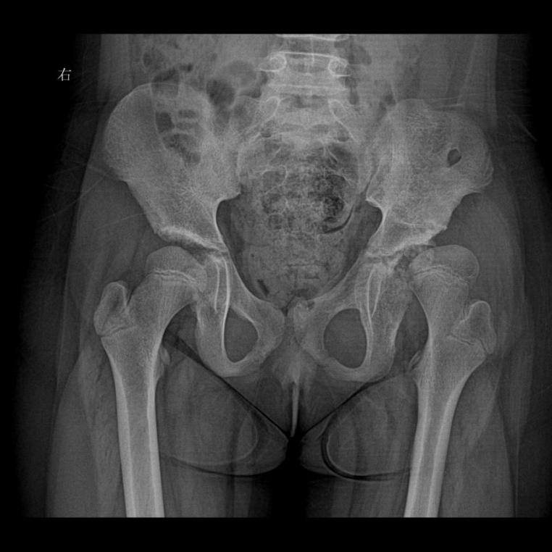
- Item 1 Age: 9 years Hip to be assessed: Left
1. ☐ Normal ☐ Abnormal
2. IHDI classification: ☐ Type I ☐ Type II ☐ Type III ☐ Type IV
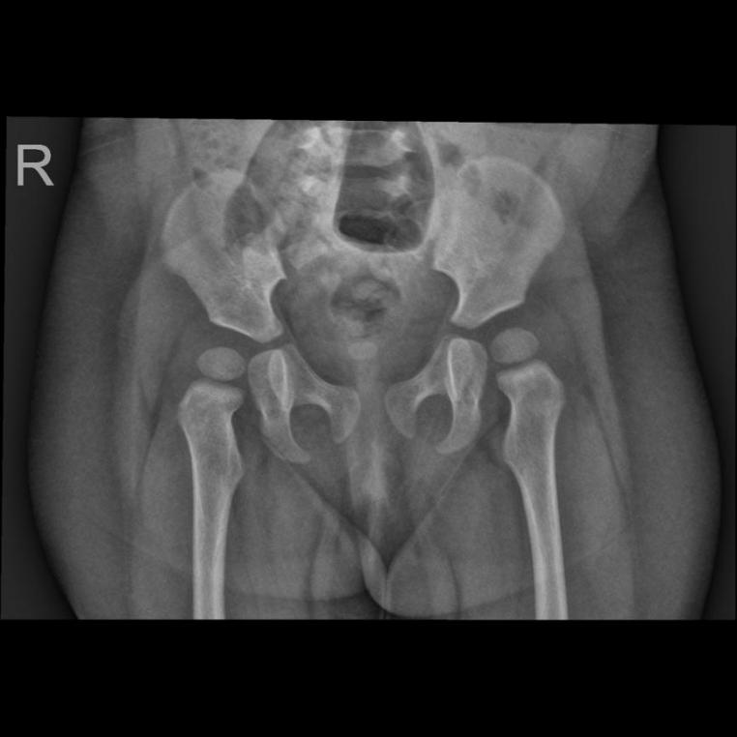
- Item 2 Age: 9 months Hip to be assessed: Right
1. ☐ Normal ☐ Abnormal
2. IHDI classification: ☐ Type I ☐ Type II ☐ Type III ☐ Type IV
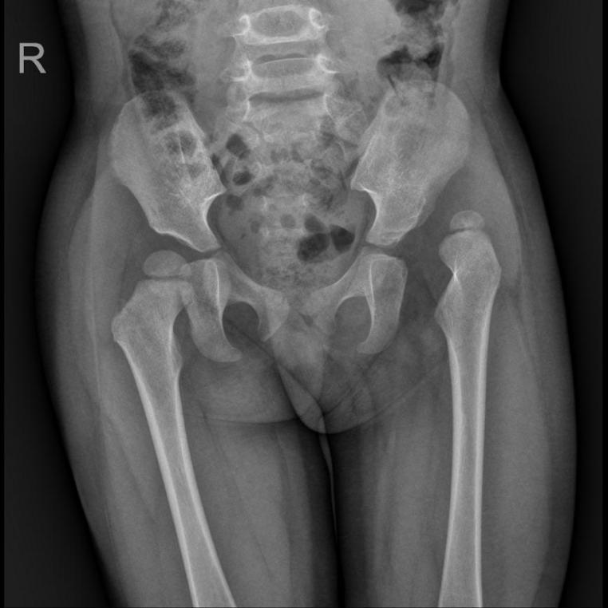
- Item 3 Age: 2 years Hip to be assessed: Right
1. ☐ Normal ☐ Abnormal
2. IHDI classification: ☐ Type I ☐ Type II ☐ Type III ☐ Type IV
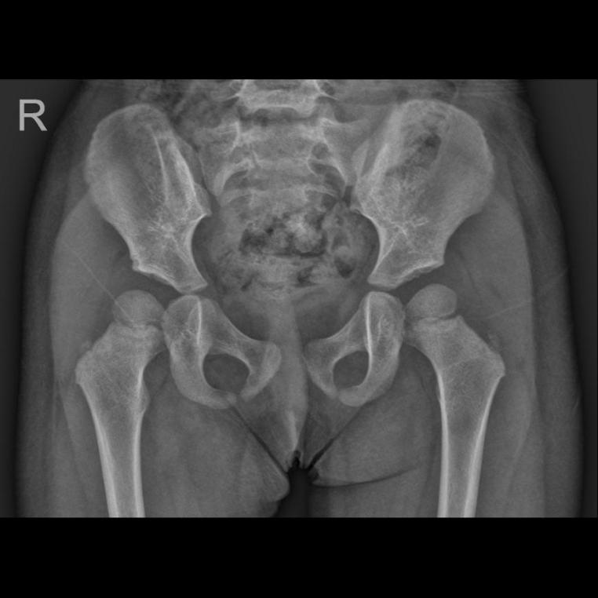
- Item 4 Age: 2 years Hip to be assessed: Right
1. ☐ Normal ☐ Abnormal
2. IHDI classification: ☐ Type I ☐ Type II ☐ Type III ☐ Type IV
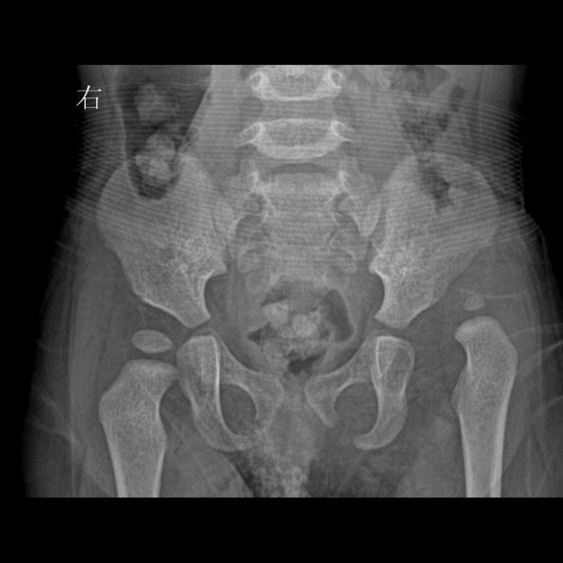
- Item 5 Age: 1 year Hip to be assessed: Right
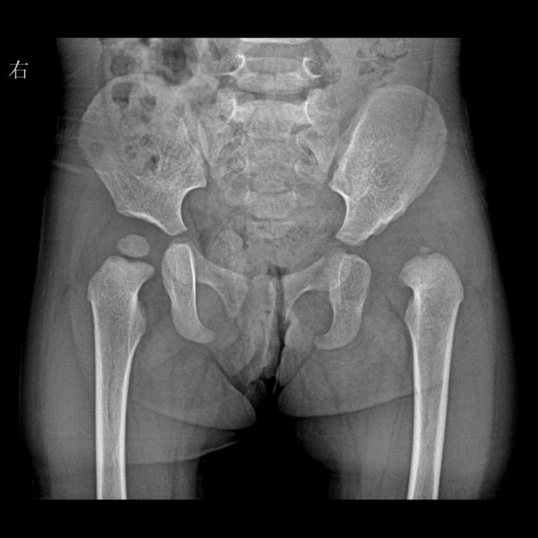
1. ☐ Normal ☐ Abnormal
2. IHDI classification: ☐ Type I ☐ Type II ☐ Type III ☐ Type IV
- Item 6 Age: 9 months Hip to be assessed: Right
1. ☐ Normal ☐ Abnormal
2. IHDI classification: ☐ Type I ☐ Type II ☐ Type III ☐ Type IV
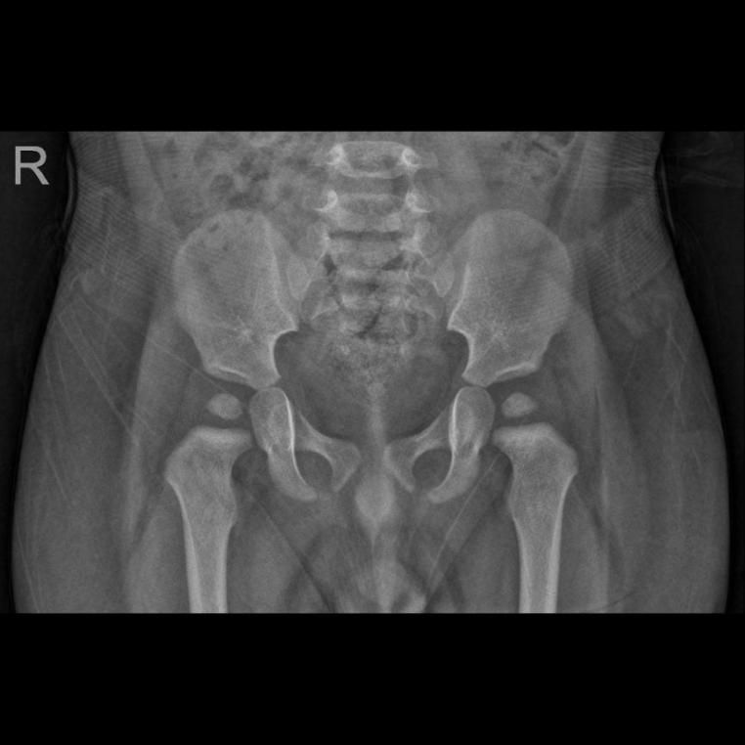
- Item 7 Age: 1 year Hip to be assessed: Left
1. ☐ Normal ☐ Abnormal
2. IHDI classification: ☐ Type I ☐ Type II ☐ Type III ☐ Type IV
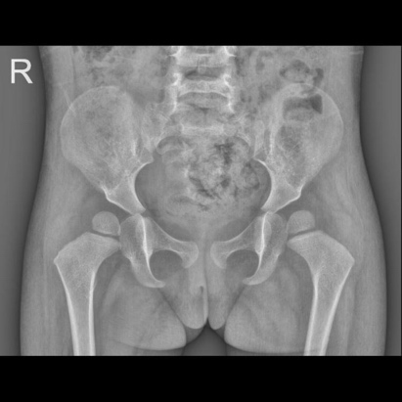
- Item 8 Age: 2 years Hip to be assessed: Right
1. ☐ Normal ☐ Abnormal
2. IHDI classification: ☐ Type I ☐ Type II ☐ Type III ☐ Type IV
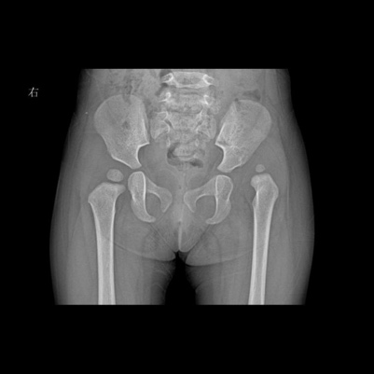
- Item 9 Age: 1 year Hip to be assessed: Left
1. ☐ Normal ☐ Abnormal
2. IHDI classification: ☐ Type I ☐ Type II ☐ Type III ☐ Type IV
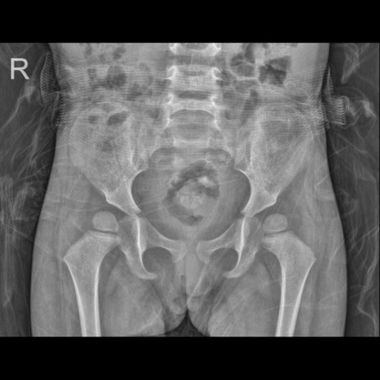
- Item 10 Age: 2 years Hip to be assessed: Right
1. ☐ Normal ☐ Abnormal
2. IHDI classification: ☐ Type I ☐ Type II ☐ Type III ☐ Type IV
- Item 11 Age: 2 years Hip to be assessed: Right
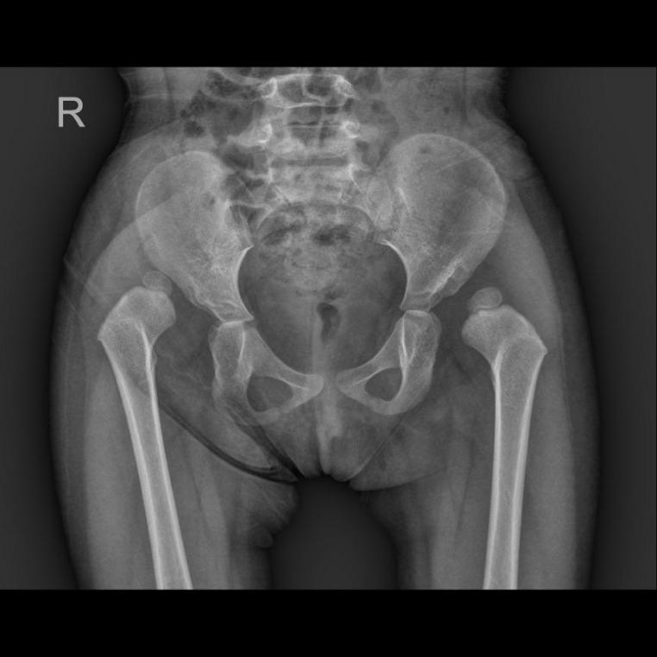
1. ☐ Normal ☐ Abnormal
2. IHDI classification: ☐ Type I ☐ Type II ☐ Type III ☐ Type IV
- Item 12 Age: 2 years Hip to be assessed: Right
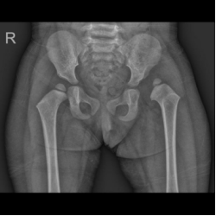
1. ☐ Normal ☐ Abnormal
2. IHDI classification: ☐ Type I ☐ Type II ☐ Type III ☐ Type IV
Supplementary Appendix S3. DDH Nursing Assessment Test
Select the best response. For items marked “Select all that apply,” more than one response may be selected.
1. At what age is an anteroposterior pelvic radiograph indicated for a child being assessed for developmental dysplasia of the hip (DDH)? (Select one)
☐ A. Older than 6 months ☐ B. Younger than 6 months ☐ C. Older than 1 year ☐ D. Older than 2 years
2. Which clinical manifestations may occur after a child with DDH begins walking? (Select all that apply)
☐ A. Abnormal gait ☐ B. Restricted range of motion ☐ C. Reduced muscle strength ☐ D. Limb-length discrepancy
3. Which are priorities when caring for a child treated with a Pavlik harness? (Select all that apply)
☐ A. Provide skin care ☐ B. Monitor distal circulation of the affected limb ☐ C. Adjust harness tightness every 2–3 weeks ☐ D. Maintain both hips in flexion and abduction
4. Which are priorities during overhead (suspended) skin traction? (Select all that apply)
☐ A. Lower the traction for feeding and restore it 30 minutes after feeding
☐ B. Do not allow the child to stand or walk while the traction is lowered
☐ C. Before traction, assess the skin and conditions such as congenital heart disease or respiratory disease
☐ D. Monitor distal circulation of the affected limb
5. Which measures are included in brace care after triple osteotomy? (Select all that apply)
☐ A. Select an appropriate brace and ensure correct positioning and fit
☐ B. Check for pressure, redness, or skin breakdown; keep the skin clean and dry and prevent infection
☐ C. Encourage appropriate activity and avoid vigorous exercise and improper positioning
☐ D. Provide pain management
Case 1: Keke is a 1-year-old boy with asymmetric gluteal folds noted since birth and no pain. IHDI classification: left hip, type I; right hip, normal.
6. Which individualized treatment plan is most appropriate? (Select one)
☐ A. External brace treatment with regular follow-up
☐ B. Conservative treatment with a Pavlik harness
☐ C. Surgical reduction followed by cast immobilization
☐ D. Surgery followed by a hip spica brace
7. Which statement about brace-assisted treatment for this child is incorrect? (Select one)
☐ A. Treatment lasts approximately 3 months
☐ B. Treatment lasts 6–9 months
☐ C. Treatment duration is determined according to recovery at follow-up
☐ D. Both hips are maintained in flexion and abduction
Case 2: Tongtong is a 2-year-old girl. Limb-length discrepancy and asymmetric medial thigh folds were noticed more than 6 months ago, and a waddling gait worsened during the past 2 months. She was admitted with bilateral DDH; both hips were classified as IHDI type IV.
8. Which individualized treatment plan is most appropriate? (Select one)
☐ A. External brace treatment with regular follow-up
☐ B. Conservative treatment with a Pavlik harness
☐ C. Surgical reduction followed by cast immobilization
☐ D. Surgery followed by a hip spica brace
9. Which statement about brace care for this child is incorrect? (Select one)
☐ A. Apply lubricating oil during skin care to reduce skin injury
☐ B. A diaper may be used to prevent urine from wetting the brace
☐ C. Encourage family members to participate in care
☐ D. If the hip is stable and there is no pain or abnormal movement, the brace may be removed briefly each day under close parental supervision
10. The family is planning another pregnancy. Which health-education statement is incorrect? (Select one)
☐ A. Attend regular health examinations
☐ B. If the next child is a boy, there is no need to be concerned about the same condition
☐ C. Do not bind an infant’s legs because their appearance is considered unattractive
☐ D. Observe the gluteal folds and compare lower-limb lengths
Supplementary Appendix S4. Teaching Satisfaction Questionnaire
Please indicate how strongly you agree or disagree with each statement. Select one response for each item.
Scoring: 5 = Strongly agree; 4 = Agree; 3 = Uncertain; 2 = Disagree; 1 = Strongly disagree. Total score: 13–65; higher scores indicate greater satisfaction and confidence.
1. The teaching methods used in the course were useful and effective.
☐ 5 ☐ 4 ☐ 3 ☐ 2 ☐ 1
2. A variety of learning materials and activities were provided and facilitated my learning.
☐ 5 ☐ 4 ☐ 3 ☐ 2 ☐ 1
3. I liked the instructor’s teaching approach.
☐ 5 ☐ 4 ☐ 3 ☐ 2 ☐ 1
4. The teaching tools used in the simulated learning activities motivated me and supported my learning.
☐ 5 ☐ 4 ☐ 3 ☐ 2 ☐ 1
5. The way the course was taught suited my preferred way of learning.
☐ 5 ☐ 4 ☐ 3 ☐ 2 ☐ 1
6. I am confident that I can master the content demonstrated by the instructor.
☐ 5 ☐ 4 ☐ 3 ☐ 2 ☐ 1
7. I am confident that the teaching process covered the key content required for the course.
☐ 5 ☐ 4 ☐ 3 ☐ 2 ☐ 1
8. I am confident that the teaching provided me with the skills and knowledge needed to perform the required tasks in a clinical setting.
☐ 5 ☐ 4 ☐ 3 ☐ 2 ☐ 1
9. The resources used by the instructor during teaching were useful.
☐ 5 ☐ 4 ☐ 3 ☐ 2 ☐ 1
10. As a student, I am responsible for learning the knowledge I need from the teaching process.
☐ 5 ☐ 4 ☐ 3 ☐ 2 ☐ 1
11. When I do not understand a concept addressed during teaching, I know how to seek help.
☐ 5 ☐ 4 ☐ 3 ☐ 2 ☐ 1
12. I know how to use the teaching tools to learn the key aspects of these skills.
☐ 5 ☐ 4 ☐ 3 ☐ 2 ☐ 1
13. The instructor is responsible for telling me what I need to learn from the course content.
☐ 5 ☐ 4 ☐ 3 ☐ 2 ☐ 1

Supplementary Appendix S5. Semi-structured Interview Guide
Administration: The questions were used flexibly. Non-leading follow-up prompts were used when clarification or elaboration was needed.
1. What were your experiences of using the deep learning–based diagnostic tool for developmental dysplasia of the hip during your clinical training, and what did you gain from the experience?
• Probe: The tool refers to the AI-assisted diagnostic system introduced during the clinical placement.
• Probe: What was your overall impression of using this tool for learning during the placement?
2. How did the diagnostic tool affect your clinical learning and practical skills?
• Probe: What advantages and limitations did the tool have in terms of diagnostic accuracy and learning efficiency?
• Probe: Did it help you better understand the imaging features of developmental dysplasia of the hip and the reasoning underlying nursing assessment and decision-making?
3. Compared with conventional orthopedic clinical training, what were the advantages and disadvantages of training supported by the deep learning–based diagnostic tool?
4. How could the teaching and use of intelligent diagnostic tools be better incorporated into nursing education? What suggestions do you have?
• Probe: What learning needs do students have when using these tools, and what prerequisite knowledge and skills are required?
• Probe: What improvements would you like schools or instructors to make in training design, practical arrangements, and technical support?

