Table A1: Topographic variables derived from System for Automated Geoscientific Analyses (SAGA) GIS [Conrad, O., Bechtel, B., Bock, M., Dietrich, H., Fischer, E., Gerlitz, L., Wehberg, J., Wichmann, V., and Boehner, J. (2015): System for Automated Geoscientific Analyses (SAGA) v. 2.1.4. Geosci. Model Dev., 8, 1991-2007, https://doi.org/10.5194/gmd-8-1991-2015]
Variable | Description | Ecological relevance to plant species
Max curvature | The maximum rate of change of the surface slope. High positive values indicate ridge-forming convexity. High negative values signify concave or valley-like landforms. | Convexities facilitate drainage and surface runoff
Min curvature | The smallest local rate of change in a surface, representing how sharply the terrain curves in any one direction. High positive minimum curvature values can indicate that the surface is curving upwards, while high negative value indicates a downward curving surface. | Concavities retain water and sediment
Generalized surface / coastal landforms | Spatially smoothed DEM | Identifies flats, pans, depressions, ridges, channels etc.
Distance to channel network | Distance from each cell in a Digital Elevation Model (DEM) to the nearest channel within a defined channel network: indicating proximity to tidal creeks and channels | Locations close to channels have frequent tidal flushing. Locations further from channels have reduced inundation and increased salinity levels due to limited flushing and evaporation processes
Relative Slope Position (RSP) | Elevation relative to coastal terrain | Low RSP areas have prolonged inundation High RSP have less inundation
Terrain Position Index (TPI) | Ridge to valley terrain position:  positive TPI = ridges; negative TPI = valleys | Ridges have higher drainage, erosion and evaporation potential; Valleys have lower drainage and increased sedimentation
Terrain Surface Convexity | Positive values in convex-upward areas and negative values in concave areas | Convex surfaces drain water; Concave surfaces retain water
Channel Network Base Level | The vertical distance from each DEM cell to the nearest channel base level cell | Lower value = higher inundation; Higher value = lower inundation
Valley Depth | The relative depth below surrounding terrain, i.e., the difference between cell elevation and channel base level | Greater water retention with increasing valley depth
Convergence Index | Index of convergence or divergence in relation to overland flow | Positive values indicate pooling; Negative values indicate diverging flow
Slope | Local morphometric slope terrain parameter | Higher values indicate rapid drainage; Lower values indicate water retention
Slope Length (LS Factor) | Calculates slope length based on slope and specific catchment area | Higher values indicate runoff; Lower values indicate water retention
Topographic Wetness Index (TWI) | Calculates an index using the catchment area per unit contour length and the local slope | Higher values indicate increased soil moisture

Table A2: Derived hydrological variables for joint species distribution modelling
Variable | Description | Ecological relevance to plant species
Max Dry Period | Longest continuous period without inundation | Determines drought tolerance thresholds, germination windows, and competition with upland species.
Inundation Frequency | Number of distinct flooding events (tidal cycles with inundation) | Affects species adapted to frequent tidal exchange (e.g., mangroves vs. saltmarshes).
Mean Inundation Height | Average water depth during periods of inundation | Influences tolerance to waterlogging and salinity intrusion; affects photosynthesis and respiration balance.
Max Inundation Height | Maximum water level above ground during the time series | Critical for understanding flood stress limits, especially in upper marsh and forest edge zones.
Mean Inundation Duration | Average length (in hours) of each inundation event | Reflects exposure time to anoxia and salinity per flood event; important for root aeration and nutrient uptake.
Mean Dry Duration | Average length of dry spells between flooding events | Important for plant desiccation recovery, seedling establishment, and terrestrial interactions.
Inundation Proportion | Proportion of time the site is inundated | A key integrative index of habitat wetness, influencing vegetation community structure along tidal gradients.
Growing Season Inundation Days | Inundation duration restricted to 1st September–31st March (southern hemisphere) | Indicates growing season flood exposure when plants are physiologically active.
Growing Season Inundation Frequency | Number of flood events during the growing season | Root growth, shoot emergence, and leaf development affected during the most critical period for biomass production.
Growing Season Inundation Proportion | Proportion of time inundated during the growing season | Reflects seasonal wetness and suitability for different life stages of wetland plants (e.g., flowering, seeding).
Growing Season Tidal Amplitude | Mean tidal amplitude restricted to the growing season | Captures seasonal energy and salinity variation relevant to species with seasonal growth strategies.
Standard Deviation of Flood Depth | Variability in flood depth across all inundation periods | Measures hydrological variability; important for species that require stable versus fluctuating inundation regimes.

Figure A1
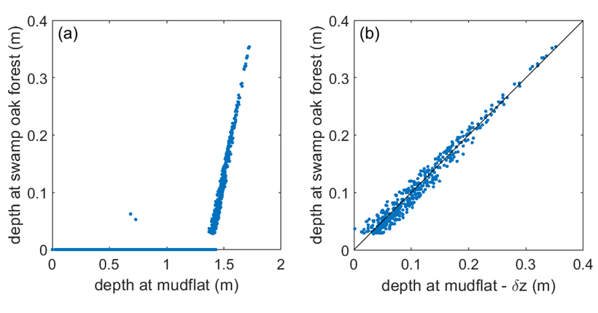
Figure A1. (a) Comparison of tidal water depths measured on the mudflat at the seaward boundary of the wetland and in the swamp oak forest at the landward boundary. (b) Same comparison as (a), but with the elevation difference (Δz) between the two depth loggers subtracted from the mudflat record. The resulting 1:1 relationship demonstrates that relative elevation is the primary determinant of water depth across the wetland, supporting the use of a bathtub approach for hydrological reconstruction.

