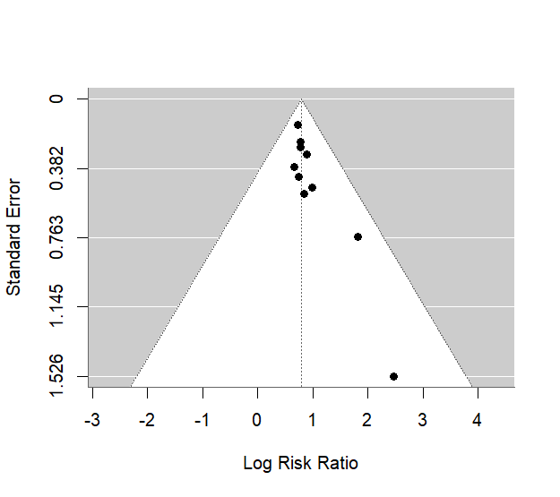
Funnel S1. Funnel plot assessing publication bias for the association between aneurysm wall enhancement and aneurysm growth.
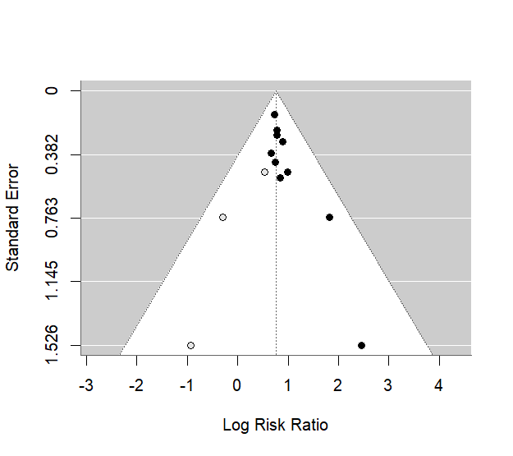
Funnel S2. Trim-and-fill funnel plot assessing the effect of potential missing studies on the pooled growth estimate.

