Supplementary Material

In Vitro Anti-Tubercular Evaluation and Selective Fe³⁺ Fluorescence Turn-Off Sensing of Aspartic Acid-Catalyzed Tetraketone and Xanthene Derivatives in Aqueous Medium
- Asif Shariffª, E. Mohan Ramª, M. I. Abdul Bazithª, A. K. Raees Ahmedª, V. N. Azger Dusthackeer^{b}, M. Ambrose Rajkumar^{d}, Sivakumar Sivalingam^{c}*, Habeebullah Thajudeenª*, V. S. Jamal Ahamedª*
ª PG & Research Department of Chemistry, The New College (Autonomous), Chennai-600 014, Tamil Nadu India
^{b}National Institute for Research in Tuberculosis, Chennai-600 031, Tamilnadu, India
^{c}Department of Chemistry, Vel Tech Rangarajan Dr.Sagunthala R&D Institute of Science and Technology, Avadi, Chennai-600 062, Tamil Nadu, India
^{d}Department of Physics, Kristu Jayanti Deemed to be University, Bengaluru.
* Correspondence: jamalahamed@thenewcollege.edu.in
thajudeen@thenewcollege.edu.in
drsivakumars@veltech.edu.in

- Molecular docking study for tetraketones (3a-3l)

PROTEIN

8AN5

MenAT1 toxin-antitoxin complex (rv0078a-rv0078b) from Mycobacterium tuberculosis H37Rv
Xu, X., Usher, B., Gutierrez, C., Barriot, R., Arrowsmith, T.J., Han, X., Redder, P., Neyrolles, O., Blower, T.R., Genevaux, P.
(2023) Nat Commun 14: 4644-4644
Released | 2023-08-02
Method | X-RAY DIFFRACTION 1.44 Å
Organisms | Mycobacterium tuberculosis H37Rv
Macromolecule | Bacterial toxin (protein)  Conserved protein (protein)

Entry | LIGAND | 3D | 2D
3a | 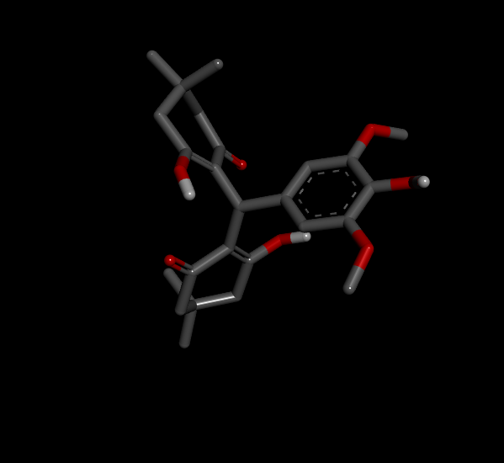 | 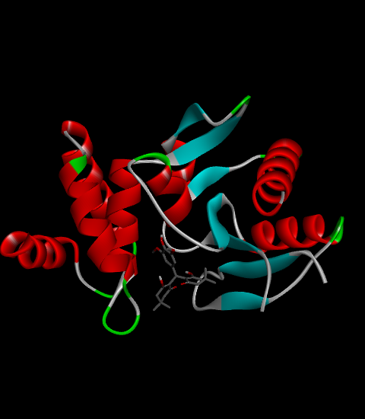 | 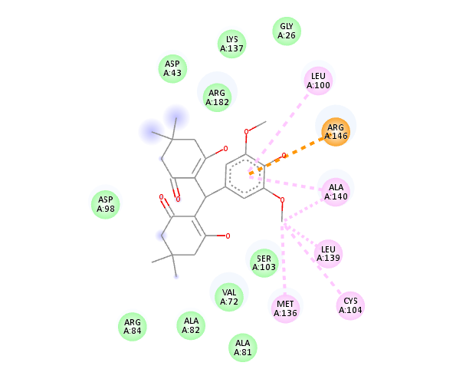
3b | 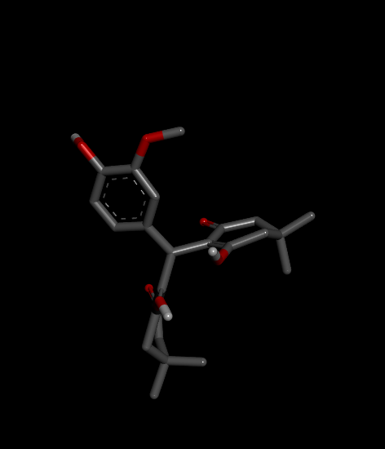 | 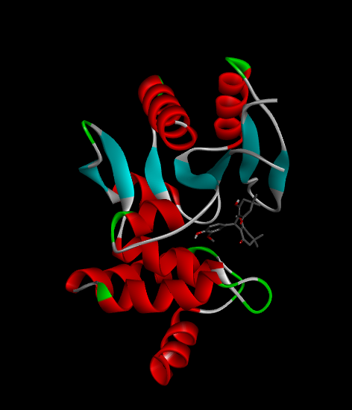 | 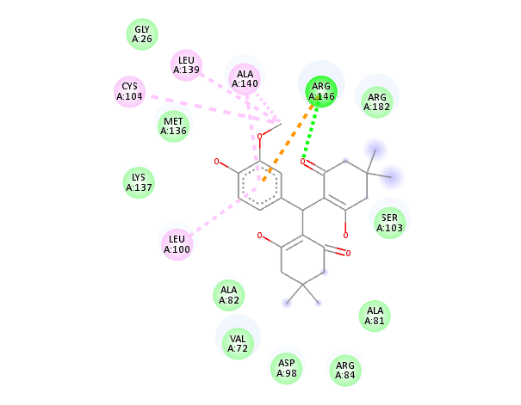
3c | 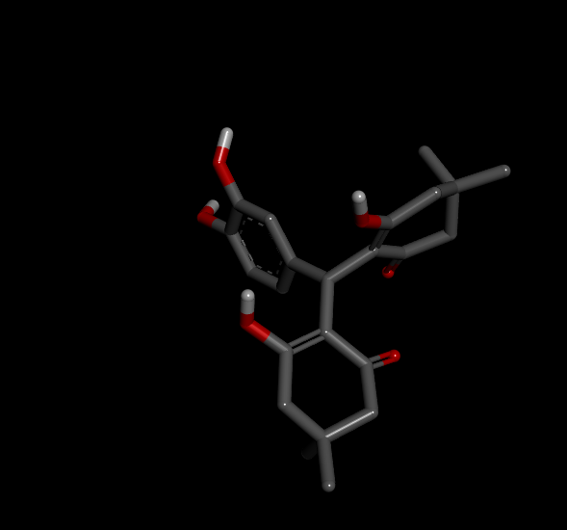 | 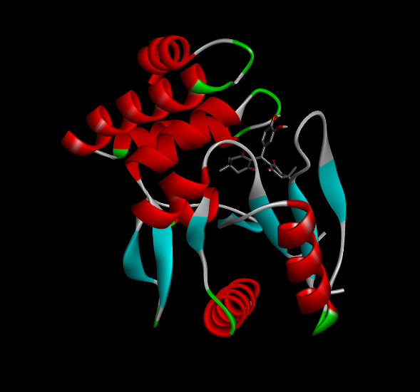 | 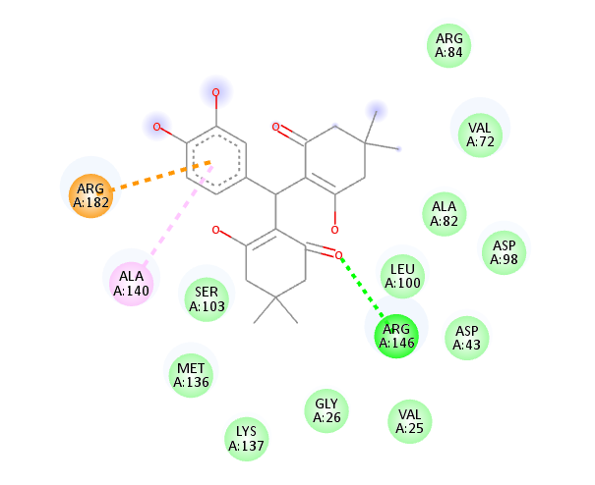
3d | 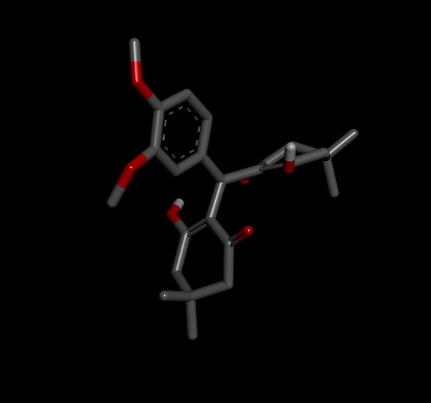 | 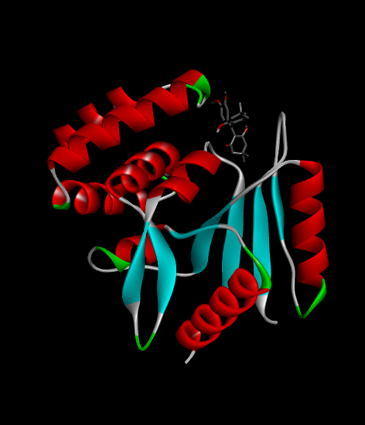 | 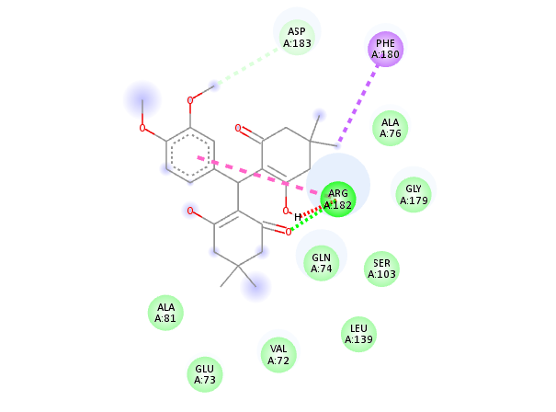
3e | 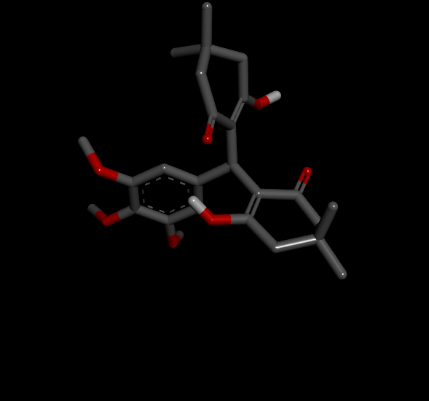 | 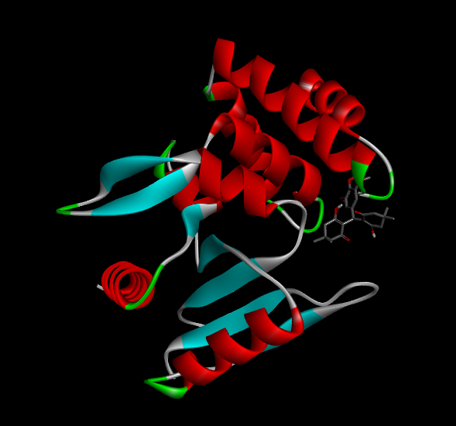 | 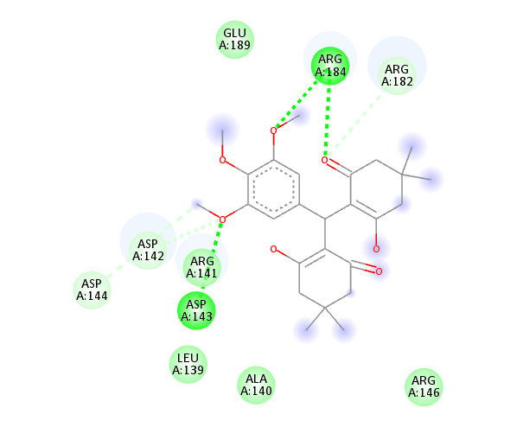
3f | 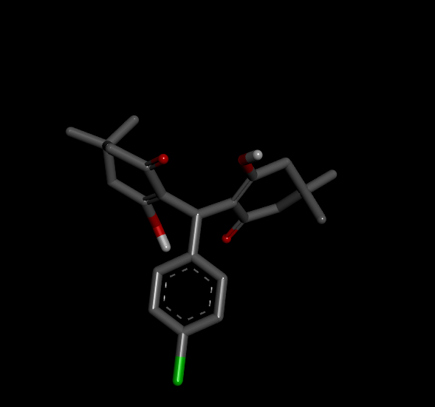 | 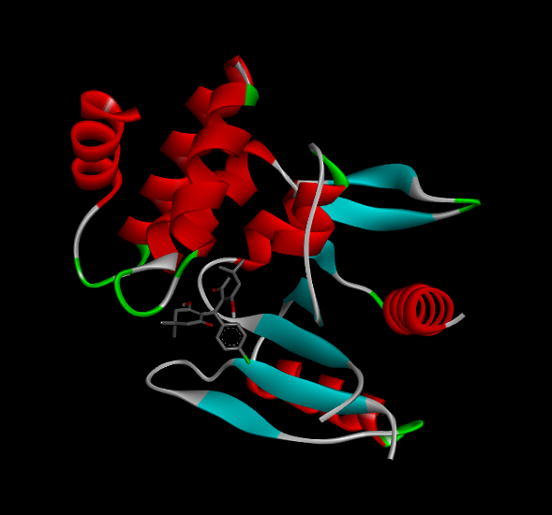 | 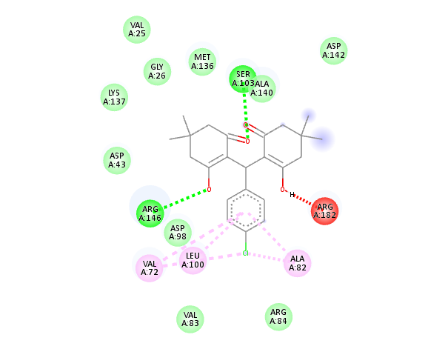
3g | 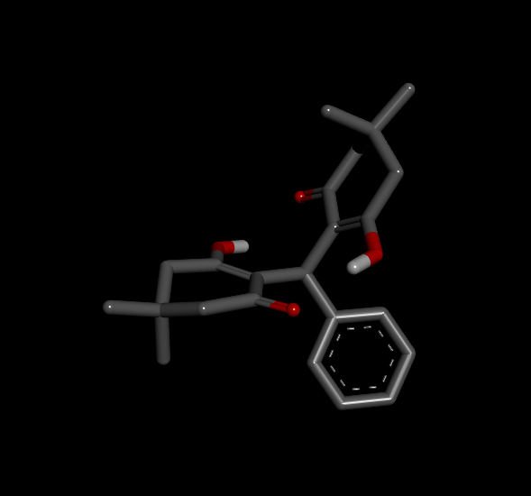 | 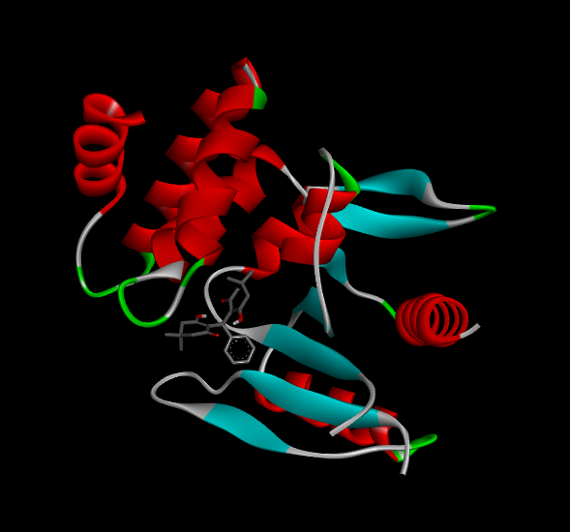 | 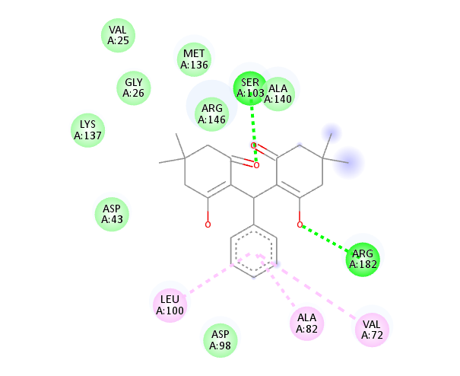
3h | 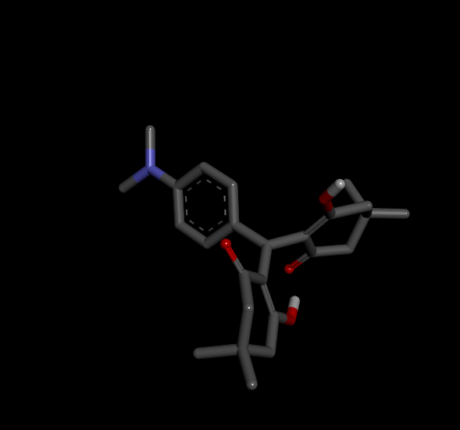 | 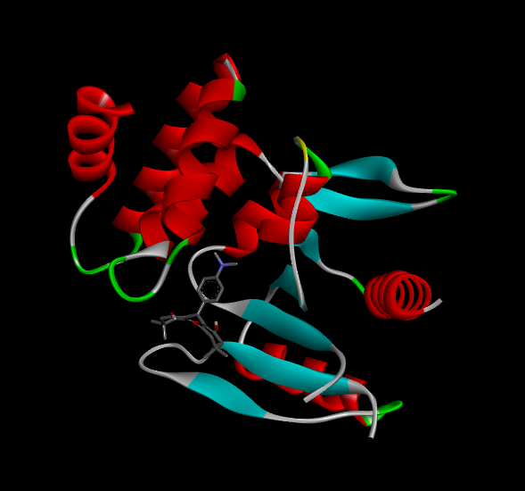 | 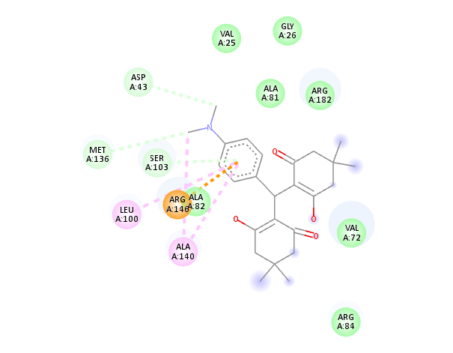
3i | 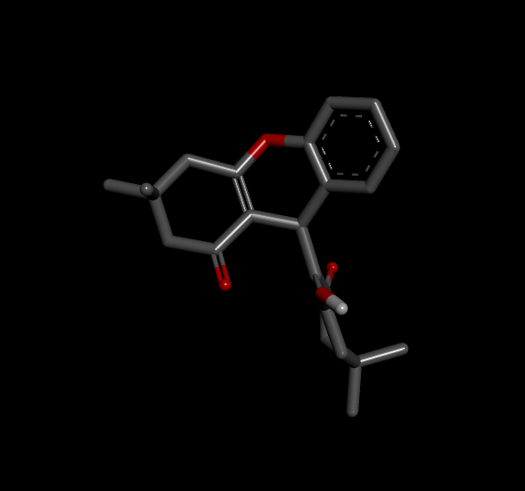 | 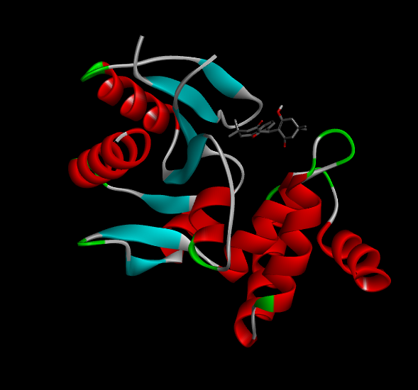 | 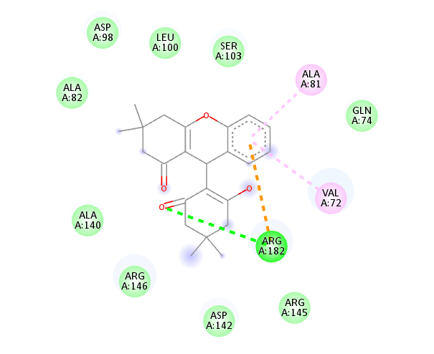
3j | 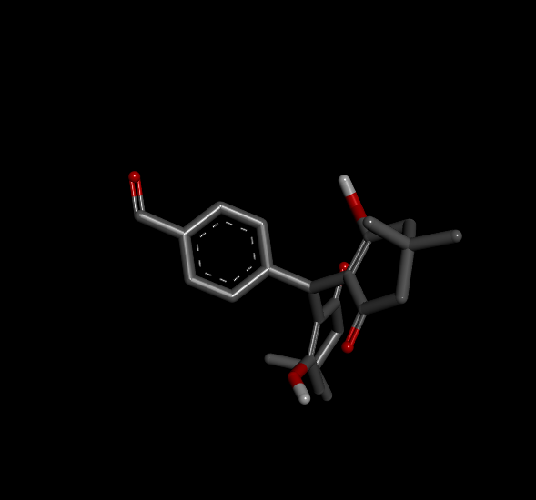 | 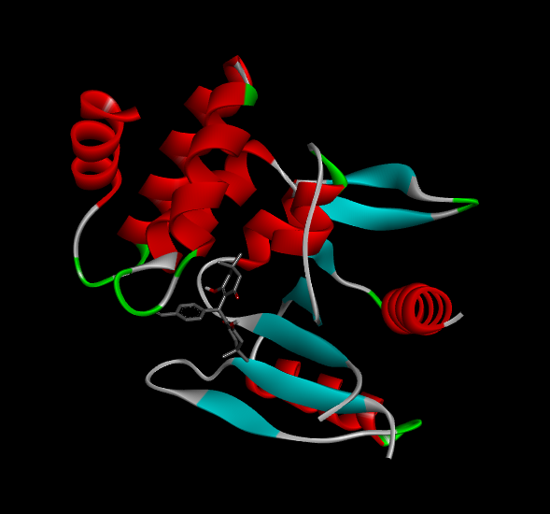 | 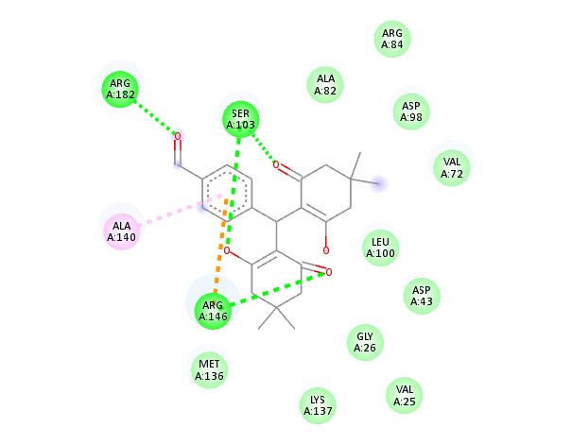
3k | 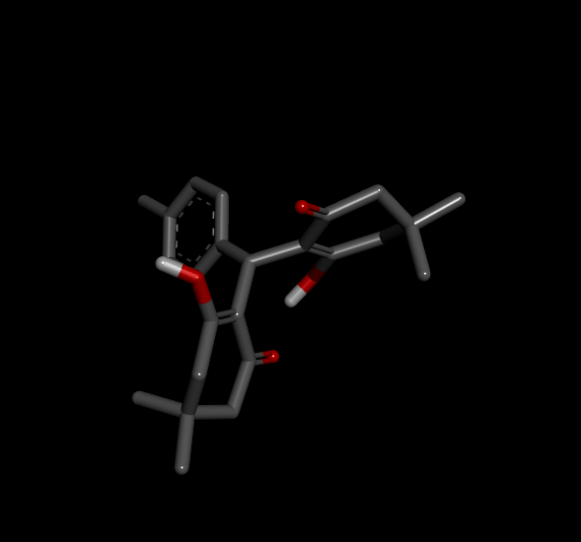 | 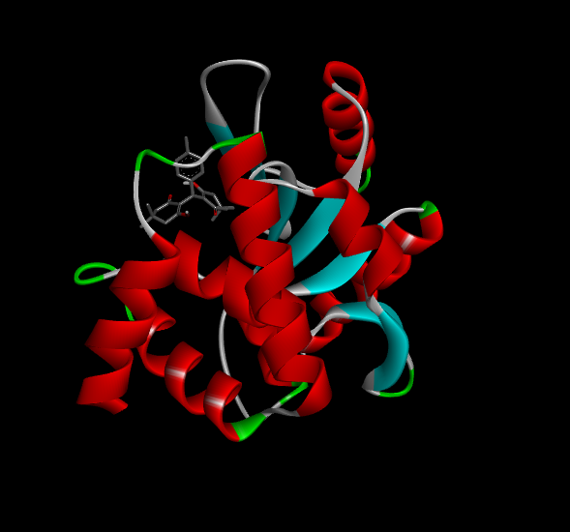 | 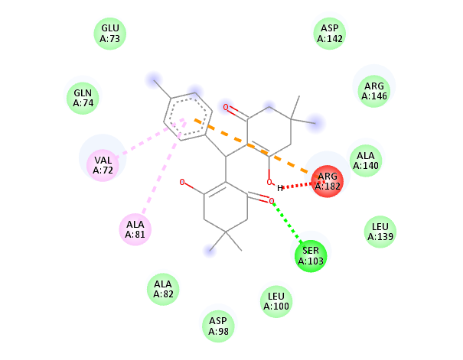
3l | 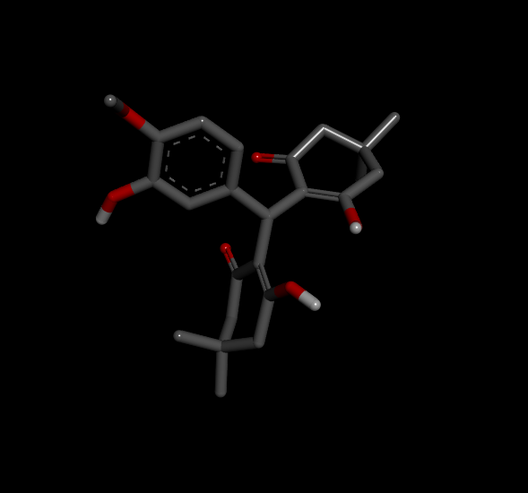 | 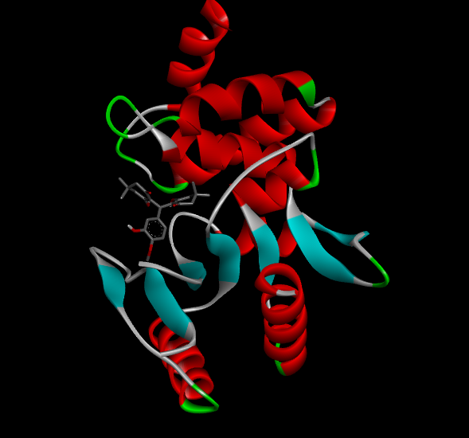 | 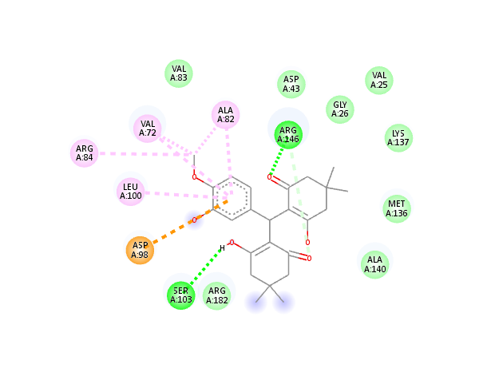

- Molecular docking study for xanthenes (4a-4i)

PROTEIN

8AN5

MenAT1 toxin-antitoxin complex (rv0078a-rv0078b) from Mycobacterium tuberculosis H37Rv
Xu, X., Usher, B., Gutierrez, C., Barriot, R., Arrowsmith, T.J., Han, X., Redder, P., Neyrolles, O., Blower, T.R., Genevaux, P.
(2023) Nat Commun 14: 4644-4644
Released | 2023-08-02
Method | X-RAY DIFFRACTION 1.44 Å
Organisms | Mycobacterium tuberculosis H37Rv
Macromolecule | Bacterial toxin (protein)  Conserved protein (protein)

Entry |  | LIGAND | 2D | 3D
4a | 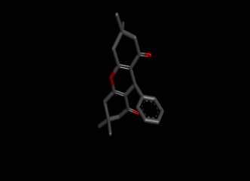 |  | 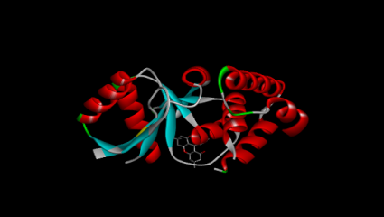 | 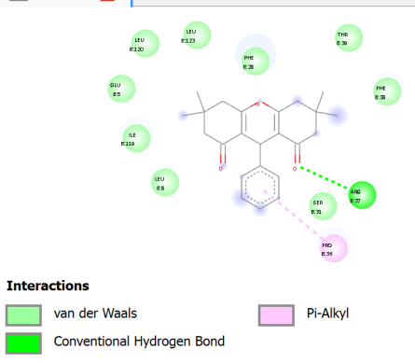
4b | 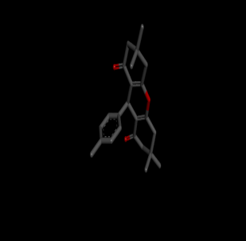 |  | 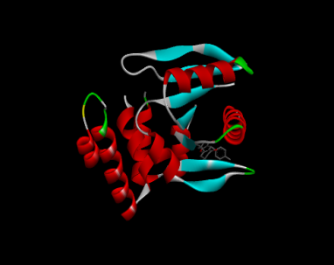 | 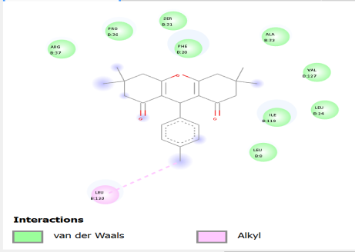
4c | 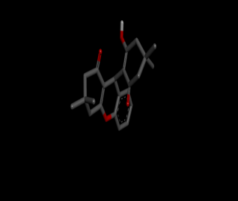 |  | 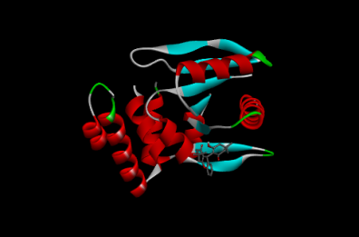 | 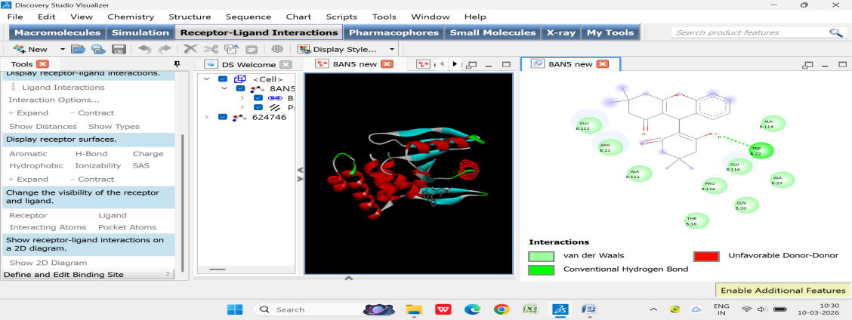
4d | 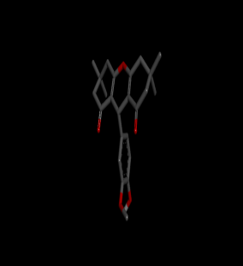 |  | 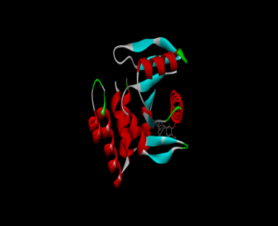 | 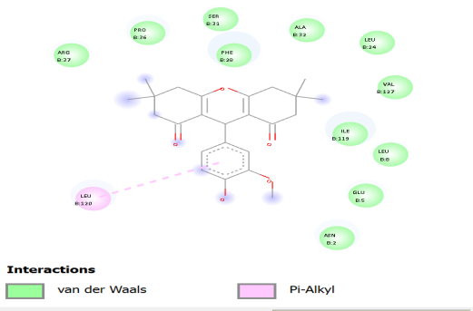
4e | 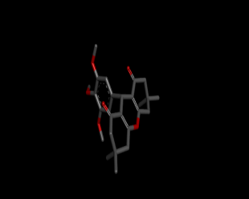 |  | 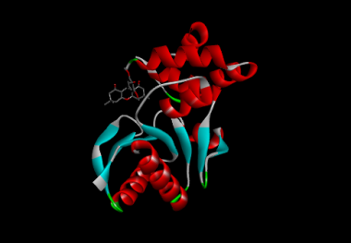 | 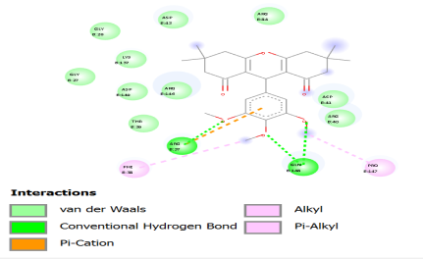
4f | 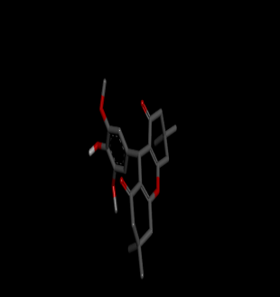 |  | 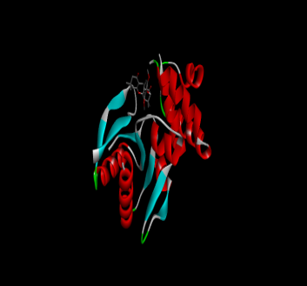 | 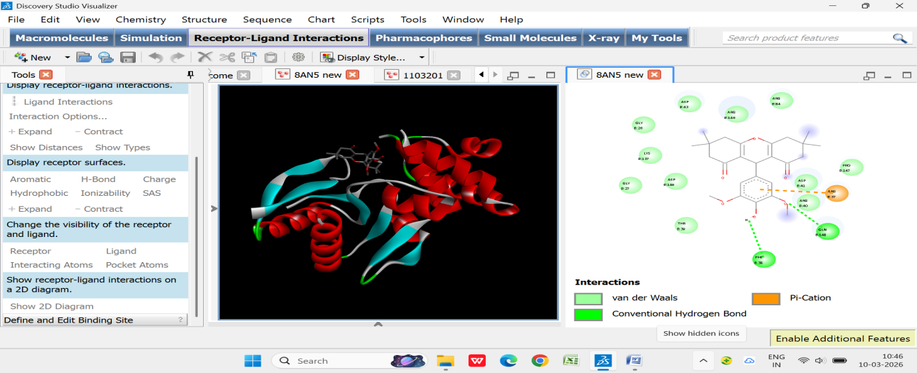
4g | 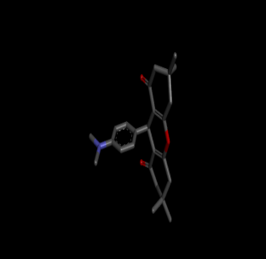 |  | 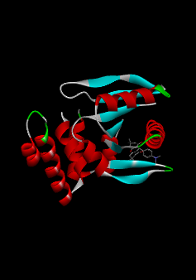 | 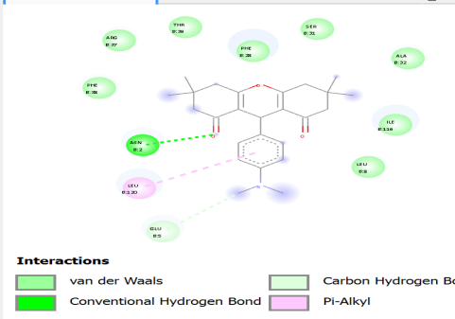
4h | 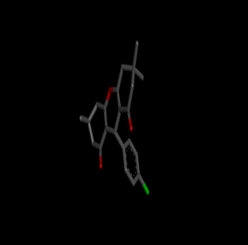 |  |  | 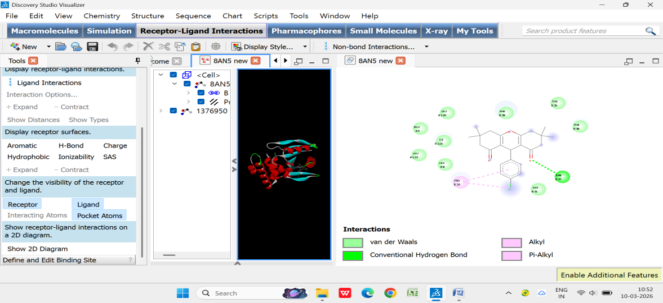
4i |  |  | 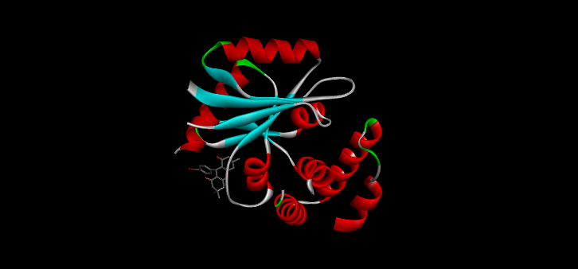 | 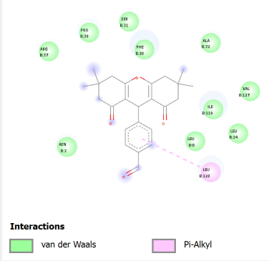

Table 6.1 In silico docking results of synthesized compounds (3a–3l) and (4a-4i) against H37Rv
Ligand | Binding Affinity | rmsd/ub | rmsd/lb
PDB_8AN_3a_uff_E=296.85 | -7.2 | 2.252 | 0.164
PDB_8AN_3b_uff_E=387.38 | -6.9 | 12.64 | 8.618
PDB_8AN_3c_uff_E=285.09 | -8.2 | 6.345 | 1.594
PDB_8AN_3d_uff_E=447.81 | -6.7 | 36.4 | 32.64
PDB_8AN_3e_uff_E=367.96 | -6.1 | 2.152 | 0.202
PDB_8AN_3f_uff_E=245.89 | -7.9 | 27.45 | 24.28
PDB_8AN_3g_uff_E=247.73 | -7.3 | 27.57 | 24.28
PDB_8AN_3h_uff_E=290.01 | -7.7 | 27.45 | 24.45
PDB_8AN_3i_uff_E=528.72 | -6.8 | 16.08 | 13.53
PDB_8AN_3j_uff_E=255.16 | -7.9 | 6.519 | 1.953
PDB_8AN_3k_uff_E=254.58 | -8.8 | 36.08 | 33.15
PDB_8AN_3l_uff_E=293.58 | -8.8 | 5.183 | 1.604
8AN5_new_4a_uff_E=317.24 | -7.4 | 15.713 | 12.408
8AN5_new_4b_uff_E=303.24 | -7.6 | 21.51 | 18.329
8AN5_new_4c_uff_E=470.25 | -7.1 | 17.321 | 14.618
8AN5_new_4d_uff_E=352.27 | -7.2 | 22.867 | 20.379
8AN5_new_4e_uff_E=382.03 | -7.3 | 5.494 | 1.588
8AN5_new_4f_uff_E=548.32 | -7.4 | 2.316 | 0.06
8AN5_new_4g_uff_E=321.74 | -7.4 | 16.128 | 13.074
8AN5_new_4h_uff_E=299.83 | -7.6 | 6.127 | 2.437
8AN5_new_4i_uff_E=300.95 | -7.3 | 6.266 | 2.446

- CHARACTERIZATION DATA FOR ALL COMPOUNDS

Synthesis of 2,2’-(Phenyl-methylene) bis(3-hydroxy-5,5-dimethyl-2- cyclohexene-1-one): 3a
Yellowish white solid, m.p. 205-206°C. Yield: 85% (0.632g) ¹H NMR (500 MHz, CDCl₃) δ 11.90 (s, 1H, OH), 7.28-7.23 (d, 2H, ArH), 7.17 -7.14 (m, 1H, ArH), 7.10-7.08 (d ,2H, ArH), 5.54 (s, 1H, CH), 2.48-2.28 (m, 8H, CH₂), 1.23 (s, 6H, CH₃), 1.09 (s, 6H, CH₃) ppm. ¹³C NMR (100 MHz, CDCl3) δ 190.48, 189.41, 138.09, 128.42, 128.23, 126.80, 125.85, 115.60, 77.41, 77.30, 77.09, 76.78, 47.08, 46.47, 32.77, 31.44, 29.66, 27.44 ppm. IR (neat): 2961, 1739, 1584, 1370, 1243, 1040, 844, 693, 576 cm^{–1}. HRMS (ESI) m/z: [M+H]⁺ Calculated for C₂₃H₂₉O₄+ 368.2060; found 368.2043. TLC: Rf =0.83 (EA: Hexane-1:1).

Synthesis of 9-(2-hydroxy-4,4-dimethyl-6-oxocyclohex-1-en-1-yl)-3,3-dimethyl-2,3,4,9-tetrahydro-1H-xanthen-1-one: 3b
Yellowish white solid, m.p. 191-195°C. Yield:79% (0.610g) ¹H NMR (500 MHz, CDCl₃) δ 10.58 (s, 1H, OH), 7.01-7.28 (m, 4H, ArH), 4.69 (s, 1H, CH), 2.63-2.46 (q, 2H, CH₂), 2.38-2.34 (m, 4H, CH₂), 1.98 (s, 2H, CH₂), 1.13 (s, 3H, CH₃), 1.03 (, 3H, CH₃),1.00 (s, 6H, CH₃), ppm. ¹³C NMR (100 MHz, CDCl3) δ 200.86, 196.76, 170.89, 169.12, 151.00, 128.03, 127.52, 124.59, 124.33, 118.32, 115.74 ,111.04, 77.52, 77.09, 76.67, 50.56, 49.94, 43.18, 41.54, 32.30, 30.99, 29.84, 29.19, 27.72, 27.19, 26.52 ppm. IR (neat): 3743, 2962, 1612, 1369, 1230, 1024, 752, 589 cm^{–1}. HRMS (ESI) m/z: [M+H]⁺ Calculated for C₂₃H₂₇O₄+ 367.1904; found 367.1892. TLC: Rf =0.80 (EA: Hexane-1:1).

Synthesis of 2,2'-((4-hydroxy-3,5-dimethoxyphenyl)methylene)bis(3-hydroxy- 5,5-dimethylcyclohex-2-en-1-one): 3c
Pure white solid , m.p. 191-192°C. Yield:80% (0.710g) ¹H NMR (500 MHz, CDCl₃) δ 12.01 (s, 1H, OH ), 6.35 (s, 2H, ArH ), 5.50(s, 1H, CH ), 3.77 (s, 6H, OCH3), 2.43 – 2.35 (m, 8H, CH2 ),1.24 (s, 6H, CH3 ), 1.12 (s, 6H, CH3 ) ppm . ¹³C NMR (100 MHz, CDCl3) δ 190.33, 189.29, 146.80, 132.74, 129.08, 115.70, 103.96, 56.09,47.13 ,46.36, 32.55, 31.13, 29.99, 26.85 ppm. IR (neat): 2955, 1739, 1584, 1452, 1370, 1211, 1113, 1043, 829, 576 cm^{–1}. HRMS (ESI) m/z: [M+H]⁺ Calculated for C₂₅H₃₂O₇+ 445.2221; found 445.2217. TLC: Rf =0.81 (EA: Hexane-1:1).

Synthesis of 2,2'-((3,4-dimethoxyphenyl) methylene) bis(3-hydroxy-5,5-dimethylcyclohex-2-en-1-one): 3d
Pure white solid , m.p. 156-159°C. Yield:86% (0.710g) ¹H NMR (500 MHz, CDCl₃) δ 11.89 (s, 1H, OH), 6.70 (d,1H,ArH ), 6.57 (d, 2H, ArH ), 5.44(s, 1H, CH), 3.79 -3.78 (s, 6H, OCH3), 2.36 – 2.23 (m, 8H, CH2), 1.17(s, 6H, CH3), 1.04 (s, 6H, CH3) ppm. ¹³C NMR (100 MHz, CDCl3) δ 210.67, 190.56, 189.86, 148.70 ,147.10, 130.47,118.90, 115.77,110.97, 110.54, 55.86, 55.68 ,47.11 ,46.41, 32.31, 31.23, 29.86, 27.09ppm. IR (neat): 2959, 1583, 1513, 1456, 1366, 1305, 1244, 1149, 1024, 879, 755, 662, 569cm^{–1}. HRMS (ESI) m/z:[M+H]⁺ Calculated for C₂₅H₃₃O₆+ 429.2272; found 429.2269. TLC: Rf =0.83 (EA: Hexane-1:1).

Synthesis of 2,2'-((4-(dimethylamino)phenyl)methylene)bis(3-hydroxy-5,5-dimethylcyclohex-2-en-1-one): 3e
Pure yellow solid, m.p. 204-206°C. Yield: 81% (0.665g) ¹H NMR (500 MHz, CDCl₃) δ 11.92 (s, 1H, OH), 6.95 -6.93 (d, 2H, ArH ), 6.67 -6.65 (d, 2H, ArH ), 5.47 (s, 1H, CH ), 2.90 (s, 6H, CH3), 2.45 – 2.29 (m, 8H, CH2 ), 1.22 (s, 6H, CH3 ), 1.09 (s, 6H, CH3 )ppm. ¹³C NMR (100 MHz, CDCl3) δ 190.21, 189.26, 148.79, 127.49, 125.64 ,115.97, 112.70, 47.11, 46.48, 40.71, 31.86, 31.38 , 29.69, 27.36 ppm. IR (neat): 2959, 1583, 1513, 1456, 1366, 1305, 1244, 1149, 1024, 913, 808, 662, 569cm^{–1}. HRMS (ESI) m/z: [M+H]⁺ Calculated for C₂₅H₃₄ NO₄+ 412.2482; found 412.2464. TLC: Rf =0.85 (EA: Hexane-1:1).

Synthesis of 2,2'-((3,4-dihydroxyphenyl)methylene)bis(3-hydroxy-5,5-dimethylcyclohex-2-en-1-one): 3f
Half grey solid, m.p. 111-115°C. Yield:87% (0.670g) ¹H NMR (500 MHz, CDCl₃) δ 11.92 (s, 1H, OH), 6.76 -6.74 (d, 1H, ArH ), 6.62 (s, 1H, ArH) 6.54 -6.52 (d, 1H, ArH ), 5.47 (s, 1H, CH ), 2.48 – 2.30 (m, 8H, CH2 ), 1.24 (s, 6H, CH3 ), 1.11 (s, 6H, CH3 ) ppm ¹³C NMR (100 MHz, CDCl3) δ 194.71, 179.75, 151.16 ,134.34, 130.03, 129.03,119.25, 115.73, 115.17,114.45, 111.43 , 53.02,47.13 ,32.11, 31.46 , 29.53, 27.53 ppm.IR (neat): 3471, 2965, 1583, 1371, 1262, 1157, 1059, 952, 868, 775, 662, 599cm^{–1}. HRMS (ESI) m/z: [M+H]⁺ Calculated for C₂₃H₂₉O₆+ 401.1959; found 401.1947. TLC : Rf =0.80 (EA: Hexane-1:1).

Synthesis of 2,2'-((4-hydroxy-3-methoxyphenyl)methylene)bis(3-hydroxy-5,5-dimethylcyclohex-2-en-1-one): 3g
Half white solid, m.p. 189-191°C. Yield:77% (0.640g) ¹H NMR (500 MHz, CDCl₃) δ 11.95 (s, 1H, OH), 6.81 -6.61 (d, 1H, ArH), 6.59 -6.56 (d, 2H, ArH), 5.49 (s, 1H, CH ), 3.76 (s, 3H, OCH3), 2.47 – 2.29 (m, 8H, CH2 ), 1.23 (s, 6H, CH3 ), 1.11 (s, 6H, CH3 ) ppm ¹³C NMR (100 MHz, CDCl3) δ 190.39, 189.36, 146.34, 143.61, 129.75, 119.53 ,115.80, 114.11 , 109.87, 55.68, 47.10, 46.41, 32.33, 31.26, 29.82, 27.11.ppm.IR (neat): 3514, 2955, 1590, 1510, 1369, 1243, 1155, 1032, 861 cm^{–1}. HRMS (ESI) m/z: [M+H]⁺ Calculated for C₂₄H₃₁O₆+ 415.2115; found 415.2079. TLC: Rf =0.82 (EA: Hexane-1:1).

Synthesis of 2,2'-((3,4,5-trimethoxyphenyl)methylene)bis(3-hydroxy-5,5-dimethylcyclohex-2-en-1-one): 3h
Pure white solid , m.p. 191-195°C. Yield:74% (0.680g) ¹H NMR (500 MHz, CDCl₃) δ 12.02 (s, 1H, OH), 6.36 (s, 2H, ArH), 5.50 (s, 1H, CH), 3.81 (s, 3H, OCH₃) , 3.76 (s, 6H ,OCH₃) , 2.36-2.41 (m, 8H, CH₂), 1.25 (s, 6H, CH₃), 1.12 (s, 6H, CH₃) ppm. ¹³C NMR (100 MHz, CDCl3) δ 190.40 , 189.31, 152.84, 135.94, 133.76, 115.52 ,104.21, 77.43 , 77.11, 76.79, 60.84, 55.92, 47.09, 46.32, 32.77, 31.10, 29.99, 26.81.ppm.IR (neat): 2947, 1580, 1508, 1369, 1238, 1126, 1010, 885, 827 cm^{–1}.HRMS (ESI) m/z: [M+H]⁺ Calculated for C₂₆H₃₅O₇ + 459.2377; found 459.2374. TLC : Rf =0.85 (EA: Hexane-1:1).

Synthesis of 2,2'-((4-chlorophenyl)methylene)bis(3-hydroxy-5,5-dimethylcyclohex-2-en-1-one) : 3i
Pure white solid , m.p. 155-157°C. Yield:82% (0.660g) ¹H NMR (500 MHz, CDCl₃) δ 11.86 (s, 1H, OH), 7.23-7.21 (d , 2H, ArH), 7.02-7.00 (d ,2H, ArH) 5.47 (s, 1H, CH), 2.48-2.29 (m, 8H, CH₂), 1.22 (s, 6H, CH₃), 1.10 (s, 6H, CH₃) ppm. ¹³C NMR (100 MHz, CDCl3) δ 190.63, 189.43, 136.71, 131.60, 128.35, 128.20, 115.34, 47.06, 46.44, 32.41, 31.43, 29.58, 27.42 ppm.IR (neat): 2962, 1580, 1366, 1253, 1157, 874, 587 cm^{–1}. HRMS (ESI) m/z: [M+H]⁺ Calculated for C₂₃H₂₈CLO₄ + 403.1671; found 403.1650. TLC: Rf =0.79 (EA: Hexane-1:1).

Synthesis of 2,2'-(p-tolylmethylene)bis(3-hydroxy-5,5-dimethylcyclohex-2-en-1-one): 3j
Pure white solid, m.p. 110-113°C. Yield:83% (0.690g) ¹H NMR (500 MHz, CDCl₃) δ 11.90 (s, 1H, OH ), 7.08 -7.06 (d, 2H, ArH ), 6.96 (d, 2H, ArH ), 5.50 (s, 1H, CH ), 2.47-2.32 (m, 8H, CH2) 1.22 (s, 6H, CH3),1.09 (s, 6H, CH3 ),1.03 (s, 3H, CH3 )ppm. ¹³C NMR (100 MHz, CDCl3) δ 203.68 ,190.43, 189.43 , 134.92, 130.15, 128.96 , 126.68 ,115.73 ,103.63, 57.33, 54.12, 47.08, 46.32 ,32.45 ,31.47, 30.93, 29.64, 28.38, 28.35,27.41 ,20.90.ppm.IR (neat): 2953, 1592, 1458, 1369, 1241, 1157, 1030, 879, 810, 653 cm^{–1}.HRMS (ESI) m/z: [M+H]⁺ Calculated for C₂₄H₃₁O₄ + 383.2217; found 383.2204.TLC : Rf =0.84 EA: Hexane-1:1).

Synthesis of 2,2',2'',2'''-(1,4-phenylenebis(methanetriyl))tetrakis(3-hydroxy- 5,5-dimethylcyclohex-2-en-1-one): 3k
Pure white solid, m.p. 239-241°C. Yield:82% (0.650g) ¹H NMR (500 MHz, CDCl₃) δ 11.82 (s, 2H, OH), 9.96 (s, 1H, OH), 7.26-7.80 (s, 4H, ArH), 5.56 (s, 2H, CH), 2.47-2.35 (m, 16H, CH₂), 1.24 (s, 12H, CH₃), 1.11 (s, 12H, CH₃) ppm. ¹³C NMR (100 MHz, CDCl3) δ 191.68, 190.75, 189.52 , 145.94, 134.39, 129.75, 127.45,126.74, 115.16 ,77.24, 47.04, 46.44, 33.36, 31.49, 31.46, 29.53, 27.48 ppm. IR (neat): 2959, 1685, 1589, 1377, 1247, 1160, 1050, 877, 668 cm^{–1}. HRMS (ESI) m/z: [M+H]⁺ Calculated for C₄₀H₅₁O₈ + 659.3578; found 659.3578. TLC : Rf =0.86 EA: Hexane-1:1).

Synthesis of 4-(bis(2-hydroxy-4,4-dimethyl-6-oxocyclohex-1-en-1-yl)methyl)benzaldehyde: 3l
Pure white solid, m.p. 155-159°C. Yield:84% (0.670g) ¹H NMR (500 MHz, CDCl₃) δ 11.83 (s, 1H, OH), 9.96 (s, 1H, CHO), 7.25-7.80 (s, 4H, ArH), 5.56 (s, 1H, CH), 2.31-2.53 (m, 8H, CH₂), 1.24 (s, 6H, CH₃), 1.11 (s, 6H, CH₃) ppm. ¹³C NMR (100 MHz, CDCl3) δ 191.72, 190.78 , 189.55 , 145.95, 134.38, 129.77, 127.45, 115.16 ,77.24, 47.03, 46.44, 33.36, 31.49, 29.56, 27.47 IR (neat): 2962, 1693, 1583, 1369, 1299, 1163, 1050, 871, 668 cm^{–1}.HRMS (ESI) m/z: [M+H]⁺ Calculated for C₂₄H₂₉O₅+ 397.2010; found 397.2005. TLC : Rf =0.82( EA: Hexane-1:1).
Synthesis of 3,3,6,6-Tetramethyl-9-phenyl-3,4,5,6,7,9-hexahydro-1H-xanthene-1,8(2H)-dione: 4a
White solid , m.p. 229-236°C. Yield:85% (0.632g) ¹H NMR (500 MHz, CDCl₃) δ 7.32- 7.29 (d, 2H,ArH), 7.25 -7.20 (t, 2H,ArH), 7.14-7.11 (d ,1H,ArH) 4.76 (s, 1H, CH), 2.48-2.15 (m, 8H, CH₂), 1.12 (s, 6H, CH₃), 1.01 (s, 6H, CH₃) ppm.¹³C NMR (100 MHz, CDCl3) δ 196.32, 162.22, 144.09,128.52, 128.39, 128.04, 126.37, 115.71, 77.33,77.02, 76.70, 50.77, 40.91, 32.19, 31.84, 29.26, 27.35 ppm. IR (neat): 2959, 1658, 1595, 1360, 1195, 1140, 1001, 697 cm^{–1}.HRMS (ESI) m/z: [M+H]⁺ Calculated for C₂₃H₂₇O₃+ 351.1955; found 351.1967. TLC : Rf =0.84(EA: Hexane-1:1).

Synthesis of 9-(2-hydroxy-4,4-dimethyl-6-oxocyclohex-1-en-1-yl)-3,3-dimethyl-2,3,4,9-tetrahydro-1H-xanthen-1-one: 4b
Yellowish white solid, m.p. 191-195°C. Yield: 82% (0.630g) ¹H NMR (500 MHz, CDCl₃) δ 10.58 (s, 1H, OH), 7.01-7.28 (m, 4H, ArH), 4.69 (s, 1H, CH), 2.63-2.46 (q, 2H, CH₂), 2.38-2.34 (m, 4H, CH₂), 1.98 (s, 2H, CH₂), 1.13 (s, 3H, CH₃), 1.03 (, 3H, CH₃),1.00 (s, 6H, CH₃), ppm. ¹³C NMR (100 MHz, CDCl3) δ 200.86, 196.76, 170.89, 169.12, 151.00, 128.03, 127.52, 124.59, 124.33, 118.32, 115.74 ,111.04, 77.52, 77.09, 76.67, 50.56, 49.94, 43.18, 41.54, 32.30, 30.99, 29.84, 29.19, 27.72, 27.19, 26.52 ppm. IR (neat): 3743, 2962, 1612, 1369, 1230, 1024, 752, 589 cm^{–1}. HRMS (ESI) m/z: [M+H]⁺ Calculated for C₂₃H₂₇O₄+ 367.1904; found 367.1892. TLC: Rf =0.85 (EA: Hexane-1:1).

Synthesis of 9-(4-Hydroxy-3-methoxyphenyl)-3,3,6,6-tetramethyl-3,4,5,6,7,9-hexahydro-2H-xanthene-1,8-dione : 4e
Pure white solid, m.p. 226-228°C. Yield:71% (0.610g) ¹H NMR (500 MHz, CDCl₃) δ 6.92 (s, 1H, OH), 6.66-6.64 (s, 1H, ArH), 6.52-6.50 (d, 1H, ArH), 5.59 (s, 1H, ArH), 4.59 (s, 1H, CH), 3.80 (s, 3H, OCH₃), 2.38 (s, 4H, CH₂), 2.18 -2.04 (m, 4H, CH₂), 1.02 (s, 6H, CH₃), 0.93 (s, 6H, CH₃) ppm. ¹³C NMR (100 MHz, CDCl3) δ 196.71, 162.63, 162.18, 145.96, 144.06, 136.42, 120.08, 115.81, 114.00, 112.29, 77.28, 55.92, 55.89, 50.76, 45.97, 40.86, 36.51, 32.19, 32.04, 31.46, 31.30, 29.29, 27.27 ppm. IR (neat): 3405, 2959, 1661, 1510, 1354, 1201, 1027, 813 cm^{–1}. HRMS (ESI) m/z: [M+H]⁺ Calculated for C₂₄H₂₉O₅+ 397.2010; found 397.2009. TLC : Rf =0.81 (EA: Hexane-1:1).
Synthesis of 3,3,6,6-Tetramethyl-9-(3,4,5-trimethoxyphenyl)-3,4,5,6,7,9-hexahydro-1H-xanthene-1,8(2H)-dione: 4f
Pure white solid, m.p. 206-209°C. Yield: 79% (0.670g) ¹H NMR (500 MHz, CDCl₃) δ 6.44 (s, 2H, ArH), 4.64 (s, 1H, CH), 3.73(s, 6H, OCH₃), 3.70 (s, 3H, OCH₃), 2.36 - 2.29 (m, 2H, CH₂), 2.22 -2.12 (dd, 6H, CH₂), 1.04 (s, 6H, CH₃), 0.96 (s, 6H, CH₃) ppm.¹³C NMR (100 MHz, CDCl3) δ 196.50, 190.38, 189.52, 189.30, 162.38, 152.83, 152.78, 139.74,136.57, 133.76, 115.55, 113.45, 105.73, 104.17, 77.30, 60.84, 60.68, 56.09, 55.89, 50.75, 47.10, 46.32, 45.98, 40.90, 32.27, 32.17, 32.03, 31.81, 31.10, 30.01, 29.36, 27.18 ppm.IR (neat): 2953, 1664, 1589, 1458, 1351, 1126, 1007, 833 cm^{–1}. HRMS (ESI) m/z: [M+H]⁺ Calculated for C₂₆H₃₃O₆+ 441.2272; found 441.2269. TLC : Rf =0.84 (EA: Hexane-1:1).
Synthesis of 9-(4-chlorophenyl)-3,3,6,6-tetramethyl-3,4,5,6,7,9-hexahydro-1H-xanthene-1,8(2H)-dione : 4g
Pure white solid, m.p. 227-230°C. Yield:79% (0.640g) ¹H NMR (500 MHz, CDCl₃) δ 7.10-7.09 (d, 2H, ArH), 6.95-6.89 (dt ,2H, ArH), 4.63 (s, 1H, CH), 2.38 (s, 4H, CH₂), 2.16 -2.07 (m, 4H, CH₂), 1.02 (s, 6H, CH₃), 0.92 (s, 6H, CH₃) ppm. ¹³C NMR (100 MHz, CDCl3) δ 196.45, 162.13, 141.20, 135.77, 135.26, 134.93, 128.95, 128.79, 128.25, 126.67, 115.78, 115.74, 77.26, 50.79, 47.09, 46.46, 40.89, 32.42, 32.21, 31.45, 31.42, 29.27, 27.39, 21.06, 20.89 ppm. IR (neat): 2884, 1461, 1343, 1279, 1027, 952, 841 cm^{–1}.HRMS (ESI) m/z: [M+H]⁺ Calculated for C₂₃H₂₆CLO₃ + 385.1565; found 385.2281. TLC : Rf =0.81 (EA: Hexane-1:1).

Synthesis of 3,3,6,6-Tetramethyl-9-(p-tolyl)-3,4,5,6,7,9-hexahydro-1H-xanthene-1,8(2H)-dione: 4h
Pure white solid, m.p. 230-232°C. Yield:75% (0.640g) ¹H NMR (500 MHz, CDCl₃) δ 7.17-7.15 (d, 2H, ArH), 7.11-7.09 (d ,2H, ArH), 4.64 (s, 1H, CH), 2.36 - 2.22 (s, 4H, CH₂), 2.18 -2.07 (m, 4H, CH₂), 1.03 (s, 9H, CH₃), 0.91 (s, 6H, CH₃) ppm.¹³C NMR (100 MHz, CDCl3) δ 196.39, 190.64, 189.44, 162.48, 142.73, 136.75, 132.02, 131.56,129.79, 128.34, 128.21, 115.33, 77.28, 50.70, 47.05, 46.43, 40.85, 32.41, 32.21, 31.48, 31.43,29.58, 29.28, 27.43, 27.29 ppm. IR (neat): 2956, 1658, 1586, 1363, 1192, 1004, 841 cm^{–1}. HRMS (ESI) m/z: [M+H]⁺ Calculated for C₂₄H₂₉O₃+ 365.2111; found 365.2126. TLC : Rf =0.85 (EA: Hexane-1:1).

Synthesis of 4-(3,3,6,6-Tetramethyl-1,8-dioxo-2,3,4,5,6,7,8,9-octahydro- 1H-xanthene-9-yl) benzaldehyde : 4i
Pure white solid, m.p. 298-302°C. Yield:80% (0.635g) ¹H NMR (500 MHz, CDCl₃) δ 9.92 (s, 1H, CHO), 7.76- 7.74 (d, 2H, ArH), 7.49- 7.47 (d, 2H, ArH), 4.81 (s, 1H, CH), 2.49 (s, 4H, CH₂), 2.27-2.14 (m, 4H, CH₂), 1.11 (s, 6H, CH₃), 0.98 (s, 6H, CH₃) ppm. ¹³C NMR (100 MHz, CDCl3) δ 196.33, 192.06, 162.79, 151.06, 134.78, 129.73, 129.18, 114.84 ,77.26, 50.80, 50.68, 40.86, 32.47, 32.22, 29.27, 28.99, 27.24 ppm. IR (neat): 2962, 1661, 1497, 1353, 1275, 1133, 1040, 714, 697 cm^{–1}. HRMS (ESI) m/z: [M+H]⁺ Calculated for C₂₄H₂₇O₄+ 379.1904; found 379.1914. TLC : Rf =0.85 ( EA: Hexane-1:1).

NMR, HRMS and IR spectra of non-cyclic tetraketone derivatives
Figure S1: 1H NMR spectrum of 2,2’-(Phenyl-methylene) bis(3-hydroxy-5,5-dimethyl-2- cyclohexene-1-one) (3a)

Figure S2: 13C NMR spectrum of 2,2’-(Phenyl-methylene) bis(3-hydroxy-5,5-dimethyl-2- cyclohexene-1-one) (3a)
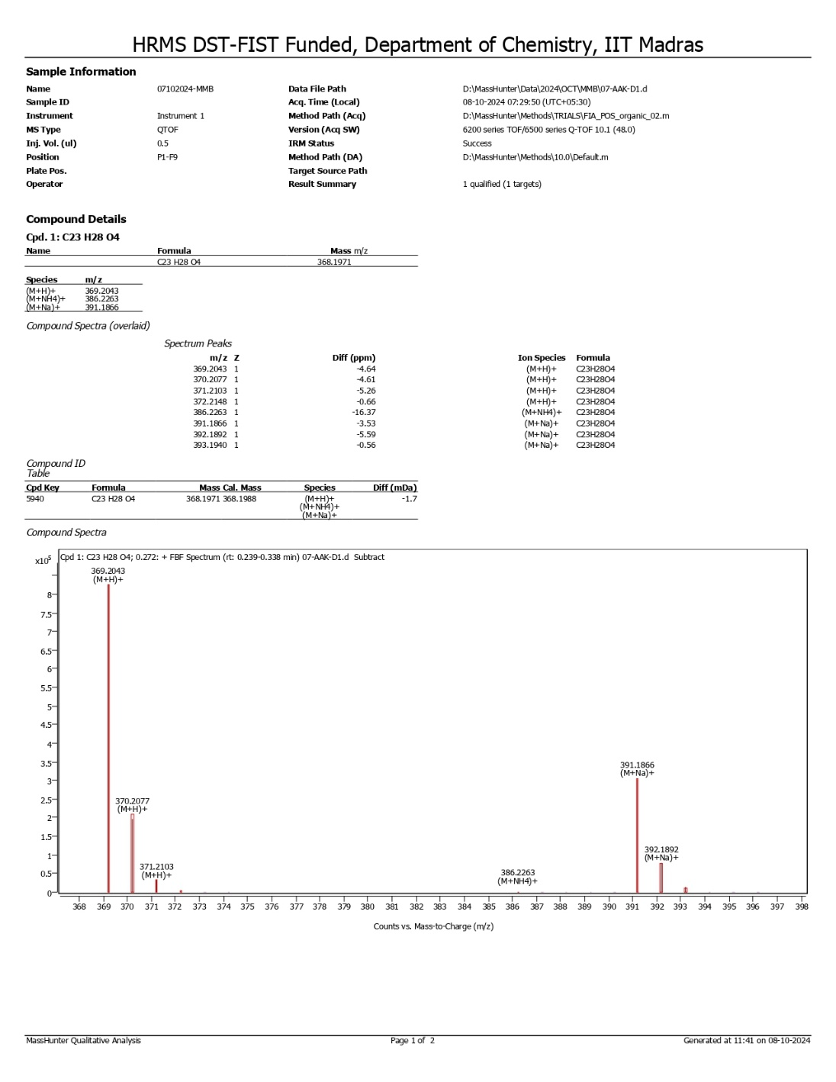
Figure S3: HRMS spectrum of 2,2’-(Phenyl-methylene) bis(3-hydroxy-5,5-dimethyl-2- cyclohexene-1-one) (3a)

Figure S4: IR spectrum of of 2,2’-(Phenyl-methylene) bis(3-hydroxy-5,5-dimethyl-2- cyclohexene-1-one) (3a)

Figure S5: 1H NMR spectrum of 9-(2-hydroxy-4,4-dimethyl-6-oxocyclohex-1-en-1-yl)-3,3-dimethyl-2,3,4,9-tetrahydro-1H-xanthen-1-one (3b)

Figure S6: 13C NMR spectrum of 9-(2-hydroxy-4,4-dimethyl-6-oxocyclohex-1-en-1-yl)-3,3-dimethyl-2,3,4,9-tetrahydro-1H-xanthen-1-one (3b)

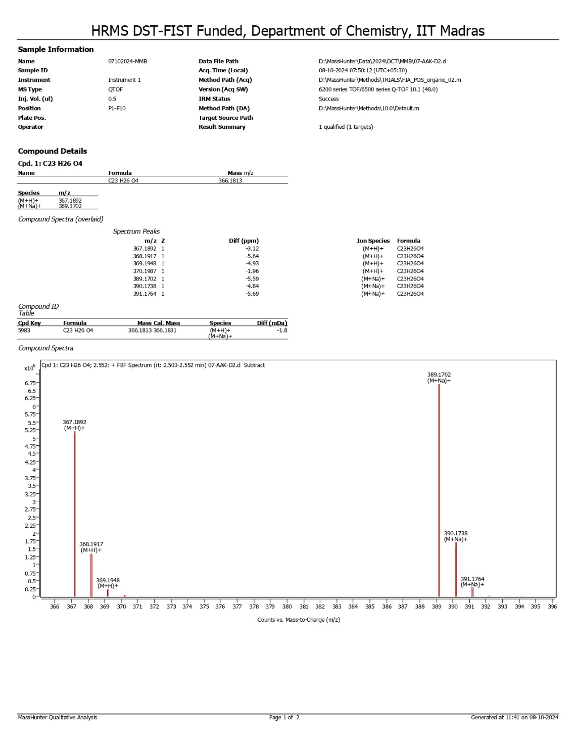
Figure S7: HRMS spectrum of 9-(2-hydroxy-4,4-dimethyl-6-oxocyclohex-1-en-1-yl)-3,3-dimethyl-2,3,4,9-tetrahydro-1H-xanthen-1-one (3b)

Figure S8: IR spectrum of 9-(2-hydroxy-4,4-dimethyl-6-oxocyclohex-1-en-1-yl)-3,3-dimethyl-2,3,4,9-tetrahydro-1H-xanthen-1-one (3b)
Figure S9: 1H NMR spectrum of 2,2'-((4-hydroxy-3,5-dimethoxyphenyl)methylene)bis(3-hydroxy- 5,5-dimethylcyclohex-2-en-1-one) (3c)

Figure S10: 13C NMR spectrum of 2,2'-((4-hydroxy-3,5-dimethoxyphenyl)methylene)bis(3-hydroxy- 5,5-dimethylcyclohex-2-en-1-one) (3c)
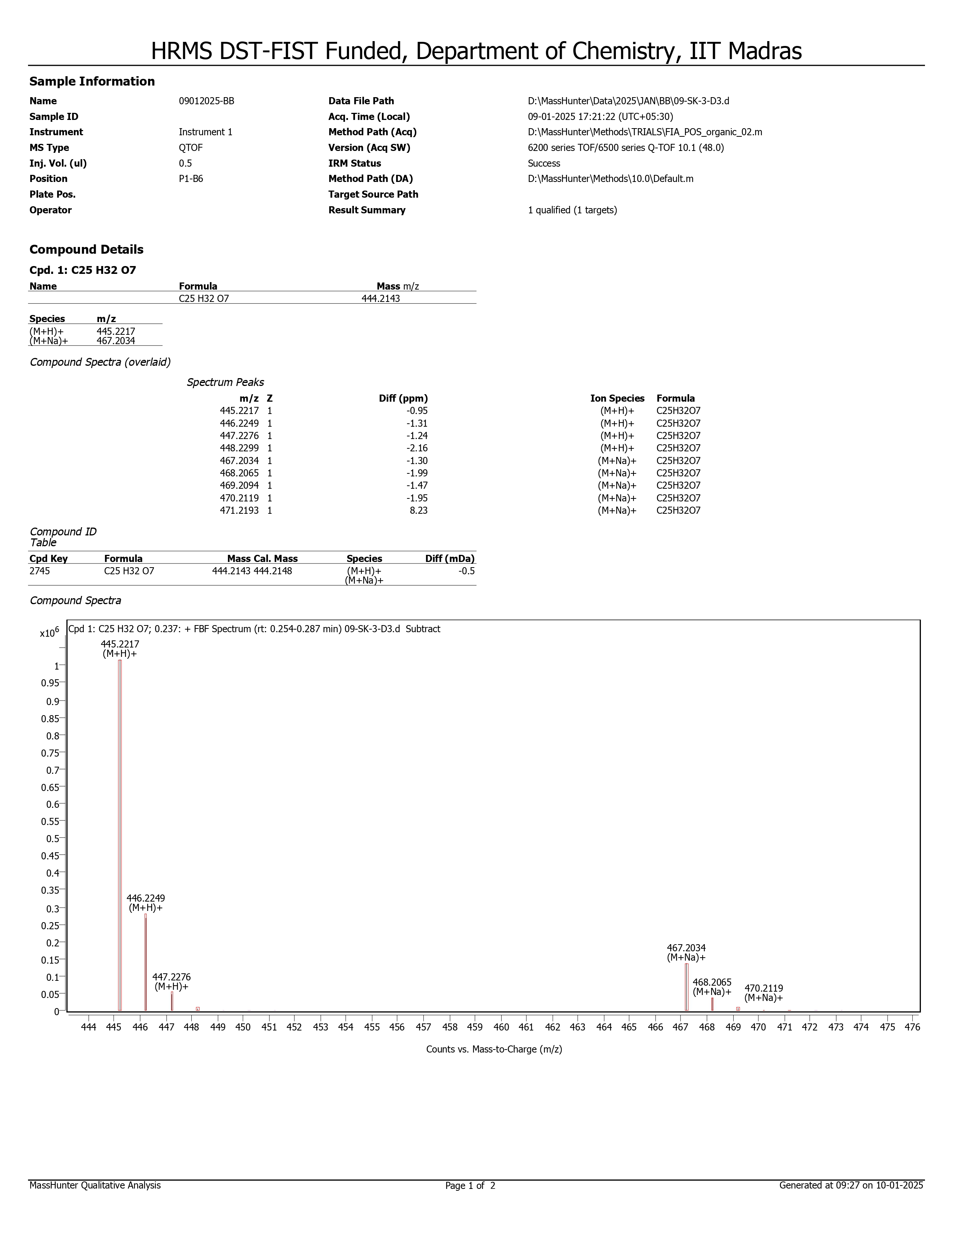
Figure S11: HRMS spectrum of 2,2'-((4-hydroxy-3,5-dimethoxyphenyl)methylene)bis(3-hydroxy- 5,5-dimethylcyclohex-2-en-1-one) (3c)

Figure S12: IR spectrum of 2,2'-((4-hydroxy-3,5-dimethoxyphenyl)methylene)bis(3-hydroxy- 5,5-dimethylcyclohex-2-en-1-one) (3c)

Figure S13: 1H NMR spectrum of 2,2'-((3,4-dimethoxyphenyl) methylene) bis(3-hydroxy-5,5- dimethylcyclohex-2-en-1-one) (3d)
Figure S14: 13C NMR spectrum of 2,2'-((3,4-dimethoxyphenyl) methylene) bis(3-hydroxy-5,5- dimethylcyclohex-2-en-1-one) (3d)

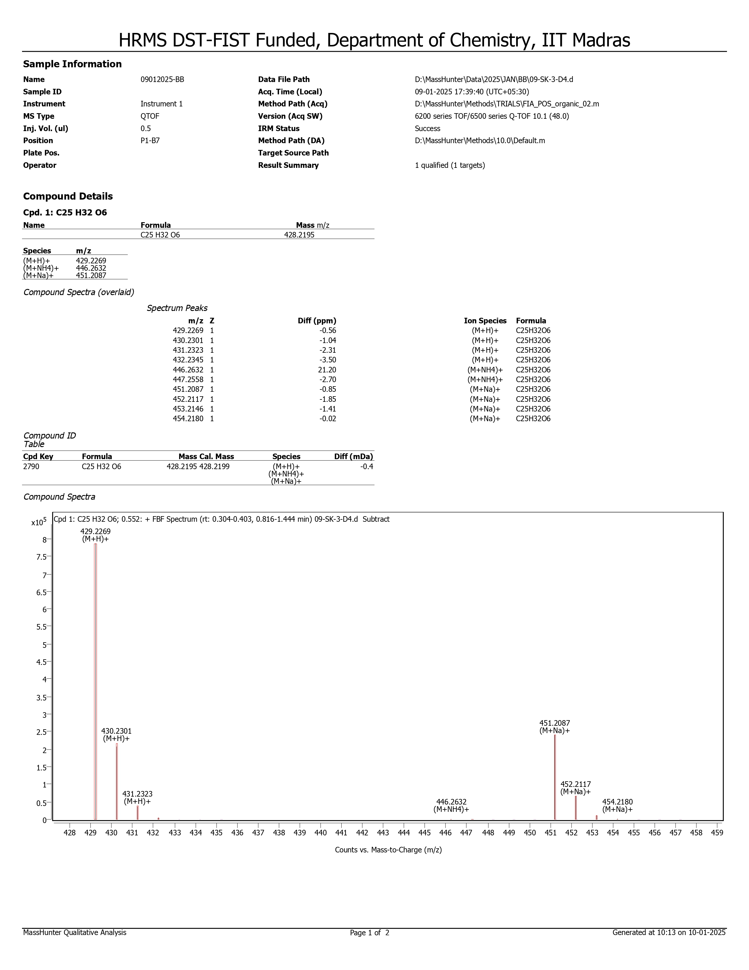
Figure S15: HRMS spectrum of 2,2'-((3,4-dimethoxyphenyl) methylene) bis(3-hydroxy-5,5- dimethylcyclohex-2-en-1-one) (3d)
Figure S16: IR spectrum of 2,2'-((3,4-dimethoxyphenyl) methylene) bis(3-hydroxy-5,5- dimethylcyclohex-2-en-1-one) (3d)

Figure S17: 1H NMR spectrum of 2,2'-((4-(dimethylamino)phenyl)methylene) bis(3-hydroxy-5,5-dimethylcyclohex-2-en-1-one) (3e)

Figure S18: 13C NMR spectrum of 2,2'-((4-(dimethylamino)phenyl)methylene) bis(3-hydroxy-5,5-dimethylcyclohex-2-en-1-one) (3e)

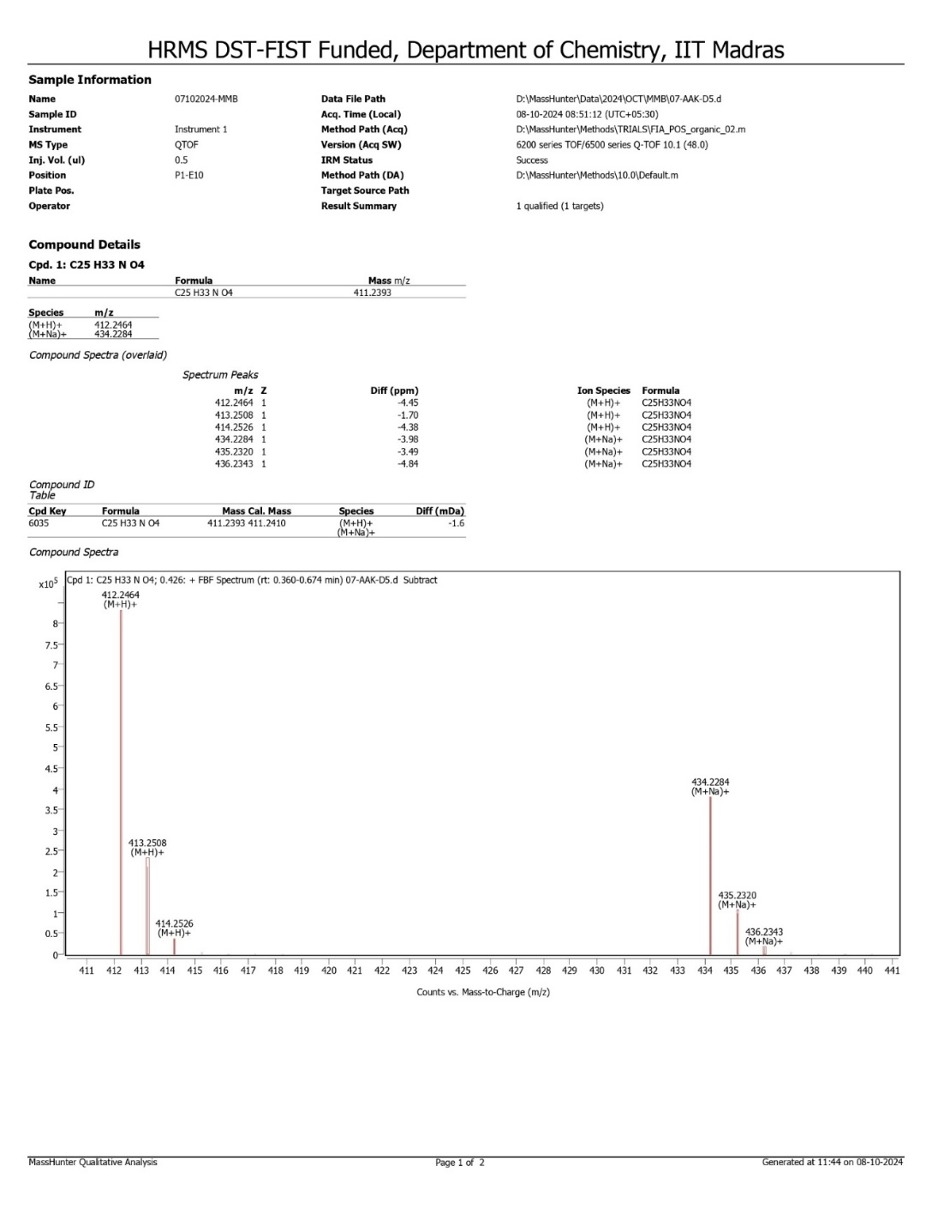
Figure S19: HRMS spectrum of 2,2'-((4-(dimethylamino)phenyl)methylene) bis(3-hydroxy-5,5-dimethylcyclohex-2-en-1-one) (3e)
Figure S20: IR spectrum of 2,2'-((4-(dimethylamino)phenyl)methylene) bis(3-hydroxy-5,5-dimethylcyclohex-2-en-1-one) (3e)

Figure S21: 1H NMR spectrum of 2,2'-((3,4-dihydroxyphenyl)methylene)bis(3-hydroxy-5,5-dimethylcyclohex-2-en-1-one) (3f)
Figure S22: 13C NMR spectrum of 2,2'-((3,4-dihydroxyphenyl)methylene)bis(3-hydroxy-5,5-dimethylcyclohex-2-en-1-one) (3f)

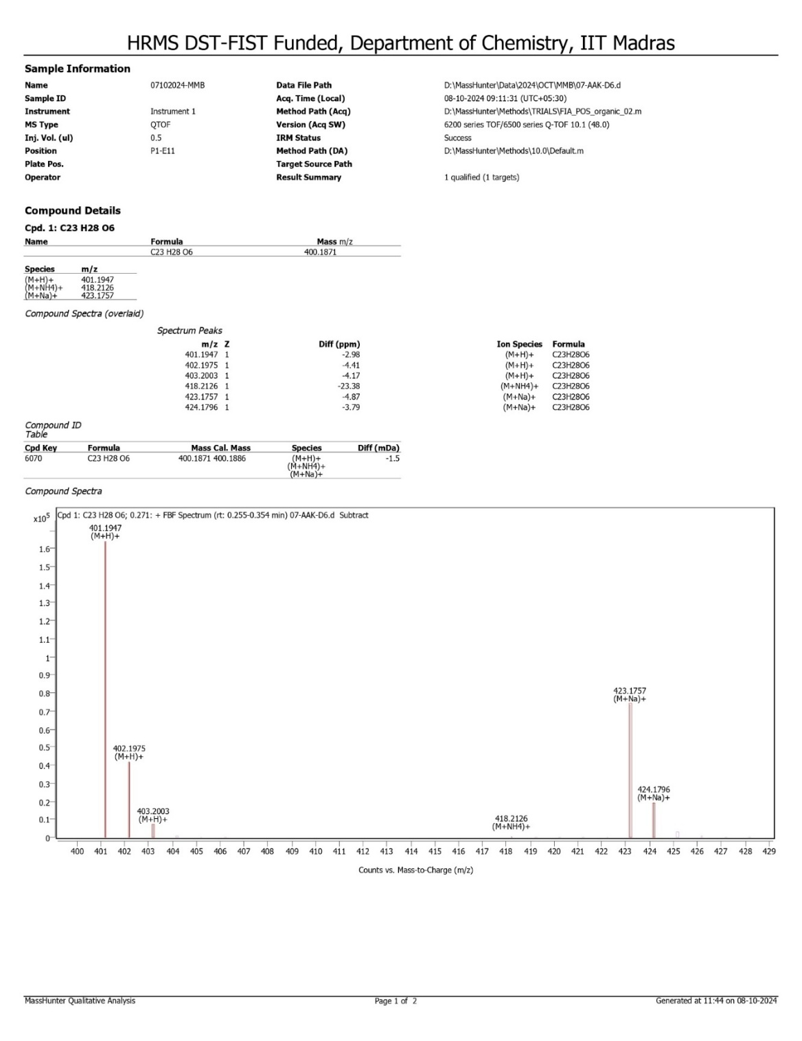
Figure S23: HRMS spectrum of 2,2'-((3,4-dihydroxyphenyl)methylene)bis(3-hydroxy-5,5-dimethylcyclohex-2-en-1-one) (3f)
Figure S24: IR spectrum of 2,2'-((3,4-dihydroxyphenyl)methylene)bis(3-hydroxy-5,5-dimethylcyclohex-2-en-1-one) (3f)
Figure S25: 1H NMR spectrum of 2,2'-(4-hydroxy-3-methoxyphenyl)methylene)bis(3-hydroxy-5,5-dimethylcyclohex-2-en-1-one) (3g)
Figure S26: 13C NMR spectrum of 2,2'-(4-hydroxy-3-methoxyphenyl)methylene)bis(3-hydroxy-5,5-dimethylcyclohex-2-en-1-one) (3g)
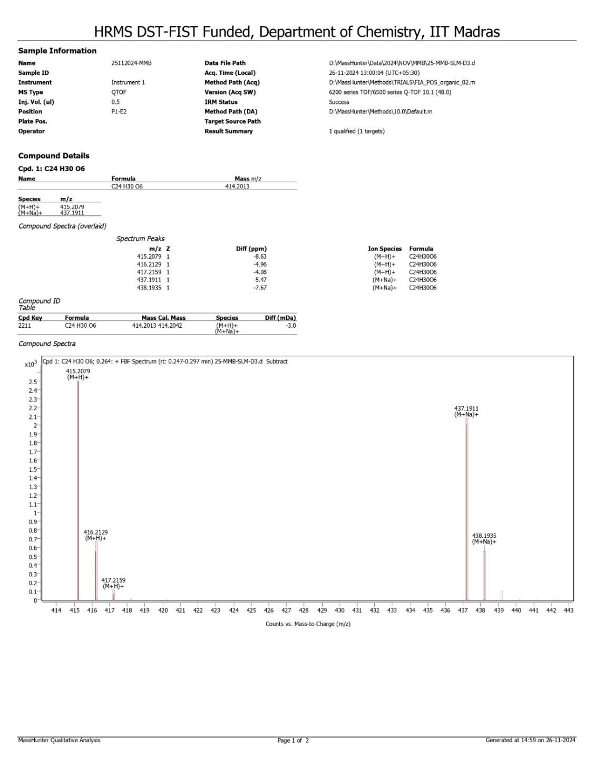
Figure S27: HRMS spectrum of 2,2'-(4-hydroxy-3-methoxyphenyl)methylene)bis(3-hydroxy-5,5-dimethylcyclohex-2-en-1-one) (3g)
Figure S28: IR spectrum of 2,2'-(4-hydroxy-3-methoxyphenyl)methylene)bis(3-hydroxy-5,5-dimethylcyclohex-2-en-1-one) (3g)

Figure S29: 1H NMR spectrum of 2,2'-((3,4,5-trimethoxyphenyl)methylene)bis(3-hydroxy-5,5-dimethylcyclohex-2-en-1-one) (3h)
Figure S30: 13C NMR spectrum of 2,2'-((3,4,5-trimethoxyphenyl)methylene)bis(3-hydroxy-5,5-dimethylcyclohex-2-en-1-one) (3h)
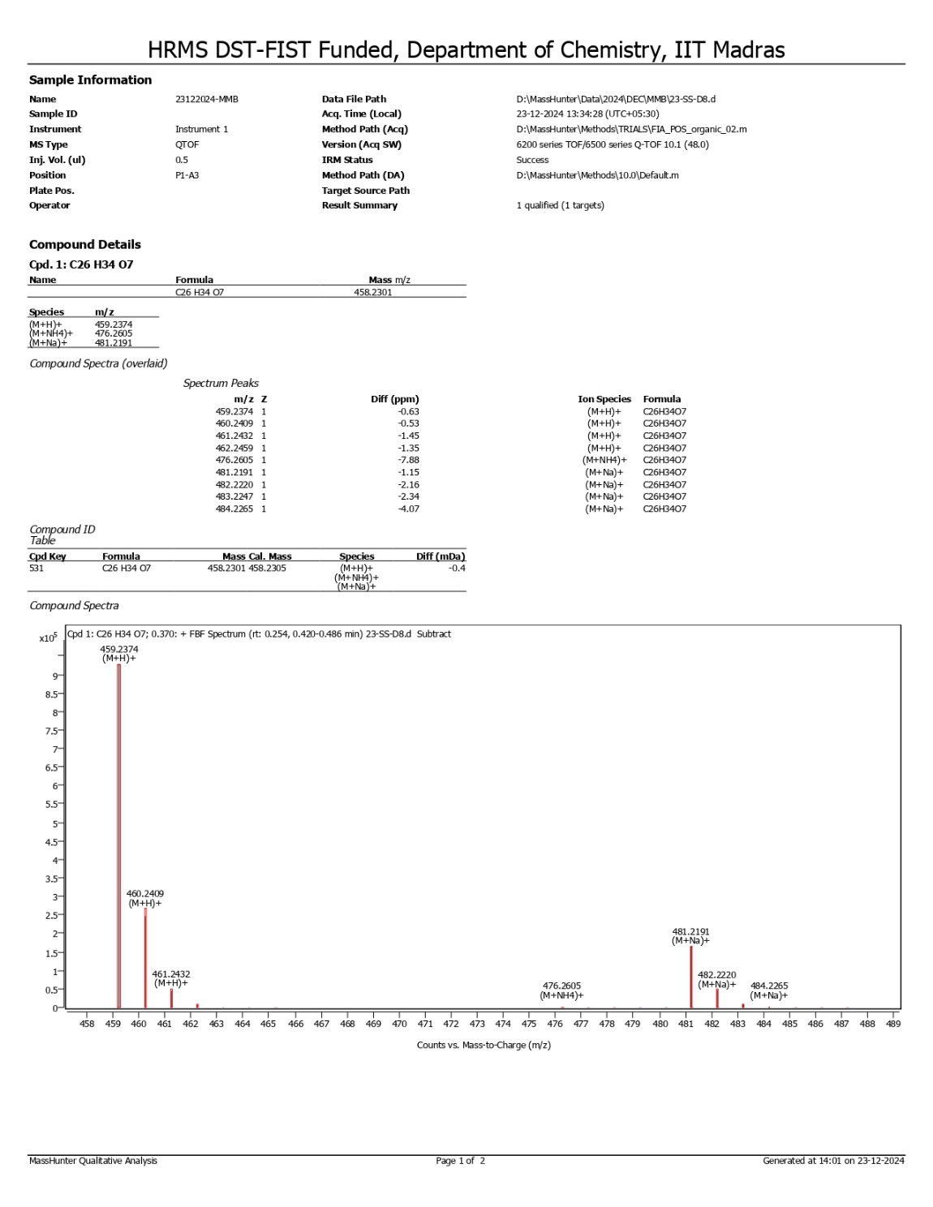
Figure S31: HRMS spectrum of 2,2'-((3,4,5-trimethoxyphenyl)methylene)bis(3-hydroxy-5,5-dimethylcyclohex-2-en-1-one) (3h)
Figure S32: IR spectrum of 2,2'-((3,4,5-trimethoxyphenyl)methylene)bis(3-hydroxy-5,5-dimethylcyclohex-2-en-1-one) (3h)
Figure S33: 1H NMR spectrum of 2,2'-((4-chlorophenyl)methylene)bis(3-hydroxy-5,5-dimethylcyclohex-2-en-1-one) (3i)
Figure S34: 13C NMR spectrum of 2,2'-((4-chlorophenyl)methylene)bis(3-hydroxy-5,5-dimethylcyclohex-2-en-1-one) (3i)
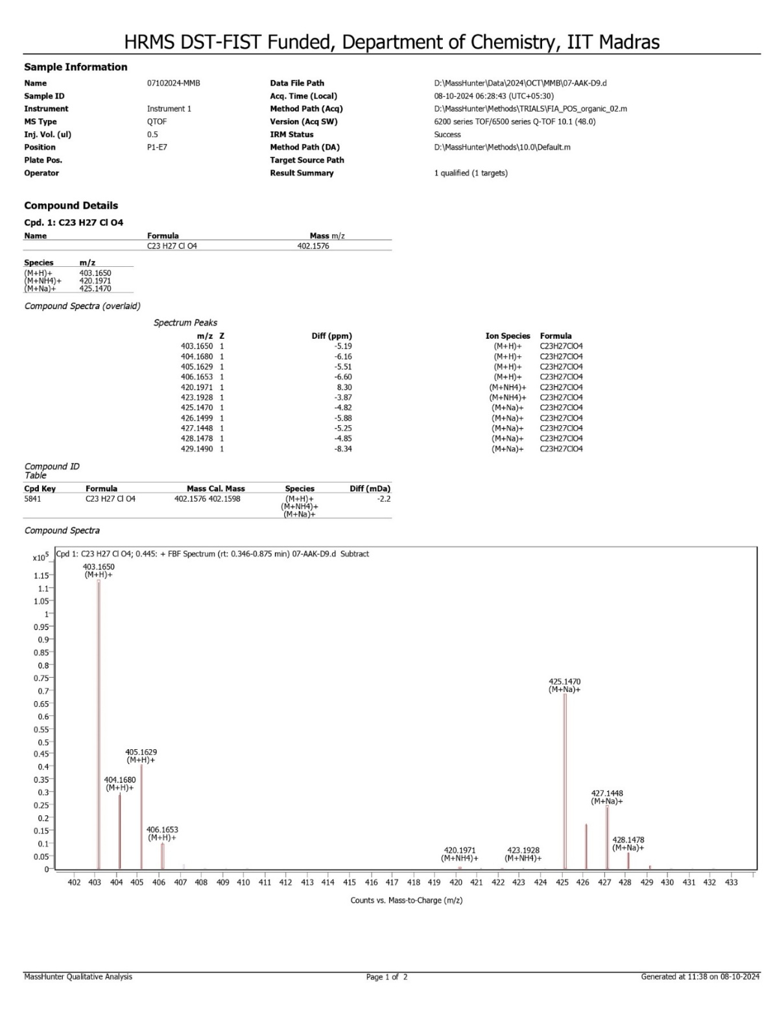
Figure S35: HRMS spectrum of 2,2'-((4-chlorophenyl)methylene)bis(3-hydroxy-5,5-dimethylcyclohex-2-en-1-one) (3i)
Figure S36: IR spectrum of 2,2'-((4-chlorophenyl)methylene)bis(3-hydroxy-5,5-dimethylcyclohex-2-en-1-one) (3i)
Figure S37: 1H NMR spectrum of 2,2'-(p-tolylmethylene)bis(3-hydroxy-5,5-dimethylcyclohex-2-en-1-one) (3j)
Figure S38: 13C NMR spectrum of 2,2'-(p-tolylmethylene)bis(3-hydroxy-5,5-dimethylcyclohex-2-en-1-one) (3j)

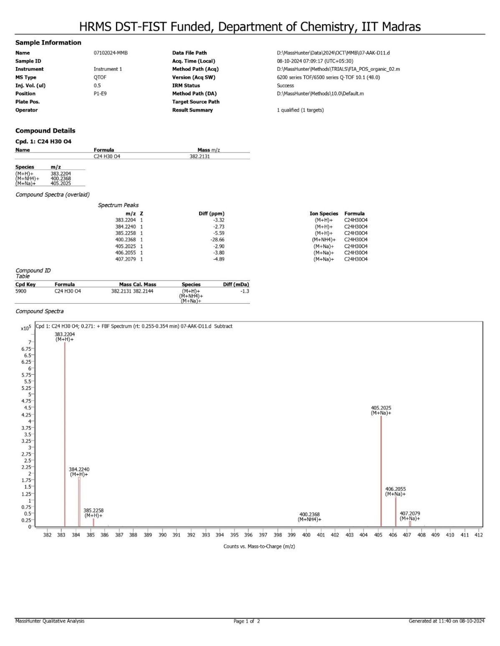
Figure S39: HRMS spectrum of 2,2'-(p-tolylmethylene)bis(3-hydroxy-5,5-dimethylcyclohex-2-en-1-one) (3j)
Figure S40: IR spectrum of 2,2'-(p-tolylmethylene)bis(3-hydroxy-5,5-dimethylcyclohex-2-en-1-one) (3j)
Figure S41: 1H NMR spectrum of 2,2',2'',2'''-(1,4-phenylenebis(methanetriyl))tetrakis(3-hydroxy- 5,5-dimethylcyclohex-2-en-1-one) (3k)
Figure S42: 13C NMR spectrum of 2,2',2'',2'''-(1,4-phenylenebis(methanetriyl))tetrakis(3-hydroxy- 5,5-dimethylcyclohex-2-en-1-one) (3k)

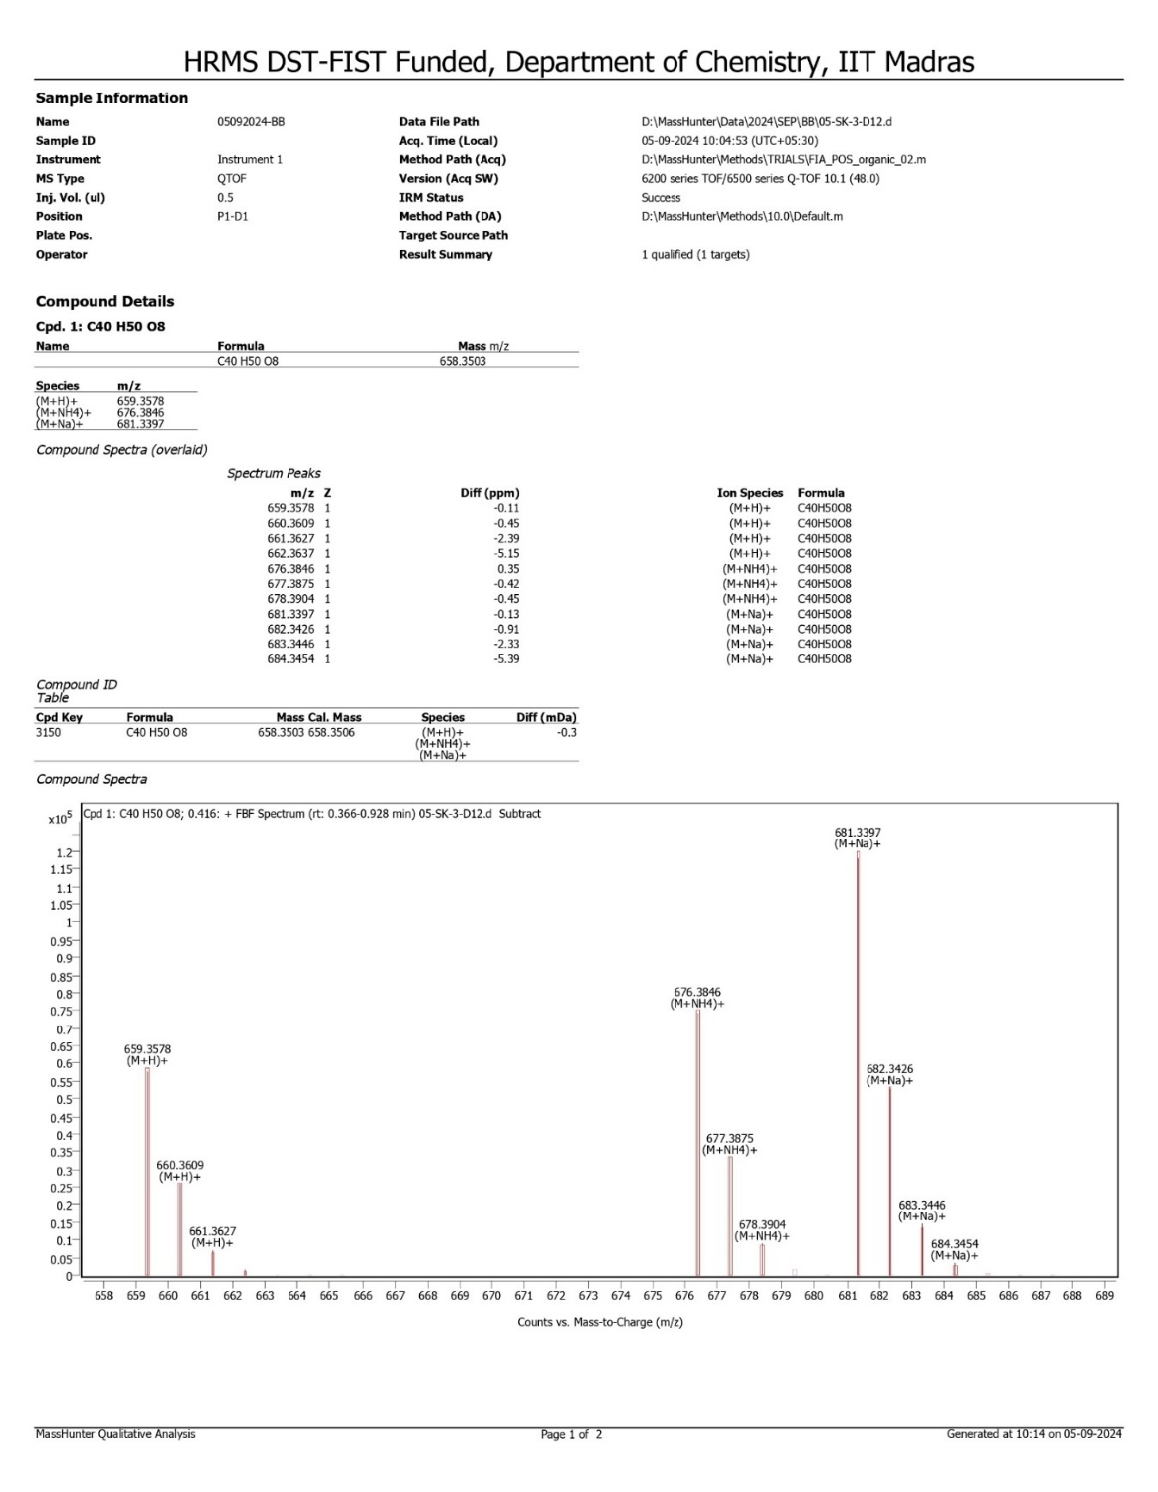
Figure S43: HRMS spectrum of 2,2',2'',2'''-(1,4-phenylenebis(methanetriyl))tetrakis(3-hydroxy- 5,5-dimethylcyclohex-2-en-1-one) (3k)
Figure S44: IR spectrum of 2,2',2'',2'''-(1,4-phenylenebis(methanetriyl))tetrakis(3-hydroxy- 5,5-dimethylcyclohex-2-en-1-one) (3k)
Figure S45: 1H NMR spectrum of 4-(bis(2-hydroxy-4,4-dimethyl-6-oxocyclohex-1-en-1-yl)methyl)benzaldehyde (3l)
Figure S46: 13C NMR spectrum of 4-(bis(2-hydroxy-4,4-dimethyl-6-oxocyclohex-1-en-1-yl)methyl)benzaldehyde (3l)

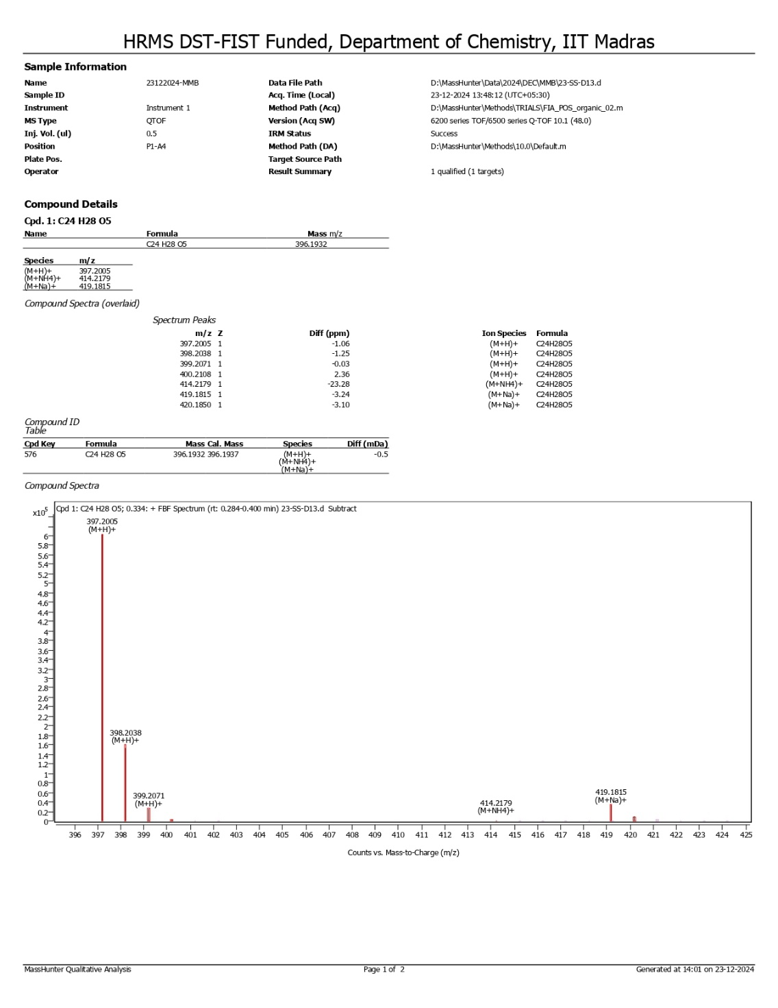
Figure S47: HRMS spectrum of 4-(bis(2-hydroxy-4,4-dimethyl-6-oxocyclohex-1-en-1-yl)methyl)benzaldehyde (3l)
Figure S48: IR spectrum of 4-(bis(2-hydroxy-4,4-dimethyl-6-oxocyclohex-1-en-1-yl)methyl)benzaldehyde (3l)

NMR, HRMS and IR spectra of cyclic xanthene derivatives

Figure S49: 1H NMR spectrum of 3,3,6,6-Tetramethyl-9-phenyl-3,4,5,6,7,9-hexahydro-1H-xanthene-1,8(2H)-dione (4a)
Figure S50: 13C NMR spectrum of 3,3,6,6-Tetramethyl-9-phenyl-3,4,5,6,7,9-hexahydro-1H-xanthene-1,8(2H)-dione (4a)

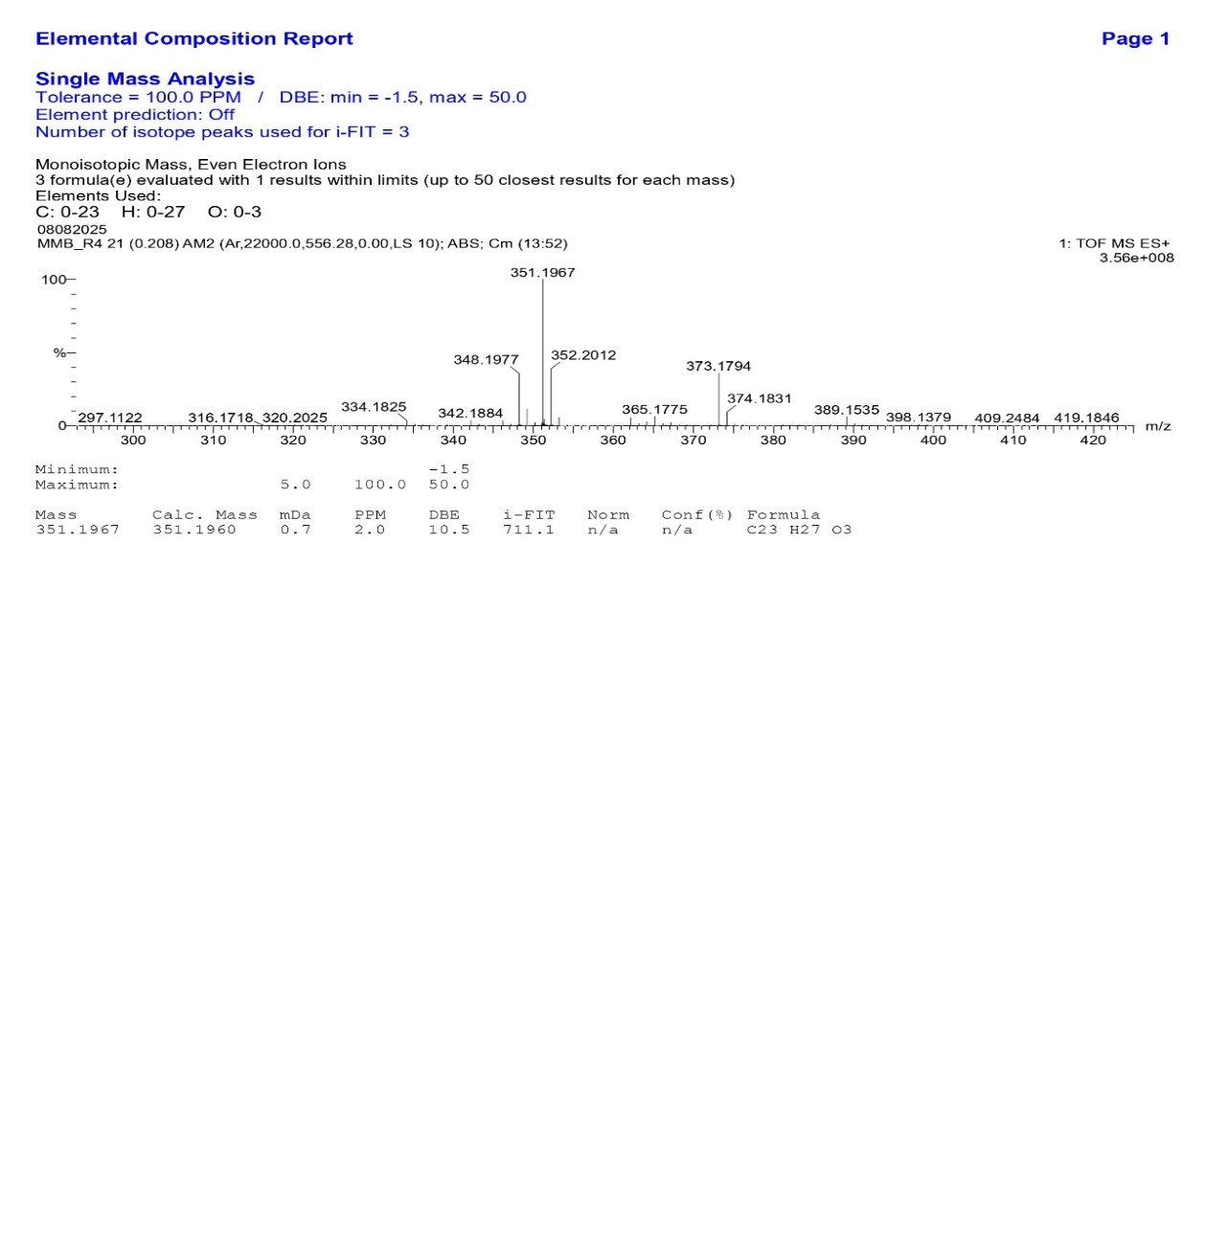
Figure S51: HRMS spectrum of 3,3,6,6-Tetramethyl-9-phenyl-3,4,5,6,7,9-hexahydro-1H-xanthene-1,8(2H)-dione (4a)
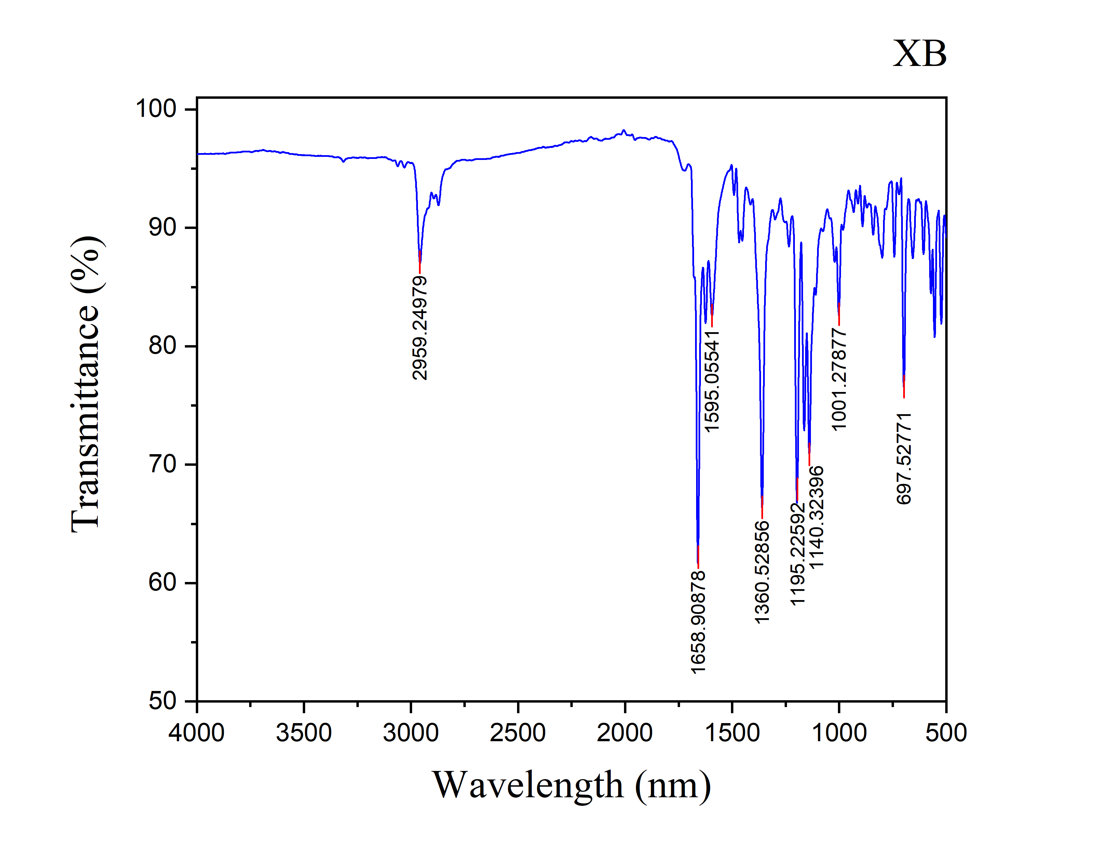
Figure S52: IR spectrum of 3,3,6,6-Tetramethyl-9-phenyl-3,4,5,6,7,9-hexahydro-1H-xanthene-1,8(2H)-dione (4a)

Figure S53: 1H NMR spectrum of 9-(2-hydroxy-4,4-dimethyl-6-oxocyclohex-1-en-1-yl)-3,3-dimethyl-2,3,4,9-tetrahydro-1H-xanthen-1-one (4b)
Figure S54: 13C NMR spectrum of 9-(2-hydroxy-4,4-dimethyl-6-oxocyclohex-1-en-1-yl)-3,3-dimethyl-2,3,4,9-tetrahydro-1H-xanthen-1-one (4b)

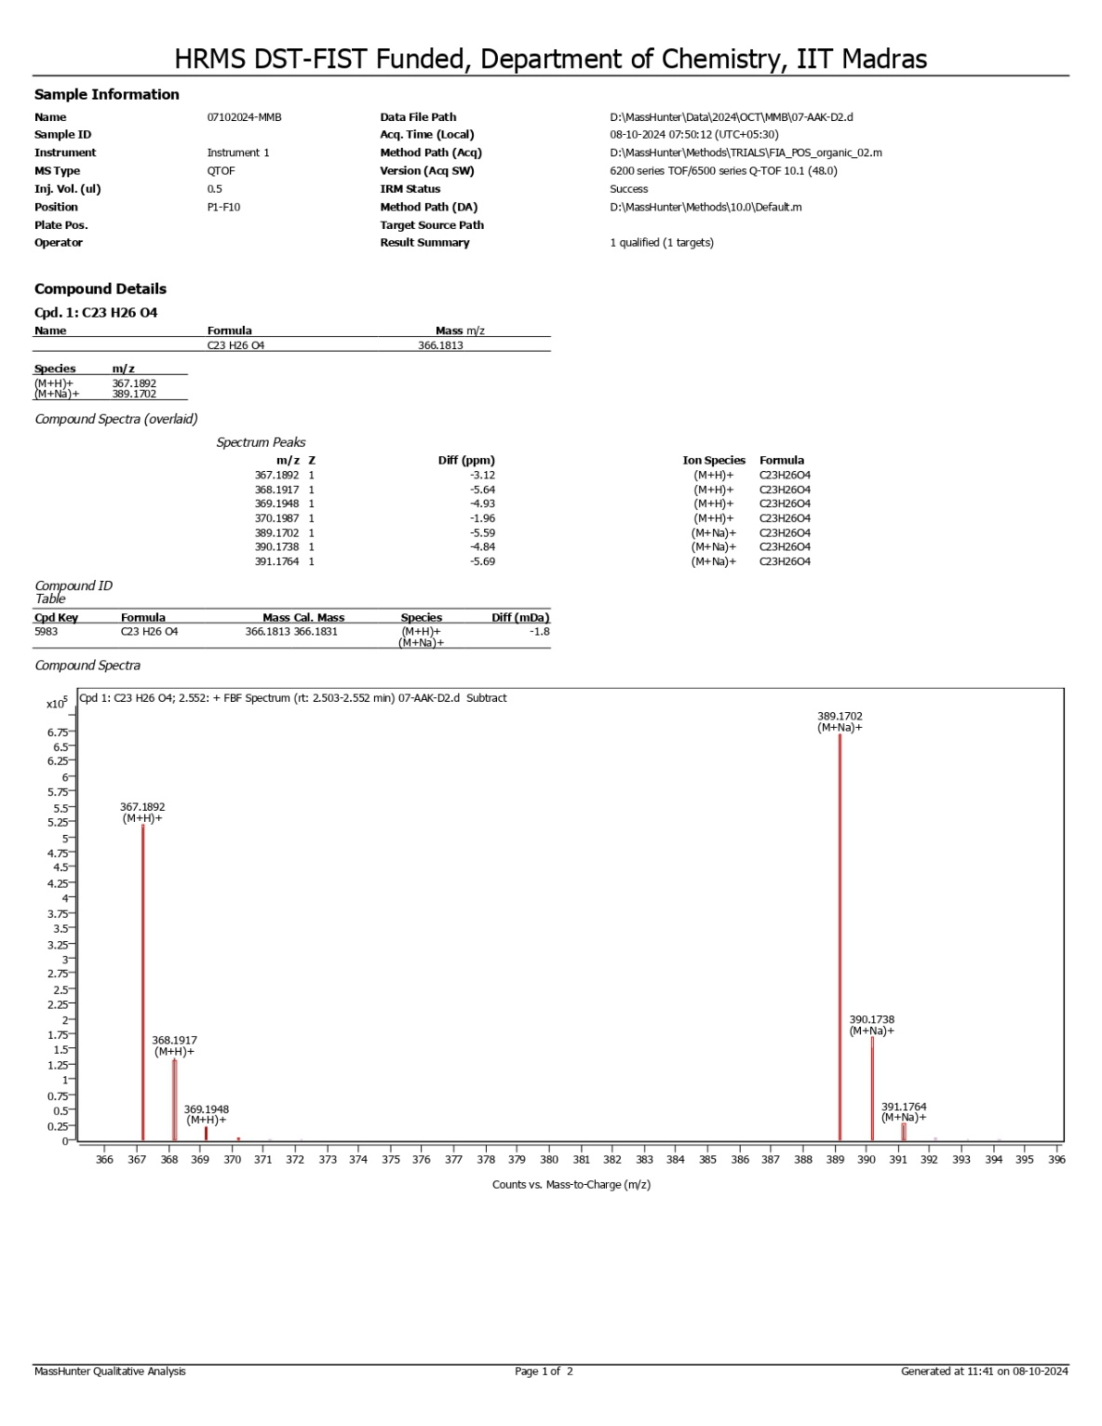
Figure S55: HRMS spectrum of 9-(2-hydroxy-4,4-dimethyl-6-oxocyclohex-1-en-1-yl)-3,3-dimethyl-2,3,4,9-tetrahydro-1H-xanthen-1-one (4b)

Figure S56: IR spectrum of 9-(2-hydroxy-4,4-dimethyl-6-oxocyclohex-1-en-1-yl)-3,3-dimethyl-2,3,4,9-tetrahydro-1H-xanthen-1-one (4b)

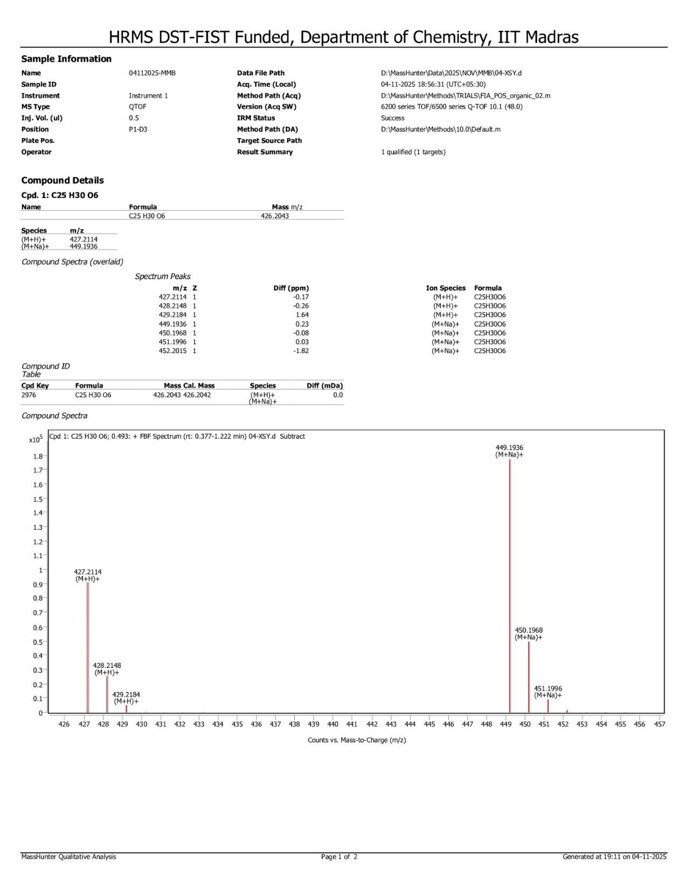

Figure S57: HRMS spectrum of 9-(4-hydroxy-3,5-dimethoxyphenyl)-3,3,6,6-tetramethyl-3,4,5,6,7,9-hexahydro-1H-xanthene-1,8(2H)-dione (4c)

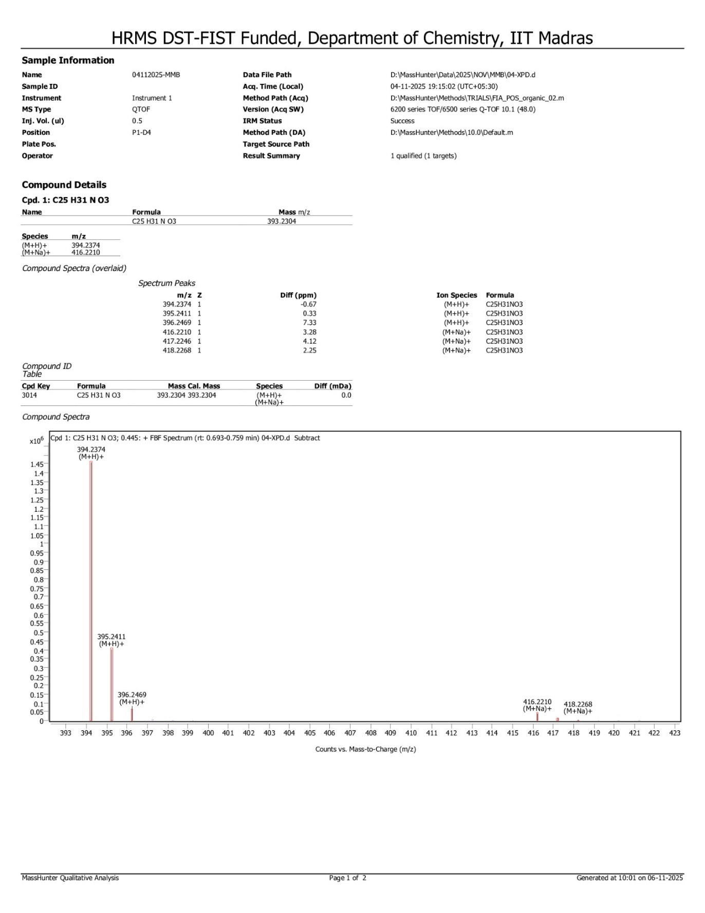
Figure S58: HRMS spectrum of 9-(4-(dimethylamino)phenyl)-3,3,6,6-tetramethyl-3,4,5,6,7,9-hexahydro-1H-xanthene-1,8(2H)-dione (4d)

Figure S59: 1H NMR spectrum of 9-(4-Hydroxy-3-methoxyphenyl)-3,3,6,6-tetramethyl-3,4,5,6,7,9-hexahydro-2H-xanthene-1,8-dione (4e)

Figure S60: 13C NMR spectrum of 9-(4-Hydroxy-3-methoxyphenyl)-3,3,6,6-tetramethyl-3,4,5,6,7,9-hexahydro-2H-xanthene-1,8-dione (4e)

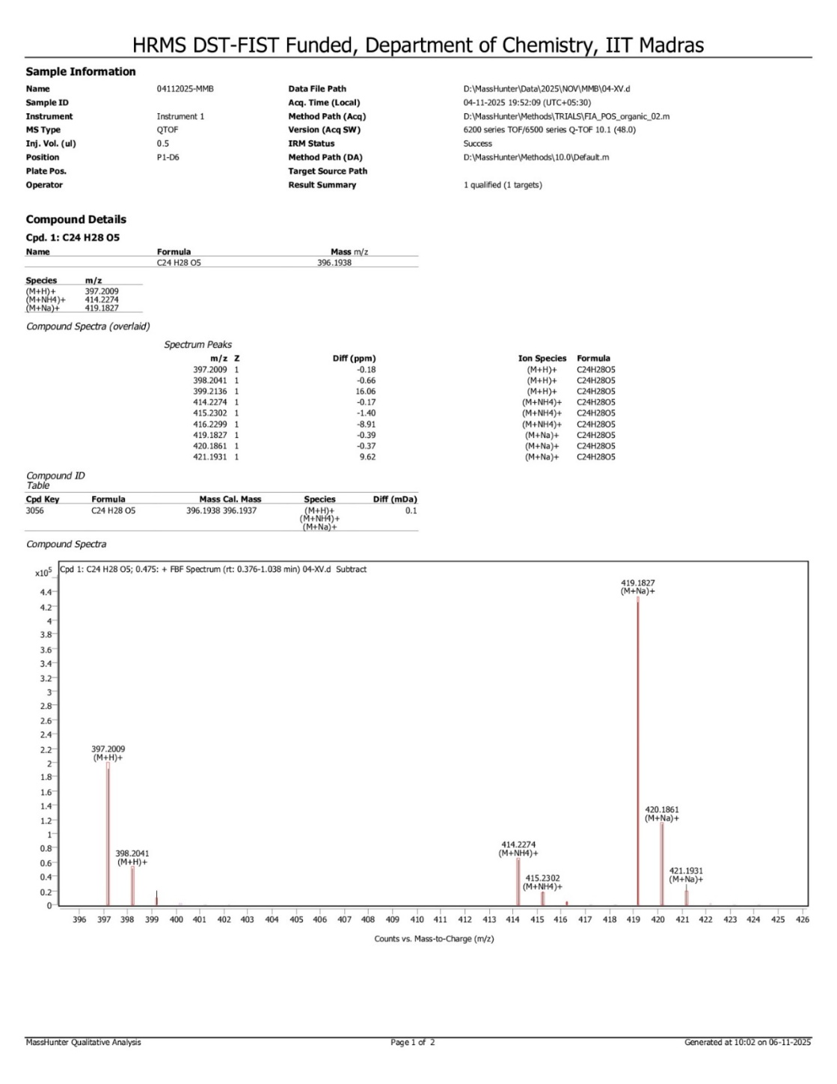
Figure S61: HRMS spectrum of 9-(4-Hydroxy-3-methoxyphenyl)-3,3,6,6-tetramethyl-3,4,5,6,7,9-hexahydro-2H-xanthene-1,8-dione (4e)
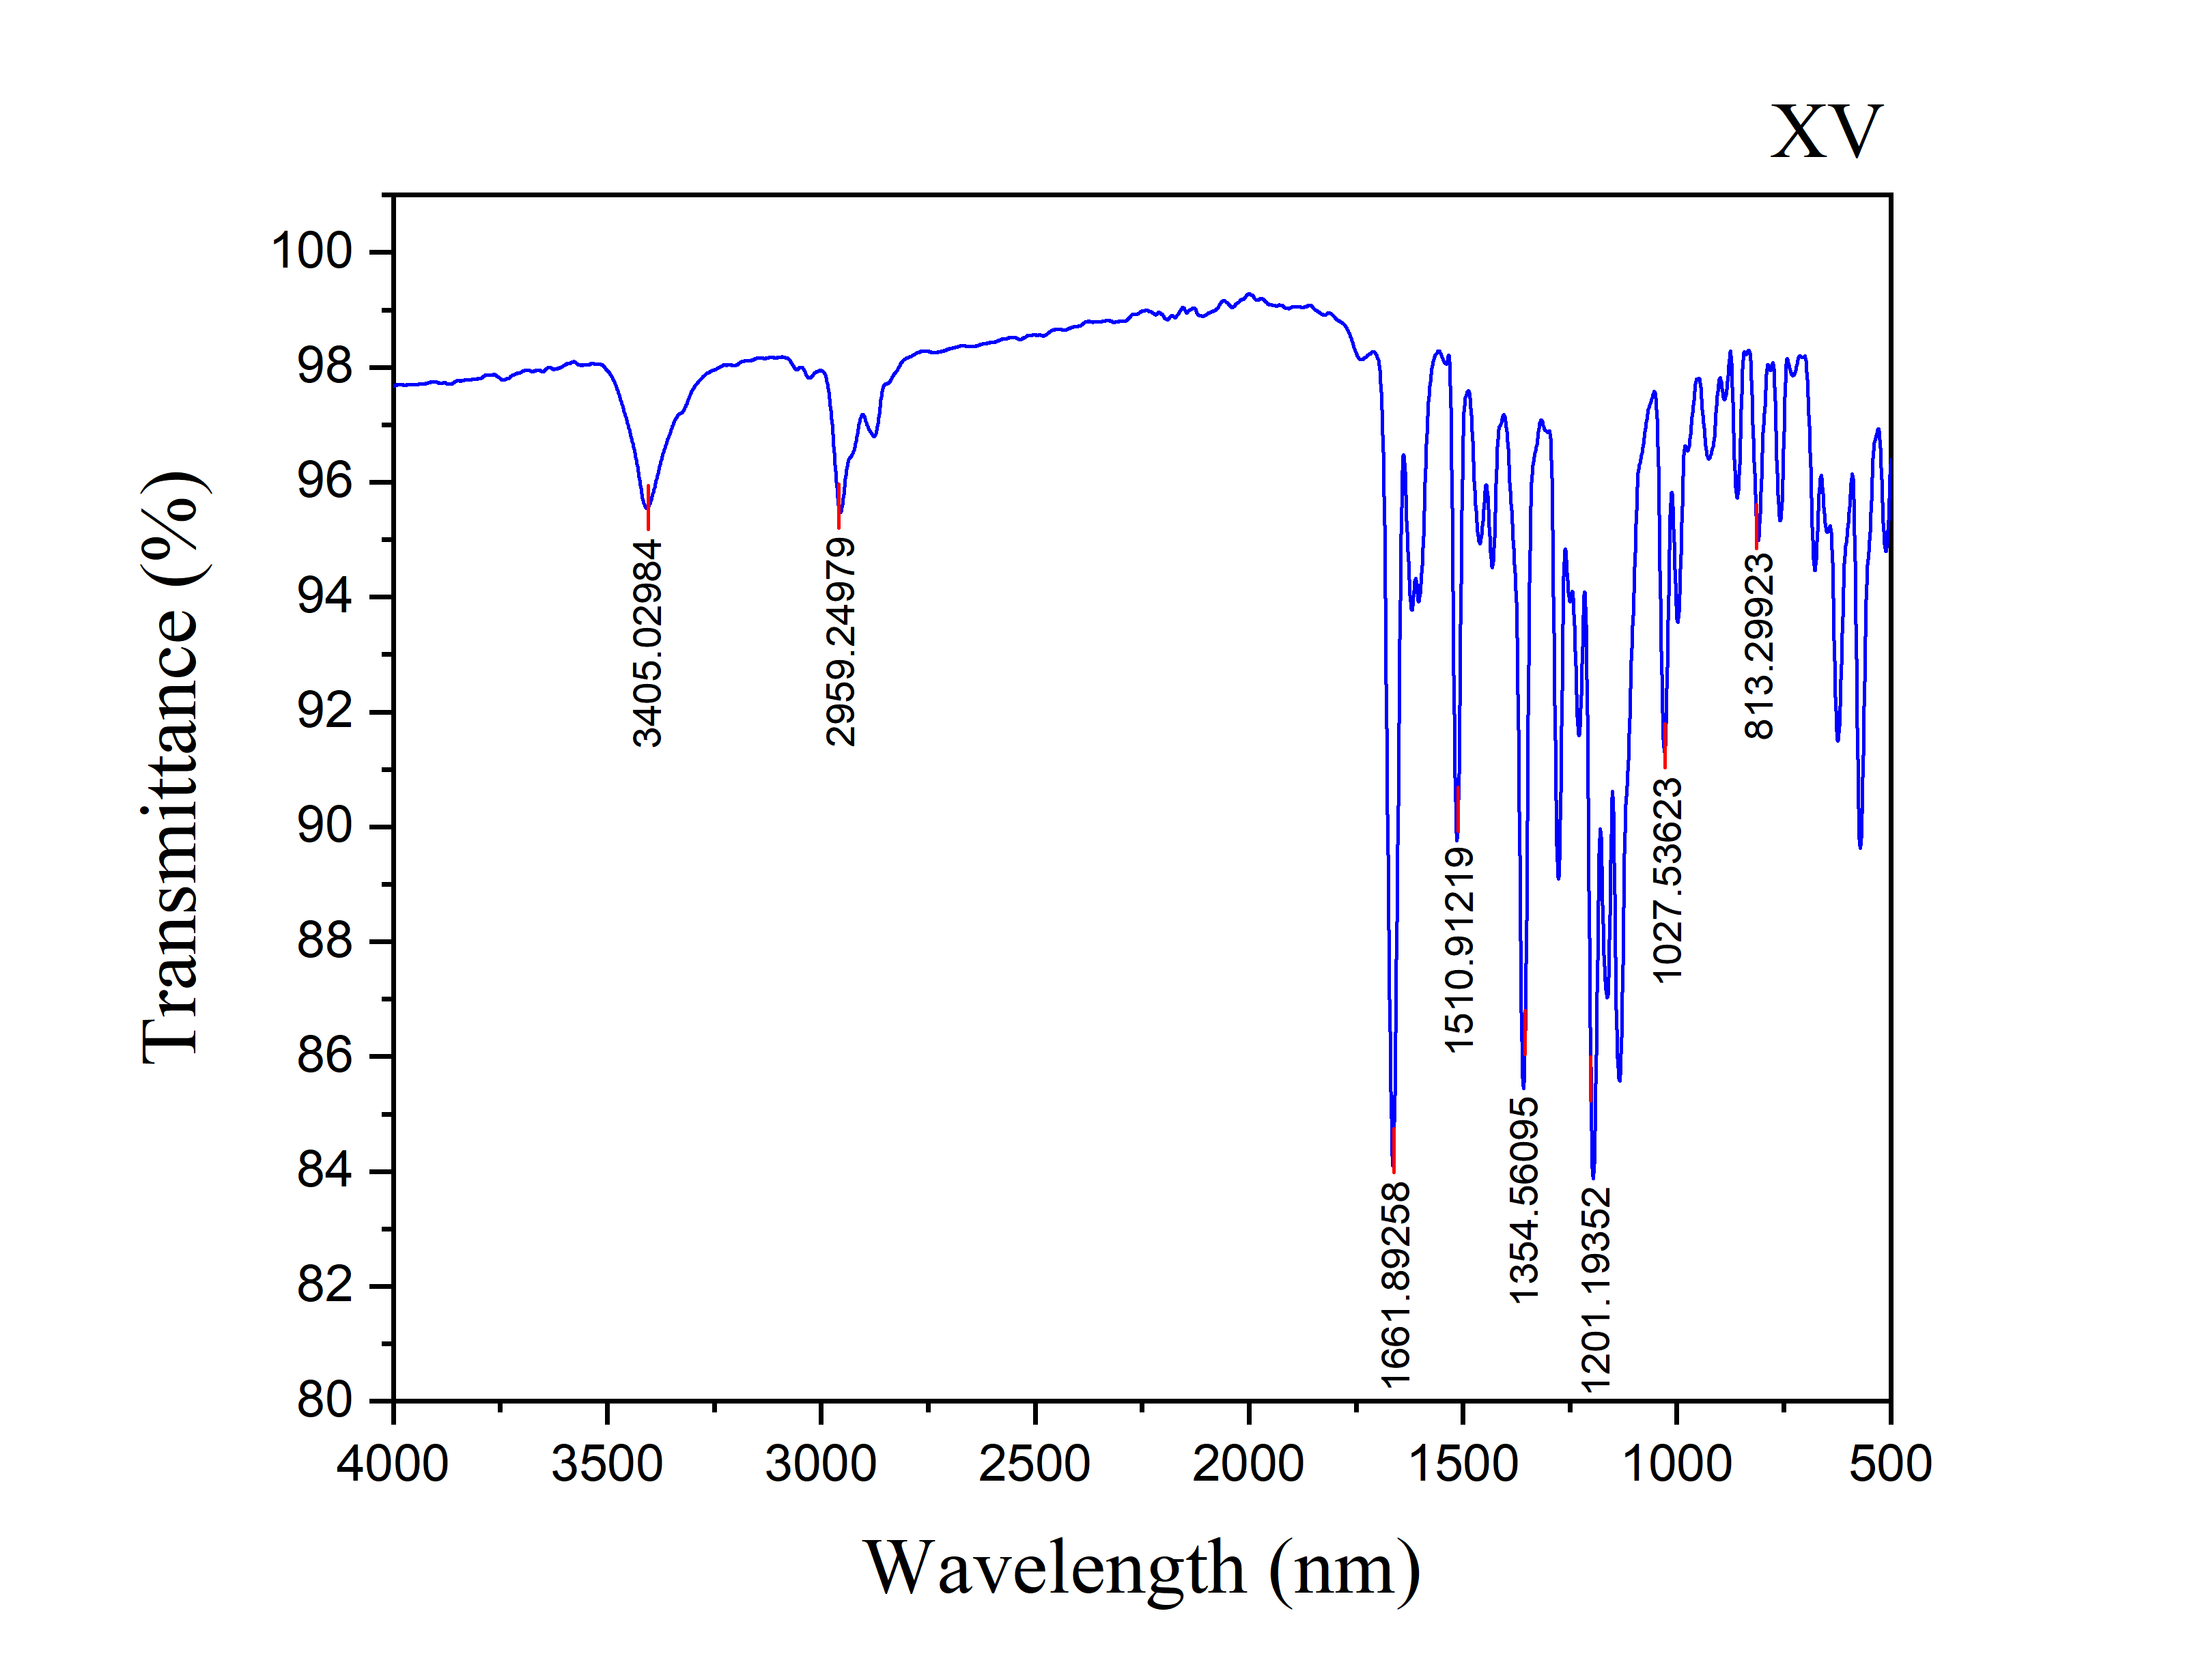
Figure S62: IR spectrum of 9-(4-Hydroxy-3-methoxyphenyl)-3,3,6,6-tetramethyl-3,4,5,6,7,9-hexahydro-2H-xanthene-1,8-dione (4e)

Figure S63: 1H NMR spectrum of 3,3,6,6-Tetramethyl-9-(3,4,5-trimethoxyphenyl)-3,4,5,6,7,9-hexahydro-1H-xanthene-1,8(2H)-dione (4f)
Figure S64: 13C NMR spectrum of 3,3,6,6-Tetramethyl-9-(3,4,5-trimethoxyphenyl)-3,4,5,6,7,9-hexahydro-1H-xanthene-1,8(2H)-dione (4f)

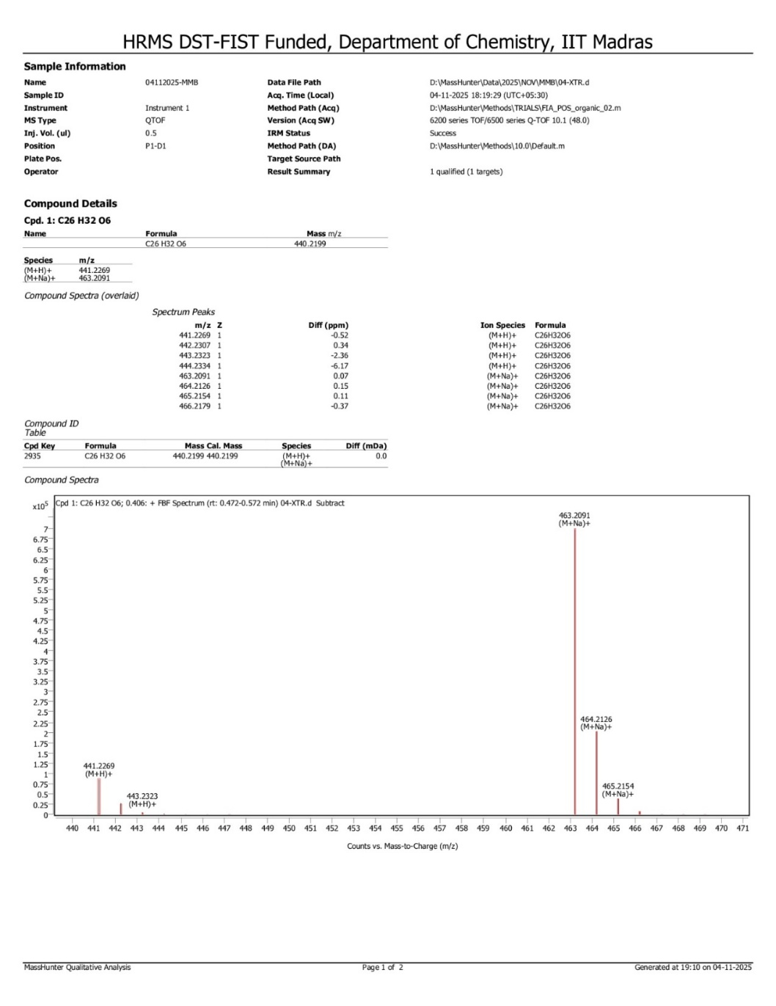
Figure S65: HRMS spectrum of 3,3,6,6-Tetramethyl-9-(3,4,5-trimethoxyphenyl)-3,4,5,6,7,9-hexahydro-1H-xanthene-1,8(2H)-dione (4f)

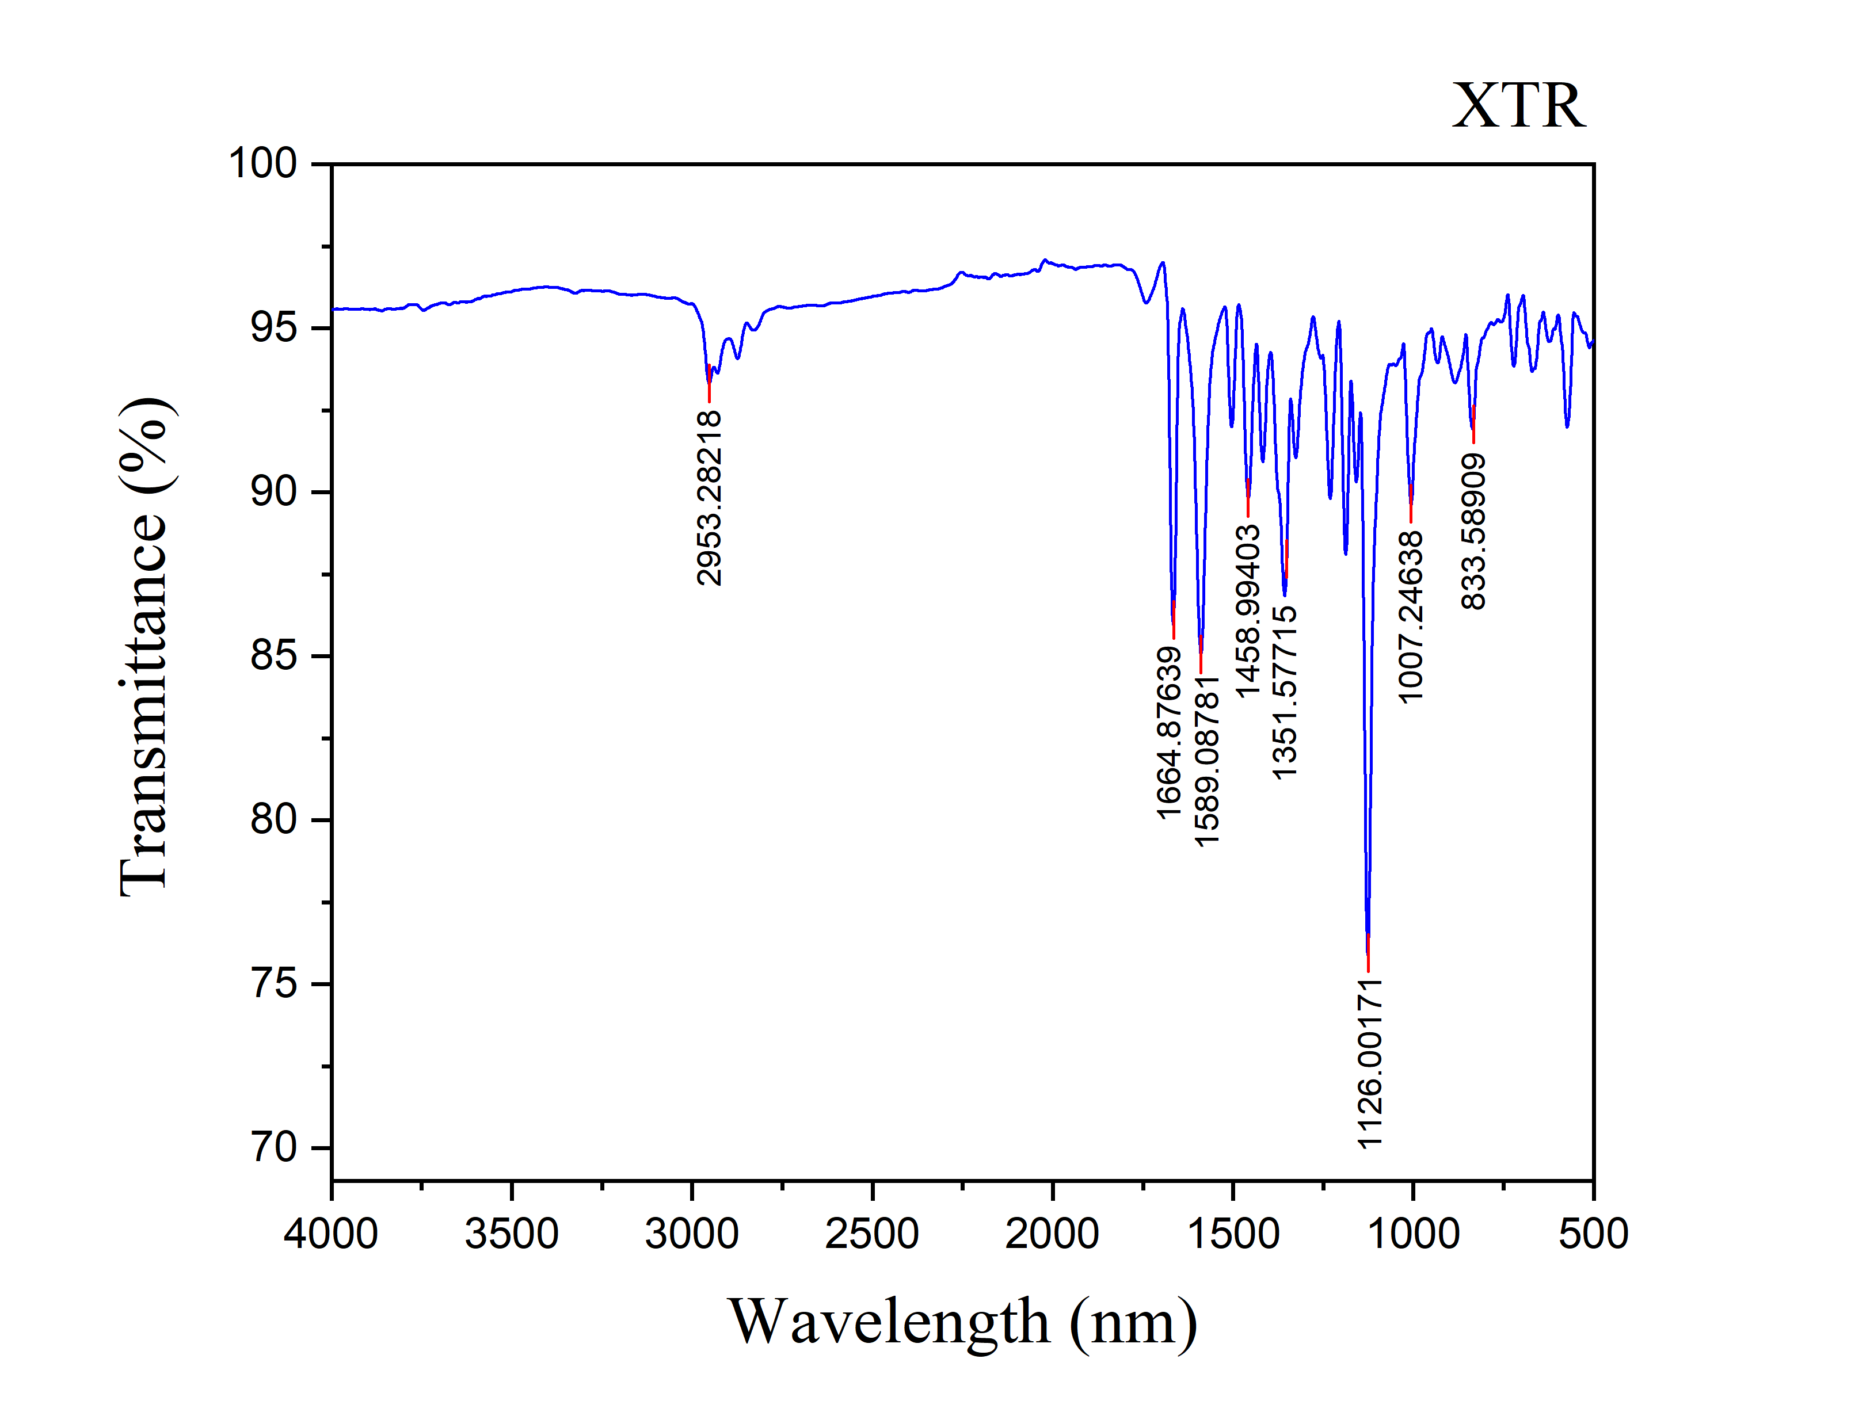
Figure S66: IR spectrum of 3,3,6,6-Tetramethyl-9-(3,4,5-trimethoxyphenyl)-3,4,5,6,7,9-hexahydro-1H-xanthene-1,8(2H)-dione (4f)
Figure S67: 1H NMR spectrum of 9-(4-chlorophenyl)-3,3,6,6-tetramethyl-3,4,5,6,7,9-hexahydro-1H-xanthene-1,8(2H)-dione (4g)
Figure S68: 13C NMR spectrum of 9-(4-chlorophenyl)-3,3,6,6-tetramethyl-3,4,5,6,7,9-hexahydro-1H-xanthene-1,8(2H)-dione (4g)

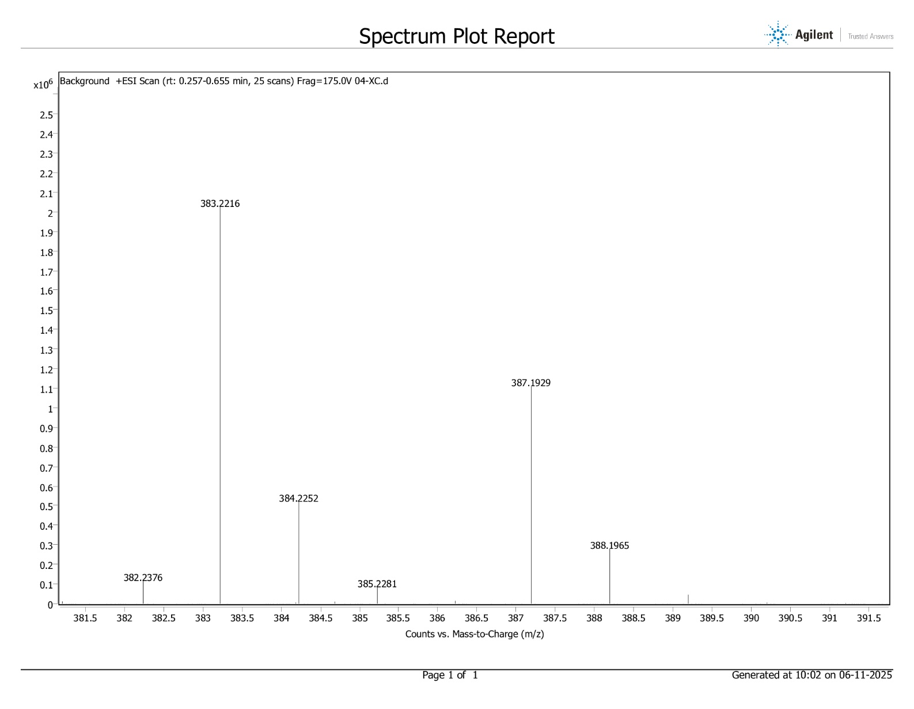
Figure S69: HRMS spectrum of 9-(4-chlorophenyl)-3,3,6,6-tetramethyl-3,4,5,6,7,9-hexahydro-1H-xanthene-1,8(2H)-dione (4g)

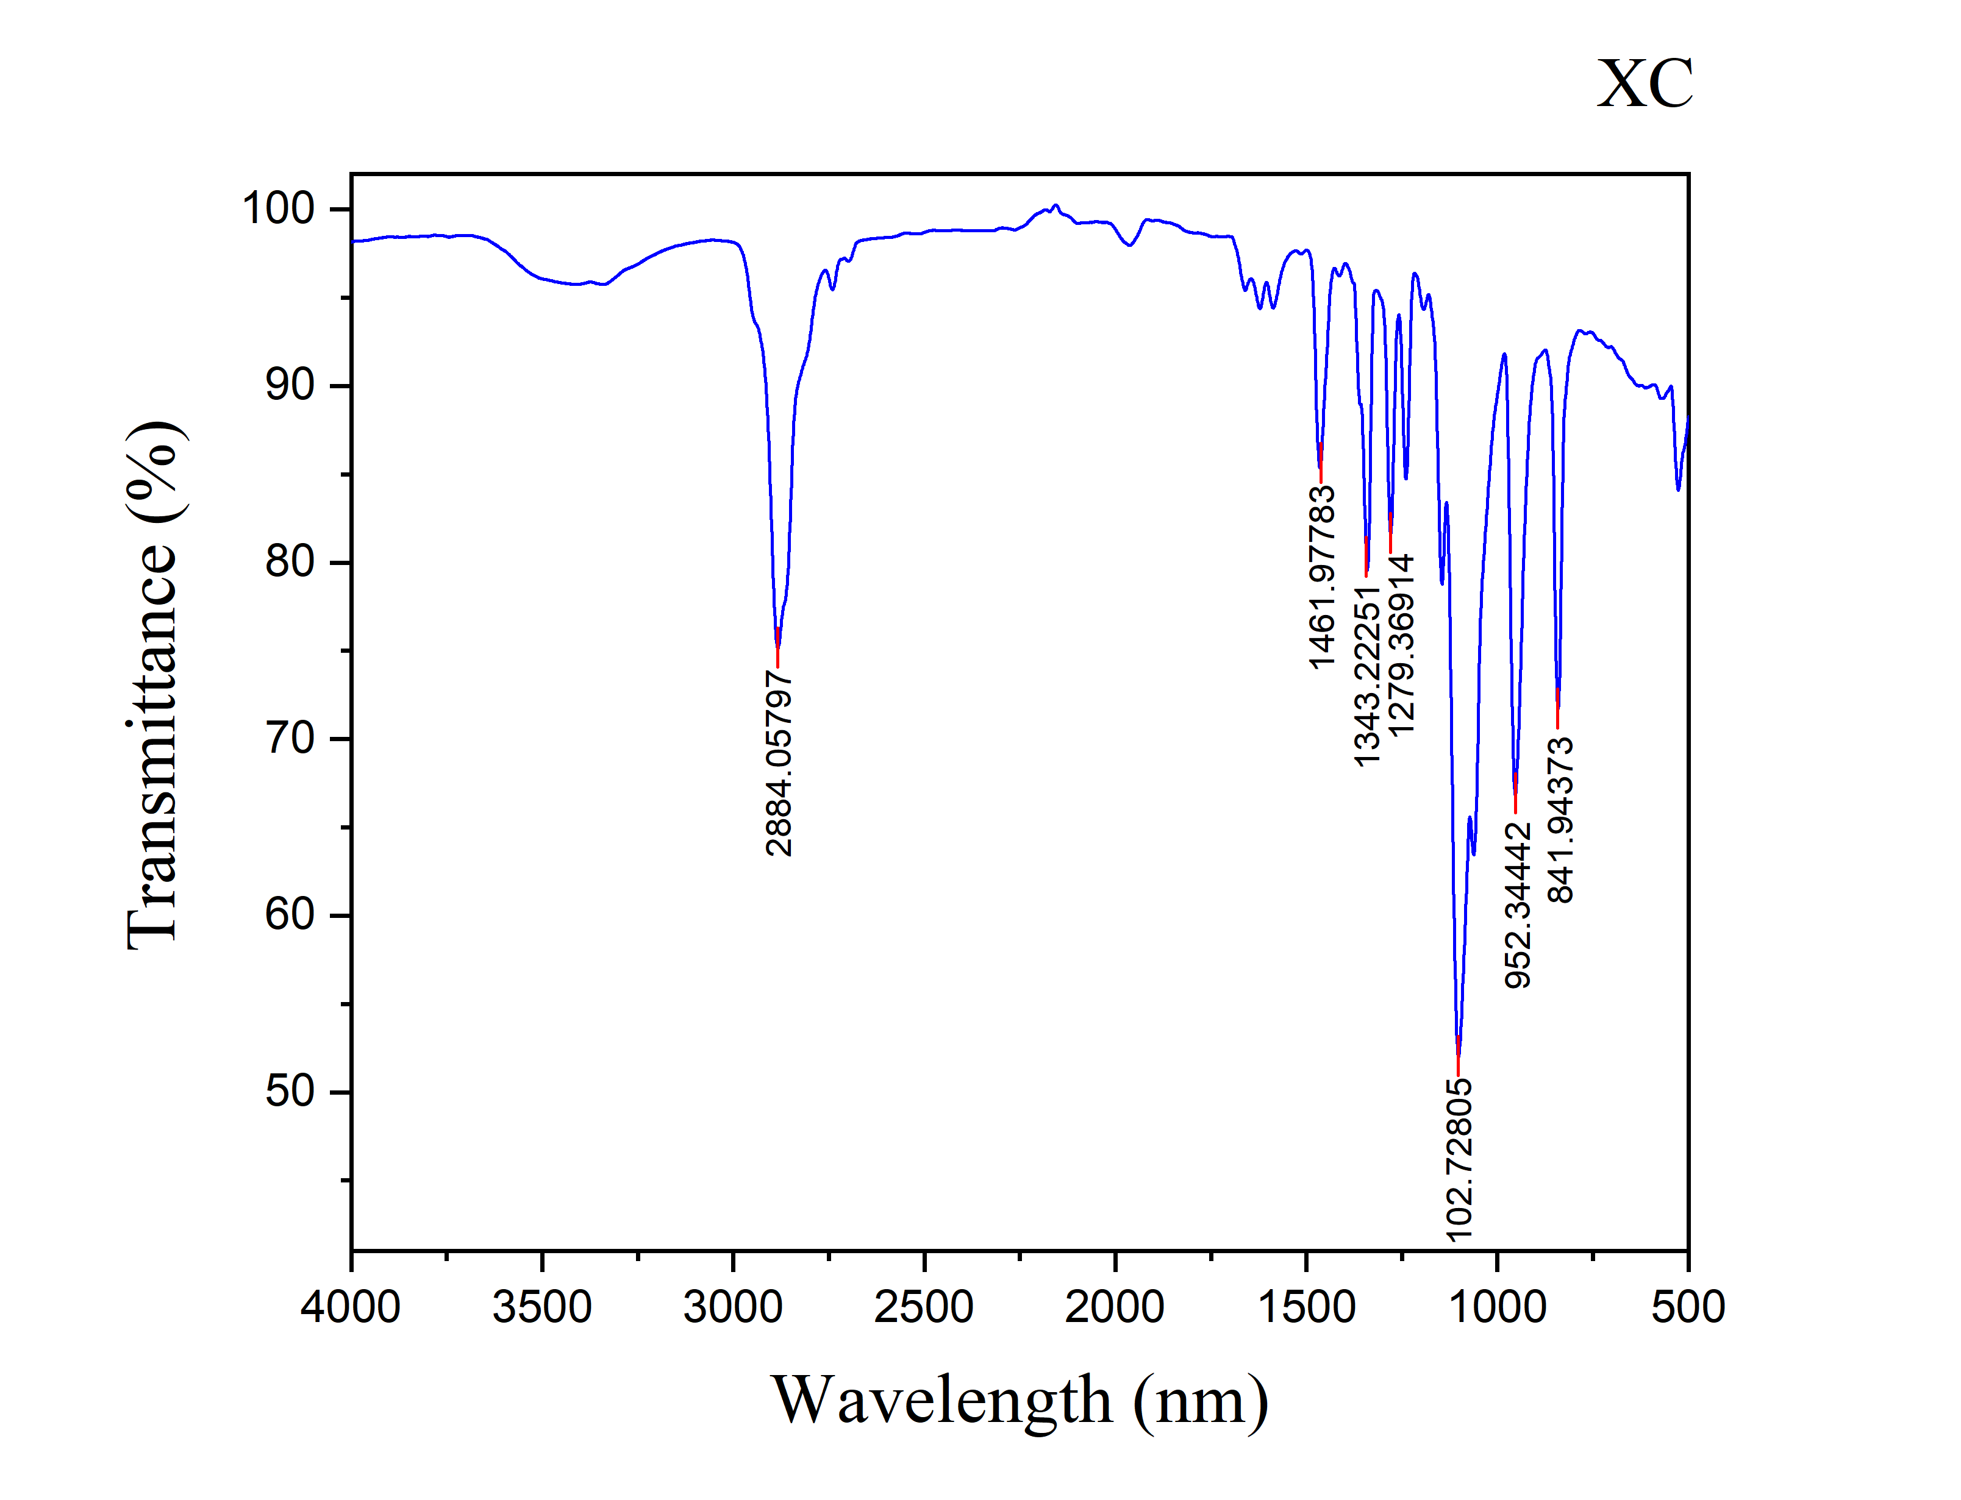
Figure S70: IR spectrum of 9-(4-chlorophenyl)-3,3,6,6-tetramethyl-3,4,5,6,7,9-hexahydro-1H-xanthene-1,8(2H)-dione (4g)

Figure S71: 1H NMR spectrum of 3,3,6,6-Tetramethyl-9-(p-tolyl)-3,4,5,6,7,9-hexahydro-1H-xanthene-1,8(2H)-dione (4h)
Figure S72: 13C NMR spectrum of 3,3,6,6-Tetramethyl-9-(p-tolyl)-3,4,5,6,7,9-hexahydro-1H-xanthene-1,8(2H)-dione (4h)

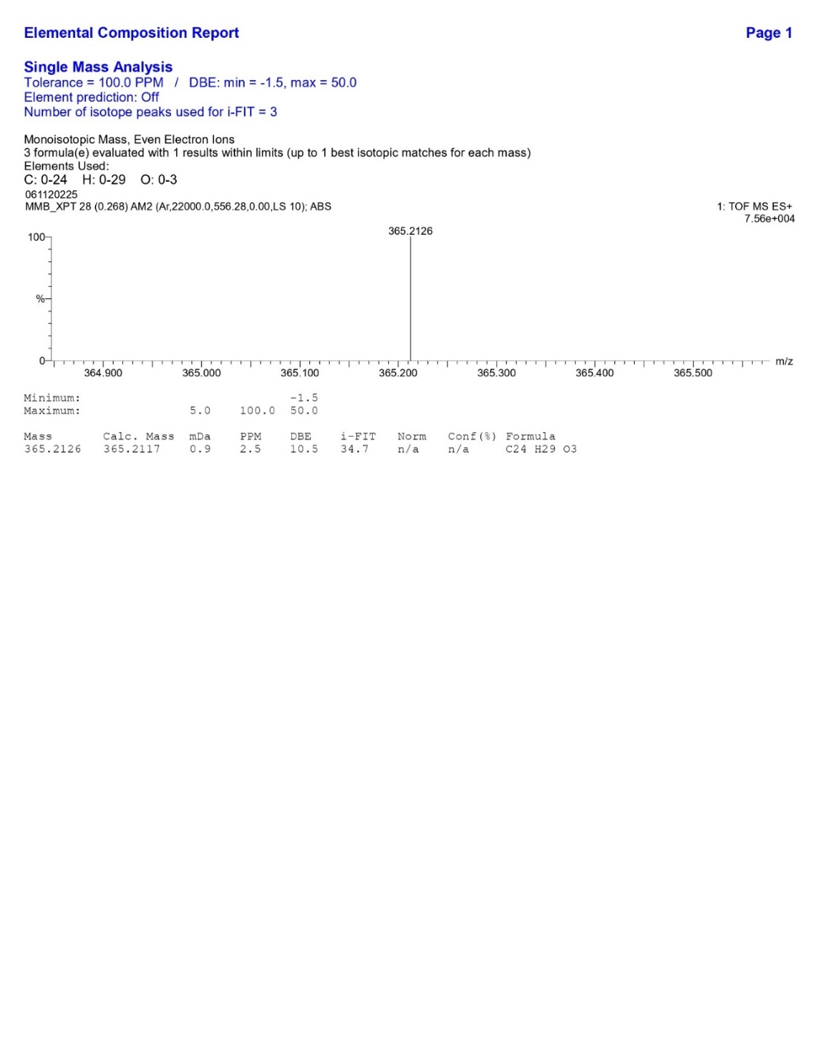
Figure S73: HRMS spectrum of 3,3,6,6-Tetramethyl-9-(p-tolyl)-3,4,5,6,7,9-hexahydro-1H-xanthene-1,8(2H)-dione (4h)
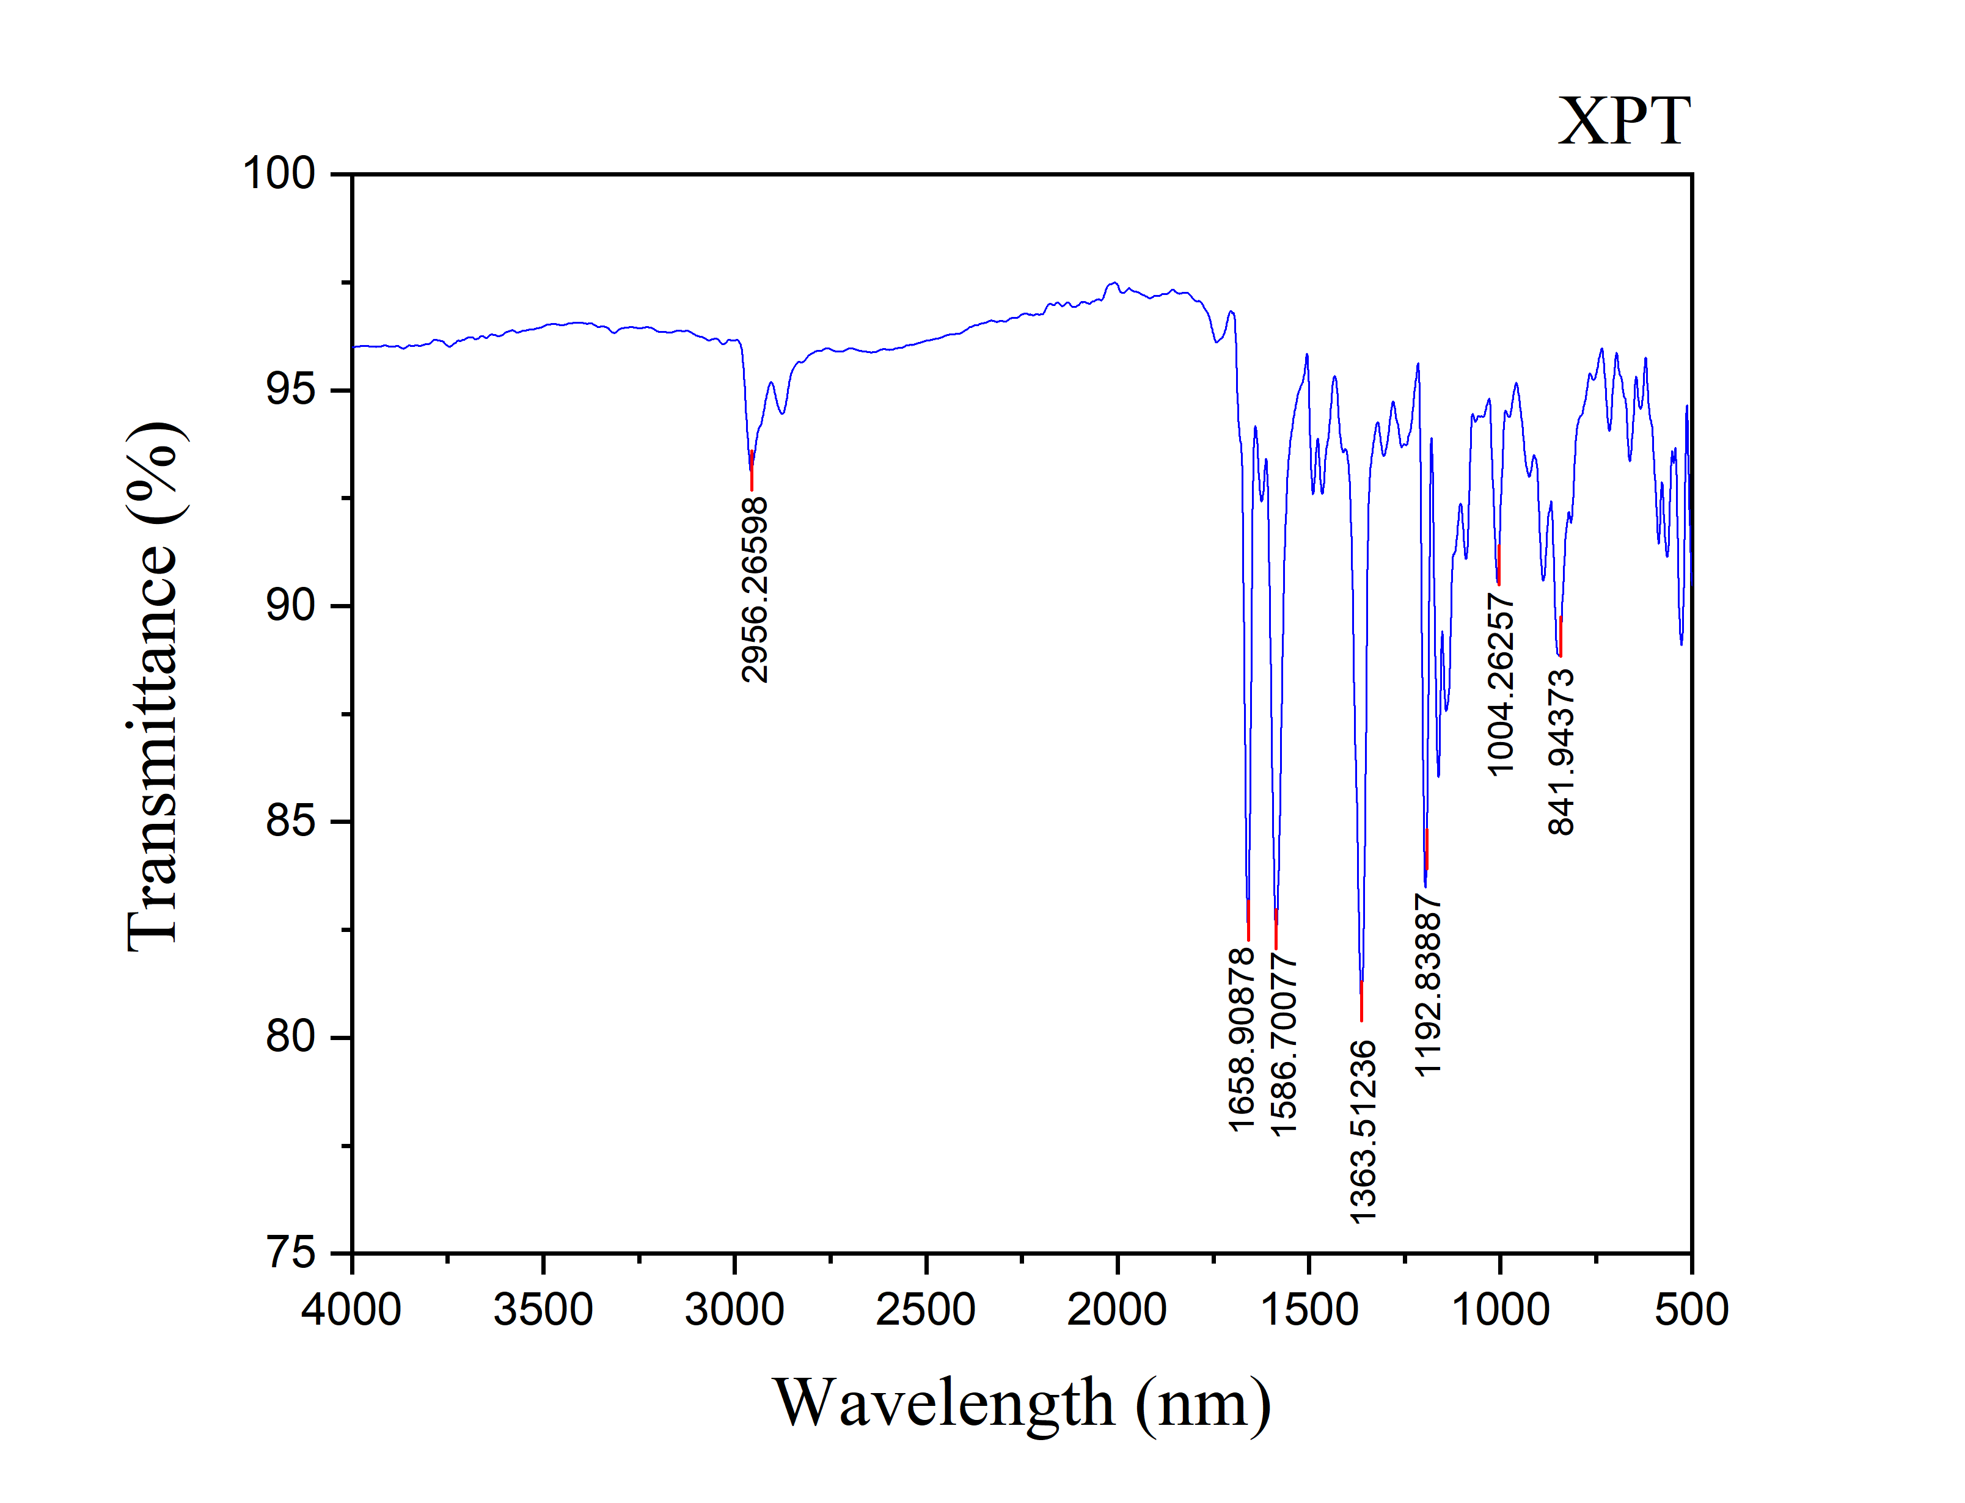
Figure S74: IR spectrum of 3,3,6,6-Tetramethyl-9-(p-tolyl)-3,4,5,6,7,9-hexahydro-1H-xanthene-1,8(2H)-dione (4h)

Figure S75: 1H NMR spectrum of 4-(3,3,6,6-Tetramethyl-1,8-dioxo-2,3,4,5,6,7,8,9-octahydro- 1H-xanthene-9-yl) benzaldehyde (4i)

Figure S76: 13C NMR spectrum of 4-(3,3,6,6-Tetramethyl-1,8-dioxo-2,3,4,5,6,7,8,9-octahydro- 1H-xanthene-9-yl) benzaldehyde (4i)

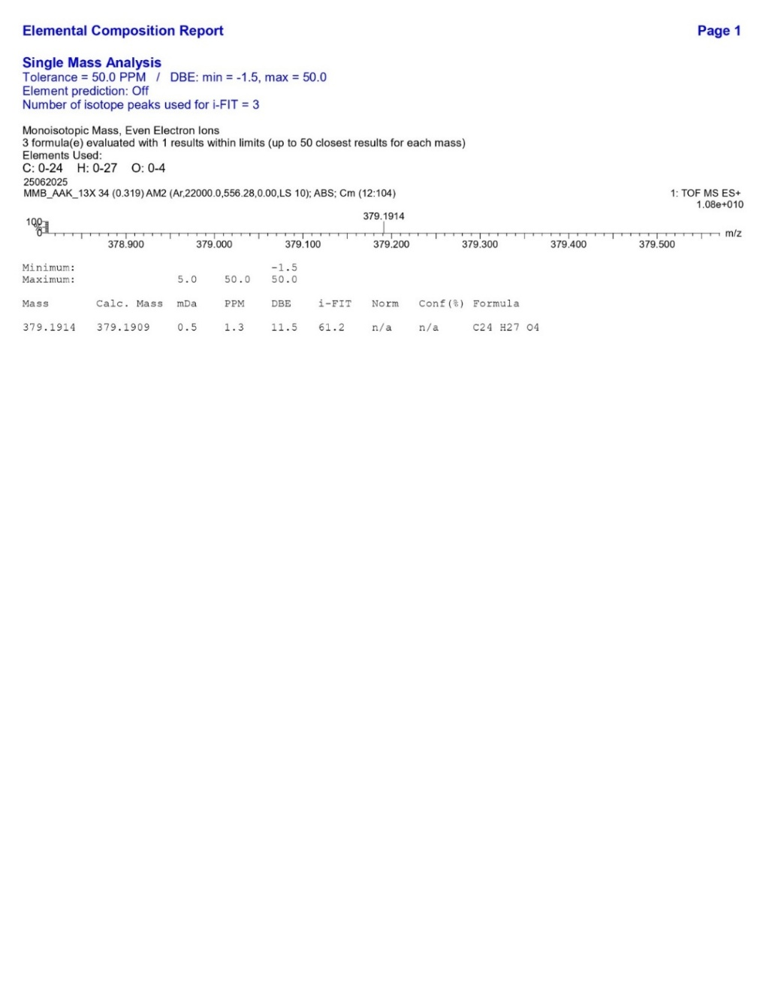
4000
3500
3000
2500
2000
1500
1000
500
65
70
75
80
85
90
95
100

697
714
1040
1133
1275
1353
1497
1661
1728
2962
Wavenumber
(
cm
-1
)
3
Figure S77: HRMS spectrum of 4-(3,3,6,6-Tetramethyl-1,8-dioxo-2,3,4,5,6,7,8,9-octahydro- 1H-xanthene-9-yl) benzaldehyde (4i)

Figure S78: IR spectrum of 4-(3,3,6,6-Tetramethyl-1,8-dioxo-2,3,4,5,6,7,8,9-octahydro- 1H-xanthene-9-yl) benzaldehyde (4i)

