A
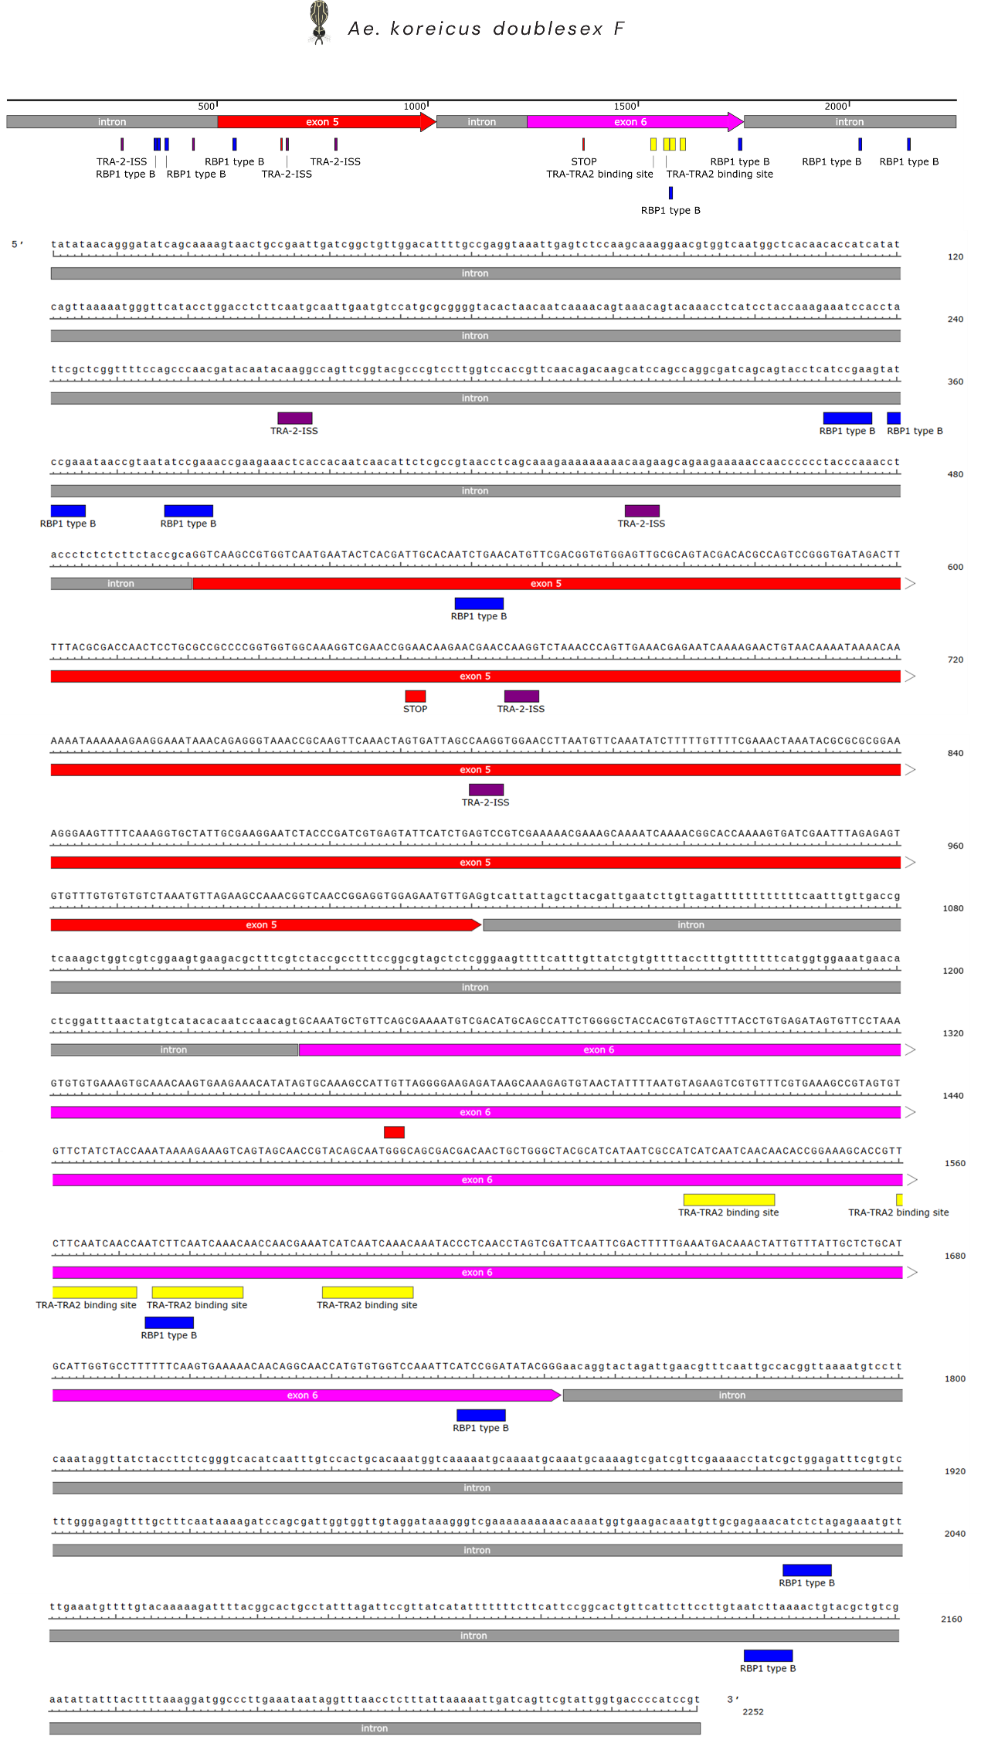
B
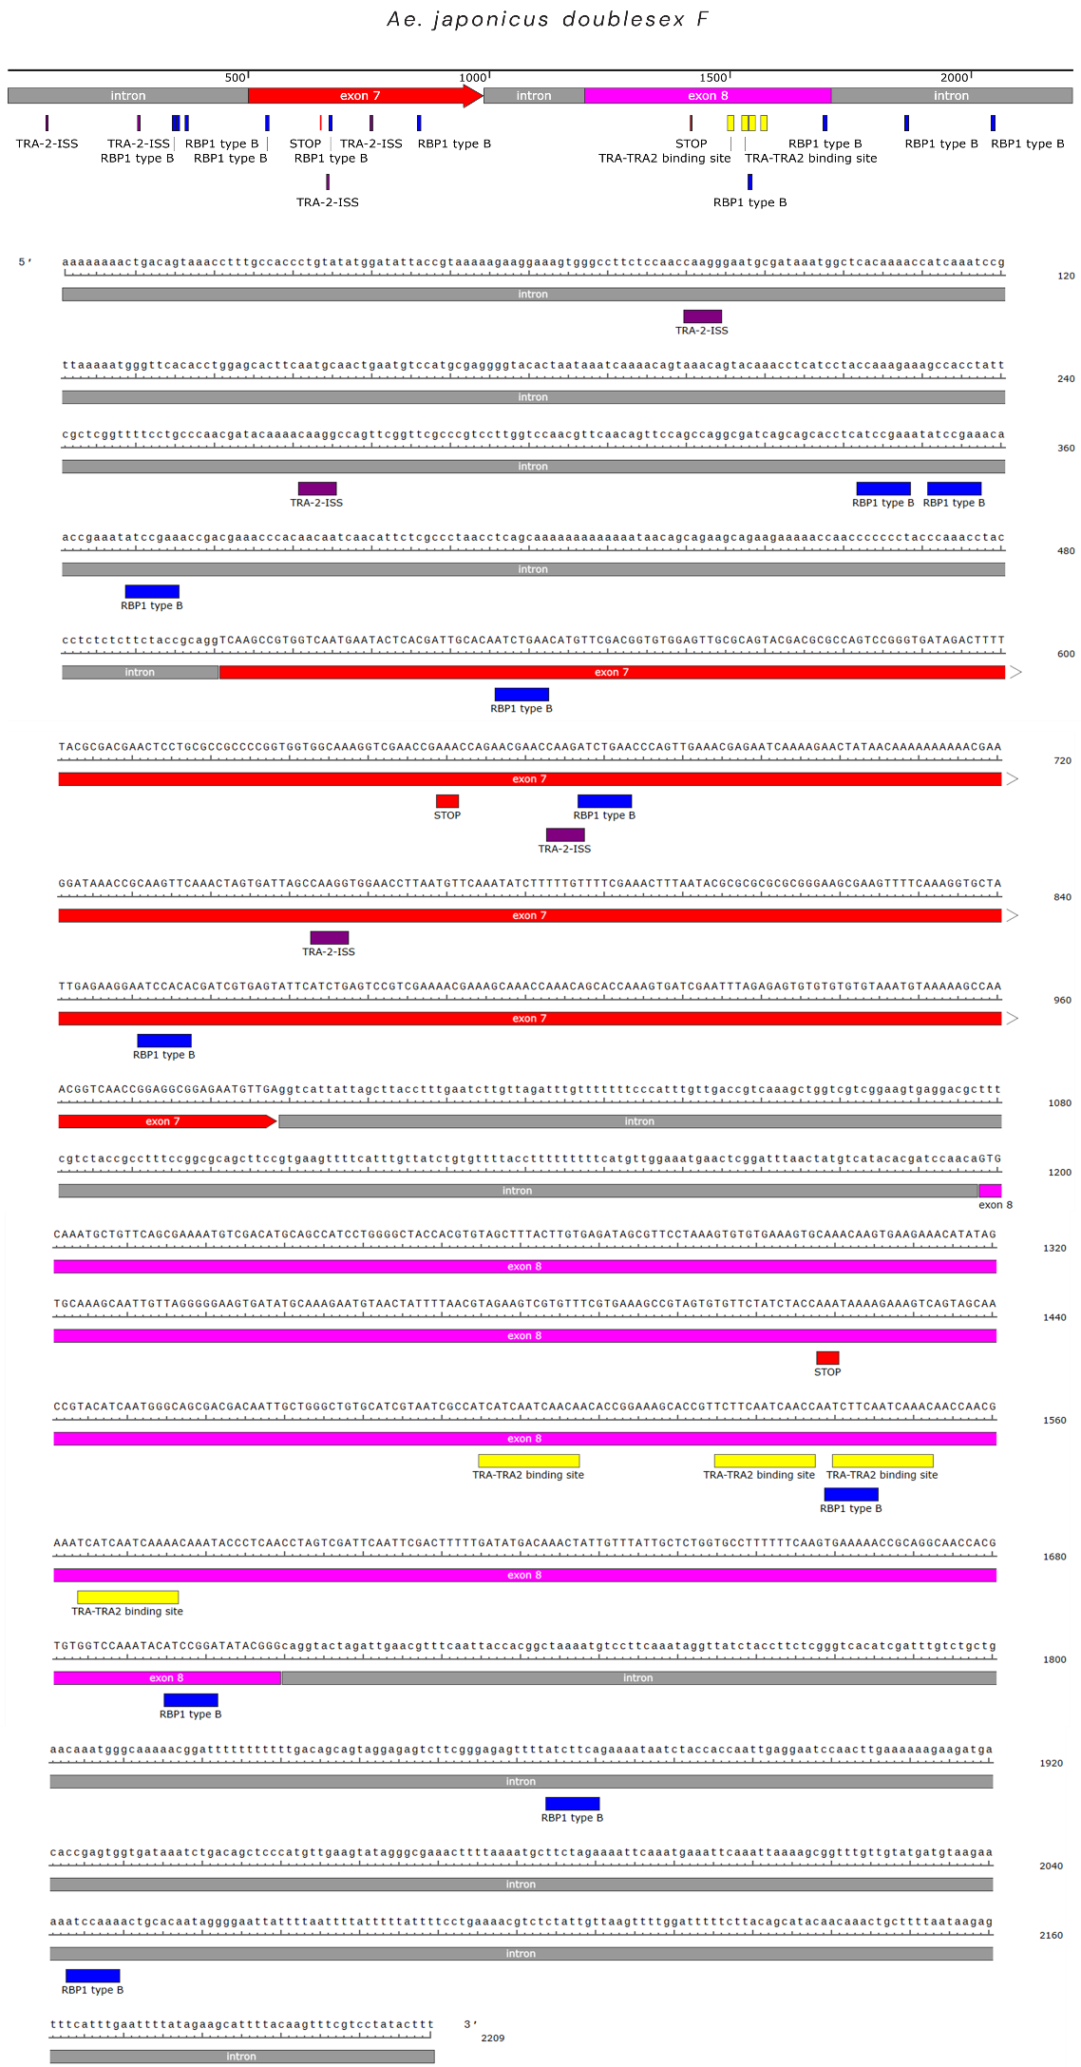
C
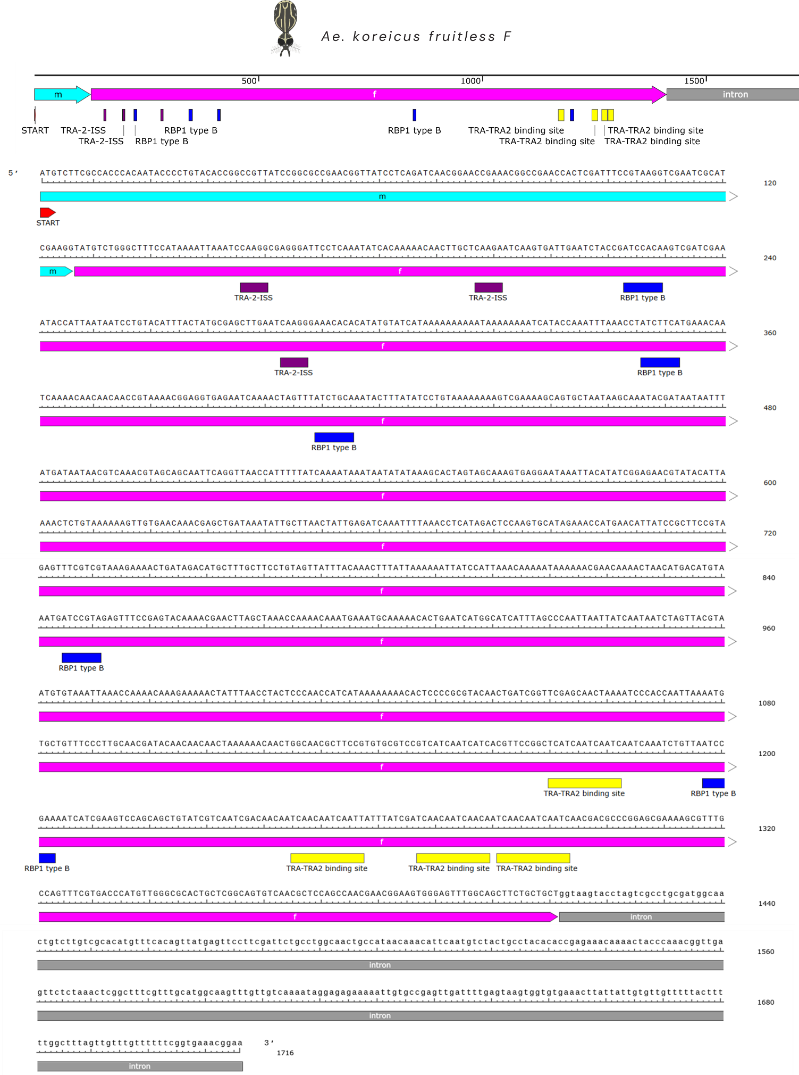
D
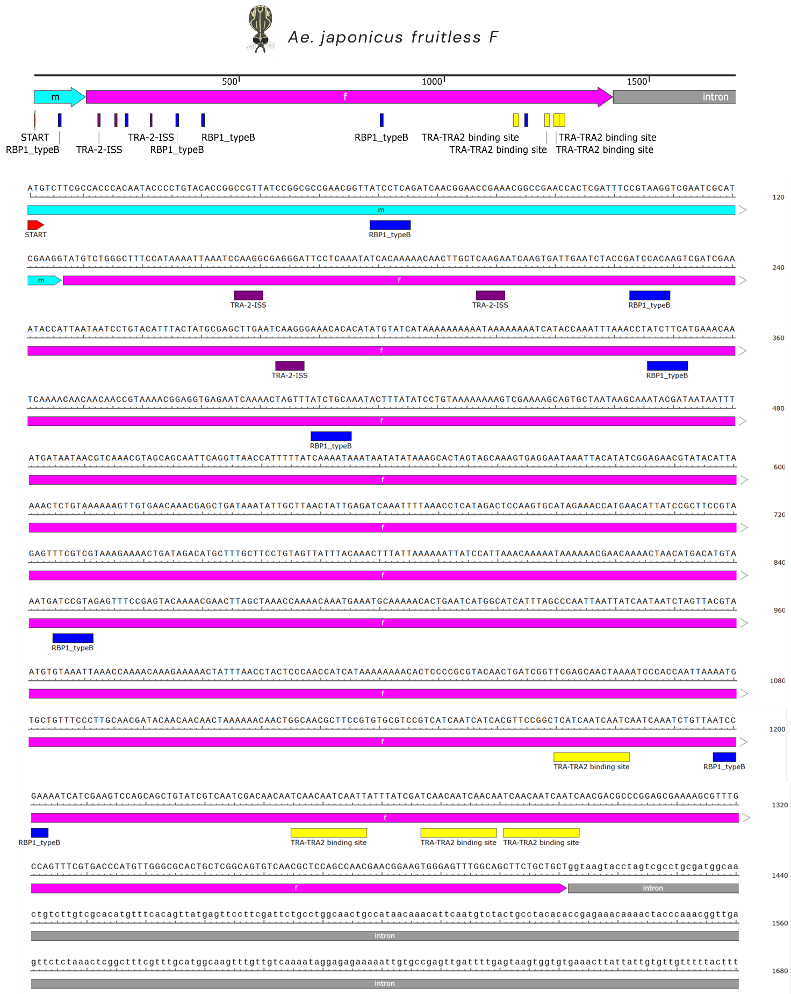

Nucleotide sequence and structural annotation of the female-specific doublesex (dsxF) and fruitless (fruF) transcripts in Aedes koreicus and Aedes japonicus. Schematic representations display the genomic regions encompassing the female-specific splicing events for: (A) Ae. koreicus dsxF; (B) Ae. japonicus dsxF; (C) Ae. koreicus fruF; and (D) Ae. japonicus fruF. For dsx transcripts, Exon 5 is highlighted in red and Exon 6 in magenta. For fru transcripts, Exon m is highlighted in light blue and Exon f in magenta. Exons are separated and flanked by intronic regions (grey bars). Putative regulatory motifs involved in sex-specific alternative splicing are mapped along the sequences: TRA/TRA-2 binding sites are indicated by yellow boxes, TRA-2 Intronic Splicing Silencers (TRA-2-ISS) by purple boxes, and RBP1 type B binding sites by blue boxes. The positions of in-frame START and STOP codons are marked with red boxes.

