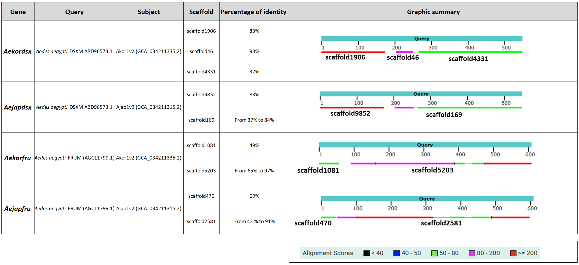

tBLASTn analysis of doublesex (dsx) and fruitless (fru) orthologs in Aedes koreicus and Aedes japonicus genomes. The Aedes aegypti DSX (DSXM, ABD96573.1) and FRU (FRUM, AGC11799.1) protein sequences were used as queries against the Ae. koreicus genome assembly v2 (Akor1v2, GCA_034211335.2) and the Ae. japonicus genome assembly v2 (Ajap1v2, GCA_034211315.2). For each gene, the genomic scaffolds hosting the best hits are shown along with their percentage of nucleotide identity to the query. Graphic summaries illustrate the positional distribution of BLAST hits (colored segments) along the query sequence (teal bar), with colors reflecting alignment scores as indicated in the legend. In both species, dsx and fru coding sequences are split across two or more scaffolds, suggesting either fragmented genomic assemblies or, alternatively, that the respective loci span large intronic regions exceeding individual scaffold lengths.

