SUPPLEMENTARY MATERIALS
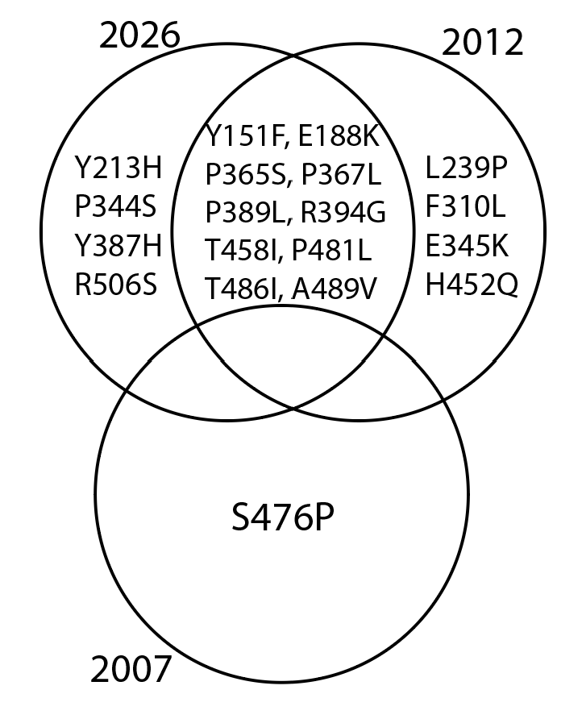
Supplementary Figure 1: Mutational overlap among BDBV outbreaks from 2007, 2012, and 2026 relative to the 2007 BDBV GP reference sequence. Shared regions indicate amino acid substitutions observed in multiple outbreaks, while non-overlapping regions represent outbreak-specific mutations. Ten substitutions (Y151F, E188K, P365S, P367L, P389L, R394G, T458I, P481L, T486I, and A489V) were conserved between the 2012 and 2026 outbreaks, whereas the 2007 outbreak was characterised by a single unique substitution (S476P).

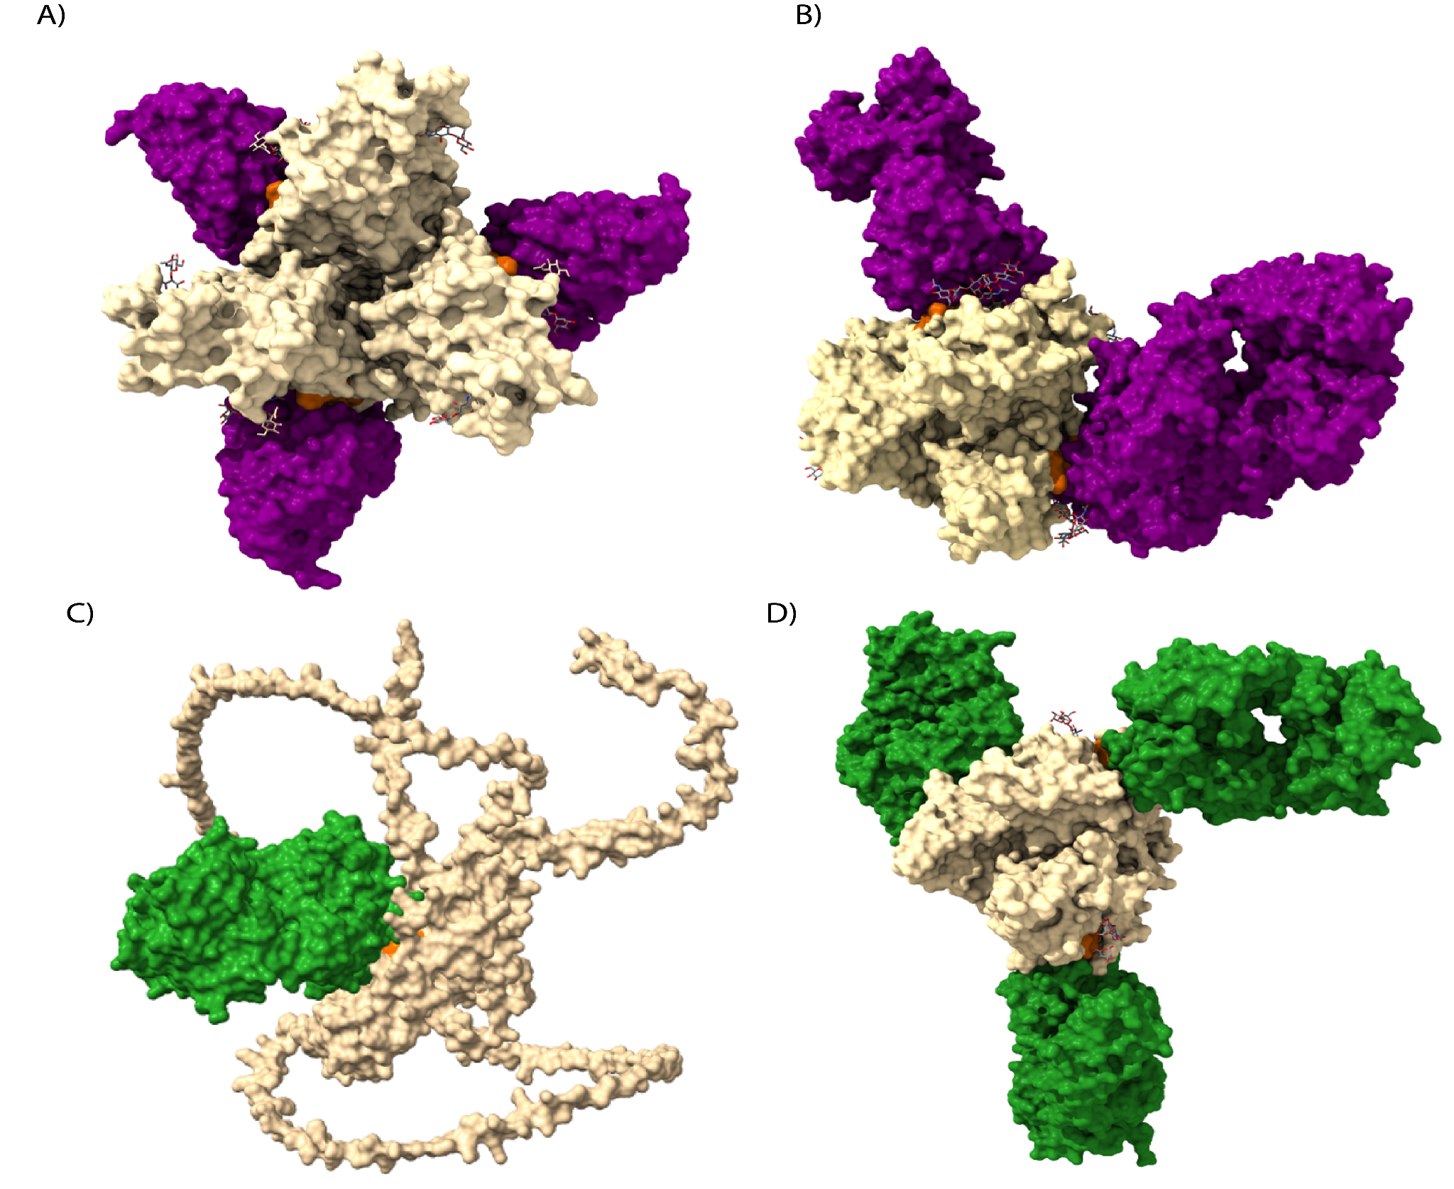
Supplementary Figure 2: Experimental and predicted structures of the MBP134. GP proteins are shown in gold, and antibody epitope sites are colored orange and red. ADI-15878 is purple and ADI-15946 is green. (A) Experimental structure of BDBV GP-ADI-15878 (PDB: 6DZM). (B) Experimental structure of EBOV GP-ADI-15878 (PDB: 6EA7). (C) AlphaFold 3 prediction of BDBV GP-ADI-15946, with antibody binding at the epitope site (orange). (D) Experimental structure of EBOV GP-ADI-15946 (PDB: 6MAM), with antibody binding at the epitope site (orange).

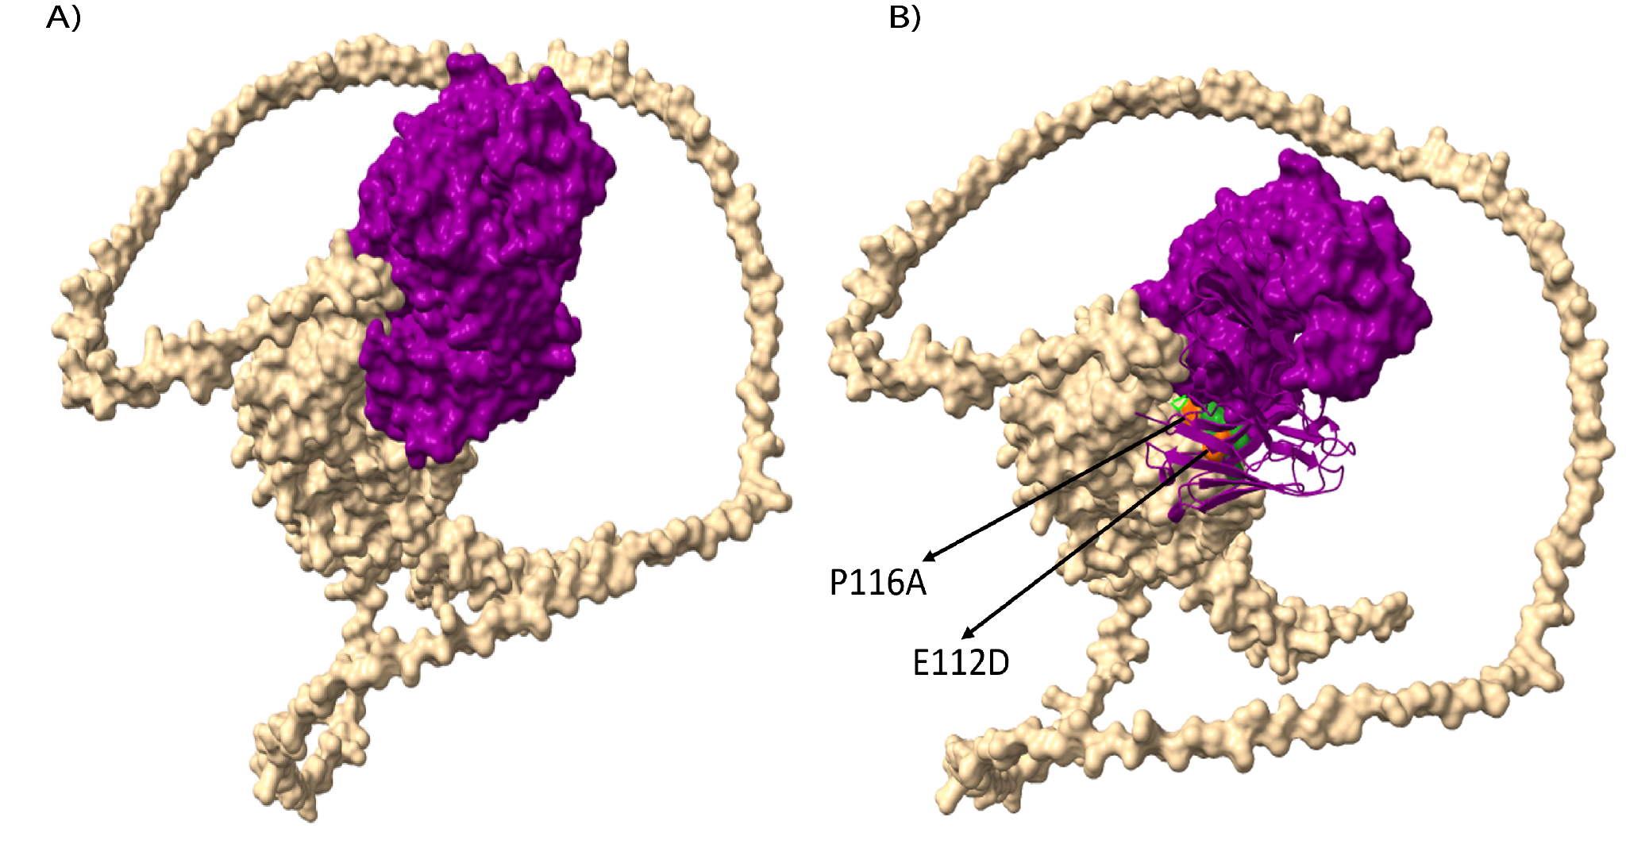
Supplementary Figure 3: Structural predictions of the REGN3471 antibody showing the mutations. (A) The REGN3471 chain shown in a block with mutations underneath within the epitope site sandwiched. (B) The REGN3471 chain with the blocks hidden showing the mutations (colored red) residing within the crevice of the GP directing at the intersection of the BDBV GP_REGN3471 interaction.

Supplementary Table 1. Glycoprotein (GP) epitopes targeted by monoclonal antibody therapeutics developed against Zaire ebolavirus (EBOV). Listed are the GP regions and contact residues recognised by the therapeutic antibodies mAb114 (Ebanga), Inmazeb (REGN3479, REGN3471, and REGN3470), and MBP134 (ADI-15878 and ADI-15946). These epitopes were mapped onto the BDBV GP sequence to determine whether key antibody-binding residues are conserved or mutated, enabling assessment of the potential impact of sequence variation on therapeutic binding and efficacy.

Monoclonal antibodies | Components | Target Region on GP | Contact residues on EBOV (Epitopes)
Ebanga (PMID: 30686586) | mAb114 | GP1 | L111, E112, I113, K114, K115, P116, D117, G118, S119
Inmazeb (PMID: 36708708) | Maftivimab (REGN3479) binds a quaternary epitope | Beta 1 - Beta 2 loops of GP1 | P34, L43,V45
Inmazeb (PMID: 36708708) | Maftivimab (REGN3479) binds a quaternary epitope | GP1 IFL | I527, G528, L529, A530, and F535, G536
Inmazeb (PMID: 36708708) | Maftivimab (REGN3479) binds a quaternary epitope | GP2 HR1 | Q560, E564, Q567) and glycan Asn563
Inmazeb (PMID: 36708708) | Maftivimab (REGN3479) binds a quaternary epitope | GP2 N-terminal | I504, V505, and A507
Inmazeb (PMID: 36708708) | Odesivimab (REGN3471) binds both the head and glycan cap of GP | GP1 | L111, E112, I113, K114, K115, P116, D117, G118
Inmazeb (PMID: 36708708) |  | GP1 | G143, T144, P146
Inmazeb (PMID: 36708708) | Atoltivimab (REGN3470) | GP1 | I260, Y261,T262,S263, G264, K265, R266, S267, N268, T269, T270
Inmazeb (PMID: 36708708) | Atoltivimab (REGN3470) | GP1 | N278,P279,E280,D282, N292
MBP134 (PMID: 30184505, 28525755, 30629917) | ADI-15878 | GP2 IFL | I I527, G528, L529, A530, and N563 glycan
MBP134 (PMID: 30184505, 28525755, 30629917) | ADI-23774/ADI-15946 | GP1 | E71, G72, N73, G74, V75
IFL - Internal Fusion Loop, HR1 - Heptad Repeat 1, GP - Glycoprotein

Supplementary Table 2: Binding Energy Predictions upon introduction of BDBD epitope mutations into EBOV GP_Inmazeb complex. This contains energy calculations for the trimeric complex with mutations, and each independent Inmazeb component interacting with the GP protein.
Inmazeb trimeric complex
Position | chain | wt | mut | ddG(kcal mol⁻¹) | Wild Type | mutant_score
112 | GP1 (T) | E | D | -42.08 | 964.33 | 922.25
116 | GP1 (T) | P | A | -128.98 | 773.99 | 645.01
263 | GP1 (T) | S | N | -76.64 | 552.68 | 476.04
265 | GP1 (T) | K | R | 25.63 | 844.27 | 869.9
504 | GP2 (V) | I | T | -248.3424 | 995.2991 | 746.9567
505 | GP2 (V) | V | L | 83.2278 | 908.7707 | 991.9986
507 | GP2 (V) | A | T | -10.185 | 849.9541 | 839.7691
Net energy |  |  |  | -397.3696
GP_REG3479 (Maftivimab)
Position | chain | wt | mut | ddG(kcal mol⁻¹) | Wild Type | Mutant Score
504 | GP2 (V) | I | T | 232.9 | 39.1 | 272
505 | GP2 (V) | V | L | 302.1 | 1.4 | 303.5
507 | GP2 (V) | A | T | -360.5846 | 391.287 | 30.7024
Net energy |  |  |  | 174.4154
GP_REG3470 (Atoltivimab)
Position | chain | wt | mut | ddG(kcal mol⁻¹) | Wild Type | Mutant Score
263 | GP1(T) | S | N | 247.31 | 552.66 | 799.97
265 | GP1(T) | K | R | -100.79 | 687.62 | 586.83
Net energy |  |  |  | 146.52
GP_REG3471 (Odesivimab)
Position | chain | wt | mut | ddG(kcal mol⁻¹) | Wild Type | Mutant Score
112 | GP1(T) | E | D | -11.1413 | -61.5728 | -72.7142
116 | GP1(T) | P | A | -39.6578 | 27.7207 | -11.9371
Net energy |  |  |  | -50.7991

