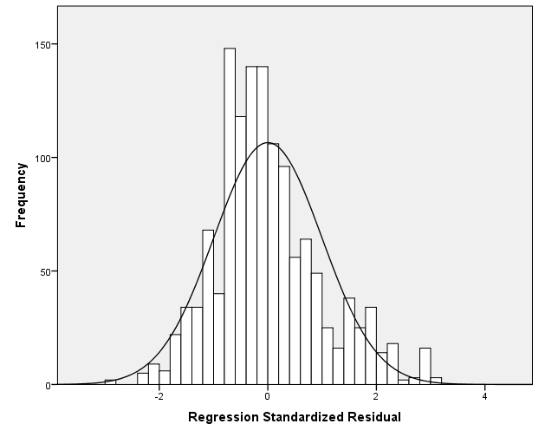Supplementary Figure 1. Histogram of the residuals with anxiety-like symptoms score (Patient Health Questionnaire-4) as the dependent variable (n=1331).
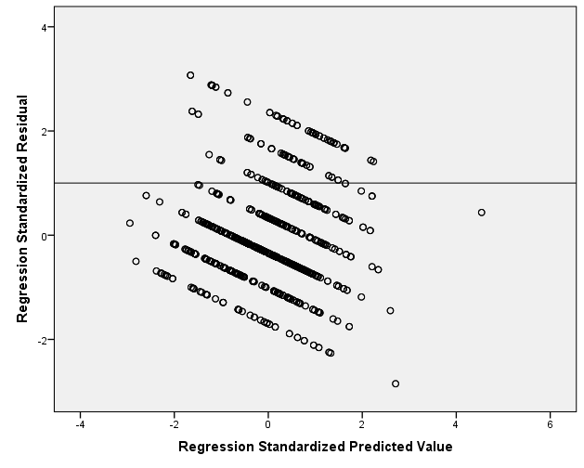Supplementary Figure 2. Scatterplot of residuals versus predicted values with anxiety-like symptoms score (Patient Health Questionnaire-4) as the dependent variable (n=1331).
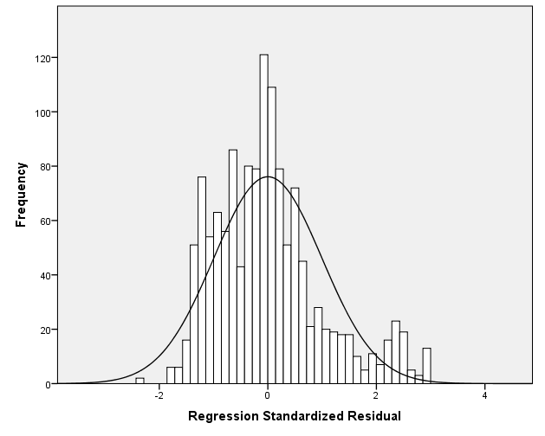Supplementary Figure 3. Histogram of the residuals with depression-like symptoms score (Patient Health Questionnaire-4) as the dependent variable (n=1331).
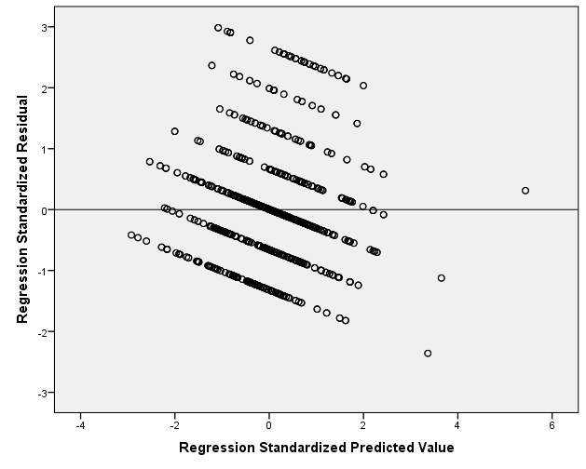Supplementary Figure 4. Scatterplot of residuals versus predicted values with depression-like symptoms score (Patient Health Questionnaire-4) as the dependent variable (n=1331).
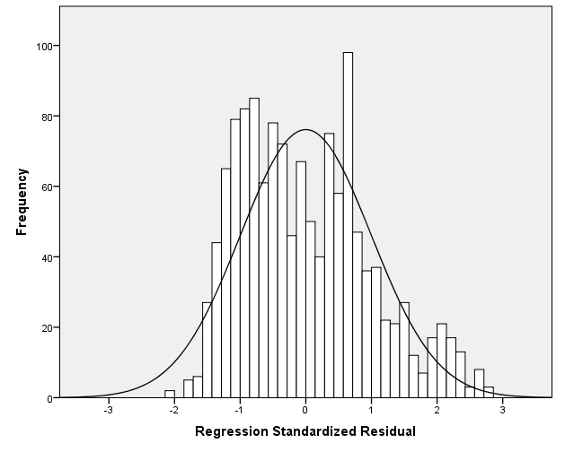Supplementary Figure 5. Histogram of the residuals with loneliness score as the dependent variable (n=1331).
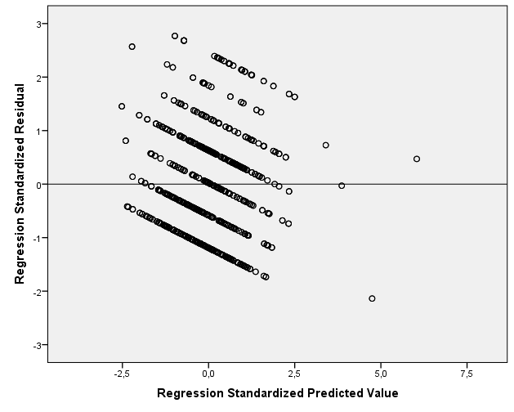Supplementary Figure 6. Scatterplot of residuals versus predicted values with loneliness score as the dependent variable (n=1331).

