Extended Data Figures and Figure Legends
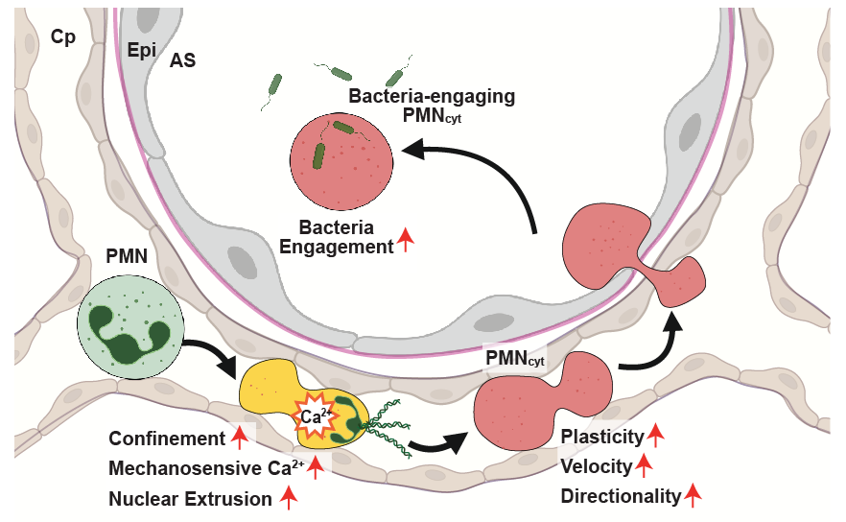
Extended Data Fig. 1 Model for confinement-driven PMN_{cyt} formation and bacterial engagement in the inflamed lung. During recruitment into the inflamed lung, PMNs pass through narrow pulmonary capillaries and undergo repeated deformation. This mechanical confinement is associated with mechanosensitive Ca²⁺ responses, nuclear remodeling and formation of anuclear PMN-derived cytoplasts (PMN_{cyt}s). PMN_{cyt}s acquire increased deformability and motility, enabling movement within spatially constrained pulmonary microenvironments and increasing their probability of interacting with bacteria during early infection.
Extended Data Movie 1 PMN Ca²⁺ influx accompanies cell deformation during pulmonary capillary transit. Representative single-cell ratiometric intravital Ca²⁺ imaging of a PMN moving through the pulmonary microvasculature. Increased intracellular Ca²⁺ signal is observed as the cell passes through a narrow capillary segment (white) and undergoes marked deformation. Scale bar, 10 μm. Time, min:sec.
Extended Data Movie 2 PMN_{cyt}s emerge in the inflamed lung. Representative two-photon intravital imaging of PMNs (Red), nuclei (Green) and pulmonary microvessels (Blue) 3 h after intraperitoneal LPS challenge. Under endotoxaemic conditions, anuclear PMN-derived cytoplasts (PMN_{cyt}s) are observed within the pulmonary microvasculature. Scale bar, 50 μm. Time, min:sec.
Extended Data Movie 3 PMN_{cyt}s are more motile than nucleated PMNs. Enlarged representative two-photon intravital imaging of a nucleated PMN and a PMN_{cyt} 3 h after intraperitoneal LPS challenge. In the inflamed lung, PMN_{cyt}s display higher motility than nucleated PMNs. Red; PMNs, Green; nuclei, Blue; pulmonary microvessels. Scale bar, 10 μm. Time, min:sec.
Extended Data Movie 4 PMN_{cyt}s are more deformable than nucleated PMNs. Enlarged representative two-photon intravital imaging of a nucleated PMN and a PMN_{cyt} 3 h after intraperitoneal LPS challenge. Under endotoxaemic conditions, PMN_{cyt}s display more prominent shape changes than nucleated PMNs. Red; PMNs, Green; nuclei. Scale bar, 10 μm. Time, min:sec.

