SUPPLEMENTARY MATERIAL

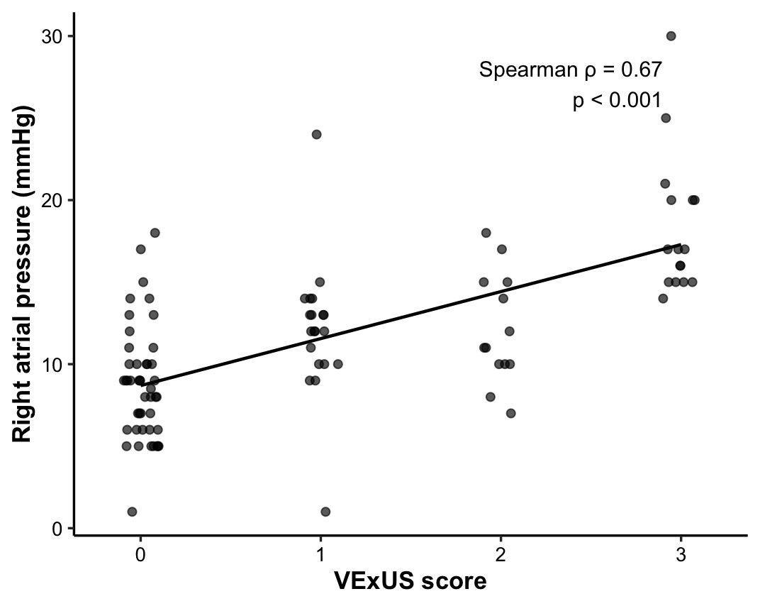
Supplementary Figure 1. Relationship between VEXUS score and right atrial pressure (RAP).
Scatter plot showing the association between VEXUS score and RAP. A positive correlation was observed (Spearman’s ρ = 0.67, p < 0.001).
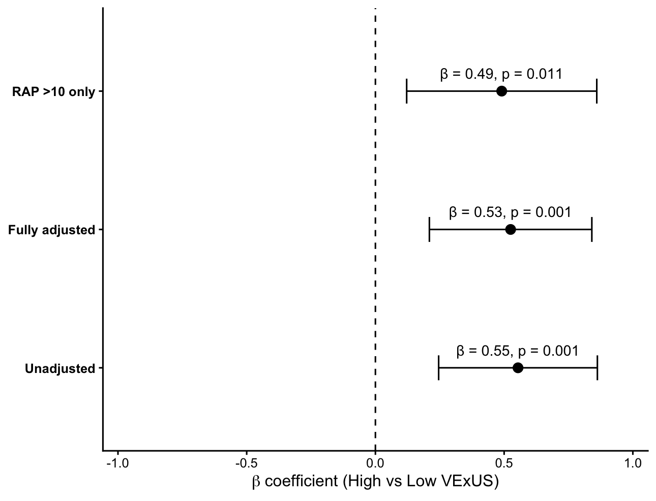

Supplementary Figure 2. Association Between High VExUS and Composite Organ Dysfunction Across Analytical Models
Forest plot illustrating the association between High VExUS (2–3) and the composite organ dysfunction index (z-score of creatinine, bilirubin, and alanine aminotransferase) across three regression models. β coefficients represent the mean difference in organ dysfunction index for High versus Low VExUS (0–1). Error bars indicate 95% confidence intervals. The vertical dashed line represents the null value (β = 0).
In the unadjusted model, High VExUS was associated with greater organ dysfunction compared with Low VExUS. This association remained materially unchanged after adjustment for SCAI stage, mean arterial pressure (MAP), and positive-pressure ventilation (PPV). In a restricted sensitivity analysis including only patients with RAP >10 mmHg, High VExUS remained independently associated with a higher organ dysfunction index after multivariable adjustment.

Supplementary Figure 3. Composite organ dysfunction across RAP–VExUS phenotypes using a 12 mmHg cutoff for right atrial pressure.
Heatmap showing the mean standardized organ dysfunction index (composite z-score of serum creatinine, alanine aminotransferase, and bilirubin) across four phenotypes defined by right atrial pressure (RAP ≤12 vs >12 mmHg) and VExUS category (Low [0–1] vs High [2–3]). Group sizes were: RAP >12 mmHg & High VExUS (n = 21), RAP >12 mmHg & Low VExUS (n = 16), RAP ≤12 mmHg & High VExUS (n = 8), and RAP ≤12 mmHg & Low VExUS (n = 49).
Overall differences among groups were significant (Kruskal–Wallis χ² = 20.98, p = 0.0001). In post-hoc Dunn analysis with Benjamini–Hochberg correction, patients with RAP >12 mmHg and High VExUS exhibited significantly higher organ dysfunction compared with those with RAP >12 mmHg and Low VExUS (adjusted p = 0.005) and with RAP ≤12 mmHg and Low VExUS (adjusted p < 0.001). A trend toward higher organ dysfunction was observed between RAP ≤12 mmHg and High vs Low VExUS phenotypes (adjusted p = 0.082).

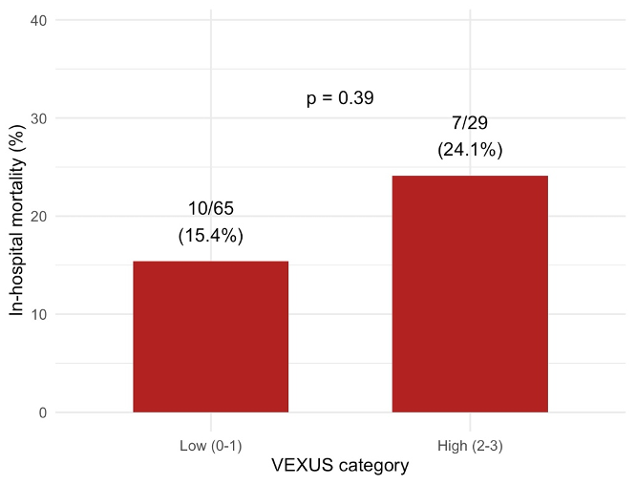
Supplementary Figure 4. In-hospital mortality according to VEXUS category. Patients with High VEXUS (score 2–3) showed a higher mortality compared with those with Low VEXUS (score 0–1), although this difference did not reach statistical significance (15.4% vs 24.1%; Fisher’s exact test p = 0.39).

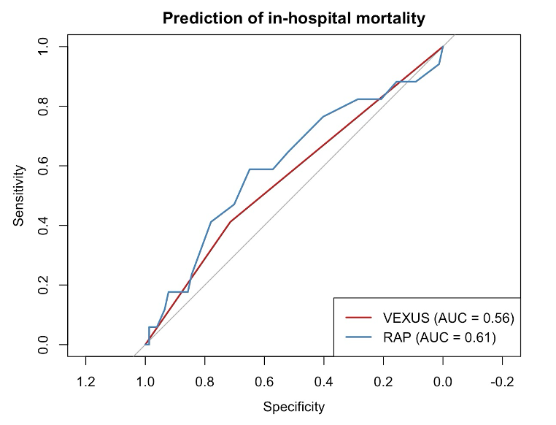Supplementary Figure 5. Discriminatory performance of VEXUS and right atrial pressure for in-hospital mortality. Receiver operating characteristic (ROC) curves comparing the ability of VEXUS score and right atrial pressure (RAP) to discriminate in-hospital mortality. The area under the curve (AUC) was 0.56 for VEXUS and 0.61 for RAP, indicating modest and comparable discriminatory performance. The diagonal line represents no discrimination.

Operator | Patients examined, n | VExUS 0 | VExUS 1 | VExUS 2 | VExUS 3
D.P. | 31 | 14 | 7 | 4 | 6
A.d’A. | 23 | 10 | 5 | 4 | 4
S.F. | 16 | 8 | 3 | 1 | 4
M.G.D.B. | 14 | 6 | 3 | 3 | 2
G.S. | 10 | 7 | 2 | 1 | 0
Overall | 94 | 45 | 20 | 13 | 16
Supplemetary Table 1. Details on VExUS grade distribution according to operator

Variable | N | Spearman ρ | FDR-adjusted p-value
RAP | 94 | 0.669 | <0.001
MAP–RAP | 94 | −0.320 | 0.005
Urine output | 94 | 0.198 | 0.069
TAPSE | 93 | −0.313 | 0.005
TAPSE/PAPs | 71 | −0.125 | 0.298
Lactate | 94 | 0.133 | 0.222
Creatinine | 94 | 0.245 | 0.028
Bilirubin | 94 | 0.342 | 0.004
ALT | 94 | 0.317 | 0.005
AST | 94 | 0.232 | 0.033
NT-proBNP | 91 | 0.253 | 0.028
Supplementary Table 2. Spearman rank correlations between VExUS score and hemodynamic, echographic and laboratory variables. P-values were adjusted for multiple testing using the Benjamini–Hochberg false discovery rate.

Biomarker | Predictor | Standardized β (per 1 SD) [95% CI] | p value
Creatinine | VExUS | 0.16 [-0.11, 0.43] | 0.235
 | RAP | 0.09 [-0.18, 0.36] | 0.495
Bilirubin | VExUS | 0.36 [0.10, 0.61] | 0.006
 | RAP | 0.03 [-0.22, 0.28] | 0.826
ALT | VExUS | 0.18 [-0.07, 0.44] | 0.159
 | RAP | 0.21 [-0.05, 0.46] | 0.117
Supplementary Table 3. Independent associations of VExUS and RAP with hepato–renal biomarkers. Standardized regression coefficients (β per 1 standard deviation) from multivariable linear models including both RAP and VExUS. Creatinine, bilirubin, and ALT were log-transformed and standardized prior to analysis. VExUS showed an independent association with bilirubin, whereas RAP was not independently associated with any biomarker.

Comparison (BH-adjusted) | Adjusted p-value
High VExUS / RAP >10 vs Low VExUS / RAP ≤10 | < 0.0001
High VExUS / RAP >10 vs Low VExUS / RAP >10 | 0.004
High VExUS / RAP >10 vs High VExUS / RAP ≤10 | 0.66
High VExUS / RAP ≤10 vs Low VExUS / RAP ≤10 | 0.12
High VExUS / RAP ≤10 vs Low VExUS / RAP >10 | 0.23
Low VExUS / RAP ≤10 vs Low VExUS / RAP >10 | 0.54
Supplementary Table 4. Pairwise comparisons of the composite index of organ dysfunction across RAP–VExUS phenotypes. Pairwise comparisons were performed using Dunn’s test following Kruskal–Wallis analysis, with Benjamini–Hochberg false discovery rate adjustment. RAP indicates right atrial pressure; VExUS, venous excess ultrasound score.

Phenotype (ref: RAP >10 / High VExUS) | β (Unadjusted) | p-value | β (Adjusted for PPV) | p-value | β (Fully adjusted*) | p-value
RAP ≤10 / High VExUS | −0.34 | 0.17 | −0.33 | 0.20 | −0.27 | 0.30
RAP >10 / Low VExUS | −0.57 | <0.001 | −0.56 | <0.001 | −0.53 | 0.001
RAP ≤10 / Low VExUS | −0.68 | <0.001 | −0.68 | <0.001 | −0.64 | <0.001
PPV (yes vs no) | — | — | −0.07 | 0.56 | −0.07 | 0.58
* Fully adjusted model includes SCAI stage, mean arterial pressure (MAP), and positive pressure ventilation (PPV).
Supplementary Table 5. Association between RAP–VExUS phenotypes and the composite organ dysfunction index across regression models. Linear regression models evaluating the relationship between RAP–VExUS phenotypes and the composite organ dysfunction index (z-score of creatinine, bilirubin, and alanine aminotransferase). β coefficients represent the mean difference in organ dysfunction index relative to the reference phenotype (RAP >10 mmHg / High VExUS). Negative β values indicate lower organ dysfunction burden compared with the reference group. Effect estimates remained materially unchanged after adjustment for positive pressure ventilation and for clinical severity (SCAI stage and mean arterial pressure).

