Supplementary Materials
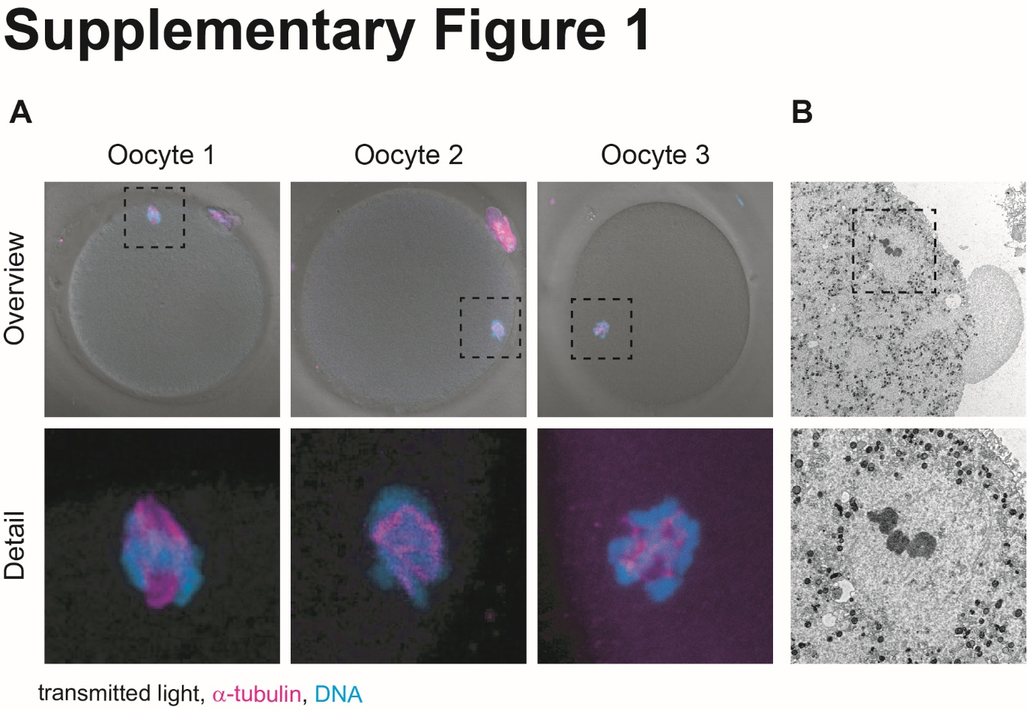

Supplementary Figure S1. Meiotic spindle microtubules are preserved after vitrification despite the absence of detectable birefringence. (A) Confocal immunofluorescence images of 3 representative MII oocytes fixed immediately after warming, in which no spindle birefringence was detectable by polarized light microscopy (PLM) at the time of fixation. Top row, overview brightfield images merged with fluorescence showing the position of the meiotic spindle (dashed box). Bottom row, magnified views of the boxed regions showing α-tubulin (magenta) and DNA (cyan). Despite the absence of a detectable PLM signal, microtubules organized into a recognizable spindle structure are detectable, although the configuration appears disorganized compared with non-vitrified controls. (B) Transmission electron microscopy of a vitrified-thawed MII oocyte fixed under matched conditions. Top, low-magnification view of the spindle region (dashed box). Bottom, higher-magnification view of the boxed area showing electron-dense chromosomes surrounded by microtubule bundles, confirming that polymerized microtubules persist after warming.

Supplementary Movie 1. Real-time brightfield microscopy of a human MII oocyte during vitrification. Time-lapse recording of a representative human MII oocyte during sequential exposure to equilibration solution. Brightfield channel shows oocyte volume changes resulting from osmotically driven water efflux and subsequent cryoprotectant influx.

Supplementary Movie 2. Real-time brightfield of a human MII oocyte during warming. Time-lapse recording of a representative human MII oocyte from the moment of dilution solution addition through completion of the warming procedure. Brightfield channel shows rapid oocyte volume recovery during cryoprotectant dilution.

Supplementary Movie 3. Live imaging of meiotic spindle response to hypoosmotic challenge. Light-sheet fluorescence microscopy of a human MII oocyte labelled with Abberior 610-tubulin (magenta) and SPY505-DNA (cyan) during exposure to hypoosmotic medium. The recording shows rapid water influx-induced cell swelling followed by progressive disorganization of meiotic spindle microtubules, recapitulating the spindle damage observed during warming.

Supplementary Movie 4. Live imaging of meiotic spindle reconstitution during post-thaw recovery. Light-sheet fluorescence microscopy of human MII oocytes labelled with Abberior 610-tubulin (magenta) and SPY505-DNA (cyan) imaged over two hours following warming. (A) shows a representative oocyte with a mature spindle at vitrification, maintaining bipolar spindle architecture throughout recovery. (B) shows a representative oocyte with an immature spindle at vitrification, displaying progressive accumulation of disorganized microtubule mass without restoration of bipolar configuration.

Supplementary Movie 5. Live imaging of supernumerary pronucleus formation following over-night imaging of a vitrified-thawed oocyte. Light-sheet fluorescence microscopy of a human oocyte labelled with Abberior 610-tubulin (magenta) and SPY505-DNA (cyan) recorded from warming over 16 hours. The recording shows multipolar anaphase following spontaneous exit from metaphase II arrest, with maternal chromatids segregating to more than two poles and each chromatin mass subsequently forming an independent pronuclear envelope, resulting in a multi-pronuclear cell.

