Urban Water Sustainability in a Rapidly Growing City: Stakeholder Perspectives, Governance Gaps and Management Priorities in Parramatta, Sydney, Australia

Supplementary Files

Contents of Supplementary Material
Item | Description
Supplementary Table S1 | Key informants' definitions of water sustainability
Supplementary Table S2 | Key informant quotes - preferred communication approaches
Supplementary Table S3 | Anticipated consequences of ecosystem deterioration
Supplementary Table S4 | Key informants' understanding of SDGs 6, 11, and 15
Supplementary Table S5 | Research priority themes - participant codes and disciplinary scope
Supplementary Figure S1 | Perceptions of the current state of water sustainability
Supplementary Figure S2 | Key factors influencing water sustainability
Supplementary Figure S3 | Indicators used by stakeholders
Supplementary Figure S4 | Frameworks and assessment approaches recognised by stakeholders
Supplementary Figure S5 | Top recommendations for improving water sustainability assessment
Supplementary Figure S6 | Themes on integrating Indigenous knowledge
Supplementary Figure S7 | Stakeholder perceptions of urban water-related ecosystem condition
Supplementary Figure S8 | Human activities influencing water resources over time
Supplementary Material B | Interview Guide (Semi-structured questions)

Supplementary Table S1. Key informants' definitions of water sustainability based on interview responses
Table S1 presents the verbatim definitions of water sustainability provided by all 15 key informants during semi-structured interviews. Definitions are presented in full to preserve the nuance and diversity of framings across government, utility, community, and environmental stakeholder groups. These definitions underpin the thematic analysis reported in Section 3.1 of the main manuscript.
Respondent ID | Definition of Water Sustainability
P1 | “Water is a valuable resource, and it has to be used wisely and efficiently, ensuring its availability for future generations”.
P2 | “To me, it is providing the resource not only now but ensuring that it will still be there in the future, managing demand and consumption responsibly”.
P3 | “Sustainability in terms of water is about balance, between ecological integrity, human use, and economic growth”.
P4 | “Sustainability is really a balanced consideration of environment, society, and economy, maintaining natural systems while meeting community needs”.
P5 | “Not using too much water so that it can sustain the environment, people, and other life forms around it”.
P6 | “It’s the terminology that describes how water should be managed sensibly, conserving and maintaining quality and quantity over time”.
P7 | “Ensuring that water quality and availability remain at levels that support both ecological systems and human wellbeing”.
P8 | “Water is a resource. It’s needed for human beings and ecosystems, so sustainability means ensuring everyone gets enough without depletion”.
P9 | “Water can be used again and again, but it is about maintaining its quality through proper management and awareness”.
P10 | “Water sustainability is our ability to maintain water resources in a way that supports current needs without compromising the future”.
P11 | “Minimising water wastage and maximising water reuse and recycling, maintaining water security for all sectors”.
P12 | “An ongoing process of managing water sources effectively, protecting ecosystems and promoting equitable access”.
P13 | “Protecting waterways in their original condition while ensuring they can still provide services and benefits to people”.
P14 | “Mimicking biodiversity and natural systems to maintain water cycles and ensure ecological balance”.
P15 | “Water sustainability differs from water management; it’s more holistic, focusing on long-term ecosystem health and community resilience”.

Supplementary Table S2. Key informant quotes illustrating preferred communication approaches for water sustainability engagement
Table S2 presents participant quotes illustrating the range of communication channels identified during interviews. These findings are discussed in Section 3.3 of the main manuscript.
Participant ID | Quoted Statement | Communication Category
P1 | “Community campaigns and school programs have made people care more.” | Community Engagement
P2 | “Council newsletters and websites are effective for reaching residents.” | Digital / Online Platforms
P3 | “We hold quarterly catchment meetings with other agencies.” | Collaborative Forums
P4 | “Workshops with students and training with staff help share knowledge.” | Education & Capacity Building
P5 | “Local radio and flyers still reach older residents.” | Traditional Media
P6 | “Citizen science monitoring is a great communication tool.” | Monitoring Feedback Systems
P7 | “Joint workshops with other councils help exchange information.” | Collaborative Forums
P8 | “Pilot sites like stormwater gardens show real examples.” | Workshops / Demonstration Projects
P9 | “Indigenous stories and art about water connect people emotionally.” | Cultural / Indigenous Storytelling
P10 | “Reports summarising local water issues help guide policy.” | Policy Briefs / Reports
P11 | “Social media updates get the most response.” | Digital / Online Platforms
P12 | “Community open days build a lot of awareness.” | Community Engagement
P13 | “Online dashboards for water quality are effective communication tools.” | Digital / Monitoring Feedback
P14 | “School visits and education sessions are vital.” | Education & Capacity Building
P15 | “Cross-agency information sharing should be formalised.” | Collaborative Forums

Supplementary Table S3. Anticipated consequences of ecosystem deterioration in the Parramatta region based on stakeholder perspectives
Table S3 presents participant-identified impact themes and supporting quotes relating to the anticipated consequences of continued ecosystem deterioration. These findings are discussed in Section 3.4 of the main manuscript.
Impact Theme | Participant Quotes (Examples)
Biodiversity & Habitat Loss | “Loss of native species and vegetation along creeks” (P1) · “Wildlife corridors gone; fewer birds” (P7) · “Wetlands have lost their ecological diversity.” (P10)
Water Quality Decline | “Pollution and sediment affecting waterways” (P2). “When creeks are degraded, flooding becomes more frequent” (P7).  “Runoff and rubbish lead to unsafe water” (P9) · “Stormwater drains discharge untreated into rivers” (P12)
Flooding & Drainage Problems | “Frequent flash flooding due to hard surfaces.” (P3) · “Drainage systems can’t cope” (P15) · “Flooding damages roads and community assets.” (P6)
Erosion & Soil Degradation | “Channelisation causes bank erosion” (P4) · “Soil washed away during heavy rain.” (P11)
Climate-Linked Vulnerabilities | “Extreme rainfall and drought cycles stress waterways” (P5) · “Hotter weather and intense rain events worsen impacts” (P10)
Health & Wellbeing Impacts | “Poor water and degraded creeks affect public health and mental well-being” (P9)
Community & Social Effects | “Public access restricted due to unsafe conditions” (P8)· “People can’t enjoy creek areas anymore.” (P3)
Economic Impacts | “Repairing flood-damaged infrastructure is costly” (P6)· “Infrastructure gets damaged from erosion and flooding, costing councils a lot” (P14)
Cultural & Emotional Loss | “People are disconnected from local rivers and cultural meaning”, and we’re losing the beauty and cultural meaning of our local creeks.” (P13)

Supplementary Table S4. Key informants' understanding of Sustainable Development Goals 6, 11, and 15
Table S4 presents a condensed summary of each participant's stated understanding of SDGs 6, 11, and 15 during interviews, classified as Deep, Basic, Unclear, or None based on the specificity of their responses. These findings are discussed in Section 3.5 of the main manuscript.
Classification criteria: Deep = specific SDG targets or local implementation described; Basic = general awareness without target-level knowledge; Unclear = sustainability discussion without SDG linkage; None = explicit non-recognition of SDGs.
Participant ID | Verbatim Summary (Condensed from interview) | Understanding Classification
P1 | Aware of SDGs in general but unsure how they apply locally. | Basic
P2 | Identifies SDG 6 and 11 clearly, and relates them to local planning. | Deep
P3 | Knows SDGs as UN goals but cannot recall specific targets. | Basic
P4 | Links SDG 6 (Clean Water) with catchment health and water reuse. | Deep
P5 | Understands sustainability but not the SDG structure. | Basic
P6 | Talks about sustainable development without mentioning SDG numbers. | Basic
P7 | Aware that councils follow global goals, but with no detailed knowledge. | Basic
P8 | Recognises SDG 11 (Sustainable Cities) in the urban planning context. | Deep
P9 | Unsure whether the SDGs guide policy; only general awareness. | Unclear
P10 | Discusses local water goals aligning with SDG 6 and 15. | Deep
P11 | Vaguely aware of SDGs; limited detail. | Basic
P12 | Has not heard of SDGs. | None
P13 | Mentions community sustainability but no SDG linkage. | Unclear
P14 | Understands sustainability concepts and relates them to UN frameworks. | Deep
P15 | Recognises the SDGs from prior policy exposure and mentions targets 6.1 and 11.4. | Deep

Supplementary Table S5. Research priority themes identified by key informants, participant codes and disciplinary scope
Table S5 presents the seven research priority themes identified through thematic analysis of key informant interviews, along with the specific issues raised, participant codes, and relevant research disciplines. Priority levels reflect frequency of mention and emphasis across the 15 interviews. This table provides supplementary evidence for the research priorities summarised in Section 3.7 of the main manuscript.
Note: Participant codes (P1-P15) refer to anonymised key informants. Sub-codes (e.g., P1-a, P1-b) denote distinct issues raised by the same participant. Themes are not mutually exclusive.
Research Priority Theme | Priority | Participant Codes | Key Issues Identified | Relevant Disciplines
1. Stormwater and Non-Point Pollution | High | P1, P2, P5, P8, P12 | Litter and diffuse runoff (P1); chemical pollutants including heavy metals and nutrients (P2); plastics (P5); pollutant traps and sewerage overflows (P8); AstroTurf and synthetic surface runoff impacts (P12) | Environmental engineering; catchment hydrology; water quality science
2. Natural Area and Habitat Health | High | P1, P4, P5, P7, P14 | Creek bank degradation (P5); weed invasion and loss of native vegetation (P1); sediment transport (P14); fish passage barriers (P7); ecosystem condition assessment (P4) | Freshwater ecology; restoration ecology; biodiversity science
3. Governance, Roles and Collaboration | High | Multiple participants | Fragmented responsibilities; absence of a unified framework; need for clearer policy mandates; coordination gaps across catchment and local scales | Environmental governance; public policy; institutional analysis
4. Community Behaviour and Social Acceptance | Medium-High | P1-c, P2-a, P8-c, P10-b, P12-a, P13-a | Low public understanding of pollution pathways (P1-c, P2-a); behaviour change (P10-b); acceptance of water reuse (P8-c); social acceptance of purified recycled water (P13-a, P12-a) | Social psychology; environmental communication; community engagement
5. Water Supply, Reuse and Diversification | Medium-High | P3-a, P3-b, P12-a, P13-a, P15-a, P15-b | Water supply strategy adequacy (P3-a); cloud seeding feasibility (P3-b); barriers to recycled water adoption (P15-a); industrial efficiency (P15-b); social acceptance (P12-a, P13-a) | Water resources engineering; socio-technical systems
6. Infrastructure and Asset Condition | Medium | Multiple participants | Ageing stormwater and sewerage infrastructure; system capacity limitations; absence of water-sensitive urban design in older developments | Civil engineering; urban planning; infrastructure management
7. Economics, Valuation and Equity | Medium | Multiple participants | Community willingness to pay; long-term cost-benefit; market and non-market valuation of water; inequitable distribution of wastewater costs | Environmental economics; public finance; social equity research

Supplementary Figures S1–S8 — Captions and Cross-References
Note: Figures S1–S8 are embedded in the original manuscript figures file. Captions and cross-references to main text sections are provided below.
Supplementary Figure S1 | Perceptions of the current state of water sustainability in the Parramatta region. Participants rated overall water sustainability as poor, mixed, or positive based on their professional and community experience. Refer to Section 3.1 for discussion.
Supplementary Figure S2 | Key factors influencing water sustainability, as identified through stakeholder interviews with government, utilities, community organisations, and environmental groups in the Parramatta region.
Supplementary Figure S3 | Indicators currently used by stakeholders to assess water sustainability in the Parramatta region, across biophysical, technical, institutional, sociocultural, and economic dimensions. See Section 3.2 for discussion.
Supplementary Figure S4 | Water sustainability frameworks and assessment approaches recognised by key informants, including the Water Sensitive Cities Index, stormwater management tools, and planning guidelines. See Section 3.2 for discussion.
Supplementary Figure S5 | The top three recommended approaches for improving water sustainability assessment, based on key informant perspectives. See Section 3.2 for discussion.
Supplementary Figure S6 | Themes emerging from stakeholder discussions on integrating Indigenous and Traditional Ecological Knowledge (TEK) into water management in the Parramatta region. See Section 3.3 for discussion.
Supplementary Figure S7 | Stakeholder perceptions of the condition of urban water-related ecosystems, including rivers, creeks, wetlands, and aquifers, in the Parramatta region. See Section 3.4 for discussion.
Supplementary Figure S8 | Human activities influencing water resources in the Parramatta region over time, as identified through key informant interviews. See Section 3.6 for discussion.

Supplementary Fig. S1 Perceptions of the current state of water sustainability in the Parramatta region. Participants rated overall water sustainability as poor, mixed, or positive based on their professional and community experience. Refer to Section 3.1 for discussion.

Supplementary Fig. S2 Key factors influencing water sustainability, as identified through stakeholder interviews with government, utilities, community organisations, and environmental groups in the Parramatta region.

Supplementary Fig. S3 Indicators currently used by stakeholders to assess water sustainability in the Parramatta region, across biophysical, technical, institutional, sociocultural, and economic dimensions. See Section 3.2 for discussion.

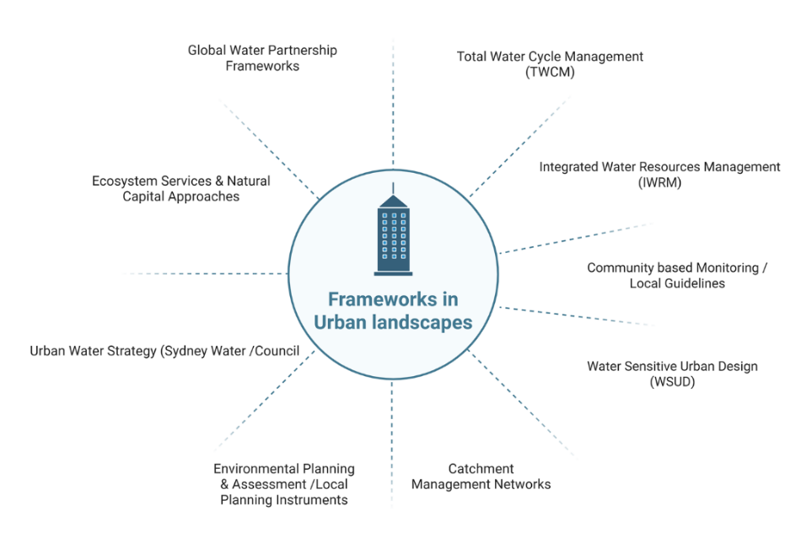
Supplementary Fig. S4 Water sustainability frameworks and assessment approaches recognised by key informants, including the Water Sensitive Cities Index, stormwater management tools, and planning guidelines. See Section 3.2 for discussion.
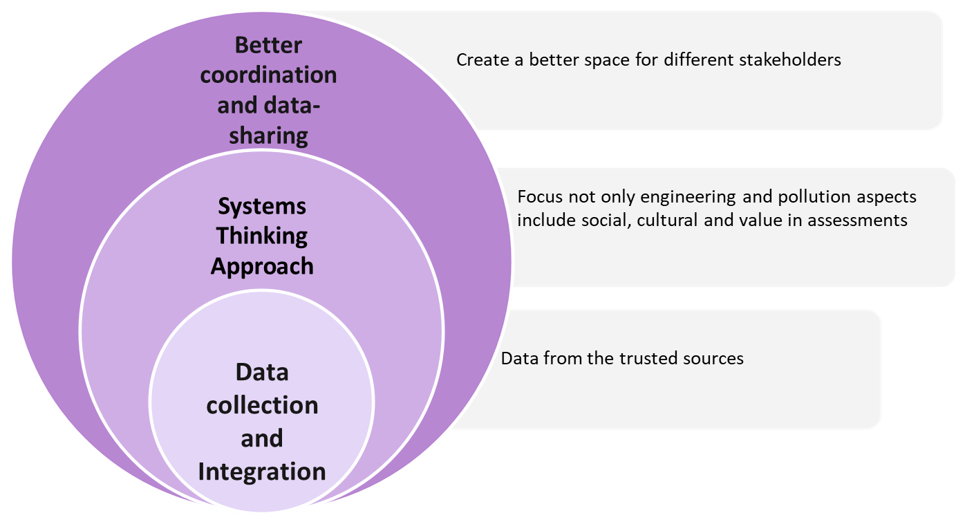
Supplementary Fig. S5 The top three recommended approaches for improving water sustainability assessment, based on key informant perspectives. See Section 3.2 for discussion.
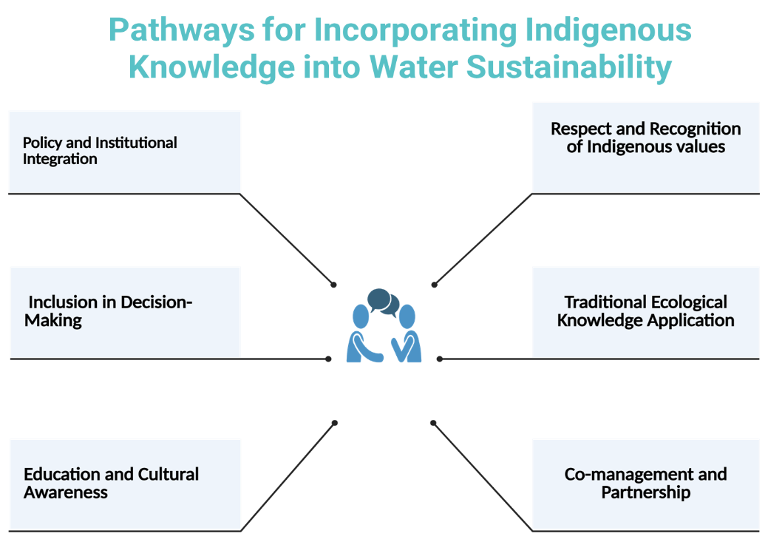
Supplementary Fig. S6 Themes emerging from stakeholder discussions on integrating Indigenous and Traditional Ecological Knowledge (TEK) into water management in the Parramatta region. See Section 3.3 for discussion.
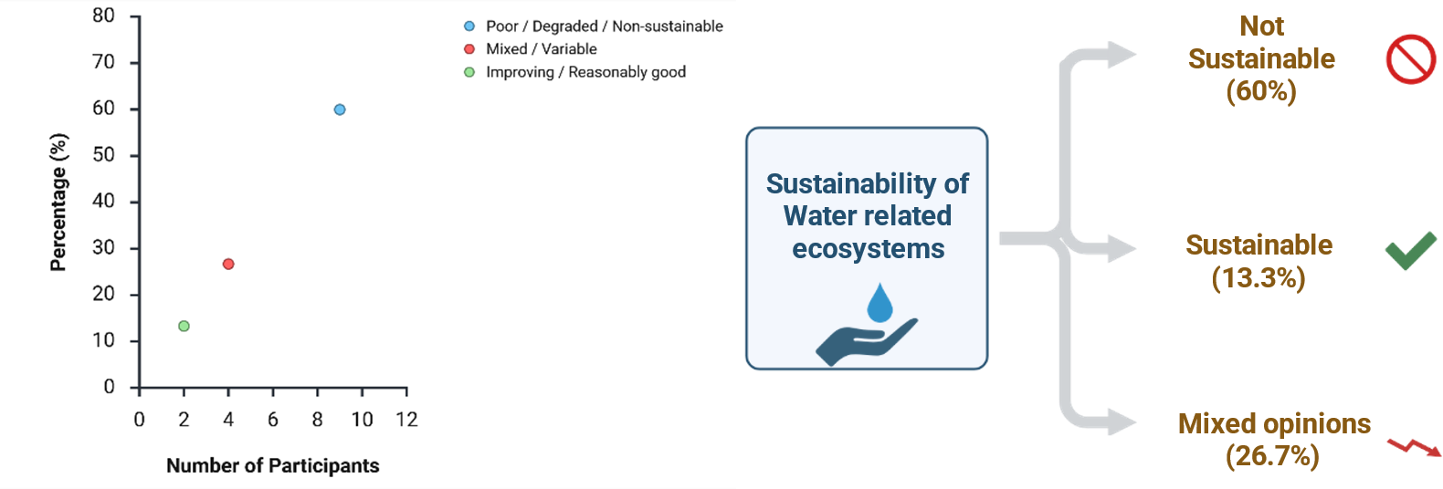
Supplementary Fig. S7 Stakeholder perceptions of the condition of urban water-related ecosystems, including rivers, creeks, wetlands, and aquifers, in the Parramatta region. See Section 3.4 for discussion.
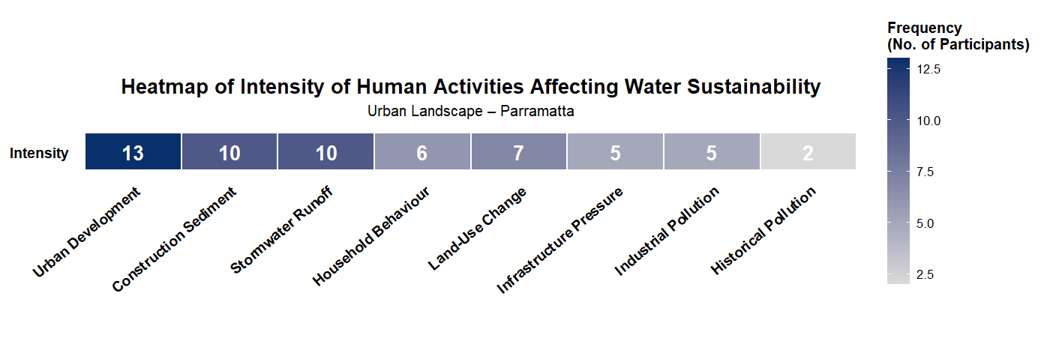
Supplementary Fig. S8 Human activities influencing water resources in the Parramatta region over time, as identified through key informant interviews. See Section 3.6 for discussion.

Supplementary Material B - Semi-Structured Interview Guide
The following interview guide was used for all 15 key informant interviews conducted between September 2023 and September 2024. The guide was structured around the study's research objectives. Interview questions were used flexibly to allow participants to expand on topics most relevant to their professional and community experience. Ethics approval: WSU HREC H16103.
Section I: General Information
1. Name
2. Age
3. Sex
4. Education
5. Suburb and postcode
6. Landscape classification: Urban / Peri-urban / Rural
7. Occupation
8. Years of experience

Section II - Key informant perspectives

Q | Theme | Interview Question(s)
1 | Perspectives on Water Sustainability | In your view, what is affecting water sustainability in your area?
2 | Definition of Water Sustainability | Based on your previous knowledge and expertise, what is the meaning and interpretation of the term 'water sustainability' for you?
3 | Current State | What are your thoughts on the current state of water sustainability in your location?
4 | Signs of Declining Sustainability | What are the apparent signs of declining water sustainability in your area?
5 | Indicators | What indicators can we use to measure water sustainability in your area?
6 | Assessing Water Sustainability | Can you share thoughts on a framework you have used or are familiar with to assess water sustainability?
7 | Better Assessment Methods | Do you have any thoughts on better ways to assess water sustainability in your area?
8 | Effective Communication | In your opinion, what are the effective ways to communicate the status of water sustainability to different stakeholders?
9 | Human Activities | Can you state significant human activities in the catchment impacting the health of water resources?
10 | Indigenous Knowledge | Could you share your thoughts about incorporating Indigenous knowledge and wisdom into sustainable water management?
11 | Ecosystem Health and Consequences | What are your thoughts on the current state of water-related ecosystems? If ecosystem health deteriorates further, what consequences do you foresee in the next 5, 10, 30, and 50 years?
12 | Improving Water Sustainability | Are current actions sufficient to improve water sustainability? Who can be most effective? What successful initiatives have worked well?
13 | Authority Actions | What actions can relevant authorities take to improve water resources health? Please share short-term, medium-term, and long-term actions. What collaboration from community and stakeholders is needed?
14 | SDG Understanding | What are your thoughts on UN Sustainable Development Goals 6, 11, and 15, and what commitments will you make to support these goals?

Note: The consent form is retained by Western Sydney University in accordance with WSU HREC Protocol H16103 and is not included in this supplementary file for participant privacy reasons. Ethics queries may be directed to humanethics@westernsydney.edu.au.

