Supporting information

Wavy-Flame Stabilization of Low-Concentration Coal Mine Methane in a Porous Media Burner with Non-Uniform Gas Intake

Peihao Qian¹, Jieming Wang², Shuhua Wang³, Pengtao Cai², Jianying Fu², Mingxiu Zhan²*, Jinqing Wang², Zuohe Chi²
1. College of Metrology & Measurement Engineering, China Jiliang University, Hangzhou, Zhejiang 310018, China
2. College of Energy Environment and Safety Engineering, China Jiliang University, Hangzhou, Zhejiang 310018, China
3. Hangzhou Linjiang Environmental Thermal Power Co., Ltd.
Corresponding author: Mingxiu Zhan, zhanmingxiu@cjlu.edu.cn

Supplementary Section S1. Error Analysis
The uncertainty of the gas concentration is calculated from the uncertainties of methane and air volumetric flow rates:
$E_{φ}=\frac{\sqrt{{\left(\frac{∂φ}{∂V_{CH_{4}}}δV_{{CH}_{4}}\right)}^{2}+{\left(\frac{∂φ}{∂V_{air}}δV_{air}\right)}^{2}}}{φ}$
The uncertainty of the Darcy velocity is calculated by:
$$E_{u}=\frac{\sqrt{{\left(\frac{∂u}{∂V_{in}}δV_{in}\right)}^{2}+{\left(\frac{∂u}{∂A}δA\right)}^{2}}}{u}$$
where V_{CH4}​​ and V_{Air} are the volumetric flow rates of methane and air (L/min), and A is the axial cross-sectional area of the burner (m²).
The uncertainty in thermocouple temperature measurement mainly originates from the temperature measurement system error, wiring errors, and the effect of thermal radiation on the thermocouple junction at high temperatures. The temperature uncertainty is calculated by:
$$T_{a}=T_{j}+∆T=T_{j}+\frac{σε_{\left(T_{j}^{4}-T_{s}^{4}\right)}}{h}$$
where Ta​ is the corrected actual temperature at the measurement point, σ is the Stefan-Boltzmann constant5.67x10⁻⁸W/(m²·K⁴), ε is the surface emissivity of the thermocouple junction, Tj​ is the measured junction temperature, Ts​ is the surface temperature of the particle at the thermocouple junction location, and h is the convective heat transfer coefficient between the gas in the packed bed and the thermocouple, given by:
$$h=1.22×\left(0.44±0.06\right)\frac{k_{g}}{d_{j}}{Re}^{0.5}{Pr}^{0.31}$$
where kg​ is the gas thermal conductivity W/(m·K), dj​ is the thermocouple junction diameter (m), Re is the gas Reynolds number in the packed bed, and Pr is the gas Prandtl number.
The uncertainty in the measured junction temperature due to the temperature measurement system and wiring errors is given by:
$$E_{T_{j}}=\sqrt{E_{B}^{2}+E_{Th}^{2}}$$
where E_{B}​ is the wiring error and ETh​ is the temperature measurement system error.
Due to the uncertainty in estimating the convective heat transfer coefficient and the junction emissivity, the uncertainty in the radiation correction is:
$$E_{∆T}=\frac{\sqrt{{\left(\frac{∂∆T}{∂h}δh\right)}^{2}+{\left(\frac{∂∆T}{∂ε_{j}}δε\right)}^{2}}}{∆T}$$
The uncertainty in the actual temperature is determined from the uncertainty of the thermocouple measurement and the radiation correction:
$$E_{T_{a}}=\frac{\sqrt{{\left(δT_{j}\right)}^{2}+{\left(δ∆T\right)}^{2}}}{T_{a}}$$
Supplementary Section S2. Experimental procedure for sphere packed-bed resistance measurement
The ceramic spheres were dried at 105-110 °C to constant mass and then naturally packed into the 70 mm × 70 mm square channel to the specified bed height H (0.2, 0.4, 0.6 m). Both ends of the bed were supported by metal screens. The blower was started, and the airflow rate was gradually increased to the target values corresponding to a flow velocity of v = 0.05-0.5 m/s. Under each steady-flow condition, the pressure difference between the upstream and downstream positions of the packed bed was recorded using a Dwyer M2000 differential pressure gauge. The stabilized pressure difference was taken as the resistance loss of the packed bed. The average pressure drop ΔP was obtained from four wall pressure taps in each row. Each test was repeated three times, and the pressure drop per unit bed height, ΔP/H, was calculated.
Most pressure-drop correlations are established using porous-medium theory. The pressure loss is considered to result from the combined viscous and inertial resistance exerted by particles on the fluid. Darcy [1] related the pressure drop in a porous medium to the fluid velocity as:
$$u=\frac{K}{μ}(-\frac{d_{p}}{d_{x}})$$
where K is the permeability of the porous medium. Irmay [2] extended the Darcy-Forchheimer equation to express one-dimensional flow through porous media in a more general form:
$$-\frac{d_{p}}{d_{x}}=\frac{f_{1}{μ\left(1-∅\right)}^{2}}{d_{p}^{2}∅^{3}}u+\frac{f_{2}ρ_{f}(1-∅)}{d_{p}∅^{3}}u^{2}$$
sphericity is introduced and defined as the ratio between the surface area of an equivalent-volume sphere and the actual particle surface area:
$$φ=\frac{π{D_{d}}^{2}}{A}$$
where A is the actual particle surface area (m²), and D_{d} is the equivalent diameter, i.e., the diameter of a sphere with the same volume as the particle (m).
The pressure drop per unit bed height can be rewritten as:
$$\frac{∆P}{H}=f_{1}\frac{{μ\left(1-∅\right)}^{2}}{{φ^{2}d}_{p}^{2}∅^{3}}u+f_{2}\frac{ρ_{f}(1-∅)}{φd_{p}∅^{3}}u^{2}$$
where dp is the particle diameter, and f₁ and f₂ are geometric factors that can be determined from empirical correlations. In the above equation, the first term corresponds to the viscous resistance coefficient:
$$\frac{1}{α}=\frac{f_{1}{\left(1-∅\right)}^{2}}{φ^{2}d_{p}^{2}∅^{3}}$$
The second term corresponds to the inertial resistance coefficient:
$$C_{2}=\frac{{2f}_{2}(1-∅)}{φd_{p}∅^{3}}$$
Supplementary Section S3. Water displacement method for porosity measurement of spheres
1. Take the ceramic spheres and dry them in an oven at 105-110 °C for 2 h until a constant mass is reached.
2. Add an appropriate amount of water into a 70 × 70 × 200 mm measuring cylinder. The water temperature should be maintained at 20 ± 1 °C to reduce errors caused by thermal expansion and contraction. Record the initial volume as V₁.
3. Slowly slide the spheres into the measuring cylinder to avoid splashing. Level the upper surface with a scraper, measure the packed-bed height H, and calculate the total bed volume V_{bed}.
4. Place the measuring cylinder in an ultrasonic cleaner and sonicate for 10 min to remove internal air bubbles. After the water surface becomes stable, record the volume as V₂.
5. The volume of displaced water is calculated as V_{d} = V₂ - V₁. This volume is taken as the solid volume of the ceramic skeleton.
6. Calculate the packed-bed porosity as follows:
$ε=\frac{v_{bed}-v_{d}}{v_{bed}}$
Using the above method, the porosities of the packed beds formed by 8 mm, 10 mm, and 12 mm spheres were determined to be 47.64%, 45.43%, and 43.83%, respectively.

Supplementary Section S4. Simulation mathematical model
(1) Mass conservation equation:
$\frac{∂ρ}{∂t}+diν(ρU)=0$
whereis the fluid density.
(2) Momentum conservation equation
Momentum conservation is essentially governed by Newton's second law and can be expressed as:
$\frac{∂\left(ρu_{i}\right)}{∂t}+\frac{∂\left(ρu_{i}u_{j}\right)}{∂x_{j}}=-\frac{∂p}{∂x_{i}}+\frac{∂τ_{ij}}{∂x_{j}}+ρg_{i}+F_{i}$
where p is the static pressure; is the stress tensor; $g_{i}$is the gravitational body force in the i-direction; $F_{i}$is the external body force in the i-direction, including other model-related source terms.
(3) Energy equation
$\frac{∂}{∂t}\left(ρE\right)+\frac{∂}{∂x_{i}}\left(u_{i}\left(pE+p\right)\right)=\frac{∂}{∂x_{i}}\left(k_{eff}\frac{∂T}{∂x_{i}}-\sum_{j^{'}}{h_{j^{'}}J_{j^{'}}+u_{j}{\left(τ_{ij}\right)}_{eff}}\right)+S_{h}$
where $J_{j^{'}}$is the diffusion flux of species $j^{'}$, $k_{eff}$is the effective heat-transfer coefficient, and $S_{h}$denotes other heat source terms.
$E=h-\frac{p}{ρ}+\frac{u_{i}^{2}}{2}$
For a compressible fluid:
$h=\sum_{j^{'}}{m_{j^{'}}h_{j^{'}}}+\frac{p}{ρ}$
The first three terms on the right-hand side of the above equation represent energy transport due to heat conduction, species diffusion, and viscous diffusion, respectively. $S_{h}$ denotes the heat of chemical reaction and other user-defined volumetric heat source terms.

Supplementary Section S5. Selection of turbulence model
Turbulence is a fluid-flow phenomenon that is widely encountered in nature and engineering applications. Its main characteristics are the nearly infinite range of vortex structures over physical scales and strong nonlinearity in mathematical descriptions. This complexity makes the accurate simulation of turbulence highly challenging. In practical numerical calculations, turbulence models are generally employed to simplify the solution procedure. Commonly used models include the Spalart-Allmaras (S-A) model, k-omega models, k-epsilon models, the Reynolds stress model (RSM), and large eddy simulation (LES).
(1) As a simplified one-equation turbulence model, the S-A model only requires the solution of a transport equation for turbulent viscosity. It is a typical large-grid, low-cost numerical simulation method. Its main advantage is its relatively high accuracy for boundary-layer flows with adverse pressure gradients and wall-bounded flows. In addition, the model has a relatively low dependence on mesh quality; even with comparatively coarse meshes, the sensitivity of the calculation error is small, indicating good robustness.
However, its limitation is that no variable length scale is introduced in the model formulation, and the isotropic dissipation characteristics of turbulence are not fully considered. Therefore, the applicability of the S-A model is limited when dealing with complex flows involving drastic changes in flow scale or pronounced anisotropy.
(2) The k-omega model is another important two-equation turbulence model in computational fluid dynamics. It closes the Reynolds stress terms by solving two transport equations, namely the turbulent kinetic energy k and the specific dissipation rate omega. The k-omega family includes the standard k-omega model and the SST k-omega model.
The standard k-omega model was proposed by Wilcox. Its main feature is that no wall function is required in the near-wall region, allowing accurate simulation of boundary-layer flows and good prediction of flow separation under adverse pressure gradients. Therefore, the standard k-omega model is particularly suitable for external-flow problems in aerospace applications, internal flows in turbomachinery, and operating conditions involving flow separation. Its main drawback is its sensitivity to the omega value in the free stream; small variations in inlet conditions may significantly affect the predicted internal flow field.
The SST (shear stress transport) model is an improved version of the standard k-omega model proposed by Menter. Its key advantage is the use of a blending function: the k-omega model is activated in the near-wall region to take advantage of its accuracy for boundary-layer simulation, whereas the model automatically switches to the k-epsilon formulation in fully turbulent regions away from the wall to avoid sensitivity to free-stream conditions. In addition, the SST model modifies the definition of turbulent viscosity and accounts for the transport effect of turbulent shear stress. As a result, the SST k-omega model provides higher accuracy and reliability for complex flows such as separation under adverse pressure gradients, airfoil flows, and shock-wave/boundary-layer interactions, and it has become one of the most recommended turbulence models for engineering applications.
(3) The k-epsilon model mainly includes two typical forms: the RNG k-epsilon model and the Realizable k-epsilon model. Both are improved versions developed from the theoretical framework of the standard k-epsilon model by introducing more rigorous mathematical derivations and physical constraints. The RNG k-epsilon model is based on renormalization group theory and can better handle low-Reynolds-number effects and near-wall flows. Its governing equations are expressed as:
$\frac{∂}{∂t}\left(ρk\right)+\frac{∂}{∂x_{i}}\left(ρku_{i}\right)=\frac{∂}{∂x_{i}}\left[\left(μ+\frac{μ_{t}}{σ_{k}}\right)\frac{∂k}{∂x_{i}}\right]+G_{k}+G_{b}-ρε-Y_{M}+S_{k}$
$\frac{∂}{∂t}\left(ρε\right)+\frac{∂}{∂x_{j}}\left(ρku_{j}\right)=\frac{∂}{∂x_{j}}\left[\left(μ+\frac{μ_{t}}{σ_{ε}}\right)\frac{∂ε}{∂x_{j}}\right]+ρC_{1}S_{ε}-ρC_{2}\frac{ε^{2}}{k+\sqrt{vε}}G_{k}+C_{1ε}\frac{ε}{k}C_{3ε}G_{b}+S_{ε}$
$C_{1}=\max\left[0.43,\frac{η}{η+5}\right]$
$η=S⋅\frac{k}{ε}$
where $G_{k}$ represents the production of turbulent kinetic energy due to the mean velocity gradients; $G_{b}$ represents the production of turbulent kinetic energy due to buoyancy; $Y_{M}$ represents the contribution of dilatation fluctuation in compressible turbulence to the overall dissipation rate; $k$ and $ε$ are the turbulent Prandtl numbers for $σ_{k}$ and $σ_{ε}$, respectively;
The standard k-epsilon model has been widely used in fluid-flow problems because it requires a moderate computational cost, has accumulated abundant validation data, and provides reasonable accuracy. $S_{k}$ and $S_{ε}$are two source terms; $μ_{t}$ denotes the turbulent viscosity and is calculated as:
$μ_{t}=\frac{ρCμk^{2}}{ε}$
Compared with the traditional k-epsilon model and the RNG k-epsilon model, the modified swirl k-epsilon model changes $C_{μ}$ from a constant to a function related to the mean strain and mean rotation rates. The expression is as follows:
$Cμ=\frac{1}{A_{0}+A_{s}\frac{kU^{'}}{ε}}$
where $U^{'}$ is a constant, and $A_{0}$ and $A_{s}$ is a function related to the mean strain rate and rotation rate.
(4) The RSM model has high requirements for computational resources, mainly reflected in its large memory consumption and long solution time. Its key advantage is that it solves the full Reynolds stress tensor, thereby effectively capturing the anisotropic characteristics of turbulence. Compared with other turbulence models, RSM can more accurately simulate the effects of rotating flows and curvature on the flow field, and it is suitable for complex flow conditions involving strong swirl and curved boundary layers.
(5) The core idea of large eddy simulation is to directly resolve the motion of large-scale eddies that dominate momentum, energy, and mass transport in turbulent flows, while modeling the unresolved small-scale eddies by introducing a sub-grid-scale model. In this way, a balance between computational accuracy and resource consumption can be achieved. However, it should be noted that this model imposes extremely high requirements on computational resources. Both the numerical algorithms of the software and the hardware performance must satisfy stringent requirements, resulting in a computational cost that is significantly higher than that of Reynolds-averaged numerical simulation methods.
The SST k-ω turbulence model was adopted in this study because the flow through the packed bed involves strong near-wall shear, local acceleration through small openings, flow separation, reattachment, and lateral redistribution inside the porous bed. The SST k-ω model combines the advantages of the k-ω formulation in the near-wall region and the k-ε formulation in the free-stream region through a blending function. Therefore, it can improve the prediction of adverse-pressure-gradient and separated flows while reducing the sensitivity of the standard k-ω model to free-stream turbulence conditions. This makes it suitable for resolving the complex three-dimensional flow and pressure-loss characteristics investigated in the present work.

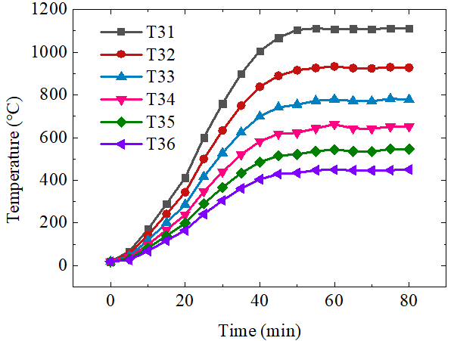 | 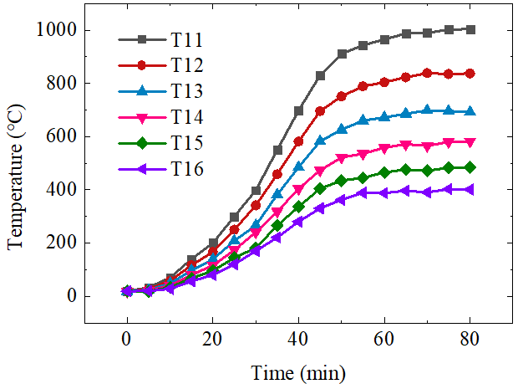
(a) center temperature | (b) wall temperature

Fig. S1 Bed temperature variation during preheating (pure methane, no low-concentration CMM co-firing)

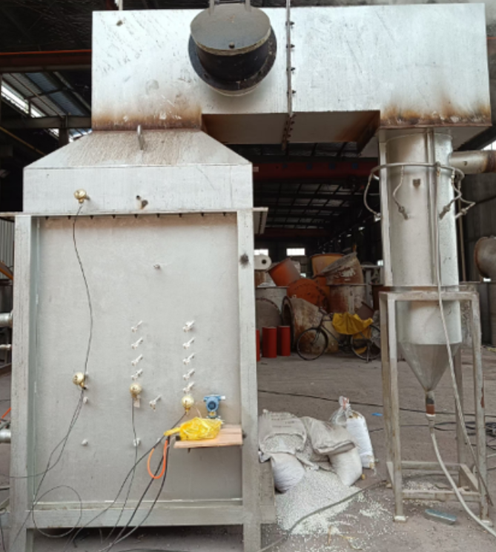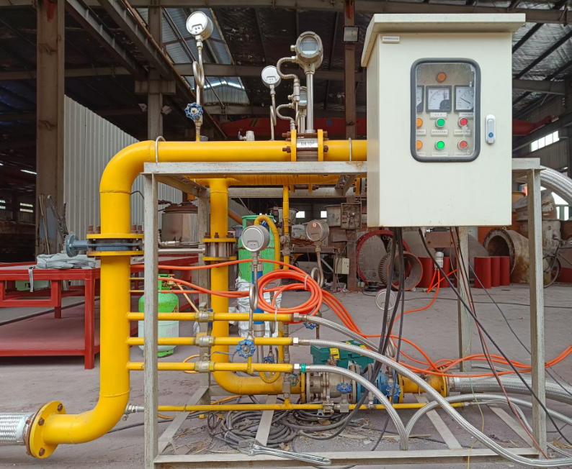

Fig. S2 Experimental granular packed bed and control valve train

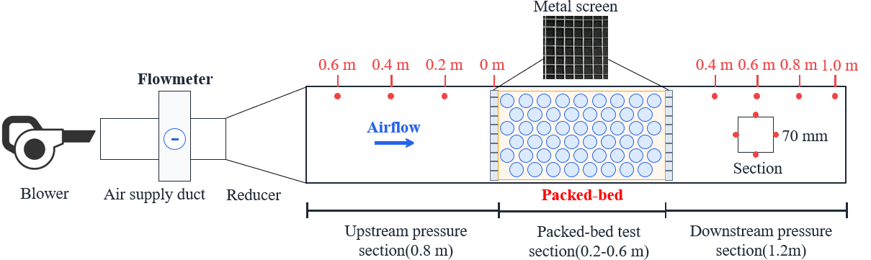
Fig. S3 Experimental systems for packed-bed resistance measurements

References
[1]H. P. G. Darcy, Les Fontaines Publiques de la Ville de Dijon. 1856, Paris: Victor Dalmont.
[2]S. Irmay, On the theoretical derivation of Darcy and Forchheimer formulas, Eos. Trans. AGU. 39(1958)702-707.

