Supplementary Information
Surrogate-Free Inverse Design of High-IP/High-EA Polyimide Constitutional Repeating Units with In-Loop Semiempirical Quantum Scoring
Yingda Li^{1,2}, Rong Sun^{1,3}, Jibao Lu^{*,1,3}
¹ Shenzhen Institutes of Advanced Technology, Chinese Academy of Sciences, Shenzhen 518055, China
² Southern University of Science and Technology, Shenzhen, 518055, China
³ Shenzhen Institute of Advanced Electronic Materials, Shenzhen Institutes of Advanced Technology, Chinese Academy of Sciences, Shenzhen, 518103, China
* Corresponding author: jibao.lu@siat.ac.cn
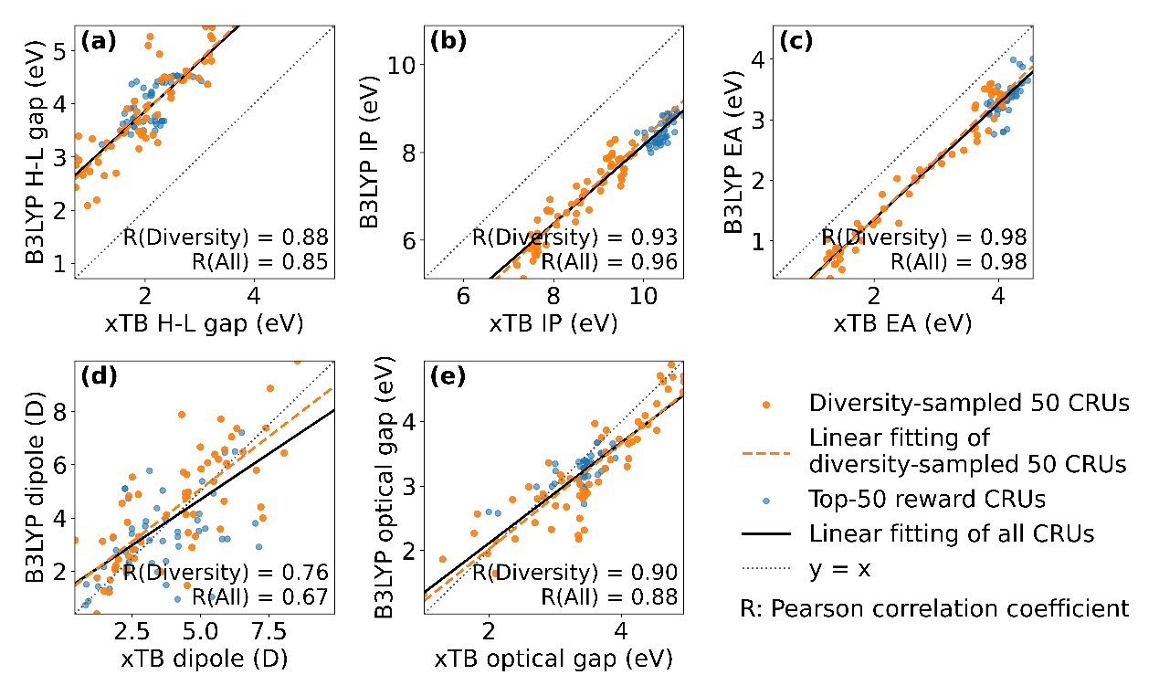
Figure S1. Parity plots comparing GFN2-xTB/sTDA predictions used during generation with DFT single-point calculations on GFN2-xTB-optimized geometries for five electronic properties: (a) HOMO-LUMO gap, (b) ionization potential (IP), (c) electron affinity (EA), (d) dipole moment, and (e) optical gap. DFT calculations were performed at the B3LYP/aug-cc-pVTZ level with COSMO solvation (benzene). The dotted line indicates the ideal parity line (y = x), and Pearson correlation coefficients (R) are reported in each panel. The plots show strong linear agreement between GFN2-xTB/sTDA predictions and DFT results evaluated on xTB-optimized geometries.

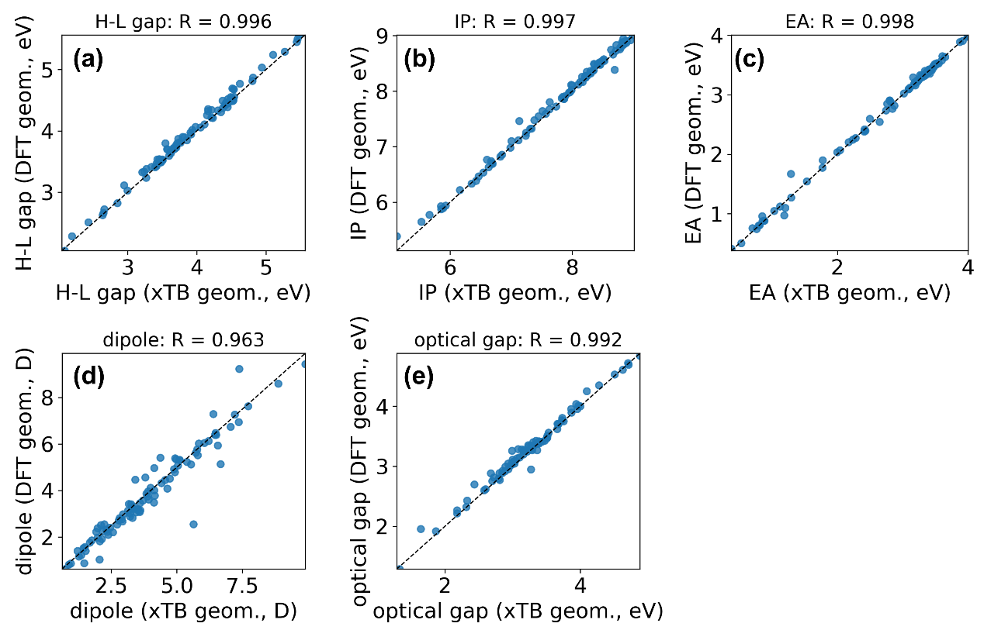
Figure S2. Comparison of single-point DFT results obtained on GFN2-xTB-optimized geometries and on fully DFT-optimized geometries for a representative subset of generated structures. All calculations were performed at the B3LYP/aug-cc-pVTZ level with COSMO solvation (benzene). Parity plots compare the two DFT datasets for five key quantum-chemical descriptors: (a) HOMO-LUMO gap, (b) ionization potential (IP), (c) electron affinity (EA), (d) dipole moment, and (e) optical gap. The strong Pearson correlations (R = 0.96–1.00) show that DFT properties evaluated on xTB-optimized geometries preserve essentially the same relative trends as those obtained from fully DFT-relaxed structures, supporting the use of xTB geometries for high-throughput screening in the inverse-design workflow.

Table S1. Statistical comparison between GFN2-xTB/sTDA and DFT predictions for the evaluated properties. Reported metrics include sample size (N), Pearson correlation coefficient (R), Spearman rank correlation coefficient (ρ), mean absolute error (MAE), root-mean-square error (RMSE), and mean bias (DFT − xTB).
Property | group | N | Pearson_R | Spearman_ρ | MAE | RMSE | Bias (DFT – xTB)
HLGap | all | 100 | 0.82 | 0.78 | 1.91 | 1.95 | 1.91
HLGap | subset | 50 | 0.86 | 0.87 | 1.90 | 1.95 | 1.90
IP | all | 100 | 0.96 | 0.94 | 1.76 | 1.78 | -1.76
IP | subset | 50 | 0.93 | 0.90 | 1.63 | 1.65 | -1.63
EA | all | 100 | 0.98 | 0.90 | 0.71 | 0.74 | -0.71
EA | subset | 50 | 0.98 | 0.95 | 0.66 | 0.70 | -0.66
Dipole | all | 100 | 0.67 | 0.65 | 1.18 | 1.54 | -0.09
Dipole | subset | 50 | 0.76 | 0.78 | 1.11 | 1.45 | -0.04
OptGap | all | 100 | 0.86 | 0.81 | 0.29 | 0.37 | -0.16
OptGap | subset | 50 | 0.89 | 0.88 | 0.35 | 0.43 | -0.19

Table S2. DFT-calculated electronic properties and synthetic accessibility (SA) scores of the top 50 candidates.
No. | Structures/smiles | HLGap  (eV) | IP  (eV) | EA  (eV) | Dipole  (Debye) | Optical gap  (eV) | SA_Score
1 | 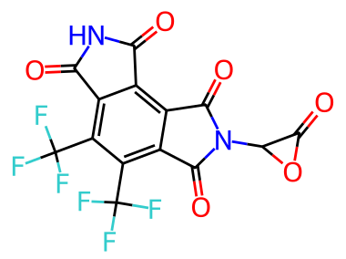  O=C(c1c(F)cnc(F)c1F)n1c(=O)c2c(C(F)(F)F)c3c(=O)[nH]c(=O)c3c(C(F)(F)F)c2c1=O | 4.35 | 8.95 | 3.34 | 5.39 | 3.43 | 3.65
2 | 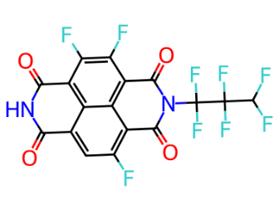  O=C1NC(=O)c2c(F)c(F)c3c4c(c(F)cc1c24)C(=O)N(C(F)(F)C(F)(F)C(F)F)C3=O | 3.71 | 8.38 | 3.52 | 4.79 | 3.31 | 3.63
3* | 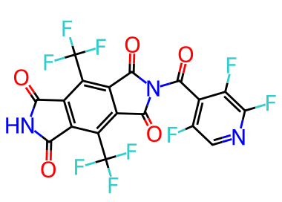  O=C1C(n2c(=O)c3c(C(F)(F)F)c(C(F)(F)F)c4c(=O)[nH]c(=O)c4c3c2=O)O1 | 3.72 | 8.57 | 3.48 | 2.98 | 3.27 | 3.85
4* | 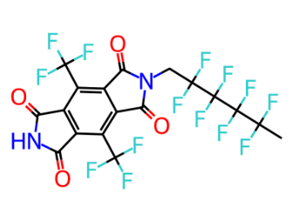  CC(=O)OOOC(=O)On1c(=O)c2cc(C(F)(F)F)c3c(c(C(F)(F)F)cc4c(=O)[nH]c(=O)c43)c2c1=O | 4.43 | 9.01 | 3.32 | 3.41 | 3.40 | 3.69
5 | 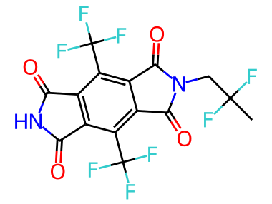  O=C1C(n2c(=O)c3cc(C(F)(F)F)c4c(c(C(F)(F)F)cc5c(=O)[nH]c(=O)c54)c3c2=O)O1 | 4.45 | 8.90 | 3.20 | 2.82 | 3.41 | 3.78
6 | 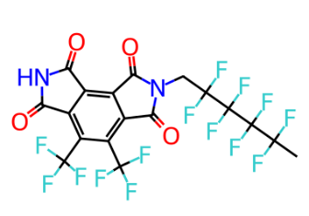  O=C1NC(=O)c2c(F)c(F)c3c4c(c(F)cc1c24)C(=O)N(C1CS(=O)(=O)C1)C3=O | 4.49 | 8.92 | 3.17 | 3.18 | 3.47 | 3.30
7 | 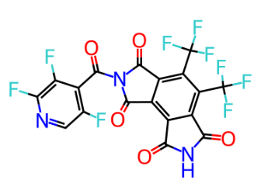  CC(F)(F)C(F)(F)C(F)(F)C(F)(F)Cn1c(=O)c2c(C(F)(F)F)c3c(=O)[nH]c(=O)c3c(C(F)(F)F)c2c1=O | 3.82 | 8.55 | 3.37 | 3.46 | 3.35 | 3.62
8 | 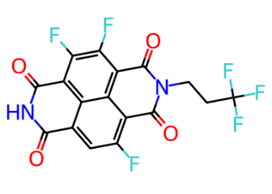  CN1C(=O)C=C(n2c(=O)c3c(C(F)(F)F)c4c(=O)[nH]c(=O)c4c(C(F)(F)F)c3c2=O)C1=O | 3.71 | 8.25 | 3.40 | 3.21 | 3.29 | 3.59
9 | 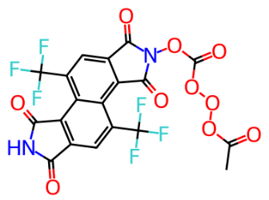  O=C(c1c(F)cnc(F)c1F)n1c(=O)c2c(C(F)(F)F)c(C(F)(F)F)c3c(=O)[nH]c(=O)c3c2c1=O | 3.66 | 8.34 | 3.60 | 3.96 | 3.09 | 3.61
10 | 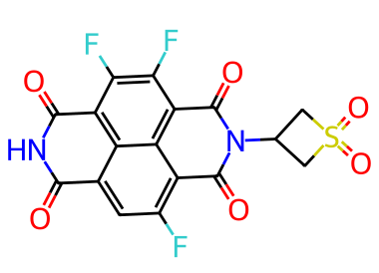  O=C(c1c(F)cnc(F)c1F)n1c(=O)c2cc(C(F)(F)F)c3c(c(C(F)(F)F)cc4c(=O)[nH]c(=O)c43)c2c1=O | 3.71 | 8.33 | 3.50 | 6.39 | 3.30 | 3.59
11* | 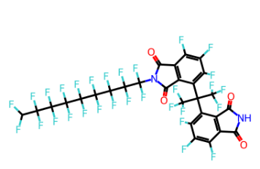  CC(=O)OOOC(=O)Nn1c(=O)c2c(C(F)(F)F)c3c(=O)[nH]c(=O)c3c(C(F)(F)F)c2c1=O | 4.43 | 8.37 | 2.84 | 1.04 | 3.59 | 3.75
12 | 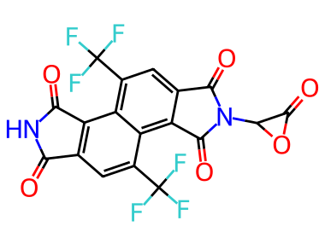  O=C1C(n2c(=O)c3c(-c4cc(C(F)(F)F)cc(C(F)(F)F)c4)c4c(=O)[nH]c(=O)c4c(-c4cc(C(F)(F)F)cc(C(F)(F)F)c4)c3c2=O)O1 | 3.70 | 8.35 | 3.65 | 5.41 | 3.06 | 3.83
13 | 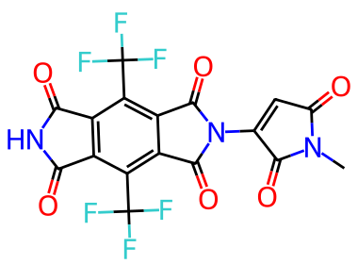  CC(F)(F)Cn1c(=O)c2c(C(F)(F)F)c3c(=O)[nH]c(=O)c3c(C(F)(F)F)c2c1=O | 3.90 | 8.50 | 3.39 | 1.40 | 3.33 | 3.43
14 | 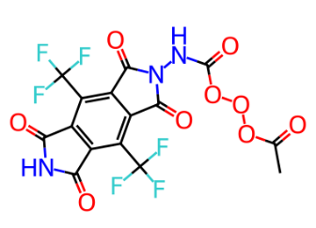  O=C1NC(=O)c2c(F)c(F)c3c4c(c(F)cc1c24)C(=O)N(CCC(F)(F)F)C3=O | 4.33 | 8.85 | 3.39 | 3.42 | 3.34 | 3.18
15 | 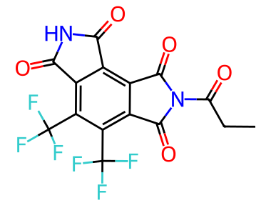O=C1NC(=O)c2c1c(F)c(F)c(F)c2C(c1c(F)c(F)c(F)c2c1C(=O)N(C(F)(F)C(F)(F)C(F)(F)C(F)(F)C(F)(F)C(F)(F)C(F)(F)C(F)(F)C(F)F)C2=O)(C(F)(F)F)C(F)(F)F | 4.31 | 8.75 | 3.21 | 4.51 | 3.41 | 4.35
16 | 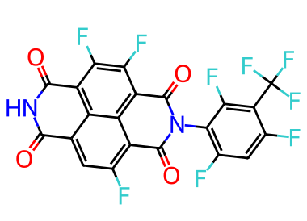  O=C1NC(=O)c2c(F)c(F)c3c4c(c(F)cc1c24)C(=O)N(c1c(F)cc(F)c(C(F)(F)F)c1F)C3=O | 4.69 | 8.52 | 2.85 | 2.25 | 3.71 | 3.46
17 | 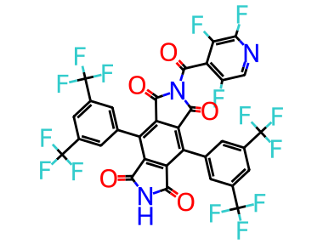  O=C(c1c(F)cnc(F)c1F)n1c(=O)c2c(-c3cc(C(F)(F)F)cc(C(F)(F)F)c3)c3c(=O)[nH]c(=O)c3c(-c3cc(C(F)(F)F)cc(C(F)(F)F)c3)c2c1=O | 4.68 | 8.49 | 2.91 | 5.32 | 3.70 | 3.78
18 | 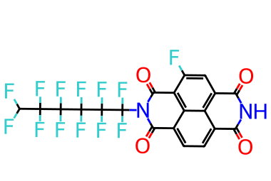  O=C1NC(=O)c2cc(F)c3c4c(ccc1c24)C(=O)N(C(F)(F)C(F)(F)C(F)(F)C(F)(F)C(F)(F)C(F)F)C3=O | 4.68 | 8.49 | 2.91 | 5.32 | 3.70 | 3.58
19 | 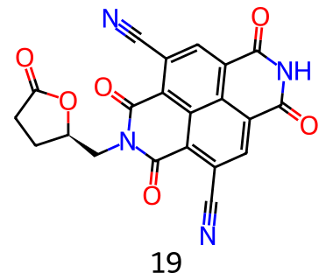  O=C1CC[C@H](CN2C(=O)c3c(C#N)cc4c5c(cc(C#N)c(c35)C2=O)C(=O)NC4=O)O1 | 3.59 | 8.17 | 3.41 | 5.23 | 3.24 | 3.77
20 | 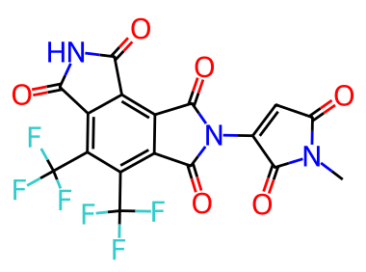  CN1C(=O)C=C(n2c(=O)c3c(C(F)(F)F)c(C(F)(F)F)c4c(=O)[nH]c(=O)c4c3c2=O)C1=O | 3.71 | 8.27 | 3.48 | 3.78 | 3.26 | 3.54
21 | 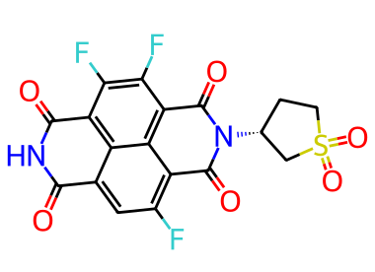  O=C1NC(=O)c2c(F)c(F)c3c4c(c(F)cc1c24)C(=O)N([C@@H]1CCS(=O)(=O)C1)C3=O | 3.73 | 8.37 | 3.34 | 1.22 | 3.15 | 3.68
22 | 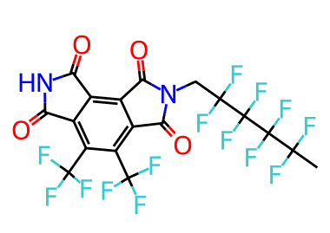  CC(F)(F)C(F)(F)C(F)(F)C(F)(F)Cn1c(=O)c2c(C(F)(F)F)c(C(F)(F)F)c3c(=O)[nH]c(=O)c3c2c1=O | 4.26 | 8.75 | 3.26 | 2.23 | 3.39 | 3.62
23 | 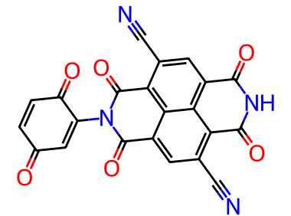  O=C1C=CC(=O)C(N2C(=O)c3cc(C#N)c4c5c(cc(C#N)c(c35)C2=O)C(=O)NC4=O)=C1 | 4.21 | 8.72 | 3.29 | 3.14 | 3.37 | 3.46
24 | 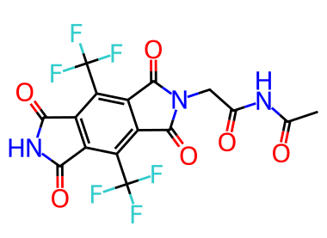  CC(=O)NC(=O)Cn1c(=O)c2c(C(F)(F)F)c3c(=O)[nH]c(=O)c3c(C(F)(F)F)c2c1=O | 3.54 | 8.26 | 3.63 | 3.75 | 3.11 | 3.24
25 | 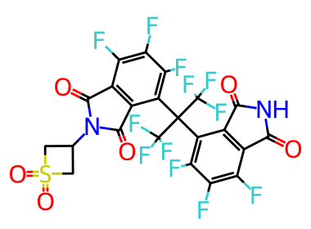  O=C1NC(=O)c2c1c(F)c(F)c(F)c2C(c1c(F)c(F)c(F)c2c1C(=O)N(C1CS(=O)(=O)C1)C2=O)(C(F)(F)F)C(F)(F)F | 3.41 | 8.13 | 3.46 | 4.27 | 2.96 | 3.83
26 | 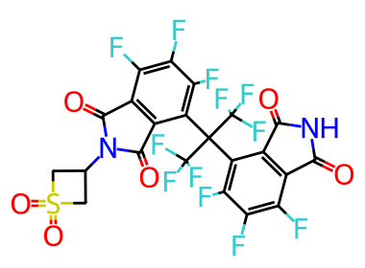  O=C1NC(=O)c2c1c(F)c(F)c(F)c2C(c1c(F)c(F)c(F)c2c1C(=O)N([C@@H]1CS(=O)(=O)C1)C2=O)(C(F)(F)F)C(F)(F)F | 4.47 | 8.88 | 3.21 | 2.73 | 3.42 | 3.83
27 | 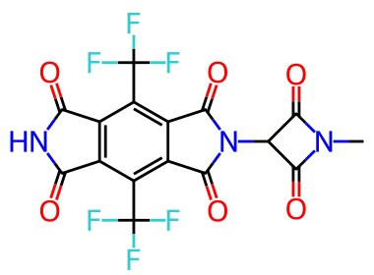  CN1C(=O)C(n2c(=O)c3c(C(F)(F)F)c4c(=O)[nH]c(=O)c4c(C(F)(F)F)c3c2=O)C1=O | 3.94 | 8.84 | 3.53 | 0.82 | 2.60 | 3.47
28 | 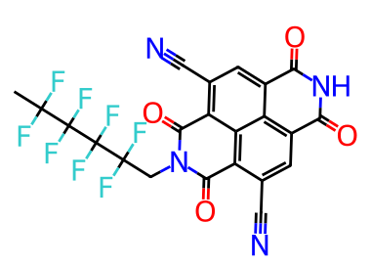  CC(F)(F)C(F)(F)C(F)(F)C(F)(F)CN1C(=O)c2c(C#N)cc3c4c(cc(C#N)c(c24)C1=O)C(=O)NC3=O | 4.02 | 8.49 | 3.29 | 2.10 | 3.43 | 3.63
29 | 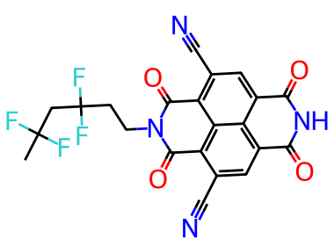  CC(F)(F)CC(F)(F)CCN1C(=O)c2c(C#N)cc3c4c(cc(C#N)c(c24)C1=O)C(=O)NC3=O | 4.49 | 8.81 | 3.10 | 3.02 | 3.48 | 3.55
30 | 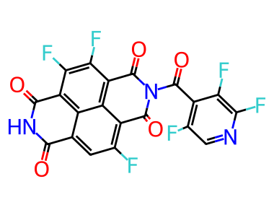  O=C1NC(=O)c2c(F)c(F)c3c4c(c(F)cc1c24)C(=O)N(C(=O)c1c(F)cnc(F)c1F)C3=O | 4.42 | 8.88 | 3.22 | 2.33 | 3.39 | 3.53
31 | 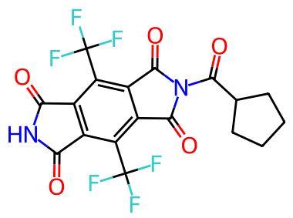  O=C(C1CCCC1)n1c(=O)c2c(C(F)(F)F)c3c(=O)[nH]c(=O)c3c(C(F)(F)F)c2c1=O | 3.48 | 7.97 | 3.48 | 3.49 | 2.72 | 3.29
32 | 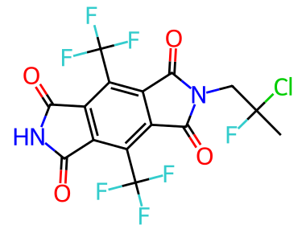  CC(Cl)(F)Cn1c(=O)c2c(C(F)(F)F)c3c(=O)[nH]c(=O)c3c(C(F)(F)F)c2c1=O | 3.71 | 8.28 | 3.48 | 6.40 | 3.30 | 3.94
33 | 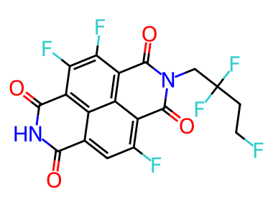  O=C1NC(=O)c2c(F)c(F)c3c4c(c(F)cc1c24)C(=O)N(CC(F)(F)CCF)C3=O | 3.34 | 8.10 | 3.43 | 7.27 | 2.82 | 3.49
34* | 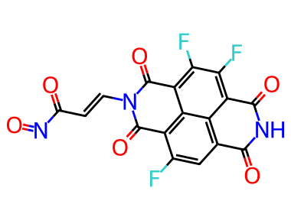  O=C(/C=C/N1C(=O)c2c(F)cc3c4c(c(F)c(F)c(c24)C1=O)C(=O)NC3=O)N=O | 3.71 | 8.28 | 3.43 | 3.57 | 3.30 | 3.72
35 | 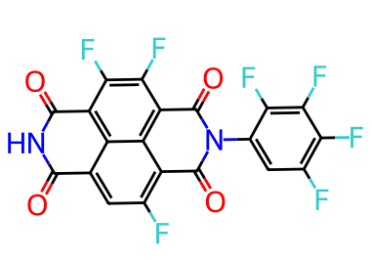  O=C1NC(=O)c2c(F)c(F)c3c4c(c(F)cc1c24)C(=O)N(c1cc(F)c(F)c(F)c1F)C3=O | 3.54 | 8.38 | 3.89 | 4.56 | 3.03 | 3.26
36 | 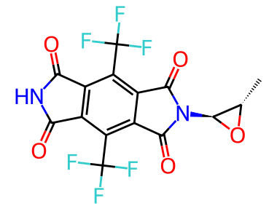  C[C@H]1[C@H](n2c(=O)c3c(C(F)(F)F)c4c(=O)[nH]c(=O)c4c(C(F)(F)F)c3c2=O)O1 | 3.72 | 8.17 | 3.32 | 1.97 | 3.29 | 4.13
37 | 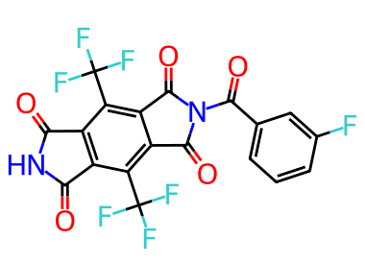  O=C(c1cccc(F)c1)n1c(=O)c2c(C(F)(F)F)c3c(=O)[nH]c(=O)c3c(C(F)(F)F)c2c1=O | 3.52 | 8.55 | 3.97 | 5.08 | 3.08 | 3.19
38 | 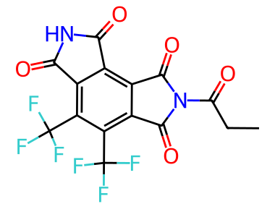  CCC(=O)n1c(=O)c2c(C(F)(F)F)c(C(F)(F)F)c3c(=O)[nH]c(=O)c3c2c1=O | 3.64 | 8.32 | 3.31 | 2.53 | 3.20 | 3.32
39 | 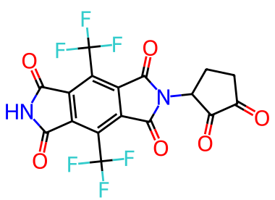  O=C1CCC(n2c(=O)c3c(C(F)(F)F)c4c(=O)[nH]c(=O)c4c(C(F)(F)F)c3c2=O)C1=O | 4.51 | 8.87 | 3.12 | 2.89 | 3.48 | 3.95
40 | 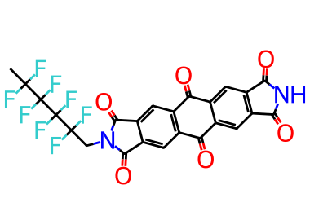  CC(F)(F)C(F)(F)C(F)(F)Cn1c(=O)c2cc3c(=O)c4cc5c(=O)[nH]c(=O)c5cc4c(=O)c3cc2c1=O | 3.50 | 8.49 | 3.99 | 0.62 | 2.62 | 3.37
41 | 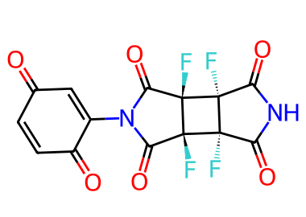  O=C1NC(=O)[C@@]2(F)[C@]1(F)[C@]1(F)C(=O)N(C3=CC(=O)C=CC3=O)C(=O)[C@]21F | 4.43 | 8.91 | 3.24 | 0.87 | 3.39 | 5.04
42 | 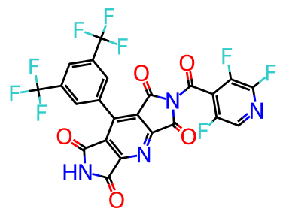  O=C(c1c(F)cnc(F)c1F)n1c(=O)c2nc3c(=O)[nH]c(=O)c3c(-c3cc(C(F)(F)F)cc(C(F)(F)F)c3)c2c1=O | 3.71 | 8.26 | 3.53 | 3.15 | 3.28 | 3.54
43 | 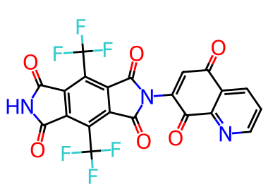  O=C1C=C(n2c(=O)c3c(C(F)(F)F)c4c(=O)[nH]c(=O)c4c(C(F)(F)F)c3c2=O)C(=O)c2ncccc21 | 3.80 | 8.52 | 3.33 | 3.19 | 3.35 | 3.47
44 | 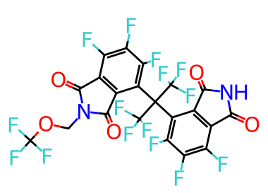  O=C1NC(=O)c2c1c(F)c(F)c(F)c2C(c1c(F)c(F)c(F)c2c1C(=O)N(COC(F)(F)F)C2=O)(C(F)(F)F)C(F)(F)F | 4.21 | 8.78 | 3.30 | 2.23 | 3.40 | 3.84
45 | 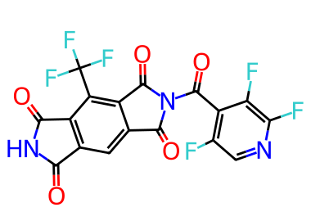  O=C(c1c(F)cnc(F)c1F)n1c(=O)c2cc3c(=O)[nH]c(=O)c3c(C(F)(F)F)c2c1=O | 3.81 | 8.27 | 3.34 | 1.52 | 3.27 | 3.42
46 | 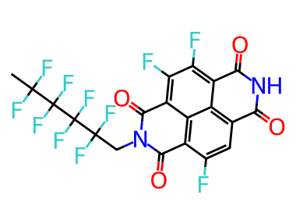  CC(F)(F)C(F)(F)C(F)(F)C(F)(F)CN1C(=O)c2c(F)cc3c4c(c(F)c(F)c(c24)C1=O)C(=O)NC3=O | 4.37 | 8.66 | 3.09 | 5.77 | 3.51 | 3.58
47 | 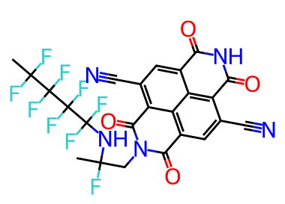  CC(F)(F)C(F)(F)C(F)(F)C(F)(F)NC(F)(C)CN1C(=O)c2cc(C#N)c3c4c(cc(C#N)c(c24)C1=O)C(=O)NC3=O | 3.52 | 8.47 | 3.90 | 2.67 | 3.01 | 4.41
48 | 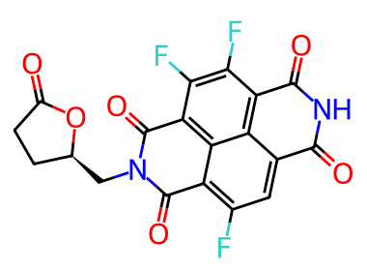  O=C1CC[C@H](CN2C(=O)c3c(F)cc4c5c(c(F)c(F)c(c35)C2=O)C(=O)NC4=O)O1 | 3.72 | 8.26 | 3.42 | 1.58 | 3.30 | 3.71
49* | 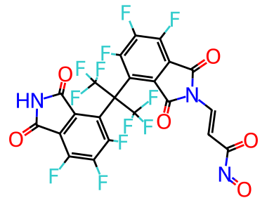  O=C(/C=C/N1C(=O)c2c(F)c(F)c(F)c(C(c3c(F)c(F)c(F)c4c3C(=O)NC4=O)(C(F)(F)F)C(F)(F)F)c2C1=O)N=O | 4.33 | 8.83 | 3.33 | 4.47 | 3.38 | 4.14
50 | 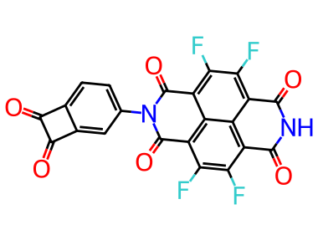  O=C1C(=O)c2cc(N3C(=O)c4c(F)c(F)c5c6c(c(F)c(F)c(c46)C3=O)C(=O)NC5=O)ccc21 | 3.54 | 8.12 | 3.47 | 3.62 | 3.05 | 3.28
* Note that No. 3 contains a β-lactone or α,β-epoxy ketone ring (oxetanone), which is a reactive electrophilic motif (Michael acceptor / ring-opening electrophile); candidates No. 4 and No. 11 contain acyl-peroxide-type N-substituents, which are known to undergo facile homolytic O–O bond cleavage under thermal or photochemical conditions and are among the least synthetically viable motifs for polymer building blocks; candidates No. 34 and No. 49 contain nitroso (N=O) substituents, which are thermally and photochemically labile.

Table S3. Literature data used for the IP-EA comparison in Figure 7. DFT-derived, electrochemical, and photoelectron-derived values are not directly interchangeable; cyclic-voltammetry-derived (CV-derived) values can differ systematically from ΔSCF-DFT values because of reference-electrode calibration, solvation, solid-state polarization, and reorganization effects.
Entry | Category | Material / system | EA (eV) | IP (eV) | Data definition / method | In Fig. 7 | Ref
1 | PI | PMDA-SPI-1unit | 3.66 | 6.68 | DFT-derived; I = -EHOMO, A = -ELUMO | Gray point | [1]
2 | PI | PMDA-SPI-3unit | 4.31 | 6.96 | DFT-derived; I = -EHOMO, A = -ELUMO | Gray point | [1]
3 | PI | PMDA-SPI-5unit | 4.33 | 6.94 | DFT-derived; I = -EHOMO, A = -ELUMO | Gray point | [1]
4 | PI | SPI-1unit-alt | 4.02 | 6.16 | DFT-derived; I = -EHOMO, A = -ELUMO | Gray point | [2]
5 | PI | SPI-3unit-alt | 3.73 | 6.33 | DFT-derived; I = -EHOMO, A = -ELUMO | Gray point | [2]
6 | PI | SPIx-1unit | 3.13 | 5.85 | DFT-derived; I = -EHOMO, A = -ELUMO | Gray point | [3]
7 | PI | SPIx-3unit | 3.01 | 5.86 | DFT-derived; I = -EHOMO, A = -ELUMO | Gray point | [3]
8 | PI | PMDA-DZ | 3.33 | 6.37 | DFT-derived; I = -EHOMO, A = -ELUMO | Gray point | [4]
9 | PI | PMDA-ODA | 3.3 | 6.23 | DFT-derived; I = -EHOMO, A = -ELUMO | Gray point | [4]
10 | PI | PMDA-APB | 3.27 | 6.03 | DFT-derived; I = -EHOMO, A = -ELUMO | Gray point | [4]
11 | PI | PMDA-TFMB | 3.5 | 7.15 | DFT-derived; I = -EHOMO, A = -ELUMO | Gray point | [4]
12 | PI | PMDA-6FAB | 3.63 | 6.91 | DFT-derived; I = -EHOMO, A = -ELUMO | Gray point | [4]
13 | PI | PMDA-6FAPB | 3.52 | 6.46 | DFT-derived; I = -EHOMO, A = -ELUMO | Gray point | [4]
14 | PI | CHDA-DZ | 1.35 | 6.34 | DFT-derived; I = -EHOMO, A = -ELUMO | Gray point | [4]
15 | PI | PMDA-ODA | 3.94 | 6.21 | DFT-derived; IP = −EHOMO, EA = −ELUMO | Gray point | [5]
16 | PI | BPDA-ODA-m | 3.51 | 6.1 | DFT-derived; IP = −EHOMO, EA = −ELUMO | Gray point | [5]
17 | PI | BPDA-ODA-p | 3.57 | 6.12 | DFT-derived; IP = −EHOMO, EA = −ELUMO | Gray point | [5]
18 | PI | BPDA-ODA-t | 3.53 | 6.11 | DFT-derived; IP = −EHOMO, EA = −ELUMO | Gray point | [5]
19 | PI | ODPA-ODA-m | 3.26 | 6.09 | DFT-derived; IP = −EHOMO, EA = −ELUMO | Gray point | [5]
20 | PI | ODPA-ODA-uu | 3.33 | 5.87 | DFT-derived; IP = −EHOMO, EA = −ELUMO | Gray point | [5]
21 | PI | ODPA-ODA-ud | 3.28 | 6.09 | DFT-derived; IP = −EHOMO, EA = −ELUMO | Gray point | [5]
22 | PI | BTDA-ODA-m | 3.8 | 6.17 | DFT-derived; IP = −EHOMO, EA = −ELUMO | Gray point | [5]
23 | PI | BTDA-ODA-uu | 3.82 | 6.13 | DFT-derived; IP = −EHOMO, EA = −ELUMO | Gray point | [5]
24 | PI | BTDA-ODA-ud | 3.77 | 6.21 | DFT-derived; IP = −EHOMO, EA = −ELUMO | Gray point | [5]
25 | PI | TPF27OPI | 2.61 | 5.9 | DFT-derived; IP = −EHOMO, EA = −ELUMO | Gray point | [6]
26 | PI | TPF99OPI | 2.53 | 5.96 | DFT-derived; IP = −EHOMO, EA = −ELUMO | Gray point | [6]
27 | PI | P1-film | 3.63 | 5.53 | Electrochemically derived; IP from oxidation onset, EA from reduction onset | Gray point | [7]
28 | PI | P2-film | 3.7 | 5.71 | Electrochemically derived; IP from oxidation onset, EA from reduction onset | Gray point | [7]
29 | PI | P3-film | 3.67 | 5.49 | Electrochemically derived; IP from oxidation onset, EA from reduction onset | Gray point | [7]
30 | PI | API-1unit | 3.71 | 5.76 | DFT-derived; IP = −EHOMO, EA = −ELUMO | Gray point | [8]
31 | PI | API-3unit | 3.75 | 5.76 | DFT-derived; IP = −EHOMO, EA = −ELUMO | Gray point | [8]
32 | n-type | Pyridinium-P1 | 4 | 6.56 | CV-derived; EA from onset reduction potential; IP = EA + optical gap | Blue point | [9]
33 | n-type | Pyridinium-P2 | 3.9 | 6.85 | CV-derived; EA from onset reduction potential; IP = EA + optical gap | Blue point | [9]
34 | n-type | Pyridinium-P3 | 4.14 | 6.3 | CV-derived; EA from onset reduction potential; IP = EA + optical gap | Blue point | [9]
35 | n-type | Poly(iI) | 3.84 | 5.54 | HOMO/LUMO-derived; IP = −EHOMO, EA = −ELUMO | Blue point | [10]
36 | n-type | Poly(iI-BTD) | 3.9 | 5.67 | HOMO/LUMO-derived; IP = −EHOMO, EA = −ELUMO | Blue point | [10]
37 | n-type | P-0 | 4.09 | 5.21 | PESA/CV-derived IP with optical-gap-derived EA (reported by original work) | Blue point | [11]
38 | n-type | P-50 | 4.3 | 5.29 | PESA/CV-derived IP with optical-gap-derived EA (reported by original work) | Blue point | [11]
39 | n-type | P-75 | 4.37 | 5.3 | PESA/CV-derived IP with optical-gap-derived EA (reported by original work) | Blue point | [11]
40 | n-type | PF1CVTP | 3.36 | 5.93 | HOMO/LUMO-derived; IP = −EHOMO, EA = −ELUMO | Blue point | [12]
41 | n-type | PF2CVTP | 3.77 | 5.72 | HOMO/LUMO-derived; IP = −EHOMO, EA = −ELUMO | Blue point | [12]
42 | n-type | NDI-1TH | 3.97 | 6.06 | Electrochemically derived; IP from oxidation onset, EA from reduction onset | Blue point | [13]
43 | n-type | NDI-2TH | 4.03 | 5.71 | Electrochemically derived; IP from oxidation onset, EA from reduction onset | Blue point | [13]
44 | n-type | NDI-3TH | 4.05 | 5.53 | Electrochemically derived; IP from oxidation onset, EA from reduction onset | Blue point | [13]
45 | n-type | NDI-4TH | 4.13 | 5.46 | Electrochemically derived; IP from oxidation onset, EA from reduction onset | Blue point | [13]
46 | n-type | NDI-2T | 4.12 | 5.83 | Electrochemically derived; IP from oxidation onset, EA from reduction onset | Blue point | [13]
47 | n-type | NDI-3T | 4.14 | 5.6 | Electrochemically derived; IP from oxidation onset, EA from reduction onset | Blue point | [13]
48 | n-type | Fused-P1 | 4.68 | 5.65 | Literature-reported IP/EA from original energy-level analysis | Blue point | [14]
49 | n-type | Fused-P2 | 4.68 | 5.64 | Literature-reported IP/EA from original energy-level analysis | Blue point | [14]
50 | n-type | Fused-P3 | 4.52 | 5.63 | Literature-reported IP/EA from original energy-level analysis | Blue point | [14]
51 | This work | Top-50 CRUs | 2.85-3.99 | 7.97-9.01 | DFT ΔSCF IP/EA; B3LYP/aug-cc-pVTZ with COSMO(benzene) | Red points | This work
52 | This work | Maximum-EA candidate / No.40 | 3.99 | 8.49 | DFT ΔSCF IP/EA; B3LYP/aug-cc-pVTZ with COSMO(benzene) | Highlighted red point | This work
53 | This work | Maximum-IP candidate / No.4 | 3.32 | 9.01 | DFT ΔSCF IP/EA; B3LYP/aug-cc-pVTZ with COSMO(benzene) | Highlighted red triangle | This work
* “PI” denotes “polyimide”; “n-type” denotes “n-type organic semiconductor”.

Table S4. The SMARTS strings corresponding to the top-20 fragments.
No. | Top-20 fragment frequency for the training set | Top-20 fragment frequency for the generated set
1 | *c1ccc(*)cc1 | *c1ccc(*)cc1
2 | *c1ccc2c(c1)C(=O)NC2=O | *c1ccc2c(c1)C(=O)NC2=O
3 | *c1ccc2c(c1)C(=O)N(*)C2=O | *c1ccc2c(c1)C(=O)N(*)C2=O
4 | *c1cccc(*)c1 | *c1cccc(*)c1
5 | *c1cccc2c1C(=O)N(*)C2=O | *c1cccc2c1C(=O)N(*)C2=O
6 | *N1C(=O)C2C3CC(C2C1=O)C1(CCC2(CC4CC2C2C(=O)NC(=O)C42)C1=O)C3 | *C1CC(=O)NC1=O
7 | *c1cccc2c1C(=O)NC2=O | *C1CC(=O)N(*)C1=O
8 | *C1CC(=O)N(*)C1=O | *c1cccc2c1C(=O)NC2=O
9 | *c1ccccc1* | *N1C(=O)C2C3CC(C2C1=O)C1(CCC2(CC4CC2C2C(=O)NC(=O)C42)C1=O)C3
10 | *C1CC(=O)NC1=O | *c1ccccc1*
11 | *C(*)(C)C | *CC(*)=O
12 | *c1ccc(*)c(*)c1 | *c1ccc(*)c(*)c1
13 | *c1ccc(*)c(C)c1 | *c1ccc(*)c(C)c1
14 | *c1ccc(*)nc1 | *c1ccc2c(c1)C1(c3ccccc3-2)c2cc3c(cc2-c2cc4c(cc21)C(=O)N(*)C4=O)C(=O)NC3=O
15 | *C(*)(C(F)(F)F)C(F)(F)F | *C1C(=O)N(*)C1=O
16 | *c1nonc1* | *C(*)(C(F)(F)F)C(F)(F)F
17 | *N1C(=O)C2C3CCC(C4C(=O)NC(=O)C34)C2C1=O | *N1C(=O)C2C3CCC(C4C(=O)NC(=O)C34)C2C1=O
18 | *c1cccc(*)n1 | *C1C(=O)NC1=O
19 | *c1ccc(C=*)cc1 | *C1CCC(*)CC1
20 | *c1nc2ccccc2o1 | *c1cc(*)cc(*)c1

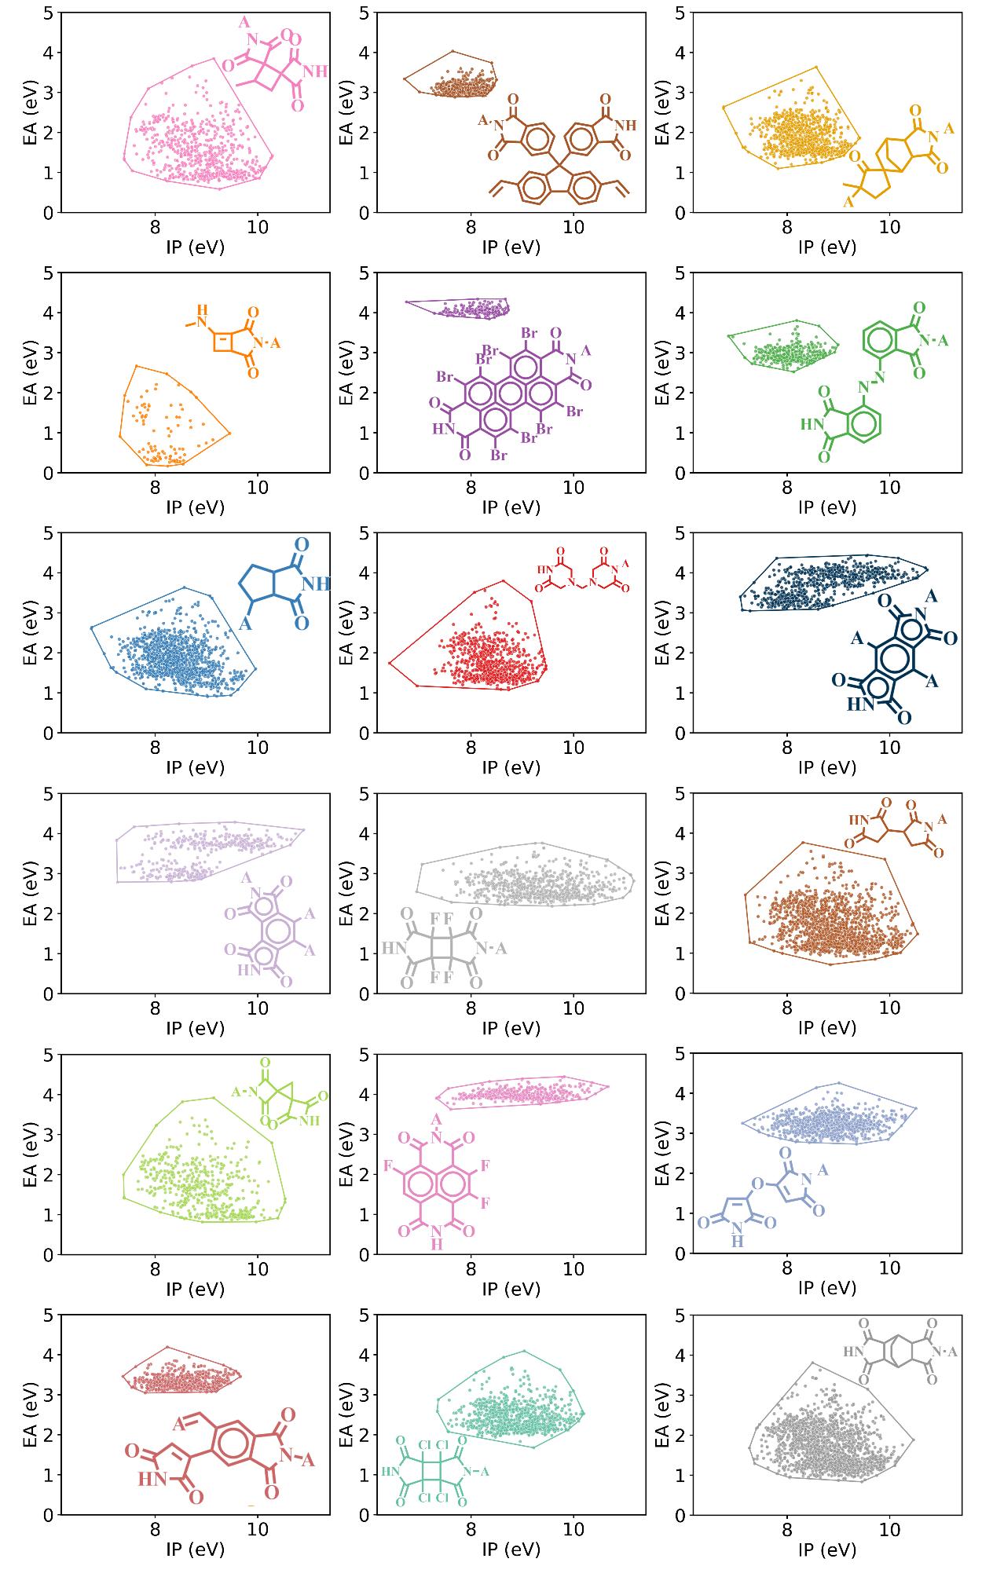
Figure S3. Fragment-wise distributions of ionization potential (IP) and electron affinity (EA) across the generated molecular library.

References:
1. U. Yildiko and A.A. Tanriverdi, Synthesis and characterization of pyromellitic dianhydride based sulfonated polyimide: Survey of structure properties with DFT and QTAIM. Journal of Polymer Research 2021, 29(1), 19.
2. U. Yildiko and A.A. Tanriverdi, A novel sulfonated aromatic polyimide synthesis and characterization: Energy calculations, QTAIM simulation study of the hydrated structure of one unit. Bulletin of the Korean Chemical Society 2022, 43(6), 822-835.
3. B. Kartal, A.A. Tanriverdi, U. Yildiko, et al., Polyimide synthesis and characterizations: DFT-assisted computational studies on structural units. Iranian Polymer Journal 2025, 34(7), 977-999.
4. Y. Ma, C. Hu, H. Guo, et al., Structure effect on transition mechanism of UV–visible absorption spectrum in polyimides: A density functional theory study. Polymer 2018, 148, 356-369.
5. J.-H. Park, A. Soon, and J.-H. Lee, A computational survey of metal-free polyimide-based photocatalysts within the single-stranded polymer model. Molecular Catalysis 2020, 497, 111184.
6. L. Qu, S. Huang, Y. Zhang, et al., Multi-functional polyimides containing tetraphenyl fluorene moieties: fluorescence and resistive switching behaviors. Journal of Materials Chemistry C 2017, 5(26), 6457-6466.
7. C.-P. Constantin, G. Lisa, and M.-D. Damaceanu, Assessing the Electrical Characteristics of p–n Heterojunction Prototype Diodes Realized with n-Type Polyimide Materials. Macromolecules 2021, 54(2), 941-957.
8. A.Ç. Ata, Ü. Yildiko, A.A. Tanriverdi, et al., Two-step novel aromatic polyimide synthesis and characterization: Survey of energy calculations and diode applications. Journal of Applied Polymer Science 2023, 140(14), e53689.
9. D. Izuhara and T.M. Swager, Poly(Pyridinium Phenylene)s: Water-Soluble N-Type Polymers. Journal of the American Chemical Society 2009, 131(49), 17724-17725.
10. R. Stalder, J. Mei, J. Subbiah, et al., n-Type Conjugated Polyisoindigos. Macromolecules 2011, 44(16), 6303-6310.
11. G. Ye, J. Liu, X. Qiu, et al., Controlling n-Type Molecular Doping via Regiochemistry and Polarity of Pendant Groups on Low Band Gap Donor–Acceptor Copolymers. Macromolecules 2021, 54(8), 3886-3896.
12. S.D. Chavhan, R.D. Abellon, A.J.J.M. van Breemen, et al., Sensitization of p-type NiO Using n-type Conducting Polymers. The Journal of Physical Chemistry C 2010, 114(45), 19496-19502.
13. E. Ahmed, G. Ren, F.S. Kim, et al., Design of New Electron Acceptor Materials for Organic Photovoltaics: Synthesis, Electron Transport, Photophysics, and Photovoltaic Properties of Oligothiophene-Functionalized Naphthalene Diimides. Chemistry of Materials 2011, 23(20), 4563-4577.
14. M. Alsufyani, R.K. Hallani, S. Wang, et al., The effect of aromatic ring size in electron deficient semiconducting polymers for n-type organic thermoelectrics. Journal of Materials Chemistry C 2020, 8(43), 15150-15157.

