Title: Development and pilot evaluation of an automated screening tool to support prioritised medication review in primary care patients with polypharmacy
Supplementary information
Table S1. Internal development workflow for the hospital admission risk component of VIGIA
Step | Description
Source population | Adults with polypharmacy registered in the Jerez Costa Noroeste and Sierra de Cádiz Health Management Area, identified from routinely collected healthcare data. Polypharmacy was defined as 15 or more active chronic medicines.
Development cohort | 1,607 eligible patients identified at the November 2019 cut-off date.
Outcome | At least one unplanned hospital admission during 2020. Admissions attributable to SARS-CoV-2 were excluded.
Outcome distribution | 143 patients with unplanned hospital admission and 1,464 patients without hospital admission.
Candidate predictors | Age, sex, total number of active chronic medicines and binary indicators for selected therapeutic groups recorded before the outcome period.
Predictor selection | Candidate pharmacological predictors were defined before model fitting, based on previous literature on hospital admission risk, medication-related harm and clinical relevance in patients with polypharmacy.
Modelling approaches | Logistic regression and random forest models were evaluated.
Class imbalance | The outcome was imbalanced, with admissions representing approximately 9% of the development cohort.
Balancing strategies | Three approaches were explored: no balancing, downsampling of the majority class and upsampling of the minority class.
Downsampling workflow | The majority class was randomly sampled in 100 replicates to match the number of admitted patients. Model performance was summarised as the mean and standard deviation across replicates.
Internal validation | Model performance was estimated using internal cross-validation within the development workflow. No external validation cohort was available.
Performance metrics | Accuracy, area under the receiver operating characteristic curve, sensitivity, specificity, positive predictive value, negative predictive value, false positive rate, false negative rate and false discovery rate.
Model selected for VIGIA | The random-forest model with downsampling was selected as the hospital admission risk component because it provided the most favourable balance between sensitivity and specificity among the approaches evaluated.
Interpretation | The model was incorporated into VIGIA as an internal prioritisation component. Performance estimates should be interpreted as internal development-stage results and not as evidence of external predictive validity.

Note: This table describes the internal development workflow for the hospital admission risk component of VIGIA. The model was developed to support patient prioritisation within the tool. Because no external validation cohort was available, model performance should be interpreted as internally derived and potentially optimistic. Quantitative model-performance estimates are reported in Table 2.

Table S2. Subgroup-specific evaluation items not pooled in Table 3
Evaluation item | Subgroup | n (%) | Note
Easy to use and rapid access to the tool | Pharmacists (n = 7) | 7 (100) | No access barriers reported
Easy to use and rapid access to the tool | Physicians (n = 6) | 2 (33.3) | Lack of integration with Diraya identified as the main barrier
Useful for improving prescribing quality | Physicians (n = 6) | 6 (100) | Item not included in pharmacist questionnaire
These results were not pooled in Table 3 because the ease-of-use and access item showed marked differences between professional subgroups, whereas the prescribing-quality item was included only in the physician questionnaire. Rapid access to the tool was the principal usability barrier identified by physicians in the pilot.

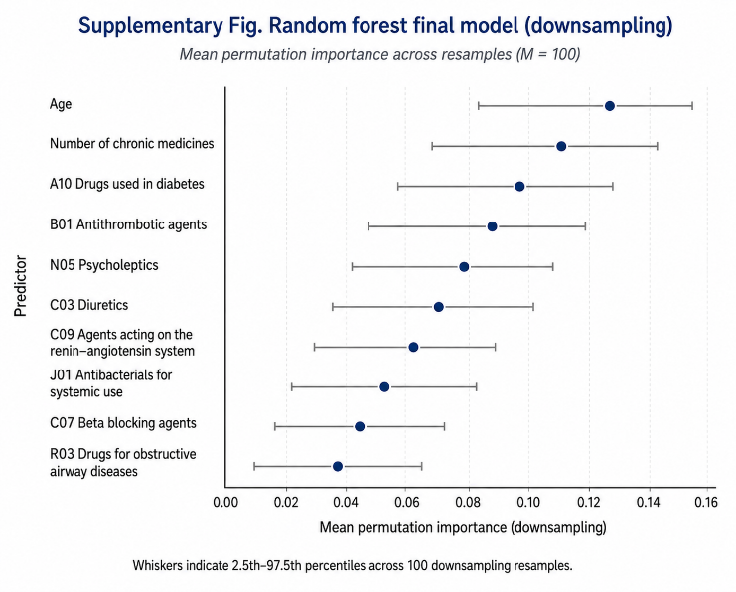

VIGIA professional evaluation and feedback questionnaire
The questionnaire was administered in Spanish; the English version below is provided for publication. It was used to assess healthcare professionals’ perceptions of the usefulness and usability of VIGIA and to elicit suggestions for improvement. VIGIA is a web-based clinical decision support tool designed to support prioritised medication review in patients with polypharmacy. Unless otherwise stated, response options were Yes/No.
Primary care physicians
No. | Item | Response option
1 | Did you find the system used to notify you about patients with medication review reports awaiting assessment useful and efficient? | Yes / No
1a | If the communication process was not satisfactory, what do you think were the reasons? | Open-ended response (if No)
2 | VIGIA simplified decision-making about whether reducing the number of medicines was appropriate in patients with polypharmacy. | Yes / No
3 | VIGIA saved me consultation time when deciding whether reducing the number of medicines was appropriate in patients with polypharmacy. | Yes / No
4 | VIGIA was easy to use and could be accessed quickly. | Yes / No
5 | It was easy to learn how to use VIGIA, and its visual display was easy to interpret. | Yes / No
6 | VIGIA was a useful tool for improving prescribing quality in patients with polypharmacy. | Yes / No
7 | I would use VIGIA again to support the management of patients with polypharmacy. | Yes / No
8 | I felt able to resolve questions arising in the management of patients with polypharmacy by using VIGIA. | Yes / No
9 | Using VIGIA increased my confidence when making decisions about the management of patients with polypharmacy. | Yes / No
10 | I found VIGIA practical for managing patients with polypharmacy, and it saved consultation time. | Yes / No
11 | What did you like most about VIGIA? | Open-ended response
12 | What improvements would you suggest for VIGIA? | Open-ended response

Primary care pharmacists
No. | Item | Response option
1 | Did you find the system used to notify physicians about patients with medication review reports awaiting assessment useful and efficient? | Yes / No
1a | If the communication process was not satisfactory, what do you think were the reasons? | Open-ended response (if No)
2 | VIGIA simplified decision-making when formulating recommendations for medication review reports for patients with polypharmacy. | Yes / No
3 | VIGIA saved me time when reviewing medication and preparing medication review reports for patients with polypharmacy. | Yes / No
4 | VIGIA was easy to use and could be accessed quickly. | Yes / No
5 | It was easy to learn how to use VIGIA, and its visual display was easy to interpret. | Yes / No
6 | I would use VIGIA again to conduct medication reviews in patients with polypharmacy. | Yes / No
7 | I felt able to resolve questions arising during medication review in patients with polypharmacy by using VIGIA. | Yes / No
8 | Using VIGIA increased my confidence when making decisions during medication review in patients with polypharmacy. | Yes / No
9 | I found VIGIA practical for conducting medication reviews in patients with polypharmacy, and it saved time during the review process. | Yes / No
10 | What did you like most about VIGIA? | Open-ended response
11 | What improvements would you suggest for VIGIA? | Open-ended response

Question domains

Table S3. Questionnaire domains and corresponding items
Domain | Physician questionnaire | Pharmacist questionnaire
Ease of use | Q4: ease of use and rapid access; Q5: ease of learning and visual interpretability | Q4: ease of use and rapid access; Q5: ease of learning and visual interpretability
Perceived usefulness and workflow support | Q1: notification and communication; Q2: decision-making support; Q3: time saving; Q6: perceived prescribing quality; Q7: intention to reuse; Q8: resolution of questions; Q9: confidence in decision-making; Q10: practicality and time saving | Q1: notification and communication; Q2: decision-making support; Q3: time saving; Q6: intention to reuse; Q7: resolution of questions; Q8: confidence in decision-making; Q9: practicality and time saving
Open-ended feedback | Q1a: reasons for unsatisfactory communication; Q11: most valued aspects; Q12: suggested improvements | Q1a: reasons for unsatisfactory communication; Q10: most valued aspects; Q11: suggested improvements
The domains were used only to organise the questionnaire content descriptively and were not intended as validated subscales. No composite domain scores were calculated. The wording of conceptually equivalent items was adapted to the respective professional role.

