Supplementary Information

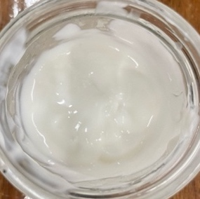
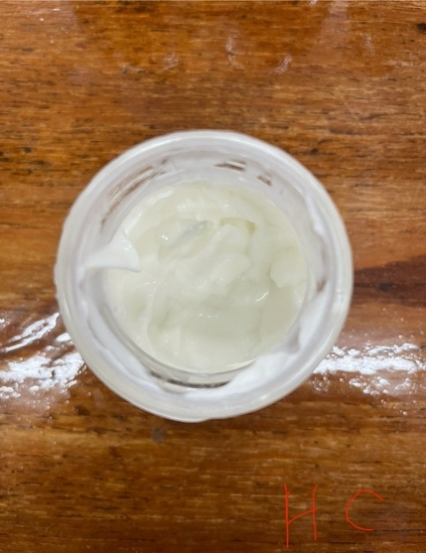
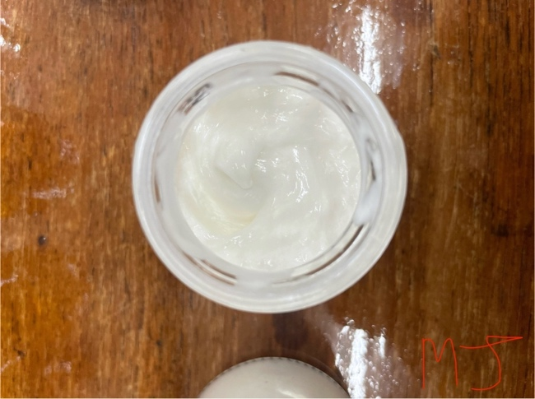
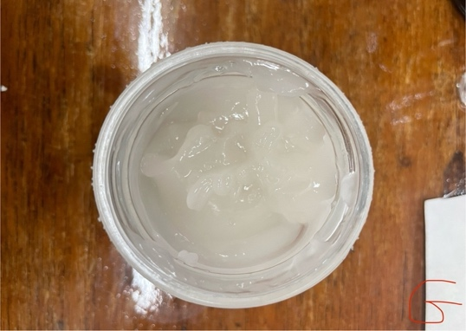
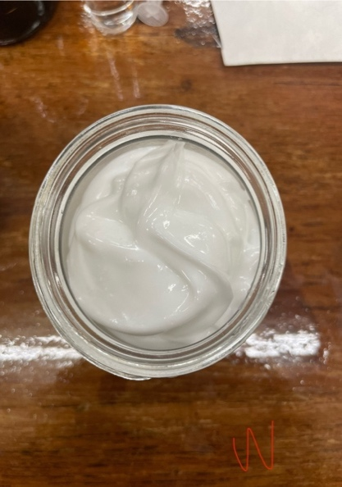
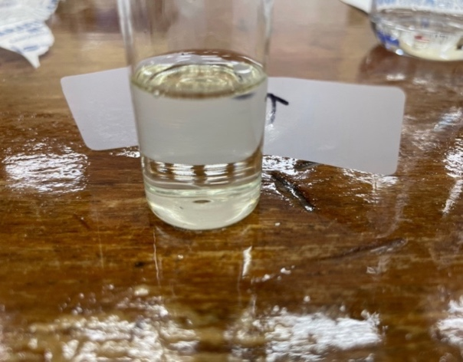
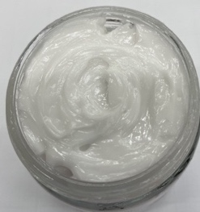
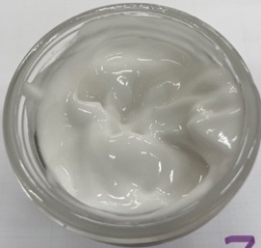
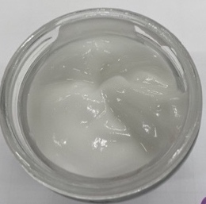
1
2
3
4
5
6
7
8
9

Figure S1. Photographic images of commercially available (1) Body Lotion, (2) Hand Cream, (3) MJ Cream, (4) Gel, (5) Tissue oil and extemporaneously prepared (6) aqueous cream, (7) 0% w/w Aerosil® R974, 0.4 % w/w ViscOptima® SE, (8) 0.8% w/w Aerosil® R974, 0.4 % w/w ViscOptima®SE, and (9) 4.5% w/w Aerosil® R974

Figure S2. Percent % change in CBD concentration (µg/ml ± SD) for extemporaneously prepared aqueous cream and o/w emulsions under the storage conditions away from light at room temperature (22°C) (dark RT) for 12 weeks (n =3) different lowercase letters indicating significant differences (p < 0.05) between different samples

Figure S3. Percent % change in CBD concentration (µg/ml ± SD) for extemporaneously prepared aqueous cream and o/w emulsions under the storage conditions light exposure at room temperature (22°C) (light RT) for 12 weeks (n =3) different lowercase letters indicating significant differences (p < 0.05) between different samples

a

Figure S4. Percent % change in CBD concentration (µg/ml ± SD) for extemporaneously prepared aqueous cream and o/w emulsions under the storage conditions away from light at 37°C (dark 37°C) for 12 weeks (n =3) different lowercase letters indicating significant differences (p < 0.05) between different samples

