Supplementary Materials

Because clinical decisions must integrate the entire CT examination rather than rely on individual slices, each patient’s multiple slice-level prediction probabilities were consolidated into a single patient-level score. To identify the most robust and clinically reliable fusion method, we investigated six aggregation strategies—median, mean, min, max, median + IQR, and mean + SD. The final ensemble model based on the “Min” aggregation strategy was selected because it achieved the highest AUC (0.952) among all tested fusion variants while maintaining competitive AIC and BIC values (42.95 and 47.26, respectively). This indicates that, despite its superior discrimination performance, the model does not incur additional overfitting penalties and preserves a favorable balance between goodness-of-fit and model complexity.

Table S1. Performance comparison of different fusion strategies for predicting treatment strategies.
Method | AUC_CT | AUC_Clincal | AUC_Ensemble | Log-likelihood | AIC | BIC | Formula
Mean | 0.754 | 0.947 | 0.939 | -18.20 | 42.39 | 46.69 | 0.92*DL_prob + 0.08*ML_proba -1.23
Median | 0.781 | 0.947 | 0.934 | -18.09 | 42.17 | 46.47 | 0.97*DL_prob + 1.19*ML_proba -1.23
Mean + SD | 0.754 | 0.947 | 0.939 | -18.19 | 44.38 | 50.12 | 0.92*DL_proba + 0.08*DL_std + 1.19*ML_proba - 1.22
Median + IQR | 0.781 | 0.947 | 0.934 | -18.09 | 44.17 | 49.91 | 0.98*DL_proba + 0.02*DL_iqr + 1.19*ML_prob - 1.23
Max | 0.733 | 0.947 | 0.899 | -18.04 | 42.09 | 46.40 | 0.98*DL_prob + 1.18*ML_proba - 1.28
Min | 0.759 | 0.947 | 0.952 | -18.48 | 42.95 | 47.26 | 0.77*DL_prob + 1.21*ML_proba -1.17

Table S2. Comparison of CT image-level deep learning model performance for the treatment strategy classification using three image input types.
Image input type | Model |  | AUC | AUPRC | SEN | SEP | PPV | NPV | F1 | MCC
Whole CT |  | ResNet-18 | 0.721  (0.636-0.805) | 0.648  (0.523-0.767) | 0.509  (0.381-0.647) | 0.918  (0.860-0.967) | 0.778  (0.634-0.903) | 0.767  (0.685-0.841) | 0.615  (0.487-0.726) | 0.482  (0.334-0.622)
 |  | ResNet-101 | 0.769  (0.693-0.842) | 0.612  (0.496-0.756) | 0.909  (0.830-0.980) | 0.588  (0.490-0.694) | 0.556  (0.456-0.663) | 0.919  (0.847-0.982) | 0.690  (0.599-0.774) | 0.486  (0.356-0.605)
 |  | DenseNet | 0.745  (0.659-0.822) | 0.685  (0.560-0.786) | 0.527  (0.400-0.656) | 0.856  (0.781-0.926) | 0.674  (0.528-0.816) | 0.761  (0.676-0.838) | 0.592  (0.467-0.703) | 0.409  (0.251-0.557)
 |  | Swin Transformer | 0.788  (0.714-0.858) | 0.647  (0.516-0.774) | 0.873  (0.778-0.949) | 0.629  (0.533-0.720) | 0.571  (0.464-0.675) | 0.897  (0.823-0.961) | 0.691  (0.600-0.771) | 0.485  (0.361-0.598)
 |  | CNN | 0.678  (0.584-0.771) | 0.462  (0.360-0.602) | 0.891  (0.805-0.963) | 0.536  (0.435-0.633) | 0.521  (0.411-0.627) | 0.897  (0.810-0.966) | 0.658  (0.556-0.747) | 0.422  (0.290-0.551)
Liver region |  | ResNet-18 | 0.791  (0.709-0.866) | 0.725  (0.613-0.831) | 0.636  (0.509-0.755) | 0.856  (0.781-0.920) | 0.714  (0.580-0.833) | 0.806  (0.724-0.878) | 0.673  (0.562-0.765) | 0.506  (0.351-0.649)
 |  | ResNet-101 | 0.759  (0.678-0.832) | 0.616  (0.482-0.745) | 0.782  (0.673-0.880) | 0.711  (0.619-0.794) | 0.606  (0.492-0.711) | 0.852  (0.770-0.921) | 0.683  (0.585-0.767) | 0.475  (0.338-0.598)
 |  | DenseNet | 0.750  (0.668-0.820) | 0.610  (0.480-0.752) | 0.782  (0.661-0.879) | 0.588  (0.486-0.682) | 0.518  (0.414-0.630) | 0.826  (0.727-0.909) | 0.623  (0.520-0.711) | 0.357  (0.211-0.487)
 |  | Swin Transformer | 0.785  (0.710-0.858) | 0.651  (0.527-0.774) | 0.836  (0.741-0.929) | 0.732  (0.637-0.814) | 0.639  (0.525-0.750) | 0.887  (0.816-0.951) | 0.724  (0.633-0.809) | 0.547  (0.420-0.674)
 |  | CNN | 0.743  (0.651-0.820) | 0.698  (0.578-0.806) | 0.691  (0.571-0.804) | 0.784  (0.694-0.853) | 0.644  (0.518-0.761) | 0.817  (0.733-0.890) | 0.667  (0.565-0.750) | 0.468  (0.320-0.595)
Liver trauma region |  | ResNet-18 | 0.739  (0.645-0.826) | 0.659  (0.526-0.783) | 0.545  (0.421-0.685) | 0.928  (0.875-0.977) | 0.811  (0.679-0.935) | 0.783  (0.708-0.856) | 0.652  (0.537-0.755) | 0.530  (0.395-0.666)
 |  | ResNet-101 | 0.746  (0.664-0.825) | 0.634  (0.524-0.754) | 0.727 (0.610-0.839) | 0.722  (0.636-0.804) | 0.597  (0.480-0.712) | 0.824  (0.736-0.898) | 0.656  (0.550-0.743) | 0.435  (0.289-0.573)
 |  | DenseNet | 0.771  (0.687-0.850) | 0.695  (0.575-0.805) | 0.727  (0.609-0.846) | 0.794  (0.710-0.875) | 0.667  (0.547-0.788) | 0.837  (0.764-0.914) | 0.696  (0.586-0.787) | 0.512  (0.365-0.644)
 |  | Swin Transformer | 0.676  (0.589-0.764) | 0.501  (0.388-0.649) | 0.473  (0.344-0.600) | 0.825  (0.747-0.903) | 0.605  (0.450-0.755) | 0.734  (0.651-0.814) | 0.531  (0.404-0.643) | 0.317  (0.159-0.476)
 |  | CNN | 0.767  (0.675-0.850) | 0.773  (0.678-0.855) | 0.600  (0.478-0.714) | 0.959  (0.920-0.990) | 0.892  (0.786-0.975) | 0.809  (0.733-0.878) | 0.717  (0.610-0.809) | 0.626  (0.508-0.743)

Table S3. Comparison of clinical data machin learning model performance for the treatment strategy classification using full features.
Model | AUC | AUPRC | SEN | SEP | PPV | NPV | F1 | MCC
SVC | 0.759  (0.539-0.926) | 0.600  (0.379-0.914) | 0.750  (0.467-1.000) | 0.842  (0.667-1.000) | 0.750  (0.462-1.000) | 0.842  (0.650-1.000) | 0.750  (0.500-0.900) | 0.592  (0.272-0.852)
GaussianNB | 0.789  (0.568-0.957) | 0.636  (0.397-0.948) | 0.833  (0.600-1.000) | 0.842  (0.667-1.000) | 0.769  (0.500-1.000) | 0.889  (0.714-1.000) | 0.800  (0.571-0.941) | 0.667  (0.367-0.879)
AdaBoost | 0.846  (0.682-0.973) | 0.709  (0.469-0.964) | 0.917  (0.714-1.000) | 0.737  (0.524-0.923) | 0.688  (0.429-0.909) | 0.933  (0.769-1.000) | 0.786  (0.571-0.929) | 0.637  (0.361-0.873)
GradientBoost | 0.732  (0.533-0.893) | 0.647  (0.376-0.880) | 0.917  (0.727-1.000) | 0.579  (0.333-0.800) | 0.579  (0.350-0.818) | 0.917  (0.750-1.000) | 0.710  (0.483-0.878) | 0.496  (0.216-0.760)
XGBoost | 0.803  (0.615-0.947) | 0.650  (0.412-0.931) | 1.000  (1.000-1.000) | 0.632  (0.409-0.850) | 0.632  (0.400-0.850) | 1.000  (1.000-1.000) | 0.774  (0.571-0.919) | 0.632  (0.437-0.824)

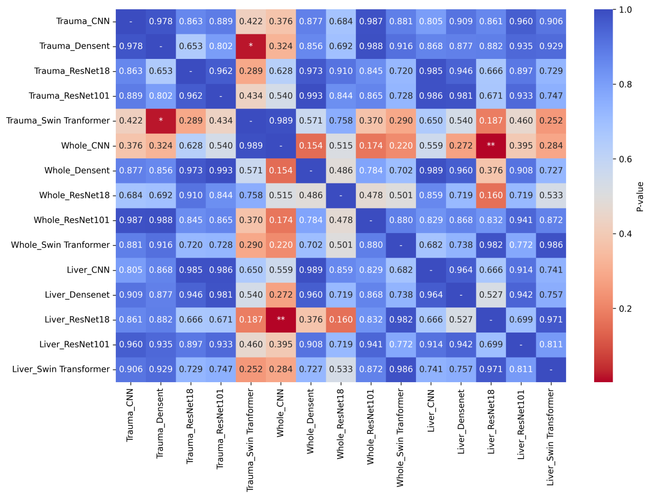
Figure S4. Saliency matrix among image-level deep learning models trained on CT images, where Trauma, Liver, and Whole denote models using the liver-trauma region, the liver region, and the entire CT image as inputs, respectively.
*p<0.05, **p<0.01, ***p<0.001.

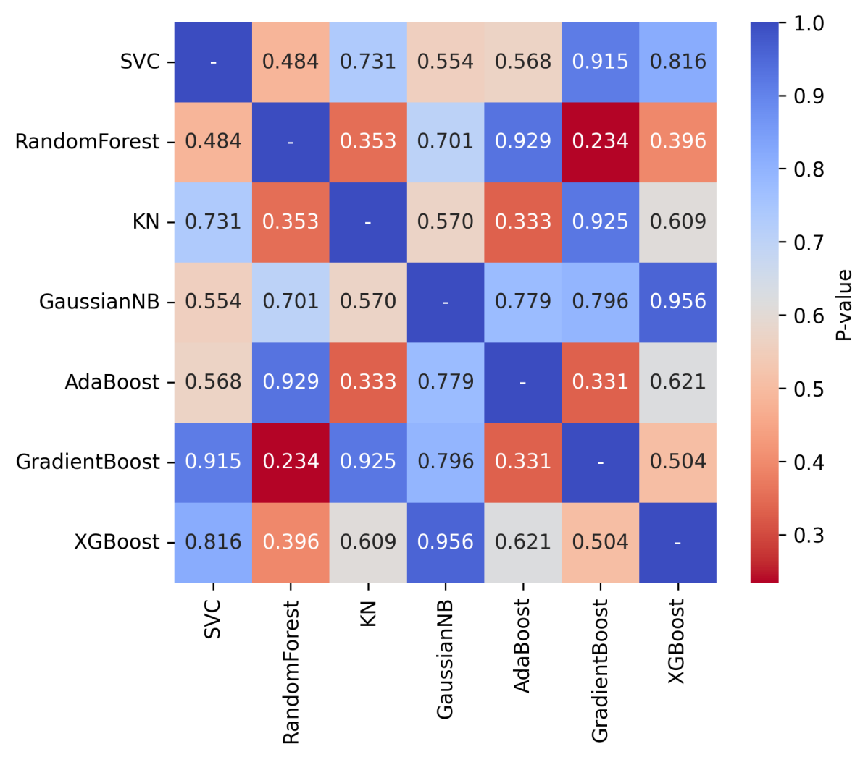
Figure S5. Saliency matrix among machine learning models trained on all clinical features.

