Dual-Function Metal–Organic Framework for Enhanced Fuel Efficiency in Composite Solid Propellants: Metal-Coordinated Catalytic Sites and Linker-Derived Polymeric Additive in Ammonium Perchlorate Decomposition
Muhammad Amjad Majeed^{1,a,b}, Farhan Ahmad^{d}, Jie Wangª, Aifeng Jiang^{c}, Jianyong Xu,*, Wenchao Zhang,*, Yanchun Li,*

ª School of Chemical Engineering, Nanjing University of Science and Technology, Nanjing, 210094, China.
^{b} College of Materials and Chemistry & Chemical Engineering, Chengdu University of Technology, l#, Dongsanlu, Erxianqiao, Chengdu 610059, Sichuan, P. R. China
^{c} Southwest Technology and Engineering Research Institute, Chongqing 400039, China
^{d} Department of Chemical Engineering, University of Engineering and Technology, Lahore 54890, Pakistan.

*Corresponding author: Wenchao Zhang
E-mail address: zhangwenchao@njust.edu.cn (W.C. Zhang)
Tel: +86 25 84315515 Fax: +86 25 84315857
Supporting Information (SI)
This manuscript Supporting Information comprises one table and ten figures that complement the structural, morphological, and catalytic performance characterization of the MOFs, MOF-derived metal oxides (MDOs), and their AP composites. Table S1 compiles a literature comparison of MOF‑catalyzed ammonium perchlorate thermal decomposition metrics. Figure S1 presents XRD patterns of the MDOs (CuO, NiO, ZnO, Co₃O₄). Figure S2 displays typical SEM images of the MDOs and the corresponding 2 wt.% MDO/98% AP composites. Figure S3 provides SEM‑EDS elemental mapping (Co, Zn, Cu, Ni, O, N, C, Cl) for the AP/MOF composites. Figure S4 shows the EDX spectra of the as‑synthesized MOFs. Figure S5 contains the N₂ adsorption/desorption isotherms of the double‑linker Zn-MOF-II and all MDOs. Figures S6 and S7 report the XPS survey spectra and high‑resolution peak fits (M 2p, N 1s, O 1s, C 1s, Cl 2p) for the AP/MOF composites and the MDOs, respectively. Figure S8 presents the MOF thermal stability with respect to their thermal analysis curves (DSC-DDSC) and TG-DTG, and S9 presents the TG‑DSC curves of the 2 wt.% MDO/AP mixtures. Figure S10 displays the quadrupole mass spectrometry profiles of evolved gas species (m/z) during decomposition of pure AP and selected composite samples. Figure S11 provides the combustion pressure–time traces for all 2% MOF/AP and 2% MDO/AP composites.

The MOF‑catalyzed thermal decomposition performance of ammonium perchlorate comparison with this work is presented in table S1.
Table S1. Comparison of MOF‑Catalyzed Thermal Decomposition Performance of Ammonium Perchlorate from the Cited Literature
No. | MOF | Metal Node(s) | Organic Linker(s) | HTD  (°C) | Heat Release (J·g⁻¹) | Apparent  E_{a} (kJ·mol⁻¹) | Ref.
1 | Co-MOF-I | Co²⁺ | 2-Methylimidazole | 327 | 1995 | 160 | This Work
2 | Zn-MOF-I | Zn²⁺ | 2-Methylimidazole | 365 | 1894 | 150 | This Work
3 | Zn-MOF-II | Zn²⁺ | Terephthalic acid (BDC)  Triethylene diamine (DABCO) | 354 | 1870 | 185 | This Work
4 | Cu-MOF-II | Cu²⁺ | Terephthalic acid (BDC)  Triethylene diamine (DABCO) | 345 | 1855 | 142 | This Work
5 | Ni-MOF-II | Ni²⁺ | Terephthalic acid (BDC)  Triethylene diamine (DABCO) | 386 | 1030 | 151
6 | Cu‑MOF/GO | Cu²⁺ | Trimesic acid (BTC) | 317.2 | 1553 | – | [1]
7 | GO@MOF‑5 | Zn²⁺ | Terephthalic acid (BDC) | 306.5 | 1559 | – | [2]
8 | 3D Cu MOF | Cu²⁺ | 1,2,4‑Triazole, malate, fumarate | 318 | 1460 | – | [3]
9 | ZnCo‑ZIF | Zn²⁺/Co²⁺ | 2‑Methylimidazole | 317.6 | 1922 | 134.5 | [4]
10 | Prussian blue | Fe²⁺/Fe³⁺ | Cyanide (–CN–) | 305.8 | 2022 | 124.5 | [5]
11 | AP@GO/Cu‑MOF | Cu²⁺ | Trimesic acid (BTC) | 310.2 | 1489 | – | [6]
12 | AZTO-Cu-4H2O  AOTO-Cu-4H2O  Energetic MOF | Cu²⁺ | Hydrazide‑,3‑amino‑1,2,4‑ oxadiazole‑substituted hydroxytetrazole | 315.1  302.5 | – | 72  125 | [7]
13 | Ce‑MOF | Ce⁴⁺ | Carboxylate‑based (BDC) | 361.5 | – | – | [8]

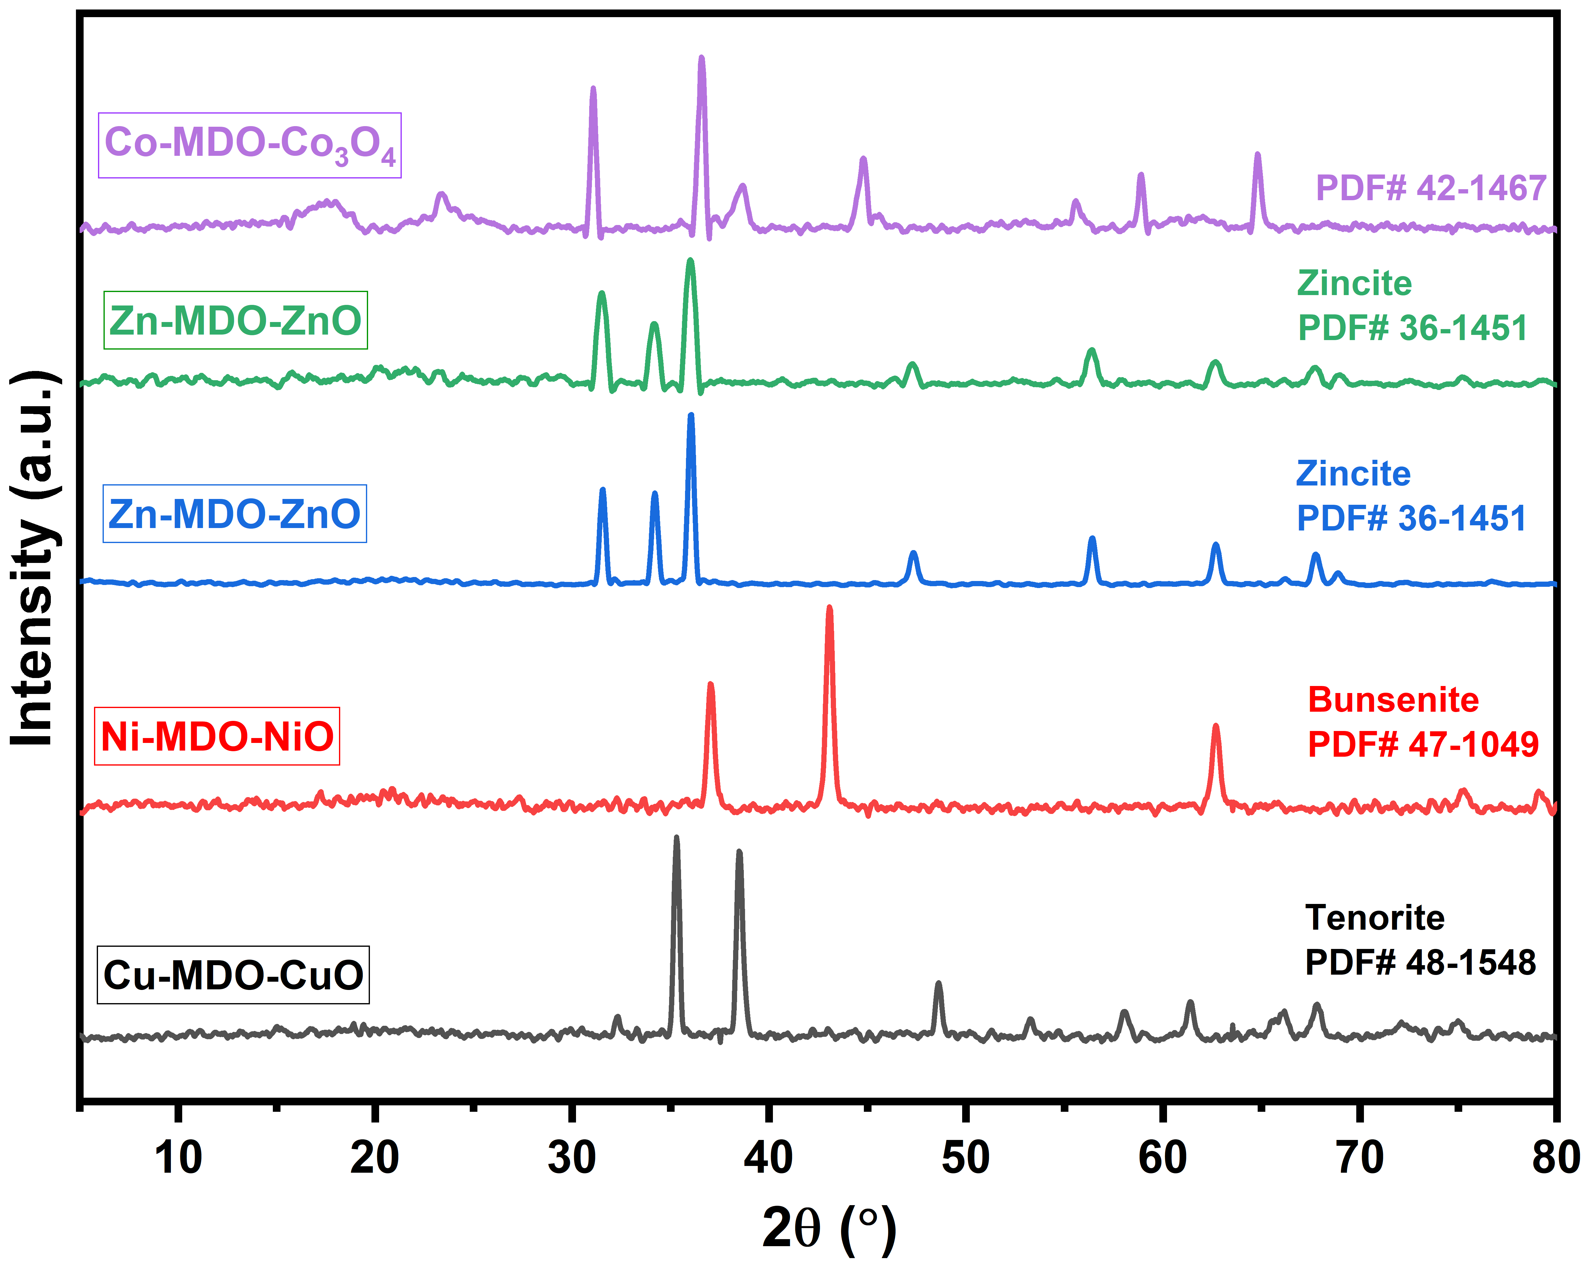
Figure S1. The XRD patterns of MOF Derived Oxide (CuO, NiO, ZnO, Co₃O₄)

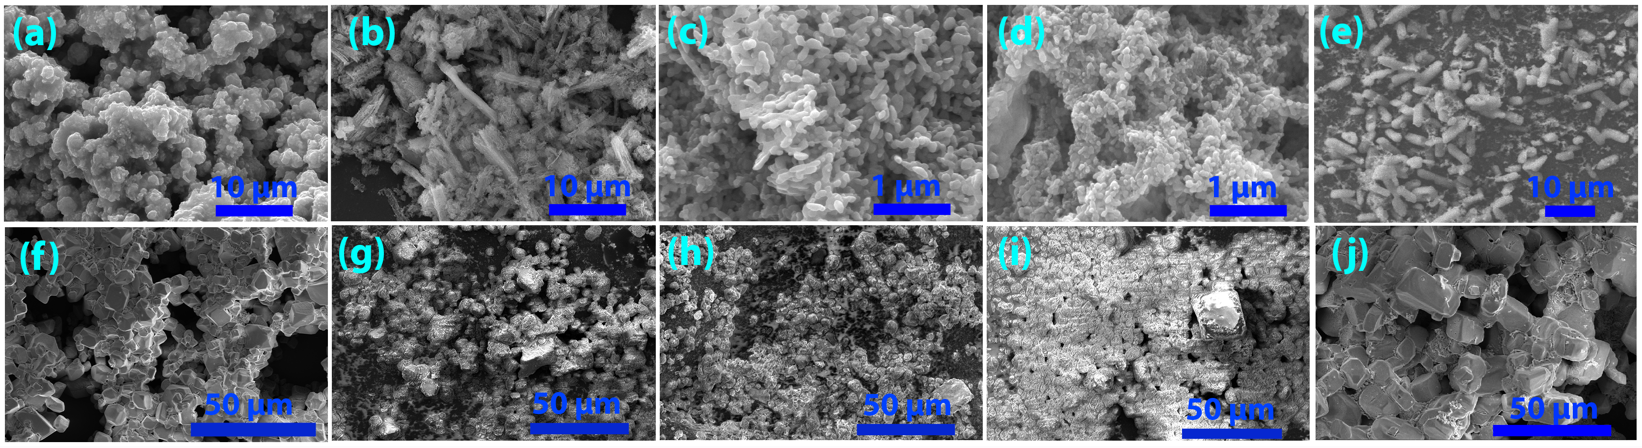
Figure S2. Typical SEM images of MOF derived metal oxides (MDO) and 2%MDO/98%AP composites (a) CuO, (b) NiO, (c) ZnO from Zn-MOF-I, (d) Co₃O₄, (e) ZnO from Zn-MOF-II, (f) CuO/AP, (g) NiO/AP, (h) ZnO (from Zn-MOF-I)/AP, (i) Co₃O₄/AP, (j) ZnO (from Zn-MOF-II/AP)

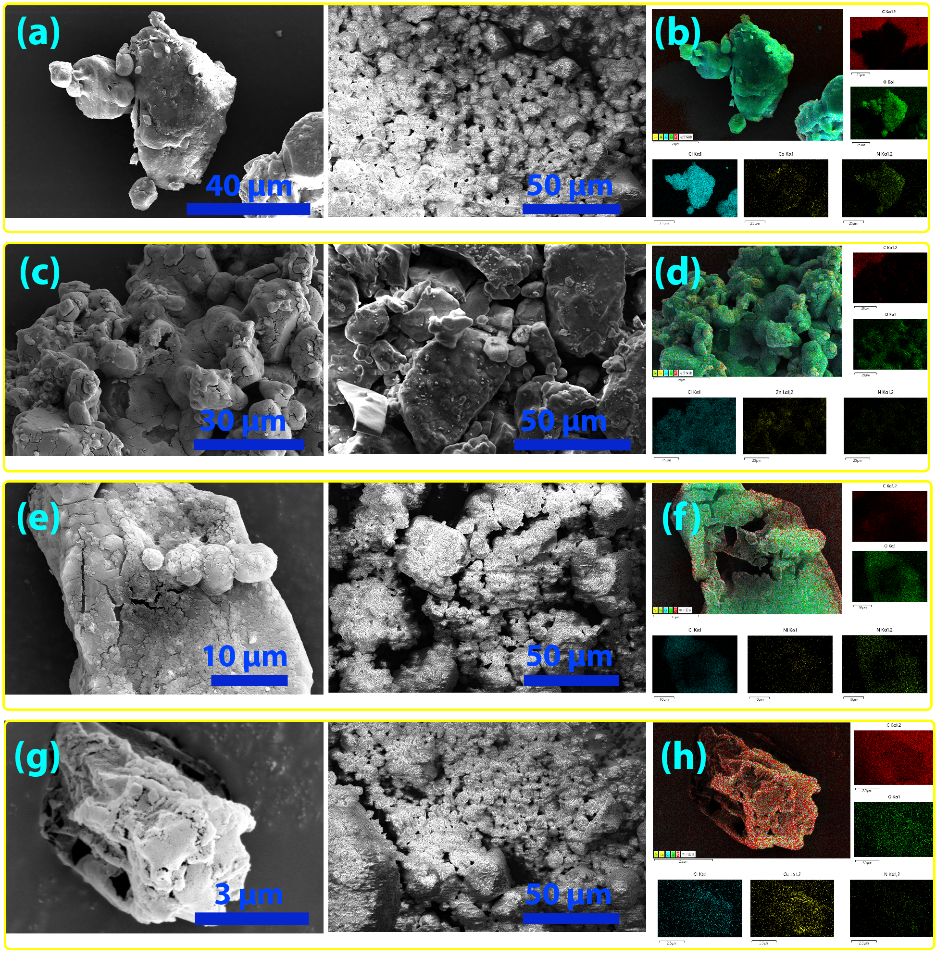
Figure S3. SEM-EDS mapping (Yellow: Co, Zn, Cu, Ni, Bright-Green: O, Green: N, Red: C, Cyan: Cl) of AP/MOF composites, (a, b) 2%Co-MOF-I/AP, (c, d) 2%Zn-MOF-I/AP, (e, f) 2%Ni-MOF-II/AP, (g, h) 2%Cu-MOF-II/AP

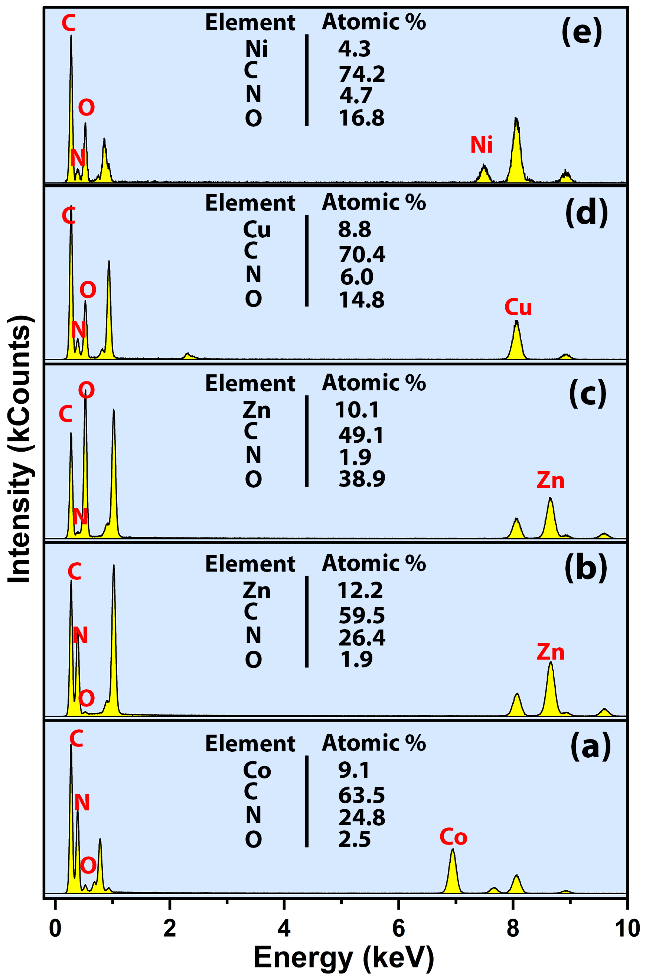
Figure S4. Energy-dispersive X-ray (EDX) spectroscopy of MOFs (a) Co-MOF-I (b) Zn-MOF-I (c) Zn-MOF-II (d) Cu-MOF-II, (d) Ni-MOF-II
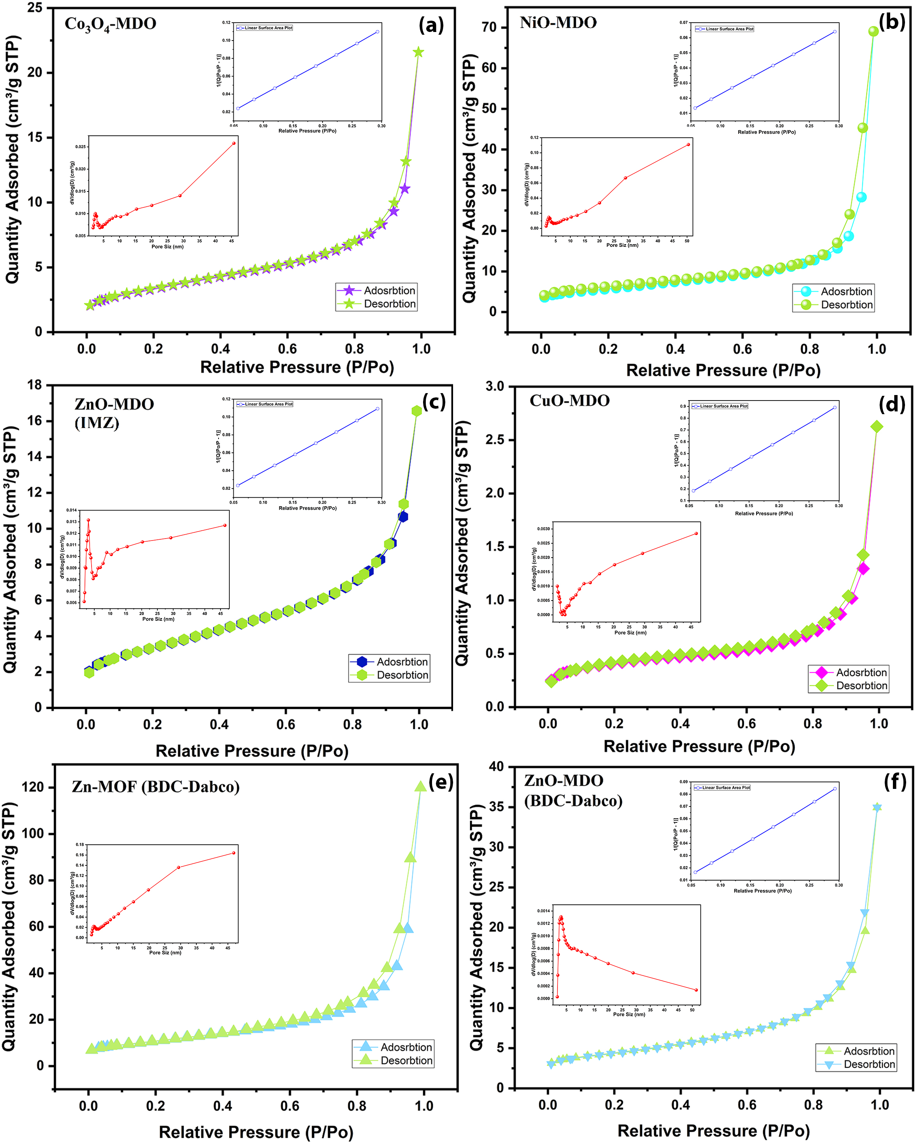
Figure S5 N₂ adsorption/desorption isotherms of MOF and MDO (a) Co₃O₄ (b) NiO, (c) ZnO from Zn-MOF-II, (d) CuO, (e) Zn-MOF-II, (f) ZnO from Zn-MOF-I
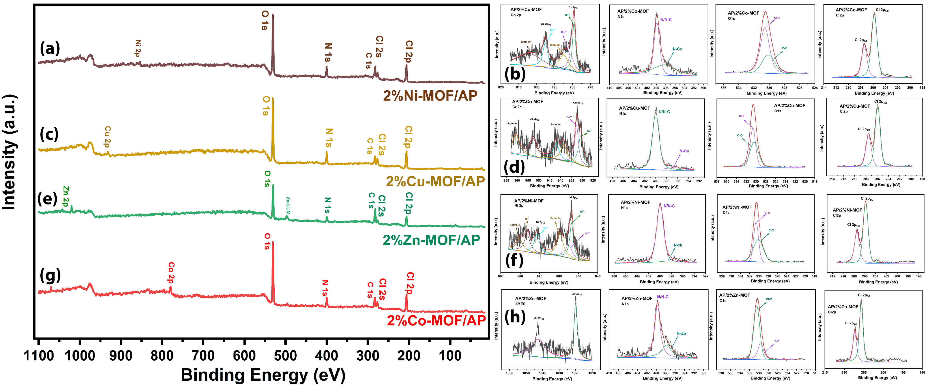
Figure S6 (a, c, e, g) XPS labelled spectra and M 2p (Co, Zn, Cu, Ni), N1s, O1s, C12p peaks fit for labelled AP/MOF composites (b) AP/2%Co-MOF-I; Co2p, N1s, O1s, C12p (d) AP /2%Cu-MOF-II; Cu2p, N1s, O1s, C12p (f) AP/2%Ni-MOF-II; Ni2p, N1s, O1s, Cl2p (h) AP/2%Zn-MOF-I; Zn2p, N1s, O1s, Cl2p.
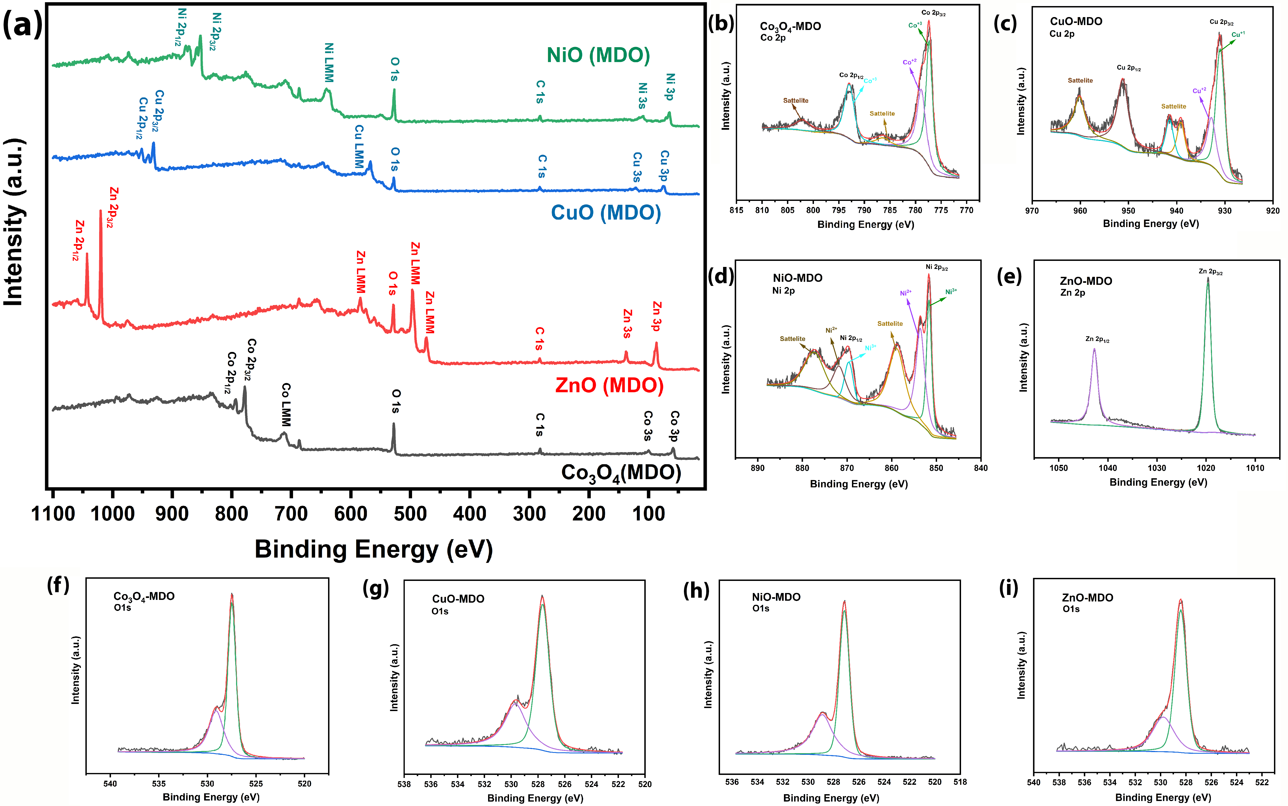
Figure S7 (a) XPS labelled spectra and M 2p (Co, Zn, Cu, Ni), O1s XPS peaks fit of MOF derived metal oxides (b, f) Co₃O₄ Co2p, O1s (c, g) CuO Cu2p, O1s (d, h) NiO Ni2p, O1s (e, i) ZnO Zn2p, O1s
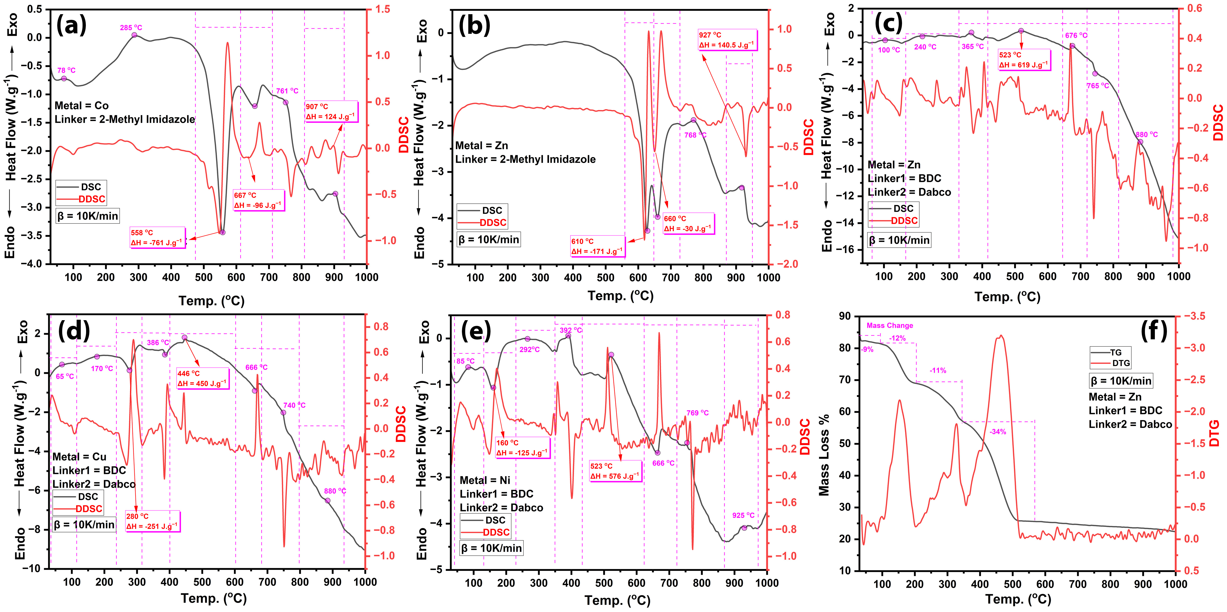
Figure S8. DSC-DDSC Curves of (a) Co-MOF-I, (b) Zn-MOF-I, (c) Zn-‎MOF-II, (d) Cu-‎MOF-II, (e) Ni-MOF-II, (f) TG-DTG of Zn-‎MOF-II
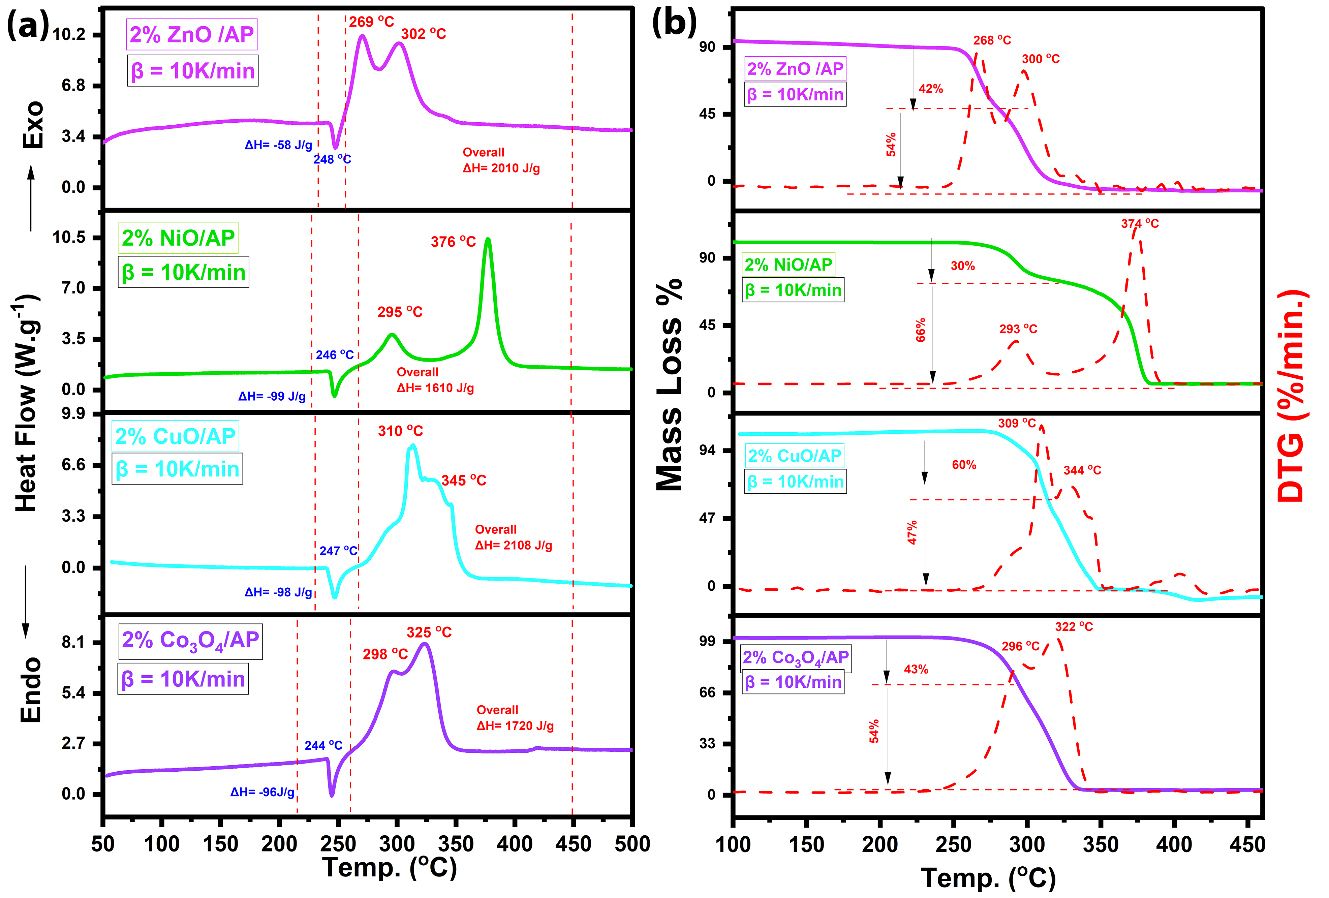
Figure S9 Thermal decomposition of AP analysis by using 2 wt% of derived metal oxides (a) DSC curves, (b) TG-DTG curves

Thermal Analysis of AP/MDO Composites
The physicochemical properties for AP decomposition are provided with insightful thermal analysis. Here, MOF calcinated and formation of derived metal oxide (MDO; Co₃O₄, CuO, NiO, ZnO) catalysts presented with different particle sizes, shapes, specific surface area and surface chemical species whose crystal structures and surface analysis discussed in previous characterization sections. The synthesized 98%AP/2%Co₃O₄, 98%AP/2%CuO, 98%AP/2%NiO and 98%AP/2%ZnO composites were analyzed by TG-DSC technique as displayed in fig. S9 with their labels.
Due to different physiochemical properties of MDO catalysts such as surface area, pore size, and pore volume derived from MOF to derived metal oxides, as provided in the table.1, shows different thermal activity to AP decomposition. The decomposition process in the 2%ZnO/98%AP system is observed better than other MDO/AP energetic systems, as presented in fig S9 (a) DSC and S9 (b) TG-DTG. It is notable in fig. S9 (a), the 2%ZnO catalyst reduced the LTD by 48°C and 128°C decrease in HTD with an overall heat release of 2010 J/g during the AP decomposition reaction. From fig. S9 (b), the mass loss in LTD and HTD zone is visible with the derivative of thermogravimetric curves. Whereas 2%CuO has a maximum heat release of 2108 J/g for catalyzing AP, a decrease in LTD is 7°C and 90°C in HTD is noted. ZnO catalytic activity is explained by its Zn²⁺ surface specie which could accelerate the superoxide reactivity between NH₄⁺ and ClO₄⁻ components during the AP decomposition process.
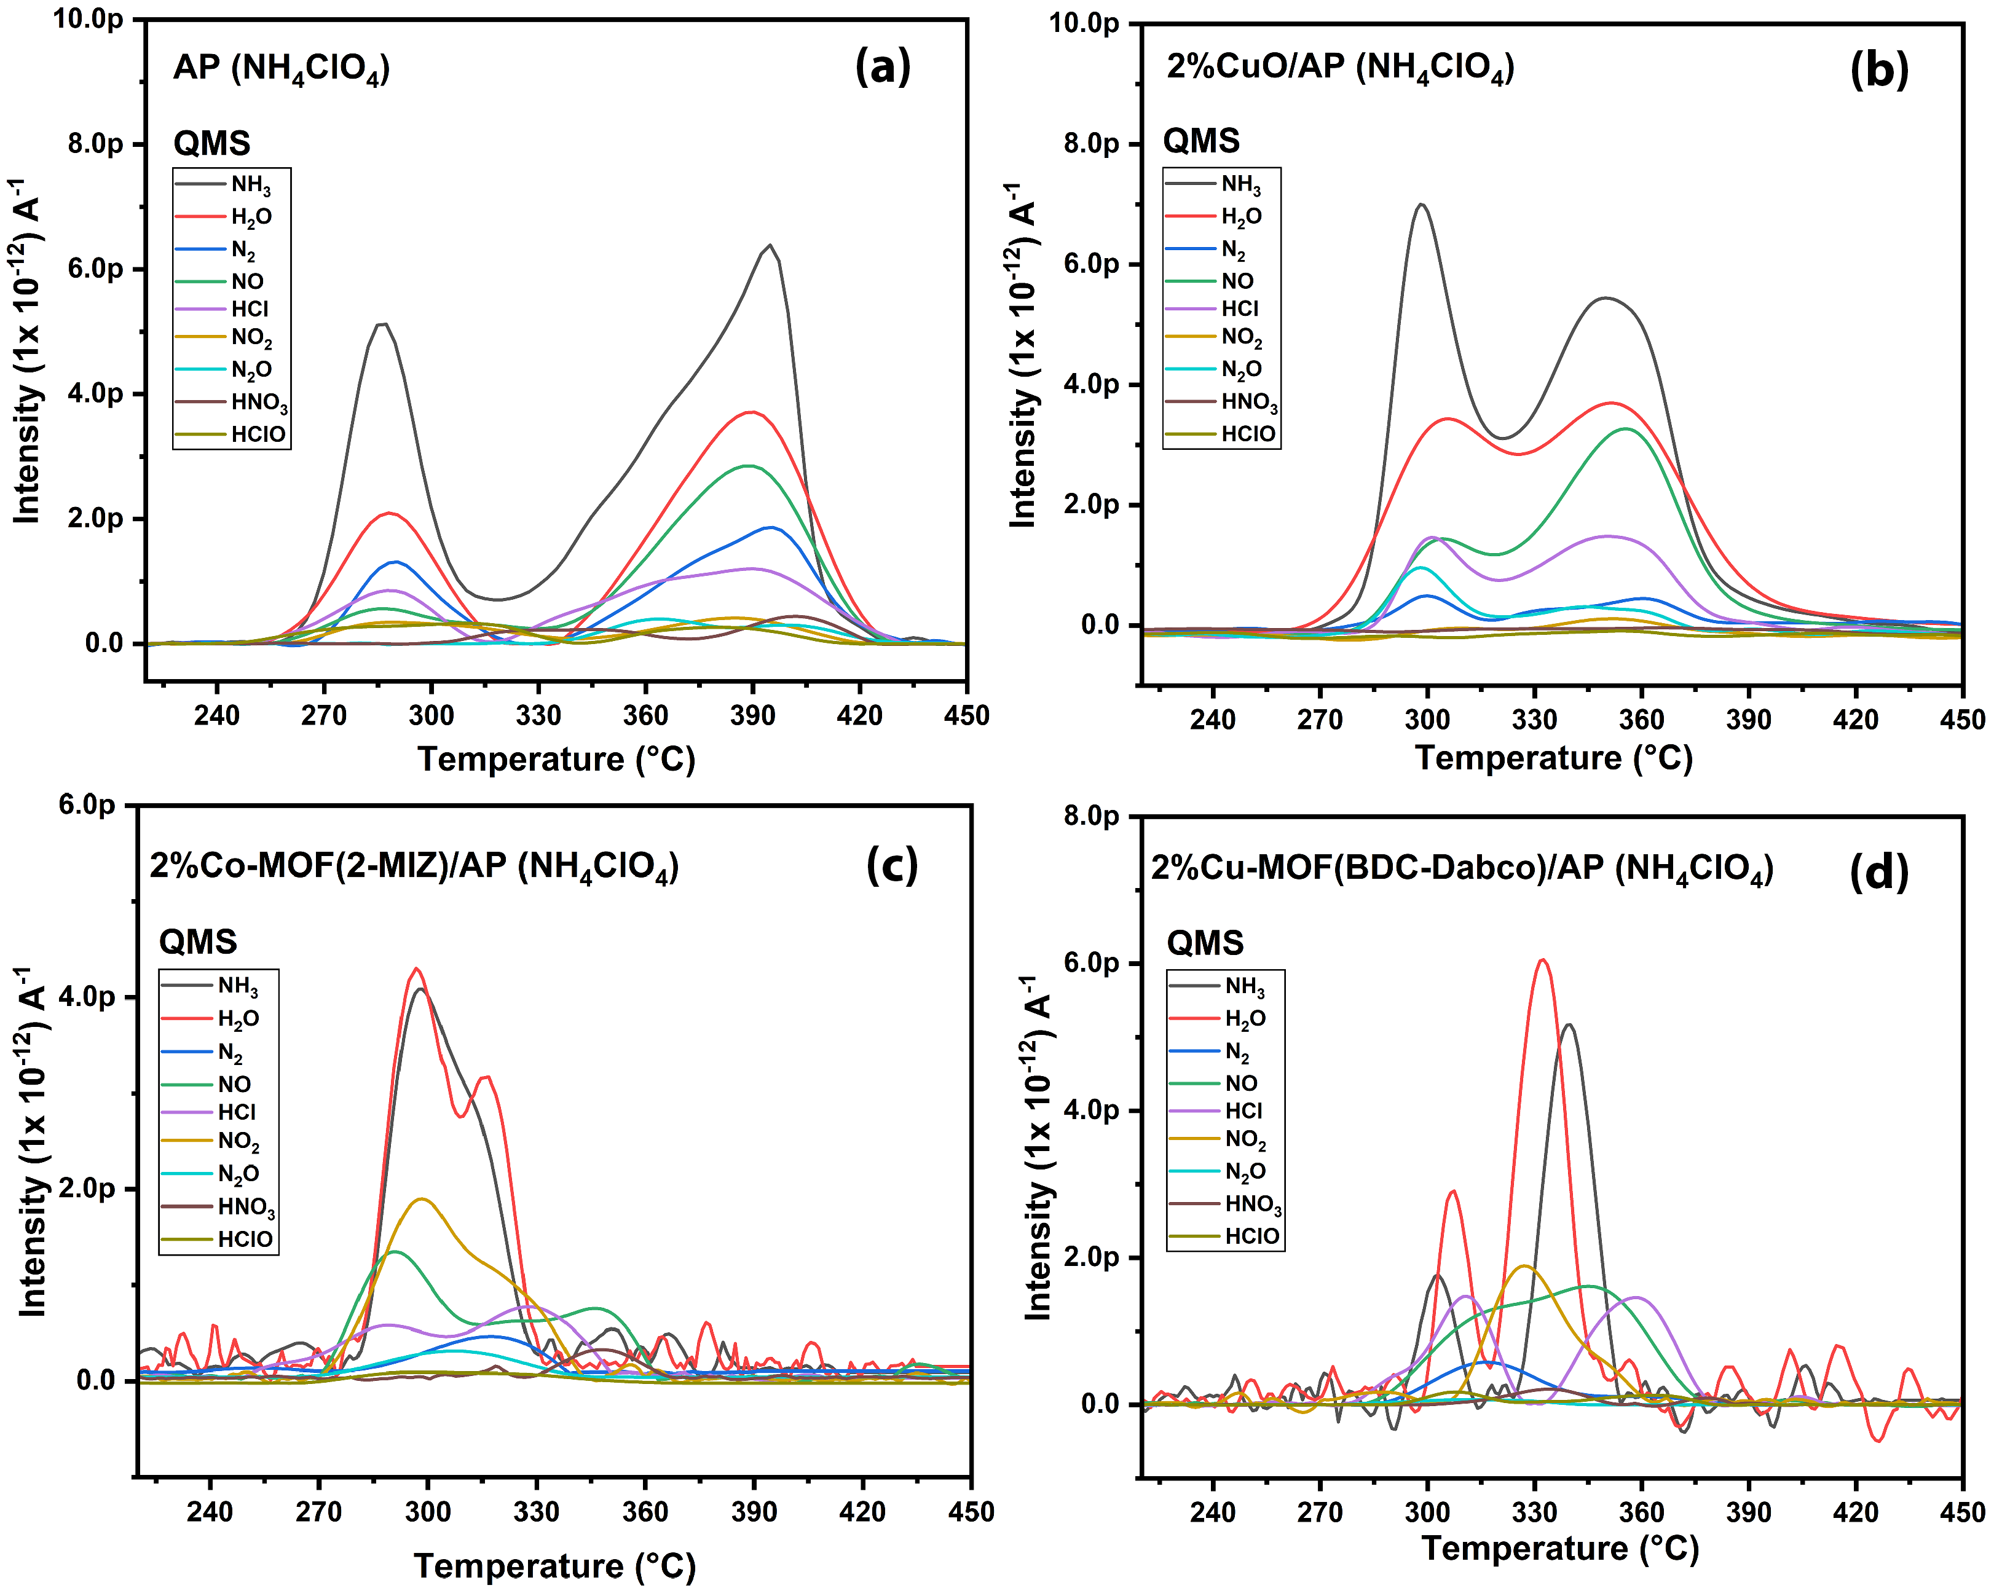
Figure S10 Quadrupole mass spectrometry of generated gas (m/z) molecules during AP decomposition reaction (a) Pure AP (b) 2%CuO/AP (c) 2%Co-MOF-I/AP (d) 2%Cu-MOF-II/AP
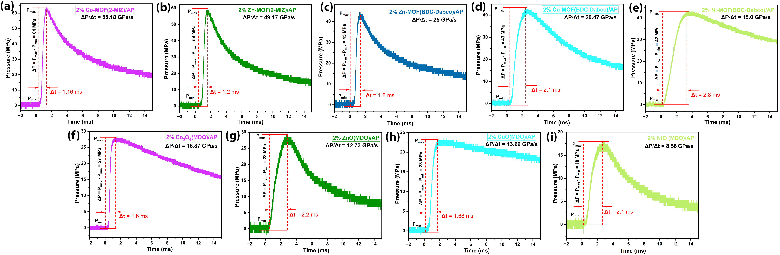
Figure S11 Combustion pressure of 2%MOF/AP composites (a) Co-MOF-I/AP (b) Zn-MOF-I/AP (c) Zn-MOF-II/AP (d) Cu-MOF-II/AP (e) Ni-MOF-II/AP (f) Co₃O₄/AP (g) ZnO/AP (h) CuO/AP (i) NiO/AP

References
1. Wang S, Ye B, An C, Wang J, Li Q. Synergistic effects between Cu metal–organic framework (Cu-MOF) and carbon nanomaterials for the catalyzation of the thermal decomposition of ammonium perchlorate (AP). Journal of Materials Science. 2019;54(6):4928-41; http://doi.org/10.1007/s10853-018-03219-4.
2. Wang S, Ye B, An C, Wang J, Li Q, Guo H, et al. Exploring the Coordination Effect of GO@MOF-5 as Catalyst on Thermal Decomposition of Ammonium Perchlorate. Nanoscale Research Letters. 2019;14(1):345; http://doi.org/10.1186/s11671-019-3163-z.
3. Yang Q, Chen S, Gao S. An unexpected 3D (6, 8)-connected metal–organic framework {[Cu5(trz)2(mal)2(fma)(H2O)4]·2H2O}n: Synthesis, structure and catalytic thermodecomposition for ammonium perchlorate. Inorganic Chemistry Communications. 2009;12(12):1224-6; http://doi.org/10.1016/j.inoche.2009.09.026.
4. Zhou P, Zhang S, Ren Z, Wang Y, Zhang Y, Huang C. Study on the thermal decomposition behavior of ammonium perchlorate catalyzed by Zn–Co cooperation in MOF. Inorganic Chemistry Frontiers. 2022;9(20):5195-209; http://doi.org/10.1039/D2QI00968D.
5. Zhou P, Ren Z, Tang X, Zheng Z, Zhang K, Liao J, et al. Interaction Between Prussian Blue Ultrathin Nanosheet and Ammonium Perchlorate for Highly Efficient Thermal Decomposition. Advanced Functional Materials. 2023;33(21):2300661; http://doi.org/10.1002/adfm.202300661.
6. Liang T, Yang X, Liu B, Song R, Xiao F, Yang Y, et al. Ammonium perchlorate@graphene oxide/Cu-MOF composites for efficiently catalyzing the thermal decomposition of ammonium perchlorate. Advanced Composites and Hybrid Materials. 2023;6(2):67; https://doi.org/10.1007/s42114-023-00651-2.
7. Yang F, He Z, Zhang R, Wang Q. MOFs with hydrazide and 3-amino-1,2,4-oxadiazole-substituted hydroxytetrazole as novel nitrogen-rich ligands: a new class of energetic materials for ammonium perchlorate decomposition catalysis. CrystEngComm. 2026;28(12):1931-7; http://doi.org/10.1039/D5CE01001B.
8. Cheng W, Zhou P, Tang X, Zheng Z, Ding C, Zhou Y, et al. Synthesis of a Wrinkled Hierarchically Porous Cerium-Based MOF for Thermal Decomposition Catalysis of Ammonium Perchlorate. Langmuir. 2025;41(30):19905-13; https://doi.org/10.1021/acs.langmuir.5c01862.

