SUPPLEMENTARY MATERIAL

A B
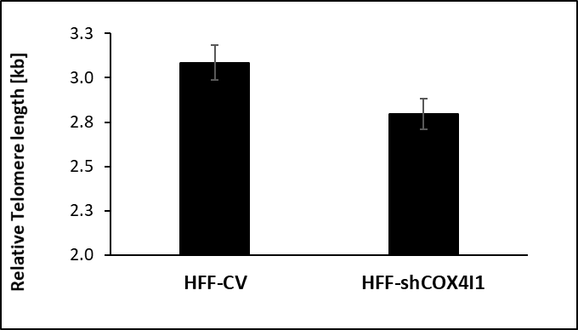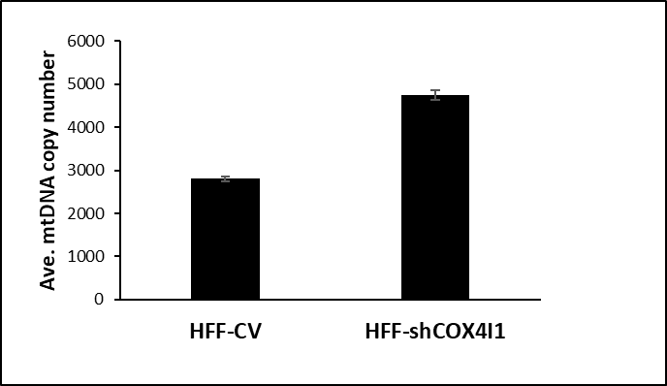

Supplementary Figure S1 Telomere length. Telomere length (A) and mitochondrial DNA (mtDNA) (B) in was estimated in human foreskin fibroblast cell line (HFF) HFF transfected with a control vector (HFF-CV), HFF with downregulated COX4I1 (HFF-shCOX4I1) by RTqPCR, showing significantly decreased telomere length in HFF-shCOX4I1 cells, while mt DNA was elevated (mean ± SEM of triplicates)

Supplementary table 1. TUNEL assay
Cell | TUNEL signal/ nucleus | SEM+/-
Control | 6.E-06 | 7.8E-07
Patient | 6.E-06 | 8.5E-07
HFF-CV | 0.734 | 0.067
HFF-shCOX4I1 | 0.579 | 0.047

Supplementary table 2. List of ranked top 20% enriched genes linked to DNA repair
PROBE/GENE SYMBOL | ALIAS NAME | RANK METRIC SCORE
TYMS | Thymidylate Synthase | -5.48
TP53 | Tumor Protein P53 | -4.56
IMPDH2 | Inosine Monophosphate Dehydrogenase 2 | -4.41
UPF3B | UPF3B Regulator Of Nonsense Mediated mRNA Decay | -4.14
GMPR2 | Guanosine 5'-Monophosphate Oxidoreductase 2 | -3.66
NELFCD | Negative Elongation Factor Complex Member C/D | -2.96
PCNA | Proliferating Cell Nuclear Antigen | -2.88
XPC | XPC Complex Subunit, DNA Damage Recognition and Repair | -2.75
TAF9 | TATA-Box Binding Protein Associated Factor 9 | -2.61
NT5C | 5', 3'-Nucleotidase, Cytosolic | -2.52
GTF3C5 | General Transcription Factor IIIC Subunit 5 | -2.5
SNAPC5 | Small Nuclear RNA Activating Complex Polypeptide 5 | -2.39
RFC3 | Replication Factor C Subunit 3 | -2.21
GSDME | Gasdermin E | -2.14
ERCC3 | ERCC Excision Repair 3, TFIIH Core Complex Helicase Subunit | -2.13
RFC4 | Replication Factor C Subunit 4 | -2.11
TAF1C | TATA-Box Binding Protein Associated Factor, RNA Polymerase I Subunit | -2.08
ERCC4 | ERCC Excision Repair 4, Endonuclease Catalytic Subunit | -2.06
ZNRD1 | RNA Polymerase I Subunit H | -1.99
POLR2G | RNA Polymerase II Subunit G | -1.91
REV3L | REV3 Like, DNA Directed Polymerase Zeta Catalytic Subunit | -1.89
SAC3D1 | SAC3 Domain Containing 1 | -1.87
PDE4B | CAMP-Specific 3',5'-Cyclic Phosphodiesterase 4B | -1.8
HCLS1 | Hematopoietic Cell-Specific Lyn Substrate 1 | -1.69
VPS28 | VPS28 Subunit Of ESCRT-I | -1.66
NFX1 | Nuclear Transcription Factor, X-Box Binding 1 | -1.6
DDB2 | Damage Specific DNA Binding Protein 2 | -1.5
AK3 | Adenylate Kinase 3 | -1.5
NCBP2 | Nuclear Cap Binding Protein Subunit 2 | -1.48
Expression of genes in bold were verified by RTqPCR

Supplementary table 4. Primer sequences used for qPCR
Gene | Forward primer | Reverse primer
XPC (NM_004628) | 5’-GATGACCTCAGGGACTTTCC-3’ | 5’-AAGACAGCAATGAAGAAGAGGA-3’
PCNA (NM_002592.2) | 5’- AATTCCAGAACAGGAGTACAGC-3’ | 5’-GAGATGCTGTTGTAATTTCCTGTG-3’
GMPR2 (NM_001002002.3) | 5’- CATCATGGCAGGGAATGT-3’ | 5’-AAAGTGGGAATTGGGCC-3’
IMPDH2 (NM_000884.3) | 5’-ACAGGGATTCATCACAGACC-3’ | 5’-TGGAAGAGATAATGACAAAGAGG-3’
UPF3B (NM_080632.3) | 5’- GGACTATCGATGATGATCCAGA-3’ | 5’-GAGACACTGCTAGAGGAAATAGA-3’
COX4I1 (NM_001861.6) | 5′-TTTCACCGCGCTCGTTAT-3′ | 5′-CTTCATGTCCAGCATCCTCTT-3′
COX4I2 (NM_032609) | 5′-GAAGACGAGGGATGCACAG-3′ | 5′-GGCTCTTCTGGCATGGG-3′
GUSB (NM_000181.4) | 5'-GAAAATATGTGGTTGGAGAGCTCATT-3' | 5’-CCGAGTGAAGATCCCCTTTTTA-3’
GAPDH (NM_001357943.2) | 5'-CAAGAGCACAAGAGGAAGAGAG-3' | 5’-CTACATGGCAACTGTGAGGAG-3’

Supplementary Figure S2 DSBs in HEK293 cells with downregulated COX4I1 HEK293 cells were transfected with a control vector (HEK293-CV) and HEK293 with downregulated COX4I1 (HEK239-shCOC4I1), seeded on coverslips and stained double stranded DNA breaks with ƔH2AX antibodies. Nuclei were stained by NucBlue. At least 100 nuclei of each group of cells were analyzed and quantified ,mean ± SEM is depicted in the histogram .

