Supplementary Table 1: Summary of topological statistics of the protein-protein interaction network constructed from 196 common chlorogenic acid and schizophrenia targets.
Statistic | Value
Number of nodes | 179
Number of edges | 3256
Avg. number of neighbors | 36.380
Network diameter | 7
Network radius | 1
Characteristic path length | 1.929
Clustering coefficient | 0.313
Network density | 0.204
Connected components | 1
Multi-edge node pairs | 0
Number of self-loops | 0
Analysis time (sec) | 14.721

Supplementary Table 2: Centrality metrics for the 17 core hub genes identified by intersection of Degree, Betweenness, and Closeness centrality analyses using CytoHubba in Cytoscape v3.10.4.
Gene | Degree | Closeness | Betweenness
ALB | 118 | 147.833 | 1355.67
IL6 | 118 | 147.833 | 2500.55
AKT1 | 116 | 146.833 | 1488.73
TP53 | 114 | 145.667 | 1642.19
TNF | 112 | 144.667 | 827.302
IL1B | 105 | 141.000 | 751.105
CASP3 | 100 | 138.667 | 582.359
JUN | 98 | 137.833 | 721.173
BCL2 | 97 | 137.333 | 442.258
NFKB1 | 96 | 136.667 | 416.375
EGFR | 95 | 136.000 | 1356.36
HIF1A | 93 | 135.167 | 513.671
GSK3B | 92 | 134.500 | 303.708
CTNNB1 | 88 | 132.500 | 766.482
PTGS2 | 86 | 131.500 | 431.092
SRC | 85 | 131.167 | 236.660
MMP9 | 84 | 130.167 | 536.445

Supplementary Table 3: Top 15 significantly enriched KEGG pathways identified from 196 common chlorogenic acid and schizophrenia overlapping targets using ShinyGO v0.85.1 (FDR < 0.05).
Pathway ID | Pathway Term | Key Hub Genes | Count | P-Value | FDR | Fold Enrichment
hsa05417 | Lipid and atherosclerosis | AKT1, BCL2, CASP3, EGFR, HIF1A, IL1B, IL6, JUN, MMP9, NFKB1, PTGS2, TNF | 12 | 2.56E-15 | 1.49E-13 | 31.03
hsa05163 | Human cytomegalovirus infection | AKT1, BCL2, CASP3, EGFR, IL1B, IL6, JUN, MMP9, NFKB1, PTGS2, SRC, TNF | 12 | 4.46E-15 | 1.49E-13 | 29.53
hsa05167 | Kaposi sarcoma-associated herpesvirus infection | AKT1, BCL2, CASP3, EGFR, IL6, JUN, MAPK1, NFKB1, PTGS2, SRC, TNF | 11 | 8.03E-14 | 1.79E-12 | 31.35
hsa05418 | Fluid shear stress and atherosclerosis | AKT1, BCL2, EGFR, IL1B, IL6, JUN, MAPK1, NFKB1, PTGS2, SRC | 10 | 3.03E-13 | 5.08E-12 | 39.34
hsa04657 | IL-17 signaling pathway | IL6, TNF, IL1B, JUN, MMP9, NFKB1, CASP3, PTGS2, MAPK1 | 9 | 8.96E-13 | 1.20E-11 | 52.92
hsa05161 | Hepatitis B | AKT1, BCL2, CASP3, EGFR, IL6, JUN, NFKB1, PTGS2, SRC, TNF | 10 | 1.07E-12 | 1.20E-11 | 34.27
hsa05200 | Pathways in cancer | AKT1, BCL2, CASP3, EGFR, HIF1A, IL6, JUN, MMP9, NFKB1, PTGS2, SRC, TP53 | 13 | 1.28E-12 | 1.23E-11 | 13.62
hsa04668 | TNF signaling pathway | TNF, IL6, NFKB1, CASP3, IL1B, JUN, PTGS2, MMP9, MAPK1 | 9 | 5.68E-12 | 4.76E-11 | 42.25
hsa05162 | Measles | AKT1, BCL2, CASP3, IL1B, IL6, NFKB1, TP53, TNF, MAPK1 | 9 | 2.01E-11 | 1.49E-10 | 36.17
hsa05210 | Colorectal cancer | AKT1, BCL2, CASP3, EGFR, JUN, NFKB1, TP53, MAPK1 | 8 | 4.54E-11 | 3.04E-10 | 51.36
hsa05131 | Shigellosis | AKT1, CASP3, EGFR, IL1B, JUN, NFKB1, SRC, TNF, MAPK1, MMP9 | 10 | 5.71E-11 | 3.48E-10 | 22.08
hsa04933 | AGE-RAGE signaling pathway in diabetic complications | AKT1, BCL2, CASP3, IL1B, IL6, NFKB1, PTGS2, TNF | 8 | 1.32E-10 | 7.37E-10 | 44.24
hsa04625 | C-type lectin receptor signaling pathway | AKT1, IL1B, IL6, NFKB1, PTGS2, SRC, TNF, MAPK1 | 8 | 1.74E-10 | 8.32E-10 | 42.56
hsa05168 | Herpes simplex virus 1 infection | AKT1, BCL2, CASP3, IL1B, IL6, JUN, NFKB1, TP53, TNF | 9 | 1.84E-10 | 8.32E-10 | 27.47
hsa05215 | Prostate cancer | AKT1, BCL2, CASP3, EGFR, NFKB1, TP53, MAPK1, MMP9 | 8 | 1.86E-10 | 8.32E-10 | 35.64

Supplementary Table 4: Total protein concentration (µg/ml) in hippocampus, prefrontal cortex, and striatum of mice across experimental groups determined by BCA assay.
Group | Hippocampus (µg/ml) | Prefrontal Cortex (µg/ml) | Striatum (µg/ml) | Interpretation
Control | 10.12 – 17.75 | 9.80 – 16.50 | 11.20 – 18.30 | Normal protein integrity across key brain regions
Ketamine (30 mg/kg) | 7.24 – 10.30 | 6.50 – 9.80 | 7.80 – 11.20 | Marked protein loss due to neurodegeneration and synaptic impairment
Haloperidol (1 mg/kg) | 10.40 – 13.73 | 9.50 – 14.20 | 10.80 – 15.60 | Good recovery via antipsychotic action
CGA (10 mg/kg) | 9.80 – 15.40 | 9.20 – 13.80 | 10.10 – 14.90 | Moderate to good dose-dependent protection; comparable to haloperidol in most regions
CGA (50 mg/kg) | 8.50 – 14.20 | 8.10 – 12.70 | 9.30 – 13.50 | Moderate protection
CGA (100 mg/kg) | 8.20 – 13.90 | 7.90 – 12.40 | 9.00 – 13.10 | Moderate protection

Supplementary Table 5: Grid center coordinates for Molecular Docking
Target Protein | PDB ID | Grid Center Coordinates (X, Y, Z)
AKT1 | 3CQU | 23.45, 18.92, 31.67
CASP3 | 1RE1 | 12.78, -5.34, 45.21
IL1B | 9ILB | -18.45, 24.63, 52.19
IL6 | 1ALU | 35.82, -42.16, 28.94
NFKB1 | 8TQD | -27.54, 16.83, -33.47
TNF | 2AZ5 | -20.80, 70.95, 37.70

Supplementary Figure 1: GO enrichment analysis of 196 common targets (FDR < 0.05). (a) Biological Processes, (b) Cellular Components, (c) Molecular Functions.

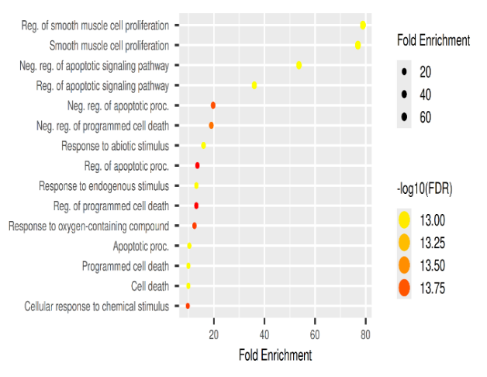
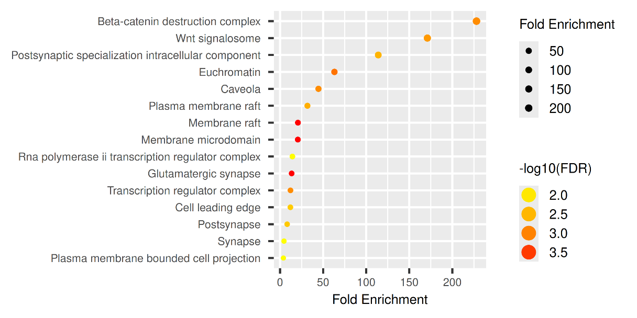
b
a

c

