10. Table Legends
Table 1. Chronological and Geographical Characteristics of the Bundibugyo Ebolavirus Glycoprotein (GP) Isolates Included in the Comparative Analysis (2007–2026)
Characteristics of the 54 Bundibugyo ebolavirus glycoprotein (GP) isolates included in the comparative analysis. The table summarizes the outbreak year, accession number, epidemiological information, and availability of complete GP sequences for each isolate. 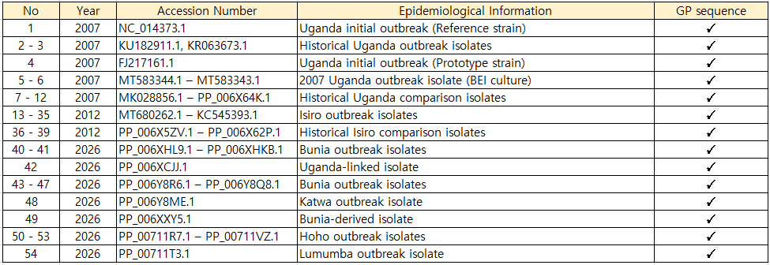
Table 2. Core Amino Acid Substitution Sites Identified in Bundibugyo Ebolavirus Glycoprotein
Table 2b. Classification of Time–Space Mutation Coordinates According to Evolutionary Pattern, Functional Domain, and Physicochemical Properties
Evolutionary patterns were categorized into Fixation, Reversion, Emergence, Within-outbreak polymorphism, and Rare variant. Fixation indicates a substitution maintained in subsequent outbreak lineages; Reversion indicates restoration of the ancestral residue; Emergence indicates a novel substitution first detected in the 2026 outbreak lineage; Within-outbreak polymorphism indicates amino acid heterogeneity among isolates collected during the same outbreak; Rare variant indicates a substitution observed in only one isolate.

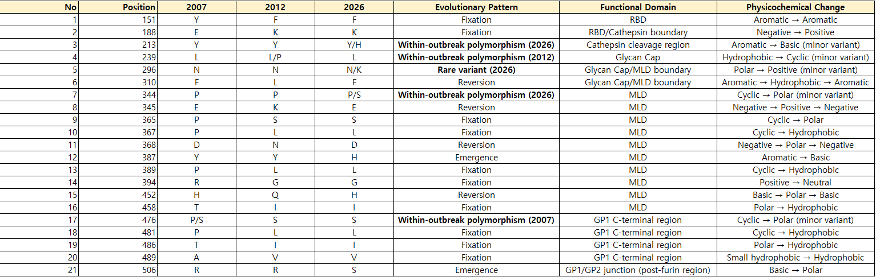

Table 4. Functional domains and structural features of the Bundibugyo ebolavirus glycoprotein (GP)
Table 4a. Functional Coordinate Framework of the Bundibugyo Ebolavirus Glycoprotein (GP)
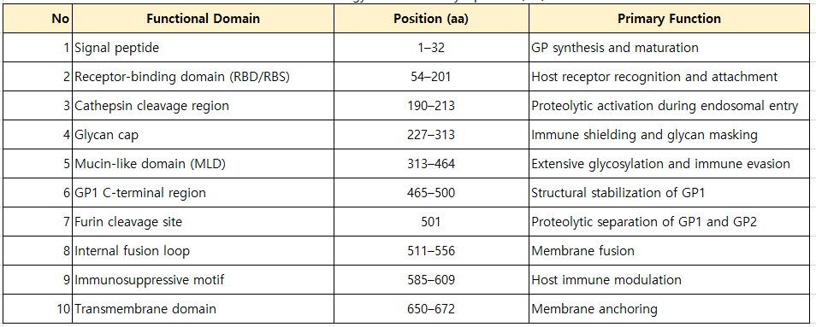
For comparative mapping, residues located within the transition zone between the Glycan cap and the mucin-like domain were grouped as the Glycan cap/MLD boundary to facilitate interpretation of mutations occurring near the domain interface. This operational classification was applied to residues 296 and 310 for comparative analysis and does not modify the canonical functional domain definitions shown in Table 4a.
Table 4b. Functional Mapping of Time–Space Mutation Coordinates within the Bundibugyo Ebolavirus Glycoprotein
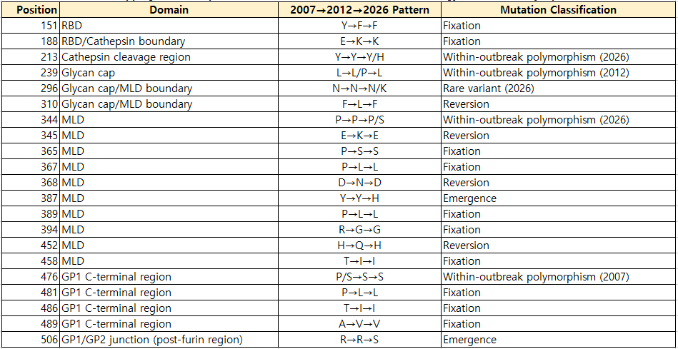
Table 4c. Distribution of Time–Space Mutation Coordinates Across Functional Domains of the Bundibugyo Ebolavirus Glycoprotein
