SUPPLEMENTARY TABLES AND FIGURES

Supplementary Figure 1: P-score ranking of interventions in the permanent dentition/first permanent molar continuous caries increment network.

Legend-Bar chart showing P-score rankings derived from the frequentist network meta-analysis. Higher P-scores indicate a higher ranking probability for reducing caries increment within this network. Because the outcome was caries increment, lower mean increments favour the intervention. Rankings should be interpreted cautiously because the evidence network was sparse and ranking probabilities alone do not establish clinical superiority

Abbreviations: FS, fissure sealant; FV, fluoride varnish; APF gel, acidulated phosphate fluoride gel; APF foam, acidulated phosphate fluoride foam; NaF gel, sodium fluoride gel.

Supplementary Figure 2: Sensitivity analysis excluding the high-frequency fluoride varnish trial in primary dentition
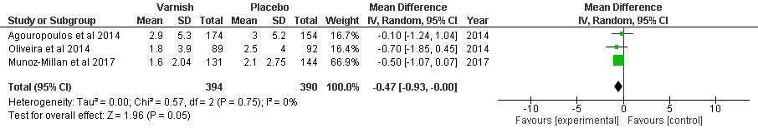
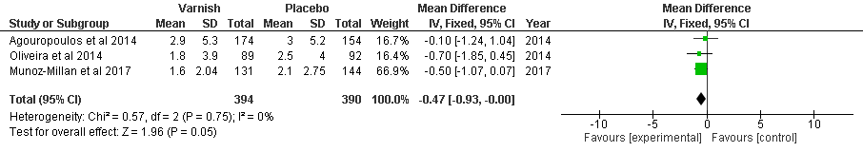
Legend: Negative mean differences favour fluoride varnish because lower caries increment indicates greater preventive benefit. Latifi-Xhemajli et al. was excluded because it represented a high-frequency FV application schedule.
Abbreviations: MD, mean difference; CI, confidence interval.

Supplementary Figure 3: Network plot for primary dentition continuous caries increment outcome
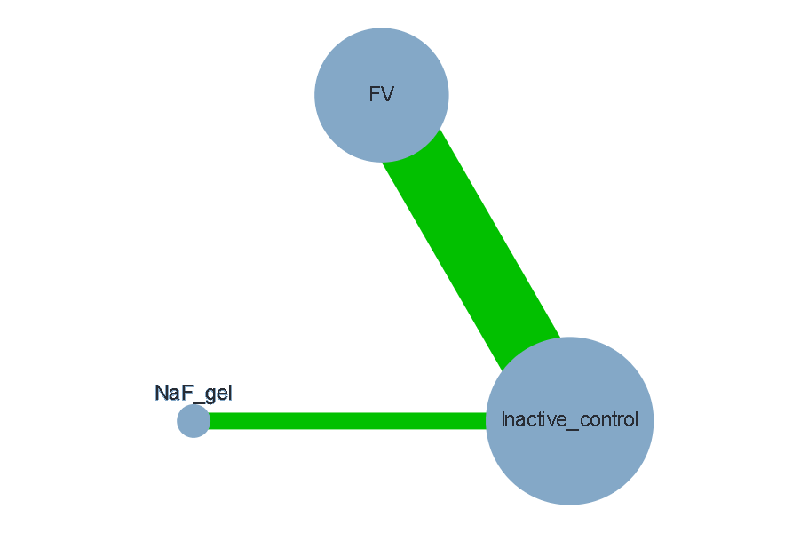
Legend:
Network plot of topical fluoride interventions for continuous caries increment outcomes in the primary dentition. Nodes represent interventions and edges represent direct comparisons between interventions. Node size reflects the number of studies contributing to each intervention node, and edge thickness reflects the number of direct comparisons between treatment pairs. Edge colour represents the majority risk-of-bias judgement for the direct comparison.
Abbreviations:
FV, fluoride varnish; NaF, sodium fluoride. Inactive control included placebo, no-treatment, usual-care, or inactive comparator arms without an active topical fluoride agent.

Supplementary Table 1: League table of network estimates for continuous caries increment outcomes in permanent dentition/first permanent molars

Treatment | APF foam | APF gel | Control | FS | FV | NaF gel
APF foam | —
APF gel | 0.03 [−0.16, 0.23] | —
Control | −0.16 [−0.35, 0.02] | −0.20 [−0.37, −0.03] | —
FS | 0.62 [0.31, 0.93] | 0.58 [0.30, 0.87] | 0.78 [0.52, 1.04] | —
FV | 0.21 [−0.04, 0.47] | 0.18 [−0.02, 0.38] | 0.38 [0.17, 0.58] | −0.36 [−0.64, −0.08] | —
NaF gel | −0.02 [−0.26, 0.21] | −0.06 [−0.28, 0.17] | 0.14 [−0.01, 0.28] | −0.64 [−0.94, −0.34] | −0.24 [−0.49, 0.01] | —

Footnote: Values are standardised mean differences with 95% confidence intervals. Each cell shows the treatment in the row compared with the treatment in the column. Negative values favour the row treatment, and positive values favour the column treatment, because lower caries increment indicates greater preventive benefit. The league table should be interpreted together with the network plot, effect estimates versus inactive control, heterogeneity, inconsistency assessment, and P-score ranking

Abbreviations: APF, acidulated phosphate fluoride; CI, confidence interval; FS, fissure sealant; FV, fluoride varnish; NaF gel, sodium fluoride gel; SMD, standardised mean difference.

Supplementary Table 2: Direct pairwise sensitivity analysis restricted to topical fluoride agents

Comparison | Study | Participants | Effect estimate | Interpretation
FV vs inactive control | Bravo et al., 1997 | 214 | SMD −0.41, 95% CI −0.68 to −0.14 | Significant benefit favouring FV
APF foam vs inactive control | Jiang et al., 2005 | 412 | SMD −0.14, 95% CI −0.34 to 0.05 | Non-significant trend favouring APF foam
APF gel vs inactive control | Jiang et al., 2005 | 421 | SMD −0.15, 95% CI −0.34 to 0.04 | Non-significant trend favouring APF gel
NaF gel vs inactive control | van Rijkom et al., 2004 | 732 | SMD −0.14, 95% CI −0.28 to 0.01 | Borderline/non-significant trend favouring NaF gel
FV vs APF gel | Seppä et al., 1995 | 254 | SMD −0.12, 95% CI −0.37 to 0.13 | No significant difference
APF foam vs APF gel | Jiang et al., 2005 | 391 | SMD 0.01, 95% CI −0.18 to 0.21 | No significant difference

Footnote:APF, acidulated phosphate fluoride; CI, confidence interval; FV, fluoride varnish; NaF, sodium fluoride; SMD, standardised mean difference. Negative SMD values favour the first-listed intervention. Resin fissure sealant was excluded because it is a non-fluoride physical barrier intervention. No pooled estimate was calculated because each comparison was informed by a single study; therefore, findings should be interpreted cautiously.

Supplementary Table 3: Summary of CINeMA confidence ratings for network meta-analysis estimates

Outcome/network | Comparison | Evidence type | No. of direct studies | Confidence rating | Main reason(s) for downgrading
Primary dentition – continuous caries increment | FV vs inactive control | Mixed | 4 | Low | Reporting bias; heterogeneity; imprecision; limited assessment of incoherence
Primary dentition – continuous caries increment | Inactive control vs NaF gel | Direct | 1 | Low | Reporting bias; imprecision; single-study evidence
Primary dentition – continuous caries increment | FV vs NaF gel | Indirect | 0 | Low | Indirect-only evidence; major imprecision; sparse network
Permanent dentition – continuous caries increment | APF foam vs APF gel | Direct | 1 | Low | Within-study bias; reporting bias; single-study evidence
Permanent dentition – continuous caries increment | APF foam vs inactive control | Direct | 1 | Low | Within-study bias; reporting bias; single-study evidence
Permanent dentition – continuous caries increment | APF gel vs FV | Indirect | 0 | Low | Indirect-only evidence; reporting bias; sparse network
Permanent dentition – continuous caries increment | APF gel vs inactive control | Direct | 1 | Low | Within-study bias; reporting bias; single-study evidence
Permanent dentition – continuous caries increment | FS vs FV | Direct | 1 | Low | Within-study bias; reporting bias; single-study evidence
Permanent dentition – continuous caries increment | FS vs inactive control | Direct | 1 | Low | Within-study bias; reporting bias; single-study evidence
Permanent dentition – continuous caries increment | FV vs inactive control | Direct | 1 | Low | Within-study bias; reporting bias; single-study evidence
Permanent dentition – continuous caries increment | Inactive control vs NaF gel | Direct | 1 | Low | Reporting bias; single-study evidence
Permanent dentition – continuous caries increment | APF foam vs FS | Indirect | 0 | Low | Indirect-only evidence; reporting bias; sparse network
Permanent dentition – continuous caries increment | APF foam vs FV | Indirect | 0 | Low | Indirect-only evidence; reporting bias; sparse network
Permanent dentition – continuous caries increment | APF foam vs NaF gel | Indirect | 0 | Low | Indirect-only evidence; reporting bias; sparse network
Permanent dentition – continuous caries increment | APF gel vs FS | Indirect | 0 | Low | Indirect-only evidence; reporting bias; sparse network
Permanent dentition – continuous caries increment | APF gel vs NaF gel | Indirect | 0 | Low | Indirect-only evidence; reporting bias; sparse network
Permanent dentition – continuous caries increment | FS vs NaF gel | Indirect | 0 | Low | Indirect-only evidence; reporting bias; sparse network
Permanent dentition – continuous caries increment | FV vs NaF gel | Indirect | 0 | Low | Indirect-only evidence; reporting bias; sparse network
Primary dentition – binary caries incidence | FV vs inactive control | Direct | 2 | Low | Reporting bias; limited number of studies; not a fully connected network
Permanent dentition – binary caries incidence | FS vs FV | Mixed | 2 | Moderate | Reporting bias
Permanent dentition – binary caries incidence | FS vs inactive control | Direct | 1 | Low | Reporting bias; heterogeneity; single-study evidence
Permanent dentition – binary caries incidence | FS vs SDF | Indirect | 0 | Low | Indirect-only evidence; reporting bias; heterogeneity; sparse evidence
Permanent dentition – binary caries incidence | FV vs inactive control | Mixed | 2 | Low | Within-study bias; reporting bias
Permanent dentition – binary caries incidence | FV vs SDF | Direct | 1 | Moderate | Reporting bias; single-study evidence
Permanent dentition – binary caries incidence | Inactive control vs SDF | Direct | 1 | Low | Reporting bias; heterogeneity; single-study evidence

Footnote: CINeMA, Confidence in Network Meta-Analysis; APF, acidulated phosphate fluoride; FV, fluoride varnish; FS, fissure sealant; NaF gel, sodium fluoride gel; SDF, silver diamine fluoride; SMD, standardised mean difference; OR, odds ratio. Control included placebo, no-treatment, usual-care, or inactive comparator arms without an active topical fluoride agent. Continuous outcomes were analysed using standardised mean differences because caries increment was reported using different indices. Binary outcomes were analysed using odds ratios. For continuous outcomes, negative SMDs favoured the first-listed intervention; for binary outcomes, ORs <1 favoured the first-listed intervention when lower event risk indicated benefit.

Supplementary Table 4: Detailed search strategy across databases

Database | Search Strategy (Final Protocol Terms) | Number of Records Retrieved
MEDLINE (PubMed) | ( child*[Title/Abstract] OR adolescent*[Title/Abstract] OR preschool*[Title/Abstract]  OR infant*[Title/Abstract] OR pediatric*[Title/Abstract] OR paediatric*[Title/Abstract]  OR "Child"[Mesh] OR "Adolescent"[Mesh] OR "Infant"[Mesh]  )  AND  ( "Dental Caries"[Mesh] OR dental caries[Title/Abstract] OR caries[Title/Abstract]  OR tooth decay[Title/Abstract] OR caries incidence[Title/Abstract]  OR caries increment[Title/Abstract] OR DMFT[Title/Abstract] OR DMFS[Title/Abstract]  OR dmft[Title/Abstract] OR dmfs[Title/Abstract] OR DFS[Title/Abstract]  )AND  ( "Fluorides, Topical"[Mesh] OR topical fluoride*[Title/Abstract]  OR fluoride varnish[Title/Abstract] OR sodium fluoride varnish[Title/Abstract]  OR NaF varnish[Title/Abstract] OR fluoride gel[Title/Abstract]  OR sodium fluoride gel[Title/Abstract] OR NaF gel[Title/Abstract]  OR acidulated phosphate fluoride[Title/Abstract] OR APF gel[Title/Abstract]  OR APF foam[Title/Abstract] OR fluoride foam[Title/Abstract]  OR silver diamine fluoride[Title/Abstract] OR SDF[Title/Abstract]  OR amine fluoride[Title/Abstract]  )AND(  randomized controlled trial[Publication Type] OR controlled clinical trial[Publication Type]  OR randomized[Title/Abstract] OR randomised[Title/Abstract]  OR randomly[Title/Abstract] OR trial[Title/Abstract]  OR placebo[Title/Abstract]  )NOT( animals[Mesh] NOT humans[Mesh] | 363
Embase | ('child'/exp OR 'adolescent'/exp OR 'infant'/exp OR child*:ti,ab OR adolescent*:ti,ab OR infant*:ti,ab OR preschool*:ti,ab OR pediatric*:ti,ab OR paediatric*:ti,ab)  AND  ('primary dentition'/exp OR 'deciduous tooth'/exp OR 'permanent tooth'/exp OR 'primary dentition':ti,ab OR 'primary teeth':ti,ab OR 'deciduous teeth':ti,ab OR 'mixed dentition':ti,ab OR 'permanent dentition':ti,ab OR 'permanent teeth':ti,ab)  AND  ('fluoride varnish'/exp OR 'topical fluoride'/exp OR 'sodium fluoride'/exp OR 'silver diamine fluoride'/exp OR 'fluoride varnish':ti,ab OR 'topical fluoride':ti,ab OR 'fluoride gel':ti,ab OR 'sodium fluoride gel':ti,ab OR 'acidulated phosphate fluoride':ti,ab OR 'APF gel':ti,ab OR 'APF foam':ti,ab OR 'silver diamine fluoride':ti,ab OR SDF:ti,ab OR 'amine fluoride':ti,ab)  AND  ('dental caries'/exp OR 'dental caries prevention'/exp OR 'dental caries':ti,ab OR caries:ti,ab OR 'caries increment':ti,ab OR 'caries incidence':ti,ab OR dmft:ti,ab OR dmfs:ti,ab OR DMFT:ti,ab OR DMFS:ti,ab OR DFS:ti,ab)  AND  ('randomized controlled trial'/exp OR 'controlled clinical trial'/exp OR randomized:ti,ab OR randomised:ti,ab OR randomly:ti,ab OR placebo:ti,ab OR trial:ti,ab OR RCT:ti,ab)  AND  ('12 months':ti,ab OR '24 months':ti,ab OR '2 years':ti,ab OR 'follow up':ti,ab OR 'follow-up':ti,ab OR longitudinal:ti,ab) | 172
Scopus | TITLE-ABS-KEY(child* OR adolescent* OR infant* OR preschool* OR pediatric* OR paediatric*)  AND TITLE-ABS-KEY("topical fluoride" OR "fluoride varnish" OR "fluoride gel" OR "sodium fluoride gel" OR "acidulated phosphate fluoride" OR "APF gel" OR "APF foam" OR "silver diamine fluoride" OR SDF OR "amine fluoride")  AND TITLE-ABS-KEY("dental caries" OR caries OR "caries increment" OR "caries incidence" OR dmft OR dmfs OR DMFT OR DMFS OR DFS)  AND TITLE-ABS-KEY("randomized controlled trial" OR "randomised controlled trial" OR RCT OR placebo) | 357
Cochrane CENTRAL | (child* OR adolescent* OR infant* OR preschool* OR pediatric* OR paediatric*)  AND  ("topical fluoride" OR "fluoride varnish" OR "fluoride gel" OR "sodium fluoride gel" OR "acidulated phosphate fluoride" OR "APF gel" OR "APF foam" OR "silver diamine fluoride" OR SDF OR "amine fluoride")  AND  ("dental caries" OR caries OR "caries increment" OR "caries incidence" OR dmft OR dmfs OR DMFT OR DMFS OR DFS)  AND  (randomized OR randomised OR placebo OR trial OR RCT) | 15
Google Scholar (supplementary search) | ("topical fluoride" OR "fluoride varnish" OR "fluoride gel" OR "silver diamine fluoride")  ("dental caries" OR "caries increment" OR "caries incidence" OR dmft OR dmfs OR DMFT OR DMFS)  (children OR adolescents OR preschool)  ("primary dentition" OR "mixed dentition" OR "permanent dentition" OR "first permanent molar")  (randomized OR randomised OR placebo OR trial) | 1110

Supplementary Table 5. Arm-level continuous outcome data used in network meta-analysis
Study | Network | Treatment node | n | Mean caries increment | SD
Agouropoulos 2014 | Primary dentition continuous | FV | 174 | 2.90 | 5.30
Agouropoulos 2014 | Primary dentition continuous | Inactive control | 154 | 3.00 | 5.20
Latifi-Xhemajli 2019 | Primary dentition continuous | FV | 218 | 5.20 | 10.50
Latifi-Xhemajli 2019 | Primary dentition continuous | Inactive control | 209 | 10.10 | 12.90
Muñoz-Millán 2018 | Primary dentition continuous | FV | 131 | 1.60 | 2.40
Muñoz-Millán 2018 | Primary dentition continuous | Inactive control | 144 | 2.10 | 2.50
Oliveira 2014 | Primary dentition continuous | FV | 89 | 1.80 | 3.90
Oliveira 2014 | Primary dentition continuous | Inactive control | 92 | 2.50 | 4.00
van Rijkom 2004 | Primary dentition continuous | NaF gel | 340 | 1.41 | 2.57
van Rijkom 2004 | Primary dentition continuous | Inactive control | 336 | 1.77 | 3.14
Bravo 1997 | Permanent dentition/FPM continuous | FS | 100 | 0.69 | 1.24
Bravo 1997 | Permanent dentition/FPM continuous | FV | 98 | 1.33 | 1.82
Bravo 1997 | Permanent dentition/FPM continuous | Inactive control | 116 | 2.13 | 2.06
Jiang 2004/2005 | Permanent dentition/FPM continuous | APF foam | 191 | 0.39 | 0.65
Jiang 2004/2005 | Permanent dentition/FPM continuous | APF gel | 200 | 0.38 | 0.69
Jiang 2004/2005 | Permanent dentition/FPM continuous | Inactive control | 221 | 0.50 | 0.87
Seppä 1995 | Permanent dentition/FPM continuous | FV | 125 | 3.10 | 3.70
Seppä 1995 | Permanent dentition/FPM continuous | APF gel | 129 | 3.60 | 4.60
van Rijkom 2004 | Permanent dentition/FPM continuous | NaF gel | 372 | 0.23 | 0.72
van Rijkom 2004 | Permanent dentition/FPM continuous | Inactive control | 360 | 0.34 | 0.85
Abbreviations: APF, acidulated phosphate fluoride; FPM, first permanent molar; FS, fissure sealant; FV, fluoride varnish; NaF gel, sodium fluoride gel; SD, standard deviation.
Footnote: Data are presented as arm-level values used for continuous network meta-analysis. Lower mean caries increment indicates greater preventive benefit. Primary and permanent dentition/FPM networks were analysed separately.

Supplementary Table 6. Arm-level binary outcome data used in network meta-analysis and supplementary quantitative analysis
Study | Dentition / network | Treatment node | Events | Total
Muñoz-Millán 2018 | Primary dentition binary | FV | 59 | 131
Muñoz-Millán 2018 | Primary dentition binary | Inactive control | 80 | 144
Oliveira 2014 | Primary dentition binary | FV | 32 | 89
Oliveira 2014 | Primary dentition binary | Inactive control | 43 | 92
Liu 2012 | Permanent dentition / FPM binary | FS | 11 | 367
Liu 2012 | Permanent dentition / FPM binary | FV | 16 | 358
Liu 2012 | Permanent dentition / FPM binary | SDF | 17 | 378
Liu 2012 | Permanent dentition / FPM binary | Inactive control | 28 | 379
Chestnutt 2017 | Permanent dentition / FPM binary | FS | 82 | 418
Chestnutt 2017 | Permanent dentition / FPM binary | FV | 73 | 417
Wang 2022 | Permanent dentition / FPM binary | FV | 406 | 2385
Wang 2022 | Permanent dentition / FPM binary | Inactive control | 622 | 2620
Abbreviations: FPM, first permanent molar; FS, fissure sealant; FV, fluoride varnish; SDF, silver diamine fluoride.
Footnote: Data are presented as arm-level event counts used for binary analysis. Primary dentition and permanent dentition/first permanent molar outcomes were analysed separately and were not pooled together. Events represent the binary caries outcome as defined in the original trial. Inactive control included placebo, no-treatment, usual-care, or inactive comparator arms without an active topical fluoride agent or fissure sealant.

