Supplementary Information

Historical connectivity but contemporary isolation: genetic diversity, gene flow, and conservation units in Myricaria germanica in Central Europe

Tania Chavarria-Pizarro^{1,2}, Christoph Scheidegger³, Kailin Weitkämper ¹, Silke Werth^{1,3}

1 Systematics and Ecology of Fungi and Algae, LMU Munich, Germany
2 Institute of Evolution and Biodiversity, University of Münster, Germany
3 Swiss Federal Research Institute WSL, Birmensdorf, Switzerland
*to whom correspondence should be sent: tchavarria@uni-muenster.de, werth@bio.lmu.de

This file includes:

Figs. S1- S18
Tables. S1-S2

Figure S1. Heatmap with population pairwise F_{ST} and Φ_{ST} values (0-1) among 67 populations of M. germanica. Lower values are dark purple and higher values are yellow. A) Heatmap of population pairwise F_{ST} values (0-1) based on 20 nuclear microsatellite data B) Heatmap of population pairwise Φ_{ST} values (0-1) based on 6 chloroplast microsatellite data.
Figure S2. Heatmap of Hardy-Weinberg disequilibrium values (0-1) based on 20 nuclear microsatellites among the 67 M. germanica populations. The colors represent the p-values, where pink color indicates values closer to 0 (significant disequilibrium) and blue colors indicates values closer to 1 (in equilibrium).

Figure S3. Population genetic structure of M. germanica of the Isar catchment populations based on 20 nuclear microsatellites. A) Geographic distribution and lineage assignments of 12 populations of Isar catchment, K1 is dark purple and K2 is dark green. The diagram represents the average of each proportion of assignment (Q) of the genetic groups for the populations’ contemporary gene pool. B) Graph of cluster analysis in STRUCTURE. Each horizontal bar represents an individual. The colors represent the coefficient of association for each genetic group based on the ΔK statistic likelihood function which identified K = 2 as the most appropriate number of genetic groups. K1 is dark purple and K2 is dark green. C) Scatterplot of the genetic structure of discriminant analysis of principal components (DAPC), showing the individuals (points) from color-coding of the 12 populations, the first two axes that together explained 83% of the total variance, and individuals from all areas were somehow separated in few small groups.

Figure S4. Heatmap with population pairwise F_{ST} values (0-1) based on 20 nuclear microsatellite data among 12 populations of M. germanica on Isar catchment. Lower values are dark purple and higher values are yellow.

Figure S5. Population genetic structure of M. germanica of the Lech catchment based on 20 nuclear microsatellites. A) Geographic distribution and lineage assignments of 7 populations of the Lech catchment. B) Graph of cluster analysis in STRUCTURE. C) Scatterplot of the genetic structure of discriminant analysis of principal components (DAPC) from color-coding of the 7 populations. See FS3 for further details.

Figure S6. Heatmap with population pairwise F_{ST} values (0-1) based on 20 nuclear microsatellite loci for 7 populations of M. germanica in the Lech catchment. Lower values are dark purple and higher values are yellow.

Figure S7. Population genetic structure of M. germanica of Taglimento catchment populations, based on 20 nuclear microsatellites A) Geographic distribution and lineage assignments of 10 populations of Taglimento catchment. B) Graph of cluster analysis in STRUCTURE. C) Scatterplot of the genetic structure of discriminant analysis of principal components (DAPC) showing the 10 populations. See FigS3 for further details

Figure S8. Heatmap with population pairwise F_{ST} values (0-1) based on 20 nuclear microsatellite data among 7 populations of M. germanica on Taglimento catchment. Lower values are dark purple and higher values are yellow.

Figure S9. Population genetic structure of M. germanica of Inn catchment populations, based on 20 nuclear microsatellites A) Geographic distribution and lineage assignments of 9 populations of Inn catchment. B) Graph of cluster analysis in STRUCTURE. C) Scatterplot of the genetic structure of discriminant analysis of principal components (DAPC) of the 9 populations. See FigS3 for further details.

Figure S10. Heatmap with population pairwise F_{ST} values (0-1) based on 20 nuclear microsatellite data among 9 populations of M. germanica on Inn catchment. Lower values are dark purple and higher values are yellow.

Figure S11. Population genetic structure of M. germanica of Po catchment populations, based on 20 nuclear microsatellites A) Geographic distribution and lineage assignments of 10 populations of Po catchment. B) Graph of cluster analysis in STRUCTURE. C) Scatterplot of the genetic structure of discriminant analysis of principal components (DAPC) the 10 populations. See Fig3 for further details.

Figure S12. Heatmap with population pairwise F_{ST} values (0-1) based on 20 nuclear microsatellite data among 10 populations of M. germanica on Po catchment. Lower values are dark purple and higher values are yellow.

Figure S13. Population genetic structure of M. germanica of Rhone catchment populations, based on 20 nuclear microsatellites A) Geographic distribution and lineage assignments of 3 populations of Rhone catchment. B) Graph of cluster analysis in STRUCTURE. C) Scatterplot of the genetic structure of discriminant analysis of principal components (DAPC) of the 3 populations. See Fig S3 for further details.

Figure S14. Population genetic structure of M. germanica of Rhine catchment populations, based on 20 nuclear microsatellites A) Geographic distribution and lineage assignments of 9 populations of Rhine catchment. B) Graph of cluster analysis in STRUCTURE C) Scatterplot of the genetic structure of discriminant analysis of principal components (DAPC) of the 9 populations. See FigS3 for further details.

Figure S15. Heatmap with population pairwise F_{ST} values (0-1) based on 20 nuclear microsatellite data among 9 populations of M. germanica on Rhine catchment. Lower values are dark purple and higher values are yellow.

Figure S16. Isolation by distance among populations based on nuclear genetic data among 67 populations of M. germanica based on 20 nuclear loci. Pairwise genetic differentiation (linearized $F_{ST}=F_{ST}/(1-F_{ST})$) is plotted against geographic distance (km) between populations. The red line shows the linear regression fitted for visualization. The Mantel test revealed a moderate but positive moderate correlation between geographic and genetic distance (Mantel’s r = 0.37, p = 0.00001), demonstrating that geographical distance represents a barrier to gene flow for M. germanica.

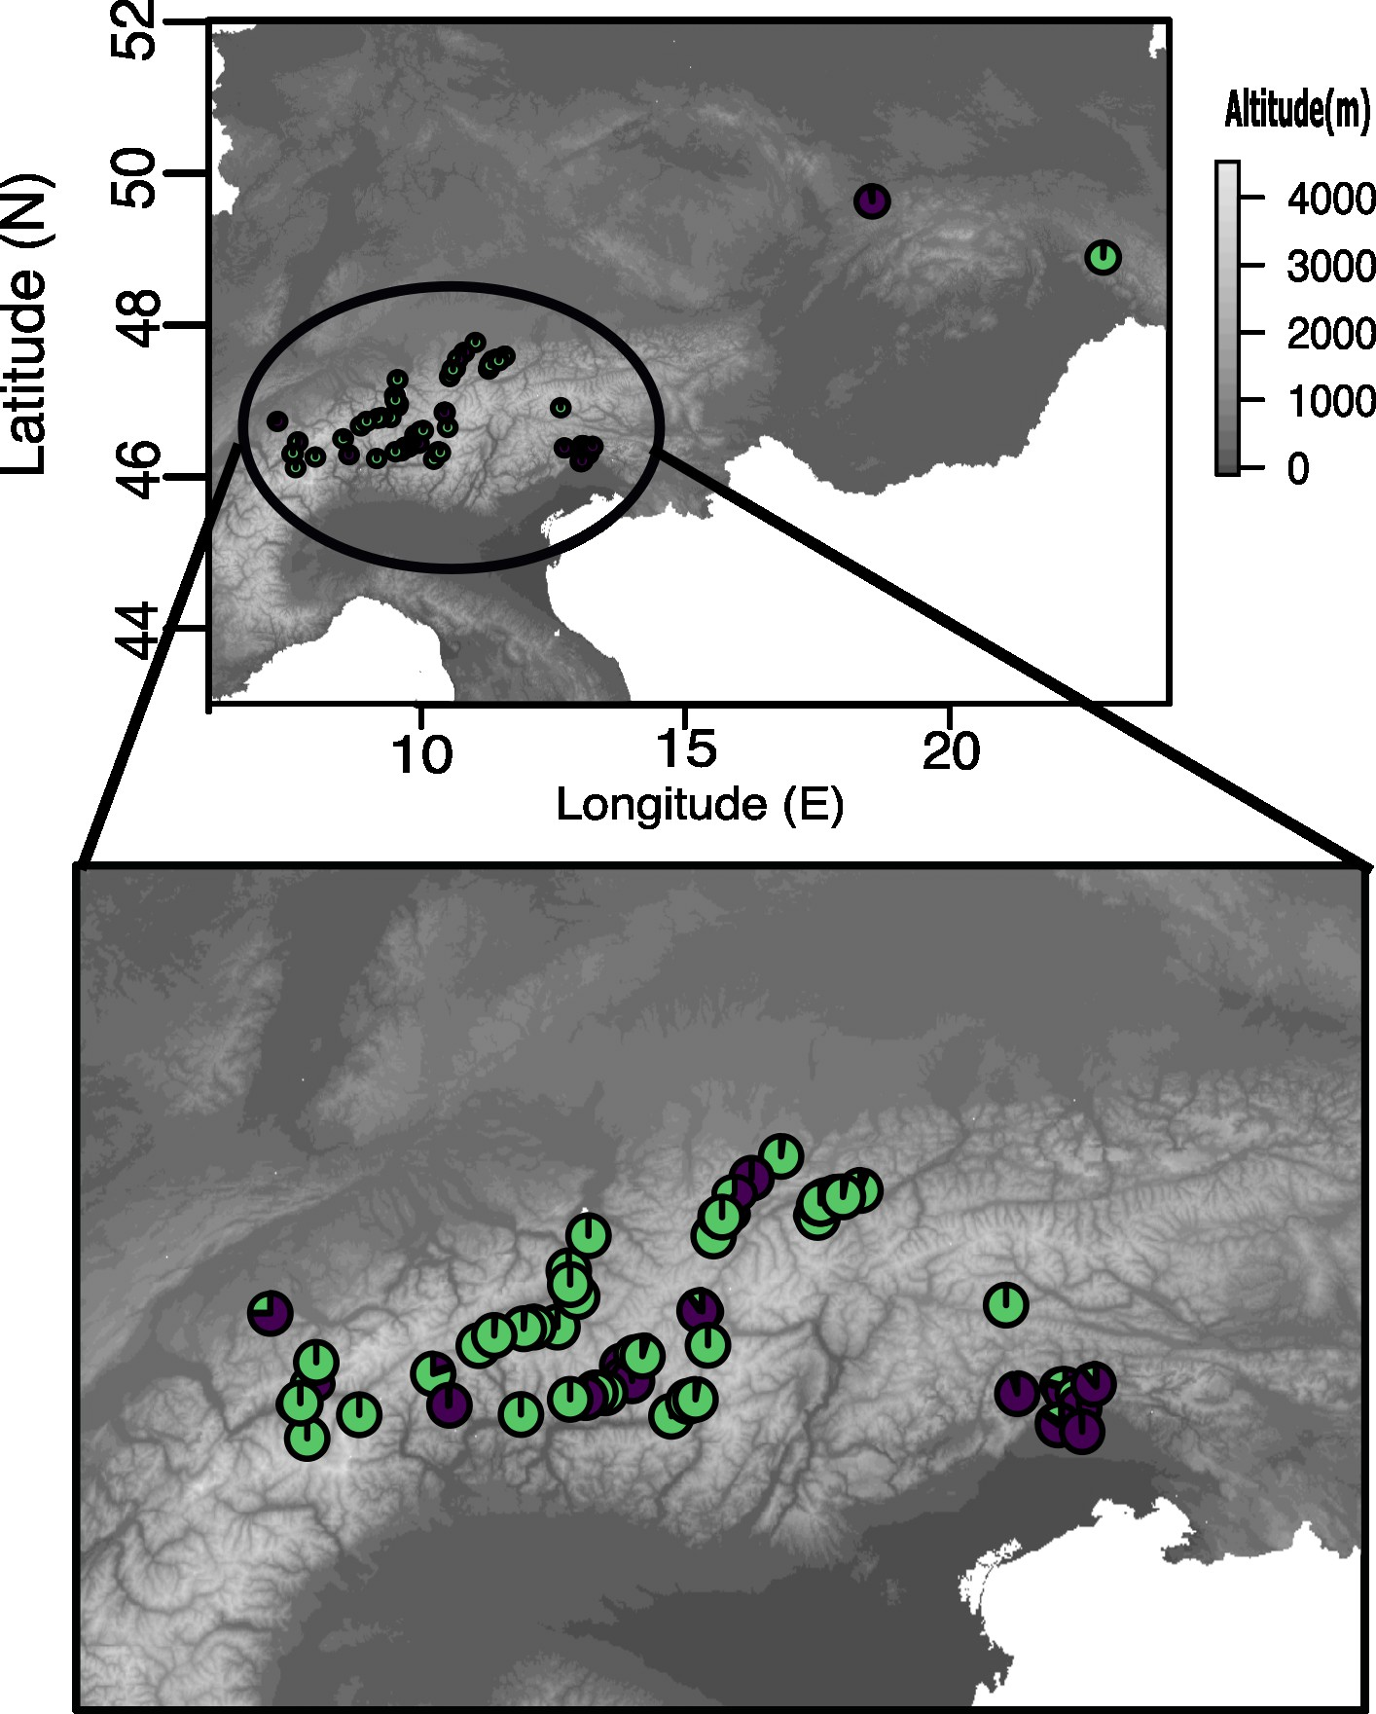
Figure S17. Geographic distribution and lineage assignments of M. germanica based on 6 chloroplast loci of the 67 populations from the 12 catchments. K1 is dark purple and K2 is dark green. The diagram represents the average of each proportion of assignment (Q) of the genetic groups for the population.

Figure S18. Isolation by distance among 67 populations of M.germanica based on 6 chloroplast loci. Pairwise genetic differentiation (linearized $F_{ST}=F_{ST}/(1-F_{ST})$) is plotted against geographic distance (km) between populations. The red line shows the linear regression fitted for visualization. Mantel test revealed a moderate but positive correlation between geographic and genetic distance (Mantel’s r = 0.22, p = 0.00001), demonstrating that geographical distance represents a barrier to gene flow for M. germanica.

Table S1. Characteristics of 20 nuclear microsatellite loci 67 M. germanica populations, based on 2212 individuals

Locus | Number of alleles | Frequency of null alleles | Ho | Hs | F_{IS} | F_{IT} | F_{ST}
Mg451 | 14 | 0.04 | 0.1954 | 0.3501 | 0.4419 | 0.5083 | 0.5049
Mg452 | 7 | 0.043 | 0.2044 | 0.2771 | 0.2621 | 0.6208 | 0.6175
Mg457 | 3 | 0.027 | 0.0738 | 0.1419 | 0.4798 | 0.6311 | 0.6278
Mg459 | 9 | 0.028 | 0.1731 | 0.2572 | 0.3269 | 0.5186 | 0.5152
Mg480 | 15 | 0.041 | 0.1681 | 0.2902 | 0.4208 | 0.5568 | 0.5533
Mg488 | 8 | 0.036 | 0.2583 | 0.3974 | 0.3501 | 0.4469 | 0.4434
Mg489 | 7 | 0.031 | 0.0432 | 0.0699 | 0.3818 | 0.8161 | 0.8140
Mg493 | 22 | 0.17 | 0.2248 | 0.3573 | 0.3707 | 0.5694 | 0.5659
Mg495 | 4 | 0.036 | 0.0721 | 0.1151 | 0.3738 | 0.7529 | 0.7503
Mg498 | 6 | 0.038 | 0.1183 | 0.2000 | 0.4086 | 0.6392 | 0.6359
Mg499 | 5 | 0.023 | 0.1974 | 0.3029 | 0.3483 | 0.3646 | 0.3614
Mg500 | 11 | 0.038 | 0.1237 | 0.2143 | 0.4230 | 0.6308 | 0.6276
Mg549 | 5 | 0.037 | 0.1862 | 0.2505 | 0.2568 | 0.6009 | 0.5975
Mg442 | 7 | 0.044 | 0.1786 | 0.2675 | 0.3324 | 0.6399 | 0.6367
Mg444 | 10 | 0.044 | 0.0672 | 0.1383 | 0.5140 | 0.7551 | 0.7525
Mg455 | 7 | 0.037 | 0.2054 | 0.3115 | 0.3408 | 0.5291 | 0.5256
Mg462 | 15 | 0.19 | 0.1352 | 0.2291 | 0.4097 | 0.6016 | 0.5983
Mg502 | 10 | 0.040 | 0.1573 | 0.2144 | 0.2663 | 0.4768 | 0.4733
Mg504 | 6 | 0.036 | 0.1754 | 0.2331 | 0.2473 | 0.6323 | 0.6291
Mg507 | 8 | 0.038 | 0.1374 | 0.1894 | 0.2744 | 0.6627 | 0.6596

Table S2. Characteristics of six chloroplast microsatellite loci for 67 M.germanica populations and 2212 individuals. Ho, observed heterozygosity, the Shannon-Wiener Diversity index; Hd, Haplotype diversity; F_{ST}, fixation index of subpopulation to total.

Locus | Number of alleles | Hd | F_{ST}
psbA | 9 | 0.6323 | 0.1495
psbC | 6 | 0.6408 | 0.1514
trnC1 | 2 | 0.5721 | 0.1100
trnC2 | 2 | 0.6128 | 0.1455
trnH | 7 | 0.6301 | 0.1568
trnL | 4 | 0.5838 | 0.1053

Table S3. Global analysis of molecular variance (AMOVA) with 20 nuclear loci, 67 populations and 2212 individuals of M. germanica. Df (degrees of freedom), SS (Sum of squares), MS (Mean square).

Source | Df | SS | MS | Sigma | % covariance
Among Pops | 66 | 6416 | 267.3 | 3.018 | 49
Within Pops | 2212 | 7010 | 3.1 | 3.095 | 51
Total | 2236 | 13426 |  | 6.113 | 100

Table S4. Global analysis of molecular variance (AMOVA) with 6 chloroplast loci, 67 populations and 2212 individuals of M. germanica. Df (degrees of freedom), SS (Sum of squares), MS (Mean square).

Source | Df | SS | MS | Est.Var | %
Among Pops | 66 | 3783 | 54.8 | 1.717 | 75.25
Within Pops | 2212 | 1213 | 0.6 | 0.565 | 24.75
Total | 2236 | 4996 |  | 2.281 | 100

Table S5. Pairwise relative migration probabilities among river catchments estimated from nuclear microsatellites using MIGRATE-n, using nine of the 12 river catchments. We excluded from the analysis three catchments that only contained data from one single population (Oder, Danube and Aare) as these had a different geographic extent of sampling than the remaining catchments.

 | Po | Isar | Lech | Inn | Drau | Rhine | Rhone | Adige | Tagliamento
Po | — | 0,54 | 0,62 | 0,38 | 0,63 | 0,39 | 0,26 | 0,28 | 0,71
Isar | 0,61 | — | 0,43 | 0,36 | 0,47 | 0,30 | 0,32 | 0,34 | 0,44
Lech | 0,50 | 0,35 | — | 0,50 | 0,44 | 0,69 | 0,56 | 0,37 | 0,44
Inn | 0,37 | 0,30 | 0,69 | — | 0,27 | 0,41 | 0,32 | 0,63 | 0,38
Drau | 0,57 | 0,46 | 0,52 | 0,32 | — | 0,52 | 0,60 | 0,73 | 0,40
Rhine | 0,62 | 0,35 | 0,35 | 0,25 | 0,81 | — | 0,29 | 0,22 | 0,66
Rhone | 0,34 | 0,49 | 0,42 | 0,84 | 0,45 | 0,23 | — | 0,50 | 0,59
Adige | 0,57 | 0,26 | 0,39 | 0,65 | 0,26 | 0,41 | 0,54 | — | 0,40
Tagliamento | 0,55 | 0,63 | 0,72 | 0,26 | 0,75 | 0,42 | 0,51 | 0,34 | —

Table S6. Population-Specific Estimates of Θ (Effective Population Size) from nuclear microsatellites by MIGRATE-N, using nine of the 12 river catchments. See Table S5 for further details.

Po | Θ (Effective Population Size)
Isar | 0.0997
Lech | 0.0997
Inn | 0.0997
Drau | 0.0997
Rhine | 0.0997
Rhone | 0.0997
Adige | 0.0982
Tagliamento | 0.0997
Po | 0.0961

Table S7. Pairwise relative migration probabilities among river catchments estimated from chloroplast microsatellites using MIGRATE-n, using nine of the 12 river catchments. See Table S5 for further details.

 | Po | Isar | Lech | Inn | Drau | Rhine | Rhone | Adige | Tagliamento
Po | — | 0,004 | 0,006 | 0,011 | 0,007 | 0,005 | 0,005 | 0,014 | 0,007
Isar | 0,013 | — | 0,005 | 0,008 | 0,003 | 0,004 | 0,005 | 0,010 | 0,006
Lech | 0,007 | 0,006 | — | 0,015 | 0,007 | 0,008 | 0,009 | 0,007 | 0,007
Inn | 0,014 | 0,008 | 0,010 | — | 0,011 | 0,011 | 0,008 | 0,012 | 0,010
Drau | 0,006 | 0,007 | 0,010 | 0,006 | — | 0,008 | 0,004 | 0,008 | 0,008
Rhine | 0,006 | 0,014 | 0,005 | 0,015 | 0,007 | — | 0,007 | 0,007 | 0,007
Rhone | 0,008 | 0,006 | 0,005 | 0,004 | 0,008 | 0,006 | — | 0,009 | 0,010
Adige | 0,004 | 0,009 | 0,010 | 0,005 | 0,011 | 0,011 | 0,006 | — | 0,004
Tagliamento | 0,012 | 0,004 | 0,008 | 0,005 | 0,008 | 0,013 | 0,012 | 0,009 | —

Table S8. Population-Specific Estimates of Θ (Effective Population Size) from chloroplast microsatellites by MIGRATE-N, using nine of the 12 river catchments. See Table S5 for further details.

Po | Θ (Effective Population Size)
Isar | 0.0996
Lech | 0.0997
Inn | 0.0996
Drau | 0.0997
Rhine | 0.0997
Rhone | 0.0995
Adige | 0.0962
Tagliamento | 0.0997
Po | 0.0949

Table S9. Pairwise relative migration probabilities among river catchments estimated from nuclear microsatellites using BA3.

 | Po | Isar | Oder | Lech | Inn | Drau | Aare | Rhine | Rhone | Adige | Tagliamento | Danube
Po | 0,688 | 0,012 | 0,033 | 0,013 | 0,011 | 0,036 | 0,027 | 0,013 | 0,024 | 0,031 | 0,008 | 0,038
Isar | 0,034 | 0,730 | 0,038 | 0,021 | 0,016 | 0,039 | 0,043 | 0,024 | 0,041 | 0,042 | 0,016 | 0,036
Oder | 0,001 | 0,001 | 0,674 | 0,001 | 0,010 | 0,006 | 0,004 | 0,001 | 0,003 | 0,006 | 0,001 | 0,008
Lech | 0,047 | 0,023 | 0,041 | 0,758 | 0,020 | 0,042 | 0,038 | 0,030 | 0,042 | 0,038 | 0,018 | 0,039
Inn | 0,069 | 0,043 | 0,041 | 0,021 | 0,779 | 0,047 | 0,047 | 0,025 | 0,046 | 0,049 | 0,033 | 0,046
Drau | 0,001 | 0,001 | 0,008 | 0,001 | 0,001 | 0,673 | 0,004 | 0,001 | 0,003 | 0,006 | 0,000 | 0,008
Aare | 0,013 | 0,006 | 0,023 | 0,006 | 0,005 | 0,022 | 0,694 | 0,005 | 0,013 | 0,022 | 0,004 | 0,026
Rhine | 0,080 | 0,035 | 0,045 | 0,036 | 0,045 | 0,044 | 0,041 | 0,844 | 0,056 | 0,045 | 0,015 | 0,043
Rhone | 0,016 | 0,008 | 0,032 | 0,009 | 0,008 | 0,027 | 0,023 | 0,008 | 0,699 | 0,028 | 0,008 | 0,027
Adige | 0,001 | 0,001 | 0,008 | 0,001 | 0,001 | 0,007 | 0,004 | 0,001 | 0,003 | 0,673 | 0,001 | 0,008
Tagliamento | 0,049 | 0,139 | 0,051 | 0,133 | 0,113 | 0,050 | 0,072 | 0,048 | 0,070 | 0,055 | 0,895 | 0,046
Danube | 0,001 | 0,001 | 0,008 | 0,001 | 0,001 | 0,007 | 0,004 | 0,001 | 0,003 | 0,006 | 0,001 | 0,675

