Supporting information
Sequential application of hydrothiolation and hydrosilylation reactions for the synthesis of new polyorganosiloxanes.
Frank I.V.^{1,2,*}, Krizhanovskiy I.N.¹, Tiulkin A.A.^{1,2}, Ratnikov A.K.¹, Manokhina E.A.¹, Temnikov M.N.¹, Anisimov A.A.^{1,2,**}

¹ Institute of Organoelement Compounds of the Russian, Academy of Sciences, Vavilov St. 28, 119991 Moscow, Russia
² Moscow Center for Advanced Studies, 20 Kulakova Str., 123592 Moscow, Russia
*ingafrank28@gmail.com
**anisimov.ineos@gmail.com

Table of contents
Synthesis of modifier with dioxaborolane protective group 3
Synthesis of divinyl-terminated polysiloxane with hydride groups distributed along the chain (compound 1) 5
Synthesis of polysiloxane with chain-distributed hydride and terminal thiophenyl fragments (compound 1.1) 10
Synthesis of polysiloxane with chain-distributed hydride and terminal trimethoxysilyl groups (compound 1.2) 15
Synthesis of polysiloxane with chain-distributed hydride and terminal perfluorinated fragments (compound 1.3) 20
Synthesis of polysiloxane with chain-distributed hydride and terminal dodecanethiol groups (compound 1.4) 26
Synthesis of polysiloxane with with chain-distributed PrOTMS and terminal thiophenyl fragments (compound 1.1.1). 31
Synthesis of polysiloxane with chain-distributed triethoxysilyl and terminal trimethoxysilyl groups (compound 1.2.1). 36
Synthesis of polysiloxane with chain-distributed phenylborone and terminal perfluorinated fragments (compound 1.3.1) 41
Synthesis of polysiloxane with chain-distributed polyethylene glycol and terminal perfluorinated fragments (compound 1.3.2) 48
Synthesis of polysiloxane with with chain-distributed PrOTMS and terminal dodecanethiol groups (compound 1.4.2). 53
Synthesis of hydride-terminated polysiloxane with vinyl groups distributed along the chain (compound 2) 55
Synthesis of hydride-terminated polysiloxane with dodecanethiol groups distributed along the chain (compound 2.1). 57

Synthesis of modifier with dioxaborolane protective group
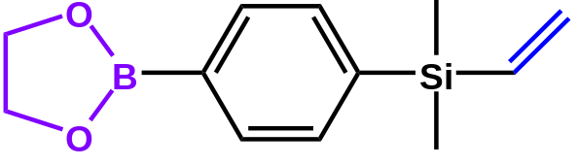
The synthesis and spectrum data of the phenylborone modifier can be found in the work [8].
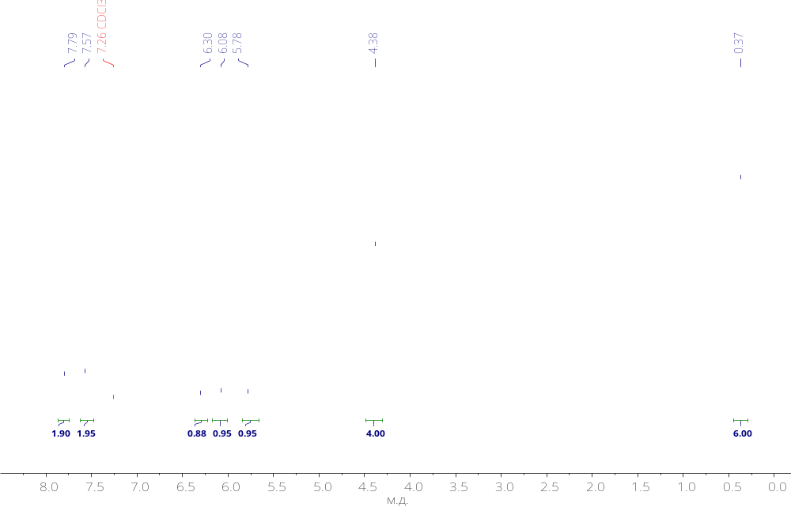
Figure S1. ¹H NMR spectrum of modifier with dioxaborolane protective group.
.

Synthesis of divinyl-terminated polysiloxane with hydride groups distributed along the chain (compound 1)
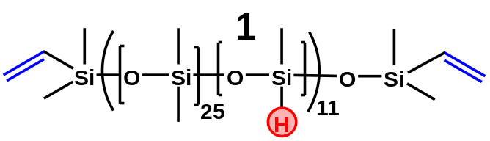
Octamethylcyclotetrasiloxane (14.17 g, 47.8 mmol), tetramethyltetracyclosiloxane (0.68g, 2.8 mmol) and tetramethyldivinyldisiloxane (0.15 g, 0.8 mmol) were loaded into a single-necked flask.
Polymerization was carried out in the block with stirring and a temperature of 80 ℃ for 8 hours. Purolite cation exchange resin (3 wt.% of the total mass of the mixture, 0.45 g) was used as a catalyst. After polymerization, the polymer was dissolved in toluene and filtered from Purolite through a folded filter. The polymer was re-precipitated by dissolving it in toluene and then ethanol was added dropwise (5 parts of ethanol per 1 toluene). After that, the polymer was evaporated at 1 mbar and 60 ℃ for 6 hours to constant weight.
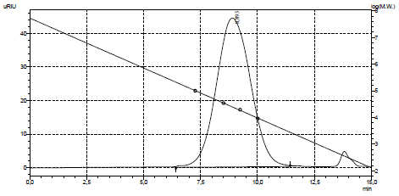
¹H: NMR (400 MHz, CDCl₃, δ/ppm, J/Hz) δ 6.13 (dd, J = 20.3, 14.9 Hz, 2H), 5.94 (dd, J = 14.8, 3.9 Hz, 2H), 5.74 (dd, J = 20.2, 4.0 Hz, 2H), 4.70 – 4.69 (m, 11H), 0.07 (s, 1414 H).
¹³C: NMR (101 MHz, CDCl₃) δ 138.72, 0.88.
²⁹Si: NMR (79 MHz, CDCl₃) δ -20.55, -21.93.
IR: 2964, 2906, 2157, 1412, 1261, 1078, 1022, 913, 865, 804, 704 cm⁻¹.
GPC: M_{n} = 19553, M_{w} = 28236, PDI = 1,44.

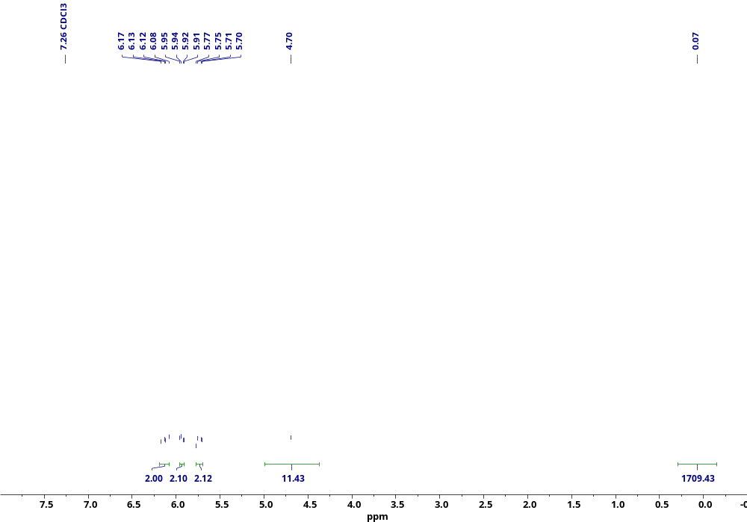
Figure S2. ¹H NMR spectrum of compound 1.
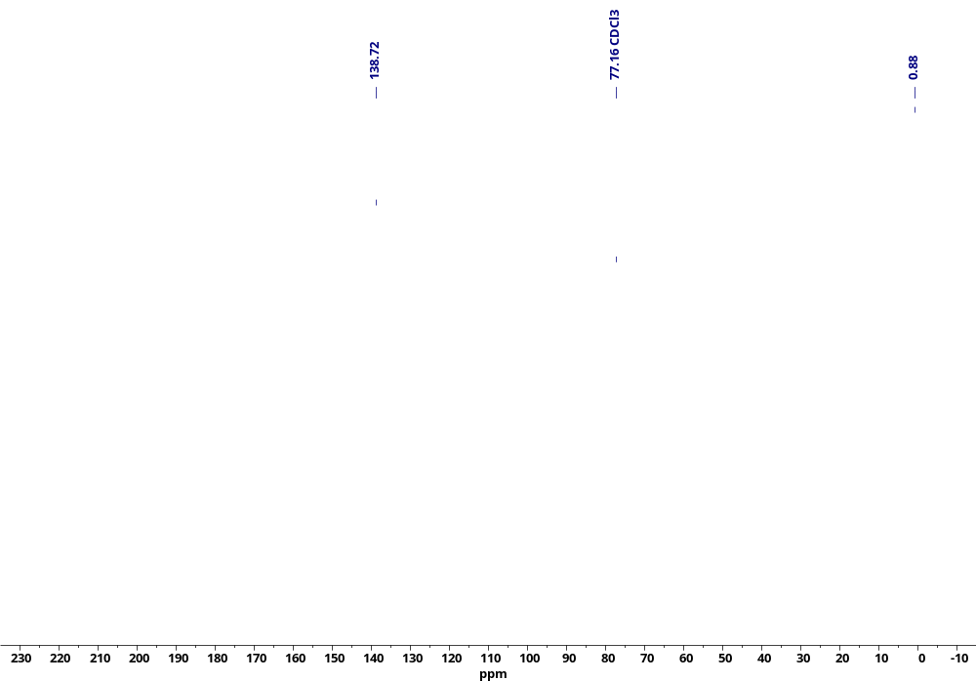
Figure S3. ¹³C NMR spectrum of compound 1.
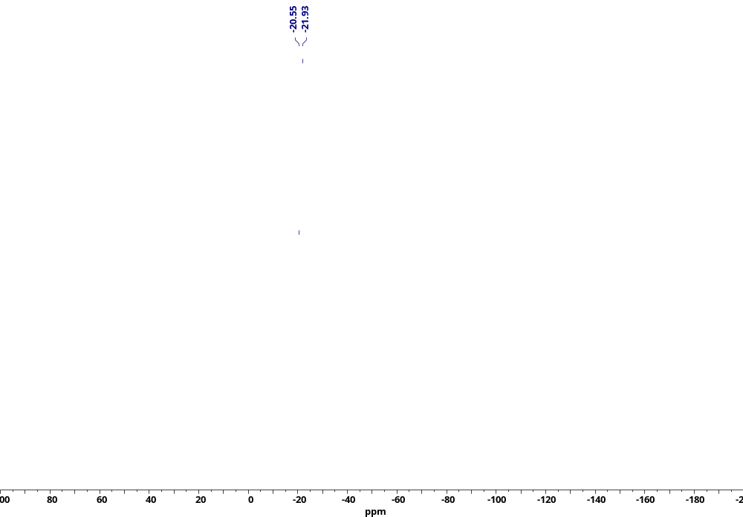
Figure S4. ²⁹Si NMR spectrum of compound 1.
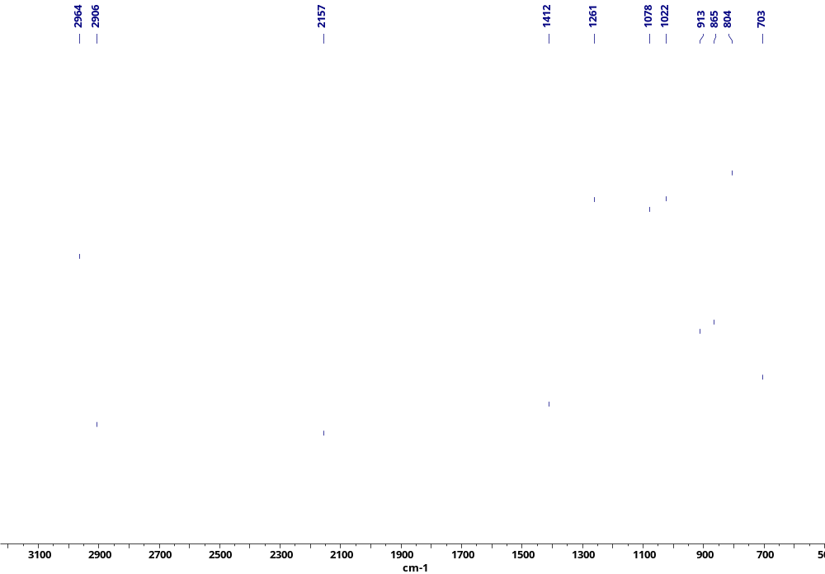
Figure S5. IR spectrum of compound 1.

Synthesis of polysiloxane with chain-distributed hydride and terminal thiophenyl fragments (compound 1.1)
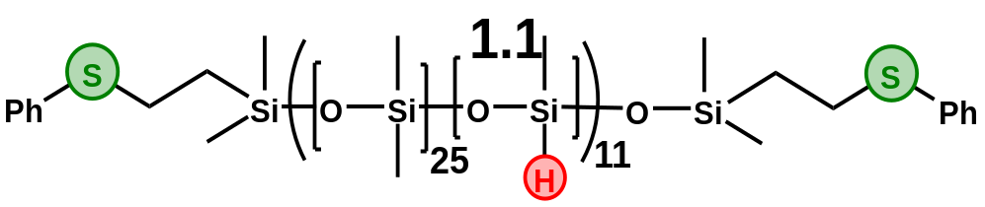
6 ml of dry deoxidized toluene was placed into a tube calcined and cooled under argon. 1 g (0.056 mol) of Polymer 1, phenylthiol (0.062 g, 0.56 mmol) and 20 mg of AIBN were loaded into the tube. The mixture was stirred for 8 hours at 85 ℃. After that, the product was re-precipitated as described for compound 1.2. After that, the product was re-precipitated as follows. 3 parts of dry acetonitrile were added to the polymer solution in toluene with stirring and left for a day (without stirring). This procedure was performed 3 times and then the product was evaporated at 1 mbar to constant weight and the yield of the target product after all re-precipitation operations was 75% (0.76 g).
¹H NMR (500 MHz, CDCl₃) δ 7.36 – 7.29 (m, 8H), 7.21 – 7.15 (m, 2H), 4.74 – 4.70 (m, 12H), 3.05 – 2.98 (m, 4H), 1.37 – 1.26 (m, 4H), 1.02 – 0.97 (m, 4H), 0.91 (t, J = 6.9 Hz, 4H), 0.19 – 0.03 (m, 1700H).
¹³C NMR (126 MHz, CDCl₃) δ 137.16, 128.94, 128.80, 125.64, 31.60, 28.72, 22.66, 18.46, 14.12, 9.31, 1.50 – -0.01.
²⁹Si NMR (79 MHz, CDCl₃) δ -20.56, -21.94.
IR: 2964, 2906, 2157, 1447, 1413, 1260, 1091, 1019, 913, 865, 799, 760, 703 cm⁻¹.
GPC: M_{n} = 18 kDa, M_{w} = 26 kDa, PDI = 1,5.

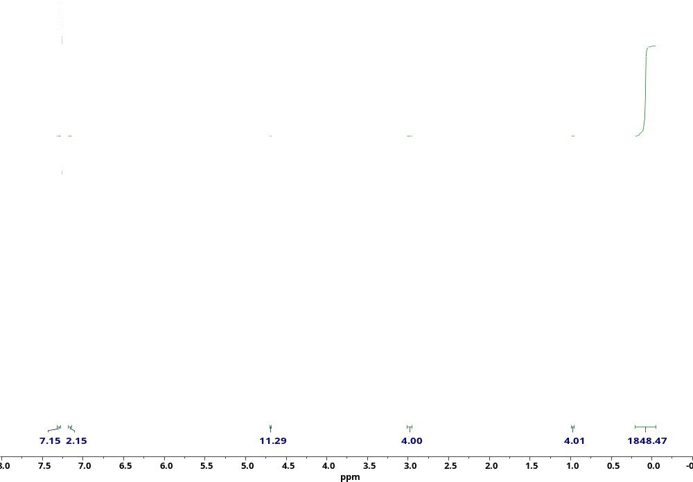
Figure S6. ¹H NMR spectrum of compound 1.1.
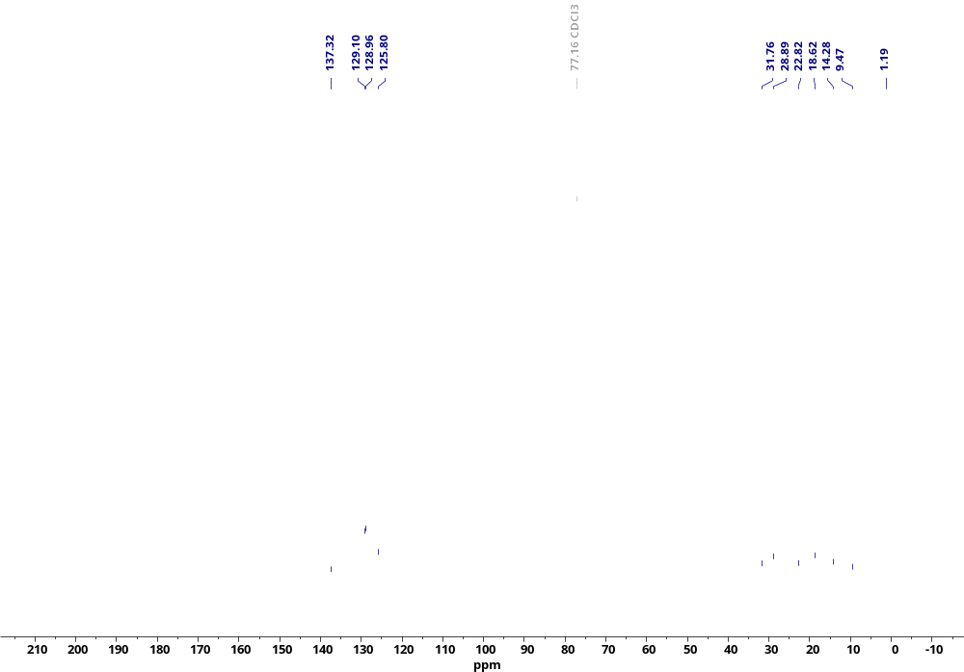
Figure S7. ¹³C NMR spectrum of compound 1.1.
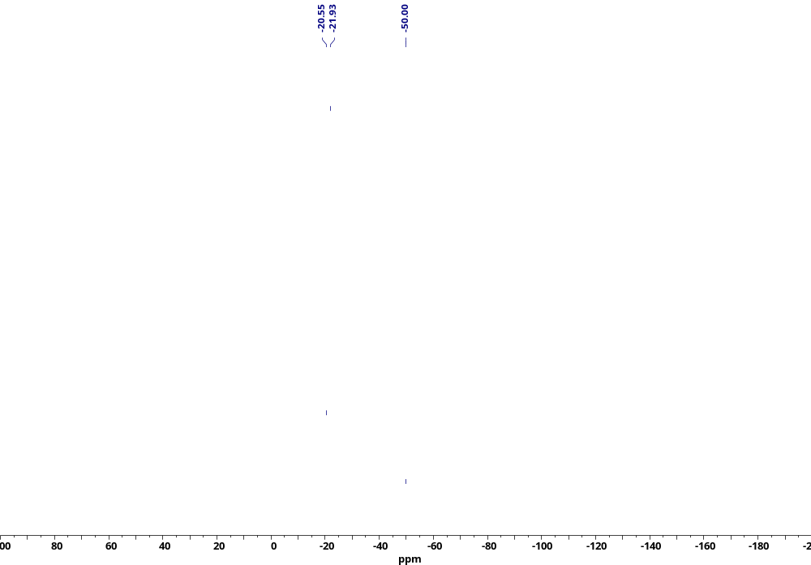
Figure S8. ²⁹Si NMR spectrum of compound 1.1.
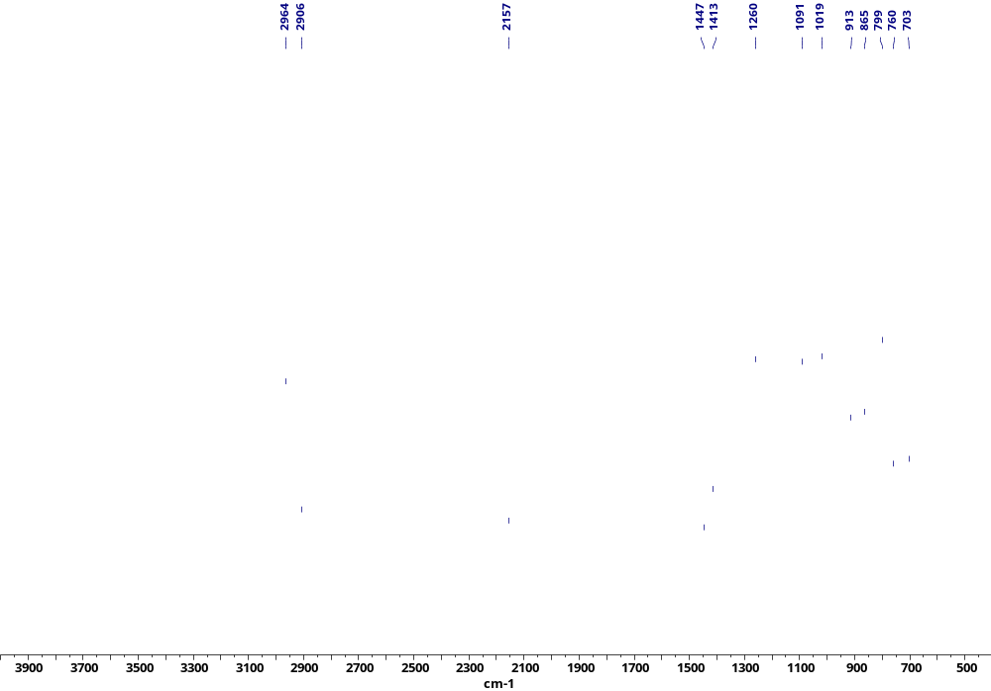
Figure S9. IR spectrum of compound 1.1.

Synthesis of polysiloxane with chain-distributed hydride and terminal trimethoxysilyl groups (compound 1.2)
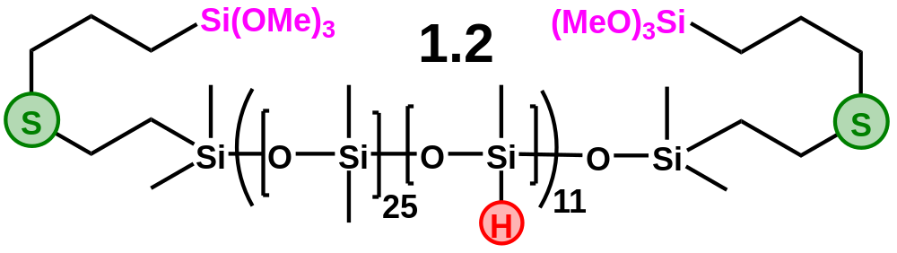
7 ml of dry deoxidized toluene was placed in a tube calcined and cooled under argon. 1 g (0.056 mol) of Polymer 1, (3-mercaptopropyl) trimethoxysilane (0.11 g, 0.56 mmol) and 20 mg AIBN were loaded into the tube. After that, the product was re-precipitated as described for compound 1.1. This procedure was performed 3 times and then the product was evaporated at 1 mbar to constant weight. The yield of the target product after all re-precipitation operations was 69% (0.7 g).
¹H NMR (400 MHz, CDCl₃, δ/ppm, J/Hz) δ 4.69 (s, 11H), 3.57 (s, 18H), 2.56 (q, J = 8.0, 7.0 Hz, 8H), 1.75 – 1.48 (m, 4H), 0.93 – 0.85 (m, 4H), 0.80 – 0.70 (m, 4H), 0.08 (s, 1414H).
¹³C NMR (101 MHz, CDCl₃) δ 50.67, 35.01, 23.05, 8.81, 1.01.
²⁹Si NMR (79 MHz, CDCl₃) δ -20.56, -21.94.
IR: 2963, 2906, 2841, 2156, 1447, 1412, 1261, 1093, 1020, 912, 865, 800, 759, 703, 688, 668 cm⁻¹.
GPC: M_{n} = 24 kDa, M_{w} = 34 kDa, PDI = 1,4.

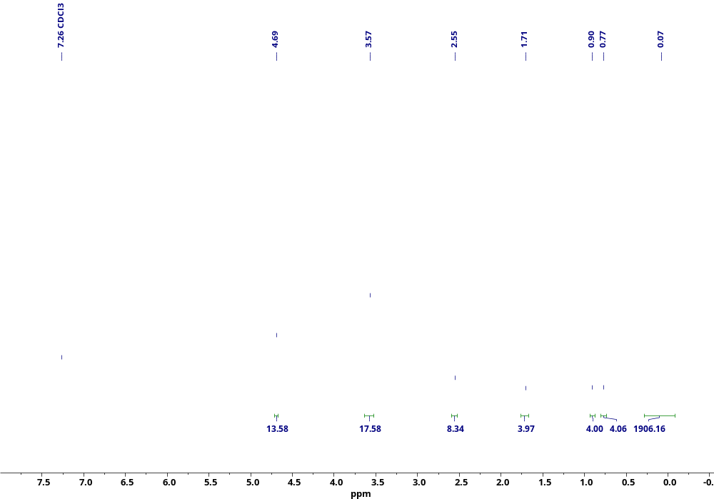
Figure S10. ¹H NMR spectrum of compound 1.2.
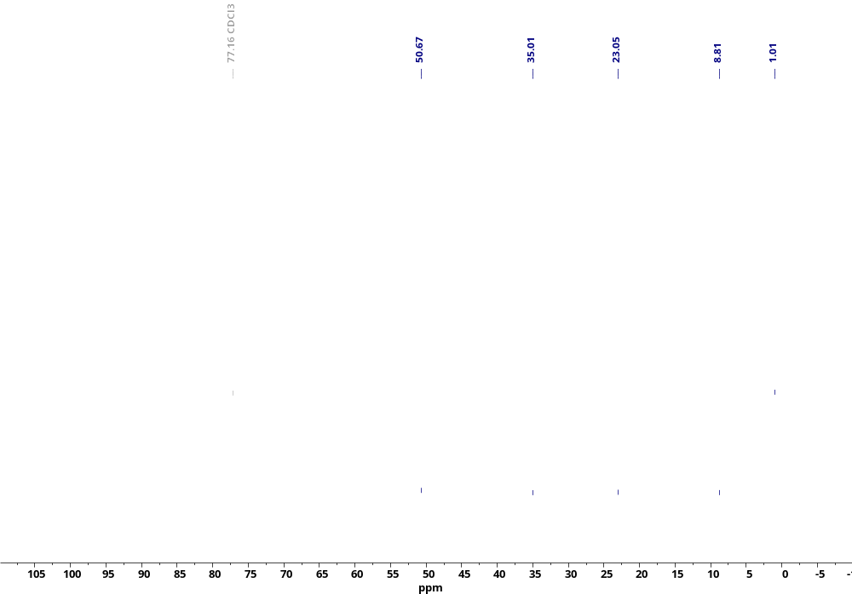
Figure S11. ¹³C NMR spectrum of compound 1.2.
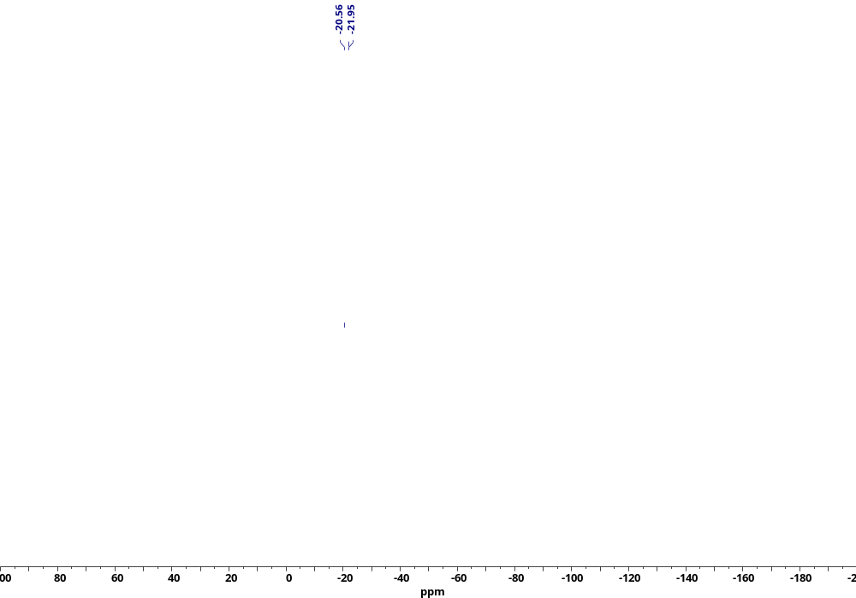
Figure S12. ²⁹Si NMR spectrum of compound 1.2.
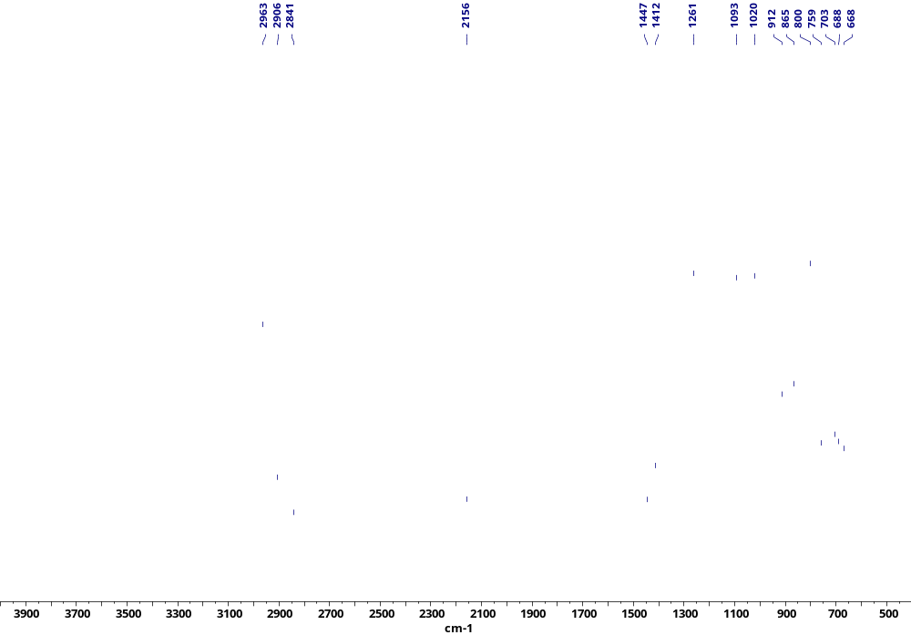
Figure S13. IR spectrum of compound 1.2.

Synthesis of polysiloxane with chain-distributed hydride and terminal perfluorinated fragments (compound 1.3)
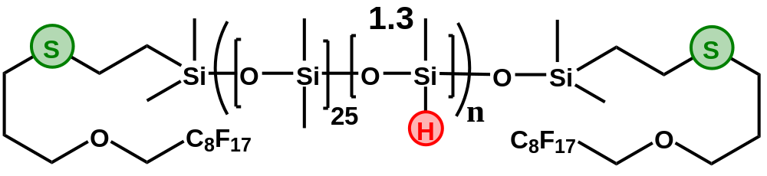
6 ml of dry deoxidized toluene was loaded into a tube calcined and cooled under argon. 0.5 g (0.028 mmol) of Polymer 1, compound 8’ (0.120 g, 0.229 mmol) and 15 mg of AIBN were loaded into the tube. The mixture was stirred for 8 hours at 85 ℃. After that, the product was re-precipitated as described for compound 1.1. The product was evaporated at 1 mbar to constant weight and the yield of the target product after all re-precipitation operations was 72% (0.38 g).
¹H NMR (400 MHz, cdcl₃) δ 4.71 – 4.62 (m, 12H), 3.92 (t, J = 13.8 Hz, 4H), 3.68 (t, J = 6.1 Hz, 4H), 2.65 – 2.49 (m, 4H), 1.85 (dd, J = 13.1, 6.9 Hz, 4H), 0.93 – 0.83 (m, 4H), 0.22 – -0.11 (m, 1500H).
¹³C NMR (101 MHz, CDCl₃) δ 71.48, 29.35, 27.95, 1.49 – 0.39.
¹⁹F NMR (471 MHz, CDCl₃) δ -80.72, -119.56, -121.98, -122.71, -123.36, -126.11.
²⁹Si NMR (79 MHz, CDCl₃) δ -20.60, -21.66 – -22.09.
IR: 2964, 2906, 2157, 1413, 1262, 1217, 1094, 1023, 913, 865, 800, 705, 662 cm⁻¹.
GPC: M_{n} = 20 kDa, M_{w} = 29 kDa, PDI = 1,4.

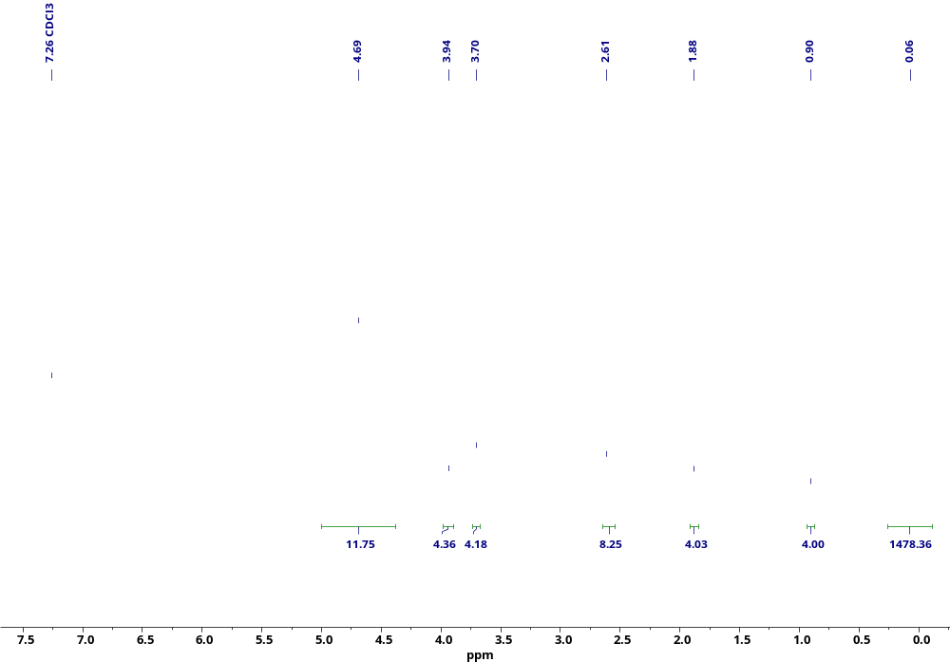
Figure S14. ¹H NMR spectrum of compound 1.3.
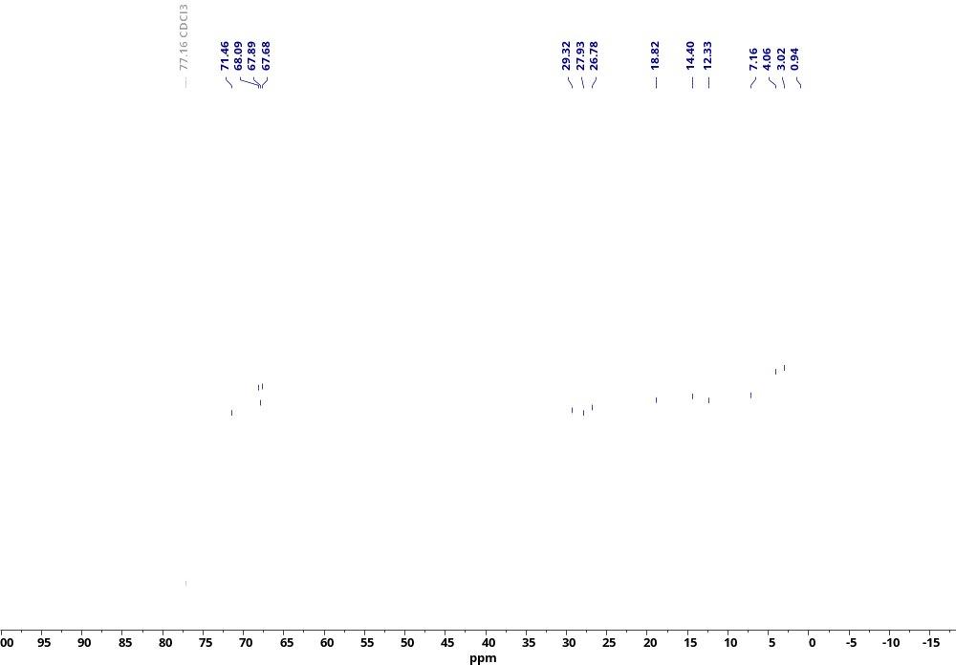
Figure S15. ¹³C NMR spectrum of compound 1.3.
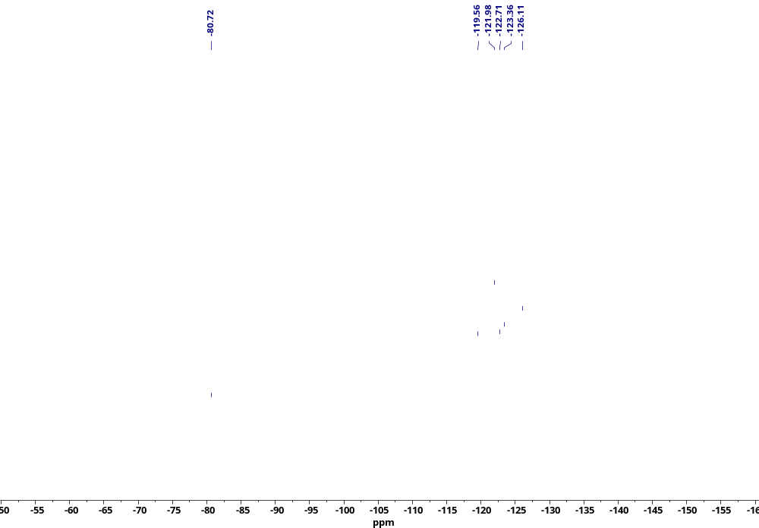
Figure S16. ¹⁹F NMR spectrum of compound 1.3.
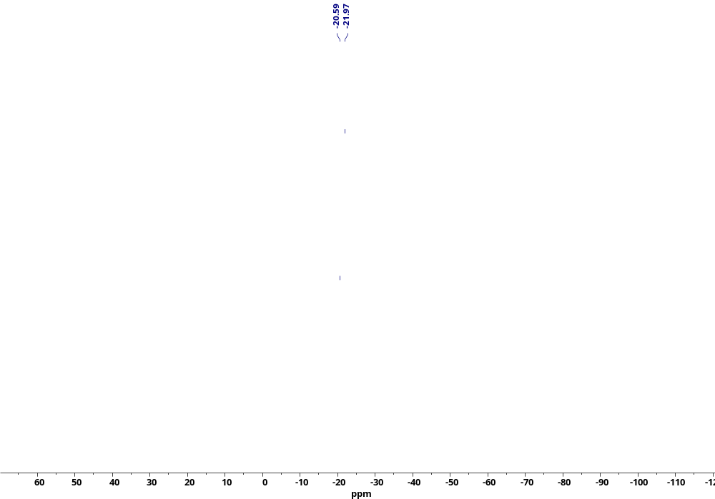
Figure S17. ²⁹Si NMR spectrum of compound 1.3.
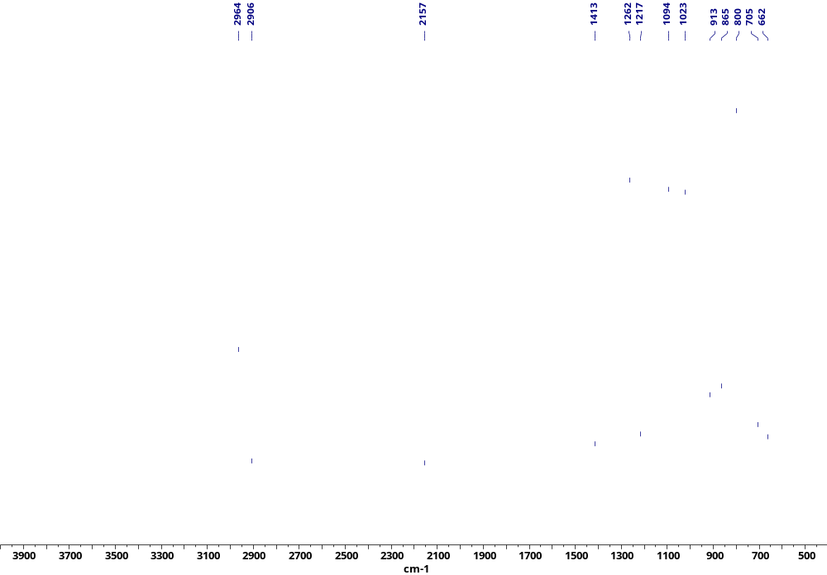
Figure S18. IR spectrum of compound 1.3.

Synthesis of polysiloxane with chain-distributed hydride and terminal dodecanethiol groups (compound 1.4)
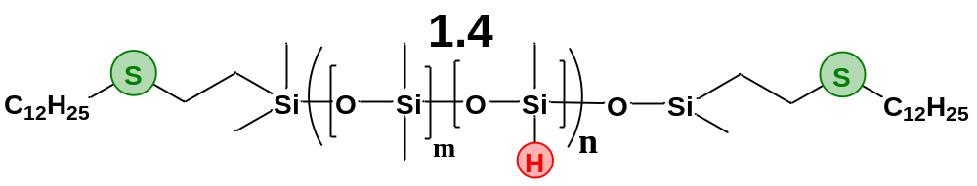
6 ml of dry deoxidized toluene was placed into a tube calcined and cooled under argon. 1 g (0.056 mmol) of Polymer 1, 1-dodecanethiol (0.113g, 0.56mmol) and 5.5 mg of AIBN were loaded into the tube. The mixture was stirred for 4 hours at 85°C. After the compound was re-precipitated as described for compound 1.1. The product was evaporated at 1 mbar to constant weight and the yield of the target product after all re-precipitation operations was 75% (0.767 g).
¹H NMR (600 MHz, Chloroform-d) δ 4.76 – 4.60 (m, 18H), 2.61 – 2.55 (m, 4H), 2.52 (t, J = 36.7, 33.1 Hz, 4H), 1.63 – 1.54 (m, 7H), 1.42 – 1.34 (m, 4H), 1.27 (m, 38H), 0.89 (m, 10H), 0.49 – -0.36 (m, 2477H).
¹³C NMR (101 MHz, Chloroform-d) δ 32.13, 29.83, 22.88, 1.21.
²⁹Si NMR (119 MHz, Chloroform-d) δ 5.96, -20.56, -21.65, -21.94, -37.58.
FTIR: 2970, 2913, 2862, 2161, 1448, 1413, 1264, 1102, 1025, 914, 867, 807
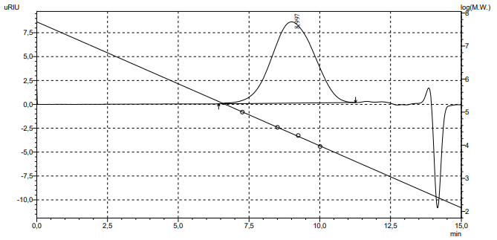
GPC: 78% – Mn = 18.4 kDa, Mw = 26.2 kDa, PDI = 1.4

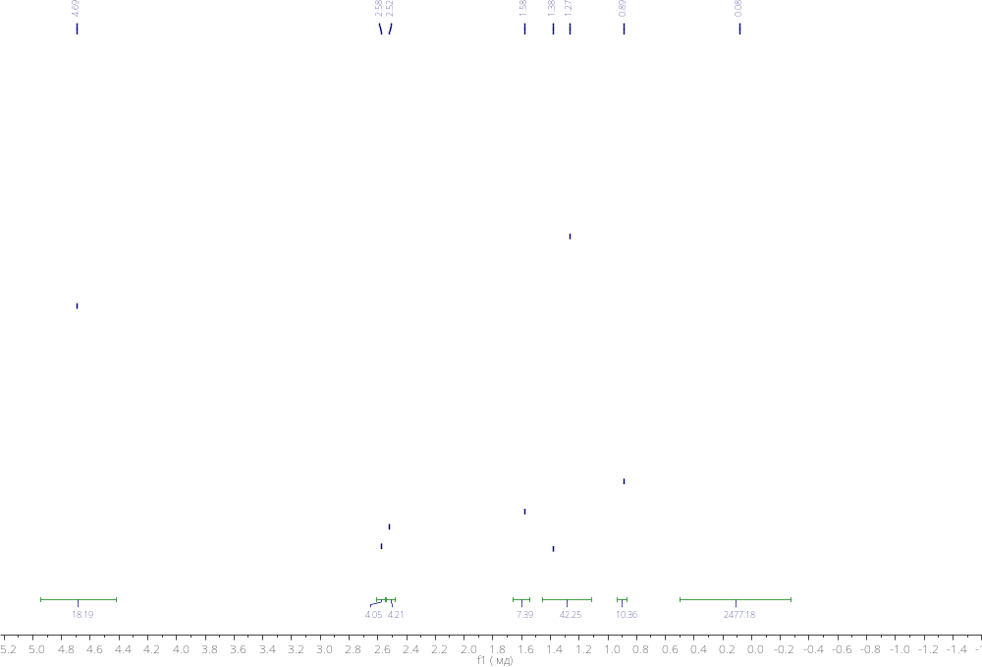
Figure S19. ¹H NMR spectrum of compound 1.4.
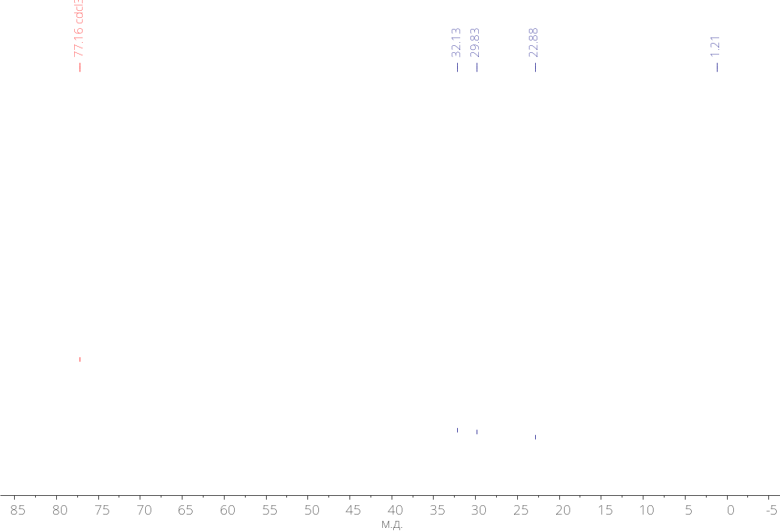
Figure S20. ¹³C NMR spectra of compound 1.4.
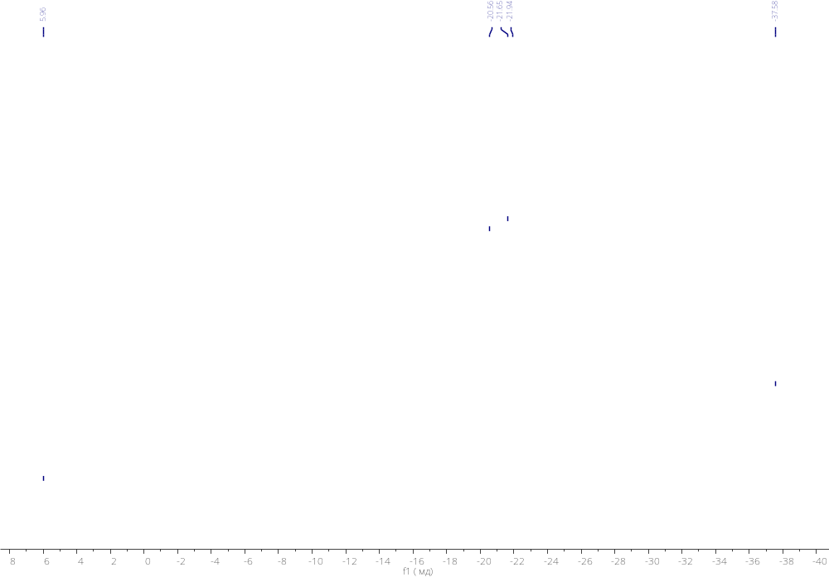
Figure S21. ²⁹Si NMR spectrum of compound 1.4.
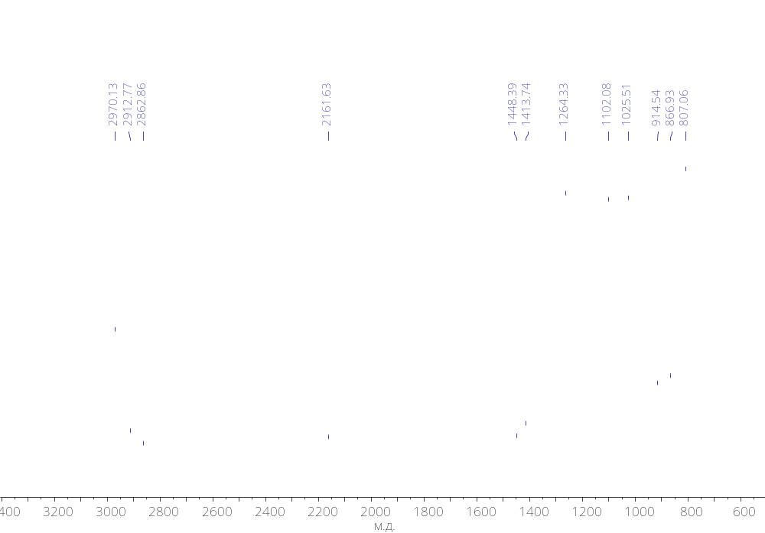
Figure S22. IR spectrum of compound 1.4.

Synthesis of polysiloxane with with chain-distributed PrOTMS and terminal thiophenyl fragments (compound 1.1.1).
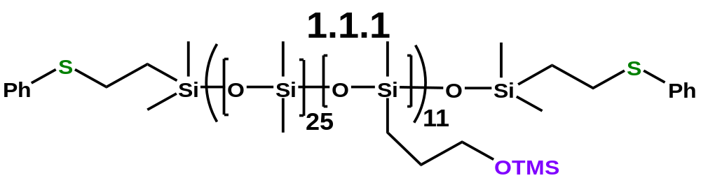
A mixture of compound 1.1 (301 mg, 0.017 mmol), Allyl-OTMS (119 mg, 0.913 mmol) and Karstedt’s catalyst (0.5 wt% [Pt] relative to Si-H groups) in dry toluene (4.5 ml) was mixed for 7 days at 80 °C. The Si-H conversion was >95% with a β-adduct selectivity of at least 95%. After that, the product was re-precipitated as described for compound 1.1. The product was evaporated at 1 mbar to constant weight and the yield of the target product after all re-precipitation operations was 76% (247 mg).
¹H NMR (400 MHz, CDCl₃) δ 7.31 – 7.25 (m, 8H), 7.17 – 7.12 (m, 2H), 3.50 (t, J = 7.0 Hz, 19H), 3.01 – 2.93 (m, 4H), 1.61 – 1.49 (m, 22H), 1.00 – 0.92 (m, 4H), 0.50 – 0.41 (m, 21H), 0.26 – -0.12 (m, 1300H).
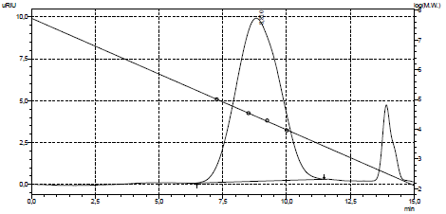
¹³C NMR (101 MHz, CDCl₃) δ 129.03, 125.81, 65.55, 38.33, 29.12, 26.49, 18.50, 13.35, 1.21, -0.38.
²⁹Si NMR (79 MHz, CDCl₃) δ 16.73, -21.95.
IR: 2965, 2905, 1445, 1413, 1260, 1090, 1017, 922, 865, 796, 703, 689, 662 cm⁻¹.
GPC: 78% – Mn = 20 kDa, Mw = 31 kDa, PDI = 1.5

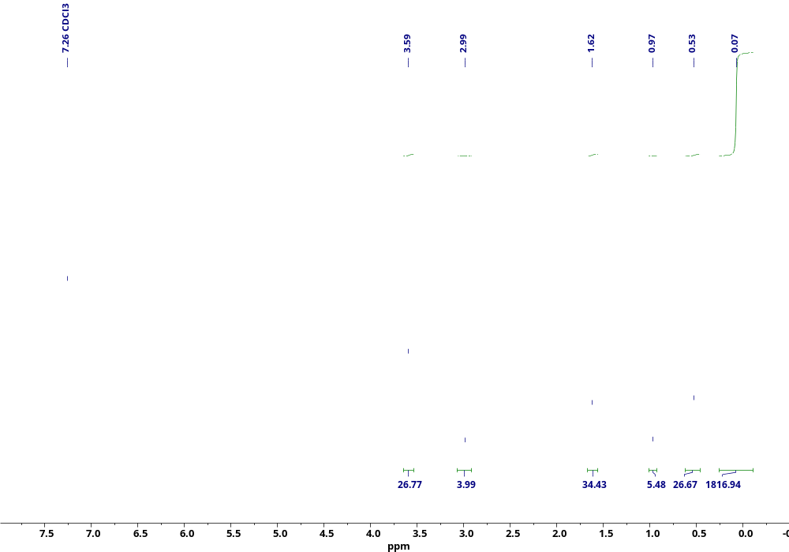
Figure S23. ¹H NMR spectrum of compound 1.1.1.
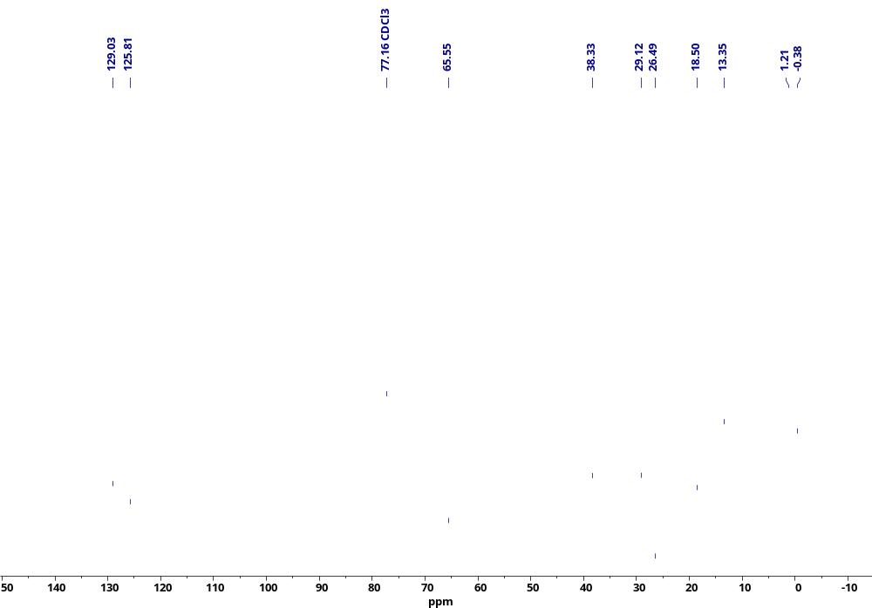
Figure S24. ¹³C NMR spectrum of compound 1.1.1.
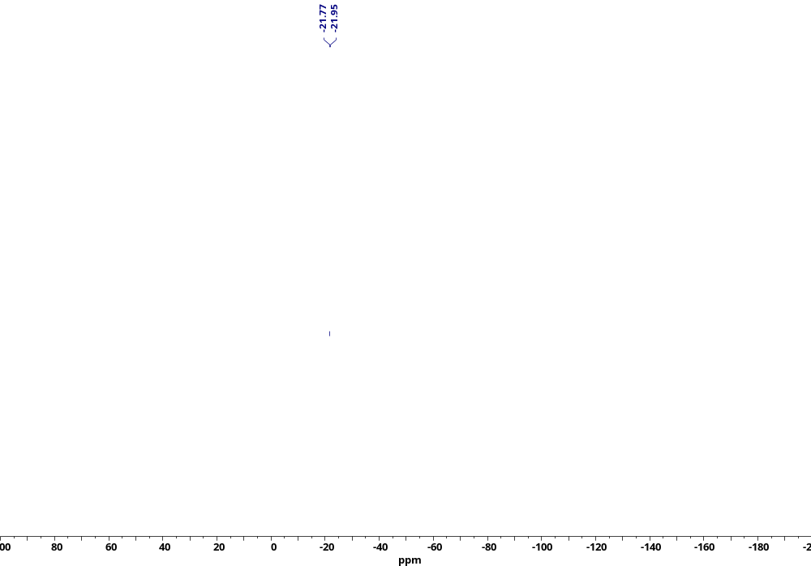
Figure S25. ²⁹Si NMR spectrum of compound 1.1.1.
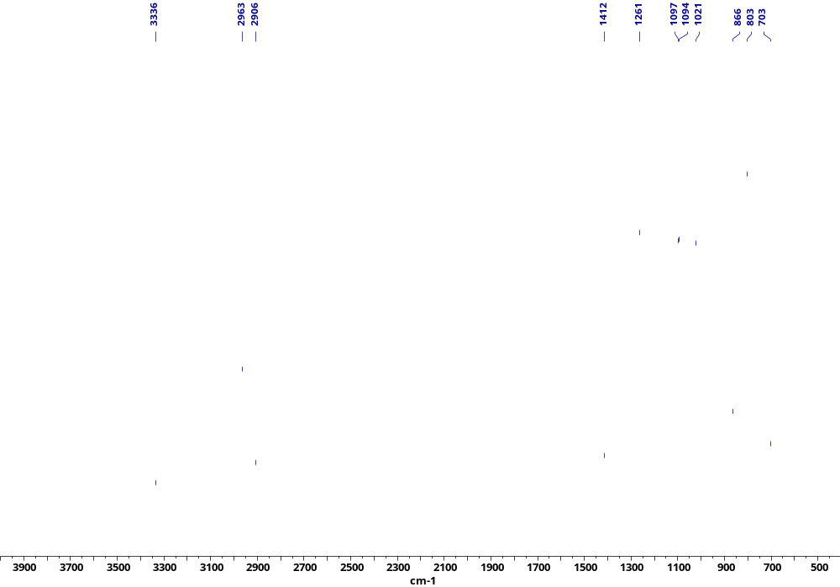
Figure S26. IR spectrum of compound 1.1.1.

Synthesis of polysiloxane with chain-distributed triethoxysilyl and terminal trimethoxysilyl groups (compound 1.2.1).
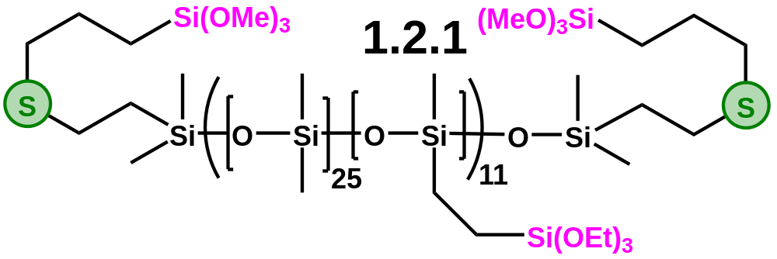
A mixture of compound 1.2 (428 mg, 0.023 mmol), vinyltriethoxysilane (0.049 mg, 0.256 mmol) and Karstedt’s catalyst (0.25 wt% [Pt] relative to Si-H groups) in dry toluene (4.5 ml) was mixed for 7 days at 80 °C. The Si-H conversion was >90% with a β-adduct selectivity of at least 95%. After that, the product was re-precipitated as described for compound 1.1. The product was evaporated at 1 mbar to constant weight and the yield of the target product after all re-precipitation operations was 67% (0.32 g, including a higher molecular weight fraction).
¹H NMR (500 MHz, CDCl₃) δ 3.83 (q, J = 7.0 Hz, 69H), 3.59 (s, 17H), 2.61 – 2.54 (m, 8H), 1.77 – 1.68 (m, 4H), 1.28 – 1.19 (m, 100H), 0.95 – 0.88 (m, 4H), 0.82 – 0.76 (m, 4H), 0.63 – 0.51 (m, 42H), 0.23 – -0.05 (m, 1570H).
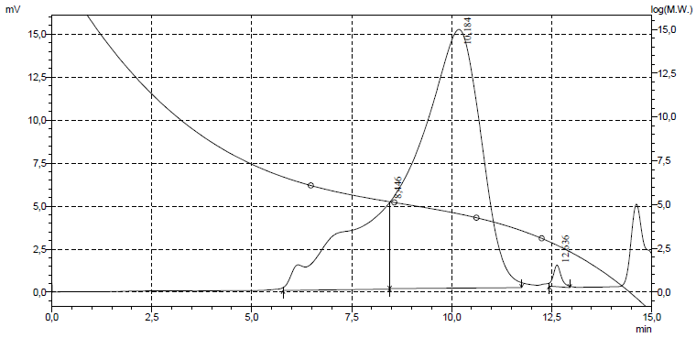
¹³C NMR (126 MHz, CDCl₃) δ 58.32, 50.51, 34.84, 26.67, 22.88, 19.03, 18.29, 8.64, 8.36, 1.61, 1.27 – 0.81, 0.18, -1.42.
²⁹Si NMR (79 MHz, CDCl₃) δ 22.03, -44.56, -96.62.
IR: 2964, 2928, 2905, 1445, 1412, 1261, 1165, 1095, 1021, 959, 864, 801, 703, 662 cm⁻¹.
GPC: 78% – M_{n} = 29 kDa, M_{w} = 47 kDa, PDI = 1.6; 22% (high molecular fraction) – M_{n} = 311 kDa, M_{w} = 551 kDa, PDI = 1.8.

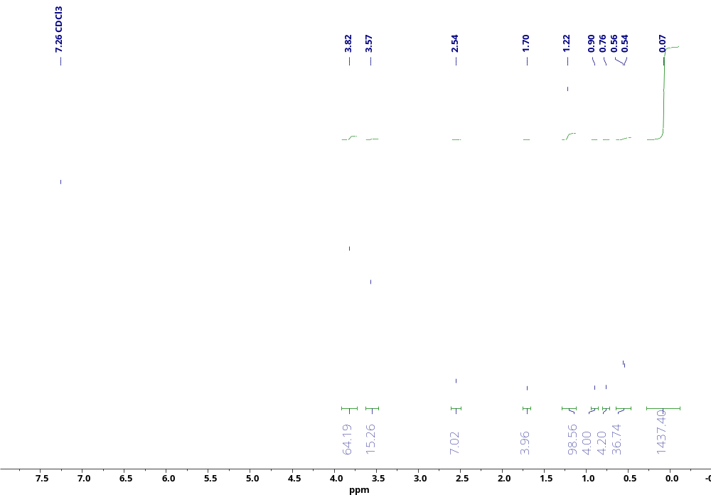
Figure S27. ¹H NMR spectrum of compound 1.2.1.
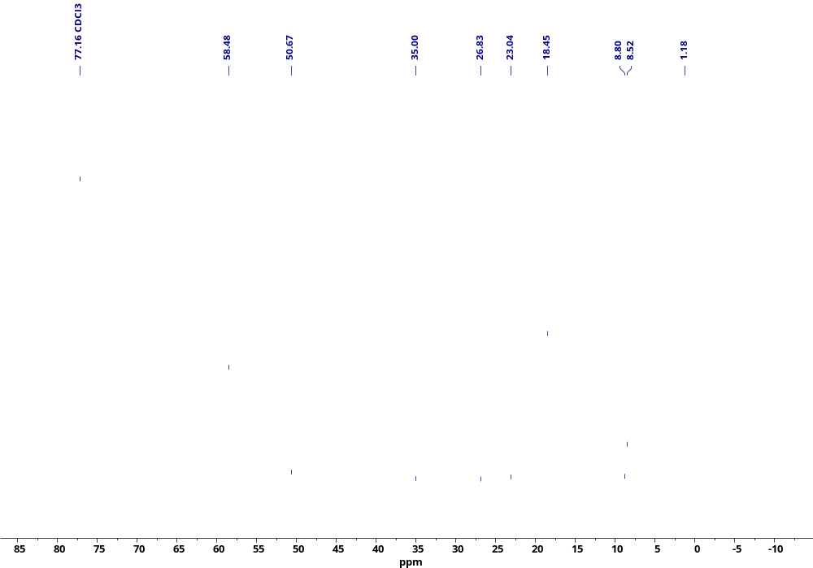
Figure S28. ¹³C NMR spectrum of compound 1.2.1.
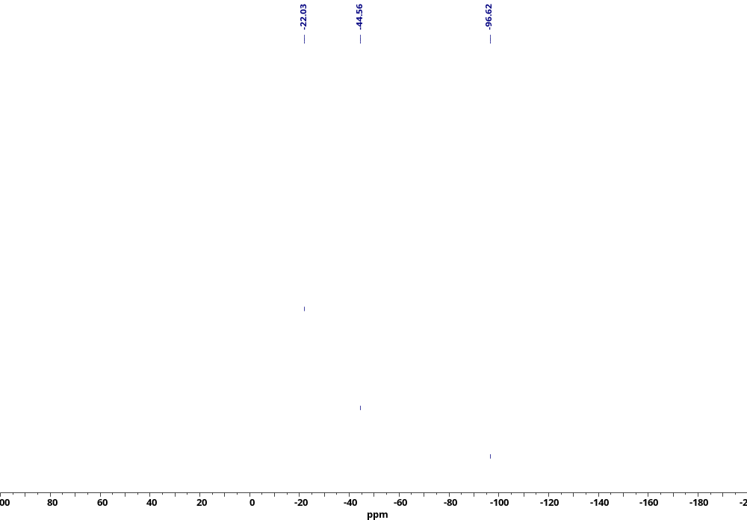
Figure S29. ²⁹Si NMR spectrum of compound 1.2.1.
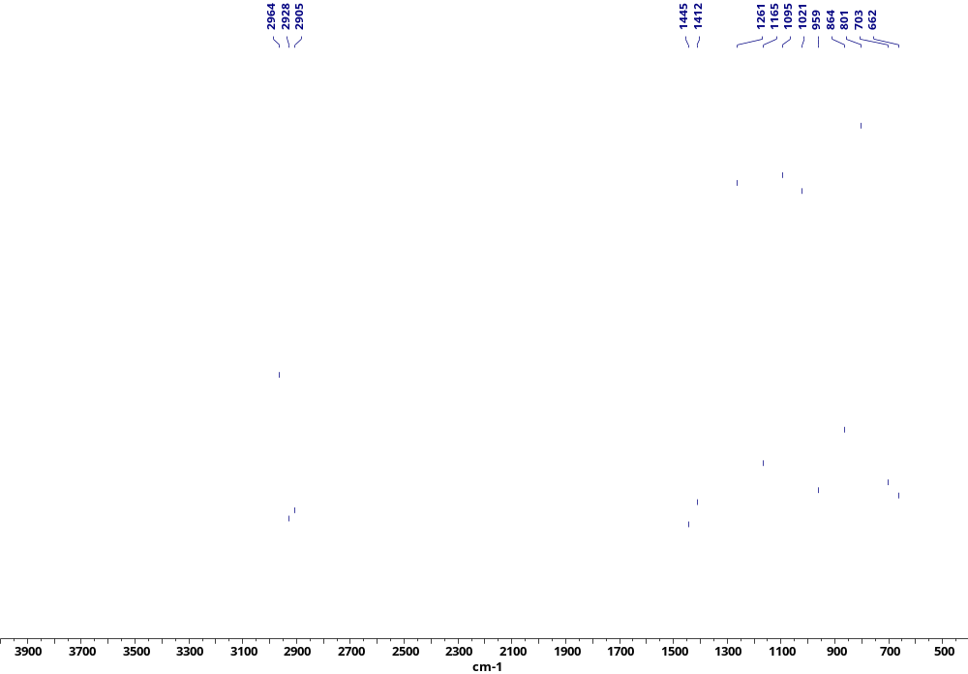
Figure S30. IR spectrum of compound 1.2.1.

Synthesis of polysiloxane with chain-distributed phenylborone and terminal perfluorinated fragments (compound 1.3.1)
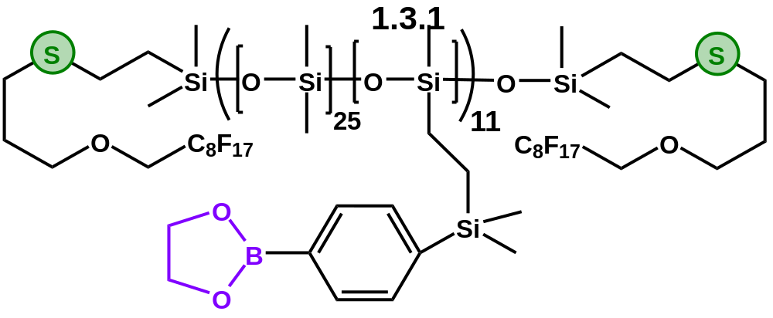
A mixture of compound 1.3 (176 mg, 0.009 mmol), modifier with dioxaborolane protective group (25 mg, 0.11 mmol) and Karstedt’s catalyst (0.25 wt% [Pt] relative to Si-H groups) in dry toluene (3.5 ml) was mixed for 7 days at 30 °C. The Si-H conversion was >95% with a β-adduct selectivity of at least 95%. Since the modifier was used in an equimolar amount, the product was not re–precipitated (the content of the unreacted modifier did not exceed 5%). The product yield was 90% (190 mg). The GPC of this polymer is absent due to very strong interchain interactions and the high viscosity of diluted solutions.
¹H NMR (500 MHz, CDCl₃) δ 7.78 (d, J = 6.8 Hz, 20H), 7.53 (d, J = 7.4 Hz, 21H), 4.38 (s, 43H), 3.94 (t, J = 13.7 Hz, 4H), 3.71 (t, J = 6.0 Hz, 4H), 2.65 – 2.54 (m, 8H), 1.93 – 1.83 (m, 4H), 0.94 – 0.88 (m, 4H), 0.75 – 0.67 (m, 22H), 0.45 – 0.37 (m, 23H), 0.26 (s, 65H), 0.08 (s, 1400H).
¹¹B NMR (160 MHz, CDCl₃) δ 31.63.
¹³C NMR (126 MHz, CDCl₃) δ 143.64, 134.03, 133.20, 129.20, 128.39, 125.47, 71.70, 66.15, 29.56, 28.16, 27.03, 21.61, 19.06, 9.55, 7.85, 6.92, 1.68 – 0.04, -1.18, -3.57.
¹⁹F NMR (471 MHz, CDCl₃) δ -80.76, -119.54, -121.74 – -122.15, -122.70, -123.35, -126.10.
²⁹Si NMR (79 MHz, CDCl₃) δ -1.09, -21.94.
IR: 3062, 2964, 2908, 1604, 1503, 1399, 1375, 1341, 1260, 1215, 1082, 1019, 941, 863, 810, 807, 802, 795, 706 cm⁻¹.

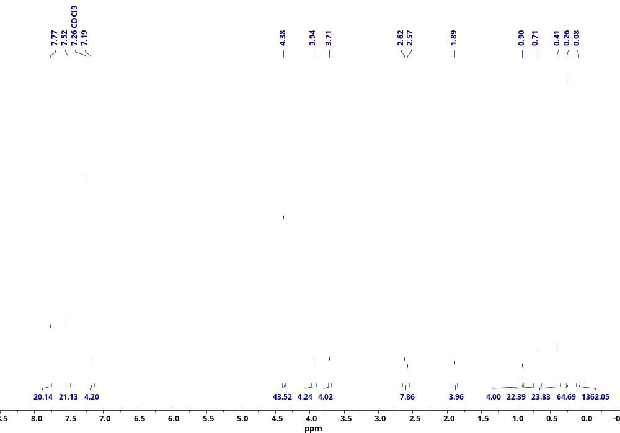
Figure S31. ¹H NMR spectrum of compound 1.3.1.
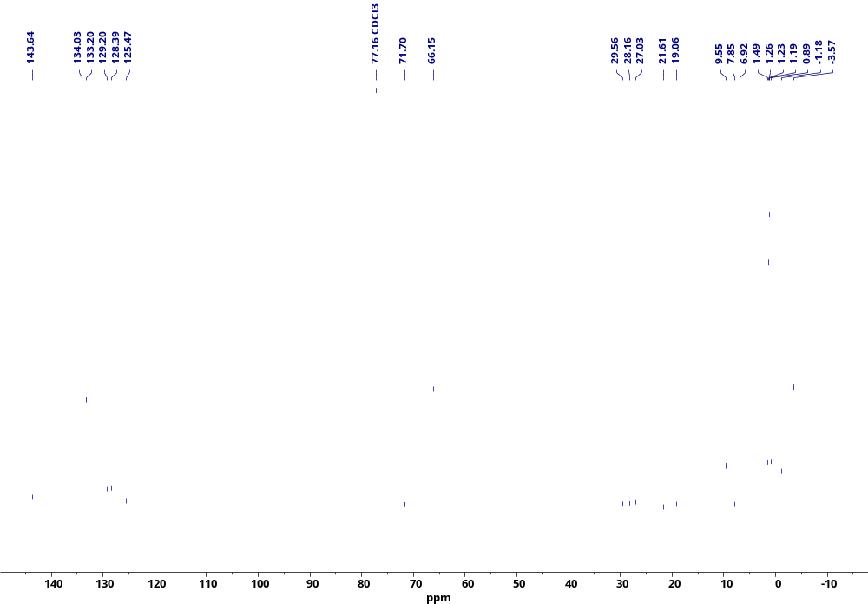
Figure S32. ¹³C NMR spectrum of compound 1.3.1.
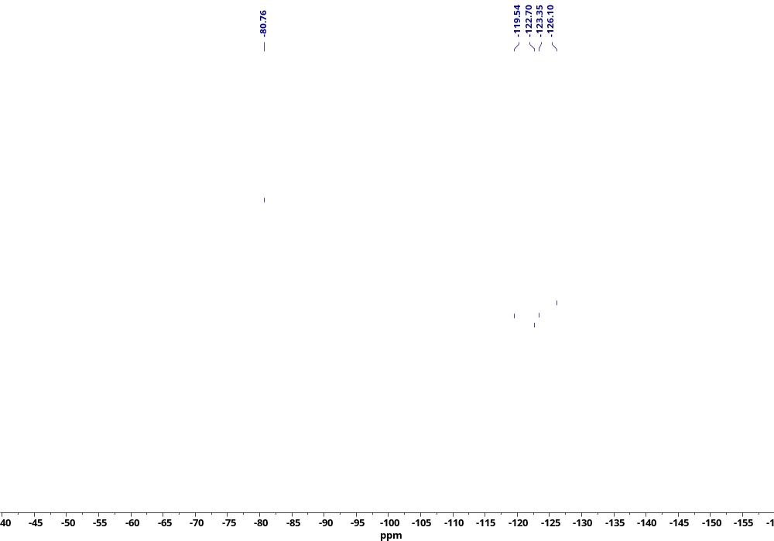
Figure S33. ¹⁹F NMR spectrum of compound 1.3.1.
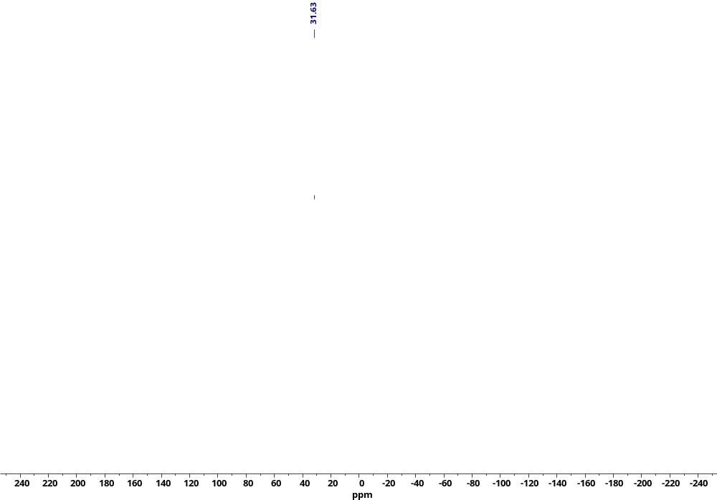
Figure S34. ¹¹B NMR spectrum of compound 1.3.1.
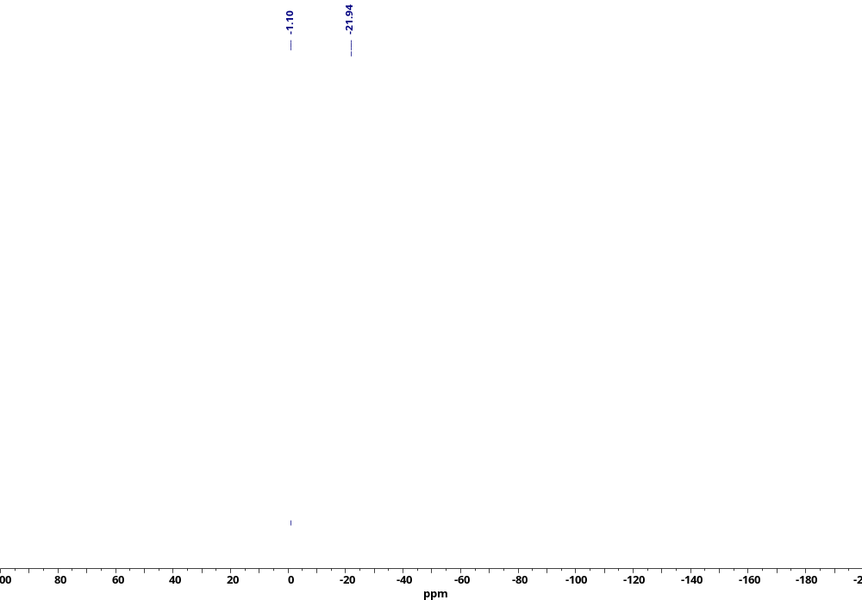
Figure S35. ²⁹Si NMR spectrum of compound 1.3.1.
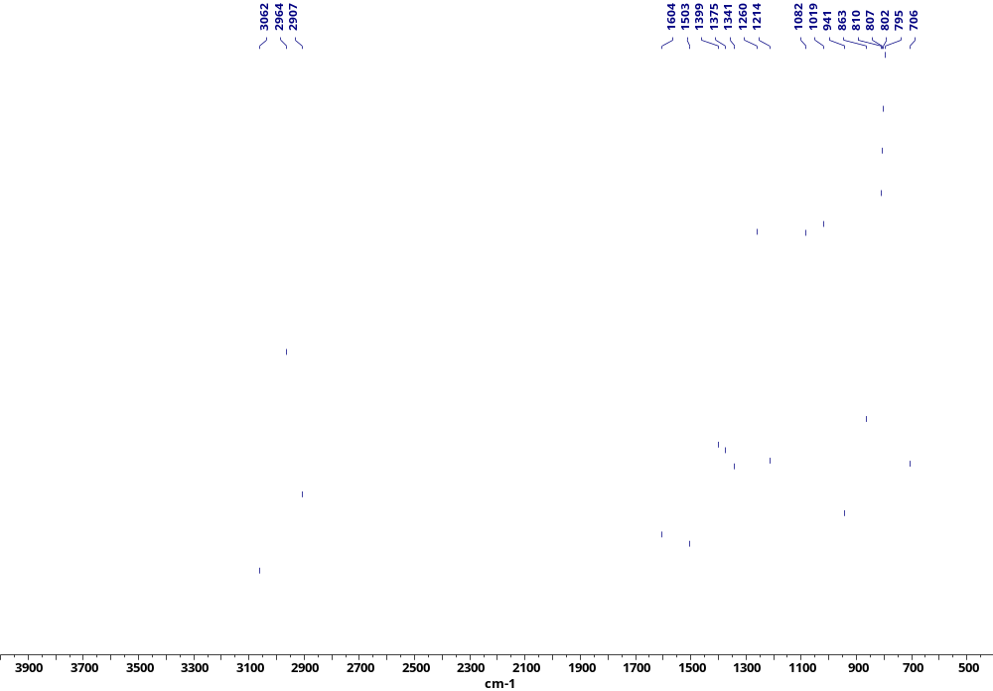
Figure S36. IR spectrum of compound 1.3.1.

Synthesis of polysiloxane with chain-distributed polyethylene glycol and terminal perfluorinated fragments (compound 1.3.2)
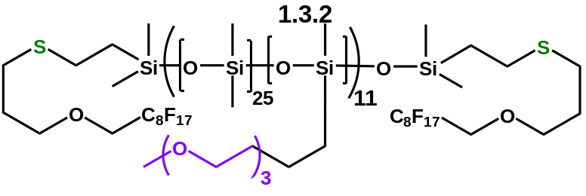
A mixture of compound 1.3 (405 mg, 0.021 mmol), compound 2’ (0.079 g, 0.387 mmol) and Karstedt’s catalyst (0.3 wt% [Pt] relative to Si-H groups) in dry toluene (4.5 ml) was mixed for 5 days at 50 ° C. The Si-H conversion was >95% with a β-adduct selectivity of at least 95%. After that, the product was re-precipitated twice by adding three parts of acetonitrile to the polymer solution in toluene. The product was then evaporated at 1 mbar to constant weight and the yield of the target product after all re-precipitation operations was 66% (0.3 g).
¹H NMR (500 MHz, CDCl₃) δ 3.96 (t, J = 13.8 Hz, 4H), 3.72 (t, J = 6.1 Hz, 4H), 3.70 – 3.65 (m, 84H), 3.62 – 3.54 (m, 43H), 3.43 (t, J = 7.1 Hz, 21H), 3.40 (s, 31H), 2.65 – 2.56 (m, 9H), 1.90 (p, J = 6.5 Hz, 4H), 1.69 – 1.59 (m, 21H), 0.95 – 0.88 (m, 4H), 0.55 – 0.46 (m, 20H), 0.09 (s, 1850H).
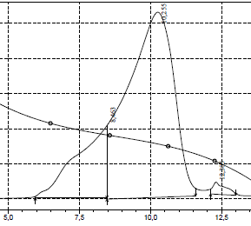
¹³C NMR (126 MHz, CDCl₃) δ 77.21, 74.08, 71.95, 71.54, 70.64, 70.62, 70.54, 69.99, 67.95, 59.01, 29.39, 28.00, 26.86, 23.07, 18.89, 13.36, 9.46, 1.18, -0.28, -0.45, -0.61.
¹⁹F NMR (471 MHz, CDCl₃) δ -80.75, -119.53, -121.77 – -122.13, -122.73, -123.34, -126.11.
²⁹Si NMR (79 MHz, CDCl₃) δ -21.92, -68.67.
IR: 2963, 2905, 2879, 1437, 1413, 1340, 1261, 1216, 1094, 1019, 864, 799, 704, 687, 662 cm⁻¹.
GPC: 79% – M_{n} = 29 kDa, M_{w} = 47 kDa, PDI = 1.6; 22% (high molecular fraction) – M_{n} = 311 kDa, M_{w} = 551 kDa, PDI = 1.8.
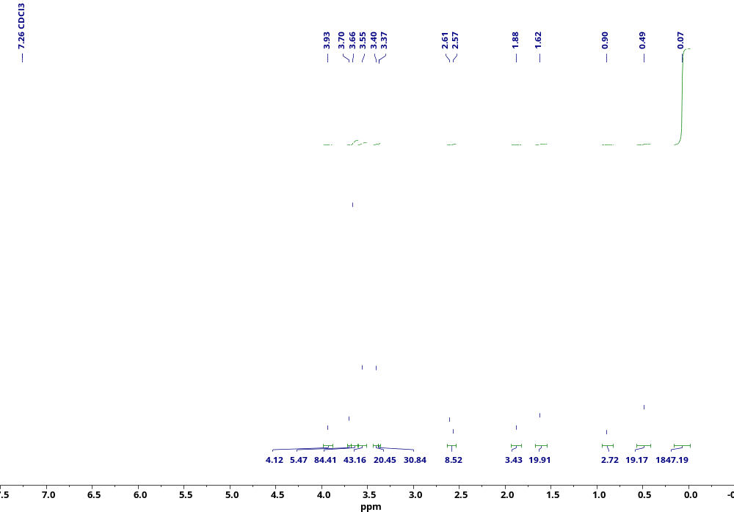
Figure S37. ¹H NMR spectrum of compound 1.3.2.
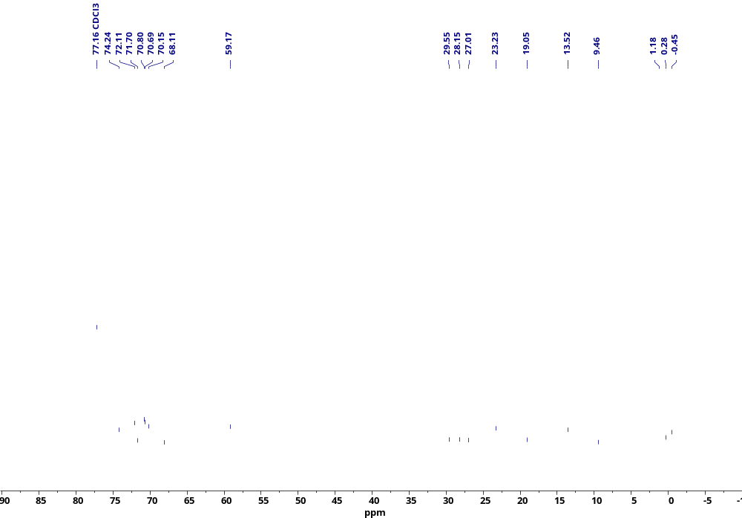
Figure S38. ¹³C NMR spectrum of compound 1.3.2.
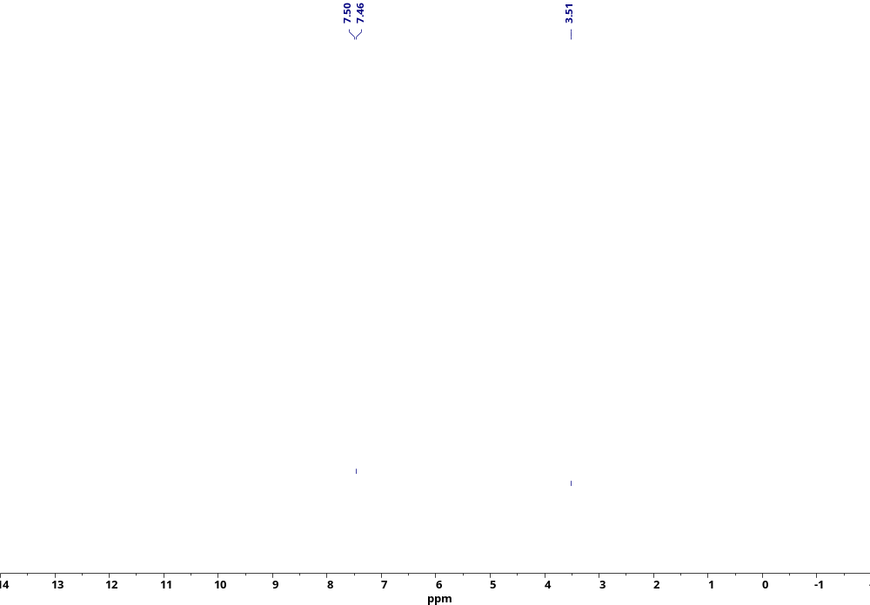
Figure S39. ²⁹Si NMR spectrum of compound 1.3.2.
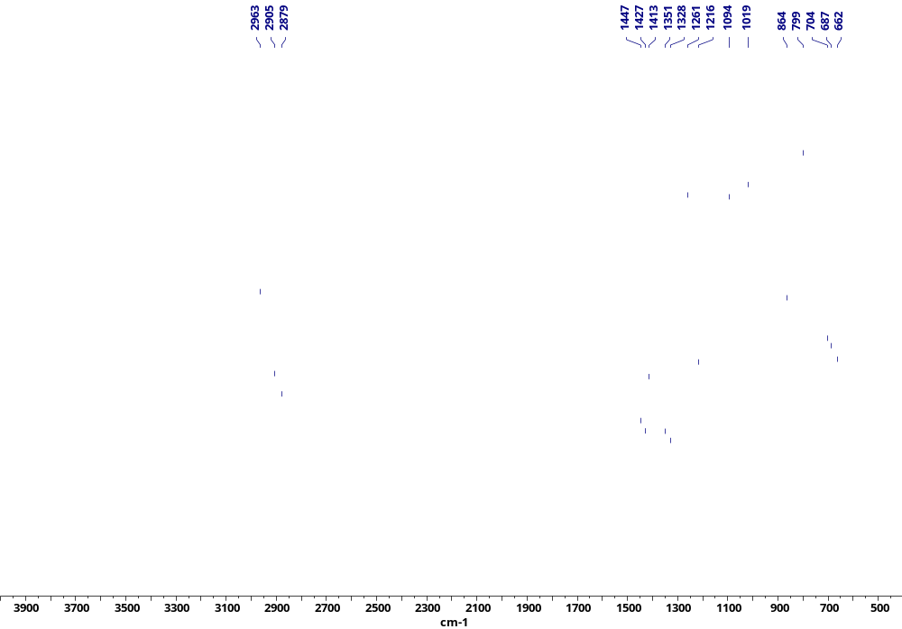
Figure S40. IR spectrum of compound 1.3.2.

Synthesis of polysiloxane with with chain-distributed PrOTMS and terminal dodecanethiol groups (compound 1.4.2).
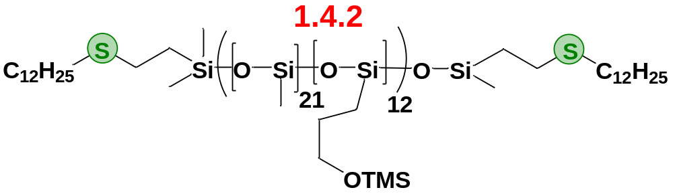
A mixture of compound 1.4 (405 mg, 0,0224 mmol), Allyl-OTMS (0.105 g, 0.806mmol) and Karstedt’s catalyst (0.3 wt% [Pt] relative to Si-H groups) in dry toluene (4.5 ml) was mixed for 5 days at 50 ° C. The Si-H conversion was >95% with a β-adduct selectivity of at least 95%. After that, the product was re-precipitated twice by adding three parts of acetonitrile to the polymer solution in toluene. The product was then evaporated at 1 mbar to constant weight and the yield of the target product after all re-precipitation operations was 72% (0.32 g).
¹H NMR (400 MHz, Chloroform-d) δ 3.51 (d, J = 38.5 Hz, 34H), 2.60 – 2.47 (m, 8H), 1.64 – 1.48 (m, 60H), 1.40 – 1.16 (m, 44H), 0.95 – 0.78 (m, 10H), 0.47 (d, J = 36.9 Hz, 34H), 0.26 – -0.14 (m, 2626H).
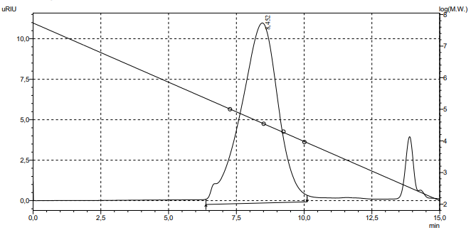
GPC: 78% – Mn = 35.2 kDa, Mw = 49.3 kDa, PDI = 1.4

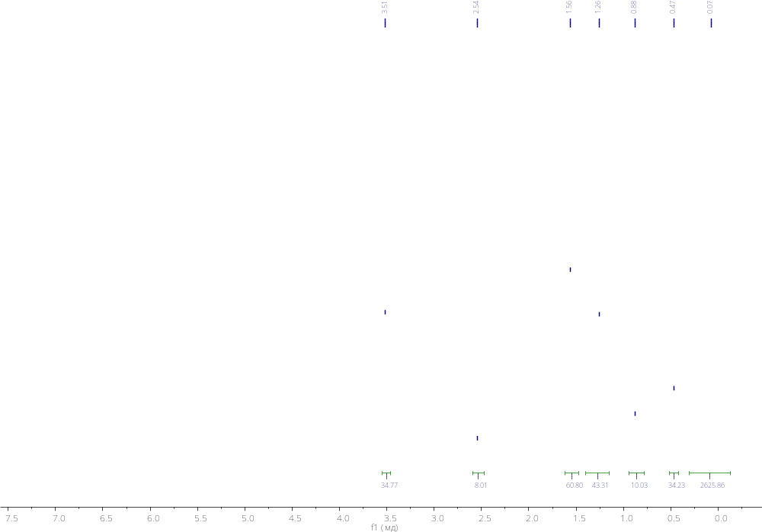
Figure S41. ¹H NMR spectrum of compound 1.4.2.

Synthesis of hydride-terminated polysiloxane with vinyl groups distributed along the chain (compound 2)
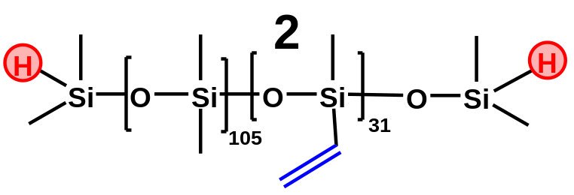
Octamethylcyclotetrasiloxane (14.17 g, 47.8 mmol), tetravinyltetramethyltetracyclosiloxane (4,86g, 14,1 mmol) and tetramethyldivinyldisiloxane (0.061 g, 0.455 mmol) were loaded into a single-necked flask.
Polymerization was carried out in the block with stirring and a temperature of 80 ℃ for 8 hours. Purolite cation exchange resin (3 wt.% of the total mass of the mixture, 0.57 g) was used as a catalyst. After polymerization, the polymer was dissolved in toluene and filtered from Purolite through a folded filter. The polymer was re-precipitated by dissolving it in toluene and then ethanol was added dropwise (5 parts of ethanol per 1 toluene). After that, the polymer was evaporated at 1 mbar and 60 ℃ for 6 hours to constant weight.
¹H NMR (300 MHz, Chloroform-d) δ 5.96 (s, 93H), 4.81 – 4.63 (m, 2H), 0.35 – -0.21 (m, 819H).
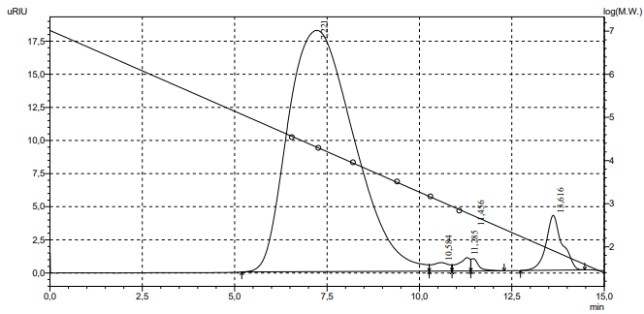
GPC: Mn = 12.7 kDa, Mw = 21 kDa, PDI = 1.64
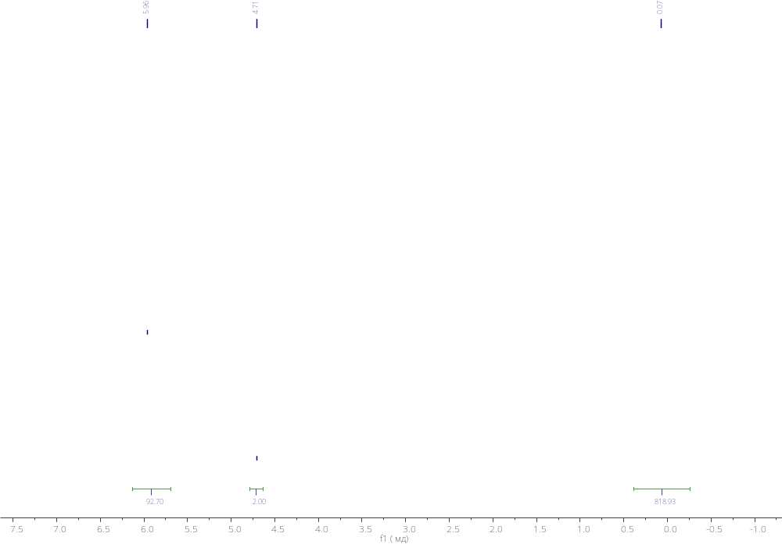
Figure S42. ¹H NMR spectrum of compound 2.

Synthesis of hydride-terminated polysiloxane with dodecanethiol groups distributed along the chain (compound 2.1).
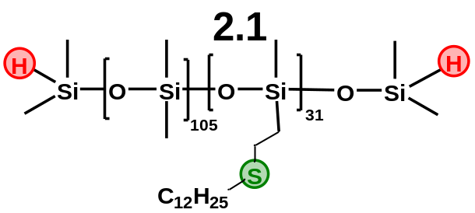

6 ml of dry deoxidized toluene was placed into a tube calcined and cooled under argon. 1 g (0.059 mmol) of Polymer 2, 1-dodecanethiol (0.372g, 1.83 mmol) and 13 mg of AIBN were loaded into the tube. The mixture was stirred for 4 hours at 85°C. After the compound was re-precipitated as described for compound 1.1. The product was evaporated at 1 mbar to constant weight and the yield of the target product after all re-precipitation operations was 77% (1.056 g).
¹H NMR (500 MHz, Chloroform-d) δ 4.71 (d, J = 30.1 Hz, 2H), 2.59 – 2.53 (m, 66H), 2.53 – 2.47 (m, 75H), 1.61 – 1.53 (m, 78H), 1.44 – 1.34 (m, 83H), 1.33 – 1.19 (m, 646H), 0.94 – 0.82 (m, 182H), 0.23 – -0.01 (m, 1198H).
¹³C NMR (126 MHz, CDCl₃) δ 129.17, 128.36, 125.44, 77.16, 32.08, 29.78, 26.62, 22.84, 18.52, 14.26, 1.17.
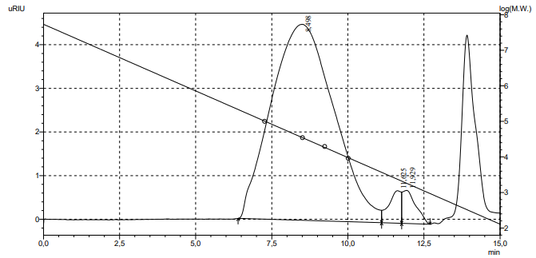
GPC: Mn = 24 kDa, Mw = 44 kDa, PDI = 1.84

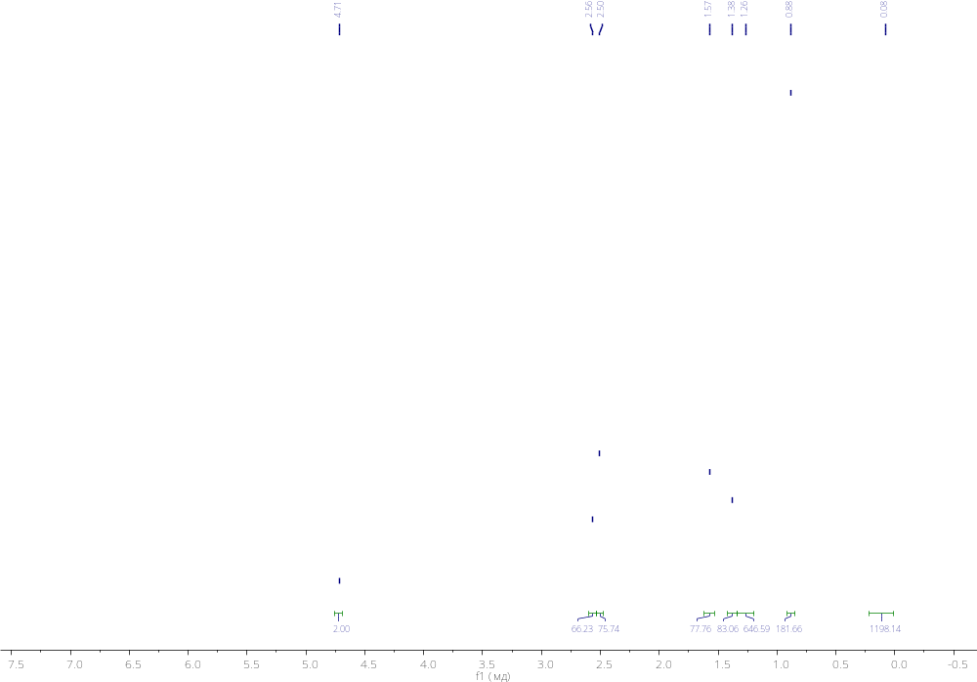
Figure S43. ¹H NMR spectrum of compound 2.1.
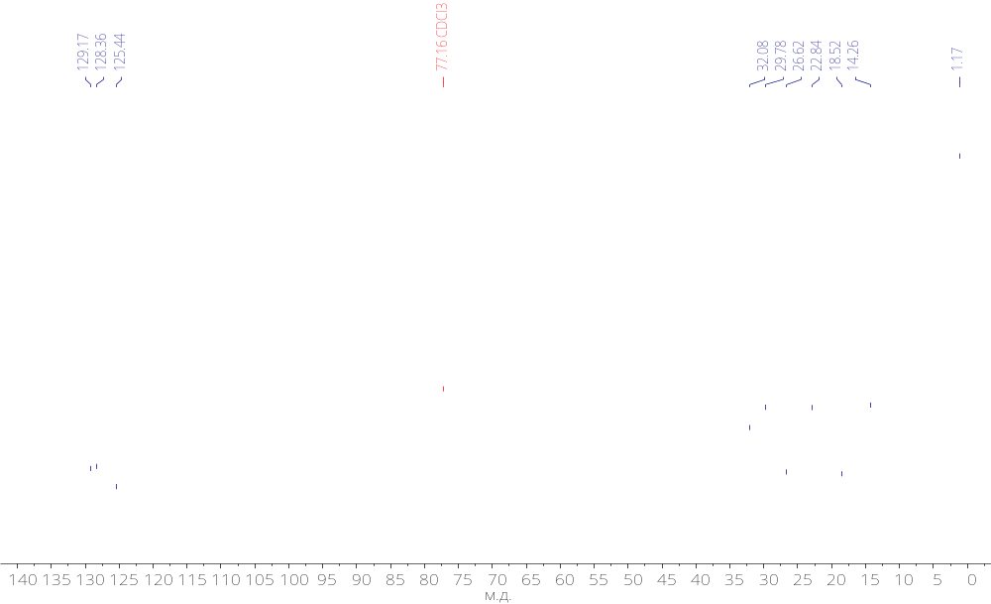
Figure S44. ¹³C NMR spectrum of compound 2.1.

