Appendix 1.
Search Strategy
1. PubMed (MEDLINE)
( ("Attention Deficit Disorder with Hyperactivity"[Mesh]) OR ("Attention Deficit Hyperactivity Disorder"[Title/Abstract] OR "ADHD"[Title/Abstract] OR "Attention Deficit Disorder"[Title/Abstract] OR "Hyperkinesis"[Title/Abstract] OR "Hyperkinetic*"[Title/Abstract]) )
AND
( ("Spectroscopy, Near-Infrared"[Mesh]) OR ("functional near-infrared spectroscopy"[Title/Abstract] OR "fNIR*"[Title/Abstract] OR "NIRS"[Title/Abstract] OR "near-infrared spectroscopy"[Title/Abstract] OR "optical topography"[Title/Abstract] OR "oxyhemoglobin"[Title/Abstract]) )

2. Web of Science (Core Collection)
#1 TS=("Attention Deficit Hyperactivity Disorder" OR "ADHD" OR "Attention Deficit Disorder" OR "Hyperkinesis" OR "Hyperkinetic*")
#2 TS=("functional near-infrared spectroscopy" OR "fNIR*" OR "NIRS" OR "near-infrared spectroscopy" OR "optical topography" OR "oxyhemoglobin")
#3 #1 AND #2

3. Cochrane Library (CENTRAL)
#1 [mh "Attention Deficit Disorder with Hyperactivity"]
#2 ("Attention Deficit Hyperactivity Disorder" OR "ADHD" OR "Attention Deficit Disorder" OR "Hyperkinesis" OR "Hyperkinetic*"):ti,ab,kw
#3 #1 OR #2
#4 [mh "Spectroscopy, Near-Infrared"]
#5 ("functional near-infrared spectroscopy" OR "fNIR*" OR "NIRS" OR "near-infrared spectroscopy" OR "optical topography" OR "oxyhemoglobin"):ti,ab,kw
#6 #4 OR #5
#7 #3 AND #6

4. Embase
#1 'attention deficit hyperactivity disorder'/exp
#2 'attention deficit hyperactivity disorder':ab,ti OR 'adhd':ab,ti OR 'attention deficit disorder':ab,ti OR 'hyperkinesis':ab,ti OR 'hyperkinetic*':ab,ti
#3 #1 OR #2
#4 'near infrared spectroscopy'/exp
#5 'functional near infrared spectroscopy':ab,ti OR 'fnir*':ab,ti OR 'nirs':ab,ti OR 'near-infrared spectroscopy':ab,ti OR 'optical topography':ab,ti OR 'oxyhemoglobin':ab,ti
#6 #4 OR #5
#7 #3 AND #6

5. PsycINFO (Ovid)
#1 exp Attention Deficit Disorder with Hyperactivity/
#2 ("Attention Deficit Hyperactivity Disorder" OR "ADHD" OR "Attention Deficit Disorder" OR "Hyperkinesis" OR "Hyperkinetic*").ti,ab,id.
#3 1 OR 2
#4 ("functional near-infrared spectroscopy" OR "fNIR*" OR "NIRS" OR "near-infrared spectroscopy" OR "optical topography" OR "oxyhemoglobin").ti,ab,id.
#5 3 AND 4

eTable 1. Risk of Bias Assessment for Randomized Controlled Trials (RoB 2.0)
Study | Intervention Type | D1_Randomization Process | D2_Deviations from Intended Interventions | D3_Missing Outcome Data | D4_Measurement of the Outcome | D5_Selection of the Reported Result | Overall Bias
Zhuo et al., 2021 (TEAS) | RCT | Low | Low | Low | Low | Low | Low Risk
Jounghani et al., 2024 (NFB) | RCT | Low | Some concerns | Low | Low | Low | Some Concerns
Wang et al., 2024 (TMS) | RCT | Low | Low | Low | Low | Low | Low Risk

eTable 2. Quality Assessment of Non-Randomized Interventional Studies (MINORS)
Study | Intervention Type | 1. A clearly stated aim | 2. Inclusion of consecutive patients | 3. Prospective collection of data | 4. Endpoints appropriate to the aim | 5. Unbiased assessment of the study endpoint | 6. Follow-up period appropriate | 7. Loss to follow up less than 5% | 8. Prospective calculation of the study size | 9. An adequate control group | MINORS Total Score
Jang et al., 2021 (MPH) | Before-after trial | 2 | 2 | 2 | 2 | 0 | 2 | 2 | 1 |  | 13/16 (Good quality)
Araki et al., 2015 (ATX) | Non-randomized controlled trial | 2 | 1 | 2 | 2 | 0 | 2 | 2 | 0 | 2.0 | 17/24 (Fair quality)
Monden et al., 2012 (MPH) | Before-after trial | 2 | 2 | 2 | 2 | 0 | 2 | 2 | 0 |  | 12/16 (Good quality)
Ota et al., 2015 (ATX) | Before-after trial | 2 | 1 | 2 | 2 | 0 | 2 | 2 | 0 |  | 11/16 (Fair quality)
He et al., 2026 (Exercise) | Non-randomized crossover | 2 | 2 | 2 | 2 | 0 | 2 | 2 | 2 | 2.0 | 20/24 (Good quality)
Kurane et al., 2024 (Off-med) | Longitudinal observation | 2 | 1 | 1 | 2 | 0 | 2 | 2 | 0 |  | 10/16 (Fair quality)
Tokuda et al., 202X (MPH) | Non-randomized controlled trial | 2 | 2 | 2 | 2 | 0 | 2 | 2 | 0 | 2.0 | 18/24 (Good quality)

eTable 3. Methodological Quality Assessment of Observational Studies (Newcastle-Ottawa Scale)
Study | Study Design | S1_Adequate Case Definition | S2_Representativeness of Cases | S3_Selection of Controls | S4_Definition of Controls | C1_Comparability (Age) | C2_Comparability (Sex/IQ) | E1_Ascertainment of Exposure | E2_Same Method of Ascertainment | E3_Non-Response Rate | Total Score (Max 9★)
Calub et al., 2022 | Case-Control | ★ | ★ | ★ | ★ | ★ | 0 | ★ | ★ | ★ | 8
Ehlis et al., 2008 | Case-Control | ★ | ★ | ★ | ★ | ★ | ★ | ★ | ★ | ★ | 9
Gu et al., 2018 | Case-Control | ★ | ★ | ★ | ★ | ★ | 0 | ★ | ★ | ★ | 8
Ma et al., 2025 | Case-Control | ★ | ★ | ★ | ★ | ★ | ★ | ★ | ★ | ★ | 9
Inoue et al., 2012 | Case-Control | ★ | ★ | ★ | ★ | ★ | ★ | ★ | ★ | 0 | 8
Friedman et al., 2023 | Case-Control | ★ | ★ | ★ | ★ | ★ | 0 | ★ | ★ | ★ | 8
Mauri et al., 2020 | Case-Control | ★ | ★ | ★ | ★ | ★ | ★ | ★ | ★ | ★ | 9
Moser et al., 2009 | Case-Control | ★ | ★ | ★ | ★ | ★ | ★ | ★ | ★ | ★ | 9
Negoro et al., 2010 | Case-Control | ★ | ★ | ★ | ★ | ★ | ★ | ★ | ★ | ★ | 9
Grazioli et al., 2019 | Case-Control | ★ | ★ | ★ | ★ | ★ | ★ | ★ | ★ | ★ | 9
Husain et al., 2023 | Case-Control | ★ | ★ | ★ | ★ | ★ | ★ | ★ | ★ | ★ | 9
Wu (Ting) et al., 2023 | Case-Control | ★ | ★ | ★ | ★ | ★ | ★ | ★ | ★ | ★ | 9
Ueda et al., 2018 | Case-Control | ★ | ★ | ★ | ★ | ★ | ★ | ★ | ★ | ★ | 9
Bian et al., 2025 | Case-Control | ★ | ★ | ★ | ★ | ★ | ★ | ★ | ★ | ★ | 9

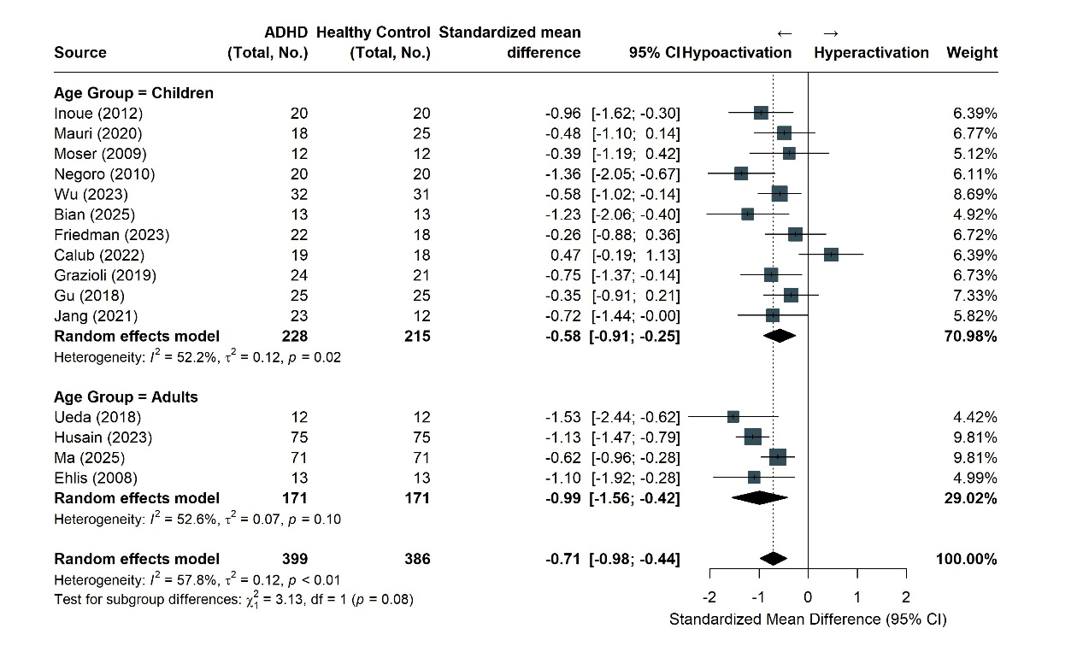

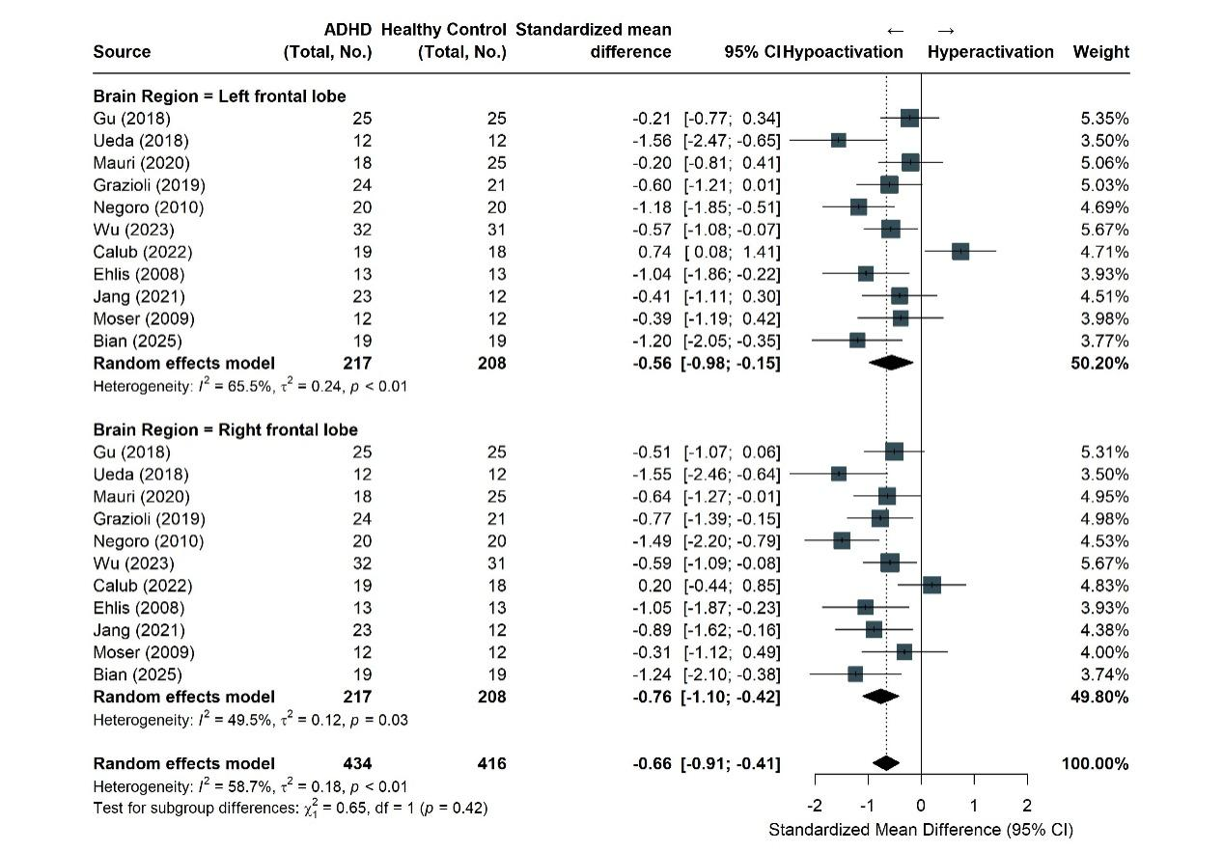

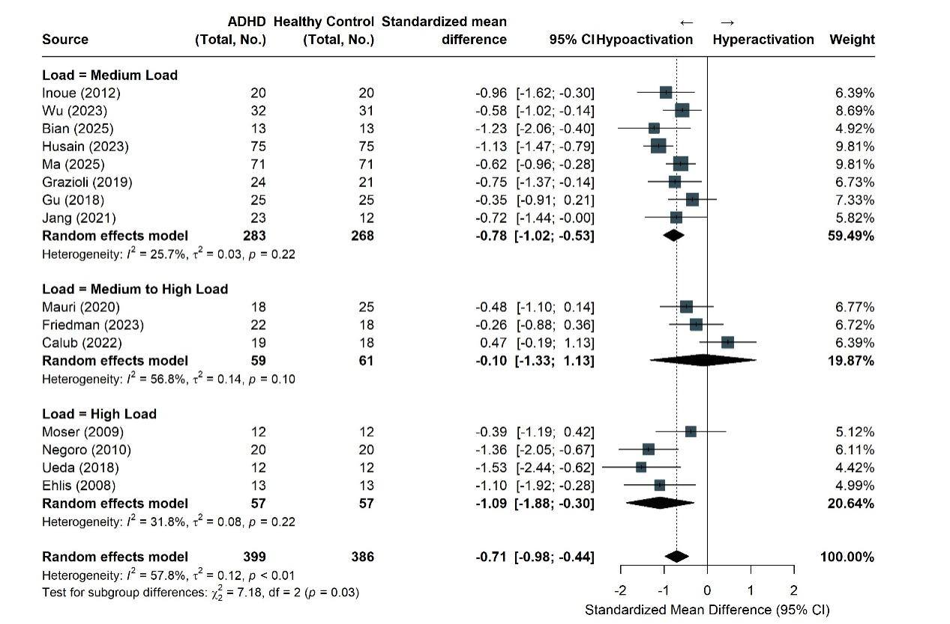
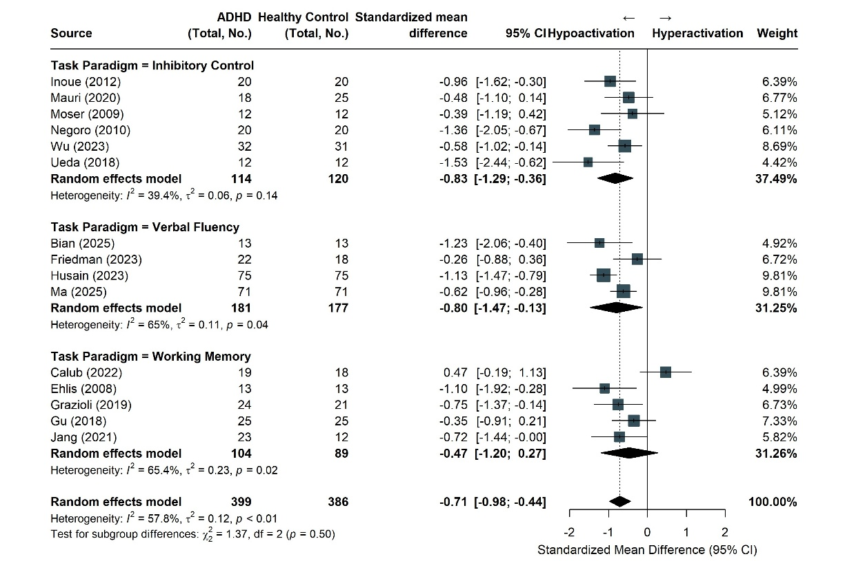
eFigure 1-4. Subgroup Analyses of Task-Evoked Prefrontal Hemodynamic Responses in ADHD vs Healthy Controls
Forest plots represent standardized mean differences (SMDs) in prefrontal oxyhemoglobin concentrations during cognitive tasks, stratified by (1) age group, (2) brain region (left vs. right frontal lobe), (3) cognitive task load, and (4) task paradigm. SMDs were calculated using Hedges’ g with a restricted maximum likelihood (REML) random-effects model. The size of each square is proportional to the study's weight. The diamonds indicate pooled SMDs for each subgroup. Error bars represent 95% CIs. Hypoactivation (left of the zero line) indicates reduced hemodynamic response in patients with ADHD compared with neurotypical controls. ADHD indicates attention-deficit/hyperactivity disorder.

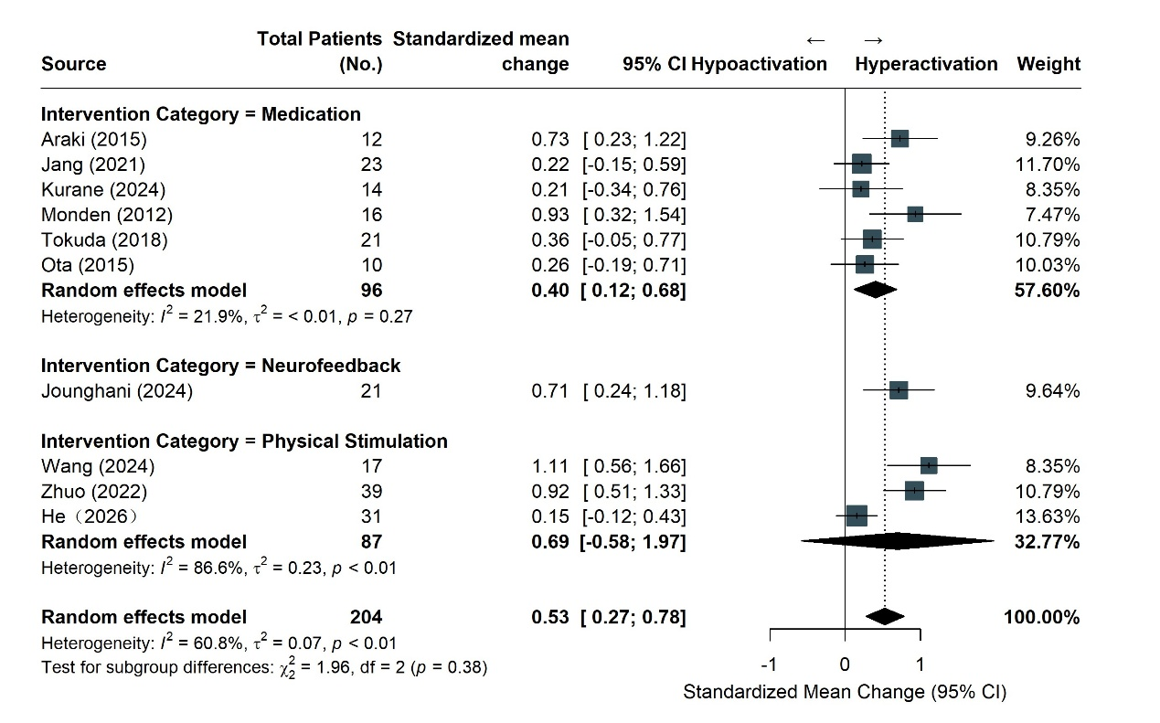
eFigure 5. Subgroup Analyses of Intervention-Induced Prefrontal Hemodynamic Changes in Patients With ADHD
Forest plots represent standardized mean change (SMC) in prefrontal oxyhemoglobin concentrations during intervention, stratified by intervention category
The standardized mean change (SMC) was calculated using Hedges’ g with a restricted maximum likelihood random-effects model, assuming a pre-post correlation coefficient of 0.5. The sizes of the squares are proportional to the weights of the individual studies. The diamond represents the pooled SMC, with its width indicating the 95% CI. Values to the right of the solid vertical line (zero) indicate an increase in task-evoked oxygenated hemoglobin concentration (hyperactivation or normalization of prefrontal deficits) following therapeutic interventions. ADHD indicates attention-deficit/hyperactivity disorder.

