SI Table 1. Definition of variables.

Variables | Definition
Pre-pregnancy BMI | BMI before pregnancy
Q1 BMI | BMI at the second trimester
Q1 Age (years) | Age at the second trimester
Q1 SES score | Socioeconomic score at the second trimester: 1 point for having a bachelor's degree, 1 point for being in a relationship and 1 point for working full time (scale 0-3)
Primipara | Primiparous (1) or not (0)
Q1 Smoking | Smoking (1) or not (0)
Q1 PCOS | Polycystic ovary syndrome diagnosed at the second trimester (1) or not (0)
Pre-pregnancy Alcohol (3 months before pregnancy) | Frequency of alcohol habits 3 months before pregnancy: never (0), once per month or fewer (1), 2-4 times per month (2), 2-3 times per week (3)
Q1 Alcohol | Drinking alcohol at the second trimester (1) or not (0)
Q1 Probiotics use | Probiotic use at the second trimester (1) or not (0)
Pre-pregnancy sleep medication | Any sleep medication before pregnancy: yes (1), no (0)
Q1 Sleep medication | Any sleep medication at the second trimester: yes (1), no (0)
Q1 Bristol Stool Scale | Bowel transit time at the second trimester. Based on the question “How do your stools typically look like?” and the Bristol stool scale (1–7). Regular transit (only 3–4), slow transit (only 1–4), fast transit (only 3–7), varied transit (both 1–2 and 5–7)
Q1 PUQUE score | PUQE (pregnancy-unique quantification of emesis and nausea) scoring at the second trimester
Q1 diet score | Proxy of diet quality at the second trimester. For fruit, vegetables and whole grain bread, answers other than "daily" would give a score of one. For sugar and sweetened beverages, "daily" and "several times weekly" would give a score of one. A combined score of three or four would categorize the participant as "unhealthy" at that timepoint, hence a score less than three would categorize the participant as "healthy
Pre-pregnancy Antidepressants | Antidepressant usage before pregnancy: yes (1), no (0)
Pre-pregnancy Metformin | Metformin usage before pregnancy: yes (1), no (0)
Pre-pregnancy PPI | PPI usage before pregnancy: yes (1), no (0)
Pre-pregnancy Antihypertensives | Antihypertensive usage before pregnancy: yes (1), no (0)
Pre-pregnancy Insulin | Insulin usage before pregnancy: yes (1), no (0)

SI Table 2. Summary table of maternal characteristics by outcome.
 | Comparison 1 |  |  | Comparison 2 |  |  | Comparison 3 |  |  | Comparison 4 |  |  | Comparison 5
Characteristic | Controls¹ | Any Complication¹ | p-value² | Control¹ | Preeclampsia¹ | p-value² | Control¹ | GestationalHypertension¹ | p-value² | Control¹ | GestationalDiabetes¹ | p-value² | Control¹ | GestationalHypertensiveDisorder¹ | p-value²
Pre-pregnancy BMI | 33.7 (5.1) | 34.5 (4.6) | 0.031 | 33.9 (4.7) | 35.3 (5.4) | 0.083 | 33.9 (4.9) | 34.6 (4.6) | 0.2 | 34.0 (5.0) | 34.6 (4.0) | 0.039 | 33.7 (4.8) | 35.0 (5.0) | 0.023
Q1 Age (years) | 31.5 (4.4) | 31.6 (4.3) | >0.9 | 31.5 (4.3) | 31.8 (4.7) | 0.8 | 31.6 (4.4) | 30.8 (3.5) | 0.4 | 31.1 (4.3) | 33.0 (4.4) | 0.021 | 31.7 (4.4) | 31.3 (4.2) | 0.6
Q1 BMI | 33.9 (5.1) | 35.0 (4.7) | 0.004 | 34.2 (4.7) | 35.9 (5.5) | 0.020 | 34.3 (4.9) | 35.0 (4.6) | 0.2 | 34.3 (5.0) | 35.1 (4.2) | 0.040 | 34.0 (4.8) | 35.5 (5.1) | 0.005
Missing | 6 | 2 |  | 7 | 1 |  | 7 | 1 |  | 7 | 1 |  | 6 | 2
BMI gain | 0.3 (0.9) | 0.4 (1.3) | 0.15 | 0.3 (1.1) | 0.6 (1.2) | 0.3 | 0.4 (1.1) | 0.3 (0.9) | 0.6 | 0.3 (1.1) | 0.5 (1.2) | 0.3 | 0.3 (1.1) | 0.5 (1.0) | 0.6
Missing | 6 | 2 |  | 7 | 1 |  | 7 | 1 |  | 7 | 1 |  | 6 | 2
Q1 SES score | 2.4 (0.8) | 2.3 (0.8) | 0.4 | 2.3 (0.8) | 2.1 (0.8) | 0.2 | 2.3 (0.8) | 2.2 (0.7) | 0.5 | 2.3 (0.8) | 2.5 (0.7) | 0.2 | 2.4 (0.8) | 2.2 (0.8) | 0.14
Primipara |  |  | 0.047 |  |  | 0.10 |  |  | 0.020 |  |  | >0.9 |  |  | 0.002
0 | 74 (65.5%) | 50 (51.0%) |  | 120 (62.8%) | 13 (44.8%) |  | 117 (62.6%) | 9 (36.0%) |  | 103 (59.2%) | 24 (60.0%) |  | 105 (65.6%) | 22 (40.7%)
1 | 39 (34.5%) | 48 (49.0%) |  | 71 (37.2%) | 16 (55.2%) |  | 70 (37.4%) | 16 (64.0%) |  | 71 (40.8%) | 16 (40.0%) |  | 55 (34.4%) | 32 (59.3%)
Q1 Smoking |  |  | 0.6 |  |  | 0.7 |  |  | >0.9 |  |  | >0.9 |  |  | 0.8
0 | 58 (51.3%) | 46 (46.9%) |  | 96 (50.3%) | 13 (44.8%) |  | 92 (49.2%) | 12 (48.0%) |  | 88 (50.6%) | 20 (50.0%) |  | 80 (50.0%) | 25 (46.3%)
1 | 55 (48.7%) | 52 (53.1%) |  | 95 (49.7%) | 16 (55.2%) |  | 95 (50.8%) | 13 (52.0%) |  | 86 (49.4%) | 20 (50.0%) |  | 80 (50.0%) | 29 (53.7%)
Q1 PCOS |  |  | 0.3 |  |  | >0.9 |  |  | 0.8 |  |  | 0.4 |  |  | 0.8
0 | 85 (75.9%) | 79 (82.3%) |  | 149 (79.3%) | 22 (78.6%) |  | 147 (79.5%) | 18 (75.0%) |  | 132 (77.6%) | 34 (85.0%) |  | 127 (79.9%) | 40 (76.9%)
1 | 27 (24.1%) | 17 (17.7%) |  | 39 (20.7%) | 6 (21.4%) |  | 38 (20.5%) | 6 (25.0%) |  | 38 (22.4%) | 6 (15.0%) |  | 32 (20.1%) | 12 (23.1%)
Missing | 1 | 2 |  | 3 | 1 |  | 2 | 1 |  | 4 | 0 |  | 1 | 2
Pre-pregnancy Alcohol (3 months before pregnancy) |  |  | 0.9 |  |  | 0.12 |  |  | 0.7 |  |  | 0.2 |  |  | 0.4
0 | 20 (17.9%) | 15 (15.5%) |  | 30 (16.0%) | 8 (27.6%) |  | 32 (17.4%) | 2 (8.0%) |  | 30 (17.3%) | 6 (15.4%) |  | 26 (16.6%) | 10 (18.5%)
1 | 39 (34.8%) | 38 (39.2%) |  | 69 (36.7%) | 11 (37.9%) |  | 66 (35.9%) | 10 (40.0%) |  | 61 (35.3%) | 19 (48.7%) |  | 55 (35.0%) | 21 (38.9%)
2 | 41 (36.6%) | 32 (33.0%) |  | 64 (34.0%) | 10 (34.5%) |  | 64 (34.8%) | 10 (40.0%) |  | 64 (37.0%) | 8 (20.5%) |  | 54 (34.4%) | 20 (37.0%)
3 | 12 (10.7%) | 12 (12.4%) |  | 25 (13.3%) | 0 (0.0%) |  | 22 (12.0%) | 3 (12.0%) |  | 18 (10.4%) | 6 (15.4%) |  | 22 (14.0%) | 3 (5.6%)
Missing | 1 | 1 |  | 3 | 0 |  | 3 | 0 |  | 1 | 1 |  | 3 | 0
Q1 Alcohol |  |  | >0.9 |  |  | >0.9 |  |  | >0.9 |  |  | >0.9 |  |  | >0.9
0 | 109 (96.5%) | 95 (96.9%) |  | 185 (96.9%) | 28 (96.6%) |  | 181 (96.8%) | 24 (96.0%) |  | 168 (96.6%) | 39 (97.5%) |  | 155 (96.9%) | 52 (96.3%)
1 | 4 (3.5%) | 3 (3.1%) |  | 6 (3.1%) | 1 (3.4%) |  | 6 (3.2%) | 1 (4.0%) |  | 6 (3.4%) | 1 (2.5%) |  | 5 (3.1%) | 2 (3.7%)
Q1 Probiotics use |  |  | 0.5 |  |  | 0.12 |  |  | 0.8 |  |  | 0.9 |  |  | 0.5
0 | 101 (89.4%) | 91 (92.9%) |  | 170 (89.0%) | 29 (100.0%) |  | 171 (91.4%) | 22 (88.0%) |  | 157 (90.2%) | 37 (92.5%) |  | 144 (90.0%) | 51 (94.4%)
1 | 12 (10.6%) | 7 (7.1%) |  | 21 (11.0%) | 0 (0.0%) |  | 16 (8.6%) | 3 (12.0%) |  | 17 (9.8%) | 3 (7.5%) |  | 16 (10.0%) | 3 (5.6%)
Pre-pregnancy sleep medication |  |  | 0.14 |  |  | 0.3 |  |  | 0.8 |  |  | >0.9 |  |  | 0.2
0 | 110 (97.3%) | 90 (91.8%) |  | 183 (95.8%) | 26 (89.7%) |  | 178 (95.2%) | 23 (92.0%) |  | 165 (94.8%) | 38 (95.0%) |  | 154 (96.3%) | 49 (90.7%)
1 | 3 (2.7%) | 8 (8.2%) |  | 8 (4.2%) | 3 (10.3%) |  | 9 (4.8%) | 2 (8.0%) |  | 9 (5.2%) | 2 (5.0%) |  | 6 (3.8%) | 5 (9.3%)
Q1 Sleep medication |  |  | 0.3 |  |  | 0.3 |  |  | >0.9 |  |  | >0.9 |  |  | 0.2
0 | 112 (99.1%) | 93 (95.9%) |  | 187 (98.4%) | 27 (93.1%) |  | 182 (97.8%) | 24 (96.0%) |  | 169 (97.7%) | 39 (97.5%) |  | 157 (98.7%) | 51 (94.4%)
1 | 1 (0.9%) | 4 (4.1%) |  | 3 (1.6%) | 2 (6.9%) |  | 4 (2.2%) | 1 (4.0%) |  | 4 (2.3%) | 1 (2.5%) |  | 2 (1.3%) | 3 (5.6%)
Missing | 0 | 1 |  | 1 | 0 |  | 1 | 0 |  | 1 | 0 |  | 1 | 0
Q1 Bristol Stool Scale |  |  | 0.6 |  |  | 0.075 |  |  | 0.2 |  |  | 0.12 |  |  | 0.3
Normal | 17 (15.2%) | 12 (12.2%) |  | 28 (14.7%) | 3 (10.3%) |  | 28 (15.1%) | 1 (4.0%) |  | 26 (15.0%) | 4 (10.0%) |  | 26 (16.4%) | 4 (7.4%)
Slow | 26 (23.2%) | 21 (21.4%) |  | 44 (23.2%) | 6 (20.7%) |  | 40 (21.5%) | 7 (28.0%) |  | 38 (22.0%) | 10 (25.0%) |  | 35 (22.0%) | 13 (24.1%)
Fast | 32 (28.6%) | 37 (37.8%) |  | 54 (28.4%) | 15 (51.7%) |  | 63 (33.9%) | 6 (24.0%) |  | 49 (28.3%) | 18 (45.0%) |  | 48 (30.2%) | 21 (38.9%)
Various | 37 (33.0%) | 28 (28.6%) |  | 64 (33.7%) | 5 (17.2%) |  | 55 (29.6%) | 11 (44.0%) |  | 60 (34.7%) | 8 (20.0%) |  | 50 (31.4%) | 16 (29.6%)
Missing | 1 | 0 |  | 1 | 0 |  | 1 | 0 |  | 1 | 0 |  | 1 | 0
Q1 PUQUE score | 5.6 (2.4) | 6.0 (2.7) | 0.5 | 5.8 (2.6) | 5.6 (2.2) | 0.9 | 5.8 (2.5) | 5.5 (2.3) | 0.7 | 5.7 (2.4) | 6.2 (2.9) | 0.4 | 5.8 (2.5) | 5.6 (2.2) | 0.7
Q1 diet score | 2.4 (1.3) | 2.2 (1.1) | 0.3 | 2.3 (1.2) | 2.0 (1.3) | 0.2 | 2.3 (1.2) | 2.3 (0.9) | 0.7 | 2.4 (1.2) | 1.9 (1.0) | 0.040 | 2.3 (1.2) | 2.1 (1.2) | 0.4
Pre-pregnancy Antidepressants |  |  | 0.4 |  |  | 0.11 |  |  | >0.9 |  |  | 0.4 |  |  | 0.3
0 | 40 (64.5%) | 33 (55.9%) |  | 68 (64.2%) | 9 (42.9%) |  | 63 (59.4%) | 9 (64.3%) |  | 59 (59.6%) | 17 (70.8%) |  | 56 (64.4%) | 18 (51.4%)
1 | 22 (35.5%) | 26 (44.1%) |  | 38 (35.8%) | 12 (57.1%) |  | 43 (40.6%) | 5 (35.7%) |  | 40 (40.4%) | 7 (29.2%) |  | 31 (35.6%) | 17 (48.6%)
Missing | 51 | 39 |  | 85 | 8 |  | 81 | 11 |  | 75 | 16 |  | 73 | 19
Pre-pregnancy Metformin |  |  | 0.4 |  |  | 0.2 |  |  | >0.9 |  |  | >0.9 |  |  | 0.3
0 | 60 (96.8%) | 54 (91.5%) |  | 101 (95.3%) | 18 (85.7%) |  | 100 (94.3%) | 13 (92.9%) |  | 93 (93.9%) | 23 (95.8%) |  | 83 (95.4%) | 31 (88.6%)
1 | 2 (3.2%) | 5 (8.5%) |  | 5 (4.7%) | 3 (14.3%) |  | 6 (5.7%) | 1 (7.1%) |  | 6 (6.1%) | 1 (4.2%) |  | 4 (4.6%) | 4 (11.4%)
Missing | 51 | 39 |  | 85 | 8 |  | 81 | 11 |  | 75 | 16 |  | 73 | 19
Pre-pregnancy PPI |  |  | >0.9 |  |  | >0.9 |  |  | >0.9 |  |  | 0.6 |  |  | >0.9
0 | 53 (85.5%) | 49 (83.1%) |  | 90 (84.9%) | 18 (85.7%) |  | 90 (84.9%) | 12 (85.7%) |  | 85 (85.9%) | 19 (79.2%) |  | 74 (85.1%) | 30 (85.7%)
1 | 9 (14.5%) | 10 (16.9%) |  | 16 (15.1%) | 3 (14.3%) |  | 16 (15.1%) | 2 (14.3%) |  | 14 (14.1%) | 5 (20.8%) |  | 13 (14.9%) | 5 (14.3%)
Missing | 51 | 39 |  | 85 | 8 |  | 81 | 11 |  | 75 | 16 |  | 73 | 19
Pre-pregnancy Antihypertensives |  |  | 0.6 |  |  | 0.6 |  |  | >0.9 |  |  | 0.2 |  |  | >0.9
0 | 60 (96.8%) | 55 (93.2%) |  | 102 (96.2%) | 19 (90.5%) |  | 101 (95.3%) | 14 (100.0%) |  | 96 (97.0%) | 21 (87.5%) |  | 83 (95.4%) | 33 (94.3%)
1 | 2 (3.2%) | 4 (6.8%) |  | 4 (3.8%) | 2 (9.5%) |  | 5 (4.7%) | 0 (0.0%) |  | 3 (3.0%) | 3 (12.5%) |  | 4 (4.6%) | 2 (5.7%)
Missing | 51 | 39 |  | 85 | 8 |  | 81 | 11 |  | 75 | 16 |  | 73 | 19
Pre-pregnancy Insulin |  |  | 0.5 |  |  | 0.025 |  |  | >0.9 |  |  | >0.9 |  |  | 0.14
0 | 62 (100.0%) | 57 (96.6%) |  | 106 (100.0%) | 19 (90.5%) |  | 105 (99.1%) | 14 (100.0%) |  | 97 (98.0%) | 24 (100.0%) |  | 87 (100.0%) | 33 (94.3%)
1 | 0 (0.0%) | 2 (3.4%) |  | 0 (0.0%) | 2 (9.5%) |  | 1 (0.9%) | 0 (0.0%) |  | 2 (2.0%) | 0 (0.0%) |  | 0 (0.0%) | 2 (5.7%)
Missing | 51 | 39 |  | 85 | 8 |  | 81 | 11 |  | 75 | 16 |  | 73 | 19
Q1 Antibiotic use |  |  | 0.8 |  |  | 0.7 |  |  | >0.9 |  |  | >0.9 |  |  | 0.6
0 | 105 (92.9%) | 93 (94.9%) |  | 177 (92.7%) | 28 (96.6%) |  | 175 (93.6%) | 24 (96.0%) |  | 162 (93.1%) | 38 (95.0%) |  | 149 (93.1%) | 52 (96.3%)
1 | 8 (7.1%) | 5 (5.1%) |  | 14 (7.3%) | 1 (3.4%) |  | 12 (6.4%) | 1 (4.0%) |  | 12 (6.9%) | 2 (5.0%) |  | 11 (6.9%) | 2 (3.7%)
Pre-preganancy antibiotic usage |  |  | 0.2 |  |  | 0.2 |  |  | 0.6 |  |  | >0.9 |  |  | 0.085
0 | 101 (89.4%) | 93 (94.9%) |  | 173 (90.6%) | 29 (100.0%) |  | 170 (90.9%) | 24 (96.0%) |  | 160 (92.0%) | 37 (92.5%) |  | 143 (89.4%) | 53 (98.1%)
1 | 12 (10.6%) | 5 (5.1%) |  | 18 (9.4%) | 0 (0.0%) |  | 17 (9.1%) | 1 (4.0%) |  | 14 (8.0%) | 3 (7.5%) |  | 17 (10.6%) | 1 (1.9%)
¹Mean (SD); n (%)
²Wilcoxon rank sum test; Pearson's Chi-squared test

SI Table 3. Comparisons between each of the 3 single modalities against the concatenated modality.

Outcome | vs Modality | Metric | Concatenated | Single modality | Delta (mean) | p-value | p-adj (BH) | sig
All Cases vs Controls | Microbiome | BA | 0.591 | 0.569 | -0.006 | 0.5 | 0.6818
All Cases vs Controls | Microbiome | AUC | 0.623 | 0.567 | 0.069 | 0.0625 | 0.1705 | .
All Cases vs Controls | GMM+Diversity | BA | 0.591 | 0.555 | 0.07 | 0.0625 | 0.1705 | .
All Cases vs Controls | GMM+Diversity | AUC | 0.623 | 0.427 | 0.146 | 0.0938 | 0.2345 | .
All Cases vs Controls | Questionnaire | BA | 0.591 | 0.544 | 0.019 | 0.5625 | 0.7337
All Cases vs Controls | Questionnaire | AUC | 0.623 | 0.53 | 0.107 | 0.0312 | 0.1705 | *
Preeclampsia | Microbiome | BA | 0.647 | 0.589 | 0.058 | 0.3125 | 0.4934
Preeclampsia | Microbiome | AUC | 0.769 | 0.633 | 0.137 | 0.0312 | 0.1705 | *
Preeclampsia | GMM+Diversity | BA | 0.647 | 0.622 | 0.149 | 0.0625 | 0.1705 | .
Preeclampsia | GMM+Diversity | AUC | 0.769 | 0.624 | 0.146 | 0.0625 | 0.1705 | .
Preeclampsia | Questionnaire | BA | 0.647 | 0.602 | 0.107 | 0.1562 | 0.3124
Preeclampsia | Questionnaire | AUC | 0.769 | 0.586 | 0.183 | 0.0312 | 0.1705 | *
Gestational Hypertension | Microbiome | BA | 0.55 | 0.526 | 0.023 | 0.3125 | 0.4934
Gestational Hypertension | Microbiome | AUC | 0.65 | 0.586 | 0.051 | 0.3125 | 0.4934
Gestational Hypertension | GMM+Diversity | BA | 0.55 | 0.533 | 0.017 | 0.3125 | 0.4934
Gestational Hypertension | GMM+Diversity | AUC | 0.65 | 0.542 | 0.108 | 0.1562 | 0.3124
Gestational Hypertension | Questionnaire | BA | 0.55 | 0.582 | 0.05 | 0.125 | 0.2885
Gestational Hypertension | Questionnaire | AUC | 0.65 | 0.365 | 0.296 | 0.0312 | 0.1705 | *
Gestational Diabetes | Microbiome | BA | 0.576 | 0.562 | -0.018 | 1 | 1
Gestational Diabetes | Microbiome | AUC | 0.67 | 0.504 | 0.177 | 0.0312 | 0.1705 | *
Gestational Diabetes | GMM+Diversity | BA | 0.576 | 0.548 | -0.065 | 0.9688 | 1
Gestational Diabetes | GMM+Diversity | AUC | 0.67 | 0.557 | 0.113 | 0.0625 | 0.1705 | .
Gestational Diabetes | Questionnaire | BA | 0.576 | 0.591 | -0.109 | 0.9375 | 1
Gestational Diabetes | Questionnaire | AUC | 0.67 | 0.689 | -0.019 | 0.5938 | 0.7422
Hypertensive Disorder | Microbiome | BA | 0.669 | 0.513 | -0.009 | 0.7812 | 0.9014
Hypertensive Disorder | Microbiome | AUC | 0.668 | 0.527 | 0.141 | 0.0625 | 0.1705 | .
Hypertensive Disorder | GMM+Diversity | BA | 0.669 | 0.599 | -0.006 | 0.75 | 0.9
Hypertensive Disorder | GMM+Diversity | AUC | 0.668 | 0.618 | 0.029 | 0.5 | 0.6818
Hypertensive Disorder | Questionnaire | BA | 0.669 | 0.607 | -0.104 | 0.9688 | 1
Hypertensive Disorder | Questionnaire | AUC | 0.668 | 0.667 | 0.001 | 0.5 | 0.6818

SI Figure 1. Association between socioeconomic status and gestational metabolic complications
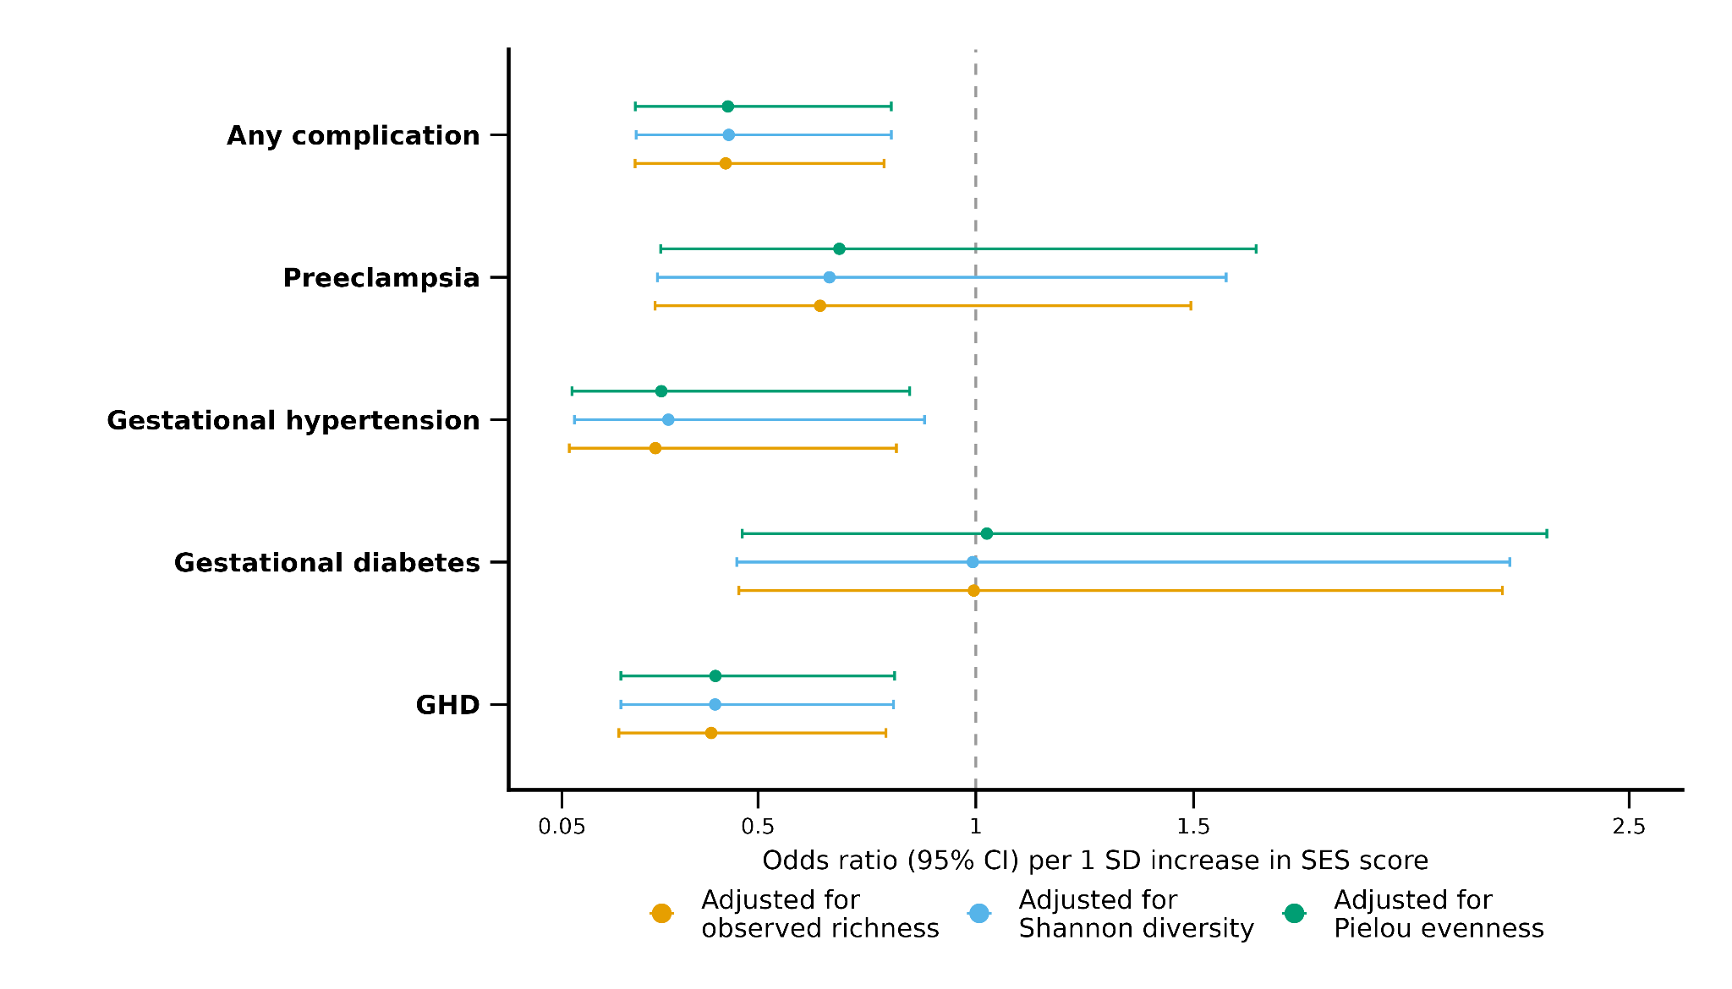
Figure S1. Odds ratios (95% confidence intervals) for the association between SES score and gestational metabolic complications, extracted from multivariable logistic regression models that adjusted for confounders and examined the association between alpha diversity and gestational outcomes. All continuous variables were z-score standardised prior to modelling; ORs therefore represent the change in odds per one standard deviation increase in SES score. Abbreviation: GHD, gestational hypertensive disorders (preeclampsia and gestational hypertension combined).

SI Figure 2. SHAP values of the top features in the best-performing concatenated models of each outcome.
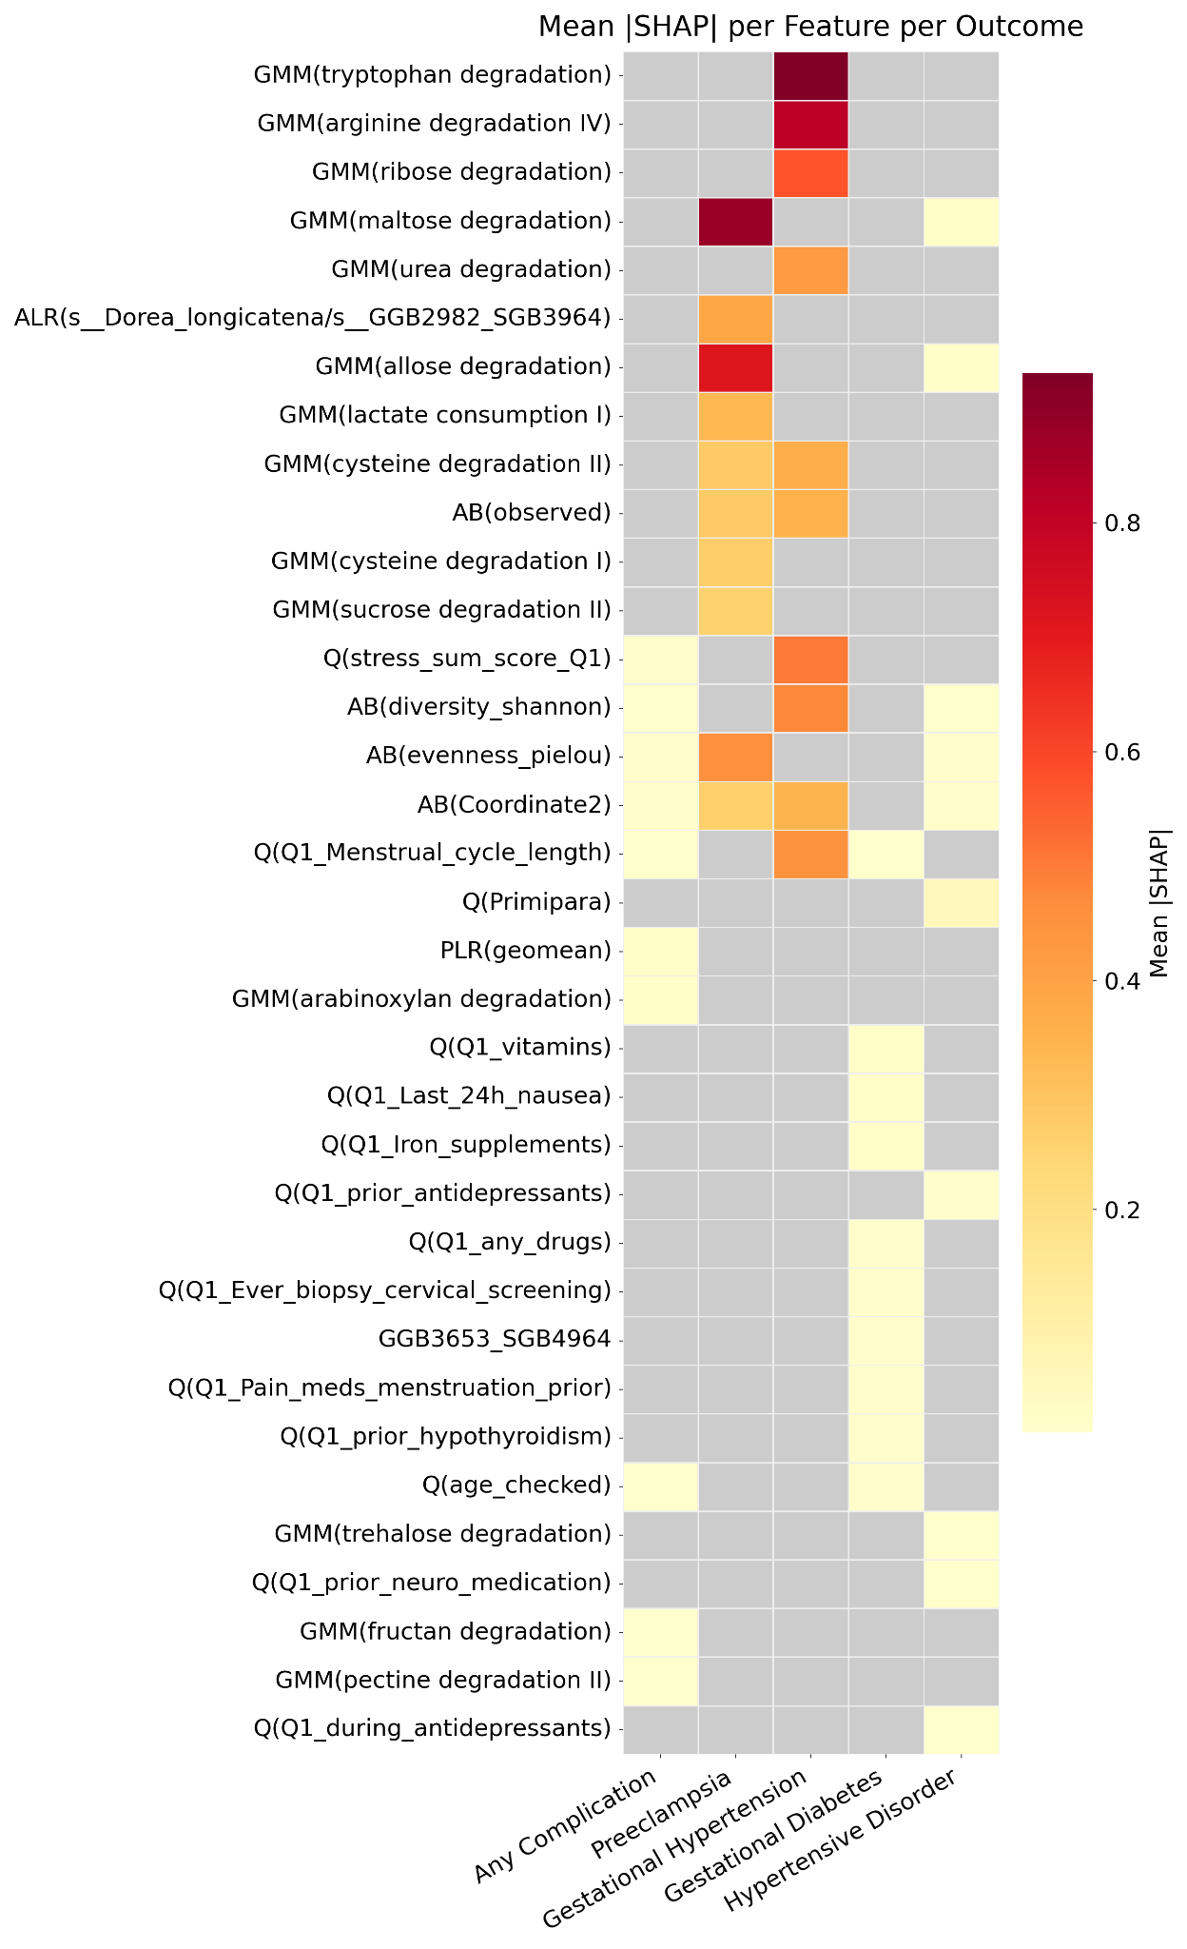
Figure S2. Mean absolute SHAP values of the top features from the best-performing concatenated models across pregnancy outcomes. Heatmap showing the mean absolute SHAP values for the union of the top 10 features (ranked within each outcome) derived from the best-performing concatenated model (ranked by BA) for each of the five outcomes. Rows correspond to outcomes and columns to features, ordered by decreasing mean absolute SHAP value averaged across outcomes. Cell colour represents the mean absolute SHAP value across all cross-validation folds and random seeds, with darker red indicating higher importance and lighter yellow representing lower importance. Grey cells denote features not ranked among the top 10 for a given outcome. Feature prefixes denote data modality: GMM, gut metabolic module activity; AB, alpha and beta indices; ALR, pairwise log-ratio of microbial species; PLR, pivot log-ratio transformation of species; Q, questionnaire-derived clinical and lifestyle variables.

