Table 1. Summary of baseline demographic, clinical, and tumor characteristics
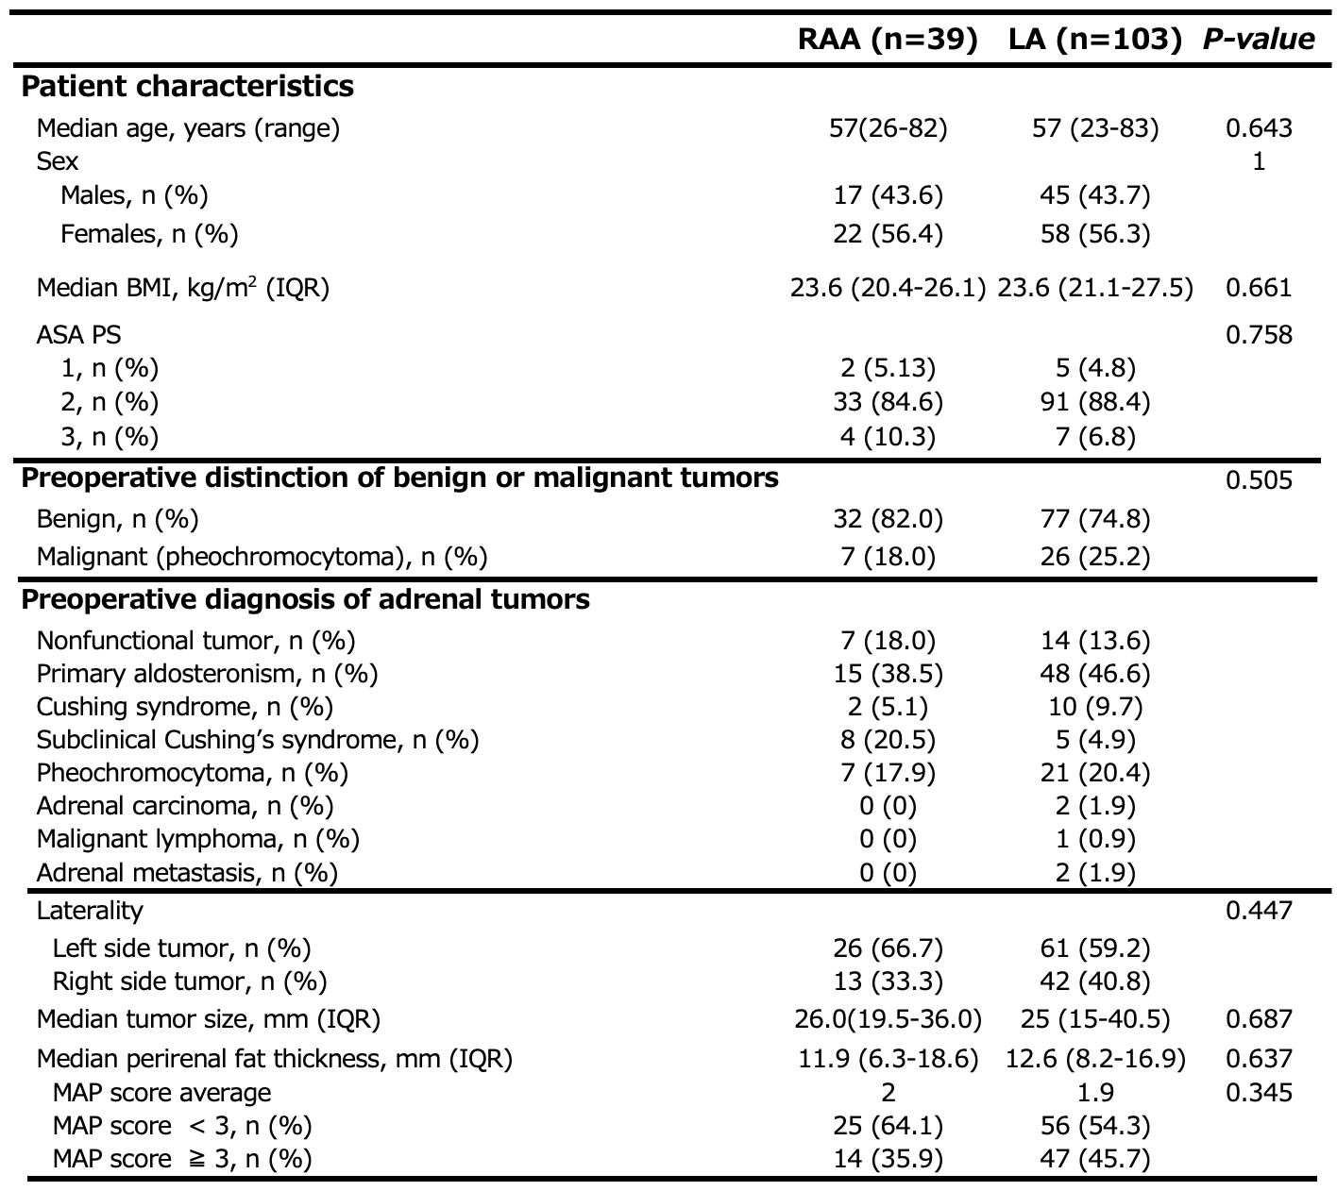
Abbreviations: BMI, body mass index; CT, computed tomography; IQR, interquartile range; MAP score, The Mayo Adhesive Probability score; ASA PS, American Society of Anesthesiologists Physical Status Classification System

Table 2. Summary of perioperative outcomes
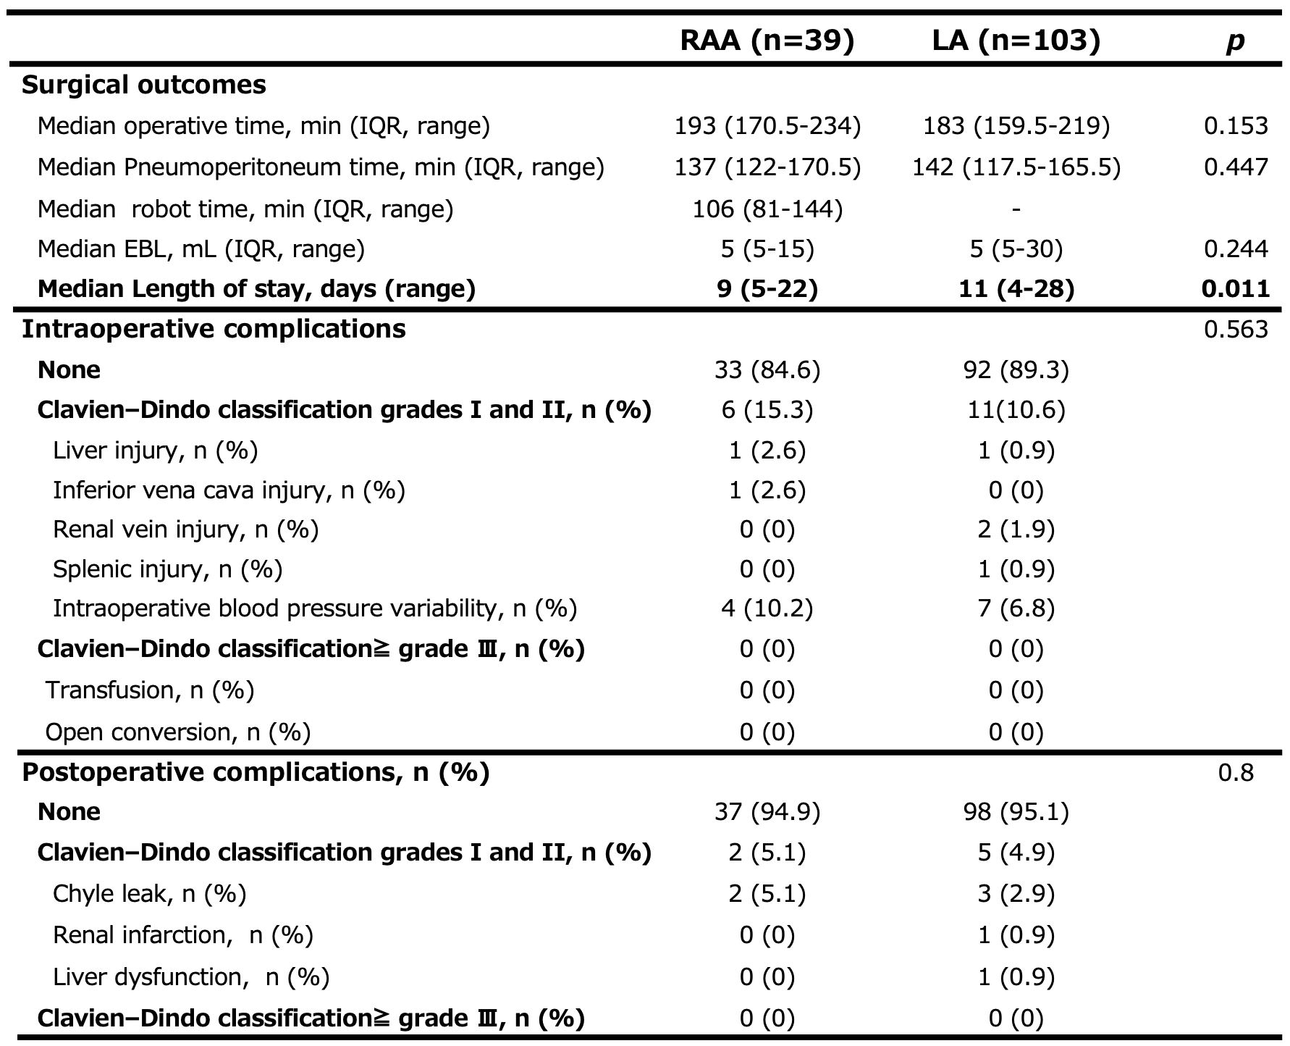

Table 3-1. Multiple regression analysis with preoperative predictors for operative time with LA
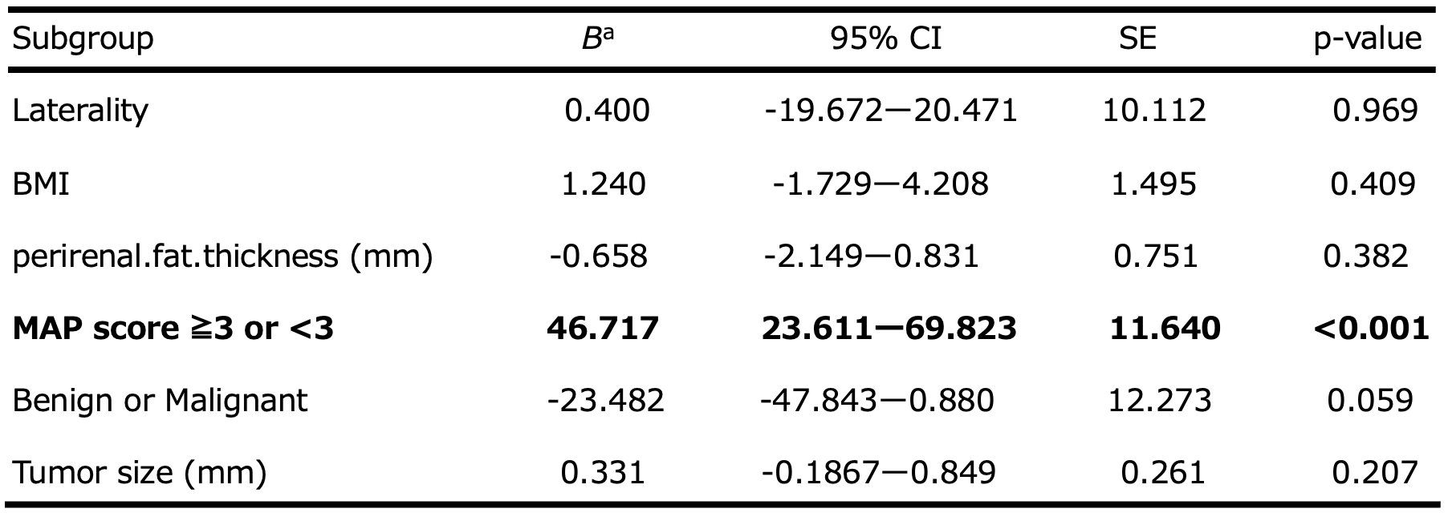

Table 3-2. Multiple regression analysis with preoperative predictors for pneumoperitoneum time with LA
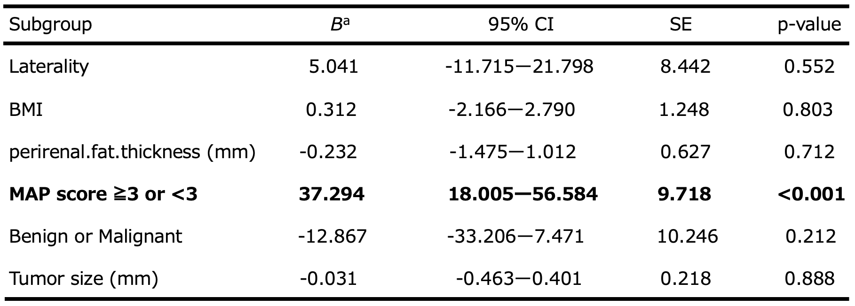

Table 3-3. Multiple regression analysis with preoperative predictors for estimated blood loss with LA

Table 3-4. Multiple regression analysis with preoperative predictors for length of hospital stay with LA
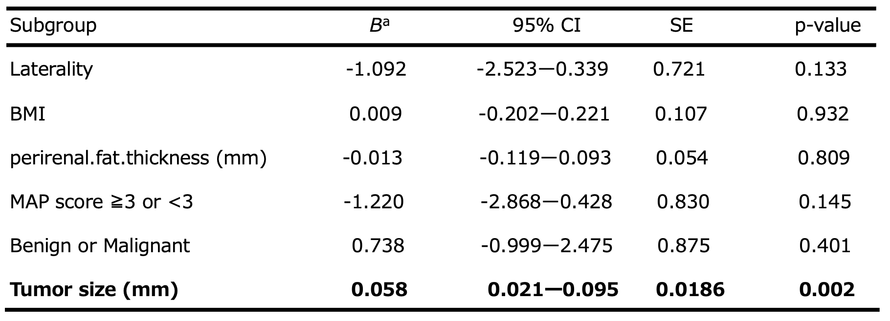
Abbreviations: BMI, body mass index; CI, confidence interval; SE, standard error. ª Unstandardized coefficient.

Table 4-1. Multiple regression analysis with preoperative predictors for operative time with RAA
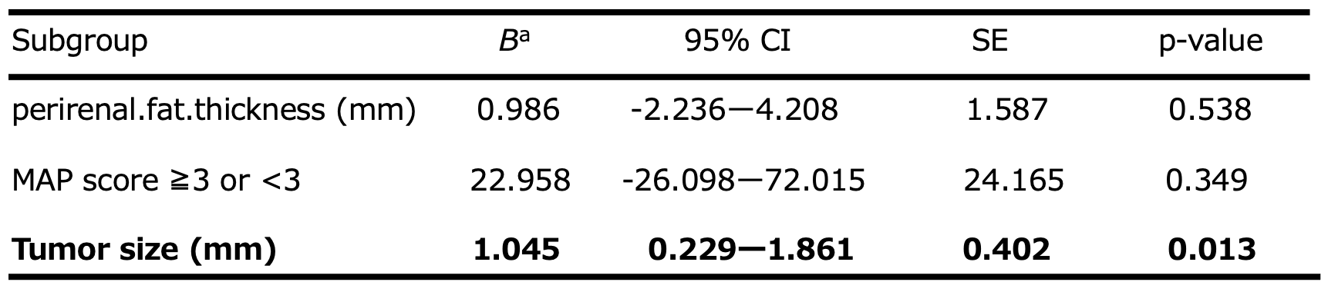

Table 4-2. Multiple regression analysis with preoperative predictors for pneumoperitoneum time with RAA
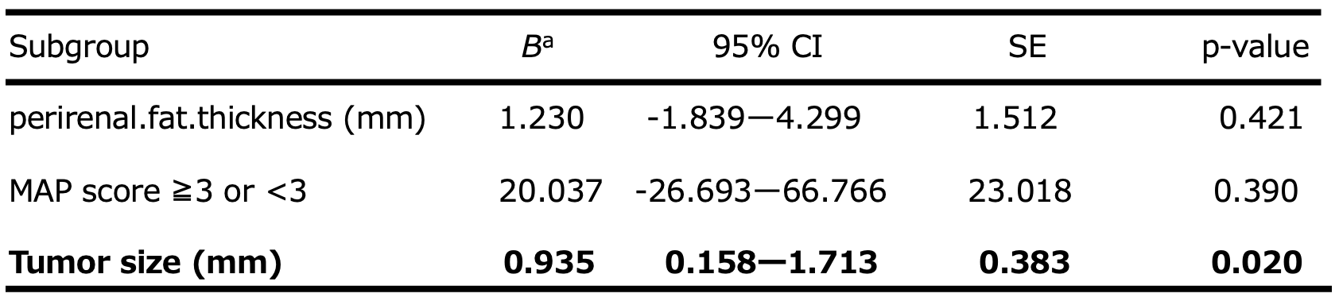

Table 4-3. Multiple regression analysis with preoperative predictors for robot time with RAA
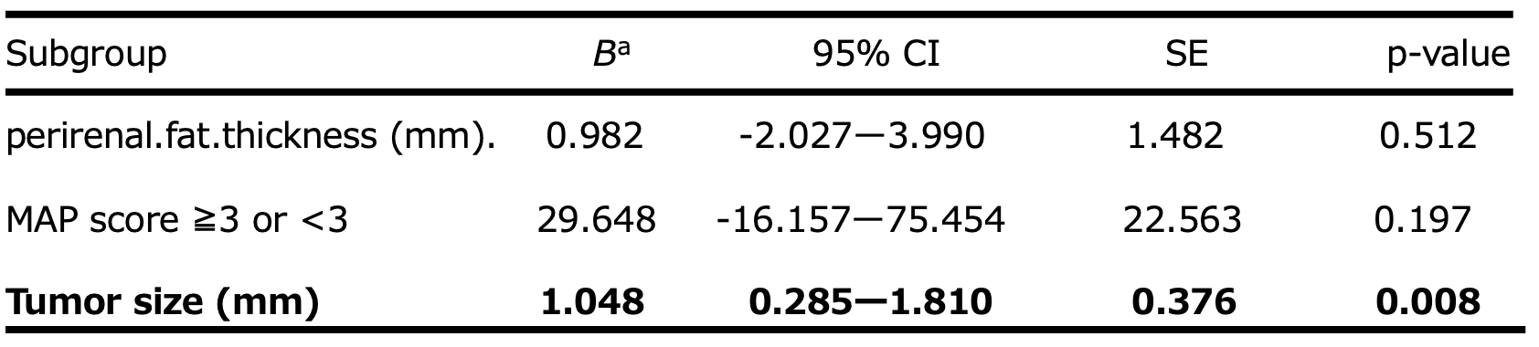

Table 4-4. Multiple regression analysis with preoperative predictors for estimated blood loss with RAA
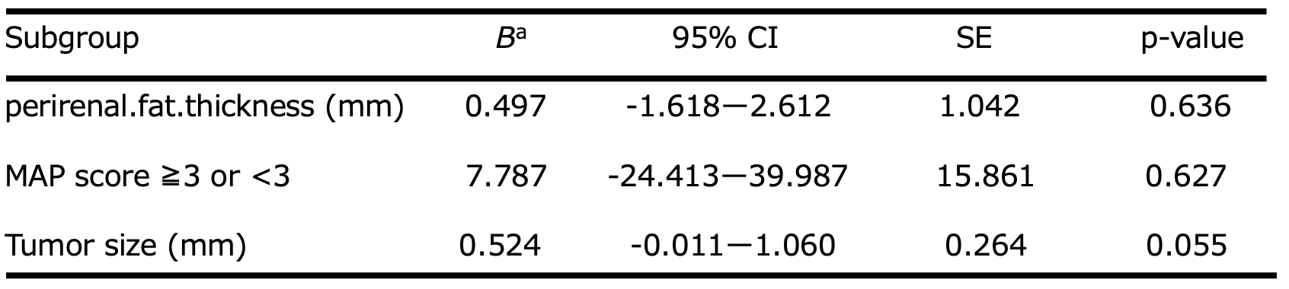

Table 4-5. Multiple regression analysis with preoperative predictors for length of hospital stay with RAA
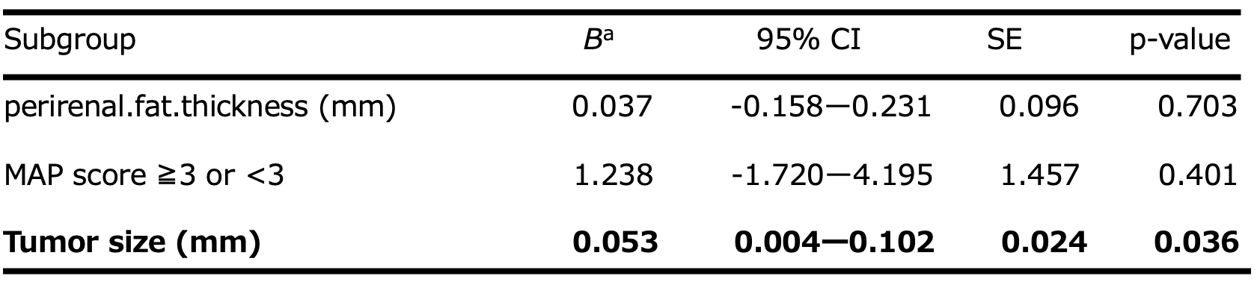
Abbreviations: BMI, body mass index; CI, confidence interval; SE, standard error. ª Unstandardized coefficient.

Table 5. Preoperative predictors of surgical outcomes of laparoscopic adrenalectomy in previous studies.
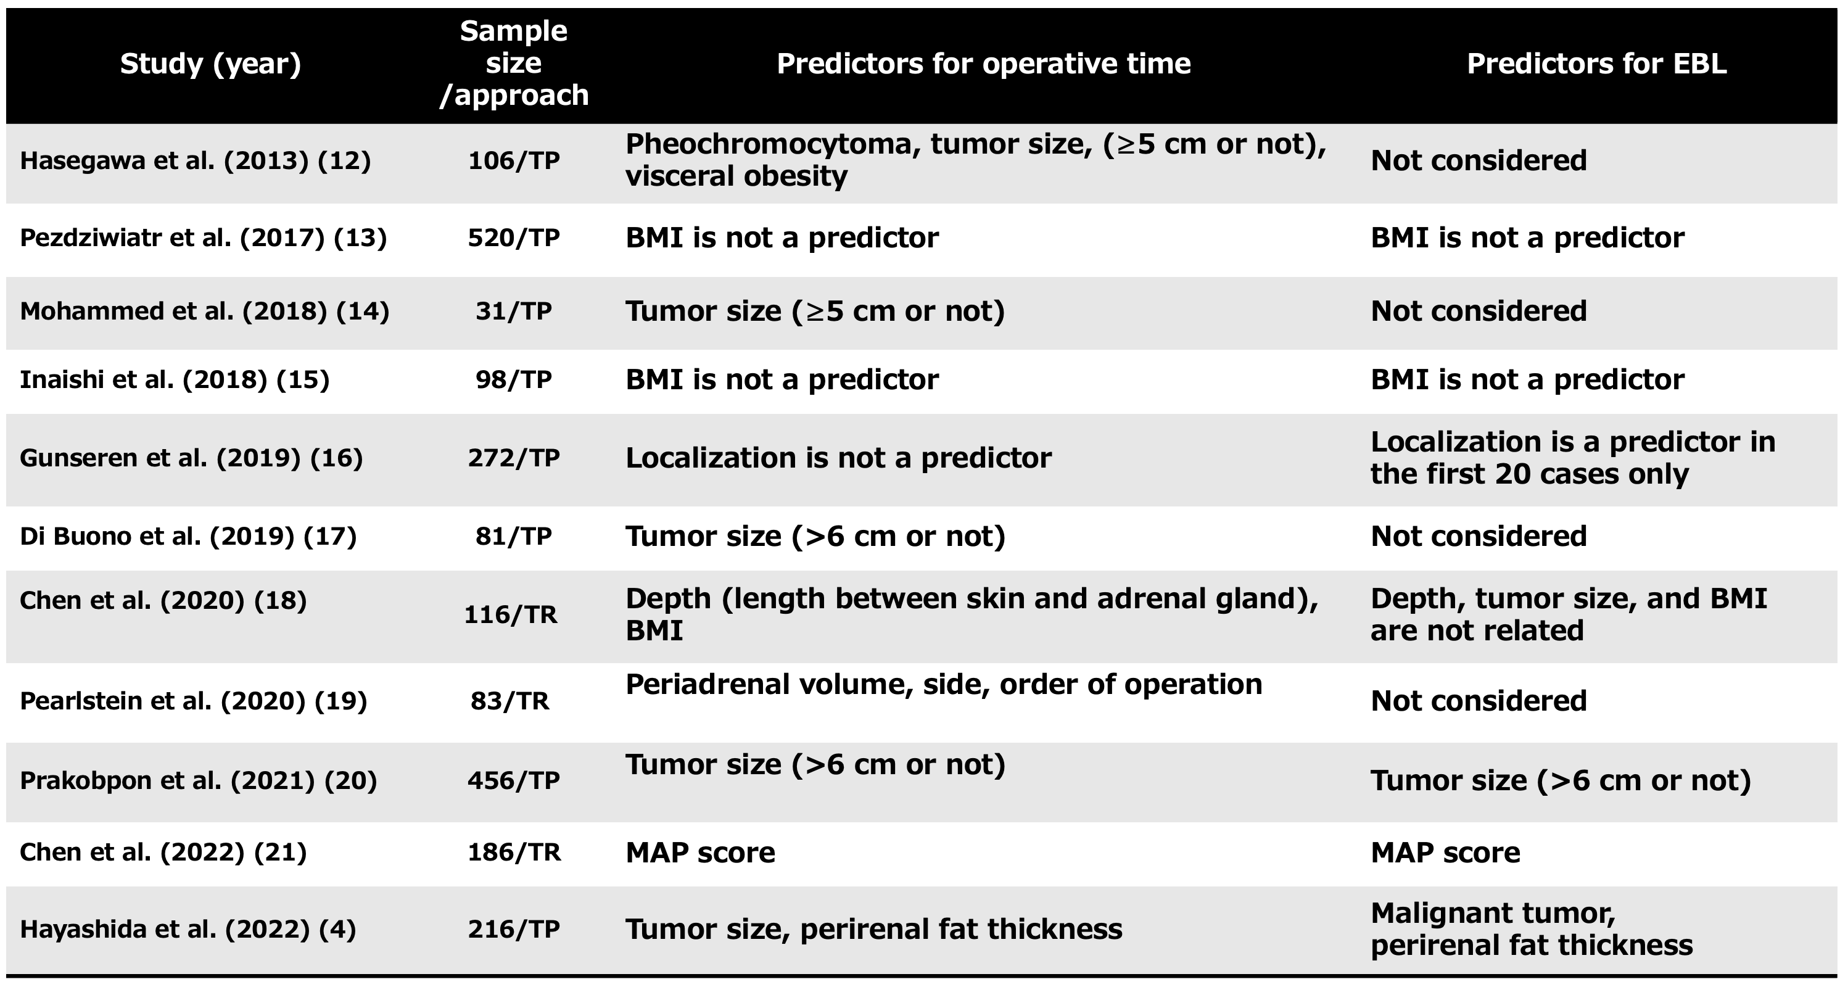
Published studies were found using PubMed searches for “laparoscopic adrenalectomy, outcomes, and/or predictors.” Abbreviations: BMI, body mass index; EBL, estimated blood loss; MAP, Mayo Adhesive Possibility. TP, Transperitoneal laparoscopic adrenalectomy. TR, Retroperitoneal laparoscopic adrenalectomy

