Design and Computational Evaluation of Quinazolinone Hydrazine Schiff Base Derivatives as EGFR Inhibitors
Prashant Singh¹ and Ramendra K. Singh¹*
- Bioorganic Research Laboratory, Department of Chemistry, University of Allahabad, Prayagraj- 211002, India
- Department of Chemistry, C.M.P. Degree College, University of Allahabad, Prayagraj- 211002, India
- Department of Chemistry, University of Allahabad, Prayagraj- 211002, India

*Corresponding author: Ramendra K. Singh, Email Id: singhramendrak@gmail.com
Si-Figures
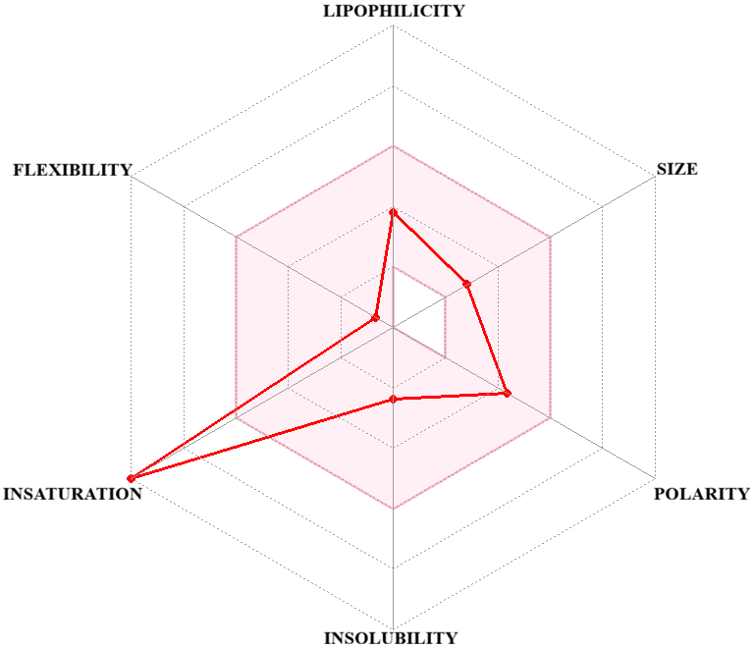  Compound 1 | 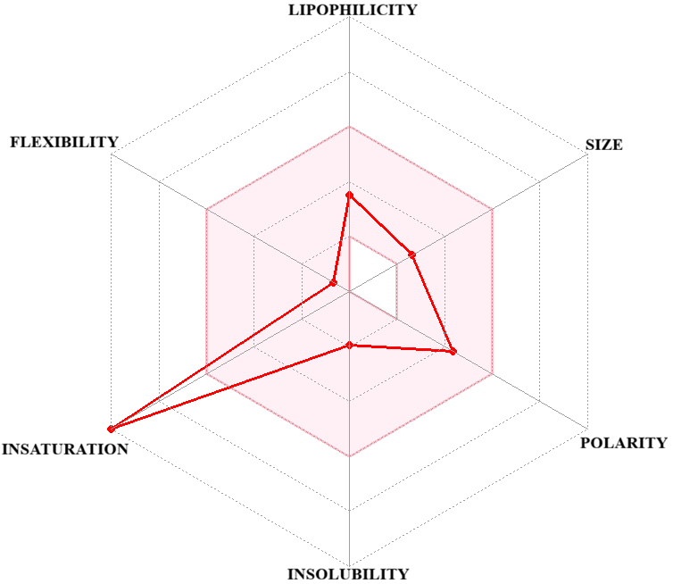  Compound 2
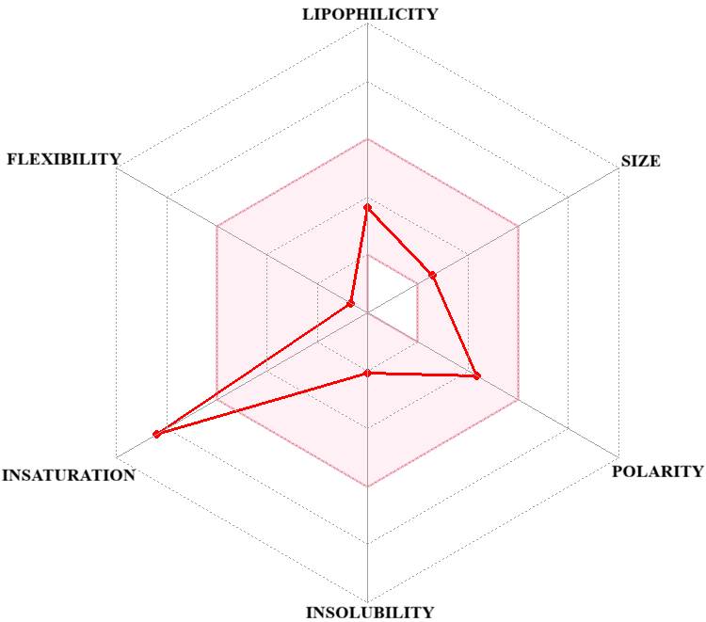  Compound 3 | 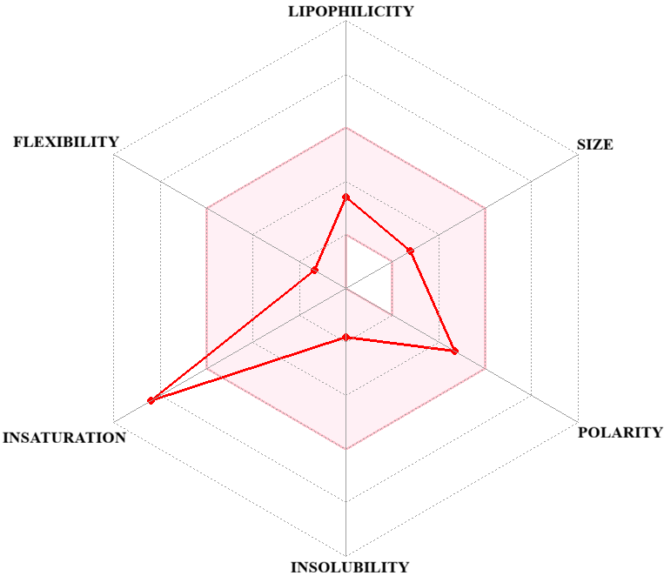  Compound 4
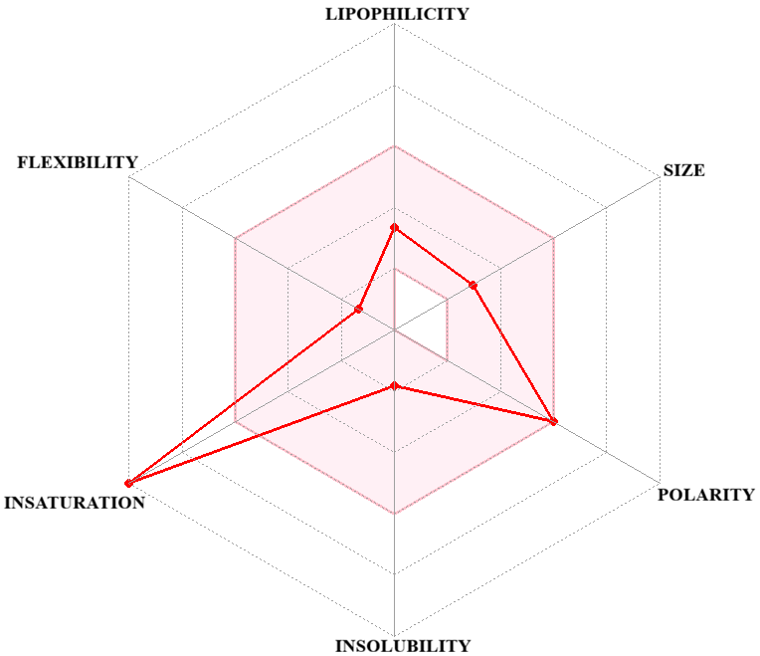  Compound 5 | 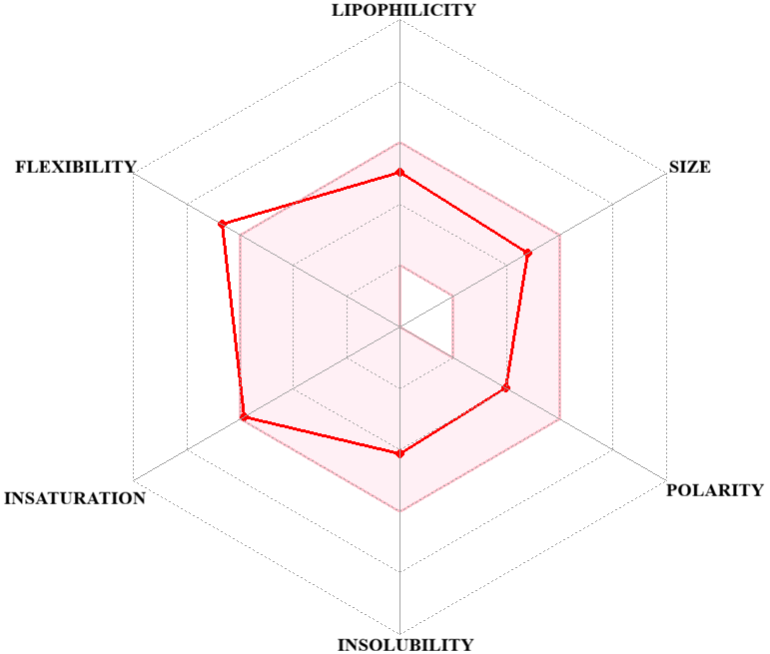  Ref.
Si-Figure 1. Radar graph of compounds 1-5 and reference drug
(The pink region highlights the acceptable ranges of characteristics related to drug-likeness in compounds)

