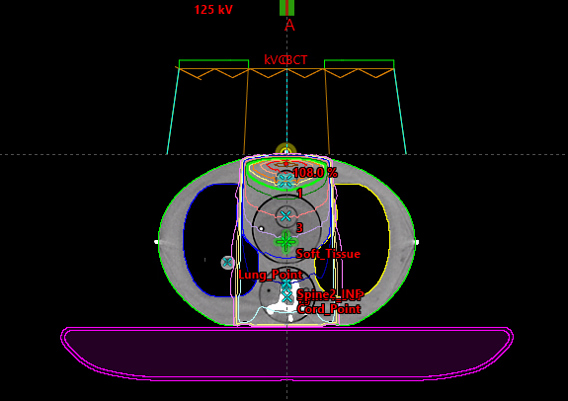  Case A field alignment | 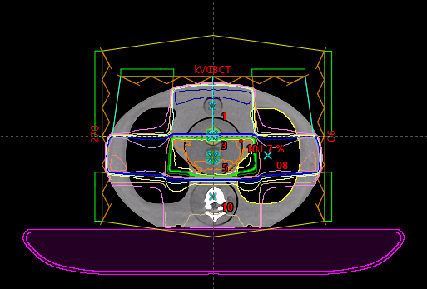  Case B field alignment | 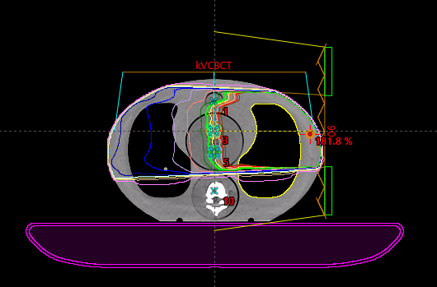  Case C field alignment
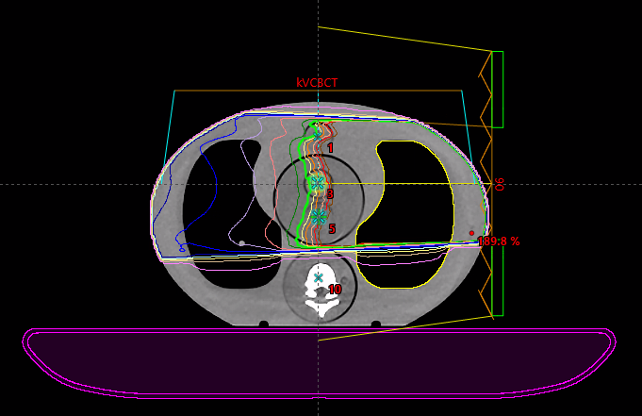  Case D field alignment | 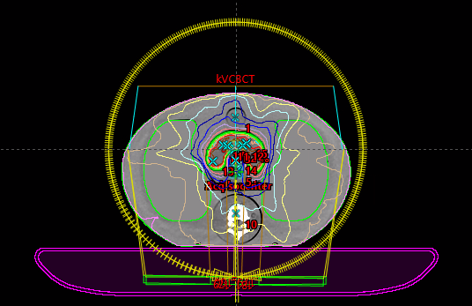  Case E field alignment | 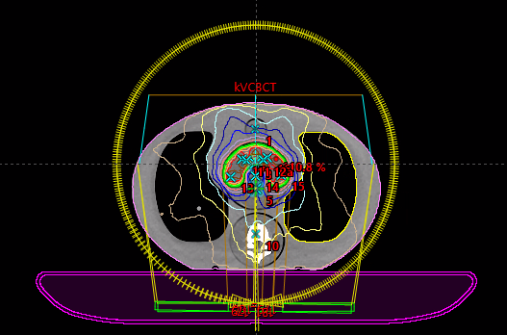  Case F field alignment
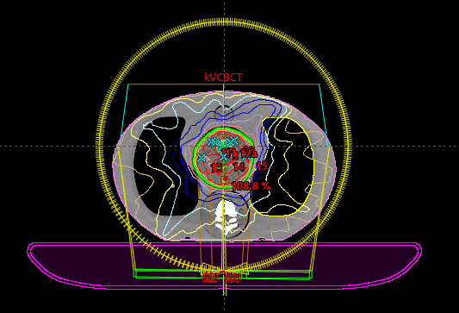  Case G field alignment | 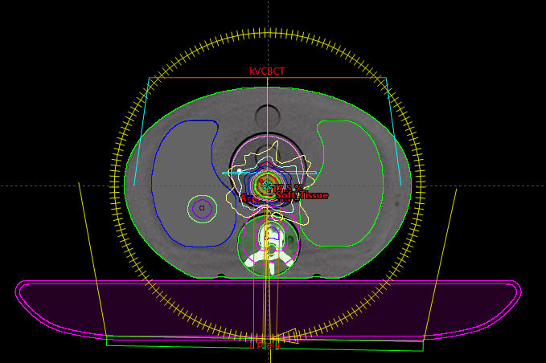  Case J field alignment | 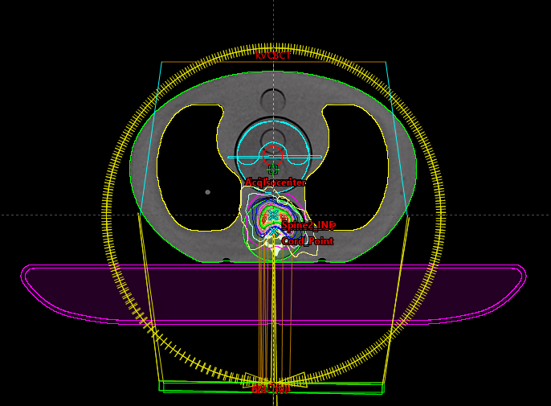  Case K field alignment
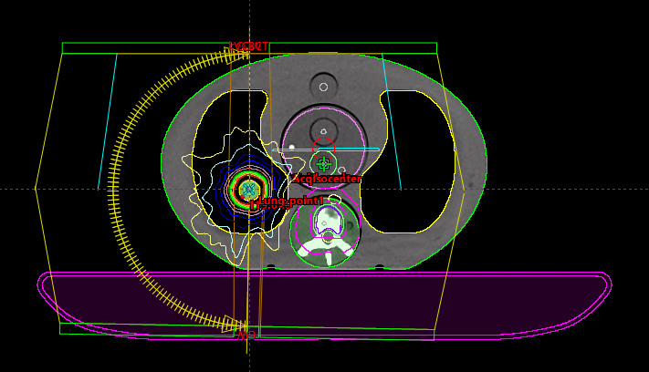
Case L field alignment
Table A1. ACDS Level 3 audit filed alignments

Case |  | Path |  | ACDS Audit Measurement [cGy] | Data A, HyperSight CT based planning [cGy] | Variation between ACDS and A | Data B, FBCT based planning [cGy] | Variation between ACDS and B | Variation between A and B
A | First audit | Tissue | Point 1 | 201.1 | 199.2 | -0.9% | 198.9 | -1.1% | 0.2% | Optimal
A | First audit | Tissue | Point 10 | 94.5 | 95.4 | 1.0% | 94.9 | 0.4% | 0.5% | Optimal
A | Second audit | Tissue | Point 1 | 198.1 | 199.2 | 0.6% | 200.3 | 1.1% | -0.6% | Optimal
A | Second audit | Tissue | Point 10 | 94.3 | 95.4 | 1.2% | 95 | 0.7% | 0.4% | Optimal
B | Field: 270 | Lung | Point 5 | 69.7 | 69 | -1.0% | 68.9 | -1.1% | 0.1% | Optimal
B | Field: 0 | Tissue | Point 5 | 61.6 | 61.6 | 0.0% | 61 | -1.0% | 1.0% | Optimal
B | Field: 90 | Lung | Point 5 | 70.8 | 69.5 | -1.8% | 69.7 | -1.6% | -0.3% | Optimal
C | Field 1 | Lung | Point 3 | 202.3 | 199.1 | -1.6% | 200.4 | -0.9% | -0.7% | Optimal
C | Field 1 | Lung | Point 5 | 199.4 | 196.9 | -1.3% | 198.2 | -0.6% | -0.7% | Optimal
D | Field 1: 90 | Lung | Point 3 | 203.5 | 200.1 | -1.7% | 201.3 | -1.1% | -0.6% | Optimal
D | Field 1: 90 | Lung | Point 5 | 210 | 206.5 | -1.7% | 208 | -1.0% | -0.7% | Optimal
F | First audit | Homogeneous | Point 11 | 224.5 | 218.8 | -2.5% | 217.2 | -3.3% | 0.7% | Optimal
F | First audit | Homogeneous | Point 12 | 217.2 | 211.6 | -2.6% | 211.4 | -2.7% | -0.1% | Optimal
F | First audit | Homogeneous | Point 13 | 205 | 210.8 | 2.8% | 210.9 | 2.9% | 0.0% | Optimal
F | First audit | Homogeneous | Avoid | 92.9 | 84.8 | -8.7% | 84.2 | -9.4% | -0.7% | Not Scored
F | First audit | Homogeneous | Point 15 | 214.1 | 212.4 | -0.8% | 211.4 | -1.3% | -0.5% | Optimal
F | First audit | Homogeneous | Point 16 | 215.8 | 208 | -3.6% | 207.7 | -3.8% | -0.1% | PASS-Review
F | First audit | Homogeneous | Point 17 | 215.6 | 210.4 | -2.4% | 210.7 | -2.3% | 0.1% | Optimal
F | Second audit | Homogeneous | Point 11 | 220.5 | 218.8 | -0.8% | 217.2 | -1.5% | -0.7% | Optimal
F | Second audit | Homogeneous | Point 12 | 213.3 | 211.6 | -0.8% | 211.4 | -0.9% | -0.1% | Optimal
F | Second audit | Homogeneous | Point 13 | 201.2 | 210.8 | 4.8% | 210.9 | 4.8% | 0.0% | Excluded
F | Second audit | Homogeneous | Avoid | 90.9 | 84.8 | -6.7% | 84.2 | -7.4% | -0.7% | Not Scored
F | Second audit | Homogeneous | Point 15 | 210.5 | 212.4 | 0.9% | 211.4 | 0.4% | -0.5% | Optimal
F | Second audit | Homogeneous | Point 16 | 212.2 | 208 | -2.0% | 207.7 | -2.1% | -0.1% | Optimal
F | Second audit | Homogeneous | Point 17 | 211.4 | 210.4 | -0.5% | 210.7 | -0.3% | 0.1% | Optimal
G | First audit | Homogeneous | Point 11 | 223.1 | 216.4 | -3.0% | 216.1 | -3.1% | -0.1% | Optimal
G | First audit | Homogeneous | Point 12 | 224.4 | 216 | -3.7% | 217.8 | -2.9% | 0.8% | PASS-Review
G | First audit | Homogeneous | Point 13 | 217.1 | 211.6 | -2.5% | 211.9 | -2.4% | 0.1% | Optimal
G | First audit | Homogeneous | Avoid | 107.4 | 102 | -5.0% | 102.3 | -4.7% | 0.3% | Not Scored
G | First audit | Homogeneous | Point 15 | 218.5 | 210 | -3.9% | 210.8 | -3.5% | 0.4% | PASS-Review
G | First audit | Homogeneous | Point 16 | 220.2 | 210.8 | -4.3% | 211.5 | -4.0% | 0.3% | PASS-Review
G | First audit | Homogeneous | Point 17 | 222.7 | 214.4 | -3.7% | 215.6 | -3.2% | 0.6% | PASS-Review
G | Second audit | Homogeneous | Point 11 | 218.4 | 216.4 | -0.9% | 216.1 | -1.1% | 0.0% | Optimal
G | Second audit | Homogeneous | Point 12 | 219.7 | 216 | -1.7% | 217.8 | -0.9% | -2.1% | Optimal
G | Second audit | Homogeneous | Point 13 | 213.1 | 211.6 | -0.7% | 211.9 | -0.6% | 0.7% | Optimal
G | Second audit | Homogeneous | Avoid | 90.9 | 102 | 12.2% | 102.3 | 12.5% | -0.2% | Not Scored
G | Second audit | Homogeneous | Point 15 | 215 | 210 | -2.3% | 210.8 | -2.0% | 0.2% | Optimal
G | Second audit | Homogeneous | Point 16 | 216.1 | 210.8 | -2.5% | 211.5 | -2.1% | 0.0% | Optimal
G | Second audit | Homogeneous | Point 17 | 219 | 214.4 | -2.1% | 215.6 | -1.6% | 0.6% | Optimal
H | First audit | Homogeneous | Point 11 | 214.7 | 209.6 | -2.4% | 209.5 | -2.4% | 0.0% | Optimal
H | First audit | Homogeneous | Point 12 | 215.6 | 208.8 | -3.2% | 209 | -3.1% | 0.1% | Optimal
H | First audit | Homogeneous | Point 13 | 221.8 | 208.8 | -5.9% | 208.5 | -6.0% | -0.1% | Excluded
H | First audit | Homogeneous | Avoid | 58.5 | 44.8 | -23.4% | 44.7 | -23.6% | -0.2% | Not Scored
H | First audit | Homogeneous | Point 15 | 217.1 | 211.2 | -2.7% | 211.2 | -2.7% | 0.0% | Optimal
H | First audit | Homogeneous | Point 17 | 208.8 | 208 | -0.4% | 208.2 | -0.3% | 0.1% | Optimal
H | First audit | Homogeneous | Point 18 | 168.9 | 165.2 | -2.2% | 165.3 | -2.1% | 0.1% | Optimal
H | Second audit | Homogeneous | Point 11 | 210.5 | 209.6 | -0.4% | 209.5 | -0.5% | 0.0% | Optimal
H | Second audit | Homogeneous | Point 12 | 212 | 208.8 | -1.5% | 209 | -1.4% | 0.1% | Optimal
H | Second audit | Homogeneous | Point 13 | 217.9 | 208.8 | -4.2% | 208.5 | -4.3% | -0.1% | PASS-Review
H | Second audit | Homogeneous | Avoid | 58 | 44.8 | -22.8% | 44.7 | -22.9% | -0.2% | Not Scored
H | Second audit | Homogeneous | Point 15 | 214 | 211.2 | -1.3% | 211.2 | -1.3% | 0.0% | Optimal
H | Second audit | Homogeneous | Point 17 | 205.4 | 208 | 1.3% | 208.2 | 1.4% | 0.1% | Optimal
H | Second audit | Homogeneous | Point 18 | 166.1 | 165.2 | -0.5% | 165.3 | -0.5% |  | Optimal
J |  | Tissue | Point Soft Tissue | 1712.8 | 1700.9 | -0.7% | 1698.8 | -0.8% | 0.1% | Optimal
K |  | Spine | Point Spine SUP | 1501.7 | 1514.5 | 0.9% | 1545.9 | 2.9% | -2.0% | Optimal
L | First audit | Lung | Point Soft Tissue | 1362.3 | 1321 | -3.0% | 1324.4 | -2.8% | -0.3% | Optimal
L | Second audit | Lung | Point Soft Tissue | 1330.2 | 1321 | -0.7% | 1324.4 | -0.4% | -0.3% | Optimal
Table A2. ACDS measured Vs HyperSight based planned Vs FBCT based planned doses, point dose measurement with associated chambers

 | Linac 1 | Linac 2 | Linac 3 | Linac 4 | Linac 5 | Linac 6 | Linac 7 | Linac 4 HypS | Linac 4 HypS Repeat | AVERAGE
Case A Pt 1 | -0.2 | 0.0 | -0.3 | 0.0 | -0.4 | 0.0 | 1.0 | -0.4 | -0.5 | -0.1
Case A Pt 10 | 0.9 | 2.1 | -0.1 | 0.4 | -1.0 | 1.6 | 0.6 | 1.5 | 0.1 | 0.7
Case B RLAT |  | -1.1 | -1.9 | -0.9 | -0.1 | 0.7 | -0.5 | -0.5 |  | -0.6
Case B AP |  | -1.9 | 0.5 | -0.7 | 1.4 | 0.0 | 1.2 | 0.5 |  | 0.1
Case B LLAT |  | -1.7 | -2.3 | -1.5 | 0.2 | -0.3 | -0.4 | -1.3 |  | -1.0
Case C Pt 3 | -0.3 | 0.4 | -0.4 | 0.8 | 1.3 | 3.3 | 1.3 | -1.1 |  | 0.7
Case C Pt 5 | -0.5 | 1.9 | -0.7 | -0.2 | 1.6 | -1.2 | 1.5 | -0.8 |  | 0.2
Case D Pt 3 |  | -0.4 | -1.2 | 0.3 | 0.7 | -1.8 | 1.0 | -1.2 |  | -0.4
Case D Pt 5 |  | 1.5 | -1.5 | -0.6 | 1.1 | 2.4 | 0.6 | -1.2 |  | 0.3
Case E Avg | -2.12 | -2.25 | -1.82 | -2.30 | -1.27 | -1.48 | -0.90 | -1.02 | -1.72 | -1.7
Case F Avg | -2.22 | -2.60 | -2.65 | -1.68 | -0.78 | -0.97 | -0.62 | -3.03 | -2.80 | -1.9
Case G Avg | -2.60 | -2.42 | -2.50 | -1.34 | -0.16 | 0.56 | -0.58 | -1.66 | -2.22 | -1.4
Case I | 0.6 |  | 2.9 | -1.4 | -2.9 |  | 0.9 | -0.2 |  | 0.0
Case L | -2.5 |  | -0.9 | -2.8 | 0.8 |  | -1.5 | -2.9 | -2.1 | -1.7
Table A3. Seven linacs and the HyperSight audit results comparison

