Supplementary Material

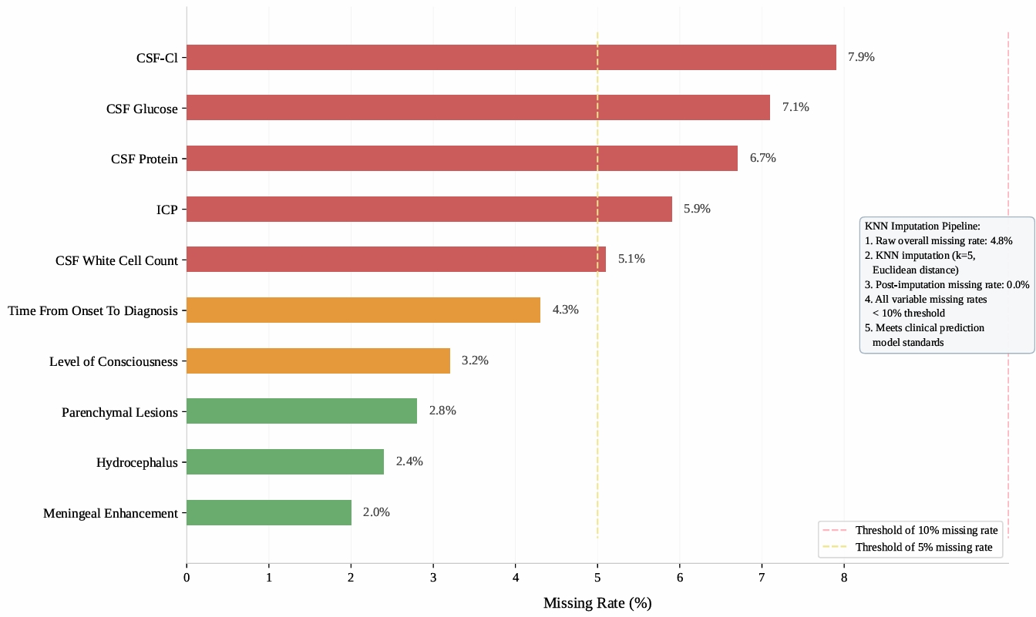
Supplementary Figure 1 Missing data distribution and KNN imputation workflow in the study cohort.
The bar chart displays the missing rates of individual baseline variables before imputation. Overall missing rate was 4.8% and all variables below the 10% threshold. After K-nearest neighbor (KNN) imputation (k=5, Euclidean distance), complete data were obtained for all variables (0.0% missing). The dashed horizontal lines indicate the 5% and 10% missing rate thresholds for reference. This imputation approach was applied exclusively within the training set to avoid data leakage, and the imputation model was then used for the internal validation and external test sets.

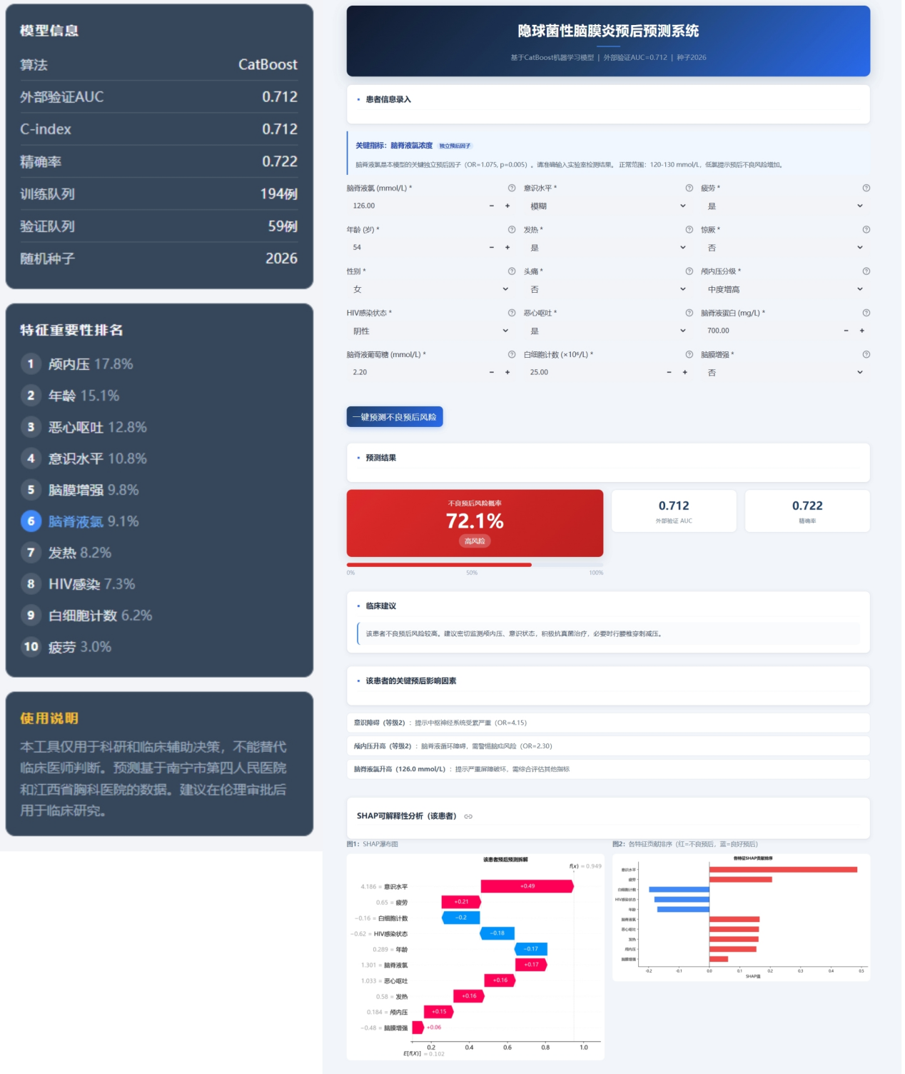
Supplementary Figure 2 Online interactive prognostic prediction tool for cryptococcal meningitis based on the CatBoost model.
This screenshot shows the user interface of the web-based prediction tool developed from the optimal CatBoost model. The tool requires input of patient characteristics including CSF chloride concentration (mmol/L), age, sex, HIV status, intracranial pressure, mental status, fever, nausea/vomiting, fatigue, meningeal enhancement, and white blood cell count. Upon submission, it outputs the predicted probability of 10-week unfavorable prognosis and assigns a risk level. The model performance metrics (external validation AUC=0.712, C-index=0.712, precision=0.722) and feature importance rankings are displayed for reference. The tool also integrates SHAP-based interpretability to provide individualized explanation of the prediction. It is intended for research and clinical decision support and should not replace clinical judgment. The tool was developed using data from two tertiary hospitals and requires ethical approval for clinical research use. The tool is currently set to Chinese.

