Supporting Information
Enhanced High-Rate Capability of LiNi_{0.83}Co_{0.11}Mn_{0.06}O₂ Cathodes by Homogeneous Sr²⁺ Doping
Teng Ma¹, Zhikun Zhang¹, Junjie Zhang¹, Shuaijie Li¹, Renfei Liu¹, fangchun Luo², Lili Zhang³, Zhen Xu¹, Fuqiang Guo^{1*}, Baohua Zhang^{1*}
1. Xinjiang Key Laboratory of High Value Green Utilization of Low-rank Coal,
School of Physics and Materials Science, Changji University, Xinjiang, Changji
831100, China
- School of Foreign Languages, Changji University, Xinjiang, Changji 831100, China
- Xinjiang Key Laboratory of Phase Transitions and Microstructures in Condensed Matters, College of Physical Science and Technology, Yili Normal University, Xinjiang, Yining 835000, China
*Corresponding authors.
*E-mail: cjxyedu@163.com (Prof. Fuqiang Guo), zbhcjxy@163.com (Baohua Zhang).

PartⅠ: Supporting Figures
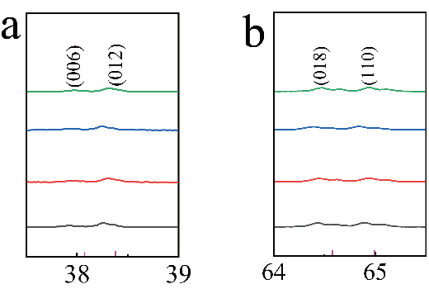
Fig. S1 (a) (003) peaks, (b) (104) peaks.
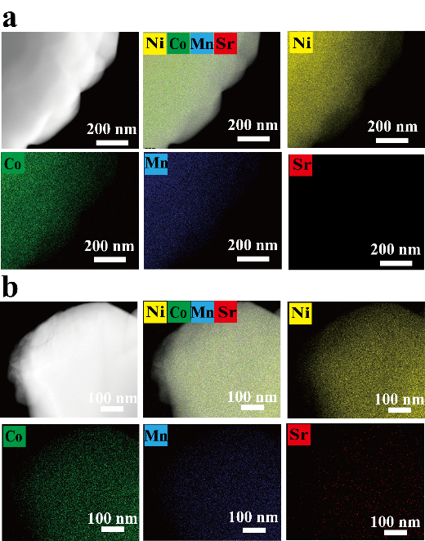
Fig.S2 EDS mapping results for NCM-Sr-0 (a); EDS mapping results for NCM-Sr-0.7 (b).
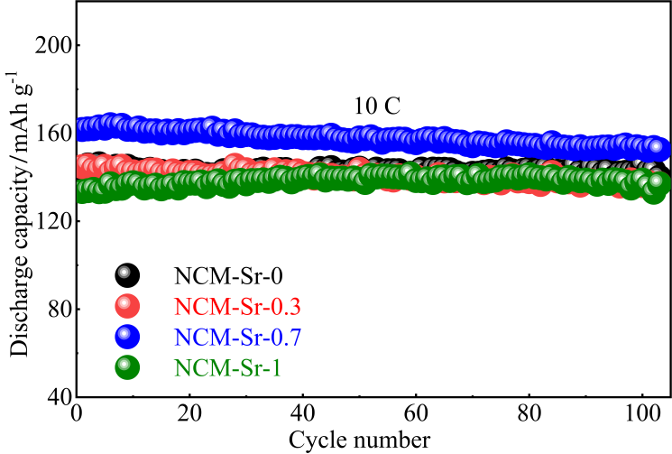
Fig.S3 long multiplicity performance of NCM-Sr-X at 10C
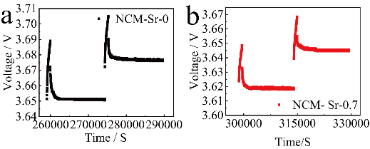
Fig.S4 (a) NCM-Sr-0-GITT and (b) NCM-Sr-0.7-GITT charging curve .

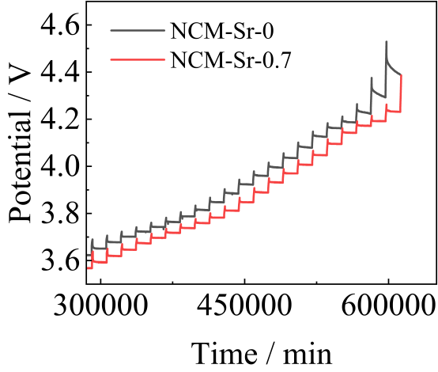
Fig. S5. NCM-Sr-0 and NCM-Sr-0.7-GITT charging curve .
For the GITT measurement, the assembled coin-type half-cells were firstly galvanostatic charge/discharged at a constant current of 0.1C for 3 cycles. Subsequently, the charging interval was set, and the open circuit lasted 4 h to allow the cell voltage to relax to its quasi-equilibrium state. The change in the steady-state voltage ΔE_{s} is obtained by subtracting the original voltage (E₀) from the steady-state voltage (E_{s}). The cell voltage increases during the current flux and the total change of cell voltage ΔE_{τ} can be obtained by calculating the voltage drop. Meanwhile, the process of the chemical diffusion is assumed to obey Fick’s second law of diffusion. With a series of simplifications, for sufficient time interval (τ<<L²/D_{Li}⁺), the equation of D_{Li}⁺ can be written as (Equation 1):
$D_{{Li}^{+}}\text{=}\frac{4}{π}{\left(\frac{m_{B}V_{m}}{M_{B}A}\right)}^{2}{\left(\frac{ΔE_{s}}{τ\left(\frac{dE_{τ}}{\sqrt{τ}}\right)}\right)}^{2}\left(τ≪\frac{L^{2}}{D_{{Li}^{+}}}\right) (1)$
where V_{m} is the molar volume of active materials, M_{B} and m_{B} are the molecular weight and mass of the host oxide, respectively, and A is the total contact area between the electrolyte and the electrode, L is the thickness of the electrode. If sufficiently small currents and short time intervals are employed, the cell voltage is a linear function of the square root of τ, Equation 1 can be further simplified as (Equation 2):
$$D_{{Li}^{+}}\text{=}\frac{{4L}^{2}}{πτ}{\left(\frac{ΔE_{s}}{ΔE_{τ}}\right)}^{2}\left(τ≪\frac{L^{2}}{D_{{Li}^{+}}}\right) (2)$$

where ΔE_{s} is the value of subtracting the original voltage (E₀) from the steady-state voltage (E_{s}). ΔE_{τ} is the change in the total temporary potential during the application of current in τ, L is the thickness of the electrode.
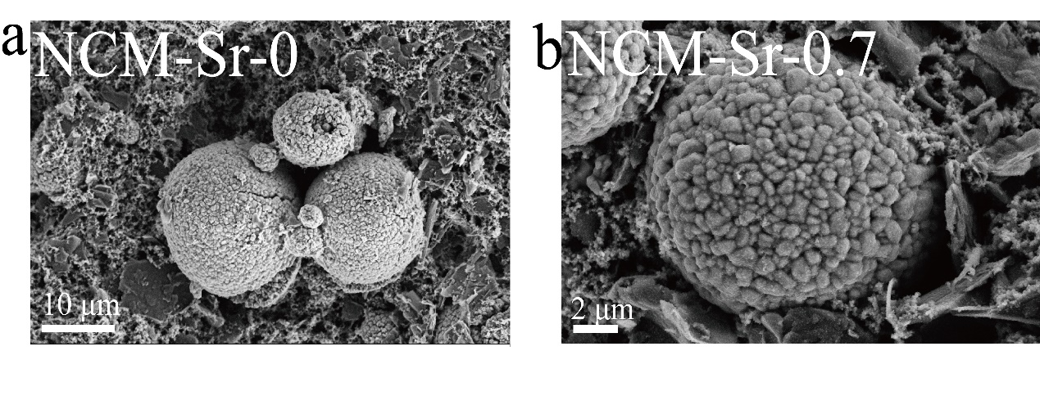 Fig. S5. the SEM images Of (a) NCM-Sr-0 and (b)NCM-Sr-0.7 after 100 cycles;

Table. S2 Precise impedance parameters of raw and Sr samples after different number of cycles.
NCM-Sr-0 | Rs | R_{f} | R_{ct} | NCM-Sr-0.7 | Rs | R_{f} | R_{ct}
3th | 4.113 | 12.19 | 12.19 | 3th | 4.1 | 12.125 | 12.46
50th | 4.432 | 8.725 | 24.22 | 50th | 4.2 | 7.055 | 36.73
100th | 5.364 | 10.38 | 46.43 | 100th | 5.6 | 12.43 | 62.86

