Prediction of Heavy Metal Adsorption onto Biochar Using Interpretable Machine Learning: A Multi-Source Data-Driven Study

Tao Chen*,Dajin Lu,Jialong Tao
Faculty of Resources and Environmental Engineering, Yunnan Vocational Institute of Energy Technology, Qujing 655001, China.

TextS1 Data Preprocessing
(1) Missing Value Imputation
Statistical analysis reveals that the missing rate of the specific surface area (SSA, also known as BET surface area) field in the raw dataset stands at approximately 8%, which primarily arises from the omission of this physical parameter in partial literature reports. As a core characteristic governing the quantity of adsorption sites on biochar, SSA cannot be simply addressed via direct deletion of samples with missing values, as such an operation would lead to substantial loss of valid data records.Accordingly, this study adopts a grouping strategy based on raw material category and pyrolysis temperature intervals (with each interval spanning 100 °C), and employs the median SSA value within each group to impute corresponding missing entries. A small number of scattered samples that fail to be categorized into any predefined group are supplemented with the global median of the entire dataset. Following the imputation procedure, the missing rate of the SSA field is reduced to 0%, restoring full integrity (100%) of the dataset.
(2) Outlier Removal
The interquartile range (IQR) method was applied to detect outliers column by column for all numerical input features. This method does not require the assumption of normally distributed data and exhibits superior robustness for right-skewed variables such as adsorption capacity data. For each feature, the normal value range was defined as [Q₁−1.5×IQR,Q₃+1.5×IQR], where Q₁ and Q₃ represent the 25th and 75th percentiles, respectively. Samples falling outside this range were identified as outliers.After screening across all features, a total of 38 outlying records were eliminated, accounting for 3.5% of the original dataset. These outliers mainly corresponded to extremely high adsorption capacities obtained under extreme modification conditions. Following outlier removal, 927 valid samples were retained. The skewness of each feature distribution decreased markedly, which effectively prevents extreme values from dominating parameter updates during model training and improves training stability.
(3) Categorical Variable Encoding
Three unordered categorical features, namely feedstock type, modification method and heavy metal species, were converted into sparse numerical vectors via one-hot encoding. This approach eliminates spurious ordinal relationships that would otherwise be introduced by label encoding.
For the heavy metal species feature, aside from one-hot encoding, intrinsic physicochemical descriptors of metals were additionally incorporated as separate numerical inputs, including ionic radius, electronegativity, primary hydrolysis constant pK₁, and hydrated Gibbs free energy. This design enables the model to not only capture discrete disparities among different metal species, but also learn continuous correlations between metal inherent properties and adsorption capacities.
(4) Standardization of Numerical Features
To eliminate interference caused by discrepancies in dimensions and magnitude across distinct numerical features during model training, all numerical variables were standardized via Z-score transformation. This procedure rescales each feature to follow a distribution with a mean of zero and a standard deviation of one. The parameters required for standardization were solely fitted on the training dataset, as expressed in Equation S1:
X_{scaled}$=\frac{X-μ}{σ}$ (S1)
Where, μ denotes the mean value of the feature calculated on the training set, and σ represents the corresponding standard deviation.

TextS2 Mechanism-Driven Features
(1)Dehydration Energy Index (Dehy_Index)
Heavy metal ions exist as hydrated species in aqueous solution. Prior to complexation with functional groups within biochar pores during adsorption, these ions must partially shed their hydration shells by overcoming the hydration energy barrier. In this study, the dehydration energy index is defined as the ratio between the absolute value of the hydrated Gibbs free energy of metal ions and the corresponding ionic radius, as expressed in Equation S2:
$Dehy_Index=\frac{{∣ΔG}_{hyd}∣}{r_{ion}}$ (S2)
Where, ΔG_{hyd} denotes the molar hydrated Gibbs free energy of metal ions (kJ/mol), and r_{ion} represents the ionic radius under hexacoordinated hydration conditions (pm).
(2)Hydrolysis Activity (Hydrolysis)
Heavy metal ions undergo hydrolysis reactions in aqueous media to form hydroxyl complex species such as
MOH⁺ and M(OH)₂. These hydrolyzed species possess lower charge density than free hydrated ions and display stronger complexation affinity toward functional groups on biochar surfaces. Accordingly, a hydrolysis activity feature was established in this work to couple the combined effects of solution pH and intrinsic metal hydrolysis properties, as presented in Equation S3:
Hydrolysis=pH−pK₁ (S3)
Where, pK₁ refers to the negative logarithm of the primary hydrolysis constant of metal ions.

(3)HSAB Hard-Soft Matching Index (HSAB_Match)
In line with Pearson’s Hard-Soft-Acid-Base (HSAB) theory, soft acid metal ions tend to coordinate with soft basic sites bearing nitrogen and sulfur, while hard acid metal ions prefer to interact with hard basic sites represented by oxygen-containing functional groups. To quantitatively quantify the interfacial interaction intensity between metal ions and surface functional groups of biochar, this study developed a mechanism-driven feature termed HSAB matching index, as illustrated in Equation S4:
HSAB_Match=HSABvalue×$\frac{SSA}{{SSA}_{max}}$ (S4)
Where, HSABvalue is assigned according to the hard/soft acid category of metal ions: hard acid = 1, borderline acid = 2, soft acid = 3, SSA/SSAmax denotes the normalized specific surface area, which quantifies the relative abundance of effective binding sites on biochar surfaces.
(4)Driving Force Field (Driving_Force)
During adsorption, the concentration gradient between the bulk solution and the adsorbent surface acts as the primary driving force for solute transport toward the biochar surface. Higher aqueous concentrations yield stronger mass transfer driving forces. Meanwhile, a larger specific surface area and lower adsorbent dosage correspond to more available binding sites per unit mass of adsorbent. Integrating the above influencing factors, this study established the driving force field feature, as shown in Equation S5:
Driving_Force= $\frac{C_{0}×SSA}{Dosage+ε}$ (S5)
Where, C₀ represents the initial metal concentration (mg/L), SSA stands for the specific surface area of biochar (m²/g), Dosage refers to the adsorbent dosage (g/L), andεdenotes a tiny constant fixed at 0.01.
(5)pH-SSA Interaction Term (pH×SSA)
The effects of pH and specific surface area (SSA) on adsorption capacity are not independent, and a prominent interactive effect exists between the two variables. At low pH values, functional groups on biochar surfaces become protonated by H⁺. On the one hand, the positively charged surface generates electrostatic repulsion against cationic heavy metal ions; on the other hand, H⁺ competes with metal ions for limited surface complexation sites. Consequently, high SSA cannot facilitate efficient metal ion adsorption under such circumstances. As pH rises, surface functional groups undergo gradual deprotonation, increasing the negative surface charge and enhancing the availability of adsorption sites supplied by SSA. In this work, a multiplicative term of pH and SSA was constructed to quantify their synergistic interaction, as presented in Equation S6:
pHxSSA=pH×SSA (S6)

(6)Temperature-Time Coupling Term (T×Time)
Elevated temperature accelerates ion diffusion and the rate constant of surface reactions, thereby shortening the equilibrium time of adsorption. The contact time, by contrast, governs the progression of adsorption reactions. Accordingly, a temperature-time coupling feature was developed in this study, as shown in Equation S7:
T×Time=Tads×ln(t+1) (S7)
Where,T_{ads} stands for the reaction temperature of adsorption experiments (℃), and t represents the contact time (min).

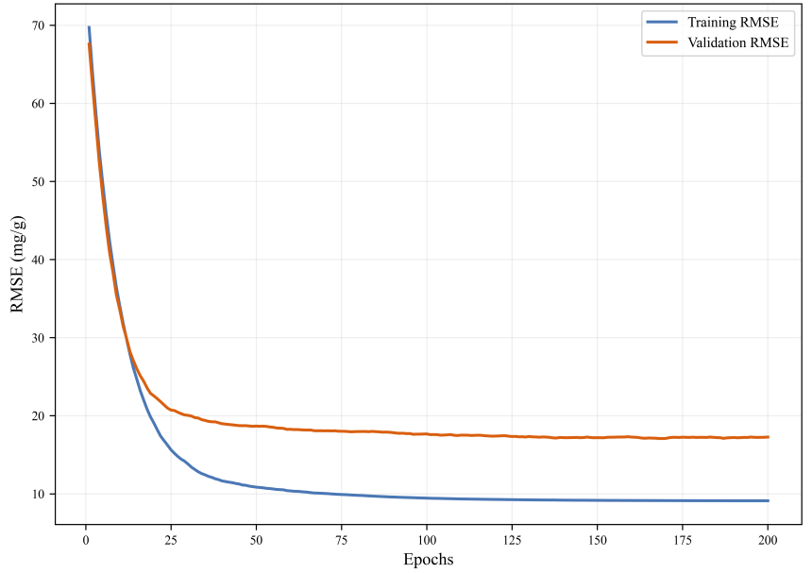
Fig.S1 The learning curve of XGBoost during the training process

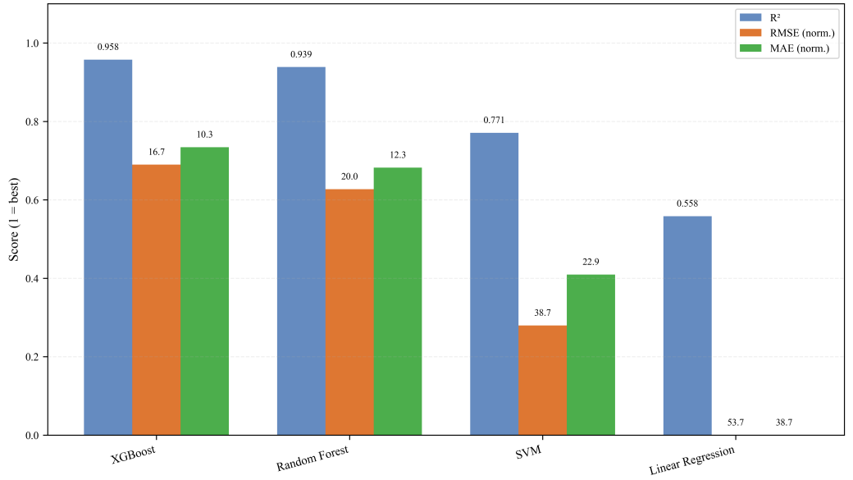
Fig.S2 Comparison of the models under the three evaluation metrics (R², RMSE, and MAE)
Heavy  Metal | Raw  Material | Modification Method | Data Size | pH | Temperature  (℃) | SSA  (m²/g)
Pb,Cd | Sawdust from pine trees | Unmodified | 160 | 2.0-5.5 | 400-800 | 86.6-293.8
Cu,Cd,Zn | Kelp / Undaria / Pine wood | Unmodified | 66 | 5-12 | 250-700 | 0.1-419.1
Pb,Cu, Ni | Dates seeds | HCl | 84 | 6 | 550 | 104.2-119.1
Cr(VI),Pb | Corn Straw | Fe/N Co-Doping | 57 | 1-6 | 800 | 141.9-530.4
Cd,Pb,Cr(VI) | Coconut Shell | TiO₂/NaHCO₃ | 124 | 1-7 | 550 | 85-142.6
Cu,Pb | Nutshell | FeCl₃ | 82 | 2-7 | 400 | 1.2-23.8
Zn,Cu | Bamboo | KMnO₄/N Co-Doping | 82 | 2-7 | 500 | 613.8-801.8
Cd, Cu, Ni, Pb, Zn | Applewood | Chitosan/  Magnetic | 225 | 2-7 | 800 | 7.5-446.0
Cd,Pb,Cr(VI) | Almond Shell | Ball-Milling | 120 | 2-6 | 550 | 100-200
Cu, Zn | Dragon Fruit Skin | Silica-Aluminum Composite | 92 | 2-6 | 600 | 80-120

Table S1 Summary of Data Sources and Research Characteristics

Table S2 Summary of input features and target variable
Category | Feature | Unit | Type | Description
Preparation condition | Pyrolysis temperature | ℃ | Numerical | Biochar preparation temperature
Preparation condition | Feedstock type | / | Categorical | Woody / Herbaceous / Nut shell / Other
Preparation condition | Modification method | / | Categorical | Unmodified / Chemical activation / Metal loading / Magnetic composite / Doping
Physical property | BET specific surface | m²/g | Numerical | Determined by N₂adsorption method
Adsorption condition | Solution pH | / | Numerical | Initial pH of adsorption experiment
Adsorption condition | Initial concentration | mg/L | Numerical | Initial heavy metal concentration
Adsorption condition | Adsorbent dosage | g/L | Numerical | Biochar dosage per solution volume
Adsorption condition | Reaction temperature | ℃ | Numerical | Adsorption experiment temperature
Adsorption condition | Contact time | min | Numerical | Duration of adsorption
Adsorption condition | Heavy metal type | / | Categorical | Pb / Cd / Cu / Zn / Ni / Cr
Metal property | Ionic radius | pm | Numerical | Metal ion radius
Metal property | Electronegativity | / | Numerical | Pauling scale
Metal property | Hydrolysis constant | / | Numerical | pK₁
Metal property | Hydration energy | KJ/mol | Numerical | Hydration free energy
Target variable | Adsorption capacity Qe | mg/g | Numerical | Equilibrium adsorption capacity

Table S3 Summary of mechanism-driven features
Feature name | Symbol | Formula | Physical meaning
Dehydration index | Dehy_Index | ΔGhyd / rion | Ease of removing hydration shell from metal ions
Hydrolysis activity | Hydrolysis | pH − pK₁ | Tendency of metal ions to hydrolyze into hydroxyl complexes
HSAB matching degree | HSAB_Match | HSAB_{value} × (SSA / SSA_{max}) | Hard-soft acid-base affinity between metal and biochar surface
Langmuir driving force | Driving_Force | C₀ × SSA / (Dosage + ε) | Metal ion loading per unit adsorption site
pH-SSA interaction | pHxSSA | pH × SSA | pH modulation of surface site availability
Temperature-time coupling | TxTime | Tads × ln(t + 1) | Coupled kinetic-thermodynamic effect

Table S4 Optimal hyperparameter configurations for each model
Model | Hyperparameter | Value
XGBoost | n_estimators | 200
XGBoost | max_depth | 6
XGBoost | learning_rate | 0.1
XGBoost | lambda | 1
Random Forest | n_estimators | 200
Random Forest | max_depth | 12
Random Forest | min_samples_split | 2
Support Vector Regression (SVR) | C | 10
Support Vector Regression (SVR) | gamma | 0.1
Support Vector Regression (SVR) | epsilon | 0.1
Multiple Linear Regression (MLR) | / | Default parameters

