Supplementary Materials

Supplementary Table. S1 Primers for the real-time-quantitative-PCR analysis.
Targets | Primer (5'-3')
ACAN-Forward | GCTACGACGCCATCTGCTAC
ACAN-Reverse | ATGTCAGGCCAGGTCACTGT
STC1-Forward | TGACTCTGTGAGCCCCAGG
STC1-Reverse | CACAGGTGGAGTTTTCCAGG
CDKL2-Forward | CCGATGGTACAGAGCTCCAG
CDKL2-Reverse | ATAGGGGTTCCCCCATGAAC
PXDNL-Forward | GGATTACCTGAACTGCAGCG
PXDNL-Reverse | TCTTGCGTCACTGCTCTGAA
KRT14-Forward | TGCCGAGGAATGGTTCTTCACC
KRT14-Reverse | GCAGCTCAATCTCCAGGTTCTG
LCA5-Forward | CGCTGGTCAGTTCTTCACCT
LCA5-Reverse | TTGGTAGACCCTTAGGGCTTG
SLC48A1-Forward | GTGGGCGTCCTCTTCTCG
SLC48A1-Reverse | TCCAGACGCTGGAGAGGTAG
RPP40-Forward | CACCGGCATCTTGTGCAG
RPP40-Reverse | TCCAGTGTTCATGACCAGGTT
TMEM101-Forward | CCAATTGGCCATTAGCACCT
TMEM101-Reverse | AACTGTGCGCGAGTACATACG
KRT5-Forward | GCTGCTGCGTGAGTACCAG
KRT5-Reverse | CTGGTCCAACTCCTTCTCCA
ENOSF1-Forward | AGAGAAGCAAATGCTGGCAC
ENOSF1-Reverse | TGGTCCAGCCATCCTTCAG
KRT17-Forward | ATCCTGCTGGATGTGAAGACGC
KRT17-Reverse | TCCACAATGGTACGCACCTGAC
RHOB-Forward | ATCCCCGAGAAGTGGGTCC
RHOB-Reverse | CGAGGTAGTCGTAGGCTTGGA
FRY-Forward | CTGCTCACCCAGTGGAAACTA
FRY-Reverse | CCGACTGAATTCTGTGACTGG
MKL2-Forward | CAGAGTGAAGCTGTGGCTCA
MKL2-Reverse | CTCGTCCTCCTTTGTTGCAG
SERPINA11-Forward | AAACATACGGGCAAGTCGTG
SERPINA11-Reverse | TCTGGTAGCGACTGAAAGGG
AGTRAP-Forward | GGCTGCATTGTATTCTCAGGCTC
AGTRAP-Reverse | CACGATGTCCAGGAAGATGGTG
FOXF2-Forward | CCGTTACCAGCATCACTCTACT
FOXF2-Reverse | CGCAGGGCTTAATATCCTGACA
LAGE3-Forward | GGCCGCACATATTCACCCTC
LAGE3-Reverse | AGTTGATGACGGAAATTCGGAG
FADS2-Forward | GCAACATGATTATGGCCACC
FADS2-Reverse | GATTCCACCAGTTGGCAGAG
ALDH6A1-Forward | TGGACCAACCATCATCTCG
ALDH6A1-Reverse | TGGATGGCTTCATCCAATG
U6-Forward | CTCGCTTCGGCAGCACA
U6-Reverse | AACGCTTCACGAATTTGCGT
GAPDH-Forward | CGAGATCCCTCCAAAATCAA
GAPDH-Reverse | TTCACACCCATGACGAACAT

Supplementary Table. S2 Sequences of target specific siRNAs.
Targets | siRNA sequences 5'-3'
TMEM101 | siRNA-1 | GCACTCCAATTGGCCATTA
 | siRNA-2 | GCGCTAGTTTCATGTCCTT
 | siRNA-3 | GAGAGAGTGTGGGCA TCTT
KRT5 | siRNA-1 | GCGTACCACTGCTGAGAAT
 | siRNA-2 | GAGCCGAGA TTGACAA TGT
 | siRNA-3 | GA TGCAGACGCA TGTCTCT
ACAN | siRNA-1 | CCA TCAGGGTTTCCTGACA
 | siRNA-2 | GCGTGATCCTTACCGTAAA
 | siRNA-3 | GCCTGACTTTAGTGGACTT
LCA5 | siRNA-1 | GTCAGTTCTTCACCTGCAA
 | siRNA-2 | CCCAGAGCCTCAATAGAGA
 | siRNA-3 | GTAGCTACGTGCCTTCGTT
RPP40 | siRNA-1 | GGGTTACACTGTCCGTTCA
 | siRNA-2 | GTGGGATACTATCGGAAGA
 | siRNA-3 | GCTATGCACTAACATACAA
LAGE3 | siRNA-1 | CTCCGAA TTTCCGTCA TCA
 | siRNA-2 | GTGGTTGGGAAGGA TCTCA
 | siRNA-3 | CGCTGGAAAGCTGAAGACT
CDKL2 | siRNA-1 | GTACAGAGCTCCAGAACTA
 | siRNA-2 | GGCCATTGGTTGTCTGGTA
 | siRNA-3 | GTCTGGCGTTGTCAAGCTA

Supplementary Figure S1
Supplementary Figure S1. The procedure of RNA filtration, signature construction, and validation. Abbreviations: HTA, Human Transcriptome Array; IDC, invasive ductal carcinoma; TNBC, triple-negative breast cancer; FDR, false discovery rate; LASSO, Least Absolute Shrinkage and Selection Operator; qPCR, real-time quantitative polymerase chain reaction; ROC, receiver operating characteristic; AIC, Akaike information criterion.

Supplementary Figure S2
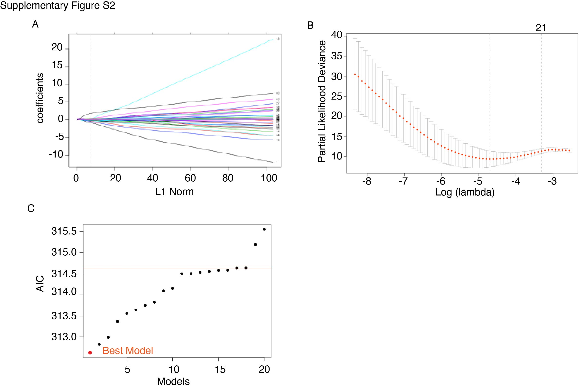
Supplementary Figure S2. Generating a 7-mRNA signature thorugh LASSO cox and all-subsets regression program. A, LASSO coefficient profiles of the 996 candidate mRNAs. A vertical line is drawn at the value chosen by 10-fold cross-validation. B, 10-fold cross-validation of the LASSO Cox regression model. C, Akaike information criterion (AIC) of top 20 models generated by all-subsets regression program. The red spot represented for the 7-mRNA signature.

Supplementary Figure S3
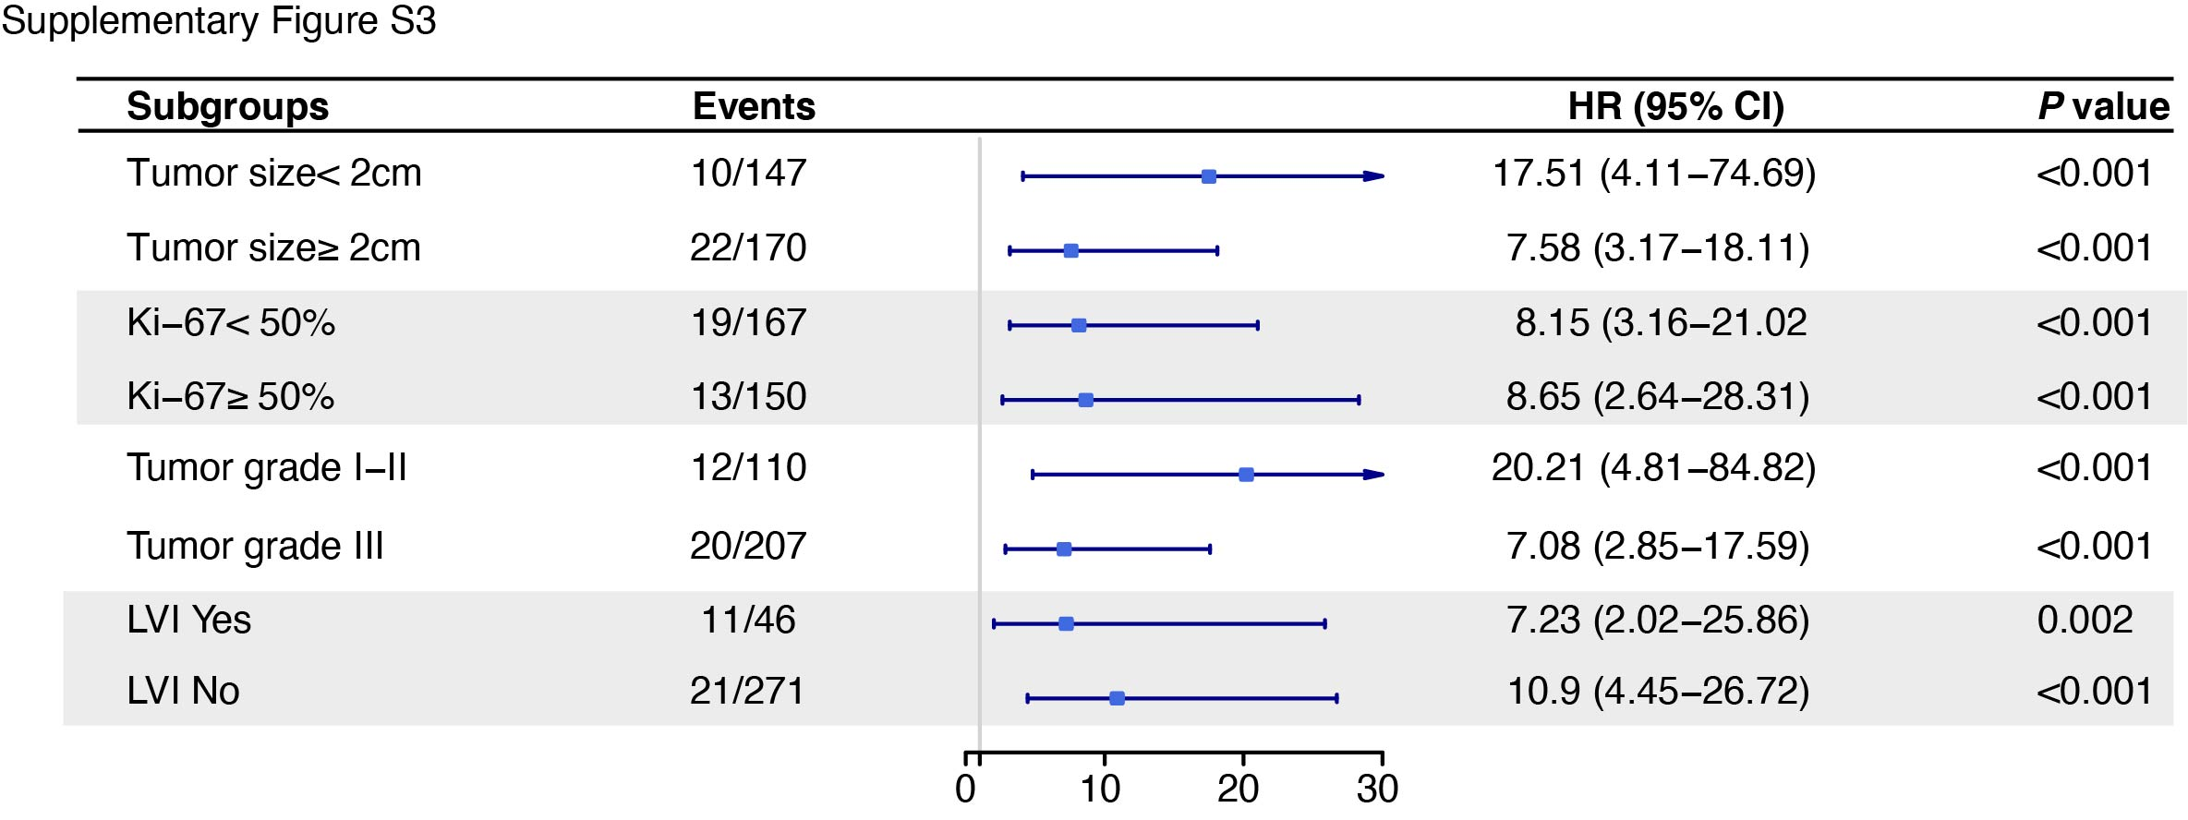
Supplementary Figure S3. Forest plot for prognostic value of the 7-mRNA signature in different subpopulations. Hazard ratio was calculated by multivariate Cox regression model and set low risk as reference. Data are mean ± SD. Abbreviations: HR, hazard ratio; LVI, lymphovascular invasion.

Supplementary Figure S4
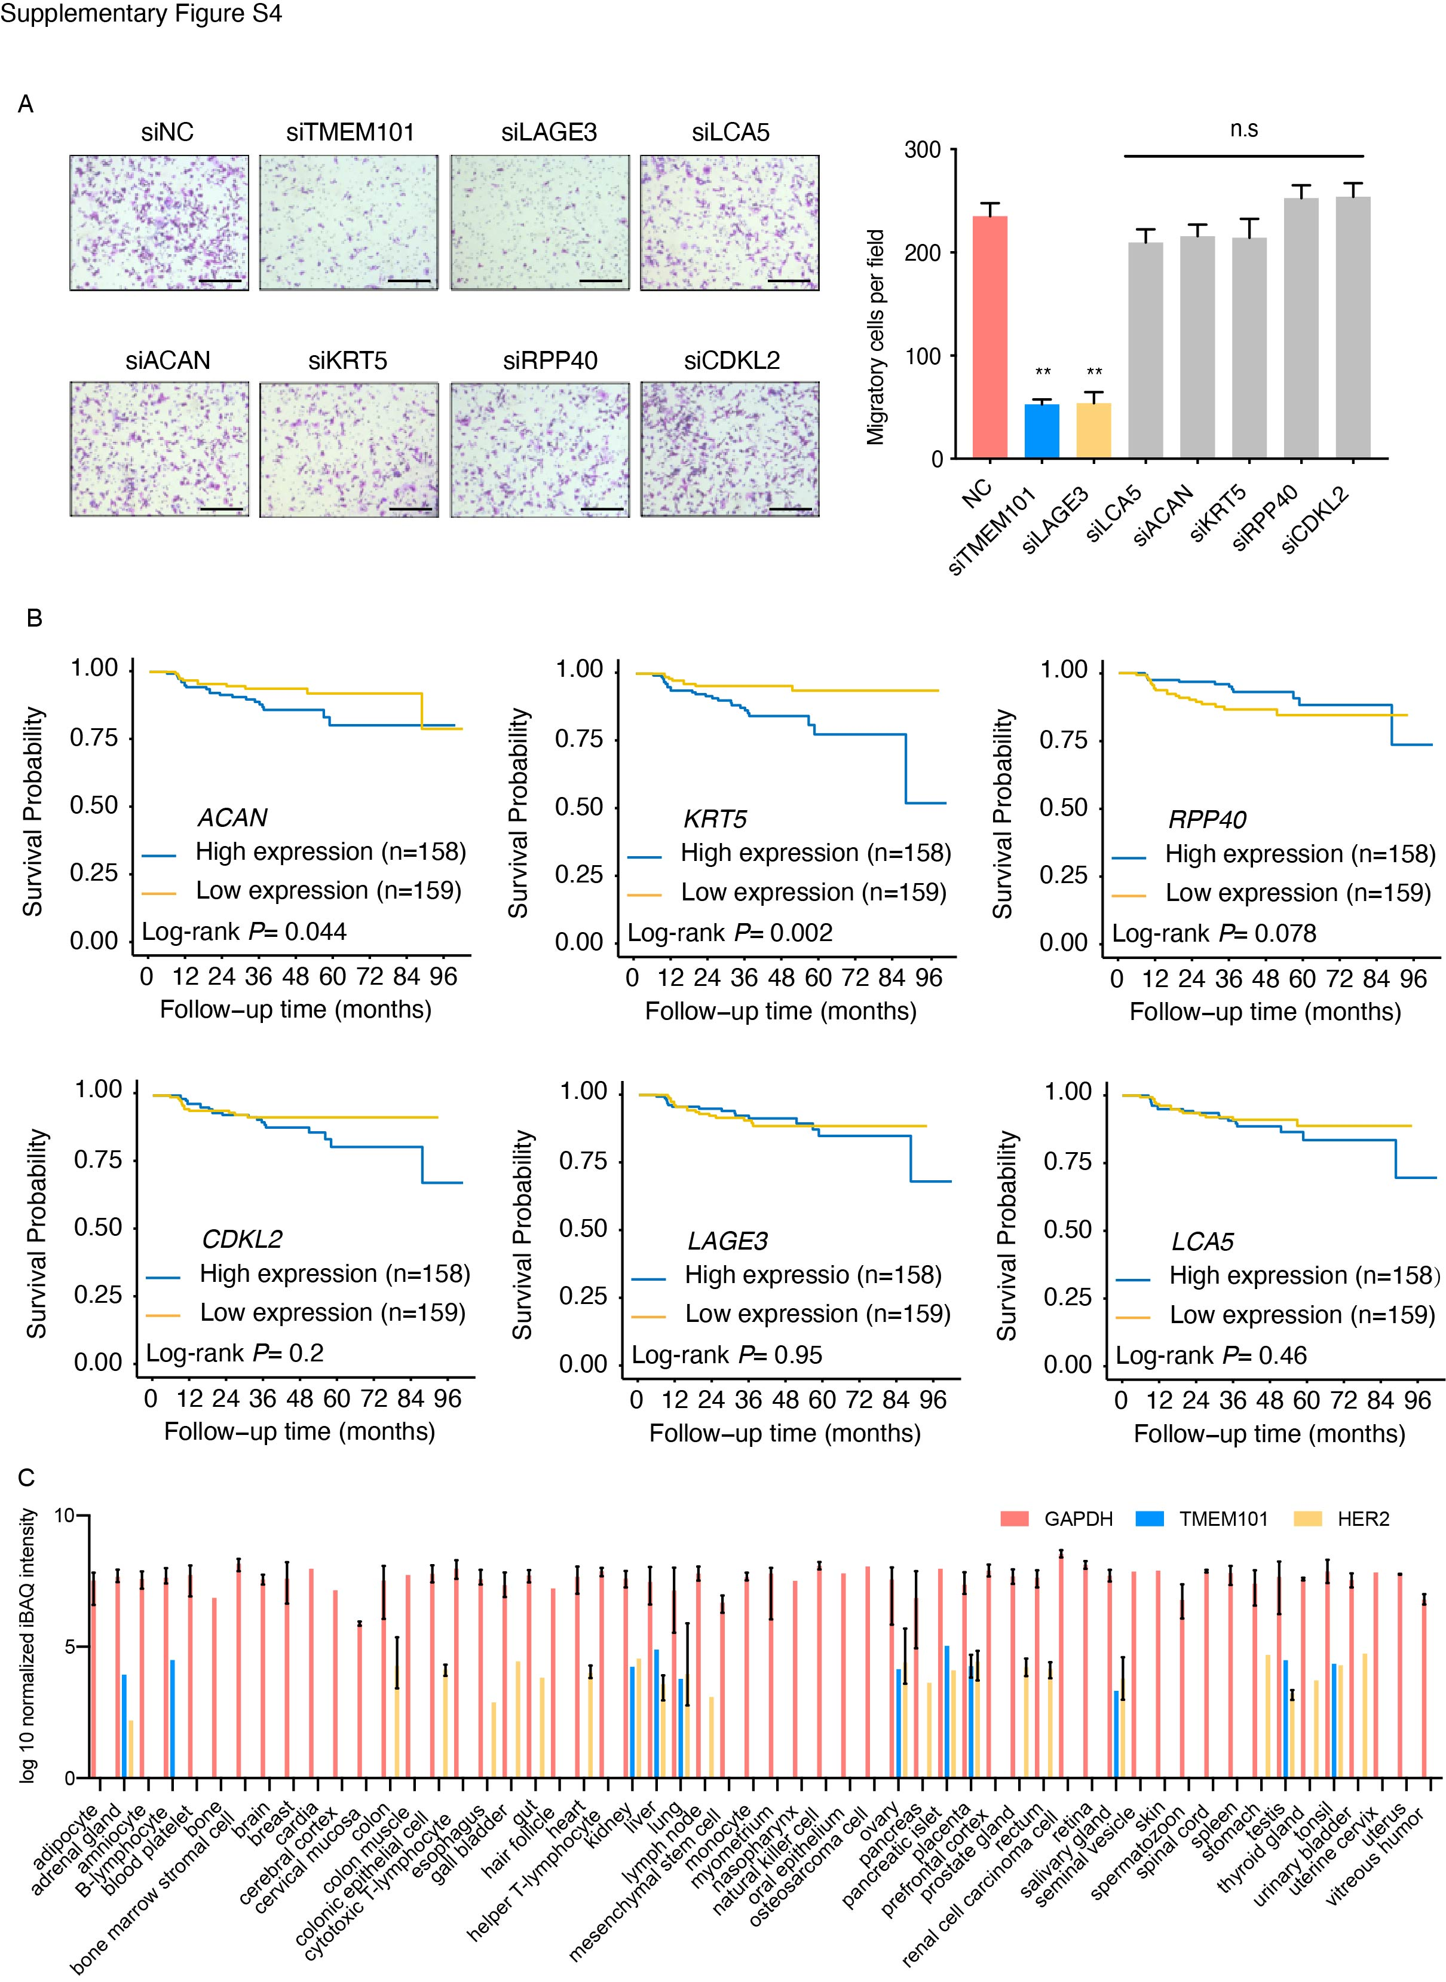

Supplementary Figure S4. The function and clinical implication of genes in the 7-mRNA signature. A, Representative Images and the number of migrated cells of MDA-MB-231 interfered with siRNAs targeting mRNAs incorporated in the signature. scale bar 100 µm. Data are mean ± SD. n.s, not significant; *, P < 0.05; **, P < 0.01; ***, P < 0.001. B, Kaplan-Meier curves of relapse-free survival of mRNAs in the signature. C, The protein level of GAPDH, TMEM101 and HER2 across 56 normal tissues. Proteome data was obtained form ProteomicsDB (https://www.proteomicsdb.org). Data are mean ± min/max.

