Supplementary Information
Supplementary Table 1 | Mathematics performance, MATHEFF, and residuals for 72 economies (canonical values; predicted and residual recomputed from the country-level OLS fit; see Methods). Group: D = deviating high performer; N = non-deviating high performer.
Rank | Economy | Math | MATHEFF | Predicted | Residual | G
1 | Korea | 527.3 | -0.564 | -0.225 | -0.339 | D
2 | Japan | 536.0 | -0.494 | -0.200 | -0.294 | D
3 | Poland | 489.0 | -0.591 | -0.334 | -0.257 | D
4 | Hong Kong (China) | 540.0 | -0.459 | -0.189 | -0.270 | D
5 | Latvia | 483.0 | -0.606 | -0.351 | -0.255 | D
6 | Estonia | 510.0 | -0.412 | -0.274 | -0.138
7 | Chinese Taipei | 547.0 | -0.350 | -0.169 | -0.181 | D
8 | Bulgaria | 417.0 | -0.719 | -0.538 | -0.181
9 | Malaysia | 410.0 | -0.764 | -0.558 | -0.206
10 | Viet Nam | 469.0 | -0.621 | -0.390 | -0.231 | D
11 | Montenegro | 406.0 | -0.764 | -0.569 | -0.195
12 | Brunei Darussalam | 430.0 | -0.653 | -0.501 | -0.152
13 | Serbia | 440.0 | -0.637 | -0.473 | -0.164
14 | Chile | 412.0 | -0.683 | -0.552 | -0.131
15 | Israel | 468.0 | -0.564 | -0.393 | -0.171
16 | Brazil | 379.0 | -0.867 | -0.646 | -0.221
17 | Czechia | 487.0 | -0.384 | -0.339 | -0.045
18 | Denmark | 489.0 | -0.345 | -0.334 | -0.011
19 | New Zealand | 479.0 | -0.417 | -0.362 | -0.055
20 | Netherlands | 493.0 | -0.295 | -0.322 | +0.027
21 | Norway | 469.0 | -0.481 | -0.390 | -0.091
22 | Belgium | 489.0 | -0.310 | -0.334 | +0.024
23 | Costa Rica | 396.0 | -0.714 | -0.598 | -0.116
24 | Greece | 448.0 | -0.580 | -0.450 | -0.130
25 | Slovenia | 485.0 | -0.379 | -0.345 | -0.034
26 | Moldova | 414.0 | -0.633 | -0.547 | -0.086
27 | Dominican Republic | 368.0 | -0.839 | -0.677 | -0.162
28 | Finland | 484.4 | -0.352 | -0.347 | -0.005
29 | Jamaica | 382.0 | -0.734 | -0.638 | -0.096
30 | Macao (China) | 552.0 | -0.107 | -0.155 | +0.048 | N
31 | Uruguay | 409.0 | -0.647 | -0.561 | -0.086
32 | Ireland | 492.0 | -0.256 | -0.325 | +0.069
33 | Italy | 471.0 | -0.439 | -0.385 | -0.054
34 | Mexico | 395.0 | -0.675 | -0.601 | -0.074
35 | Mongolia | 409.0 | -0.621 | -0.561 | -0.060
36 | Slovak Republic | 474.0 | -0.391 | -0.376 | -0.015
37 | Argentina | 378.0 | -0.730 | -0.649 | -0.081
38 | Philippines | 355.0 | -0.822 | -0.714 | -0.108
39 | Portugal | 472.0 | -0.409 | -0.382 | -0.027
40 | Singapore | 574.8 | 0.244 | -0.090 | +0.334 | N
41 | Türkiye | 453.0 | -0.463 | -0.436 | -0.027
42 | Cambodia | 336.0 | -0.810 | -0.768 | -0.042
43 | Sweden | 482.0 | -0.299 | -0.353 | +0.054
44 | Australia | 487.0 | -0.243 | -0.339 | +0.096
45 | Canada | 497.0 | -0.084 | -0.311 | +0.227
46 | Lithuania | 475.0 | -0.329 | -0.373 | +0.044
47 | Kosovo | 343.0 | -0.753 | -0.748 | -0.005
48 | Morocco | 365.0 | -0.717 | -0.686 | -0.031
49 | Switzerland | 508.0 | 0.000 | -0.280 | +0.280
50 | United Kingdom | 489.2 | -0.175 | -0.333 | +0.158
51 | Jordan | 360.0 | -0.682 | -0.700 | +0.018
52 | Romania | 428.0 | -0.443 | -0.507 | +0.064
53 | Georgia | 401.0 | -0.544 | -0.584 | +0.040
54 | Hungary | 473.0 | -0.294 | -0.379 | +0.085
55 | North Macedonia | 391.0 | -0.580 | -0.612 | +0.032
56 | Guatemala | 334.0 | -0.712 | -0.774 | +0.062
57 | Germany | 475.3 | -0.210 | -0.372 | +0.162
58 | United States | 465.1 | -0.331 | -0.401 | +0.070
59 | Austria | 487.0 | 0.028 | -0.339 | +0.367
60 | Saudi Arabia | 390.0 | -0.498 | -0.615 | +0.117
61 | Qatar | 414.0 | -0.404 | -0.547 | +0.143
62 | Panama | 355.0 | -0.600 | -0.714 | +0.114
63 | Colombia | 383.0 | -0.476 | -0.635 | +0.159
64 | Spain | 473.0 | -0.198 | -0.379 | +0.181
65 | Peru | 391.0 | -0.462 | -0.612 | +0.150
66 | France | 474.1 | -0.046 | -0.376 | +0.330
67 | Uzbekistan | 393.0 | -0.420 | -0.606 | +0.186
68 | Malta | 466.0 | -0.221 | -0.399 | +0.178
69 | Iceland | 459.0 | -0.255 | -0.419 | +0.164
70 | United Arab Emirates | 431.0 | -0.267 | -0.498 | +0.231
71 | Croatia | 463.0 | -0.209 | -0.407 | +0.198
72 | Albania | 368.0 | -0.260 | -0.677 | +0.417
Supplementary Table 2 (provided as a formula-verified workbook, Tables_all.xlsx) reports the official OECD Table V.B1.5.58 extract (family support and MATHEFF, before/after socio-economic controls) merged with the analysis sample.

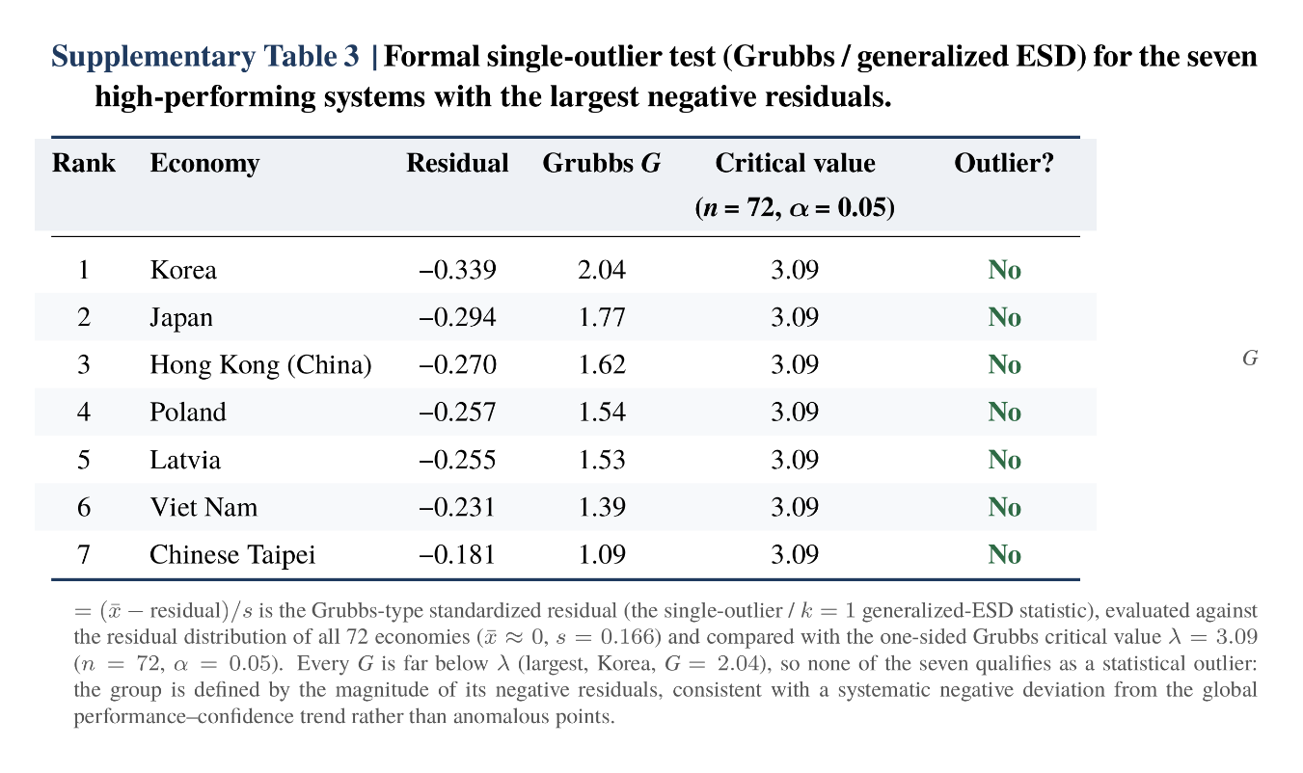
Supplementary Table 3 | Formal single-outlier test (Grubbs / generalized ESD) for the seven high-performing systems with the largest negative residuals. For each economy the Grubbs-type standardized residual G = (mean − residual)/s is tested against the one-sided Grubbs critical value λ = 3.09 (n = 72, α = 0.05). Every G falls well below λ (largest, Korea, G = 2.04), so none is flagged as a statistical outlier; the group is defined by residual magnitude, consistent with a systematic negative deviation from the global performance–confidence trend rather than anomalous points.

