Supplementary Table S1. Antibodies used in this study
Antibody | Supplier | Catalog No. | Dilution | Application
Mouse Anti-TREM2 | Santa Cruz | sc-373828 | 1:1000 | WB
Rabbit Anti-Claudin-5 (E8F3D) | CST | 49564S | 1:1000 | WB
Rabbit Anti-MMP-9 | GeneTex | GTX100458 | 1:1000 | WB
Rabbit Anti-NF-κB p65 | Proteintech | 10745-1-AP | 1:1000 | WB
Rabbit Anti-phospho-NF-κB p65 (Ser536) | Beyotime | AB3013 | 1:1000 | WB
Rabbit Anti-β-actin | Proteintech | 81115-1-RR | 1:10000 | WB
Rabbit Anti-NRF2 | Proteintech | 11639-1-AP | 1:2000 | WB
Mouse Anti-KEAP1 | Proteintech | 60027-1-Ig | 1:2000 | WB
Rabbit Anti-HO-1 | Proteintech | 2728-1-AP | 1:2000 | WB
Rabbit Anti-phospho-COP1 (Ser387) | Biodragon | BD-PP0477 | 1:1000 | WB
Rabbit Anti-COP1 | Biodragon | BD-PT1059 | 1:1000 | WB
Rabbit Anti-TLR4 | Proteintech | 19811-1-AP | 1:1000 | WB
Mouse Anti-MYD88 | Proteintech | 67969-1-Ig | 1:10000 | WB
HRP-conjugated Goat Anti-Rabbit IgG | ZSGB-BIO | ZB-2301 | 1:5000 | WB
HRP-conjugated Goat Anti-Mouse IgG | ZSGB-BIO | ZB-2305 | 1:5000 | WB
Rabbit-Anti CD9 | Zenbio | R380441 | 1:2000 | WB
Rabbit-Anti CD63 | Zenbio | P08962 | 1:1000 | WB
Rabbit Anti-Calnexin | Proteintech | 10427-2-AP | 1:5000 | WB
Rabbit Anti-ALIX | Zenbio | R23425 | 1:5000 | WB
Rabbit Anti-TSG101 | Zenbio | R25999 | 1:5000 | WB
Rabbit Anti-C/EBPβ | Bioss | bs-1396R | 1:1000 | WB
Mouse Anti-IRAK4 | Proteintech | 67180-1-Ig | 1:1000 | WB
Rabbit Anti-COX2 | Proteintech | 27308-1-AP | 1:1000 | WB
Iba1 Guinea pig pAb | Oasis Biofarm | OB-PGP049-01 | 1:1000 | IF
GFAP Polyclonal antibody | Proteintech | 16825-1-AP | 1:1000 | IF
MYD88 Monoclonal antibody | Proteintech | 67969-1-Ig | 1:500 | IF
CD11b Polyclonal Antibody | Invitrogen | PA5-79533 | 1:500 | IF
CD31 Guinea pig pAb | Oasis Biofarm | OB-PGP161 | 1:500 | IF
Mouse TREM2 Antibody | R&D systems | AF1729 | 1:250 | IF
Alexa Fluor® 594 AffiniPure® Donkey Anti-Rabbit IgG (H+L) | Jackson ImmunoResearch | 711-585-152 | 1:500 | IF
Alexa Fluor® 594 AffiniPure® Donkey Anti-Sheep IgG (H+L) | Jackson ImmunoResearch | 713-585-003 | 1:500 | IF
Alexa Fluor® 647 AffiniPure® Donkey Anti-Mouse IgG (H+L) | Jackson ImmunoResearch | 715-605-150 | 1:500 | IF
Alexa Fluor® 488 AffiniPure® Donkey Anti-Guinea Pig IgG (H+L) | Jackson ImmunoResearch | 706-545-148 | 1:500 | IF

Supplementary Table S2. qPCR primers and siRNA sequences used in this study
All primer and siRNA sequences are listed in the 5'-to-3' orientation.
qPCR primers
Target gene | Primer name | Direction | Sequence (5'→3')
β-actin | β-actin-F | Forward | TGTCCACCTTCCAGCAGA
β-actin | β-actin-R | Reverse | GCTCAGTAACAGTCCGCCTA
MYD88 | m-MyD88-2-F | Forward | AGGACAAAACGCCGGAACTTT
MYD88 | m-MyD88-2-R | Reverse | CATGCGGCGACACCTTTTCT

siRNA duplexes
Name | Strand | Sequence (5'→3') | Use
siMYD88 | Sense | CAACCUGGGUCAAGUGUAAdTdT | MYD88 knockdown
siMYD88 | Antisense | UUACACUUGACCCAGGUUGdTdT | MYD88 knockdown
siNC | Sense | UUCUCCGAACGUGUCACGUdTdT | Negative control
siNC | Antisense | ACGUGACACGUUCGGAGAAdTdT | Negative control

Supplementary Figure 1
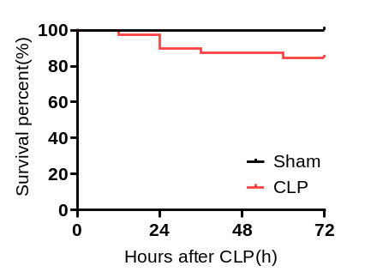
Supplementary Figure 1. Early survival after CLP before EV treatment. Kaplan-Meier survival curves of sham-operated and CLP mice during the first 72 h after surgery, before EV treatment (Sham, n=10; CLP, n=39).

Supplementary Figure 2
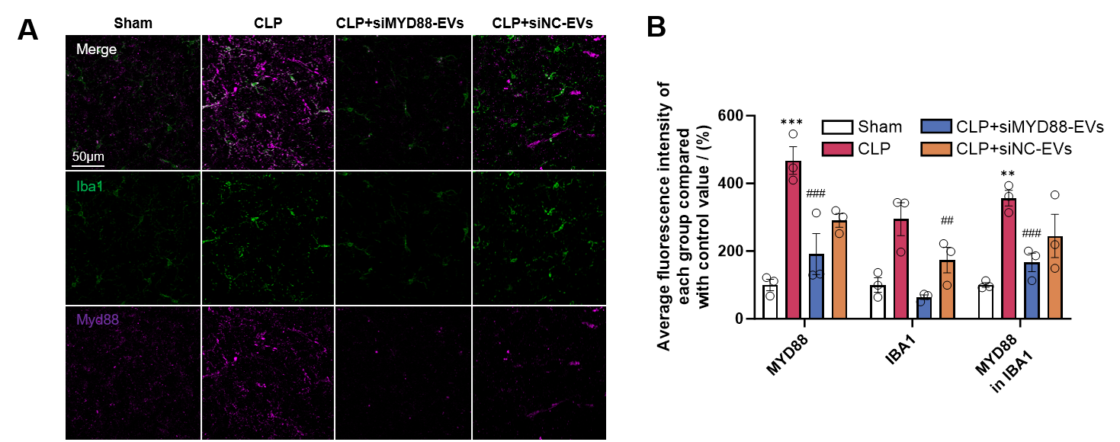
Supplementary Figure 2. siMYD88-EVs reduce MYD88 expression and microglial activation in the prefrontal cortex after CLP. (A) Representative immunofluorescence images of IBA1 (green) and MYD88 (magenta) in the prefrontal cortex of Sham, CLP, CLP+siMYD88-EVs and CLP+siNC-EVs mice. Scale bar, 50 μm. (B) Quantification of total MYD88 fluorescence, IBA1 fluorescence and MYD88 fluorescence within IBA1-positive areas, expressed relative to Sham. Data are shown as mean ± SEM (n=3); one-way ANOVA with Dunnett's multiple-comparisons test; **P < 0.01, ***P < 0.001 versus Sham; ##P < 0.01, ###P < 0.001 versus CLP; ns, not significant.

Supplementary Figure 3
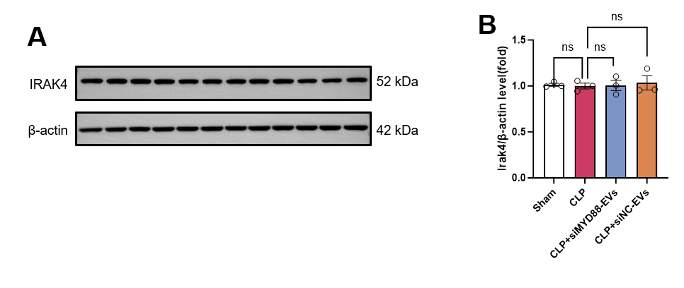
Supplementary Figure 3. IRAK4 expression remains unchanged after CLP and EV treatment. (A) Representative western blots of IRAK4 and β-actin in brain tissue. (B) Densitometric quantification of IRAK4 normalized to β-actin. Data are shown as mean ± SEM (n=3); one-way ANOVA with Tukey's multiple-comparisons test; ns, not significant.

Supplementary Figure 4
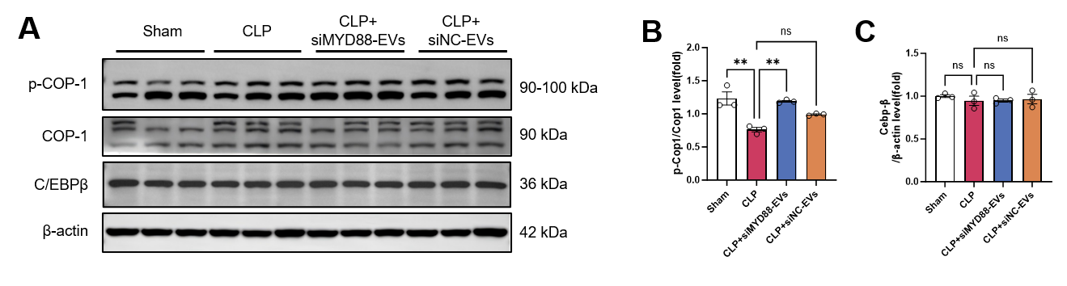
Supplementary Figure 4. siMYD88-EVs restore COP1 phosphorylation without altering C/EBPβ expression after CLP. (A) Representative western blots of p-COP1, COP1, C/EBPβ and β-actin in brain tissue. (B) p-COP1/COP1 ratio. (C) Densitometric quantification of C/EBPβ normalized to β-actin. Data are shown as mean ± SEM (n=3); one-way ANOVA with Tukey's multiple-comparisons test; **P < 0.01; ns, not significant.

