Supplementary Information

Fabrication of Black In₂O₃ with Dense Oxygen Vacancy through Dual Functional Carbon Doping for Enhancing Photothermal CO₂ Hydrogenation

Yuhang Qi, Jiawei Jiang, Xichen Liang, Shuxin Ouyang,* Wenbo Mi,* Lei Zhao, Shangbo Ning, Jinhua Ye

Computational Methods and Details
The first-principles calculations on Carbon doped In₂O₃ (C-In₂O₃) are performed using Vienna ab initio simulation package (VASP), with the generalized gradient approximation (GGA) for the exchange and correlation function by Perdew, Burke and Ernzerhof (PBE).¹⁻³ Kohn-Sham single-particle wave functions are expanded in the plane wave basis set with a kinetic energy cutoff at 400 eV. A Monkhorst-Pack 4×4×4 k-point grid is adopted to sample the Brillouin zone. The energy and force convergence criteria are 10⁻⁵ eV and 0.01 eV/Å, respectively. Formation energy calculations are performed to investigate the energetic stability using the equation , where , and represent the energy of the C doped system, the energy of the pure In₂O₃ and the chemical potential of single atom, respectively. Hybrid functional (HSE06) is used to predict the band structure and formation energy accurately.⁴ Bond-valence sum (BVS) is calculated to estimate the ionic valence. ⁵⁻⁷
According to previous researches ^{8, 9}, a 2×2×1 k-point grid generated by the Monkhorst−Pack method are found to give converged results for the CO₂ reaction on C-In₂O₃(110) surface calculations. The C-In₂O₃(110) surface is created based on the optimized bulk unit cell, while placing the defect site at the center of the surface. In all surface calculations, the bottom two layers of C-In₂O₃ are frozen at their equilibrium bulk positions, whereas the top two layers together with the adsorbates are allowed to relax. The forces on all unconstrained atoms are ≤0.03 eV/Å. Gibbs free energy calculations are performed by the equation , where , , and represent the adsorption energy, zero-point vibration energy, room temperature and entropy change, respectively. Among them, the equation of adsorption energy calculation is , where and represent the energy of C-In₂O₃(110) surface and adsorbate, respectively.

Supplementary Tables

Table S1. Performance comparison of different photocatalysts for CO₂ hydrogenation. ¹⁰⁻²⁶
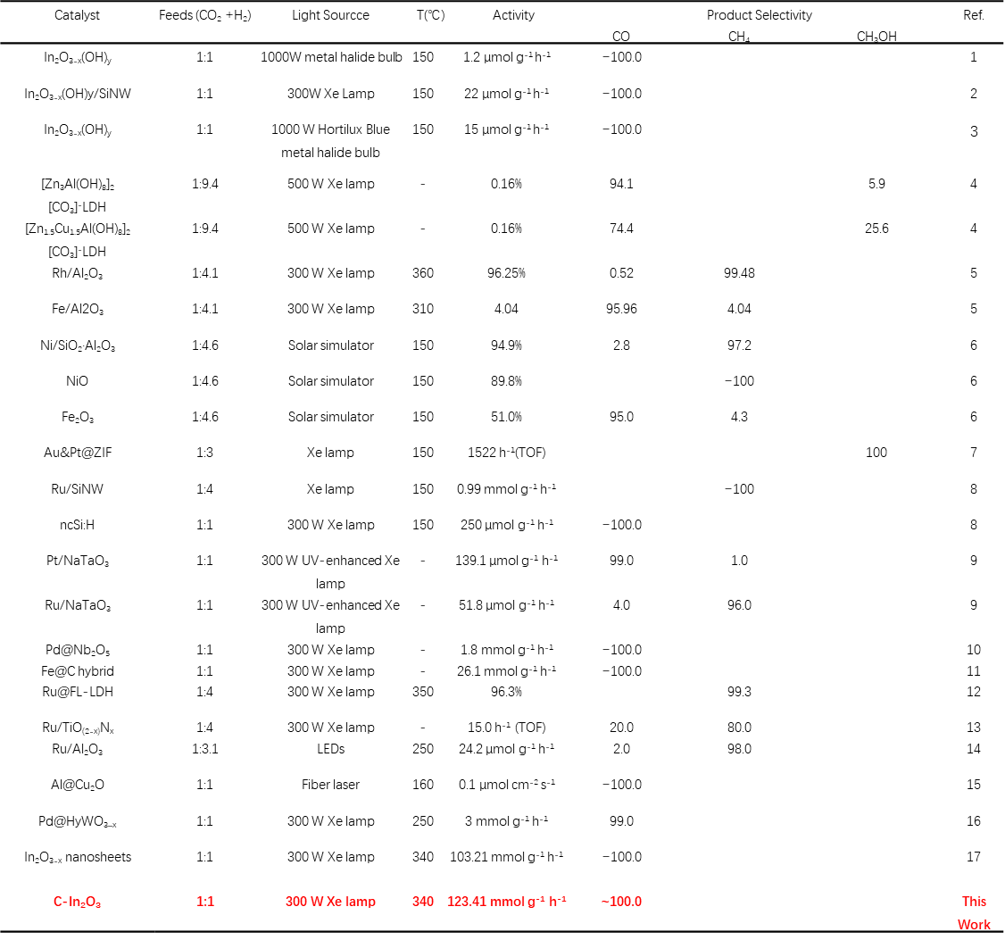

Table S2 Energetic properties and geometry structures of the C-In₂O_{3-x} systems, including formation energy E_{f}, bond length l and ionic valence V.
System | E_{f} (eV) | l_{In-In} (Å) | l_{In-O} (Å) | V_{In} | V_{O} | V_{C}
pure | - | 3.33~3.35 | 2.13~2.22 | +2.83~2.86 | -1.89 | -
O_{vac} | 4.98 | 3.30~3.46 | 2.10~2.29 | +2.18~2.86 | -1.83~1.93 | -
C_{s}-O | 11.42 | 3.30~3.45 | 2.12~2.30 | +2.23~2.89 | -1.82~1.93 | +0.04
C_{s}-In_{A} | 12.11 | 3.22~3.40 | 2.12~2.27 | +2.68~2.84 | -1.48~1.95 | +2.08
C_{s}-In_{B} | 8.29 | 3.24~3.48 | 2.06~2.60 | +2.57~2.91 | -1.38~1.98 | +3.12
C_{i} | 7.59 | 3.09~3.47 | 2.10~2.41 | +2.40~2.95 | -1.83~2.26 | +2.52
C_{i}+O_{vac} | 3.10 | 3.19~3.46 | 2.10~2.29 | +2.11~2.91 | -1.78~2.03 | +0.68

Table S3. Local structure parameters around In estimated by EXAFS analysis
Sample | Path | C.N. | R (Å) | σ²×10³ (Å²) | ΔE (eV) | R factor
In₂O₃ standard | In-O | 6* | 2.16±0.01 | 6.4±1.0 | 0.7±1.0 | 0.009
In₂O₃ standard | In-In | 6* | 3.36±0.01 | 6.8±0.6 | 1.1±1.1 | 0.009
C-In₂O_{3-x} | In-O | 2.4±0.3 | 2.18±0.01 | 2.6±2.5 | 6.8±1.0 | 0.019
C-In₂O_{3-x} | In-In | 2.6±0.8 | 3.35±0.02 | 3.8±3.4 | 4.1±1.6 | 0.019

Table S4. Elemental analysis of carbon content
Sample | Carbon [wt. %]
V_{o}-poor In₂O₃ | 0.03 %
V_{o}-rich In₂O₃ | 0.04 %
C-In₂O₃-1 | 0.32 %
C-In₂O₃-2 | 0.65 %
C-In₂O₃-3 | 0.96 %
C-In₂O₃-4 | 1.76 %
C-In₂O₃-5 | 2.69%

Table S5. Calculated electronic energy, zero-point energy, and entropy of each molecule and CO₂ RR intermediate.
System | Species | E_{DFT} (eV) | E_{ZPE} (eV) | -TS (eV)
- | CO₂ | -23.02 | 0.31 | -0.65
- | H₂ | -6.78 | 0.27 | -0.42
- | CO | -14.79 | 0.14 | -0.67
- | H₂O | -14.23 | 0.58 | -0.65
pure | * | -425.67 | - | -
pure | (CO₂+2H)* | -456.23 | 0.83 | -0.06
pure | (COOH+H)* | -457.08 | 0.99 | -0.18
pure | CO*+H₂O | -455.32 | 0.79 | -0.80
O_{vac} | * | -418.31 | - | -
O_{vac} | (CO₂+2H)* | -448.83 | 0.70 | -0.06
O_{vac} | (COOH+H)* | -448.45 | 0.83 | -0.18
O_{vac} | CO*+H₂O | -448.33 | 0.80 | -0.80

Supplementary Figures
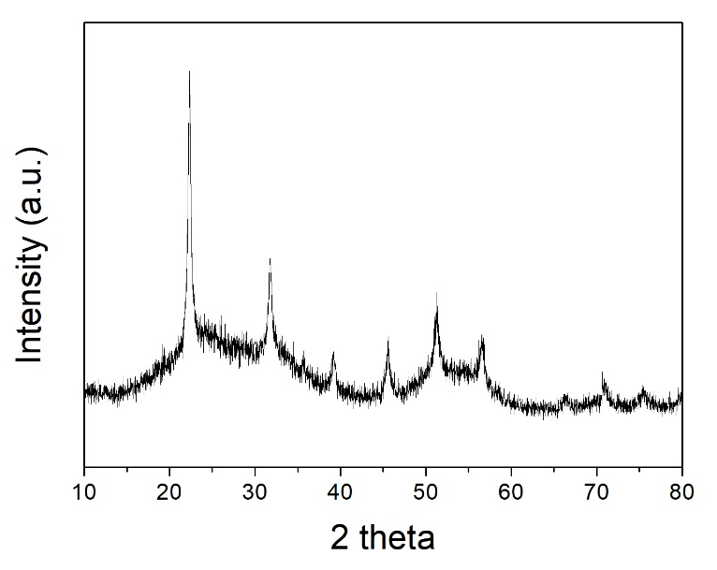
Figure S1. XRD patterns of C-In(OH)₃ nano partials.

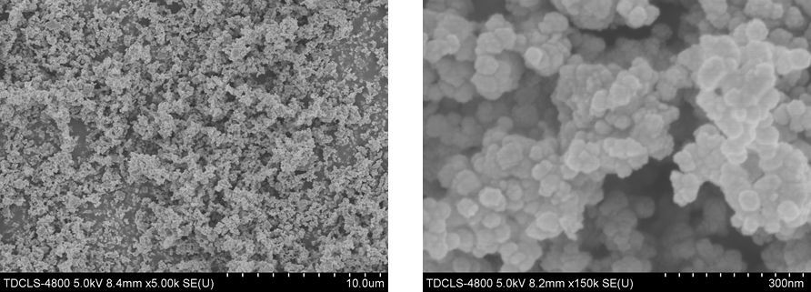
Figure S2. SEM images of C-In(OH)₃ nano partials.

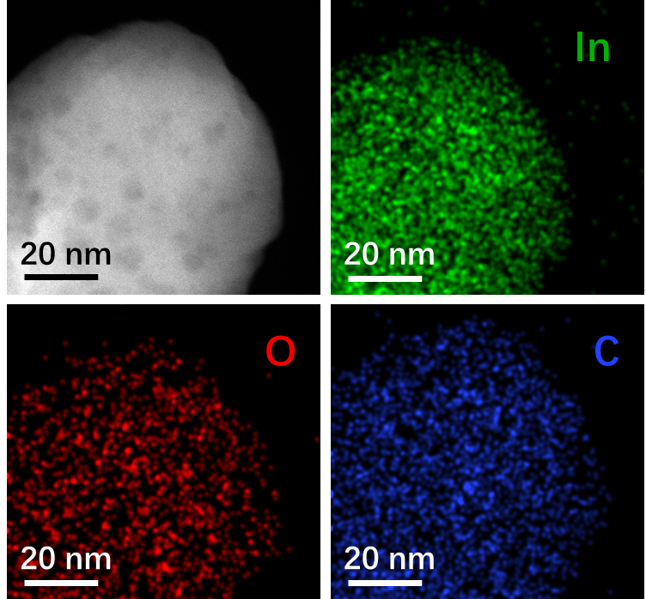

Figure S3. EDS elemental mapping profiles of C-In₂O_{3-x}.

Supporting information discussion: In order to further verify the distributed carbon element in the C-In₂O_{3-x}, the elemental mapping is performed that the presence of the carbonaceous matters is homodispersed and exists in heterogeneous interfaces. And, decomposed gaseous water and the random nucleation-growth behaviors on the substrate make for nanoholes.

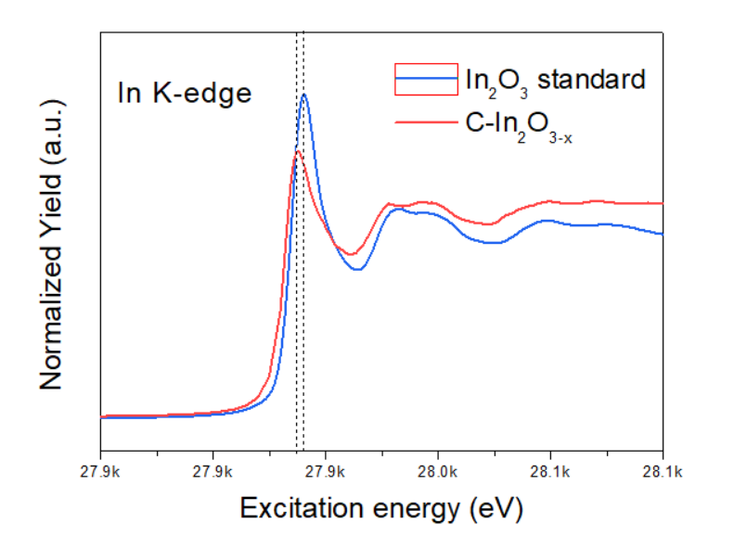
Figure S4. Normalized In K-edge XANES spectra of C-In₂O_{3-x}

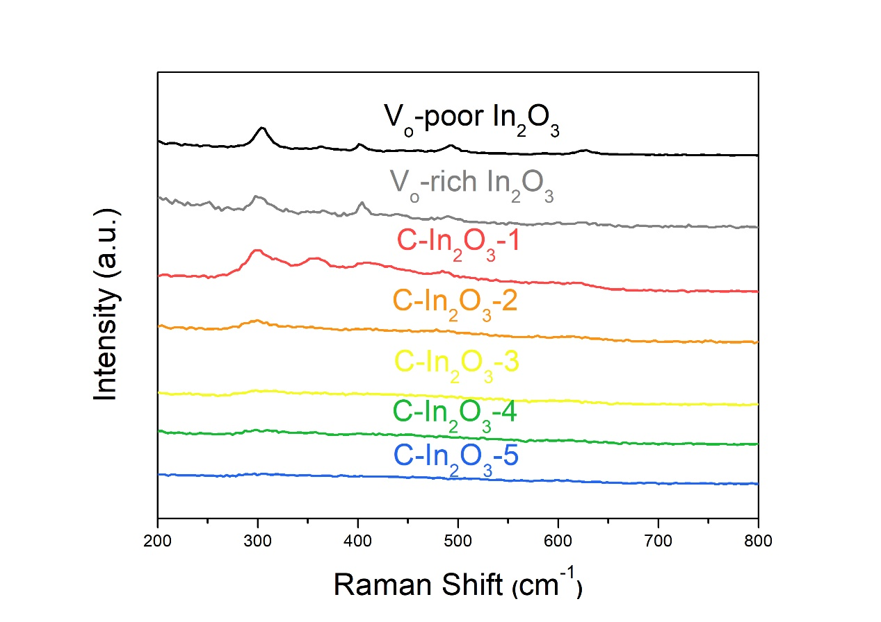
Figure S5. Raman spectrum of different carbon content of In₂O₃.

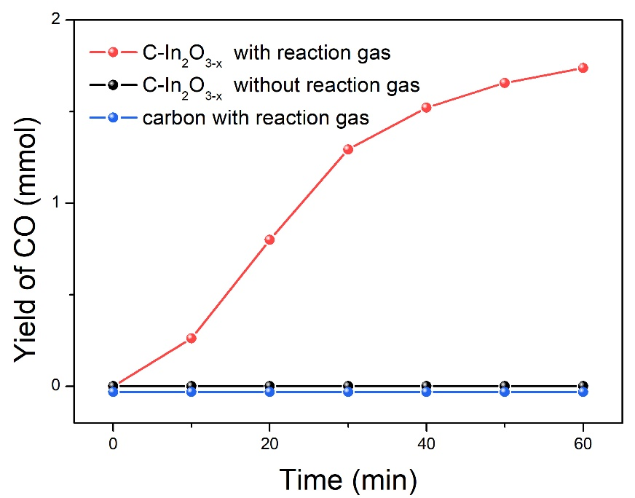
Figure S6. The CO production rates of C-In₂O_{3-x} with and without reaction gas and only carbon with reaction gas.

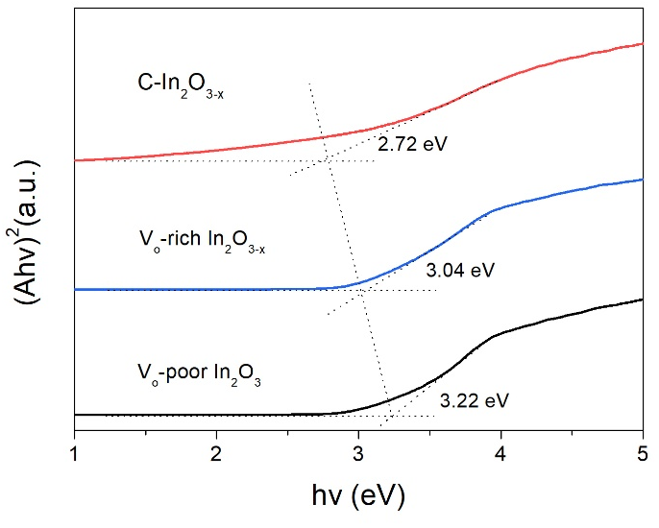
Figure S7. Band gap of V-poor In₂O₃, V_{o}-rich In₂O_{3-x} and C-In₂O_{3-x}.

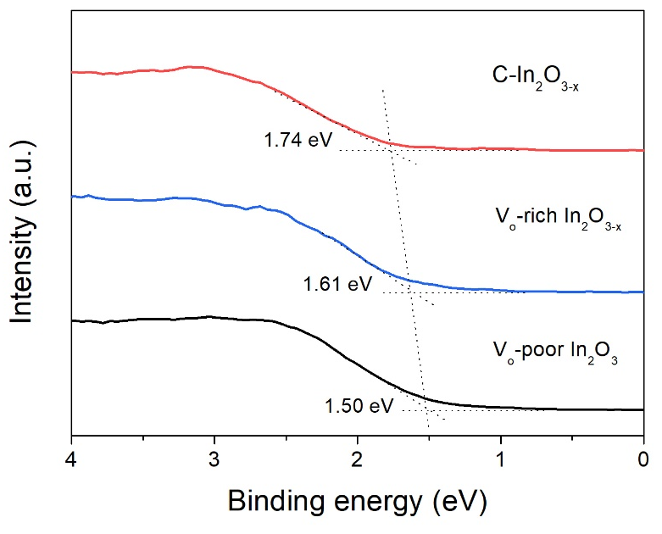
Figure S8. Valence band XPS spectra of V_{o}-poor In₂O₃, V_{o}-rich In₂O_{3-x} and C-In₂O_{3-x}.

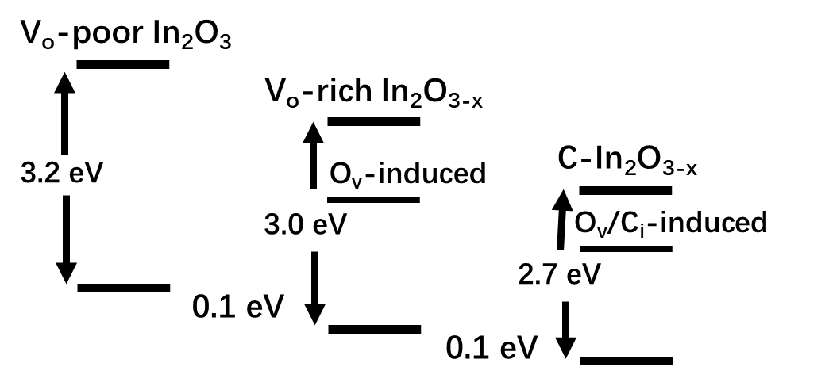
Figure S9. Schematic illustration of the DOS.

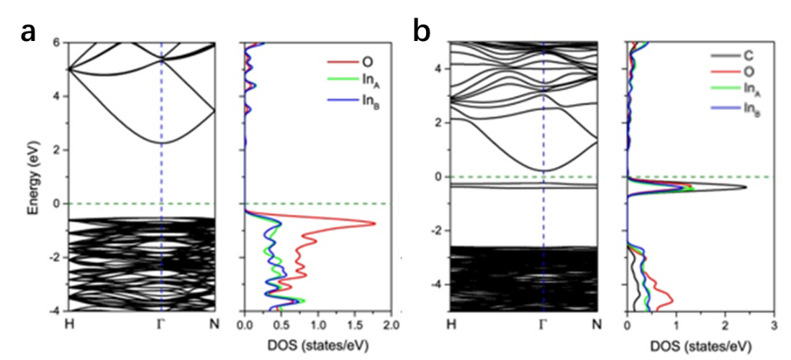
Figure S10. Calculated band structure and density of states for a) prefect In₂O₃ and b) In₂O₃ with one C atom interstitial and one O atom vacancy

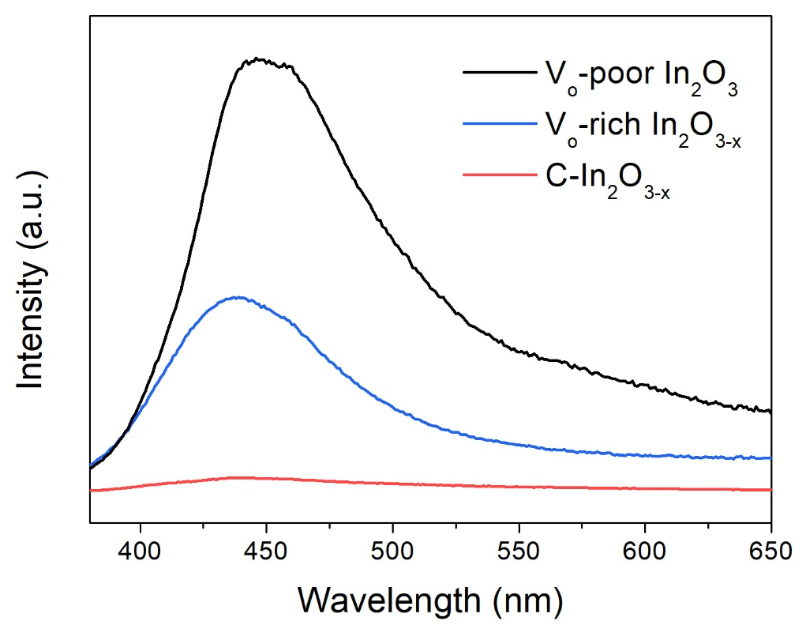

Figure S11. The PL spectrum of V_{o}-poor In₂O₃, V_{o}-rich In₂O_{3-x} and C-In₂O_{3-x}.

Supplementary Discussion: The photoluminescence (PL) spectrum was tested. The emission peak at 450 nm for V_{o}-poor In₂O₃ could be mainly ascribed to the recombination of the photogenerated hole with the two-electron-trapped O-vacancy, while the blue-shifted peak at 440 nm for the V_{o}-rich In₂O_{3-x} could be mainly attributed to the recombination of the photogenerated hole with the single-electron-trapped O-vacancy.
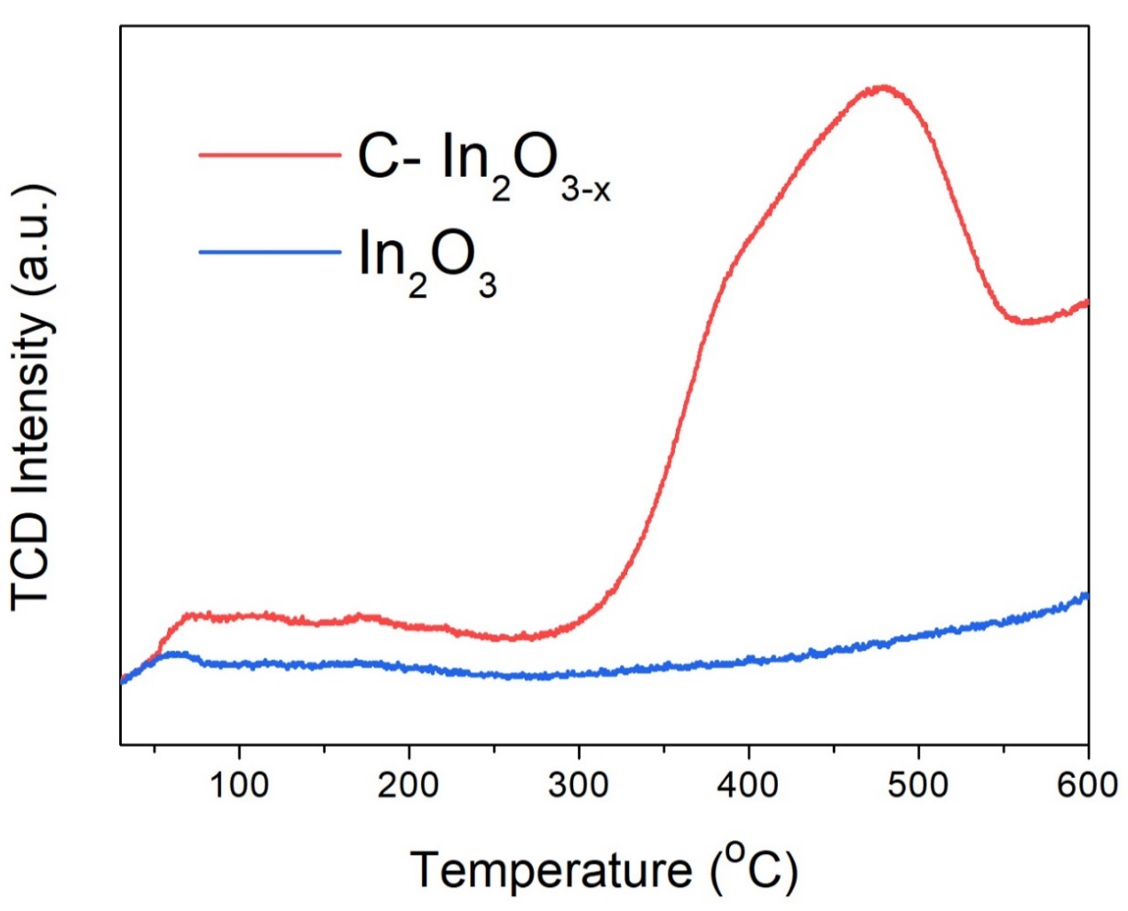
Figure S12. CO₂-TPD profiles of C-In₂O₃ with and without active sites via calcination treatment.

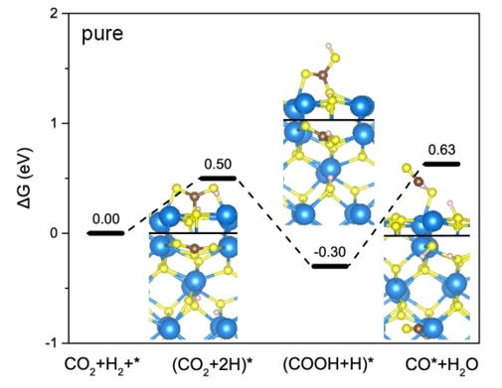
Figure S13. Gibbs free energy profile for CO₂ reaction with the coadsorbed H atoms on the In₂O₃ (110) surface.

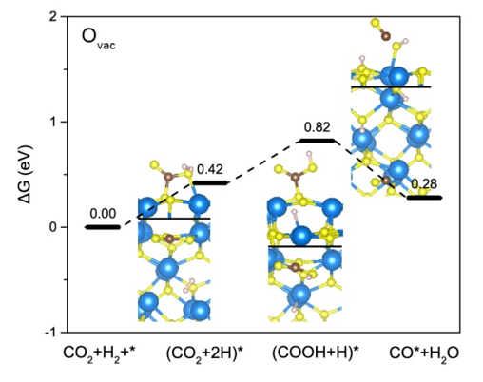
Figure S14. Gibbs free energy profile for CO₂ reaction with the coadsorbed H atoms on the In₂O₃ (110) surface with oxygen vacancy.

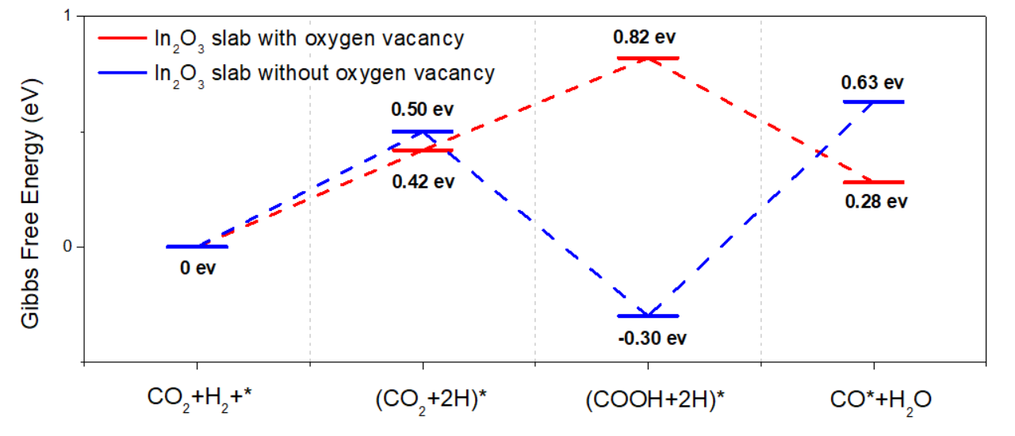
Figure S15. Gibbs free energy profile for CO₂ reduction reaction on the In₂O₃ (110) surface.

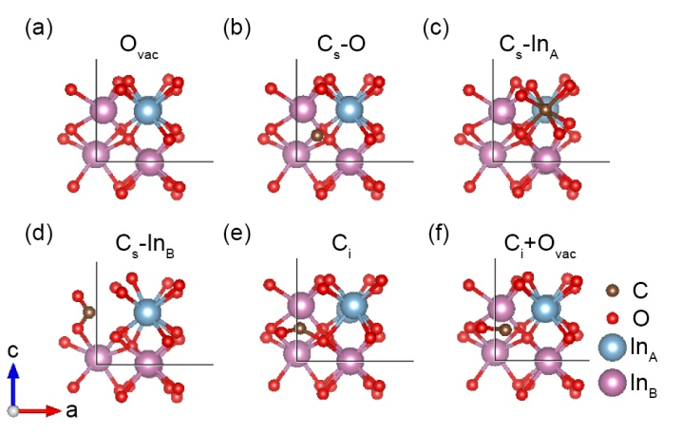
Figure S16. Relaxed local defect structures of (a) one O atom vacancy, (b) one O atom substituted by C atom, (c) one In_{A} atom substituted by C atom, (d) one In_{B} atom substituted by C atom, (e) one C atom interstitial and (f) one C atom interstitial with one O atom vacancy.

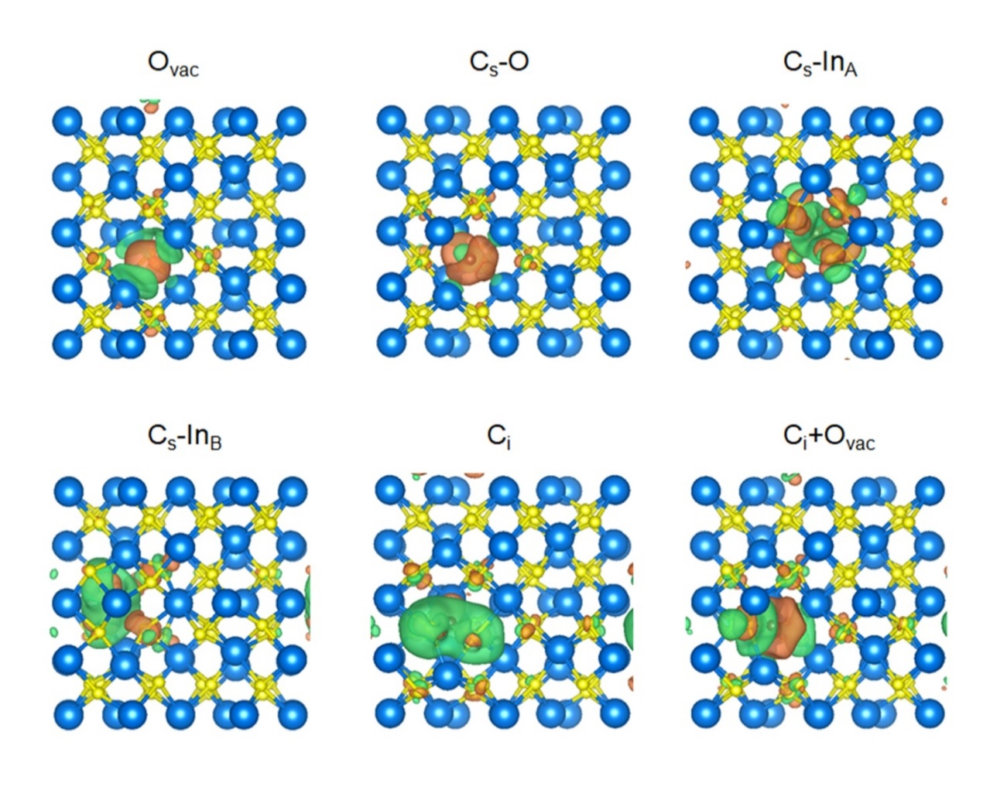
Figure 17. Side views of charge difference density of C doped In₂O₃ systems. The isosurface value is 3 e nm⁻³. Yellow and blue regions represent net charge gain and loss, respectively.
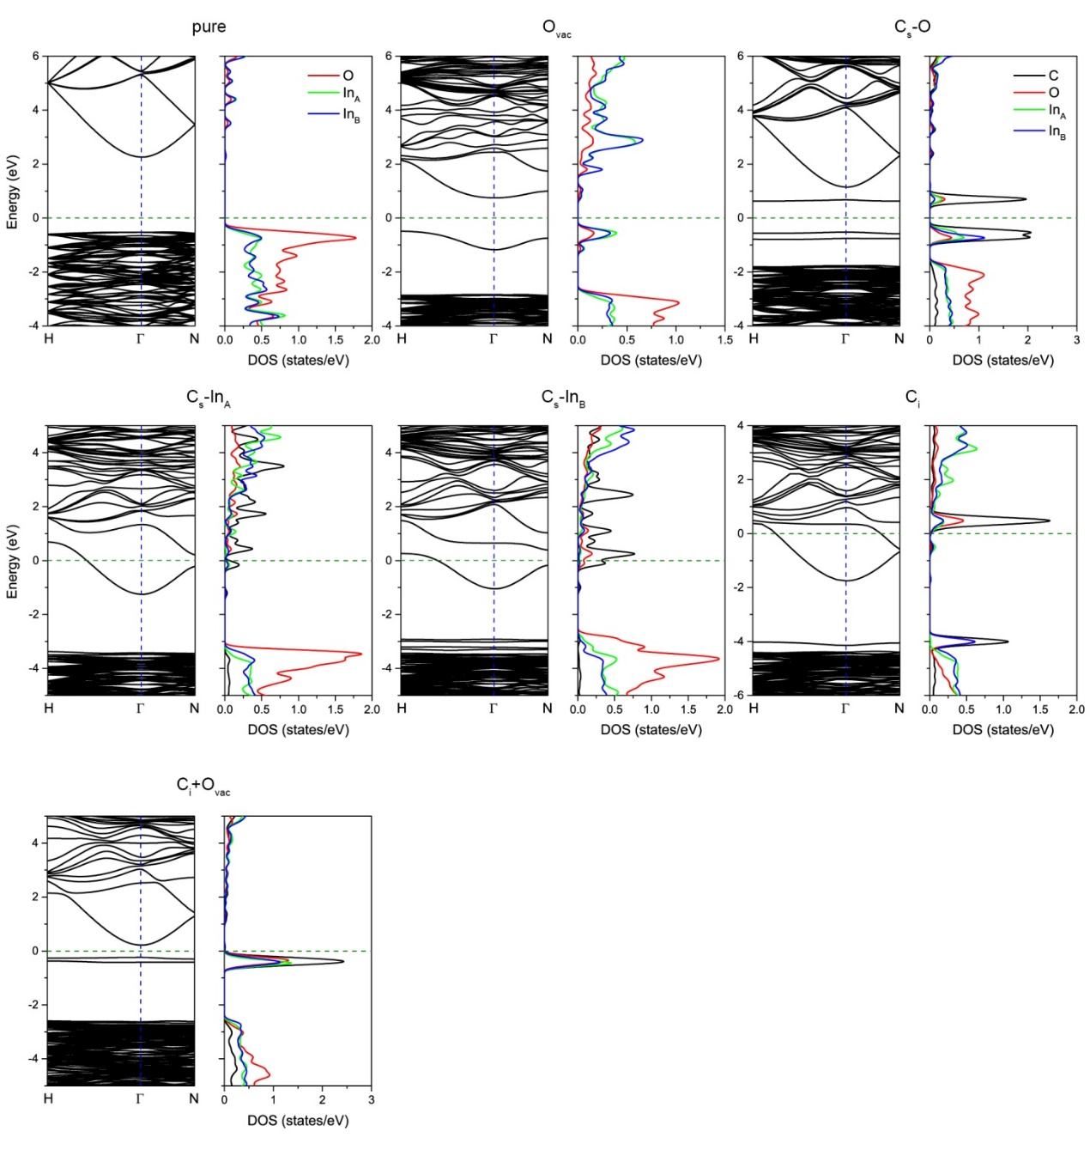
Figure S18. Band structures and projected density of states of C doped In₂O₃ systems. Fermi level is set to zero.

References
1. Kresse, G. & Furthmuller, J. Efficient iterative schemes for ab initio total-energy calculations using a plane-wave basis set. Physical Review B 54, 11169-11186 (1996).
2. Kresse, G. & Joubert, D. From ultrasoft pseudopotentials to the projector augmented-wave method. Physical Review B 59, 1758-1775 (1999).
3. Perdew, J.P., Burke, K. & Ernzerhof, M. Generalized gradient approximation made simple. Physical Review Letters 77, 3865-3868 (1996).
4. Krukau, A.V., Vydrov, O.A., Izmaylov, A.F. & Scuseria, G.E. Influence of the exchange screening parameter on the performance of screened hybrid functionals. J Chem Phys 125, 224106 (2006).
5. Brown, I.D. & Altermatt, D. Bond-Valence Parameters Obtained from a Systematic Analysis of the Inorganic Crystal-Structure Database. Acta Crystallogr B 41, 244-247 (1985).
6. Brese, N.E. & Okeeffe, M. Bond-Valence Parameters for Solids. Acta Crystallogr B 47, 192-197 (1991).
7. Brown, I.D. Chemical and Steric Constraints in Inorganic Solids. Acta Crystallogr B 48, 553-572 (1992).
8. Ye, J.Y., Liu, C.J. & Ge, Q. DFT Study of CO₂ Adsorption and Hydrogenation on the In2O3 Surface. J Phys Chem C 116, 7817-7825 (2012).
9. Ye, J.Y., Liu, C.J., Mei, D.H. & Ge, Q.F. Active Oxygen Vacancy Site for Methanol Synthesis from CO₂ Hydrogenation on In₂O₃(110): A DFT Study. Acs Catal 3, 1296-1306 (2013).
10. He, L. et al. Spatial Separation of Charge Carriers in In₂O_{3-x}(OH)_{y} Nanocrystal Superstructures for Enhanced Gas-Phase Photocatalytic Activity. Acs Nano 10, 5578-5586 (2016).
11. Hoch, L.B. et al. Nanostructured Indium Oxide Coated Silicon Nanowire Arrays: A Hybrid Photothermal/Photochemical Approach to Solar Fuels. Acs Nano 10, 9017-9025 (2016).
12. Hoch, L.B. et al. The Rational Design of a Single-Component Photocatalyst for Gas-Phase CO₂ Reduction Using Both UV and Visible Light. Adv Sci 1, 1400013 (2014).
13. Ahmed, N., Shibata, Y., Taniguchi, T. & Izumi, Y. Photocatalytic conversion of carbon dioxide into methanol using zinc-copper-M(III) (M=aluminum, gallium) layered double hydroxides. J Catal 279, 123-135 (2011).
14. Meng, X.G. et al. Photothermal Conversion of CO₂ into CH₄ with H₂ over Group VIII Nanocatalysts: An Alternative Approach for Solar Fuel Production. Angew Chem Int Edit 53, 11478-11482 (2014).
15. Zhang, W.B. et al. Integration of Photothermal Effect and Heat Insulation to Efficiently Reduce Reaction Temperature of CO₂ Hydrogenation. Small 13,1602583 (2017).
16. O'Brien, P.G. et al. Photomethanation of Gaseous CO₂ over Ru/Silicon Nanowire Catalysts with Visible and Near-Infrared Photons. Adv Sci 1 ,1400001 (2014).
17. Li, M. et al. Highly efficient and stable photocatalytic reduction of CO₂ to CH₄ over Ru loaded NaTaO₃. Chem Commun 51, 7645-7648 (2015).
18. Jia, J. et al. Visible and Near-Infrared Photothermal Catalyzed Hydrogenation of Gaseous CO₂ over Nanostructured Pd@Nb₂O₅. Adv Sci 3 ,1600189 (2016).
19. Zhang, H.B. et al. Surface-Plasmon-Enhanced Photodriven CO₂ Reduction Catalyzed by Metal-Organic-Framework-Derived Iron Nanoparticles Encapsulated by Ultrathin Carbon Layers. Adv Mater 28, 3703-3710 (2016).
20. Ren, J. et al. Targeting Activation of CO₂ and H₂ over Ru-Loaded Ultrathin Layered Double Hydroxides to Achieve Efficient Photothermal CO₂ Methanation in Flow-Type System. Adv Energy Mater 7 ,1601657 (2017).
21. Lin, L.L. et al. The visible-light-assisted thermocatalytic methanation of CO₂ over Ru/TiO_{2-X}N_{X}. Appl Catal B-Environ 204, 440-455 (2017).
22. Zhang, X. et al. Product selectivity in plasmonic photocatalysis for carbon dioxide hydrogenation. Nat Commun 8, 1-9 (2017).
23. Robatjazi, H. et al. Plasmon-induced selective carbon dioxide conversion on earth-abundant aluminum-cuprous oxide antenna-reactor nanoparticles. Nat Commun 8 ,1-10 (2017).
24. Sastre, F., Puga, A.V., Liu, L.C., Corma, A. & Garcia, H. Complete Photocatalytic Reduction of CO₂ to Methane by H₂ under Solar Light Irradiation. J Am Chem Soc 136, 6798-6801 (2014).
25. Li, Y.F. et al. Pd@H_{y}WO_{3-x} Nanowires Efficiently Catalyze the CO₂ Heterogeneous Reduction Reaction with a Pronounced Light Effect. Acs Appl Mater Inter 11, 5610-5615 (2019).
26. Qi, Y. et al. Photoinduced Defect Engineering: Enhanced Photothermal Catalytic Performance of 2D Black In₂O_{3-x} Nanosheets with Bifunctional Oxygen Vacancies. Adv Mater 32, 1903915 (2019).

