Additional file 1
Supplementary Tables and Figures
Stable redundancy and variable ranking of metabolic surrogate indicators for incident ischemic heart disease
Description: candidate-indicator audit, locked formula definitions, cohort harmonization, sample completeness, multi-evidence competition, raw-component upper-bound benchmarks, transport and missingness diagnostics, machine-learning stability, and restricted-cubic-spline, calibration, and decision-curve analyses.
This file contains Supplementary Tables S1-S8 and Supplementary Figures S1-S5 for the main manuscript.
Contents
Table S1 Candidate-universe eligibility audit and locked definitions of primary indicators and new scores
Table S2 Variable harmonization, analytic samples, and Core-3 information completeness
Table S3 Verified multi-evidence competition of the 10 candidate indicators
Table S4 Focused benchmark and prespecified new-score challenge models
Table S5 Transport, missingness, and component-heterogeneity diagnostics
Table S6 Machine-learning stability and contribution transport
Table S7 Restricted cubic splines, decision curves, and calibration diagnostics
Table S8 Formula-based metabolic surrogates versus raw-component upper-bound models
Figures
Figure S1 Missingness and distribution drift across analytic stages
Figure S2 Detailed stage-specific performance of the 10 candidate metabolic indicators
Figure S3 New-score challenge, data completeness, and bidirectional transport
Figure S4 Machine-learning contribution patterns and transportability of feature importance
Figure S5 Dose-response shape and incremental decision-curve evidence

Table S1. Candidate-universe eligibility audit and locked definitions of primary indicators and new scores
Panel A. Eligibility audit of the broader derived-indicator universe
Indicator | Stage-1 role | Required components | ELSA feasibility status | Cross-cohort disposition | Primary 10 | Final rationale
TyG | Locked core | TG, glucose | Passed formula audit | Retained in common core | Yes | Glycolipid core
AIP | Locked core | TG, HDL-C | Passed formula audit | Retained in common core | Yes | Atherogenic lipid axis
TG/HDL-C | Locked core | TG, HDL-C | Passed formula audit | Retained in common core | Yes | Alternative parameterization of the AIP axis
TyG-BMI | Locked core | TyG, BMI | Passed formula audit | Retained in common core | Yes | Anthropometric-enhanced TyG
METS-IR | Locked core | Glucose, TG, HDL-C, BMI | Passed formula audit | Retained in common core | Yes | Multicomponent IR surrogate
Lower SPISE | Locked core | TG, HDL-C, BMI | Passed formula audit | Retained in common core | Yes | Multicomponent IR surrogate
WHtR | Candidate | Waist, height | Passed formula audit | Retained in common core | Yes | Body-size axis
non-HDL-C | Candidate | Total cholesterol, HDL-C | Passed formula audit | Retained in common core | Yes | Clinical cholesterol benchmark
TyG-WC | Conditional candidate | TyG, waist | Passed formula audit | Retained in common core | Yes | Waist-enhanced TyG
Lower eGDR (WC-based) | HbA1c-dependent candidate | HbA1c, hypertension, waist | Passed after HbA1c source/unit audit | Retained in common core | Yes | WC-based eGDR; sign reversed for risk direction
Remnant cholesterol | Optional | Total cholesterol, LDL-C, HDL-C | Formula audited | Not advanced beyond feasibility audit | No | Optional derived lipid outside the bounded panel
TC/HDL-C | Optional | Total cholesterol, HDL-C | Formula audited | Not advanced beyond feasibility audit | No | Optional ratio; lipid-ratio coverage already represented
eGDR-BMI | Sensitivity only | HbA1c, hypertension, BMI | Formula audited | Not advanced beyond feasibility audit | No | Alternative eGDR specification; WC-based form retained
Uric acid/HDL-C ratio | Optional | Uric acid, HDL-C | Required separate source/unit audit | Not carried into the harmonized common core | No | Not included in the final cross-cohort data layer
Note: The broader formula universe was defined during the stage-1 feasibility audit. That audit performed no regression, imputation, feature selection, machine learning, or marker ranking; endpoint information was used only to assess event support and defensible model complexity. The 10-indicator panel was subsequently frozen before any formal marker-outcome association or predictive comparison, using source and unit validity, cross-cohort availability, and redundancy considerations. 'Primary 10' denotes inclusion in the formal competition reported in Table S3 and Figure S2. TC, total cholesterol; LDL-C, low-density lipoprotein cholesterol; HDL-C, high-density lipoprotein cholesterol.

Panel B. Locked formulas, directions, and analytic roles of the primary indicators and prespecified new scores
Indicator / score | Locked formula | Required components | Unit / preparation | Risk direction | Family / analytic role
TyG | ln[(TG × glucose)/2] | TG, glucose | TG and glucose in mg/dL | Higher = greater risk | Glycolipid index
AIP | log10[(TG/88.57)/(HDL-C/38.67)] | TG, HDL-C | Molar TG/HDL-C ratio | Higher = greater risk | Atherogenic lipid axis
TG/HDL-C | (TG/88.57)/(HDL-C/38.67) | TG, HDL-C | Molar ratio | Higher = greater risk | Atherogenic lipid axis
TyG-BMI | TyG × BMI | TG, glucose, BMI | BMI in kg/m² | Higher = greater risk | Anthropometric-enhanced
METS-IR | ln[(2 × glucose) + TG] × BMI / ln(HDL-C) | Glucose, TG, HDL-C, BMI | Lipids/glucose in mg/dL | Higher = greater risk | Multicomponent IR
Lower SPISE | −[600 × HDL-C^0.185 / (TG^0.2 × BMI^1.338)] | TG, HDL-C, BMI | Risk-direction transformation | Higher = greater risk | Multicomponent IR
Lower eGDR | −[21.158 − 0.09 × waist − 3.407 × hypertension − 0.551 × HbA1c] | Waist, hypertension, HbA1c | Waist in cm; HbA1c in % | Higher = greater risk | Multicomponent IR
TyG-WC | TyG × waist circumference | TG, glucose, waist | Waist in cm | Higher = greater risk | Anthropometric-enhanced
WHtR | Waist circumference / height | Waist, height | Both in cm | Higher = greater risk | Anthropometric-enhanced
non-HDL-C | Total cholesterol − HDL-C | Total cholesterol, HDL-C | mg/dL | Higher = greater risk | Cholesterol burden
Core-3 Equal | [z(ln TG) + z(ln glucose) − z(ln HDL-C)] / 3 | TG, glucose, HDL-C | z scores frozen in ELSA development | Higher = greater risk | Prespecified new score
Extended-4 Equal | [z(ln TG) + z(ln glucose) − z(ln HDL-C) + z(WHtR)] / 4 | TG, glucose, HDL-C, WHtR | z scores frozen in ELSA development | Higher = greater risk | Prespecified extension
Note: TG, triglycerides; HDL-C, high-density lipoprotein cholesterol; BMI, body mass index; WC, waist circumference; WHtR, waist-to-height ratio; HbA1c, glycated hemoglobin; IR, insulin resistance. Lower SPISE and Lower eGDR were sign-reversed so that higher values consistently indicated greater estimated risk. z scores and preprocessing parameters for the new scores were frozen in ELSA development.

Table S2. Variable harmonization, analytic samples, and information completeness across development and validation stages
Panel A. Canonical variable registry and reporting format
Order | Layer | Canonical variable | Display name | Type | Unit | Summary format | Canonical definition
1 | Clinical | age | Age | Continuous | years | Mean ± SD | Age at the baseline landmark
2 | Clinical | female | Female sex | Binary | 0/1 | n (%) | Female sex
3 | Clinical | education | Education level | Categorical | 1/2/3 | n (%) | Harmonized low / middle / high education category
4 | Clinical | smoker | Current smoking | Binary | 0/1 | n (%) | Current smoking at baseline
5 | Clinical | hypertension | Hypertension | Binary | 0/1 | n (%) | Doctor-diagnosed or measured hypertension at baseline
6 | Clinical | baseline_diabetes | Diabetes | Binary | 0/1 | n (%) | Doctor-diagnosed diabetes at baseline
7 | Raw components | bmi | Body mass index | Continuous | kg/m² | Mean ± SD | Body mass index
8 | Raw components | waist_cm | Waist circumference | Continuous | cm | Mean ± SD | Measured waist circumference
9 | Raw components | height_cm | Height | Continuous | cm | Mean ± SD | Measured height
10 | Raw components | sbp | Systolic blood pressure | Continuous | mmHg | Mean ± SD | Measured systolic blood pressure
11 | Raw components | dbp | Diastolic blood pressure | Continuous | mmHg | Mean ± SD | Measured diastolic blood pressure
12 | Raw components | glucose_mg | Glucose | Continuous | mg/dL | Median [IQR] | Blood glucose
13 | Raw components | hba1c_pct | HbA1c | Continuous | % | Mean ± SD | Glycated hemoglobin
14 | Raw components | tg_mg | Triglycerides | Continuous | mg/dL | Median [IQR] | Triglycerides
15 | Raw components | hdl_mg | HDL-C | Continuous | mg/dL | Mean ± SD | High-density lipoprotein cholesterol
16 | Raw components | ldl_mg | LDL-C | Continuous | mg/dL | Mean ± SD | Low-density lipoprotein cholesterol
17 | Raw components | tc_mg | Total cholesterol | Continuous | mg/dL | Mean ± SD | Total cholesterol
18 | Raw components | crp | C-reactive protein | Continuous | mg/L | Median [IQR] | C-reactive protein
19 | Candidate indicators | tyg | TyG | Continuous | index | Median [IQR] | Triglyceride-glucose index
20 | Candidate indicators | aip | AIP | Continuous | index | Median [IQR] | Atherogenic index of plasma
21 | Candidate indicators | tg_hdl | TG/HDL-C | Continuous | ratio | Median [IQR] | Triglyceride-to-HDL-C ratio
22 | Candidate indicators | tyg_bmi | TyG-BMI | Continuous | index | Median [IQR] | TyG multiplied by BMI
23 | Candidate indicators | mets_ir | METS-IR | Continuous | index | Median [IQR] | Metabolic score for insulin resistance
24 | Candidate indicators | lower_spise | Lower SPISE | Continuous | index | Median [IQR] | Negative SPISE so that higher values indicate greater risk
25 | Candidate indicators | lower_egdr | Lower eGDR | Continuous | index | Median [IQR] | Negative estimated glucose disposal rate
26 | Candidate indicators | tyg_wc | TyG-WC | Continuous | index | Median [IQR] | TyG multiplied by waist circumference
27 | Candidate indicators | whtr | WHtR | Continuous | ratio | Mean ± SD | Waist-to-height ratio
28 | Candidate indicators | non_hdl_mg | non-HDL-C | Continuous | mg/dL | Mean ± SD | Total cholesterol minus HDL-C

Panel B. Locked cohort roles and analytic sample flow
Cohort stage | Analytic role | Observation window | Analysis unit | Harmonized rows | Missing outcome excluded | Analytic rows | Unique participants | Exact-IHD events, n (%) | Model use
ELSA pooled development | Pooled development | ELSA W2→W4 and W4→W6 | Participant-landmark rows | 16,309 | 4,745 | 11,564 | 7,795 | 367 (3.2%) | Participant-grouped repeated OOF development
ELSA temporal validation | Frozen temporal validation | ELSA W6→W8 | Participants | 8,054 | 2,275 | 5,779 | 5,779 | 163 (2.8%) | Unchanged frozen predictions
HRS external validation | Frozen external validation | HRS 2016→2020 | Participants | 6,345 | 1,278 | 5,067 | 5,067 | 171 (3.4%) | Unchanged frozen predictions
Panel C. Core-3 component completeness and imputation strata
Validation stage | Information-completeness stratum | Rows | Events | Fraction of stage | Analytic interpretation
ELSA temporal validation | All outcome-observed rows | 5779 | 163 | 100.0% | Primary frozen validation population
ELSA temporal validation | All three Core-3 components observed | 2549 | 55 | 44.1% | Complete-case sensitivity population
ELSA temporal validation | One component imputed | 2018 | 65 | 34.9% | Sensitivity stratum
ELSA temporal validation | Two or more components imputed | 1212 | 43 | 21.0% | Too few events for some formal contrasts
ELSA temporal validation | Any Core-3 component imputed | 3230 | 108 | 55.9% | Material contributor to validation contrast
HRS external validation | All outcome-observed rows | 5067 | 171 | 100.0% | Primary frozen external population
HRS external validation | All three Core-3 components observed | 5008 | 168 | 98.8% | Complete-case sensitivity population
HRS external validation | One component imputed | 22 | 0 | 0.4% | Not formally performance-eligible
HRS external validation | Two or more components imputed | 37 | 3 | 0.7% | Not formally performance-eligible
HRS external validation | Any Core-3 component imputed | 59 | 3 | 1.2% | Minimal information loss
Note: All denominators use outcome-observed analytic rows. ELSA pooled development is a participant-landmark dataset; ELSA temporal validation and HRS external validation are participant-level datasets. No between-cohort P values were calculated. Panel C reports the prespecified Core-3 completeness strata used in the missingness sensitivity analysis; the complete-case analysis remains selective and does not replace the frozen all-row validation.

Table S3. Verified multi-evidence competition of the 10 candidate metabolic indicators
Overall rank | Indicator | Development OR per SD (95% CI) | FDR q | Association rank | Predictive rank | Incremental rank | Transport rank | Champion probability | Top-3 probability | Evidence role
1 | AIP | 1.12 (1.00–1.26) | 0.096 | 4.5 | 3.6 | 2.89 | 4.4 | 39.4% | 75.0% | Moderate consensus champion
2 | TG/HDL-C | 1.11 (1.02–1.21) | 0.074 | 3.75 | 3.8 | 3.44 | 6.6 | 11.4% | 57.2% | Pareto-front contender
3 | TyG-WC | 1.13 (1.02–1.26) | 0.074 | 1.75 | 5.4 | 5.56 | 5.4 | 4.4% | 23.2% | Pareto-front contender
4 | TyG | 1.08 (0.97–1.21) | 0.194 | 8.5 | 4.4 | 4.56 | 1.2 | 19.1% | 67.4% | Pareto-front contender
5 | METS-IR | 1.13 (1.02–1.25) | 0.074 | 2.75 | 5.33 | 5.0 | 6.2 | 14.1% | 37.6% | Pareto-front contender
6 | WHtR | 1.09 (0.98–1.22) | 0.158 | 7.5 | 5.2 | 5.33 | 5.4 | 9.3% | 27.2% | Non-champion
7 | Lower SPISE | 1.13 (1.01–1.27) | 0.074 | 2.25 | 7.07 | 7.22 | 8.4 | 0.6% | 4.0% | Non-champion
8 | TyG-BMI | 1.10 (0.99–1.23) | 0.122 | 6.5 | 6.4 | 6.11 | 6.2 | 0.3% | 8.2% | Non-champion
9 | Lower eGDR | 1.11 (0.95–1.29) | 0.206 | 7.5 | 7.27 | 8.0 | 5.6 | 0.5% | 3.8% | Non-champion
10 | non-HDL-C | 1.02 (0.90–1.15) | 0.808 | 10.0 | 6.53 | 6.89 | 5.6 | 0.9% | 8.0% | Non-champion
Note: Rankings were recalculated after enforcing one unique record for each indicator-by-domain combination. Every ranking set included all 10 candidate indicators, and ranks were constrained to 1–10. Lower domain ranks indicate better performance. AIP ranked first overall, but no indicator was uniformly superior across all evidence domains. TyG had the strongest transportability rank. Focused validation therefore retained AIP as the lipid-ratio representative, TyG as a distinct glycolipid axis, and Core-3 Equal as the prespecified new score; TG/HDL-C was not duplicated because it is a monotonic transformation of AIP.

Table S4. Focused benchmark and prespecified new-score challenge models
Model | Role | ELSA temporal AUROC | ELSA temporal AUPRC | ELSA temporal Brier | HRS AUROC | HRS AUPRC | HRS Brier | Mean validation rank | Interpretation
Clinical | Reference | 0.669 | 0.056 | 0.02724 | 0.643 | 0.056 | 0.03247 | 10.67 | Reference model; not winner eligible
Clinical + TyG | Existing Benchmark | 0.676 | 0.057 | 0.02722 | 0.652 | 0.058 | 0.03242 | 5.67 | Existing-indicator benchmark; hierarchy retained
Clinical + AIP | Existing Benchmark | 0.678 | 0.062 | 0.02722 | 0.650 | 0.057 | 0.03245 | 4.00 | Existing-indicator benchmark; hierarchy retained
Clinical + TG/HDL-C | Existing Benchmark | 0.677 | 0.061 | 0.02722 | 0.652 | 0.055 | 0.03280 | 6.00 | Existing-indicator benchmark; hierarchy retained
Clinical + Core-3 Equal | Primary New Score | 0.674 | 0.059 | 0.02723 | 0.658 | 0.060 | 0.03243 | 4.83 | Transparent supportive compression score; not a validated replacement
Clinical + Extended-4 Equal | Key Extension | 0.673 | 0.059 | 0.02724 | 0.659 | 0.061 | 0.03241 | 4.67 | Extension did not meet promotion criterion
Clinical + Core-3 PCA | Supportive | 0.677 | 0.061 | 0.02722 | 0.656 | 0.059 | 0.03244 | 3.83 | Supportive data-driven score; descriptive only
Clinical + Extended-4 PCA | Supportive | 0.676 | 0.058 | 0.02723 | 0.657 | 0.058 | 0.03242 | 5.17 | Supportive data-driven score; descriptive only
Core-3 conditional Ridge | Exploratory | 0.670 | 0.057 | 0.02724 | 0.643 | 0.056 | 0.03247 | 9.33 | Exploratory conditional model; no hierarchy revision
Extended-4 conditional Ridge | Exploratory | 0.669 | 0.057 | 0.02724 | 0.643 | 0.056 | 0.03247 | 9.00 | Exploratory conditional model; no hierarchy revision
Clinical + Core-3 raw components | Information Upper Bound | 0.679 | 0.060 | 0.02722 | 0.640 | 0.053 | 0.03254 | 6.67 | Information upper bound; not winner eligible
Clinical + Extended-4 raw components | Information Upper Bound | 0.677 | 0.059 | 0.02723 | 0.638 | 0.053 | 0.03252 | 8.17 | Information upper bound; not winner eligible
Note: Performance estimates are frozen point estimates. Brier scores are displayed to five decimal places. Mean validation rank is the mean of the AUROC, AUPRC, and Brier ranks within ELSA temporal validation and HRS external validation, averaged across the two stages; lower values indicate better descriptive performance. These ranks do not overwrite the verified multi-evidence hierarchy. Core-3 Equal remains a supportive transparent compression score; Extended-4 Equal did not meet the promotion criterion. PCA and conditional-ridge variants are supportive or exploratory, and raw-component models are information upper bounds rather than simplified-score candidates.

Table S5. Transport, missingness, and component-heterogeneity diagnostics
Panel A. Technical reconstruction and missingness diagnosis
Diagnostic item | Result | Interpretation
Raw-unit and formula checks | Passed | Units and published formulas reproduced the locked indicators
Frozen preprocessing and prediction checks | Passed | Development-derived centers, scales, imputations, and frozen predictions were reproduced
ELSA temporal validation: all rows / complete cases | 5,779 / 2,549 rows; 163 / 55 events | Complete-case restriction retained 44.1% of rows and changed at least one comparison direction
HRS external validation: all rows / complete cases | 5,067 / 5,008 rows; 171 / 168 events | Complete-case restriction retained 98.8% of rows and did not materially alter conclusions
ELSA temporal validation: any Core-3 component imputed | 3,230 rows; 108 events (55.9%) | Substantial differential information completeness
HRS external validation: any Core-3 component imputed | 59 rows; 3 events (1.2%) | Very little component imputation
ELSA all-row Core-3 vs TyG, ΔAUROC | −0.23 percentage points | Core-3 performed slightly worse on discrimination
ELSA all-row Core-3 vs AIP, ΔAUROC | −0.43 percentage points | Core-3 performed slightly worse on discrimination
HRS all-row Core-3 vs TyG, ΔAUROC | +0.52 percentage points | Core-3 performed slightly better on discrimination
HRS all-row Core-3 vs AIP, ΔAUROC | +0.80 percentage points | Core-3 performed slightly better on discrimination
Frozen-score distribution shift | Moderate-or-larger shift detected | Limits direct transport interpretation
Primary missingness diagnosis | Differential imputation materially influenced ELSA contrasts | Sensitivity evidence; the frozen all-row validation remains primary
Panel B. Frozen-component heterogeneity between ELSA temporal validation and HRS external validation
Diagnostic item | Estimate / decision | Scale / interpretation
Joint log-glucose component β, ELSA temporal validation | −0.065 | Log-odds coefficient per frozen ELSA-development component SD
Joint log-glucose component β, HRS external validation | 0.072 | Log-odds coefficient per frozen ELSA-development component SD
Difference in β, HRS minus ELSA | 0.138 | Same frozen component-SD and log-odds scale
Stage × log-glucose interaction P value | 0.100 | Not decisive at α=0.05
Complete-case difference in β, HRS minus ELSA | 0.081 | Interaction P=0.420
Three-component omnibus interaction P, all rows | 0.188 | No decisive joint heterogeneity
Three-component omnibus interaction P, complete cases | 0.262 | No decisive joint heterogeneity
Formal component-heterogeneity diagnosis | Limited formal evidence with residual effect differences | Event counts limited interaction precision
Panel C. Exploratory reverse-transport diagnosis
Comparison | Majority-win probability / decision | Interpretation
HRS grouped OOF: Core-3 vs TyG | 82.4% | Majority-win probability favored Core-3
HRS grouped OOF: Core-3 vs AIP | 95.8% | Majority-win probability favored Core-3
ELSA temporal validation, HRS-frozen: Core-3 vs TyG | 68.8% | Partial reverse-direction support
ELSA temporal validation, HRS-frozen: Core-3 vs AIP | 87.6% | Partial reverse-direction support
Reverse-transport diagnosis | Partial bidirectional transport without clear universal superiority | Exploratory diagnosis; the primary development hierarchy was not revised
Note: Technical and formula errors were effectively ruled out. Differential information completeness materially influenced the ELSA contrasts, while HRS was almost entirely complete for the Core-3 components. Component coefficients are reported on the frozen ELSA-development component-SD log-odds scale. The locked compact heterogeneity output retained point estimates and interaction P values; confidence intervals were not recomputed during table assembly. Reverse transport was exploratory and did not revise the primary development hierarchy.

Table S6. Machine-learning stability and frozen contribution transport
Panel A. Constrained probability-forest design and reporting decision
Item | Locked value | Interpretation
Outer resampling | 5 folds × 10 repeats | 50 participant-grouped outer models
Input features | 18 | Full prespecified explanatory panel
Forest engine | ranger probability forest | Shallow, constrained probability trees
Frozen selected grid | R3 | 350 trees; mtry=9; minimum node size=20; maximum depth=4; sample fraction=0.85
HRS used for tuning | No | External validation remained untouched
Class rebalancing | No | No SMOTE or outcome-guided resampling
Parent-model upgrade criterion | Not met | External performance and/or calibration did not justify a predictive-model upgrade
Reporting placement | Supplement only | Full validation curves and stage-performance estimates are displayed in Supplementary Figure S4
Panel B. Top cross-fold approximate-Shapley features
Rank | Feature | Mean rank | Top-5 frequency
1 | Age | 1.00 | 100.0%
2 | Hypertension | 3.66 | 86.0%
3 | Lower eGDR | 3.66 | 94.0%
4 | WHtR | 4.26 | 76.0%
5 | non-HDL-C | 4.66 | 68.0%
Panel C. Top cross-fold feature families
Rank | Feature family | Mean family rank | Top-5 frequency
1 | Clinical | 1.00 | 100.0%
2 | Anthropometric-enhanced | 2.84 | 100.0%
3 | Multicomponent IR | 2.84 | 98.0%
4 | Cholesterol burden | 4.06 | 94.0%
5 | Prespecified new scores | 4.56 | 80.0%
Panel D. Contribution-transport interpretation guardrails
Item | Locked decision | Interpretation
Feature-rank correlation, ELSA temporal to HRS | Spearman ρ=0.959 | Strong descriptive feature-rank transport
Family-rank correlation, ELSA temporal to HRS | Spearman ρ=0.893 | Strong descriptive family-rank transport
Top-five feature overlap | 5/5 | The same five leading features appeared in both validation settings
Parent-model upgrade criterion | Not met | Stable explanation did not establish reliable external prediction
Reporting placement | Supplement only | Attributions remain model-dependent under correlated inputs
Causal interpretation | Not allowed | SHAP and permutation importance explain the fitted model, not biology
Note: The probability forest was an explanatory support model. The same leading features and highly similar feature- and family-rank patterns were observed in ELSA temporal validation and HRS external validation, but the parent model did not meet the predictive-upgrade criterion. Stable attributions do not establish causal biology, resolve attribution ambiguity among correlated predictors, or revise the verified indicator hierarchy.

Table S7. Restricted cubic splines, decision curves, and complete calibration diagnostics
Panel A. Focused four-knot restricted-cubic-spline audit
Marker | P-nonlinear: development | P-nonlinear: ELSA temporal validation | P-nonlinear: HRS external validation | Shape decision
TyG | 0.726 | 0.677 | 0.185 | No strong nonlinearity evidence
AIP | 0.598 | 0.841 | 0.671 | No strong nonlinearity evidence
Core-3 Equal | 0.738 | 0.869 | 0.868 | No strong nonlinearity evidence
Panel B. Corrected calibration intercepts and slopes for frozen validation predictions
Validation stage | Model | Calibration intercept (95% CI) | Calibration slope (95% CI) | Descriptive calibration range
ELSA temporal validation | Clinical | -0.16 (-0.31–-0.01) | 0.90 (0.66–1.09) | Met
ELSA temporal validation | Clinical + AIP | -0.13 (-0.29–0.02) | 0.91 (0.68–1.10) | Met
ELSA temporal validation | Clinical + TyG | -0.16 (-0.31–-0.01) | 0.93 (0.69–1.12) | Met
ELSA temporal validation | Clinical + Core-3 Equal | -0.16 (-0.31–-0.01) | 0.91 (0.68–1.10) | Met
HRS external validation | Clinical | 0.04 (-0.10–0.19) | 0.75 (0.53–0.96) | Not met
HRS external validation | Clinical + AIP | 0.05 (-0.09–0.20) | 0.76 (0.55–0.98) | Not met
HRS external validation | Clinical + TyG | 0.03 (-0.11–0.18) | 0.78 (0.57–1.01) | Not met
HRS external validation | Clinical + Core-3 Equal | -0.07 (-0.21–0.09) | 0.78 (0.59–0.99) | Not met
Panel C. Decision-curve summary over thresholds from 1% to 10%
Enhanced model | Threshold grid favoring model: ELSA temporal validation | Threshold grid favoring model: HRS external validation | Interpretation
Clinical + TyG | 52.6% | 84.2% | Intermittent net-benefit gains did not overcome external-calibration limitations
Clinical + AIP | 42.1% | 57.9% | No stable net-benefit advantage across both validation settings
Clinical + Core-3 Equal | 52.6% | 73.7% | Intermittent net-benefit gains did not overcome external-calibration limitations
Note: RCS knots were fixed at the 5th, 35th, 65th, and 95th percentiles of the observed ELSA-development distribution and transported unchanged. Nonlinearity P values are descriptive and were not multiplicity adjusted. Calibration intercepts and slopes were estimated from individual-level frozen predictions with participant-clustered bootstrap intervals. For DCA, the percentages denote the fraction of the prespecified 1%–10% threshold grid at which the enhanced model had greater net benefit than the Clinical model; they do not describe the magnitude of the gain. Intermittent positive differences cannot overcome external-calibration limitations, define a treatment threshold, or establish clinical utility.

Table S8. Formula-based metabolic surrogates versus raw-component upper-bound models under frozen validation
Indicator | Formula model | Raw-component upper-bound model | Formula-better cells | AUROC better in both stages | Brier better in both stages | Interpretation
AIP | Clinical + AIP | Clinical + log TG + log HDL-C | 5/6 (83.3%) | No | Yes | Partial compact-form advantage; not universal raw-component superiority
TG/HDL-C | Clinical + TG/HDL-C | Clinical + log TG + log HDL-C | 4/6 (66.7%) | No | Yes | No consistent transported formula advantage over raw components
TyG-WC | Clinical + TyG-WC | Clinical + log TG + log glucose + waist | 3/6 (50.0%) | No | No | No consistent transported formula advantage over raw components
TyG | Clinical + TyG | Clinical + log TG + log glucose | 4/6 (66.7%) | Yes | No | Discrimination advantage did not extend consistently to overall accuracy
METS-IR | Clinical + METS-IR | Clinical + log glucose + log TG + log HDL-C + BMI | 3/6 (50.0%) | No | No | No consistent transported formula advantage over raw components
WHtR | Clinical + WHtR | Clinical + waist + height | 3/6 (50.0%) | No | No | No consistent transported formula advantage over raw components
Lower SPISE | Clinical + Lower SPISE | Clinical + log TG + log HDL-C + log BMI | 1/6 (16.7%) | No | No | No consistent transported formula advantage over raw components
TyG-BMI | Clinical + TyG-BMI | Clinical + log TG + log glucose + BMI | 3/6 (50.0%) | No | No | No consistent transported formula advantage over raw components
Lower eGDR | Clinical + Lower eGDR | Clinical + HbA1c + waist | 2/6 (33.3%) | No | No | No consistent transported formula advantage over raw components
non-HDL-C | Clinical + non-HDL-C | Clinical + total cholesterol + HDL-C | 3/6 (50.0%) | No | Yes | No consistent transported formula advantage over raw components
Note: Raw-component models were information upper bounds and were not winner-eligible. The six validation metric cells were AUROC, AUPRC, and Brier performance in ELSA temporal validation and HRS external validation; positive cells favoured the compact formula. For Brier, lower values were better, so formula advantage means the formula model had a lower Brier score than the raw-component model. For Lower eGDR, hypertension was already included in the locked Clinical comparator; the raw-component upper-bound model therefore added HbA1c and waist. No tested formula showed consistent transported superiority over its own raw-component upper-bound model across both validation stages.
Abbreviations
Note: AIP, atherogenic index of plasma; AUPRC, area under the precision–recall curve; AUROC, area under the receiver-operating-characteristic curve; BMI, body mass index; CI, confidence interval; DCA, decision-curve analysis; eGDR, estimated glucose disposal rate; ELSA, English Longitudinal Study of Ageing; FDR, false discovery rate; HDL-C, high-density lipoprotein cholesterol; HRS, Health and Retirement Study; IHD, ischemic heart disease; IR, insulin resistance; METS-IR, metabolic score for insulin resistance; OOF, out-of-fold; RCS, restricted cubic spline; SPISE, single-point insulin sensitivity estimator; TG, triglycerides; TyG, triglyceride–glucose index; WC, waist circumference; WHtR, waist-to-height ratio.
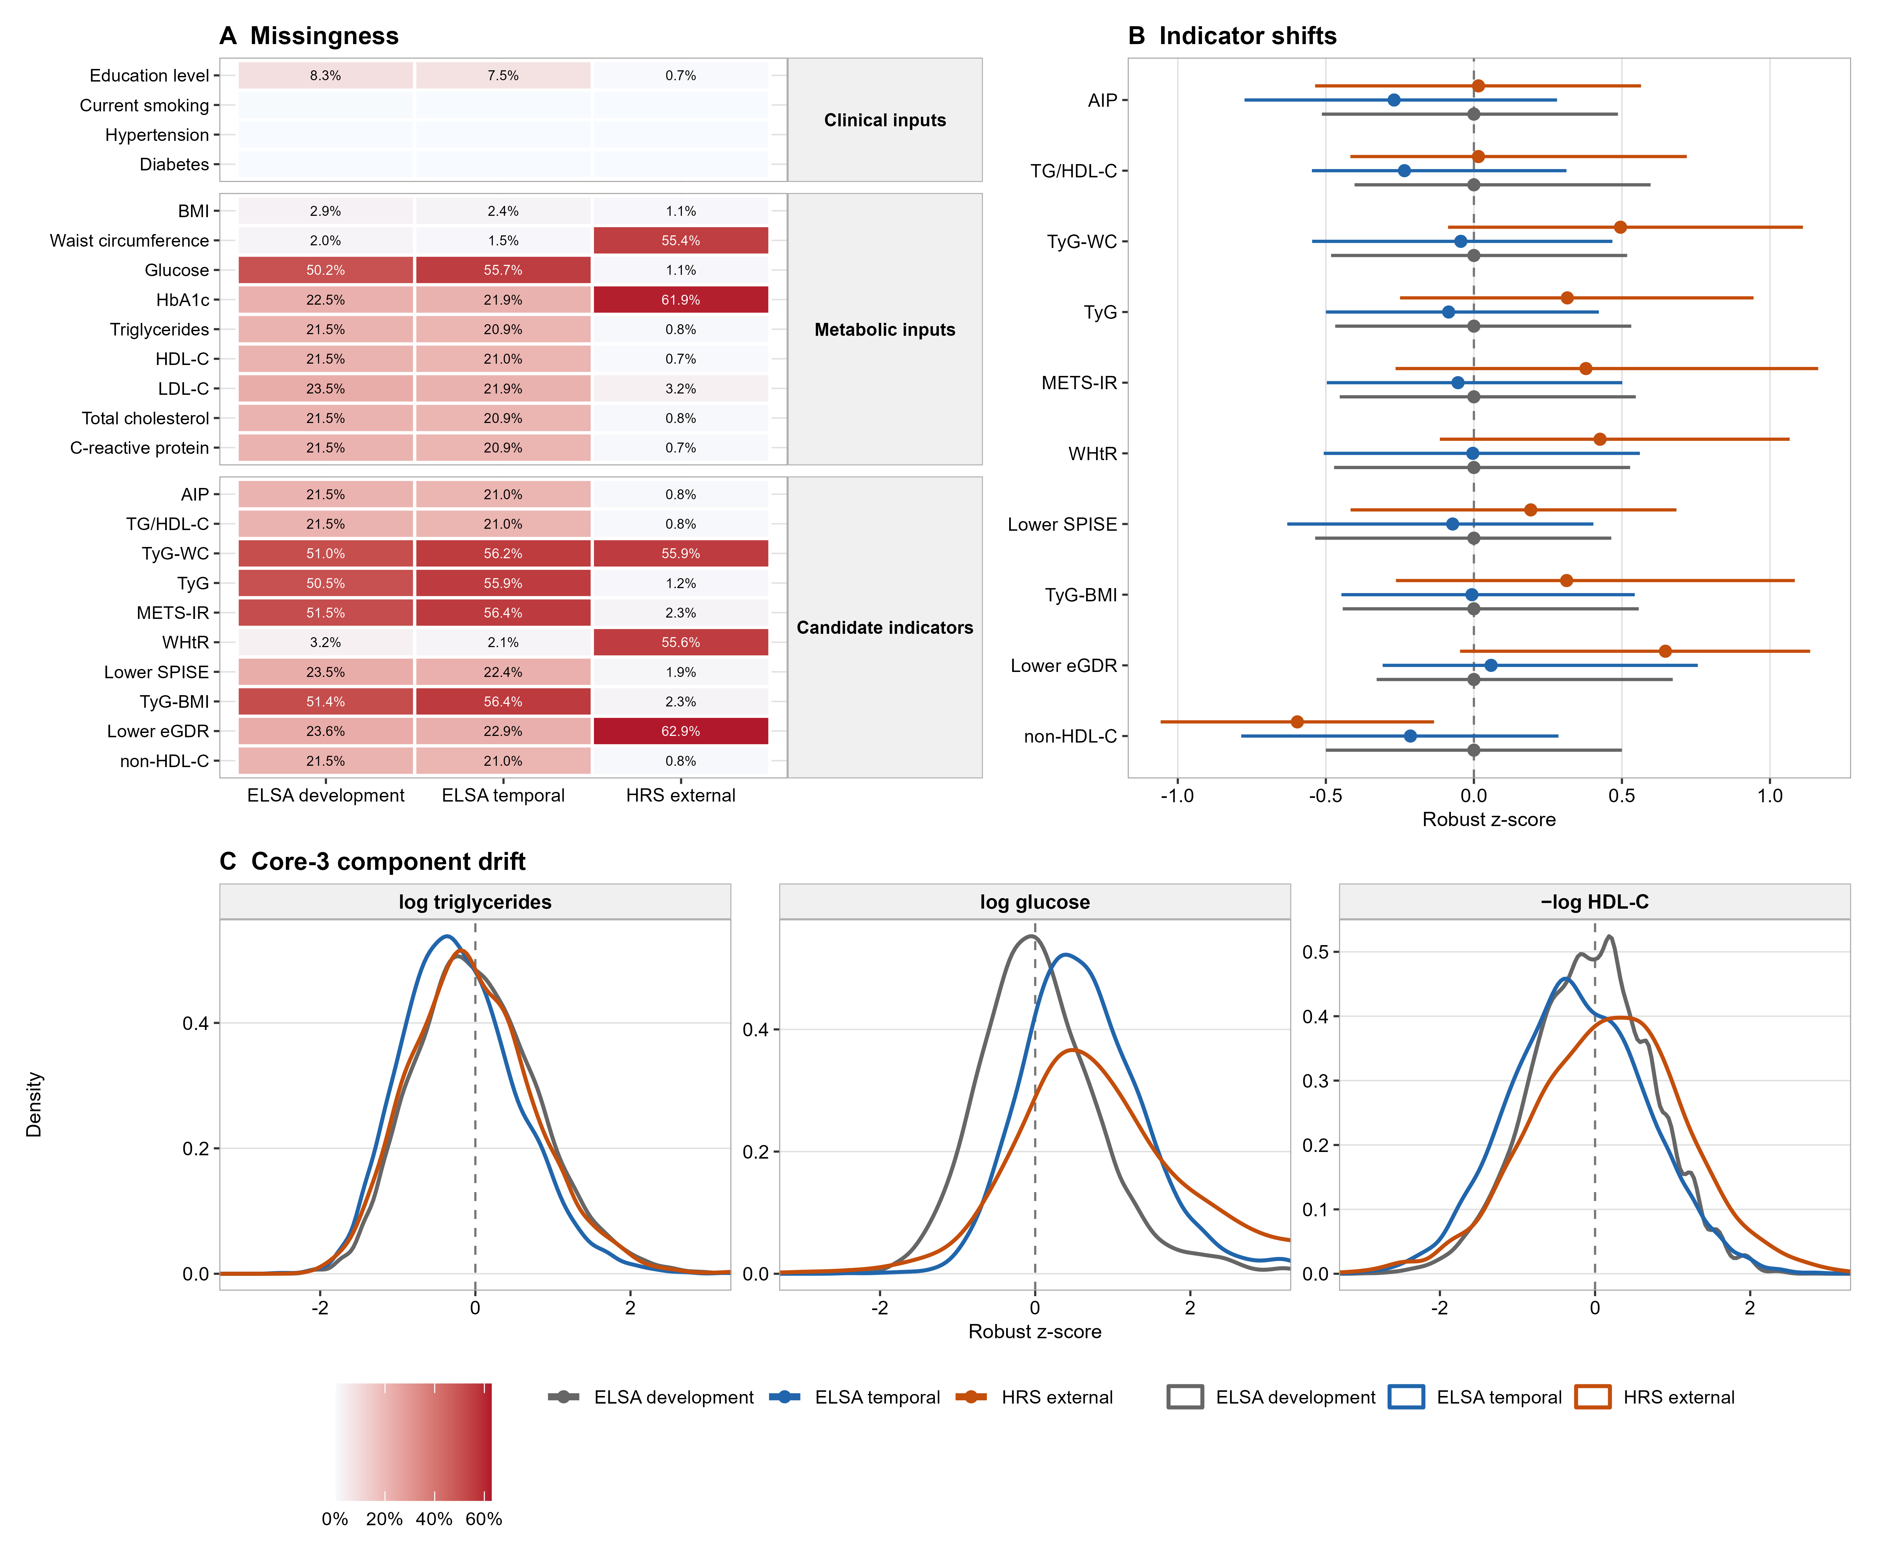
Figure S1. Missingness and distribution drift across analytic stages. A, missingness percentages by variable layer and analytic stage among outcome-observed analytic rows. B, development-referenced robust z-score shifts for the 10 candidate indicators across ELSA development, ELSA temporal validation, and HRS external validation. C, distributional drift of the three Core-3 components on the ELSA-development robust z-score scale. The figure documents both missingness differences and validation-stage distribution shifts relevant to transport interpretation.
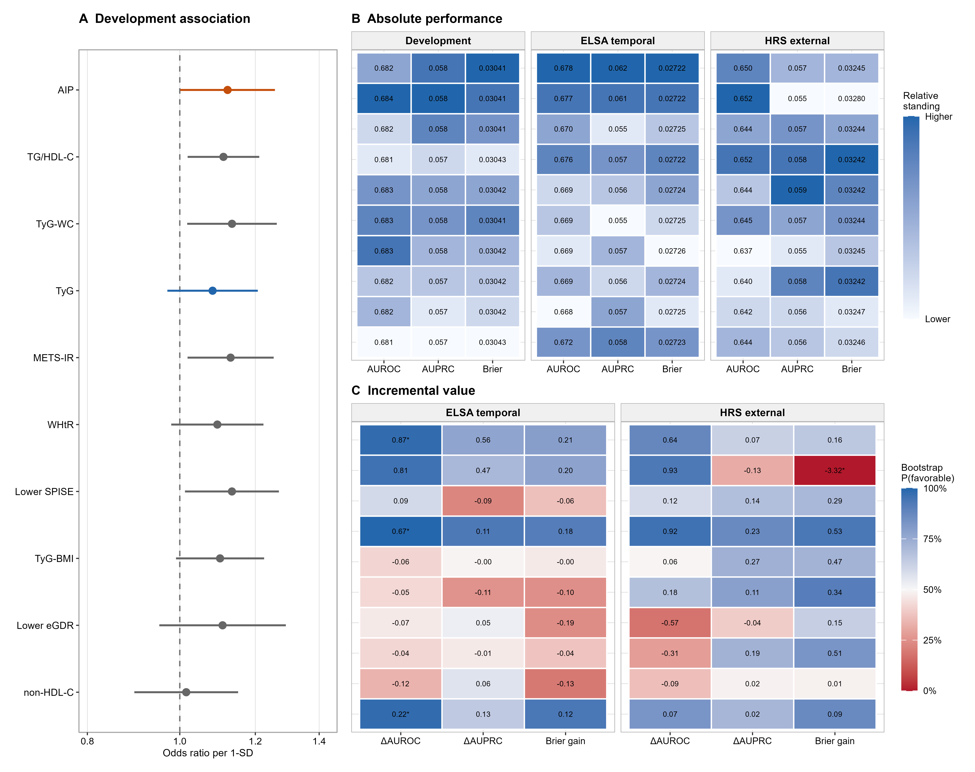
Figure S2. Detailed stage-specific performance of the 10 candidate metabolic indicators. A, development associations reported as odds ratios per 1-standard-deviation increase. B, absolute AUROC, AUPRC, and Brier performance across development, ELSA temporal validation, and HRS external validation. C, incremental value relative to the Clinical model in ELSA temporal validation and HRS external validation. Rows in Panels B and C follow the same indicator order as Panel A. In Panel C, values are metric differences relative to the Clinical model; blue indicates higher bootstrap probability favoring the enhanced model.
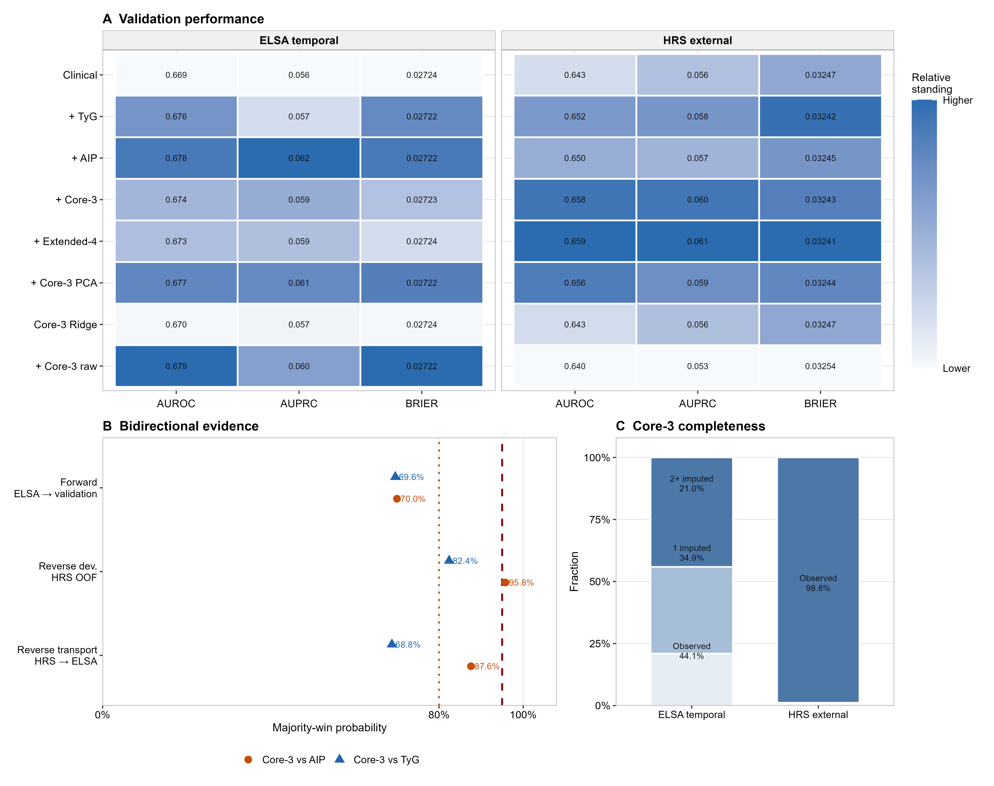
Figure S3. New-score challenge, data completeness, and bidirectional transport. A, validation performance of the Clinical model, existing benchmarks, Core-3/Extended-4 variants, and raw-component upper-bound models. B, majority-win probabilities for Core-3 Equal against AIP and TyG in forward validation, HRS grouped out-of-fold development, and HRS-to-ELSA reverse transport. C, Core-3 component completeness strata in ELSA temporal validation and HRS external validation. Core-3 showed a stronger signal in HRS, where component completeness was high, but did not meet the prespecified promotion rule across validation settings.
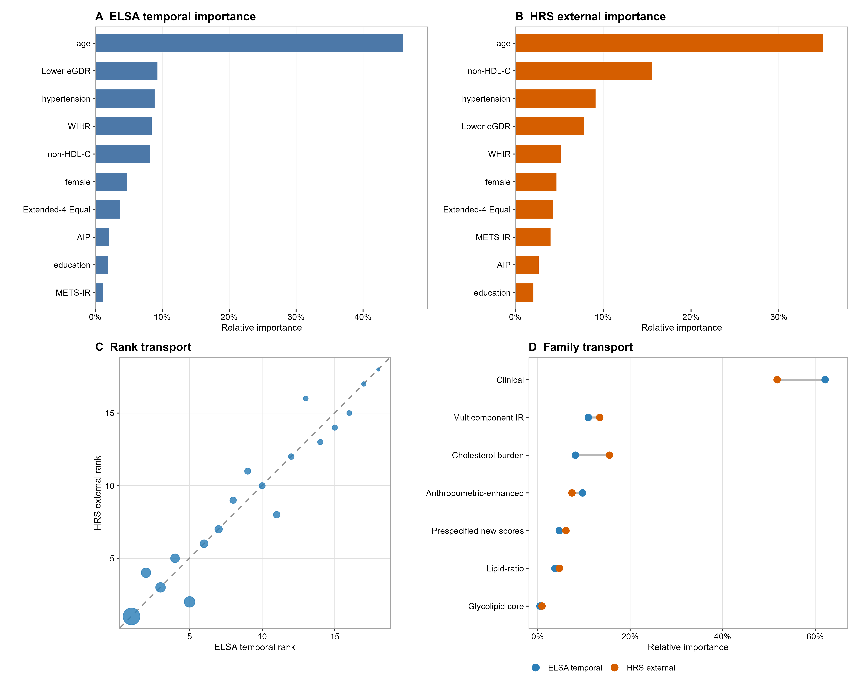
Figure S4. Machine-learning contribution patterns and transportability of feature importance. A-B, leading feature contributions in ELSA temporal validation and HRS external validation from the constrained probability forest. C, feature-rank transport between ELSA temporal validation and HRS external validation; the dashed line denotes equal rank, and point size encodes relative importance. D, family-level contribution transport across validation settings. These model-dependent attributions were descriptive, not causal, and did not revise the verified indicator hierarchy.
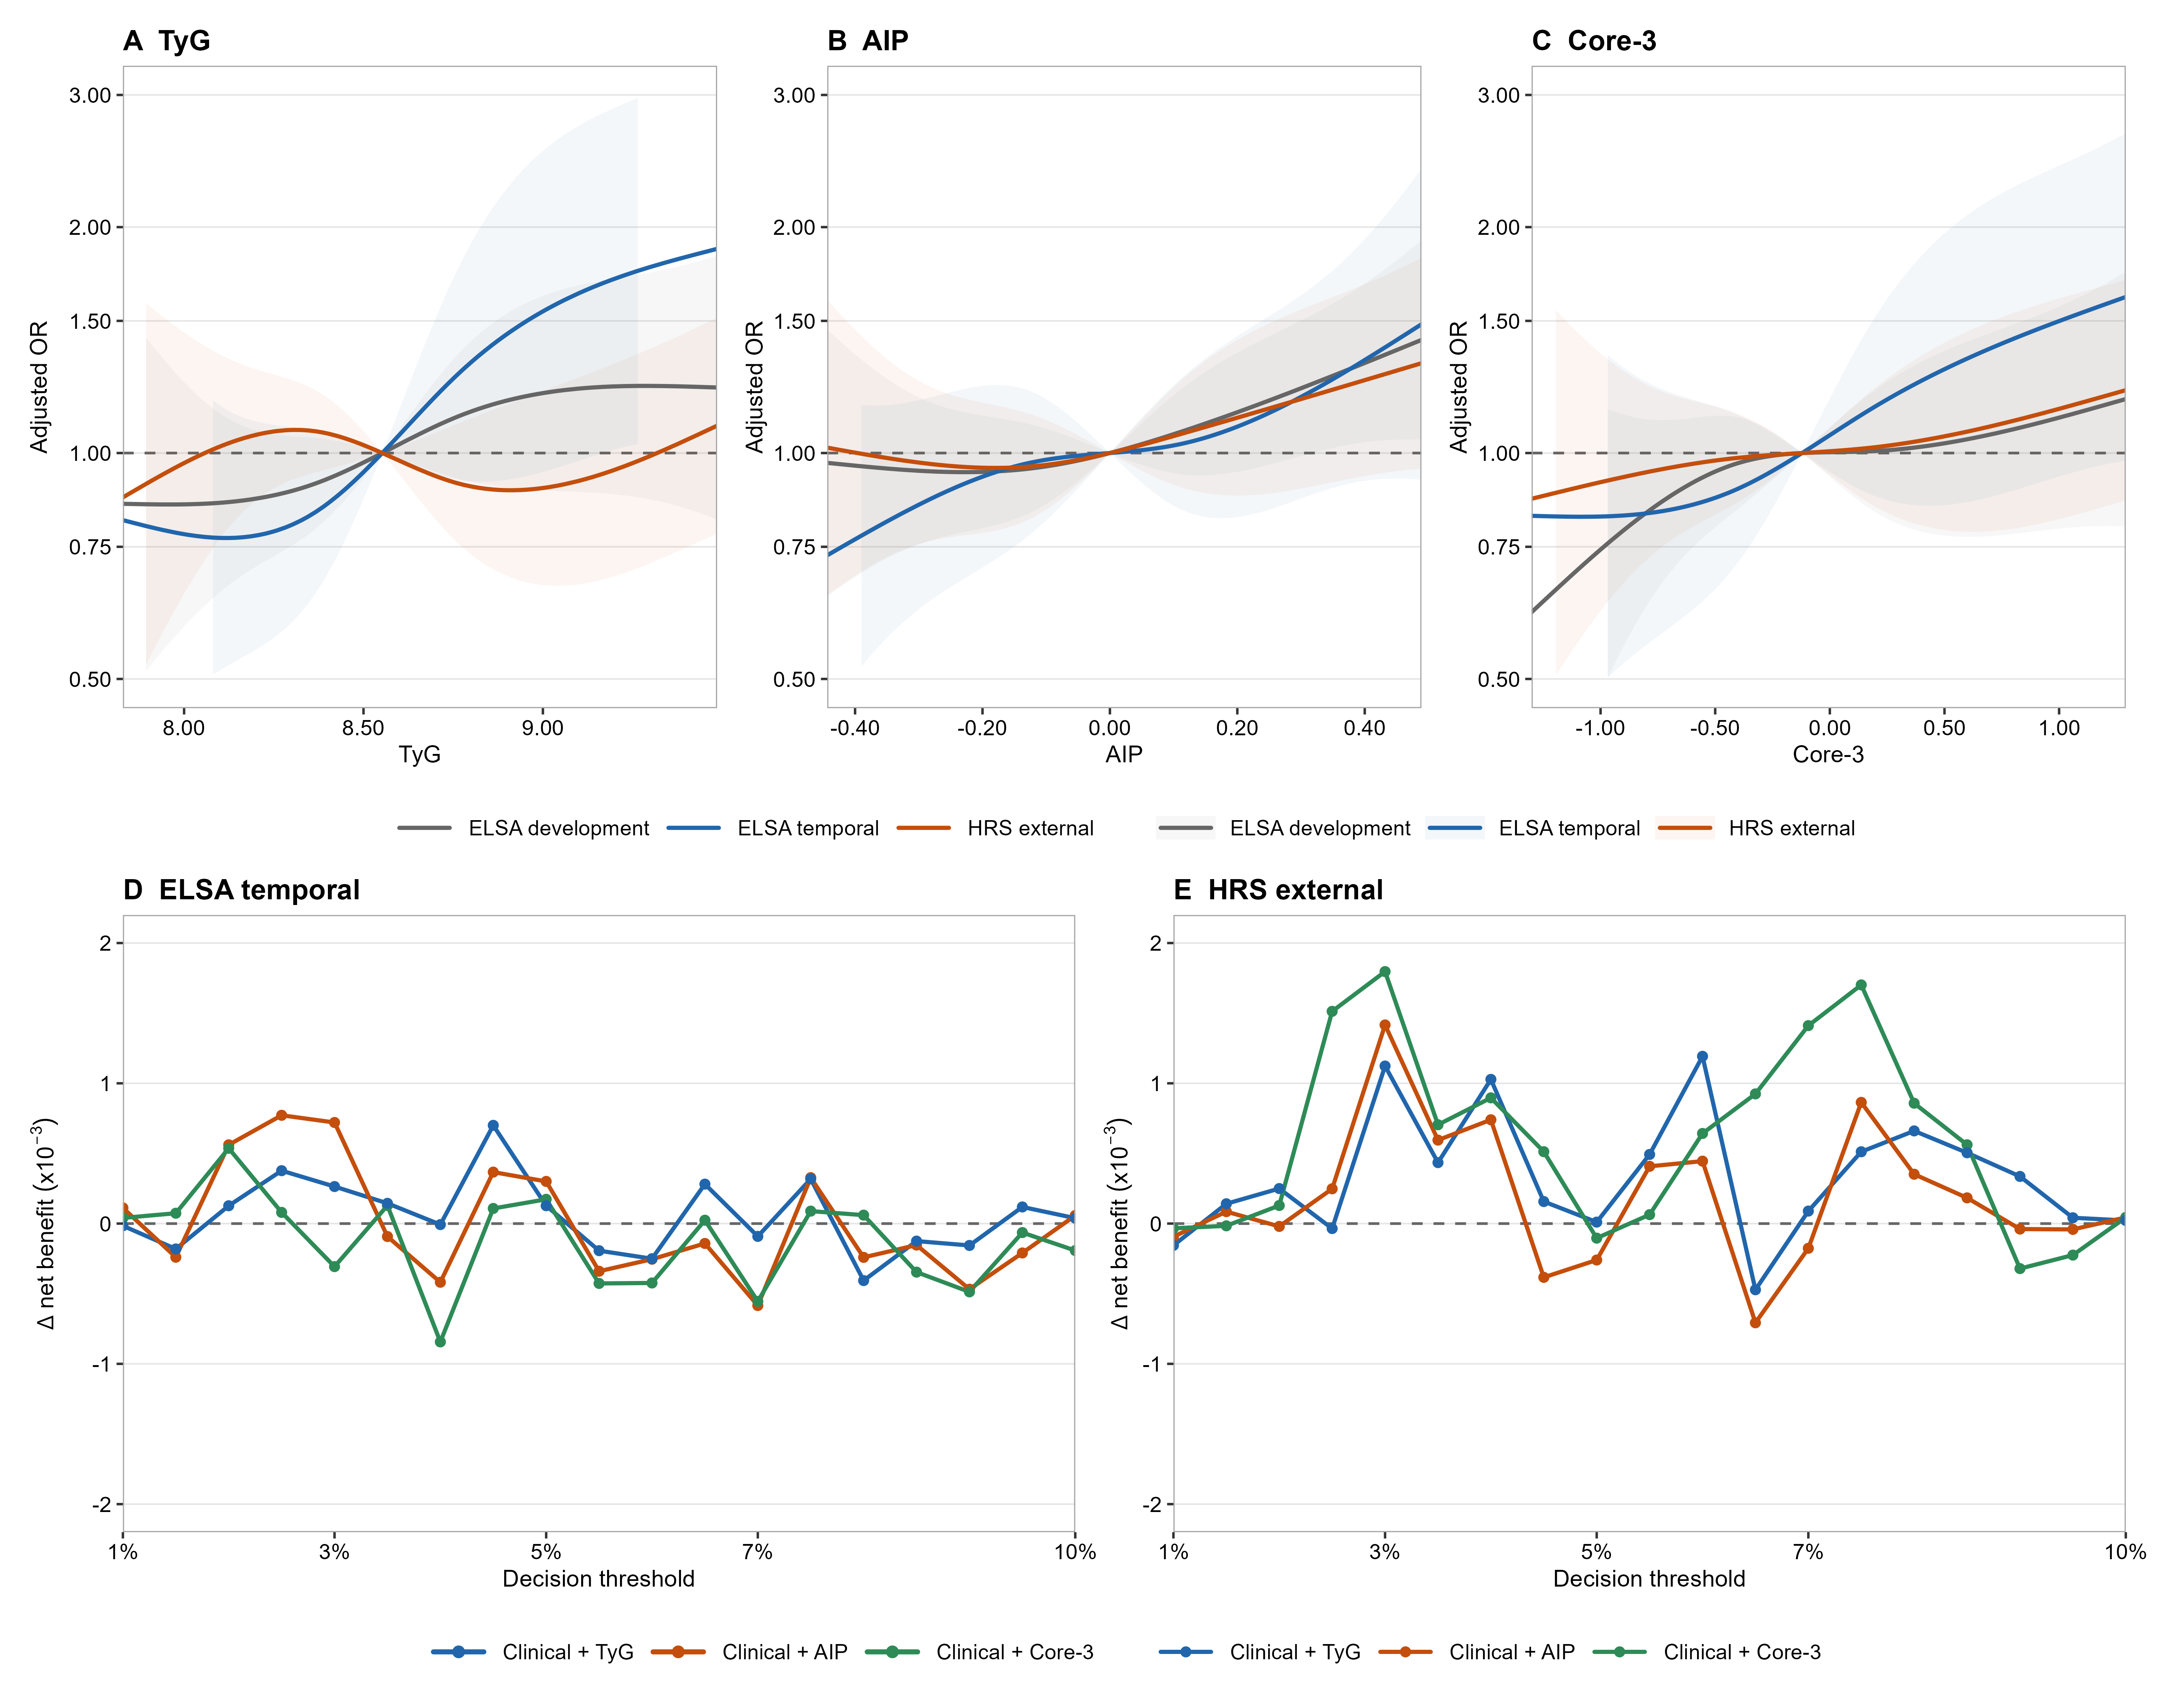
Figure S5. Dose-response shape and incremental decision-curve evidence. A-C, restricted cubic spline curves for TyG, AIP, and Core-3 Equal across ELSA development, ELSA temporal validation, and HRS external validation. Knots were fixed at the 5th, 35th, 65th, and 95th percentiles of the ELSA-development distribution and transported unchanged. Shaded bands indicate confidence intervals. D-E, incremental net benefit of Clinical + TyG, Clinical + AIP, and Clinical + Core-3 Equal relative to the Clinical model across decision thresholds from 1% to 10% in ELSA temporal validation and HRS external validation. Decision-curve signals were descriptive and did not override frozen validation, calibration, or promotion criteria.

