Micron-scale Quantum Dot Light-Emitting Diodes with EQE Exceeding 42%

Hao Liu^{1,†}, Kuibao Yu^{1,†}, Tian Liu¹, Jiahao Wang¹, Kai Xie¹, Haolin Luo¹, Zhihan Lin¹, Jingnan Su¹, Guihua Lin¹, Peijun Wang¹, Weiguo Chen¹, Kaiyu Yang¹, Fushan Li^{1,2,}*, Hailong Hu^{1,2,}*
¹Institute of Optoelectronic Technology, Fuzhou University, Fuzhou 350116,
P. R. China
²Fujian Science and Technology Innovation Laboratory for Optoelectronic Information of China, Fuzhou 350108, P. R. China
E-mail addresses: huhl@fzu.edu.cn (H. Hu); fsli@fzu.edu.cn (F. Li)

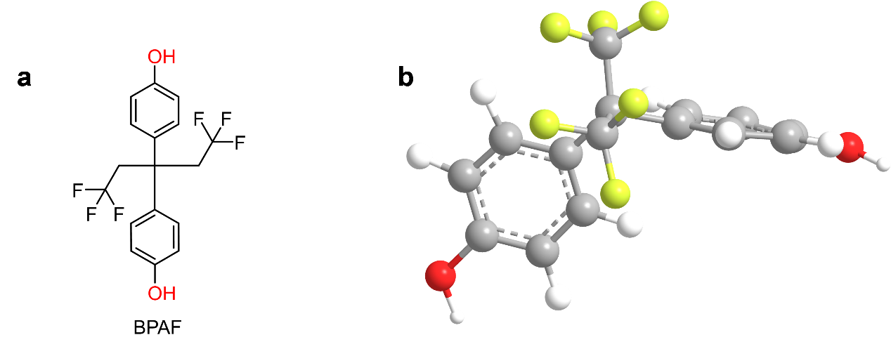Figure S1: (a) Two-dimensional molecular structure of small-molecule BPAF. (b) Corresponding three-dimensional spatial molecular conformation of BPAF.
Figure S2: Schematic illustration of energy-level alignment as well as charge generation, injection and transport pathways within the tandem QLEDs.
Figure S3: Cross-sectional TEM micrograph of the tandem QLED, marking the measured thickness of each functional layer.

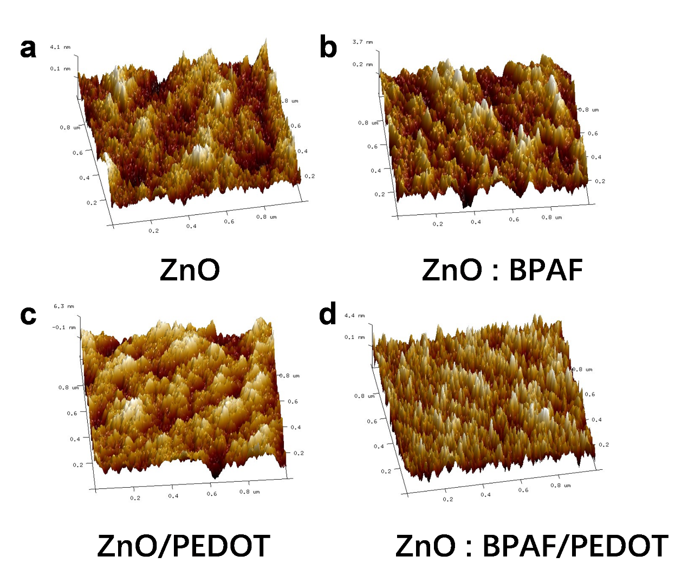Figure S4: 3D topographical height profile of the film surface characterized via AFM.
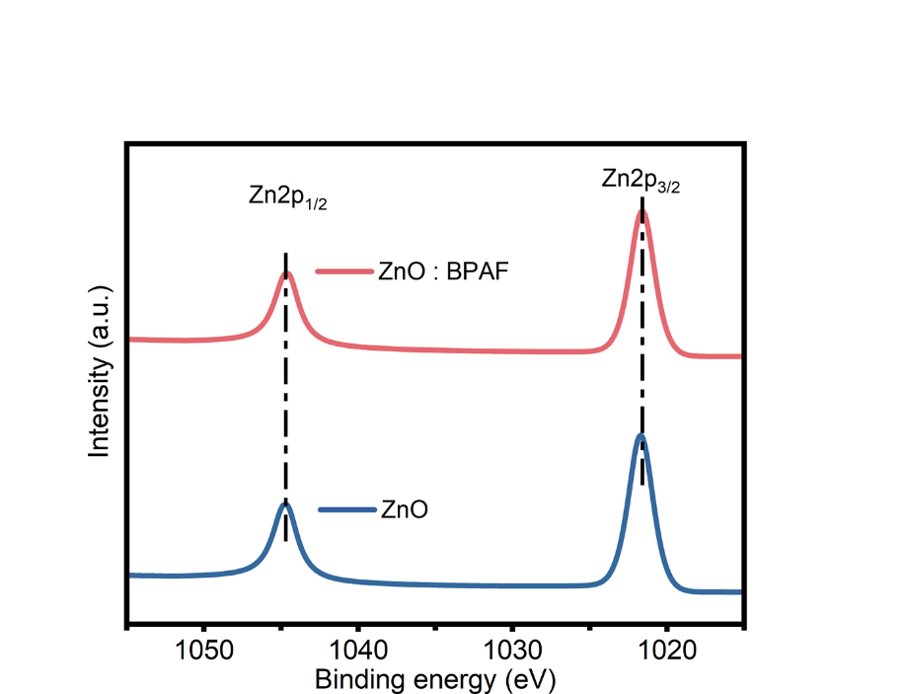
Figure S5: High-resolution XPS spectra of Zn 2p orbitals for pristine ZnO and ZnO:BPAF composite films.
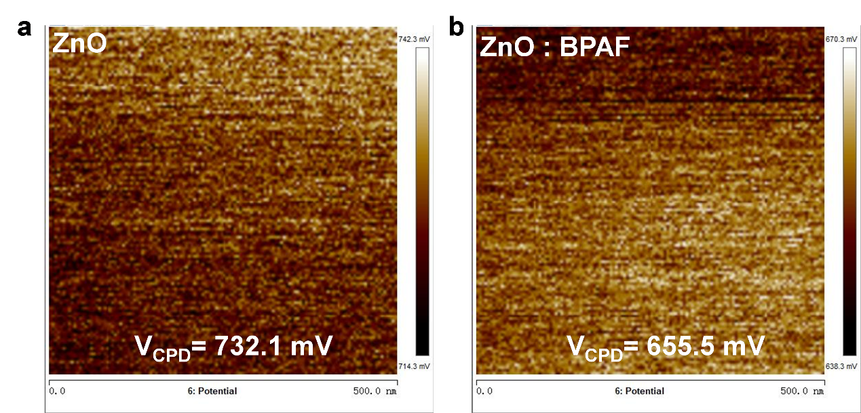Figure S6: Surface potential distribution mappings of pristine ZnO and ZnO:BPAF films characterized by KPFM.

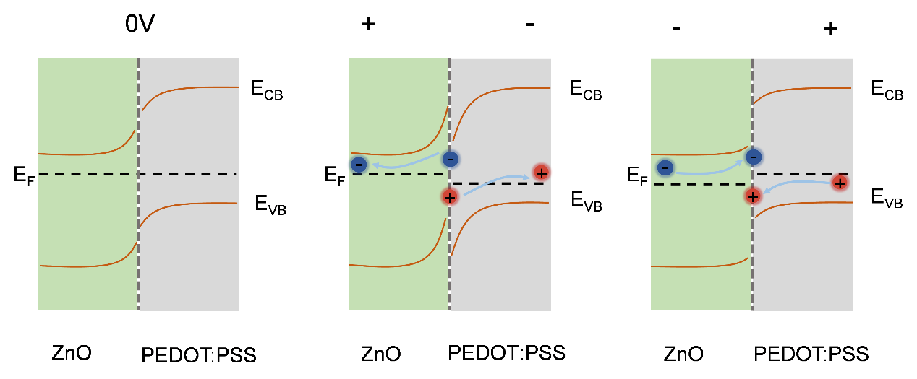Figure S7: Schematic illustration of the electric-field-induced charge separation mechanism: (a) Device state under zero-bias condition. (b) Generation and spatial separation of charge carriers under forward bias. (c) Radiative and non-radiative recombination of electrons and holes under reverse bias.

Table S1. Performance benchmark of state-of-the-art non-patterned tandem QLEDs from previous literature and the optimized device presented in this work.
Process | EQE (%) | CE (cd A⁻¹) | V_{on} (V) | Ref.
Spin-coating | 29.4 | / | 4.5 | Ref. 51
Spin-coating | 35.5 | 52.0 | / | Ref. 50
Spin-coating | 42.9 | / | 4.0 | Ref. 29
Spin-coating | 48.4 | 59.4 | 3.0 | Ref. 28
Sputtering | 51.2 | / | 2.8 | Ref. 49
Spin-coating | 49.8 | 64.7 | 2.5 | This work

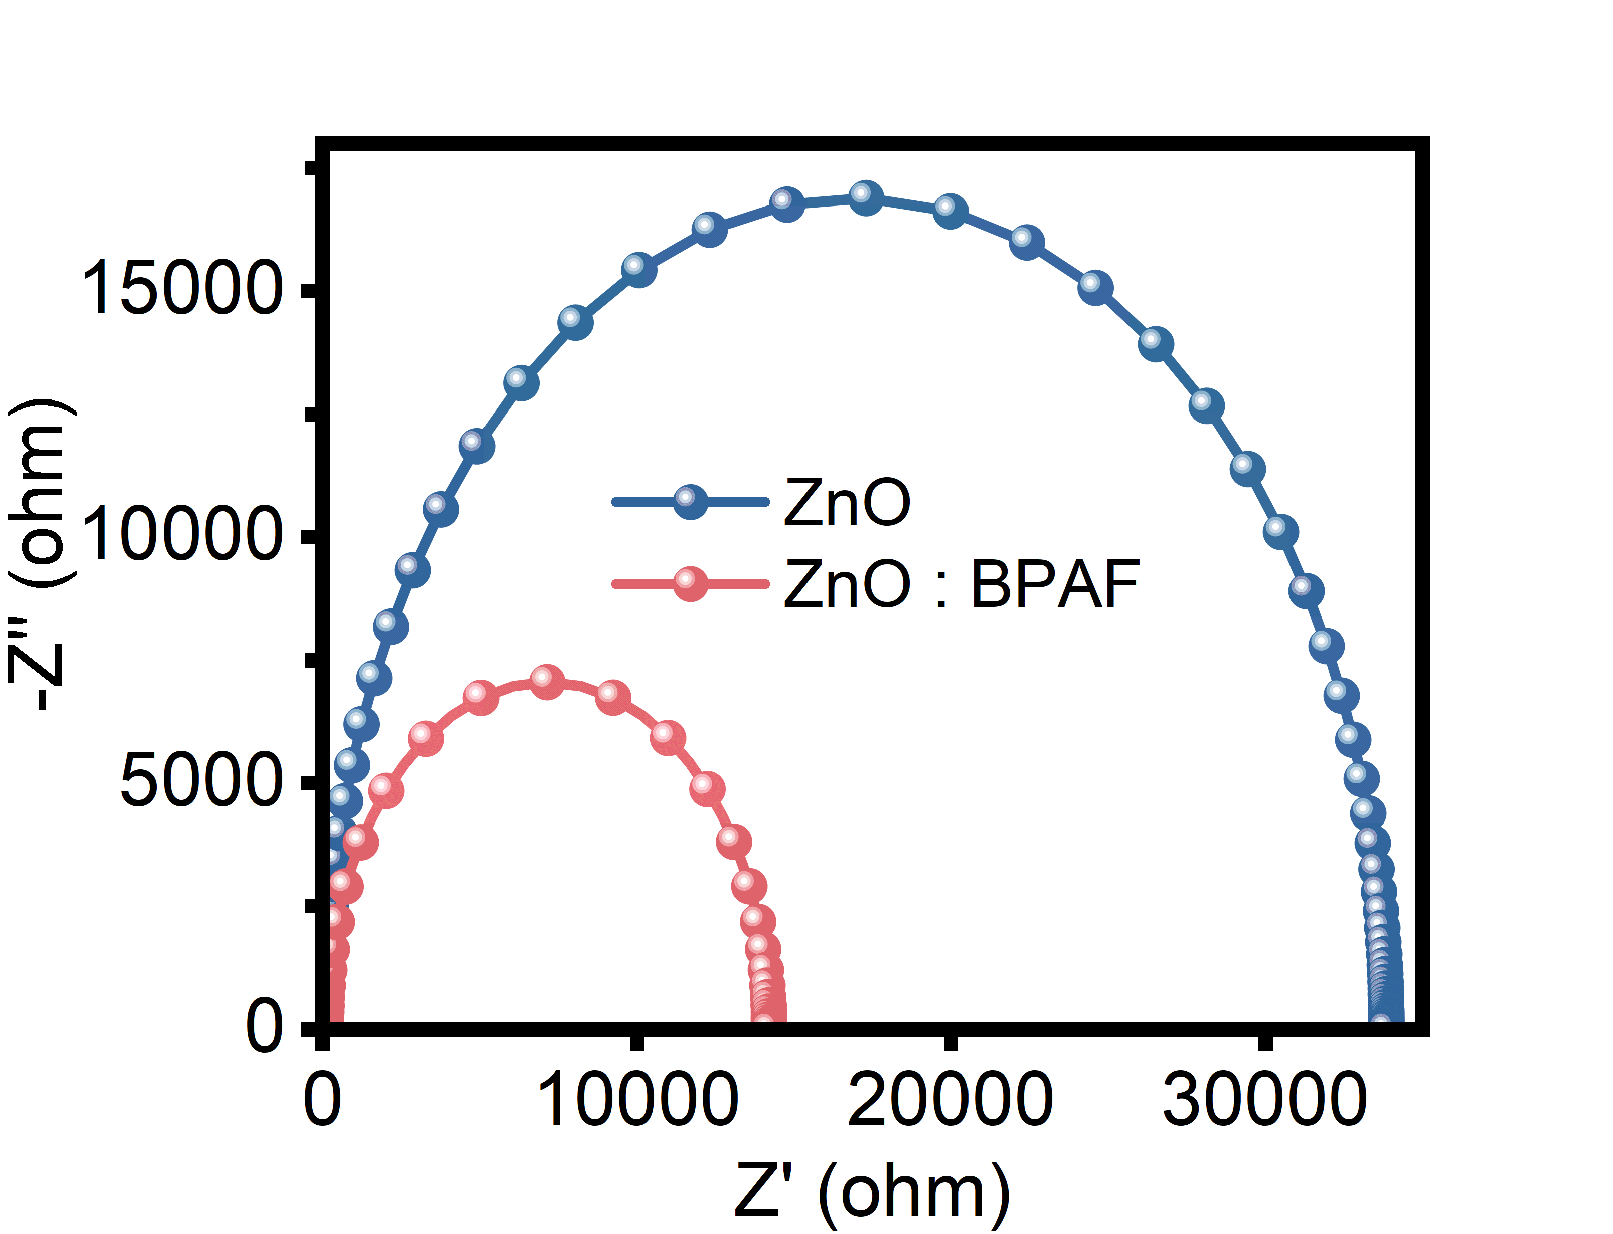
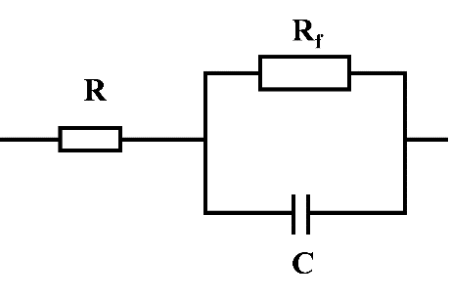
Figure S8: Schematic of the simplified equivalent circuit model for the tandem QLED device.
All parametric values are summarized in Table S2, where the high-frequency series resistance (R_{s}) and low-frequency recombination resistance (R_{f}) are extracted from the corresponding Nyquist plots.
Table S2:
Tandem QLED | R_{s} (Ω) | R_{f} (Ω)
W/O BPAF | 93.09 | 33791
With BPAF | 53.68 | 14110

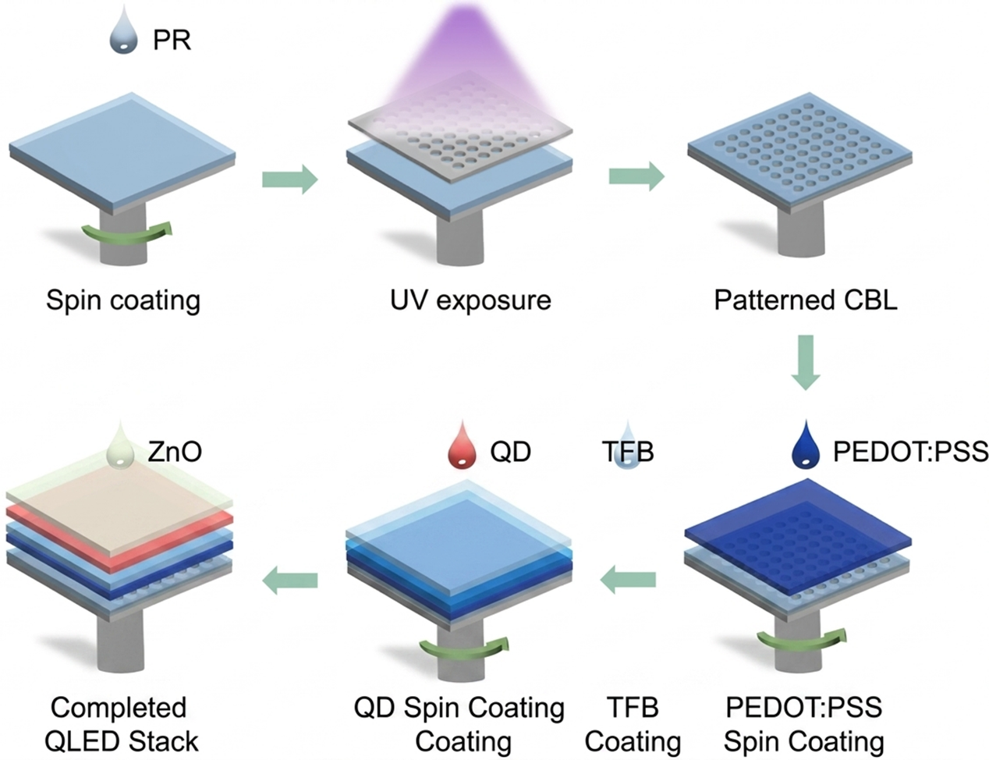
Figure S9: Schematic fabrication workflow of high-resolution patterned QLEDs.
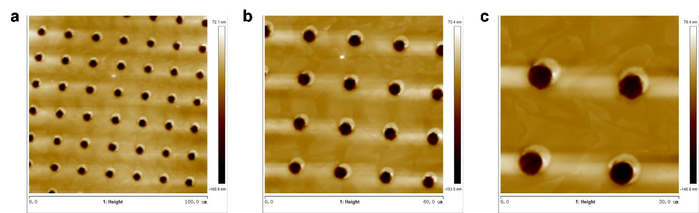
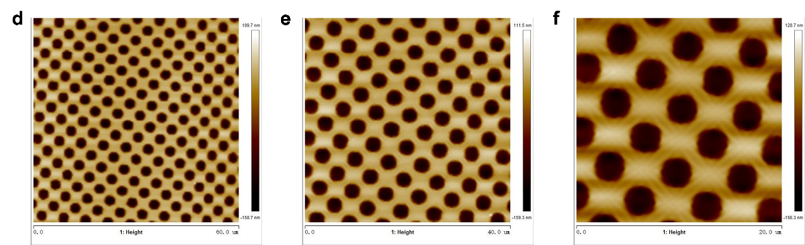
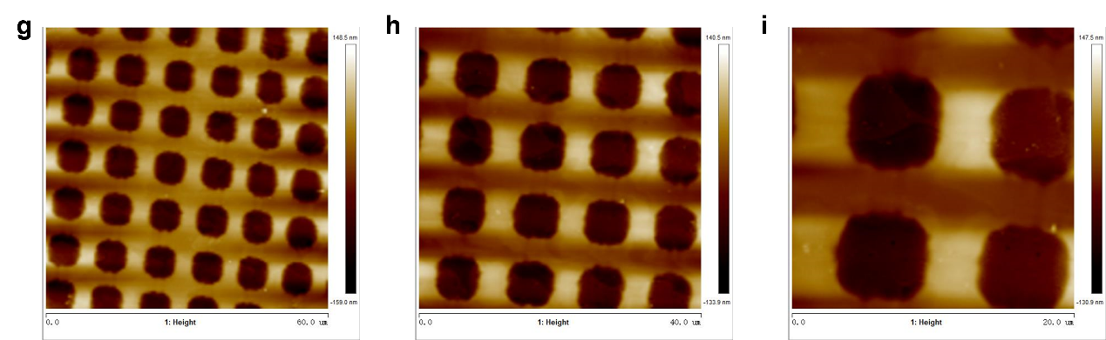
Figure S10: AFM topographical images of patterned charge barrier layer (CBL) arrays with varying feature sizes and geometric morphologies.

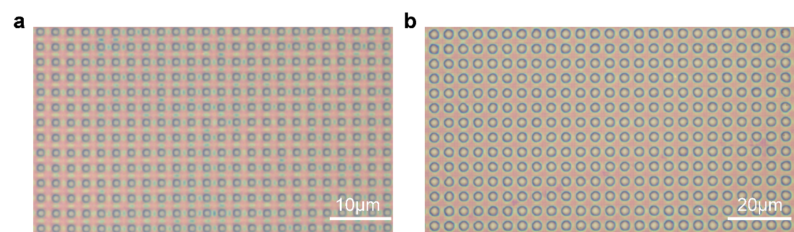
Figure S11: 3D optical microscopic morphological images of the patterned CBL arrays.
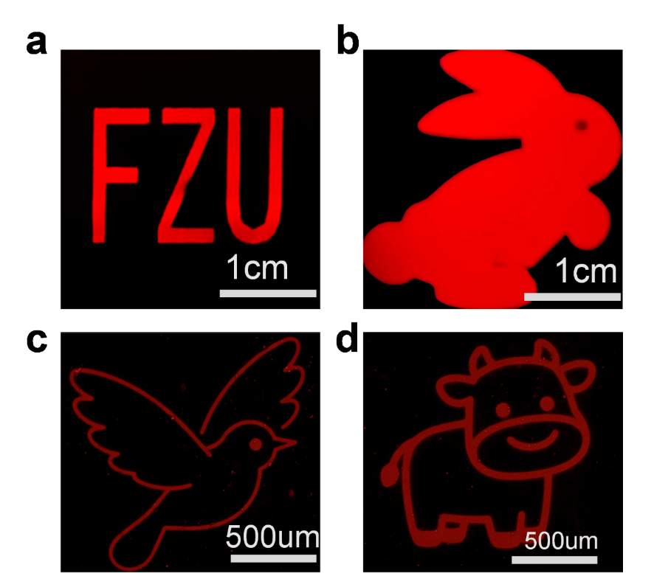
Figure S12. Fluorescence micrographs of red QD patterns prepared by aligned direct photolithography.

