Supplementary information
Proof of Concept of Surface Anticoagulation in Electrically Active Mechanical Mitral Valve Using Biomimetic Glycocalyx: In Vivo Swine Model Study
Lokeswara Rao Sajja (Responsible corresponding author) ^{1,3}*, Thomas Mathew ^{2,3}, Aditya Koppula (corresponding author) ^{3,4}*

Results
Supplementary Tables
Table S1: Baseline pre-surgical Hematology parameters for study animals. Blood sample was collected prior to valve implantation surgery.
S.No | Parameters | Standardization phase Test valves (n=4)  Mean (SD) | Experimental phase Test valves (n=3)  Mean (SD) | Controls (n=3)  Mean (SD)
1 | Hemoglobin (gm/dL) | 12.8 (0.6) | 13.5 (1.5) | 12.1 (0.72)
2 | Hematocrit (%) | 35.0 (2.0) | 36.7 (3.8) | 33 (1.7)
3 | RBC count (millions/mm³) | 6.3 (0.3) | 7 (0.9) | 6.6 (0.6)
4 | WBC count (× 10³ cells/mm³) | 7.1 (2.5) | 8.1 (1.8) | 8.4 (1.5)
5 | Neutrophil % | 37.5 (8.5) | 45.7 (1.2) | 38 (12.1)
6 | Lymphocyte% | 59.8 (10.7) | 51.7 (1.5) | 55.7 (10.4)
7 | Eosinophil % | 2.5 (1.9) | 2.7 (2.5) | 6.3 (3.2)
8 | Platelet count (× 10⁵ cells/mm³) | 2.3 (0.2) | 2.5 (0.8) | 2.5 (0.6)
9 | ACT (secs) | 115 (26.1) | 93 (5.3) | 101.3 (23.8)
10 | Glucose (mg/dL) | 134 (17.1) | 136 (30.3) | 146 (15.1)
11 | SGOT (IU/L) | 35.4 (6.8) | 51.3 (7.6) | 39.0 (19.9)
12 | SGPT (IU/L) | 35.1 (8.7) | 35.2 (2.5) | 38.1 (9.1)
13 | Total protein (gm/dL) | 6.8 (0.2) | 6.4 (0.2) | 6.4 (0.7)
14 | Albumin (gm/dL) | 4.4 (0.1) | 4.0 (0.4) | 4.0 (0.4)
15 | Cholesterol (mg/dL) | 96.9 (15.3) | 107.3 (11.2) | 105.8 (20.9)
16 | BUN (mg/dL) | 13.5 (4.0) | 13.5 (3.7) | 11.8 (2.1)
17 | Creatinine (mg/dL) | 1.9 (0.3) | 1.8 (0.3) | 1.5 (0.2)
18 | ALP (IU/L) | 90.9 (28.5) | 129 (60.3) | 108.3 (43.0)
19 | Total bilirubin (mg/dL) | 0.38 (0.10) | 0.37 (0.06) | 0.37 (0.06)

Table S2: Pre-implantation (T1) and pre-explantation (T2/ prior to elective autopsy) hematology parameters for study animals that completed 20 weeks of follow-up after surgery. In addition to T1 and T2 values of the blood-derived metrics, percentage change (%) are also shown; positive values indicate increase, while negative values indicate decrease of the hematology parameters at T2 relative to that at T1. The IDs of the 4 animals (3 test and 1 control) that completed the follow-up period are also shown.

S.No | Parameters | ID: 286528  Test valve phase 2 |  |  | ID: 281430  Test valve phase 2 |  |  | ID: 286049  Test valve phase 2 |  |  | ID: 291354  Control valve
S.No | Parameters | T1 | T2 | % change | T1 | T2 | % change | T1 | T2 | % change | T1 | T2 | % change
1 | Hemoglobin (gm/dL) | 13.2 | 13.2 | 0 | 12.2 | 14.3 | 17.2 | 15.1 | 12.9 | -14.6 | 11.6 | 13.9 | 19.8
2 | Hematocrit (%) | 35 | 35 | 0 | 34 | 40 | 17.6 | 41 | 35 | -14.6 | 32 | 37 | 15.6
3 | RBC count (millions/mm³) | 6.4 | 6.2 | -3.1 | 6.6 | 7 | 6.1 | 8 | 6.4 | -20 | 6.9 | 7.8 | 13
4 | WBC count (× 10³ cells/mm³) | 10.1 | 9.5 | -5.9 | 6.8 | 7.3 | 7.4 | 7.3 | 6.8 | -6.8 | 6.8 | 8.2 | 20.6
5 | Neutrophil % | 45 | 33 | -26.7 | 47 | 20 | -57.4 | 45 | 33 | -26.7 | 31 | 46 | 48.4
6 | Lymphocyte% | 52 | 62 | 19.2 | 53 | 78 | 47.2 | 50 | 67 | 34 | 59 | 49 | -16.9
7 | Eosinophil % | 3 | 5 | 66.7 | 0 | 2 | na | 5 | 0 | -100 | 10 | 5 | -50
8 | Platelet count (× 10⁵ cells/mm³) | 3.46 | 5.01 | 44.8 | 2.12 | 6.5 | 206.6 | 2.04 | 2.47 | 21.1 | 3.2 | 2.32 | -27.5
9 | ACT (secs) | 95 | 107 | 12.6 | 97 | 73 | -24.7 | 87 | 51 | -41.4 | 74 | 73 | -1.4
10 | Glucose (mg/dL) | 102 | 146 | 43.1 | 146 | 110 | -24.7 | 160 | 140 | -12.5 | 130 | 112 | -13.8
11 | SGOT (IU/L) | 46.3 | 48.9 | 5.6 | 60 | 60.2 | 0.3 | 47.5 | 26.8 | -43.6 | 62 | 42.2 | -31.9
12 | SGPT (IU/L) | 38 | 22 | -42.1 | 33.5 | 25.2 | -24.8 | 34 | 30 | -11.8 | 48 | 37.8 | -21.3
13 | Total protein (gm/dL) | 6.4 | 7.1 | 10.9 | 6.2 | 6.4 | 3.2 | 6.5 | 6.5 | 0 | 5.7 | 6.7 | 17.5
14 | Albumin (gm/dL) | 4.2 | 3.5 | -16.7 | 4.3 | 3.7 | -14 | 3.6 | 4 | 11.1 | 3.5 | 3.8 | 8.6
15 | Cholesterol (mg/dL) | 120 | 102 | -15 | 99 | 87 | -12.1 | 103 | 110 | 6.8 | 129 | 104 | -19.4
16 | BUN (mg/dL) | 16.4 | 11.6 | -29.3 | 9.4 | 13.6 | 44.7 | 14.7 | 17 | 15.6 | 13.8 | 12 | -13
17 | Creatinine (mg/dL) | 2 | 1.3 | -35 | 1.5 | 1.8 | 20 | 1.9 | 1.7 | -10.5 | 1.3 | 1.6 | 23.1
18 | ALP (IU/L) | 83 | 62 | -25.3 | 197.3 | 142 | -28 | 106.7 | 84 | -21.3 | 151 | 172 | 13.9
19 | Total bilirubin (mg/dL) | 0.3 | 0.4 | 33.3 | 0.4 | 0.3 | -25 | 0.4 | 0.3 | -25 | 0.3 | 0.3 | 0

Table S3: Hemodynamic data from cardiac catheterization in animals scheduled for autopsy.
S.No | Parameters | ID: 286528  Test valve phase 2 | ID: 281430  Test valve phase 2 | ID: 286049  Test valve phase 2 | ID: 291354  Control valve
1 | Average Pulmonary artery wedge pressure (mmHg) | 17.8 | 9.2 | 14.5 | 5.1
2 | Average Left ventricular pressure (mmHg) | 13.2 | 6.6 | 9.3 | 1.7
3 | Average Pressure difference (=PA wedge – LV pressure) [mmHg] | 4.6 | 2.6 | 5.2 | 3.4
4 | Average cardiac cycle duration (ms) | 1080.3 | 946.5 | 985.7 | 919.5
5 | Positive pressure differential period (ms) | 274.5 | 268.2 | 228.8 | 358.2
6 | Average heart rate (bpm) | 55.5 | 63.3 | 60.9 | 65.3
7 | Cardiac output (Litres/min) | 1.94 | 2.04 | 1.64 | 2.2

Supplementary Figures
Figure S1: SEM images of one explanted standardization phase valve (a-c) and an un-implanted negative control valve (d-f). Standardization phase test valve images are obtained from the valve retrieved from animal ID: 280750. An unused and freshly unpacked valve served as the negative control. Images d-f were previously published in a manuscript by the same authors¹ (available online at https://journals.plos.org/plosone/article?id=10.1371/journal.pone.0336760) under a Creative Commons Attribution license (CC-BY 4.0).
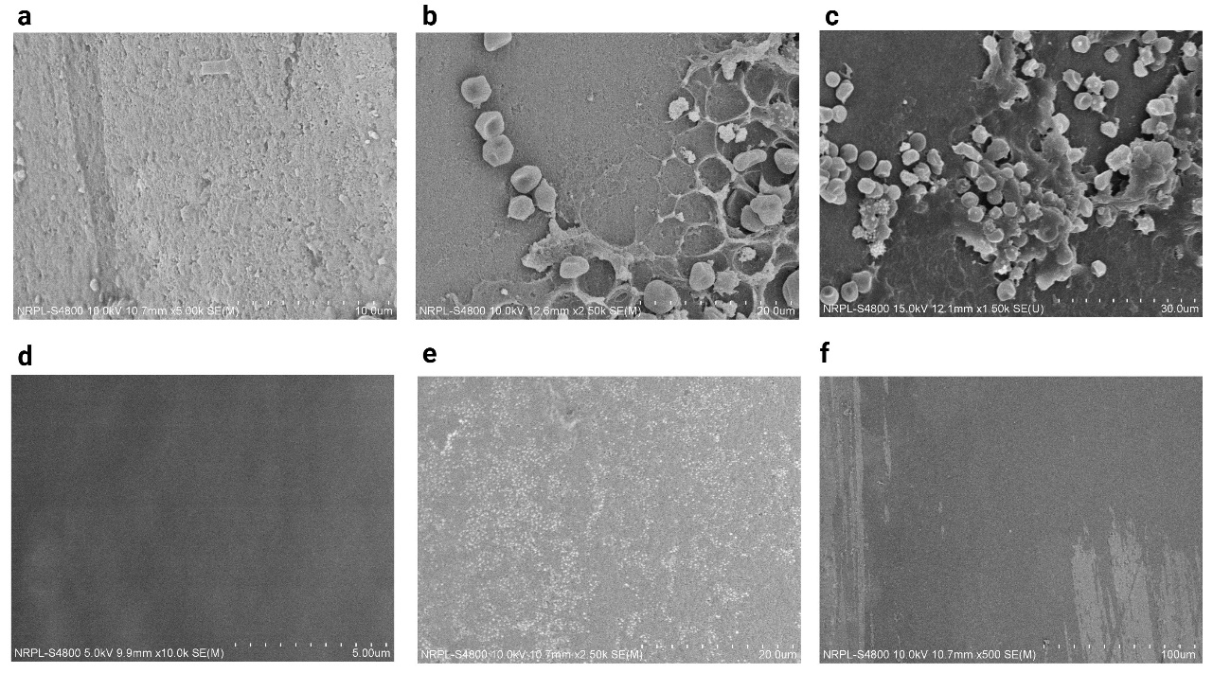
¹Sajja, L. R., Koppula, A., Mathew, T. & Bhatt, A. Surface anticoagulation of mechanical heart valves using electrically induced biomimetic glycocalyx: An in-vitro study to assess hemocompatibility and optimal voltage. PLoS One 21, e0336760 (2026)

Figure S2: SEM images of one explanted experimental phase test valve (a-c) and a control valve (d-f). Experimental phase test valve images are obtained from the valve retrieved from animal ID: 286528, and control valve images are obtained from animal ID: 29154.
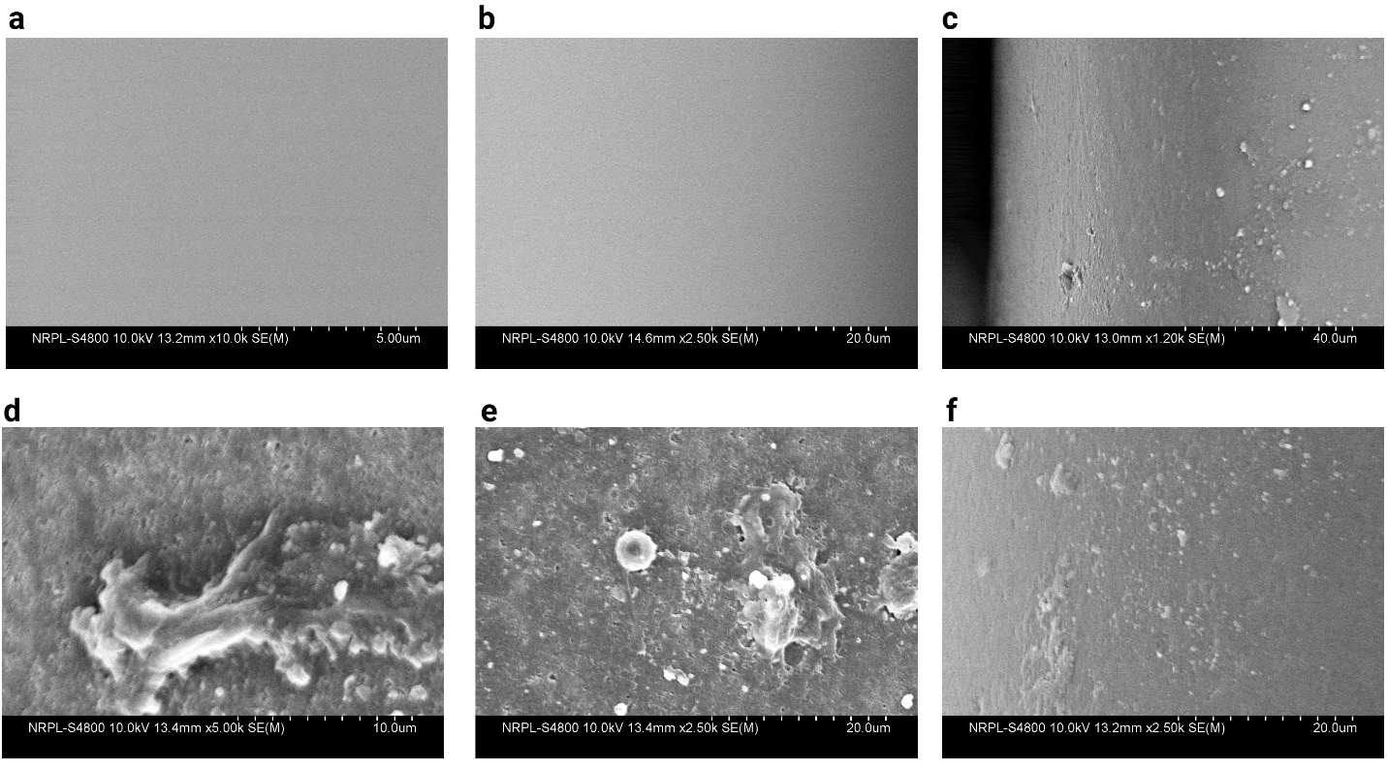

Figure S3: Surgical procedure for implantation of electrical activated mechanical prosthetic heart valve in mitral position of swine. a- Valve-lead couples with valve holders. b- Valve is sutured to the mitral annulus c- Seating of the valve on the annulus. d- Lead is brought through the left atrial appendage. e-IPG is being prepared for anchoring to the chest wall f- IPG is anchored to the inside of the chest wall.
