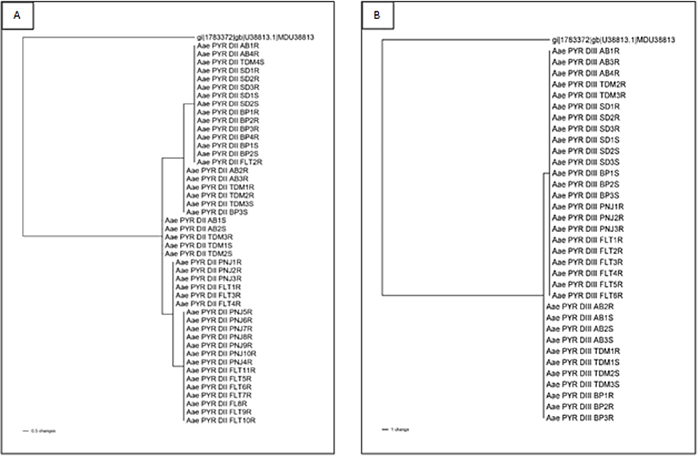
Fig. S2 Maximum parsimony phylogenetic tree of the vgsc fragment spanning exon 15 to exon 16 in domain II (A) and exon 23 to exon 25 in domain III (B) shows a correlation between haplotype and phenotype of resistance and susceptible samples. Susceptible Musca domestica (GenBank accession number U38813.1) was used as an outgroup.

