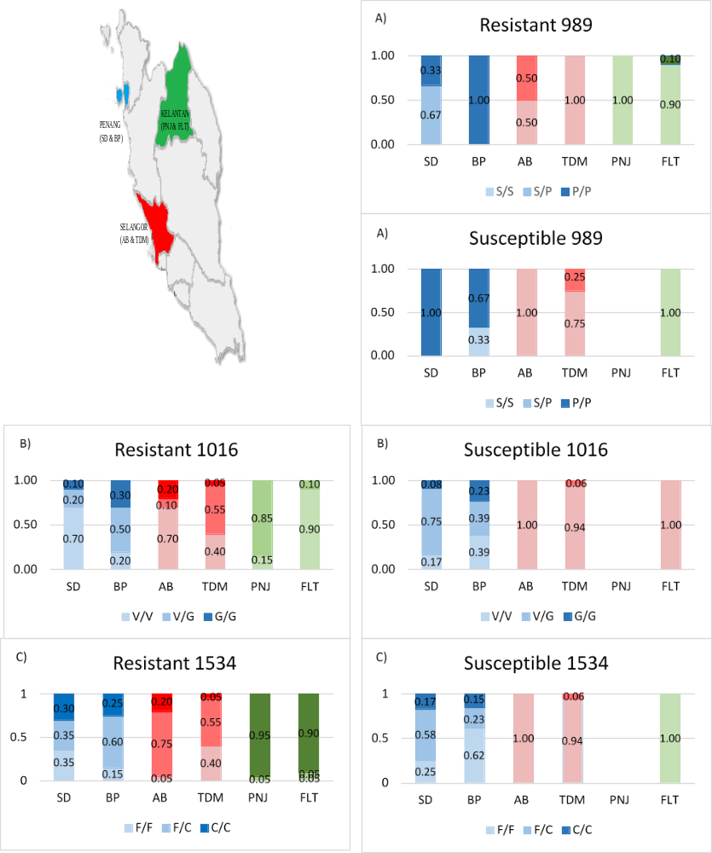

Fig. S1 Illustration map of Malaysia; three states in Malaysia where the resistance study was conducted and also the distribution of kdr allele at codon A) 989, B) 1016 and C) 1534 in the phenotype resistant and susceptible of field population of Malaysian Ae. aegypti.

